Midterm Study Guide - CST8285
Below is a list of topics that you should be familiar with prior to the midterm. I have divided the lists into three sections; HTML, CSS, and JavaScript.

HTML Review

- What is HTML?
  - HyperText Markup Language (HTML) is a language organized by elements that describes how data should appear in a browser.

- What is an element?
  - A tag is used to define an HTML element.
  - Tags are written in the form of <tagname>, where tagname is the type if html element required.
  - Most elements have an opening tag <tag> and a closing tag </tag>.

- What is an attribute?
  - A tag attribute provides additional information about an HTML element.
  - Syntax: <tag attribute = “value”>

- How to define an element
  - Inside a pointed bracket <tagname>

- How to close an element
  - Has a slash (/) inside before the tagname - </tagname>

- How to write a comment
  - Comments can be anywhere in the HTML document after the <!DOCTYPE> tag.
  - Syntax: <!-- This is an HTML comment -->

- What is a DOCTYPE declaration?
  - DOCTYPE declaration (DTD) tells the browser the version of the HTML in which the document is written.
  - The DTD for HTML5 looks like: <!DOCTYPE html>

- Common HTML elements and their attributes
  - <html>
    - The parent element for all other elements in a web page
    - <html> tag indicates the beginning of an HTML document, and the closing </html> tag indicates the end of the document.
  - <head>
    - Holds information about the webpage, such as the title, encoding, links to scripts and CSS files, and metadata for search engines.
    - Most of what is shown here does not appear on the webpage itself.
    - Has a closing tag </head>

  - <title>
    - Located inside the <head> tag
    - Holds the title of the page that is displayed in the browser, as well as by search engines.
  - <meta>
    - Located inside the <head> tag
    - Describes a characteristic of the webpage.
    - Is a standalone tag, doesn’t need a closing tag.
    - Example: <meta charset = "utf-8”>.
  - <body>
    - Most of the webpage code that you write will be within these tags.
    - The body contains the code for the visual part of your webpage.
    - Has a closing tag </body>
  - <a>
    - Primarily used to create Hyperlinks to other webpages
    - Text or images contained in an anchor tag with an ‘href’ attribute will become a hyperlink
    - Can also define an anchor point on a page, which can be linked to within the document (ex. Jump to top of the page)
    - Example: <a href = “http://google.ca”> Google </a>
    - Defining an anchor point: <a name = “top”></a>
    - Linking to an anchor point: <a href = “#top”> Return to top </a>
  - <h1> - <h6>
    - HTML text headings
    - There are 6 sizes of heading to choose from (h1-h6), with h1 being the biggest font size and h6 being the smallest.
    - Has closing tags </h1>
  - <p>
    - Paragraph element
    - Text contained in a paragraph element is displayed in a block with spacing above and below the text
    - Example: <p> This is a paragraph tag. </p>
    - By default, text in paragraph element is aligned to the left, but can be changed with CSS
  - <strong>
    - Text contained in a <strong> element will appear in bold
    - Has closing tag </strong>
  - <em>
    - Used to emphasize text
    - Text in an <em> element will appear in italics
    - Has closing tag </em>
  - <fieldset> & <legend>
    - The <fieldset> element is used to group several controls as well as labels (<label>) within a web form.
    - <legend> is a nested element providing caption for the <fieldset>
  - <div>
    - A <div> element is a block element which are used to wrap sections of a document
  - <span>
    - An inline element which are used to wrap small sections of text, images, etc.
  - <ul>, <ol> and <li>
    - Two types of lists: ordered and unordered.
    - Unordered list uses <ul>…</ul> tags
      - <ul>
      - <li> This is item 1 </li>
      - <li> Thid is item 2 </li>
      - </ul>

    - Ordered list uses <ol>…</ol> tags
      - <ol>
      - <li> This is item 1 </li>
      - <li> Thid is item 2 </li>
      - </ol>
    - List items defined by <li>…</li>
  - <img>
    - Is a standalone tag (doesn’t need a closing tag).
    - Requires two parameters in HTML 5:
      - The ‘src’ parameter, which tells the browser the location of the image.
      - The ‘alt’ parameter, which is a description of the image
        - The alt tag is displayed when users have disabled images. It is also used by search engines and screen readers.
    - Optional attributes include:
      - Width and height – measured in pixels.
      - id – a unique id for the image which is used by CSS and JavaScript
      - title – contains advisory information about the image. This is displayed in most browsers when the mousse hovers over the image.
    - Example: <img src=”images/welcome.png” alt=”Welcome” width=”500” height=”200” title=”Welcome to our page!”>

- Tables (NOTE: There was an error in the slides regarding the <table> element's border attribute. The only acceptable values are "" (blank string), or 1, according to the HTML 5 specification.

  - The <table>, <tr>, <th> and <td> elements
    - <table> tag creates a table
    - <tr> tag are rows within the <table> element.
    - <td> tag are table data or cells within the <tr> element. The number of <td> elements in a row define the number of columns
    - <th> tag is used to define table headers, text in a <th> tag will appear in bold.

  - The colspan and rowspan attributes
    - Colspan and rowspan are attributes of the <td> and <th> elements
    - colspan defines the amount of columns a cell should cover
    - rowspan defines the amount of rows a cell should cover
    - Both accept an integer value for the number of rows/columns to span

  - The <thead>, <tbody>, and <tfoot> elements.
    - Used to group row elements (<tr>) together in logical sections
    - Can be helpful when styling rows with CSS
    - Example:

<table border = “1”>
<thead>
<tr>
<th> Item </th>
<th> Cost </th>
</tr>
</thead>
<tbody>
<tr>
<td> Computer </td>
<td> 750.00 </td>
</tr>
</tbody>
<tfoot>
<tr>
<td> Total </td>
<td> 1000.00 </td>
</tr>
</tfoot>
</table>

- Forms
          - Used to retrieve data from the user. HTML forms on their own does nothing for it needs some client side/server side processing. HTML comes with controls to display text boxes, password fields, radio buttons, checkboxes, drop-down lists, section lists, and more

  - <input> element types (textbox, checkbox, password,radio buttons, etc), and their associated attributes.
    - Used to display several types of form elements
    - Inputs are standalone elements (doesn’t need closing tags)
    - Elements identified by the type attribute.
    - Common attributes for <input> elements:
      - type: the type of form element to display (i.e. text box, checkbox, etc)
      - name: unique identifier for the element within the form, used by client and server side scripting
      - id: unique identifier for the element within the page. Used by CSS and scripting.
      - In general, the name and id are the same

    - Textbox:
      - Displays a single line text box
      - Used for names, email address, URLs, and more
      - Syntax: <input type=”text” name=”firstName” id=”firstName”>
      - Other attributes:
        - value: assigns an initial value
        - maxlength: the maximum acceptable value, in characters

    - Submit Button:
      - Used to call the script in the action attribute of the form element, sending the form data to the server.
      - Syntax: <input type=”submit” name=”btnSubmit” id=”btnSubmit” value=”Submit Form”>
      - Attributes:
        - value: The text to be displayed in the button

    - Reset Button:
      - Used to return form elements to their default values.
      - Syntax: <input type=”reset” name=”btnReset” id=”btnReset” value=”Reset Form”>
      - Attributes:
        - value: the text to be displayed in the button

    - Check box:
      - Allows user to select one or more of a group of related items
      - Good for yes/no questions, or scenarios where a “select al that apply” question is being asked.
      - Syntax: <input type=”checkbox” name=”agreeToTerms” id=”agreeToTerms” value=”yes”>
      - Other attributes:
        - checked: box is checked by default when displayed in browser.

    - Radio Buttons:
      - Allows user to select one (and only one) item from a group of items
      - Define multiple elements with the same name to form a group:
<input type=”radio” name=”gender” id=”genderMale” value=”male”> Male <br>
<input type=”radio” name=”gender” id=”genderFemale” value=”female”> Female

      - Other attributes:
        - checked: box is checked by default when displayed in browser.

    - Password Field:
      - Similar to a text box, but the contents are obscured with dots
      - Syntax: <input type=”password” name=”password” id=”password”>

  - The <textarea> element, and its attributes
    - Accepts larger amounts of text than a textbox.
    - Used for comments, questions, or descriptions.
    - Syntax: <textarea name=”comments” id=”comments” cols=”40” rows=”6”> Enter Comments </textarea>
    - Has closing tags
    - Other attributes:
      - cols: the width of textarea, in characters
      - rows: the height of the textarea, in rows.

  - The <select> and <option> element and its attributes
    - Can be configured to a display a dropdown list, or an option box.
    - Configuration is determined by the size attribute, where a size of 1 will display a dropdown box, and a size of 2 or more will display an option box.
    - The <option> element configures the options presented to the user, and the value of each option that is sent to the browser when selected.
    - Dropdown list allows the user to choose ONE item, while the option list allows user to choose ONE OR MORE items.
    - Syntax:
<select name=”favColor” id=”favColor” size=”4”>
<option disabled> Select a color </option>
<option value=”red”> Red </option>
<option value=”blue”> Blue </option>
<option value=”Yellow”> Yellow </option>
</select>

  - The <form> element, along with its method, action and name attributes
    - Contains the form controls. It tells the browser what to do with the data using these attributes:
      - method: can be ‘get’, or ‘post’ (required).
        - get: form data will be appended to the URL and sent to the browser (less secure)
        - post: transmits data in body of the HTTP request (more secure, recommended)

      - action: URL of server side processing script (required)

    - Other <form> attributes:
      - name: used to identify the form. Useful for pages with multiple forms (optional)
      - autocomplete: can be set to on or off. Tells the browser to remember values entered in these fields. (optional)
      - id: unique identifier for the form. Cannot be the same as other id value on the page. (optioinal)

- The difference between a block and an inline element
  - Block-level elements always starts on a new line and takes up the full width available (stretches out to the left and right as far as it can)
    - Block-level elements in HTML:
      - address, canvas, dt, footer, hr, nonscript, section, video, article, dd, fieldset, form, li, ol, table, aside, div, figcaption, h1-h6, main, p, tfoot, blockquote, dl, figure, header, nav, pre, ul
  - Inline elements does not start on a new line and only takes up as much width as necessary
    - Inline elements in HTML:
      - a, bdo, cite, i, label, q, small, sup, var, abbr, big, code, img, map, samp, span, textarea, acronym, br, dfn, input, object, script, strong, time, b, button, em, kbd, output, select, sub, tt

CSS Review

- What is CSS?
  - Cascading Style Sheets (CSS) defines typographical style, colours, and layout of a webpage.
  - Separates the style from the structure and can apply CSS styles to visible HTML elements

- The ways to apply CSS (inline, embedded and external)
  - Inline: Apply styles to an HTML element with the style attribute.
    - Unlike embedded and external style rules, inline styles do not use a selector.
    - Selectors are passed in the property: value; format as the value of the style attribute
      - style attribute can be applied to any visible HTML element
    - Syntax: <p style=”text-align:center”>
    - Element level inline styles will override all other styles

  - Embedded: Define styles in a <style> element in the <head> section
    - Applies to the entire document in which it is defined.
    - Uses the same syntax as an external stylesheet
    - Syntax:
<style>
p { color: #FF0000; }
h1 { color: #0000FF; }
</style>

  - External: Coded in an external sheet
    - Styles are saved in an outside file with .css extension
    - Useful for defining styles across multiple pages
    - Added to a page in the <head> section using a <link> element
    - Syntax: <link href=”css/style.css” rel=”stylesheet”>

- The CSS "Rules of precedence"
  - CSS uses rules of precedence to apply styles, with the items on the right overriding items on the left.

- Defining a CSS rule (syntax)
  - Example: td { background-color: #FF0000; }
    - td – selector
    - background-color – property
    - #FF0000 – value
  - The curly brackets contain all of the style rules for the chosen element.
  - The property and value(s) of a rule are separated by a colon (:).
  - The property-value pair is called a rule

- CSS Colors
  - Two main properties for applying color with CSS: color and background-color
    - color: configures the text color of an element
    - background-color: configures the background color
  - The value of color and background-color can be of the following types:
    - Hexadecimal (ex: #FF0000)
    - Decimal (ex. Rbg(255, 0, 0))
    - Hue, Saturation, and Lightness (ex. hsl (0, 100%, 50%))
    - Color words (ex. red)

- CSS selectors
  - Selectors are used to identify which elements a CSS rule applies to
  - Selectors include: HTML element, class, id
    - HTML Element:
      - Uses the element itself as the selector

        - Ex: p { text-align: center; }
      - Will apply to every occurrence of that element within the scope of the rule
    - Class:
      - In embedded and external stylesheets, you can define a style class
      - Class identified by a dot, then the class name
        - Ex: .red { color: ##FF0000; }
      - To apply the class to an HTML element, use the class attribute
        - Ex: <p class=”red”> This is a red text </p>
      - Can apply a CSS class to multiple elements

    - id:
      - In embedded and external stylesheets, you can define a style for an id
      - id is identified by a # then the id name
        - Ex. #header { text-align: center; }
      - To apply the id style, give the HTML element the corresponding id
        - Ex: <div id=”header”>
  - Descendant selector
    - You can define a style for an element in the context of a container element
      - Ex: #header h1 { color: #FF0000; }
      - The style above would apply to all h1 elements in the header context
    - A selector can have multiple descendants
      - Ex: #header .nav li { color: #0000FF; }

- The CSS box model
  - Margins and Padding:
    - Margins are the non-visible space outside of the element
      - Ex: margin: 5px; - would place a non-visible space of 5px around the element
    - Padding is the space between the border and the content of an element
      - Ex: padding: 5px; - would place a 5px space between the border and the element’s content
    - Can specify margins and the padding at the top, left, right, or bottom of an element
      - Ex: padding-top: 5px; - would put 5px of padding only on the top of the element.

- CSS positioning
  - Positioning can be static, fixed, relative, or absolute
    - static: default positioning
    - fixed: relative to browser window
    - relative: relative to its static position
    - absolute: relative to first non-static parent element
  - Position with top, bottom, left, and right
    - Value is a pixel value (px) of how many pixels between the property and the element
      - Ex: top: 50px; would be 50px from the top of the element

- How to modify text with CSS
  - Common CSS properties for modifying text:
    - text-align: positions the text
      - values include: left, center, right, or justified

    - font-weight: changes thickness of letters:
      - values include: lighter, normal, bold, bolder
    - color: sets the color of the text
    - text-decoration: sets decoration to the text
      - values include: underline, overline, line-through

- How to modify tables with CSS
  - Common CSS properties for modifying <table> elements:
    - width: specifies width in pixels or percent of screen
    - border-spacing: configures space between cell borders
    - border: configures the border of the table (not the cells)
    - border-collapse: collapse (no space between borders), separate (space between borders, default value)
  - Styled that modify text and color applied to the table will apply to all cells in that table, unless they are overridden.

  - Common CSS properties for modifying <td> elements:
    - color: defines the text color
    - background-color: defines the background-color
    - padding: defined the amount of space between the cell contents and the border

- The float property
  - Elements floated horizontally
  - Can float an image to the right or left, not up or down
  - Text elements found after a floated element will flow around it.
  - Text elements before a floated object will not be affected.
  - Elements that are absolutely positioned ignore the float property

JavaScript Review

- What is JavaScript?
  - JavaScript is a versatile, interpreted client-side programming language
  - Supported by all major browsers
  - Used to add functionality to webpages
    - JavaScript can respond to events
    - JavaScript can access and modify HTML elements
  - JavaScript is NOT JAVA!

- Static vs. Dynamic web pages
  - The content of static webpages does not change, unless the source code is modified.
  - Static webpages DO NOT allow for user input/interaction
  - Dynamic webpages have content that changes, without having to edit the source code.
  - Most webpages have some dynamic content.

  - In static webpages, pages will remain the same until someone changes it manually. While dynamic webpages are used where the information is changed frequently (i.e. weather information, stock prices, etc)

- Client side vs. Server side programming
  - Client side
    - Code runs IN the BROWSER
    - Languages: JavaScript, Angular.js, jquery
    - Has direct access to the browser and the page elements
    - Unreliable (scripts can be disabled, input validation can be manipulated)

  - Server side
    - Code runs ON the SERVER
    - Languages: PHP, PHP frameworks (Laravel, CakePHP, and more), Ruby on Rails, Python, C#
    - Does not have access to the browser
    - Reliable (user has no direct access, theoretically secure)

  - The client and server don’t know what the other is doing

- How to add JavaScript to a web page
  - You can put JavaScript in your webpage in two ways:
    - Inside a <script> element
<script>
document.write(“Hello World”);
</script>
    - Link to a JavaScript file (.js) using the <script> src attribute:
<script src = “script/jquery.js”></script>

- How to declare a function
  - A basic function declaration looks like this:
function myFunction() {
// do stuff here
}
  - A function declaration with parameters looks like this:
function myFunction(param1, param2) {
// do stuff here
}

- How to declare a variable
  - Variables are declared with the term var
    - Ex 1: var myName = “Matt”;
    - Ex 2: var myName;
  - The equals sign (=) is the assignment operator
  - Variables are dynamically typed – they do not require a data type specification

- Local vs. global variable scope
  - Variables declared outside of a function have a global scope
  - Variables declared inside of a function have a local scope

- Data types (string, number, boolean)
  - String data type
    - Strings can be enclosed in single or double quotes
    - Examples:
      - var a = “hello world!”;
      - var b = ‘hello world!’;
      - var c = “55”;
    - You can use quotes in a string as long as they don’t match the container quotes
      - Ex: var statement = “ He said ‘Hello World!’ to me. “;
    - Strings can be added together using the + operator
    - Example:
var firstName = “Matt”;
var lastName = “LaCasse”;

var fullName = firstName + “ “ + lastName;

  - Number data type
    - JavaScript only has one number type
    - Can be written with or without a decimal
    - Example:
var a = 50;
var b = 50.5;
    - Very large and very small numbers can be written in scientific notation
    - Example:
var a = 19e7; // 190000000
var b = 12e-7; // 0.0000012

  - Boolean data type
    - Can be true or false
    - Example:
var isThisANumber = false;
var isThisABoolean = true;

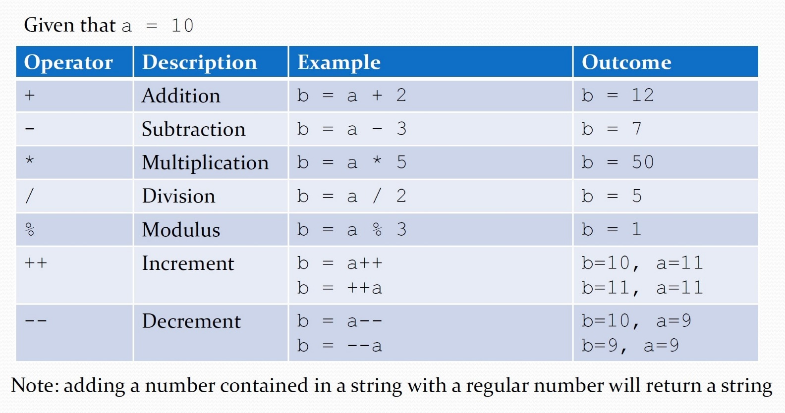
- Arithmetic Operators

- Assignment Operators
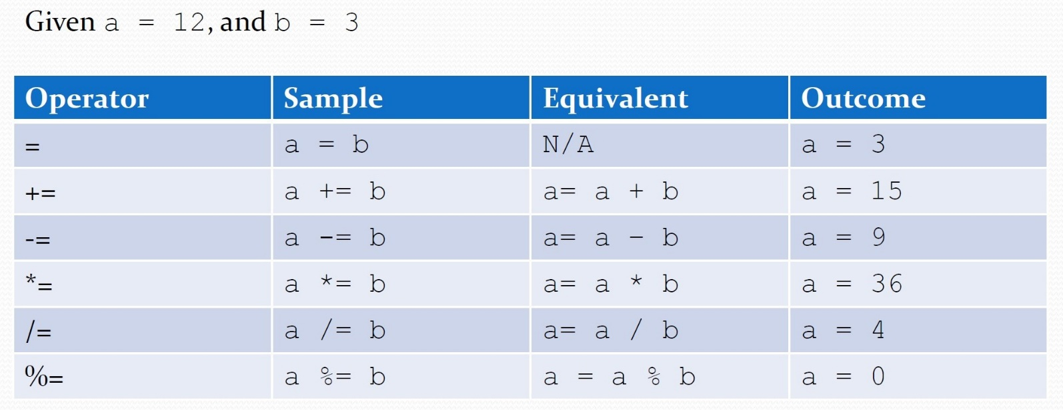
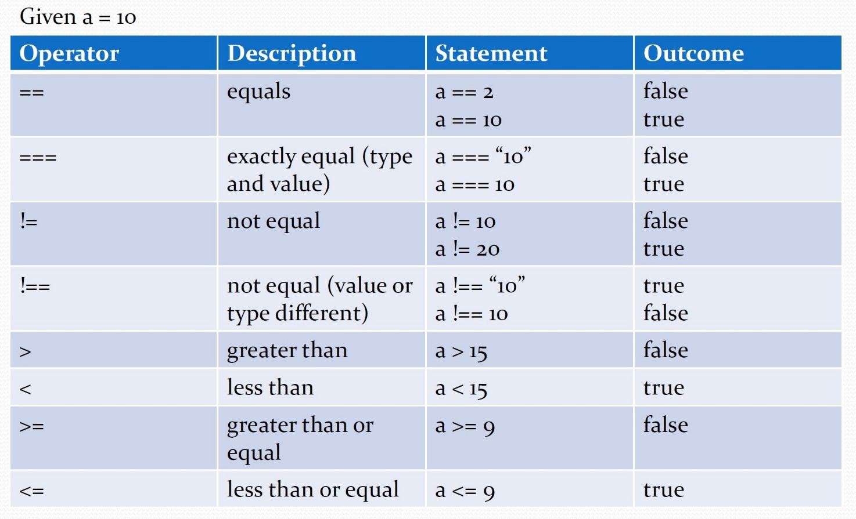
- Comparisons

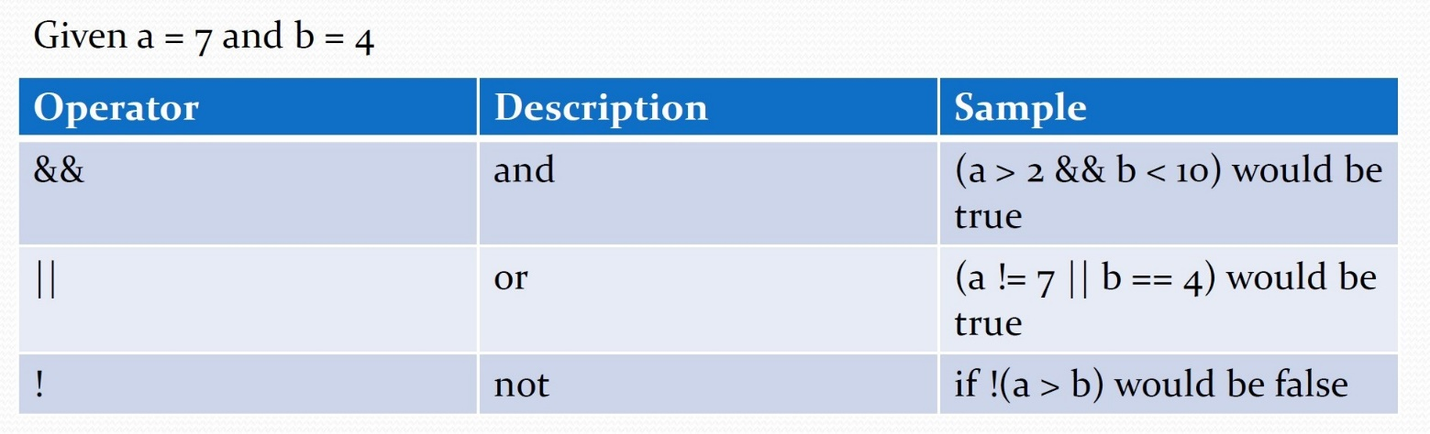
- Logical Operators

- Conditional statements
  - JavaScript uses if, if…else, if…else, if…else, and switch statements for conditional actions
  - if statement syntax:
if (expression) {
// do something
}

  - if…else example:
if (expression) {
// do something if the expression is true
} else {
// do something if the expression is false
}
  - if…else if…else example
if (expression1) {
//do something if expression1 is true
} else if (expression2) {
// do something if expression2 is true
} else {
// do something if neither expression is true
}

  - Switch statement:
    - The value after case is called the case label
    - The code found after the case label will run if the variable matches the case label
    - If there is no match between the variable and the case label, the code after default will run.
    - The break; statements tells the switch statement to stop.
    - Switch example:
switch (variable) {
case 1:
// do something
break;
case 2:
// do something
break;
default:
// do this if none of the above cases are true
}

- prompt and alert
  - Prompt
    - A JavaScript prompt displays a message box to the user with a message, and a textbox for them to reply.
    - Called by the prompt function
    - You can assign the result of a prompt to a variable
      - Ex: var name = prompt(“What is your name?”);
    - A prompt can have a default value, specified by a second parameter.
      - Ex: var name = prompt(“What is your name?”, “noname”);

  - Alert
    - An alert is similar to a prompt, but it does not accept user input
      - Ex: alert(“Transaction was successful”);

- parseFloat and parseInt
  - JavaScript provides two methods for converting non-number primitives into number.
  - parseInt() – parses a string and returns an integer
    - The radix parameter is used to specify which numeral system to be used, for example, a radix of 16 (hexadecimal) indicates that the number in the string should be parsed from a hexadecimal number to a decimal number.
    - If the radix parameter is omitted, JavaScript assumes the following:
      - If the string begins with “0x,” the radix is 16 (hexadecimal)
      - If the string begins with “0,” the radix is 8 (octal). This feature is deprecated.
      - If the string begins with any other value, the radix is 10 (decimal)
      - NOTE: Only the first number in the string is returned. Leading and trailing spaces are allowed. And if the first character cannot be converted to a number, parseInt() returns NaN.
      - Syntax: parseInt(string, radix)

  - parseFloat() – converts a value into a floating-point number
    - This function determines if the first character in the specified string is a number. If it is, it parses the string until it reaches the end of the number, and returns the number as a number, not as a string.
    - NOTE: Only the first number in the string is returned. Leading and trailing spaces are allowed. And if the first character cannot be converter to a number, parseFloat() returns NaN.
    - Syntax: parseFloat(string)

- The onclick DOM event
  - HTML elements have attributes that can run JavaScript when a certain event happens, an example would be the onclick event.
  - To run a JavaScript function, add the name of the function as the event attribute’s value:
    - Ex:
<input type=”button” name=”btnConvertTemp” id=”btnConvertTemp” onclick=”convertTemp();” value=”Convert Temperature”>

    - When the button above is clicked, the convertTemp() function will run.

