Paper Summary 1
Huddling Conserves Energy, Decreases Core Body Temperature, but Increases Activity in Brandt’s Voles (Lasiopodomys brandtii) by Sukhchuluun et al. 2018 – Summary
Take Home Message:
Huddling is a cooperative behaviour in the studied species which aids in reducing metabolic costs for thermoregulation, non-shivering thermogenesis (NSTmax), core body temperature (T_{b}) and interscapular brown adipose tissue (iBAT) mass. These reductions allow the voles to remain active for a longer period of time in the cold season, without having to use increased energetic costs to compensate.
Experimental Approach:
The researchers used 124 captive bred female voles in 31 cages with 4 voles in each. The voles were then exposed to cool (23°C) or cold (4°C) temperatures while being either allowed to huddle, or forced to separate, resulting in 4 groups of voles: Cold-H (7 cages), Cold-S (7), Cool-H (8) and Cool-S (9) where
H = huddled and S = separated.
Key Findings:
- Fig 1. B. After 3 weeks of acclimation the Cold-H consumed only slightly more food than the Cool-S. Additionally, both huddled groups decreased food consumption between the 2nd and 3rd weeks, but the separated groups both slightly increased in food consumption.
- Fig 1. C and D. Separated groups had, on average, higher resting metabolic rate (RMR) and NSTmax. At lower ambient temperatures (T_{a}) they also had higher wet thermal conductance. RMR decreased by upwards of 35% for both huddling groups. NSTmax was significantly lower in H-groups.
- Fig 1. E. Cold groups, huddled or not, had higher wet thermal conductance than cool groups, however, huddling decreased wet thermal conductance between Cold-H and Cold-S.
- Fig 2. and Fig 3. Cold-H voles had the lowest daytime and nighttime T_{b}, and, between the 2 cold groups, had higher levels of activity, roughly matching that of the Cool-H voles.
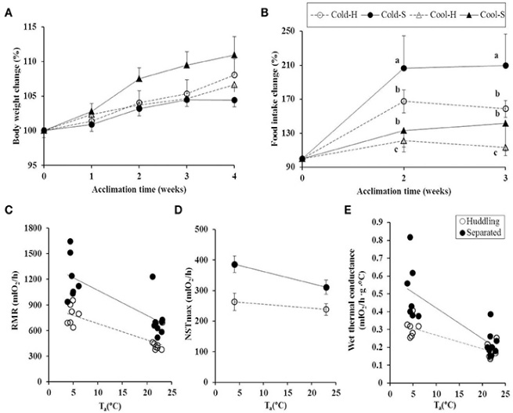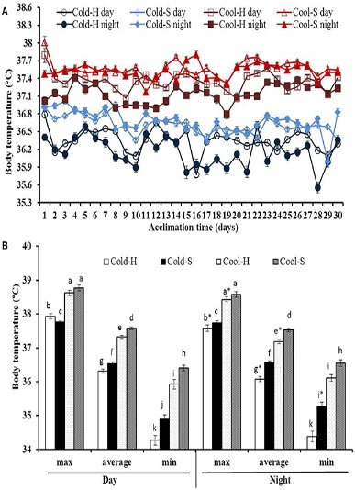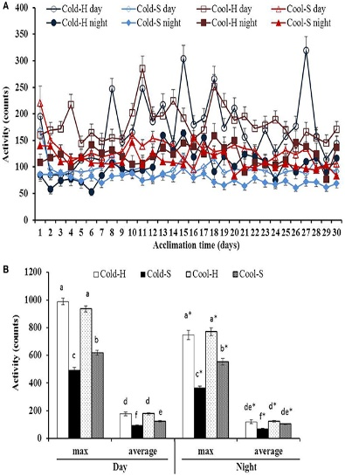
Fig 1. Fig 2. Fig 3.
Strengths and Weaknesses:
The greatest strength is in the controls, by comparing not only huddled versus separated, but cold and cool ambient temperature as well. While the number of voles is satisfactory, I think an ideal number would have allowed the four groups of voles to be in equal numbers.

Paper Summary 2
Mechanisms and evolution of hypoxia tolerance in fish by Mandic, Todgham, and Richards – Summary
Take Home Message:
The study shows a phylogenetically independent correlation between tolerance to hypoxic conditions, via O₂ extraction ability, and distribution of closely related fish species (Sculpins). Sculpins with higher tolerance, inhabit areas with variable amounts of O₂, while less tolerant sculpins will live in the more O₂ stable zones. Despite being in the same family, variations in tolerance between species allows for different habitats.
Experimental Approach:
11 species of sculpin were obtained from the wild, all within a 5m distance from the shore. All sculpins were kept at 12°C water and allowed to acclimate for 3 weeks prior to the study beginning. All fish fed daily, with the exception of a 24-hour fasting period prior to trials. Respirometry had been performed on the fish prior to the experiment and some fish were sampled for gill SA and RBC Hb characteristics. The fish were housed overnight in a well-aerated sampling basket. To sample, benzocaine was flooded into the chamber, and the fish was then removed, dried, weighed, and a blood sample was taken, along with the right gill basket.
Key Findings:
1) By maximizing O₂ intake the animal is able to remain in a hypoxic area for a longer time before it initiates the hypoxia response. This is especially of import for animals living in intertidal zones as these areas fluctuate O₂ levels often.
2) A phylogenetic tree shows that more ancestral sculpins were found to be primarily subtidal, while derived sculpins were found to be more intertidal.
3) P_{crit}, or the value at which the organisms O₂ consumption rate becomes dependant on the environment rather than independent, was found to strongly correlate (positively) with the species’ maximum depths. Species located in tide pools had the lowest P_{crit}, as well as the lowest depth levels. These species, as seen in the below figure, were found to have, after correcting for phylogenetic relationships, the lowest MO₂, larger gill SA, and lower whole cell P₅₀ (torr). This is done to lower metabolic demands, enhance O₂ uptake, and thus handle hypoxic conditions both better and for longer time periods.
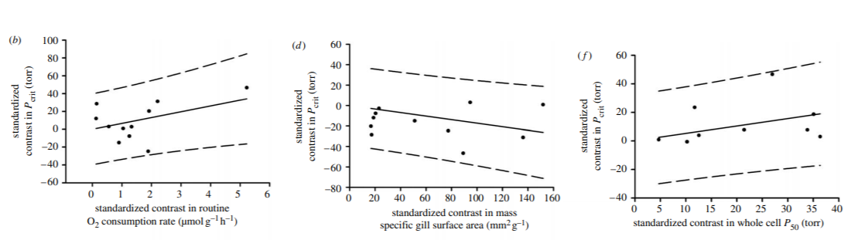
Strengths and Weaknesses:
Weaknesses included a difficulty in finding (Or absence of) some info such as the amount of fish studied, as well as a somewhat confusing writing style, although the language used in the study was well done and easily understood. Strengths included the high amount of preparation going into the experiment, as well as the thoroughness of the findings.
Paper Summary 3
Control of breathing and ventilatory acclimatization to hypoxia in deer mice native to high altitudes by Ivy and Scott – Summary
Take Home Message:
The study shows a comparison between the control of breathing and heart rate between high and low altitude populations of deer mice. The purpose of which is to show clearly what physiological specializations help the high-altitude mice cope with hypoxia.
Experimental Approach:
Deer mice native to high altitudes and low altitudes were taken and bred in captivity at sea level. These mice were then bred (separately) and the children, after being raised to adulthood, were then acclimated to normoxic or hypobaric hypoxia conditions for 5 months. Two methods were used to measure responses to acute stepwise hypoxia: 1) The barometric technique and 2) the double-chambered pneumotachography.
1) was done on unrestrained and uninstrumented mice, while 2 was performed on restrained mice, instrumented with pulse oximetry collars.
Key Findings:
1) Highland deer mice have developed higher rates of alveolar ventilation and respiratory O2 uptake. They have evolved to have deeper breathing patterns, yet a much lower breathing frequency.
2) The mice have developed the above without significant enlargement of carotid bodies, a consequence that is typical of VAH in lowland animals. Likely, this is done to aid in adjusting the hypoxic chemoreflex.
3) Lowland mice, when raised under hypoxic conditions, appear to imitate the adaptations the highland mice have more naturally. This can be seen in the below figures, in which the lowlanders have a more drastic change between normoxia and hypoxia, than the highlanders who show little difference. Compare this to the 3rd set of graphs showing the separate data on the species. (Natural conditions)
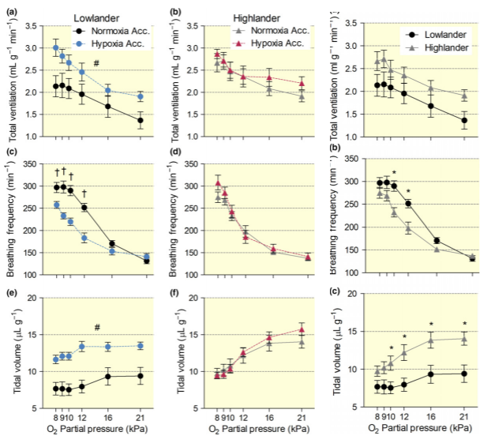
Strengths and Weaknesses:
Strengths include an easy readability of the study, as well as a larger acclimation time for the conditions when compared to previous studies read. There was adequate recovery time (2 days) between experiments on the mice, and adequate time to get used to the experiments when they were about to occur; However, I believe it to be a weakness that not all the mice were tested with both methods of experimentation.
Paper Summary 4
Paper 3 by Ivy et al. – Summary
Take Home Message:
Burrowing mammals tend to be hypoxia tolerant, thanks to the ability to decrease their metabolic rate (MR). The naked mole rat (NMR) is one of, if not the, most hypoxia tolerant mammals. This study dealt with 8 related species of mole rat, and found that each had strong tolerance to hypoxia, used both increased ventilation and decreased MR to survive these conditions, and that eusociality was not fundamental to the physiological response to hypoxia of the NMR.
Experimental Approach:
Utilized both whole-body plethysmography and indirect calorimetry.
Measured the hypoxic ventilatory and metabolic responses.
Done by placing the mole rats in a chamber, at 28°C, (60 to 90 mins acclimation time to allow for a constant resting breathing rate) and then measuring the breathing and metabolism incrementally as the PO₂ was lowered. Once the rats showed signs of distress, that was considered to be the lowest they can comfortably survive at and were taken out.
Key Findings:
1) Mole rats do have a ventilatory response to hypoxia – however, in most cases, ventilation only increased when hypoxia was less than 5kPA O_{2.} Additionally, this pattern of ventilation increase and pulmonary O₂ extraction maintenance was found to differ among mole rats. (Table 1)
2) All mole rats were found to depress metabolic rate when under hypoxia, T_{b} dropped significantly aiding the metabolic rate depression. (Table 1)
3) Sociality (and possibly body size) were found not to affect hypoxia sensitivity. Hypoxia tolerance was similar among a eusocial species, and multiple solitary species. The study found that this suggests eusociality may only be partially responsible for the NMR high tolerance to severe hypoxia. Body size was also found to possibly be a non-factor to an extent. The largest mole rat was found to be the least tolerant, but the second largest rat was the most tolerant in the 8 studied.
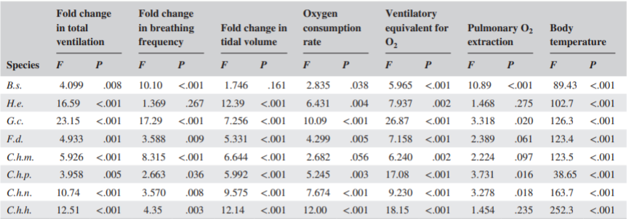
Strengths and Weaknesses:
Strengths: The study seems to have found a lot of useful information, and may represent a large step in our understanding of hypoxia-tolerant mammals. Additionally, the study is well written and clearly worded.
Weaknesses: Utilizing PIC to determine what part of this tolerance may be genetic, and what may not be would aid to strengthen the argument of eusociality and even body size not affecting hypoxia resistance.
One species was found to have blunted breathing, possibly due to the high altitude and low PO₂ burrows they were obtained from.

Paper Summary 5
The urinary bladder as a physiological reservoir that moderates dehydration in a large desert lizard, the Gila monster Heloderma suspectum by Davis and DeNardo – Summary
Take Home Message:
This study takes a look at the bladder in the Gila monster and tests the hypothesis that it serves as a reservoir to provide water which buffers increases in the osmolarity of the plasma should the animal be unable to find water or food from other sources. They found that the lizards did use the bladder to preform this act, and found that this is the first known adult lizard to use this method of water reservation in the bladder. This allows the lizards to manage water budget on a long-term basis rather than short-term.
Experimental Approach:
Wild-caught Gila monsters were used. 7 lizards were anesthetized and a catheter was inserted into the colon. The catheter was then inflated with 2-3ml of deionized water, pulled to evert the cloaca slightly, and then taped onto the lizard. Then, a second catheter was introduced to the lizard’s urinary bladder. This catheter was then pulled gently to not cause blockage to the bladder, and taped to the tail as well. At this point, the initial catheter into the colon was removed.
Key Findings:
1) FULL (Liquid in bladder) lizards took 2.5 times longer than EMT (Empty bladders) lizards to reach 360 mOsmol/kg plasma osmolarity. Once FULL lizards absorbed all urinary bladder fluid, the Osmol/day nearly doubled, but was still below that of EMT lizards and not significantly different from the initial FULL values. This can be seen in Fig. 1.
2) Absorption of water in the bladder was found to have a direct osmoregulatory benefit to Gila monsters by delaying osmolarity elevation. This can be seen in Fig. 2 below, in which the FULL group was able to delay osmotic perturbation 135% longer than those in the EMT group.
Fig. 1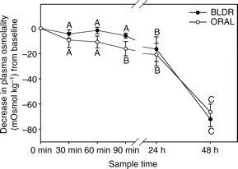Fig. 2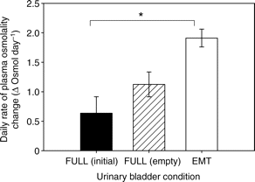
Strengths and Weaknesses:
Strengths: First study to find the urinary bladder’s osmoregulatory function in adult lizards, and has good evidence to back up the claim. Well written for the most part, and with very readable graphs to show the data.
Weaknesses: The N for the study was only 12, which is not ideal, but likely sufficient for the study. The study would, however, be made stronger with a higher N value.

