CHM 1321 Lab

Experiment 6 Regioselective Nitration of Acetanilide

INTRODUCTION
Nitration is a chemical process in which a nitro group such as NO2, is inserted into an organic compound. In the mechanism below, nitric acid is protonated by sulfuric acid to produce the nitronium ion. Nitration then occurs with three possible isomers: meta, ortho and para depending on which area of the organic compound is nitrated. Below is the mechanism, para isomer is the most stable of the three, because it has full octets.
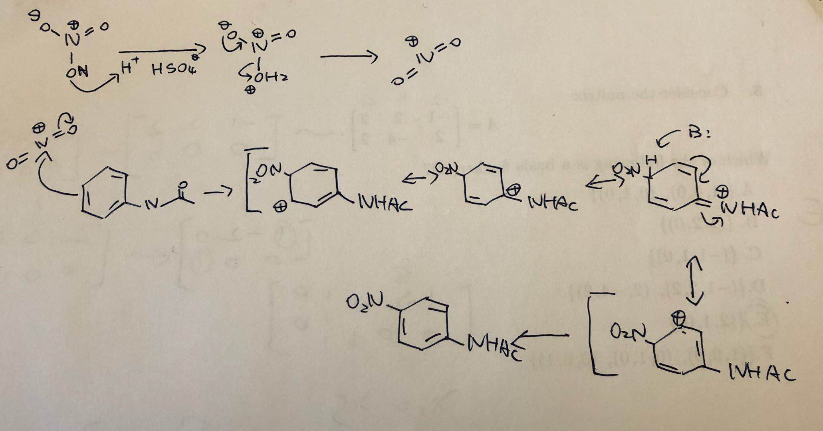

Procedure
Refer to the laboratory manual and note the following points:
- 5 mL of H2SO4 will be used to dissolve acetanilide. At this step the sulfuric acid is used as solvent.
- Add 0.8 mL of H2SO4 and 0.6 mL of HNO3 in step 5.
- In step 6 use TLC to to check if the reaction is complete.
- Isolation of Crude Product (step 8)
•Place four or three pieces of small ice cubes in a 125 mL Erlenmeyer flask with about 20 mL of cold water and a stir bar. Place the flask on the stir plate and add the mixture from the reaction flask. Rinse the reaction flask with water to get most of the reaction mixture into the 125 mL Erlenmeyer flask. Continue stirring until the ice cubes have completely melted.
- Use 2 TLC's in step 11. Ortho and meta on the first TLC, para and 2-4-dinitro on the other TLC.
- In step 17: Use 2 TLC's in step 17. On the first TLC spot CP, mother liquor on the other TLC.

Observations
- Sulfuric acid and acetanilide formed a yellow liquid with some undissolved solid.
- When a mixture of concentrated nitric acid and concentrated sulfuric acid were added dropwise to the acetanilide, the mixture turned dark brown, almost black.
- When the reaction mixture is mixed with cold water and ice, a bright yellow liquid with a thick precipitate is produced.
- During the recrystallization process, the liquid mixture turns into deep yellow solid and with suction filtration, very little mother liquor is produced.

MATERIALS
1 g acetanilide, 25 ml round bottom flask, 5 ml H2sO4, ice bath container, 50 ml erlenmeyer flask, 0.6 ml HNO3, 0.8 ml H2So4, 5 TLC plates, ice cubes, 125 ml Erlenmeyer flask, gravity filtration, 2 ml CH2CL2, ortho, meta, para, 2-4-dinitro, EtOAc:hexanes 5:5, mother liquor.

DATA
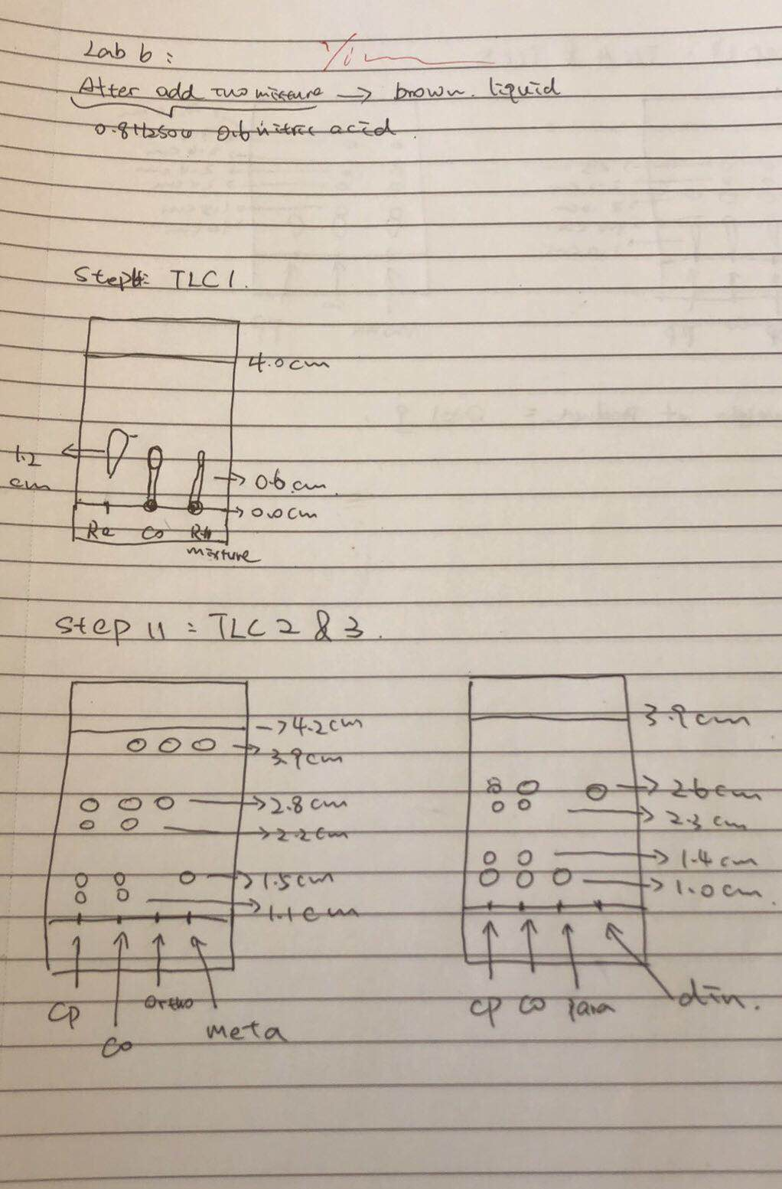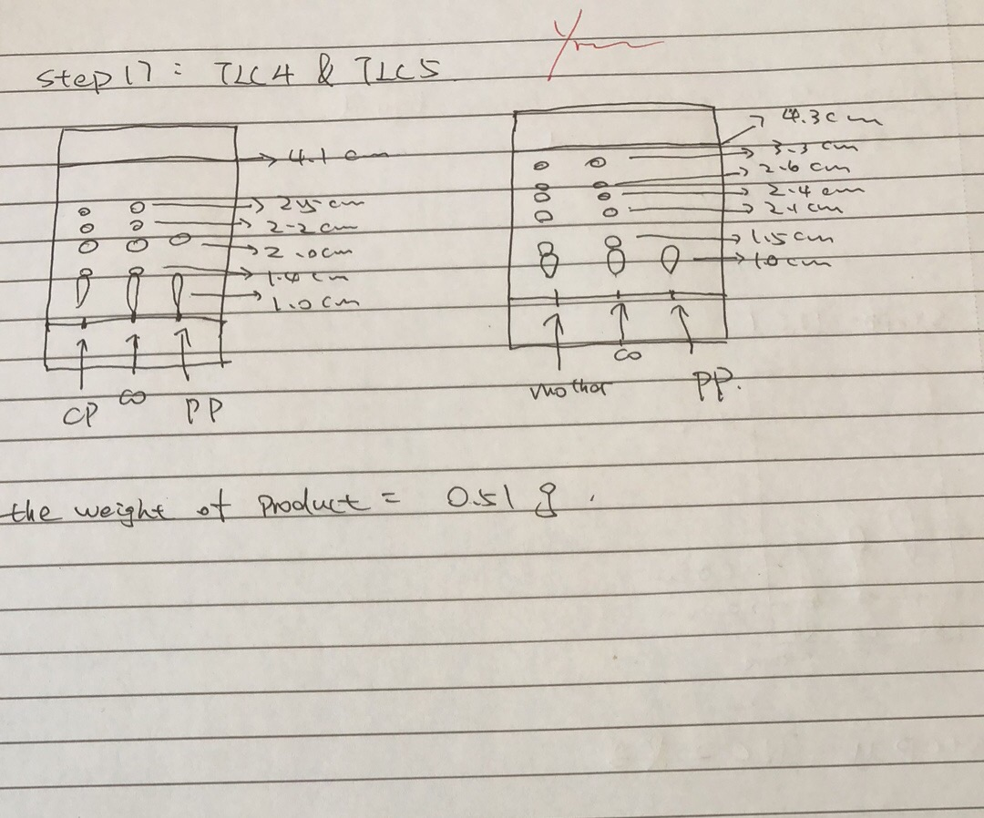
RESULTS
For the TLC 1: Rf1=0.3, Rf2=0.15
For the TLC2 of o/m: Rf1=0.93, Rf2=0.67, Rf3=0.55, Rf5=0.357, Rf6=0.262
For the TLC3 of p/d: Rf1=0.667, Rf2=0.590, Rf3=0.359, Rf4=0.256
For the TLC4 of cp: Rf1=0.610, Rf2=0.537, Rf3=0.488, Rf5=0.341, Rf6=o.244
For the TLC5 of mother: Rf1=0.767, Rf2=0.605, Rf3=o.558, Rf4=0.488, Rf5=0.349, Rf6=0.233
The product collected=0.51g
Percent yield=0.51 g/15.77 g =3.23%

Discussion
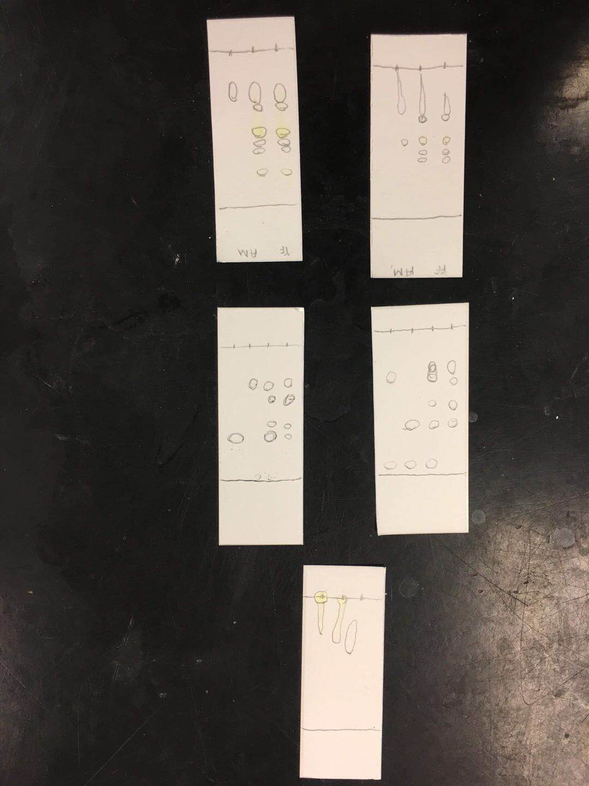
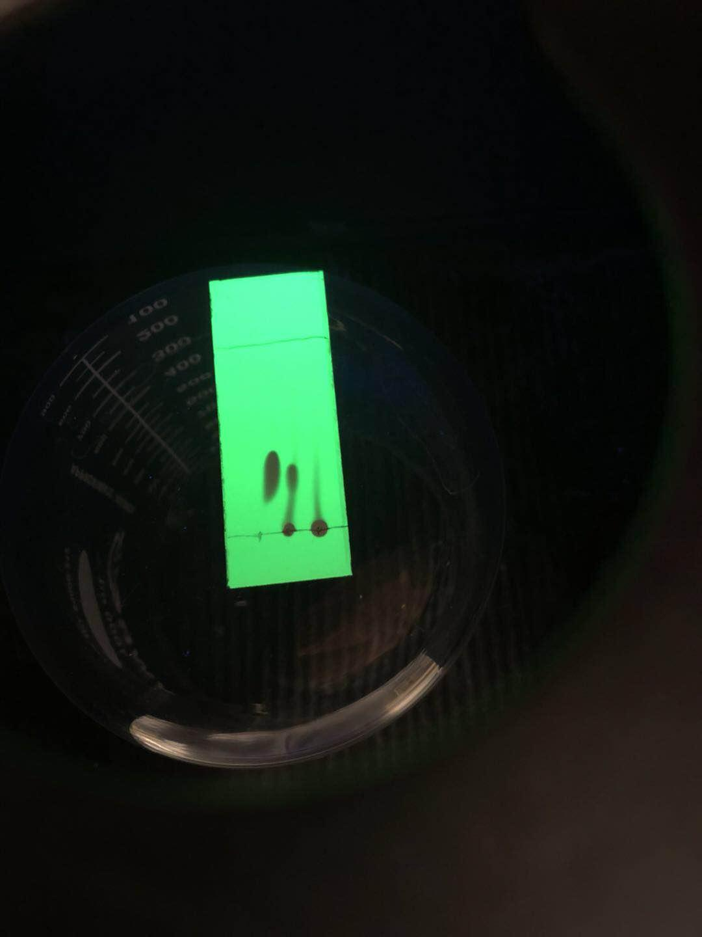
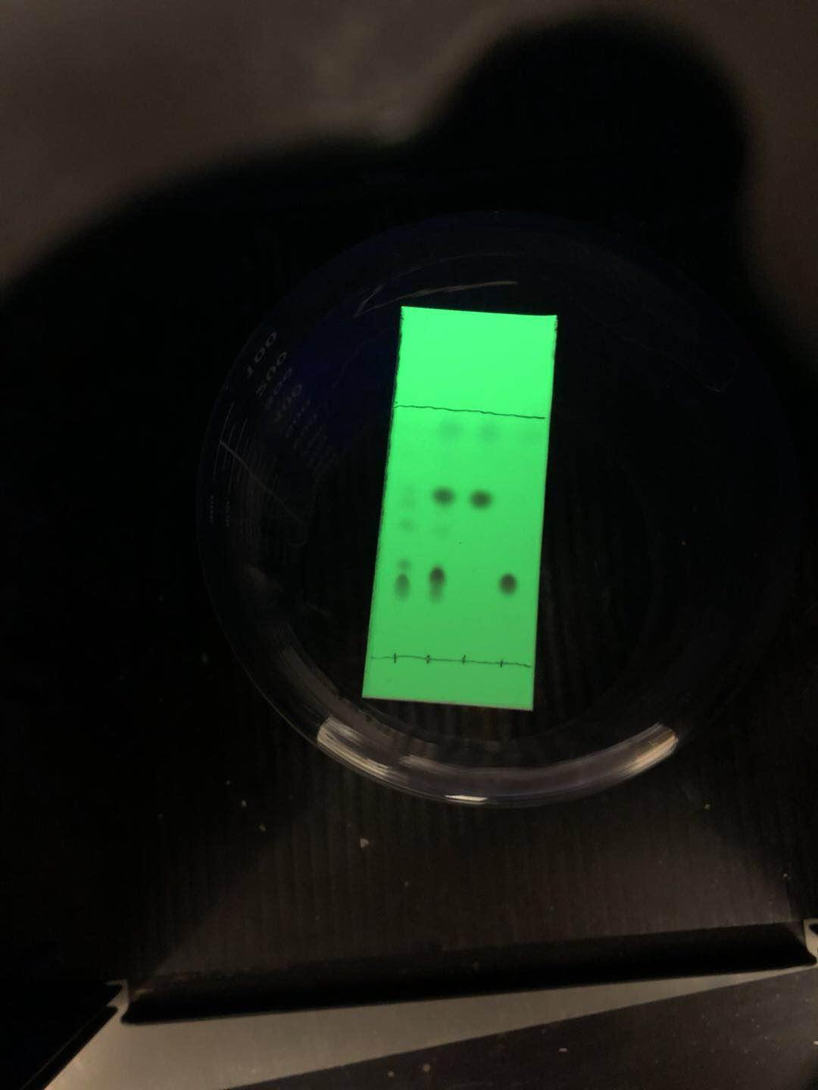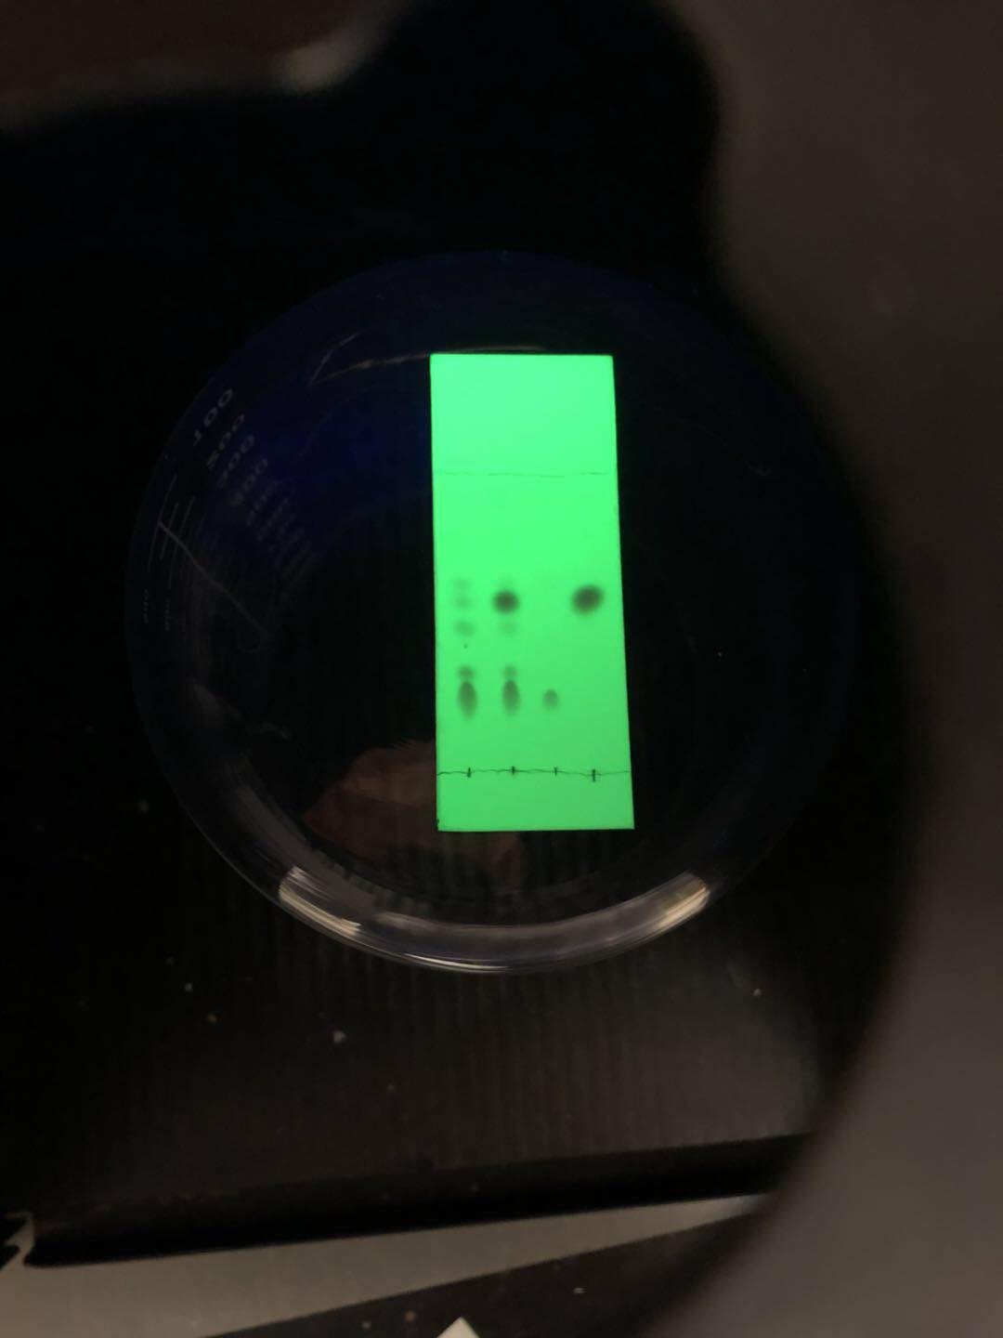
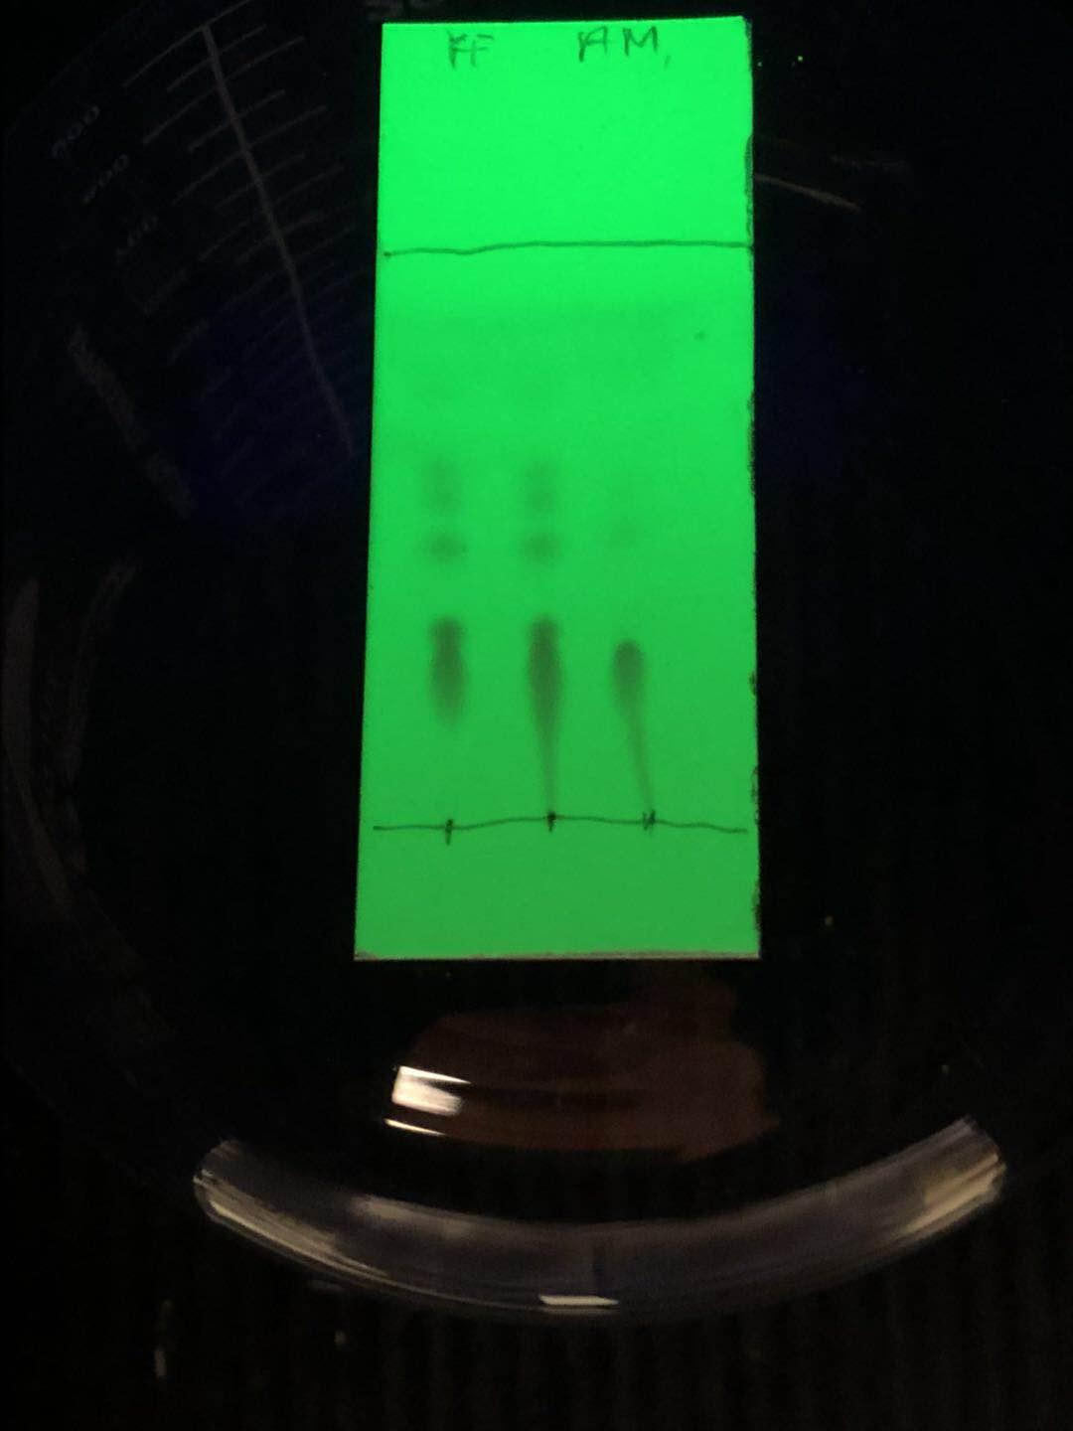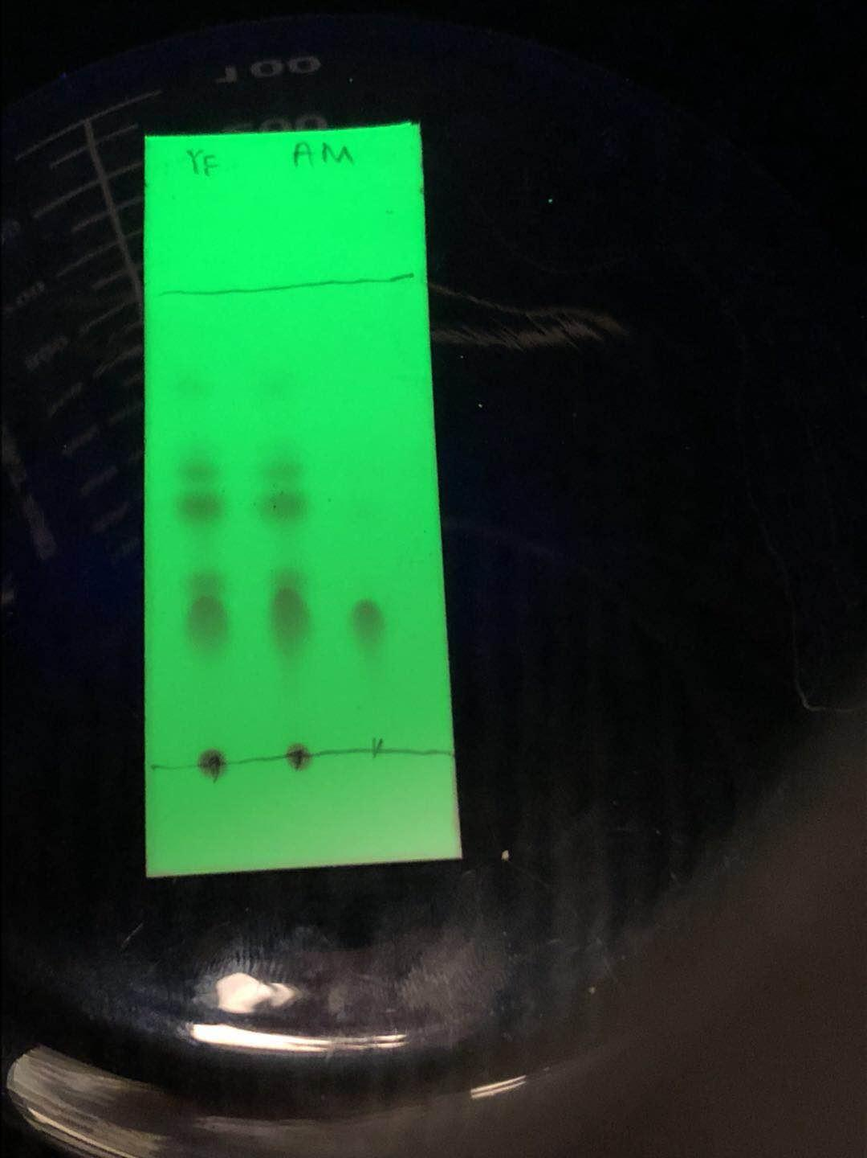
The goal of this experiment is leading to acetanilide nitration. As mentioned in the introduction, aromatic substitution of benzene is likely to produce three different isomers - ortho product, meta product and para product. In our laboratory, TLC plates are used to determine the formation of these isomers. By identify those TLC plates, we can clearly see that we have produced the maximum number of the para isomer NO2-Ph-NHAc. The evidence for this conclusion is that the spots on TLC plates are very similar to the spotted sample of the para isomer in Rf values. The reason that para-isomers seem to be the most advantageous of the three is simple. Since there are two functional groups on the ring, the counterpoint positions place them relative to each other in possible positions on the ring. This reduces the steric hindrance between functional groups as compared to ortho and meso isomers. The lower the steric hindrance, the lower the activity of the isomer, so it has a greater energy advantage over other isomers, which also explains the preference for isomer formation.

CONCLUSION
After recrystallization the final pure product weighed in at 0.51g out of a possible 15.77g, giving a percent yield of 3.23%. Such a lower yield should take into account errors that may occur during the experiment, such as not being thoroughly removed during the rinsing process. *Note: All the TLCs eluent by 5:5 EtoAc:Hexanes. In this experiment, the probability of error is very high and there are many factors. Such as crystal collection difficulty, human error and so on. First, five TLCs were taken in this experiment. This can cause many similar errors to occur on each TLC. These errors include over positioning of the solution on the plate. This can lead to spots that are too large, which can affect a student's ability to correctly calculate Rf values and distinguish components of different solutions. Contamination of TLC or solution may result in faulty analysis or less analysis of other potential spots.

Questions
1.Nitration is an electrophilic reaction. Therefore, the higher the electron density of the aromatic ring is, the easier and faster the reaction will be. in first reaction nitro groups are added by NO2 with a relatively electron-rich ring (Ph-NAc). The second is the reaction of NO2 with a less electron-rich ring (NO2-Ph-NAc). Because of the low electron content of this ring, the formation will be slower than the first reaction.
2.
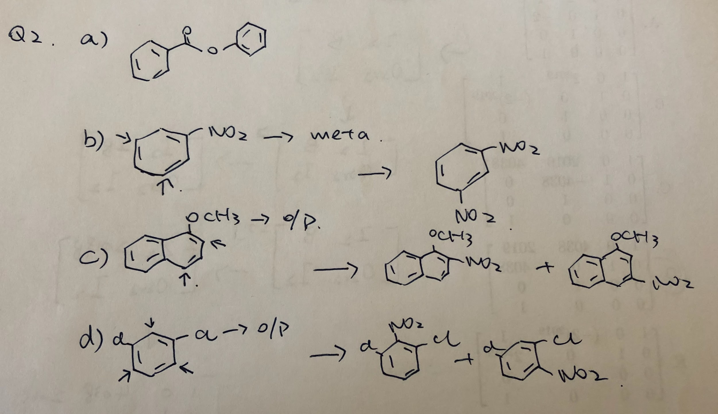
3.
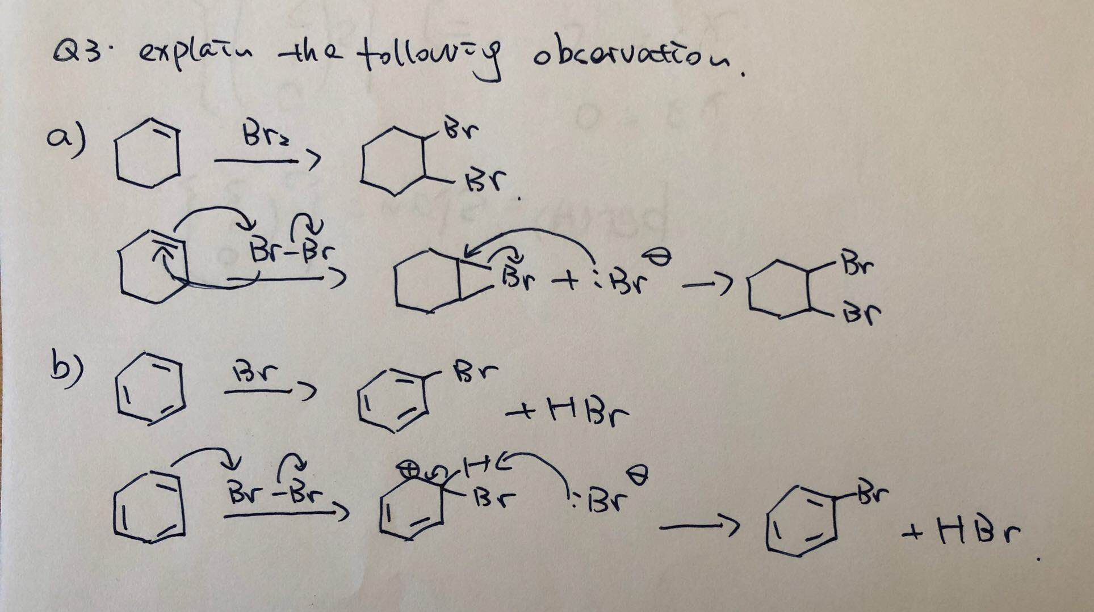

4.
a) Identity the limiting reagent
ratio of benzene to nitric acid to sulfuric acid 1:1:1
moles of benzene = 10 g/78 g/mol=5/39=0.128mol
moles of nitric acid =9 ml ·16 M=14.4 mol/L
mole of sulfuric acid =9 ml ·18 M=16.2 mol/L
Therefore benzene is limit reagent

b)
Theoretical yield of nitrobenzene =0.128 mol· 123 g/mol =15.77g
Percent =0.51 g/15.77 g =3.23%

c)

d) H2SO4 work as reactant in this step
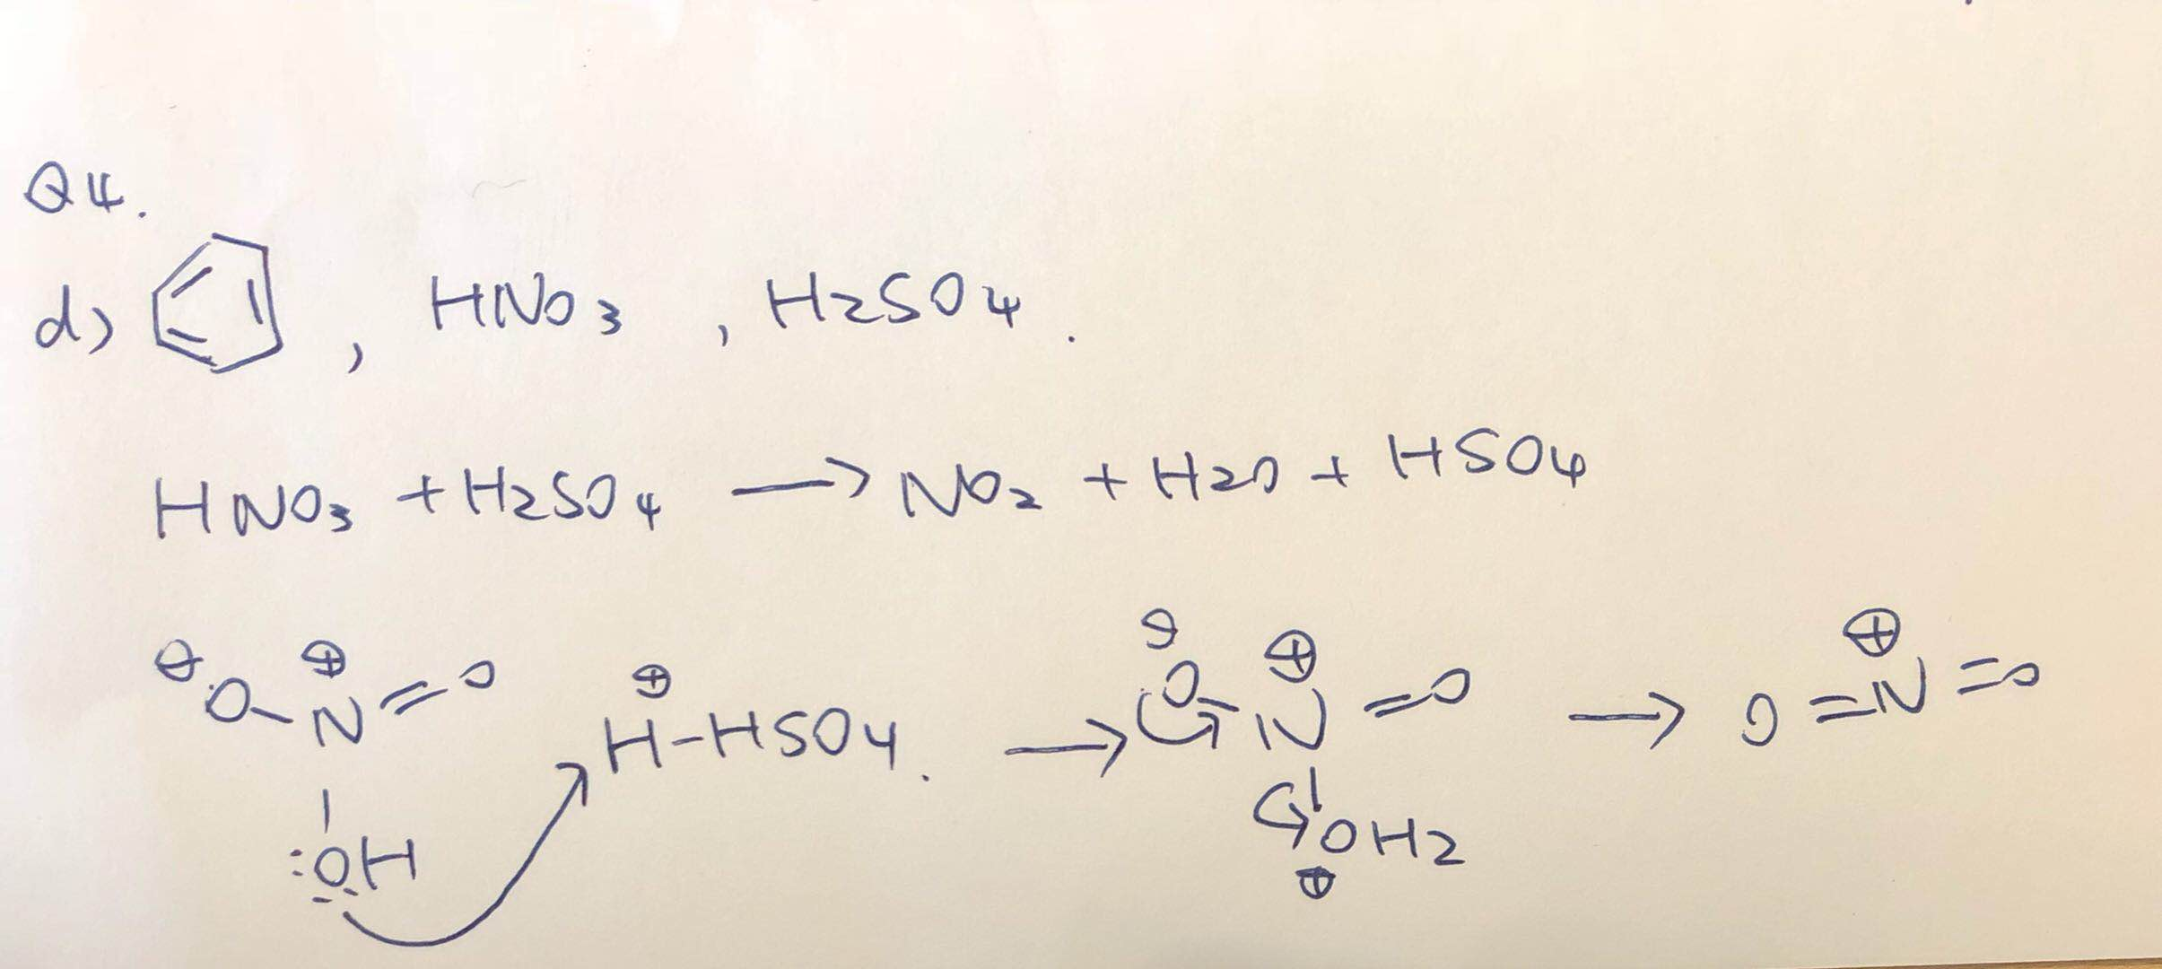

5. 1-nitrofuran has induced dipoles from the positive oxygen atom because of the sigma bond.
6.


