Lecture 1: Introduction to Music Therapy

What is Music Therapy?
- Discipline in which credentialed professionals (MTA*) use music purposefully within therapeutic relationships to support development, health and well-being.
- Music therapists use music safely and ethically to address human needs within cognitive, communicative, emotional, musical, physical, social and spiritual domains

Music Therapy in Canada
- Canadian Association of Music Therapists (CAMT)

Provincial Music Therapy Associations in Canada
- Most provinces have a provincial body
- Provincial body provides support, they do not regulate the profession

Educational Preparations
- Education and training of a music therapist is multidisciplinary
- Involves a thorough study of music
- Encompasses subjects such as physiology, anatomy, biology, psychology, counselling, anthropology and movement
- The student must complete a 1000hr supervised internship, providing the student with an opportunity to gain practical experience and refine his/her clinical skills

Requirements to become MTA
- Supervision is an important part of the internship process and continued professional development
- Certification Board of Music Therapists (CBMT) Examination
- Continuing Educational-MTA must maintain their credential through CAMT continuing education process (5-year cycle)

What are the personal qualifications of an MTA?

Personal Qualifications:
- Musician
  - Excellent functional musical skills
  - Broad knowledge of different musical styles
  - Uses music flexibly, creatively and in an aesthetically satisfying manner
- Therapist
  - Good physical and emotional stability
  - Sincere interest in helping others
  - Patience, tact and understanding
  - Reliable, genuine and ethical
  - Clinical objectivity

What does a session look like?

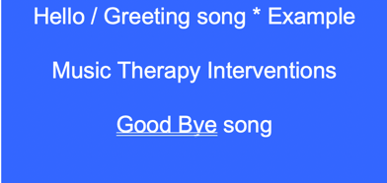
- All the songs are age appropriate
- Play music in a way that ques them to get engaged with the music
- Start with a hello song, end with a goodbye song

Music Therapy Interventions
- Pre-composed music
- Listening
- Singing
- Improvisation
- Lyric analysis
- Song writing

Listening
- Listening helps to develop cognitive skills such as attention and memory
- Early to mid-stage dementia, listening can provide a sense of the familiar and increase orientation to reality

Singing
- Singing: assists in the development of articulation, rhythm, and breath control (via greater O2 intake)
- In a group setting – can improve social skills and foster a greater awareness of others
  - Brings people together!
- For those with dementia, singing can encourage reminiscence and discussions of the past, while reducing anxiety and fear

Song Writing
- Facilitates the sharing of feelings, ideas and experiences.
- Hospitalized children’s mean of expressing and understanding fears.
- Terminal illness, vehicle for examining feelings about the meaning in life and death.
- Opportunity for creating a legacy or a shared experience with a caregiver, child or loved one, prior to death.

Why Music?
- Music is a universal phenomenon. People of all ages and cultural backgrounds can listen, perform, create and enjoy it.
- Music is a flexible therapeutic medium because it has many different styles and a variety of ways in which one can be involved (i.e. composing, performing, listening).

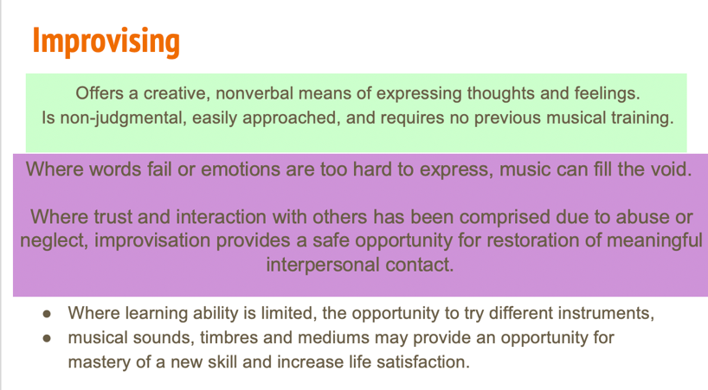

What is NOT Music Therapy?
- The client or patient does not need to have a musical background.
- Music therapy is not entertainment and does not refer to playing live or recorded music or engaging in musical activities for leisure / as a hobby.
- Music therapy does not refer to musical lessons to hone one’s skill on an instrument or voice.
- Music therapy is not special music education in which specific techniques and activities are used to teach special learners about music.

Process to Receiving Music Therapy?
- Referral
- Assessment
- Goals
- Treatment plan (interventions)
- Reports & re-assessments

Referral Process
- Anyone can make a referral
- Reasons for referral
- All ages and diagnosis
- No experience with music or an instrument needed
- No “music” prescription
- Examples for referral…

Assessment
- 1 day
- 6 weeks
- On going
- To determine treatment plan (goals)

Goals
- Based on observations/assessments
- Example: Client will increase vocabulary to include social interactions such as hello / good-bye.
- Example: Client will increase attention span to 5minutes per intervention.

Treatment Plan (Interventions)
- Pre-composed music
- Singing
- Listening (including client recordings)
- Instrumental playing (including rhythm based)
- Improvising
- Composing
- Lyric analysis

With Whom Does an MTA Work?
- All Ages & Diagnosis – Music Transcends Beyond the Diagnosis
- ABI, Pain, Autism, Geriatric care, Cancer, Neonatal care, Mental Health difficulties, Palliative care, Teens at risk, Personal growth, Substance Abuse

Where do MTAs Work?
- Medical hospitals
- Clinics
- Group homes
- Centers for persons with developmental disabilities
- Prisons
- Schools
- Mental health facilities
- Private Practice

Class 1 reading: page 167-180

- Initial assessment: taken prior to the start of a treatment
- Comprehensive assessment: completed when a client is referred to music therapy
- Ongoing assessment: which tracks functional levels and progress through the treatment process

Areas of assessment: in order to determine a treatment plan, the team will assess the strengths and needs of the client in the following areas.
- Medical
- Physical
- Cognitive
- Emotional
- Social
- Communication
- Family
- Vocational/education
- Leisure skills

Treatment plans can take place in a:
- Multidisciplinary setting where each individual does their own job and reports it together in a group meeting.
- Interdisciplinary setting where each team member takes primary responsibility for particular treatment goals
- This clinic used a Transdisciplinary approach where several specialists collaborative on particular goals and objectives

Treatment goals for Donna page 175-180

Lecture 2: History of Music Therapy

Preliterate Cultures
- Definition: used complex languages, but no symbol system for reading
- Music was a supernatural force that affected mental and physical wellbeing
- Music and medicine were almost interchangeable in these cultures
- “Medicine-men” – healing rituals to appease Gods

Early Civilization
- 5000-6000yrs BC
- Music played important role in:
  - Rational medicine
  - Magic and healing ceremonies

Ancient Greece (600BC)
- Music had force over thought emotional and physical health
- Healing shrines and temples had hymn specialists and music was prescribed to the mentally disturbed
- Aristotle: emotional catharsis
- Plato: medicine of the soul

The middle ages (C.476 – 1450 AD)
- Medicine influenced by the 4 humors
- Boethius believed music had the power to degrade or improve human morals
- Saint basil believed it to be a positive vehicle for sacred emotion
- Hymns were considered effective against certain unspecified respiratory diseases

The renaissance (1300 – 1600)
- Advances in anatomy, physiology & clinical medicine marked the beginning of the scientific approach to medicine.
- Treatment of disease still based on 4 humors
- Physicians prescribed music as a preventative medicine.
- Many epidemics occurred during this time; music was considered a powerful tool to improve emotional health
Baroque Period (1580 – 1750)
- Medicine continues to be informed by the four humors
- Kircher (use of music for disease) – matching music to personality characteristics.

Modern music (1800 – now)
- Scientific Methodology
- What happened to music in medicine?
- Big Pharma
- Re-Active opposed to Pro-Active

History of MT in Canada (1950s – 60s)
- Mid 1950s: Music therapists were working independently in Canada

- In 1960: Norma Sharpe
  - Norma Sharpe conducted a survey of music in hospitals across Canada
  - Discovered that many hospitals use music and music activities and that many of the staff have musical training/background
  - Survey provided baseline measure for music therapists
  - Survey increased awareness about music therapy in hospitals and institutions

History of MT in Canada (1970s)
- Early 1970: Sharpe had regular contact with individuals and organizations across Canada who shared an interest in music therapy

- Mid 1970s: Conferences held to unify those working in the field of music therapy throughout Canada. Led to the formation of Canadian Music Therapy Association (1974)

Lecture 2: part 2 – Evolution of Music

- Music is a universal and multifunctional cultural behavior
- Two major elements of music:
  - Pitch and Rhythm
- Rhythmic and vocal music are the oldest and most universal forms of music

Why did music evolve?
- A descended voice box has an evolutionary trade-off:
  - Increased chance of choking, and increased fatality of choking
  - Clapping hands and beating rocks also takes energy, and is often painful
- There are multiple theories on why song evolved
  - Most agree that singing promotes social bonding in some form
  - Motherese, emotional communication, courtship, alarm calls
  - Important: everyone was a musician and dancer!

- The cathartic properties of music continued to be recognized
but with the rise of rational medicine and the theory of humors, it was generally used on an individual level

CLASS 3 GUEST LECTURE: NEUROLOGIC MUSIC THERAPY

NEUROLOGICAL CONDITIONS

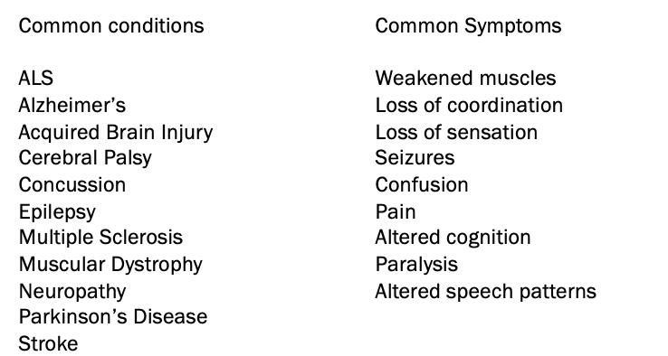
- Some are congenital present at birth
- Others are acquired, from trauma like ABI, or concussion
- Others may be hereditary, and a type of neurodegeneration like PD or Alzheimer’s

MUSIC

- Dr. Michael Thaut is a tier one researcher at the University of Toronto specializing in music and neuroscience, music and neurorehabilitation. Dr. Corene That is a music therapist, they are a husband and wife team who founded Neurologic Music Therapy. Wanted to bridge the gap between the neuroscience research and music therapy applications. Wanted to better understand WHY music was so effective; music therapists often see results but sometimes lack a common language to describe what intervention they used or why it was effective.
- * Neuroplasticity ‘brain rewiring’ or ‘changing’ that occurs when listening to, engaging in, and playing music

MUSIC AND THE BRAIN

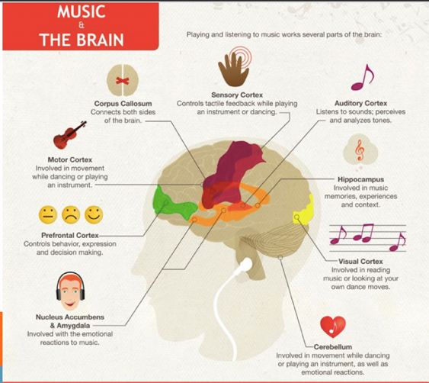

- Music is one of the only activities that uses all areas of the brain

- Musicians have a bigger corpus callosum than non-musicians? The corpus callosum is the part of our brains that connects the right hemisphere to the left. It allows both sides to communicate with each other, and is responsible for eye movement and helping us maintain our balance

- Auditory cortex – Researchers have discovered that even just watching someone play music (or watching any stimulus that has an associated sound) activates the auditory cortex, AND likewise, when listening to music, motor areas are activated even when someone is stationary

- Visual cortex: Research indicates that some music can provoke a response in this part of the brain, as the engaged listener tries to conjure up appropriate imagery to match the changes and progression in the music

- Nucleus accumbens plays a central role in the reward circuit and feelings of pleasure – its operation is based mainly on two neurotransmitters dopamine the ‘feel good’ neurotransmitter, and serotonin

- Brain equivalent of a Full body workout

- The connections made between different areas tend to neurorehabilitation, neuroplasticity, re-learning, re-training

NEUROLOGICAL MUSIC THERAPY

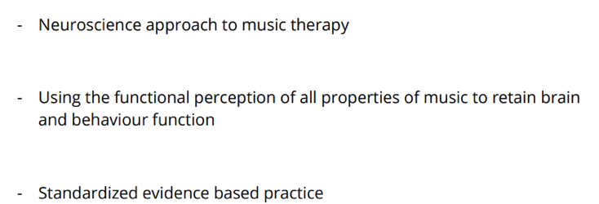
Neurologic Music Therapy (NMT) is a research-based system of 20 standardized clinical techniques for sensorimotor training, speech and language training, and cognitive training. It’s treatment techniques are based on the scientific knowledge in music perception and production and the effects thereof on nonmusical brain and behavior functions.

MUSIC AND WHAT IT IMPACTS (REGIONS OF THE BRAIN)
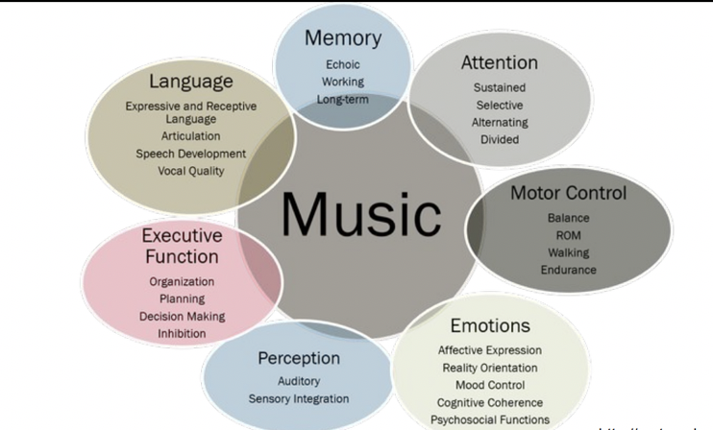
- Echoic memory: Sensory memory register for sounds people have just heard
Working memory: temporarily stores information

20 NMT TECHNIQUES 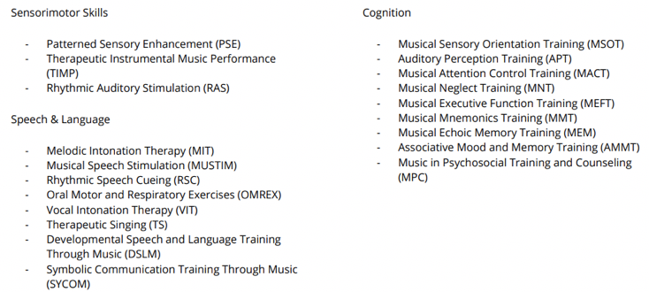
- These give standardized names to interventions that many music therapists are already using

- A common experience for MTs who take the NMT training, is to realize that they are doing a lot of these techniques already, but they leave with a greater understanding of why these techniques work and the growing body of research supporting them

DR. OLIVER SACKS

TRANSFORMATIONAL DESIGN MODEL (TDM)
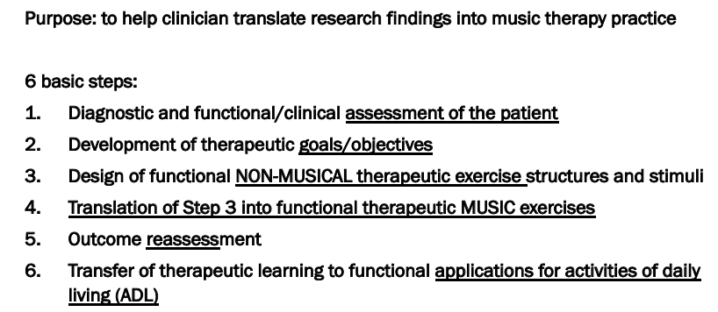

- They encourage the use of standardized assessments; many of these are available for anyone to use (Ots SLPs etc), not ‘protected’ or regulated in a way that it would violate any rule to use them; they are up for grabs.

- Enable a common language when discussing with other healthcare professionals, communicating progress to a team, or to the client and their loved ones. Measuring goals accurately.

- Ie. someone with Parkinson’s losing voice strength. Assessment – recording the loudness of their voice when speaking using a phone app, measured in decibels.

- Therapeutic goal – enhance voice strength

- Reassess: measure voice strength in decibels after interventions.

- Practice, provide strategies to use in daily life, connect the singing techniques (ie breathing from diaphragm) to every speaking

- Add music: Through therapeutic singing and breath exercises, practicing getting louder and using voice, singing from diaphragm

TIMP
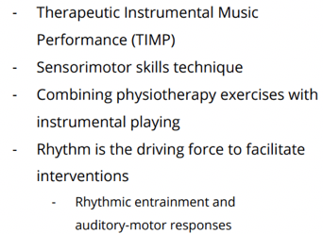

RAS
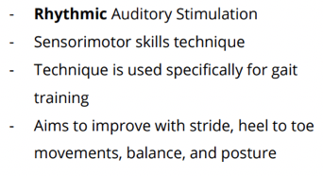
- IN PD, substantia nagra stops producing dopamine.
- Rhythm and music Facilitates dopamine release in the basal ganglia

COGNITION
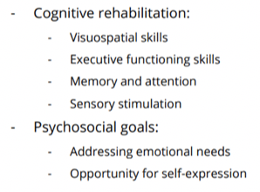
- Using different elements of music such as harmony, rhythm, tempo in a rehabilitation manor
- Can combine MIT and TS
- Mvt activates contralateral side of his brain, uses movement to rewire parts of brain that’s not damaged to reroute the brain by using neuroplasticity

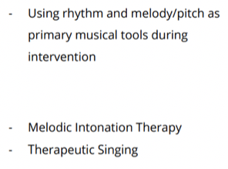
SPEECH AND LANGUAGE SKILLS

- Taking pathways that were undamaged through singing and rewiring them for other functionalities.

NEUROLOGICAL MUSIC THEAPY TAKE-AWAYS:

- The neuroscience of music perception is the foundation for music in brain rehabilitation

- The functional perception and production of musical elements and patterns (ie. rhythm, melody, tempo) in the structure of music is the basis for neurologic music therapy

Music Therapy Class 3 Webinar

- Approach vs model, these will be used interchangeably

- Do all MTAs use the same approach?
  - Every individual is different so there must be more than one approach
  - No there are many approaches, trainings and additional training
  - Setting and client group can influence approach
  - Each country / health care system has different influence
  - Government, economic demands, societal pressures (EBP – funding)
  - Advances in research (fMRI,EEG)

- Psychotherapy approach
  - Psychodynamic therapy (Sigmund Freud, 1890-1920)
  - Freud – unconscious thought / connections to childhood / free association
  - Behavior therapy (1950’s) – learned behavior
  - Watson – classical conditioning
  - Skinner – operant conditioning
  - Humanistic Based Therapy (1960s) – carl rogers
  - Positive abilities and aspirations, free-will, wholeness, “self-actualization”
  - Controversy and becoming eclectic

- AOM: analytically oriented music therapy – Priestly Model (founder Mary Priestly)
  - Approach influenced by psychotherapy, improvising freely parallels of Freuds concept of free association and then verbally processing music created in therapy sessions
  - Music used as a tool to explore client’s inner life – to provide a way forward for growth and greater self-knowledge

- Free Improvisation – The Alvin Model
  - Totally free: no rules, client is completely free to express themselves without any preconceived notion of musical rules and to fully see themselves in the music
  - Emphasis on understanding physiological and psychological effect of music
  - Improvisation reveals our true selves
  - “music is a human creation and there for each person can see him/herself in self-created music”

- Behavioural Model
  - The use of music as a contingent reinforcement or stimulus cue to increase or modify behavior
  - Result-driven and therapist-led
    - Example
  - Example: NICU infants using stimulus of music listening to suck for nutrition

- Creative music therapy
  - Established by Nordoff and Robbins
  - Builds on the concept of the music child
    - Concept that every individual despite a diagnosis can be reached through a music child
  - Built from 2 therapists
    - One on piano
    - One with child
    - Originally was for children with special needs, but now it is for everyone despite age/diagnosis

- BioMedical Models – biopsychosocial
  - Pain is a biological, psychological and social event
  - Bio – limbic system
  - Psycho – memories/trauma and emotions
  - Social – brings us together or apart
  - Pain is an emotion which is the result of a biological event (or not)
  - Pain perception is affected by our mood

- Neurological Music Therapy
  - Post music therapy training
  - NMT is a standardized evidence-based intervention and the outcomes are measurable
  - NMT focuses on physical goals

- Cognitive Behavioral Model
  - Providing new experiences
    - Reframing experiences
    - Take risks and have new positive experiences
  - Replace irrational thinking

- Guided Imagery Method
  - Post MTA training (3 years)
  - Helen bonny
  - Pre-recorded music (classical)
  - Discussion around images (music replace clinical use of LSD(1970s)
  - Activate inner reflection

- Multiculturalism and thinking about approach
  - MTA needs to have a clear comprehension of his /her own culture, values, and belief’s and how each impacts work
  - Engaging in supervision is an important part of being a music therapist
- Community Music Therapy
  - Takes place in non-clinical settings
  - Concerned with context (cultural and social)
  - Making music for purpose of supporting health, human development, equity and social change
  - Examples in later classes
- Eclectic Model
  - Humanistic (client centered)
  - The MTA uses whichever model(s) felt to best benefit the client – within the MTA’S scope of practice/training/ability
  - Use several different models pending on the need of the client

- Every model has its own benefits and they all are equally beneficial

- When trying to pick which model to use, the MTA needs to recognize their own limitations and expertise as well as when to refer a client to another MTA or a different health care practitioner
  - Consider strengths of MTA and needs of the client

Class 3 Reading: The Music therapy treatment process

- Treatment is discontinued when the client has met his or her treatment goals or when the treatment team decides that the client has gained the maximum amount of benefit
- Two approaches developed primarily in field of MT:

- Nordoff-Robbins Music Therapy: active music therapy wehre primarily it uses improvisation to attain therapeutic goals and is founded on the idea that all persons, no matter the level of difficulty have inborn musical ability and creativity. Taps into the client’s innate musical ability musical child.
  - Technique: one person played piano, the other worked directly with client
  - The primary instrument is a guitar or piano
  - Concept of self-actualization is emphasized
  - Goal: develops clients individual potential

- Bonny Method of Guided Imagery and music: idea of using classical music to stimulate and sustain a dynamic process through imagination, which facilitates both self-exploration and “peak experiences” (Abraham Maslow) in persons seeking self-awareness
  - Help to expand client’s self-awareness through music and imagery based on humanistic and transpersonal theories

- Behavioural approach to music therapy: the use of music in association with the therapist to change unhealthy patterns of socially important behaviour(such as drug abuse) into more appropriate skills(abstaining from drugs).
  - Classical and operant conditioning principles explain behaviour
  - Applied Beahvioural Analysis: method used to change behaviour
  - Techniques in behavioural therapy: positive and negative reinforcement, punishment, extinction of undesirable behaviours, token economics to strengthen socially desirable behaviour
  - Reinforcement and shaping can be easily integrated into MT

- Cognitive-Behavioural therapy: on the premise that what we think about an event, object it person has an enormous influence of what we feel and how we act

- Psycho dynamic approach: based on the idea that human behaviour is strongly influenced by unconscious psychological processes. Therapy helped to allow client to gain insight and awareness of the unconscious conflicts

- Neurological Music Therapy: the inherent link between music and the brain and its effect on on brain function.
  - Rational Scientific Mediating Model: how the brain is parallel with and affects certain parts of the brain and psychological processes.
  - Three domains of rehabilitation:
    - Sensorimotor rehabilitiation
    - Speech and language rehabilitation
    - Cognitive rehabilitation
  - Two additional concepts:
    - Technique standardization: naming techniques so that there is no confusing with communicating
    - Assessment: making sure best practice is given

- Eclectic/integrative approach: therapists draw freely on techniques from all types of therapy without necessarily accepting the theoretical frameworks behind them

Class 4

Guest Lecture: MT with acquired brain injury and PTSD

Goals of MT for an ABI
- Psychological: mobility/motor skills
- Cognitive: speech, executive function, impulse control/initiate action
- Social: coping with change/loss
- Emotional: Coping with change/loss
- Spiritual: self-expression

Group interventions of ABI
- Listening
- Lyric analysis
- Improvisation
- Songwriting

Defense Mechanisms
- An unconscious psychological mechanism that reduces anxiety arising from unacceptability or potential harmful stimuli
- Brought into play by the unconscious mind to manipulate, deny or distort reality and unacceptable impulses to maintain ones self-schema
- 7 defense mechanisms:
  - Repression – forgetting something so it doesn’t hurt you
  - Projection – unacceptable feeling attributed to others
  - Displacement – transferring unacceptable feelings to a safer target
  - Rationalization – excuses used to justify situations that reflect negatively on you
  - Denial
  - Regression – returning to an early stage of development
  - Sublimation - take socially unacceptable impulses turn them into healthy behaviours

Vocal manifestations of defenses:
- Closed mouth
  - Vocal psychotherapy someone defending or not feeling
safe may just hum
- Small voice
- Distant voice
- Closed-off range
- Rapid speech
  - Talk fast when nervous
- Erratic vocal lines
  - Harmonize with someone but they are all over the place
- Laughing
  - At the end of every sentence.

Instrumental manifestations of defenses:
- Resistance to play, stay in session
  - May not stay in room
- Excessively loud / quiet playing
- Misuse or mistreatment of instruments
  - Destroying or breaking things
- Excessive imitation
- Giggling/laughing

Transference
- redirection of a client’s feelings for a significant person to the therapist
- Unconscious

Countertransference
- the therapist’s feelings redirected onto the client
Sharing Countertransference
- level of disclosure varies with each individual client

Post-Traumatic Stress Disorder: psychiatric disorder that can occur in people who have experienced or witnessed a traumatic event.
- Re-experience
- Emotional numbness/avoidance
- Hyper-arousal

- Analytic Music Therapy
  - Uses psychoanalysis to explore clinical significance of music created
- Vocal Psychotherapy
  - Dr. Diane Austin’s method which focuses on voice to uncover unconscious material
- Bonnie Method of Guided Imagery in Music
  - Individually designed music listening programs to facilitate psychological healing
- Jungian Music Psychotherapy
  - Joel Kroeker’s method of analytic music psychotherapy informed by principles and philosophy of Jungian Analytic psychology

Vocal psychotherapy
- Dr. Diane Austin developed model using voice and therapist on piano to reveal unconscious material

Class 4 Lecture: Music Therapy & Elderly

What is aging?
- To date there exists NO NORMATIVE established values of what cognitive impairment or memory loss, or what neurochemical and neurophysiological changes accompany normal aging
- Complex developmental process that involves the intersection of physical, psychological and social factors
- Older adults: fastest growing population
- Chronological Age – the number of years
- Biological Age – on going physical process (birth death)
- Psychological Age
- Psychosocial Age – cultural views and expectations

Perspectives on Aging

Dementia
- An acquired decline of cognitive function represented by memory and language impairment
Class 4: Music Therapy with the Elderly (35-46) Reading
- Introduction
  - Dementia: Chronic disability that leads to spiraling health care expenditure and progressive disturbance of quality of life for patient and family
  - In determining any acquired cognitive disorder like dementia little progress was made until the evolution of the nosological approach to disease and early clinical descriptions of neurosyphilis and Huntington’s chorea in the 1800s.
  - First histopathological characterization of cognitive disorder enabled by developments in optical microscope (Example: Alzheimer discovering a neuronal degenerative disease along with memory impairment and giving it his name)
  - Diagnosis of Alzheimer’s disease is prone to errors:
    - Difficult to distinguish between disease symptoms and normal aging signs which was poorly understood itself.
    - Sometimes it is masked by other conditions one of which is depression which itself can cause cognitive and behavioural disorders.(20 -30% of alzheimer’s patients will have depression as well)
- Clinical Descriptions of Dementia
  - Characterized by an acquired decline of cognitive function represented by memory and language impairment.
  - Term specifically applied to 2 conditions:
    - 1. Dementia of the Alzheimer’s Type (DAT)
    - 2. Multi-infarct Dementia
  - Alzheimer’s:
    - progressive deterioration associated with degenerative changes in the brain.
    - Episodic changes and a pattern of particular cognitive failings which are variable.
    - Cognitive failings
      - Short and long-term memory changes,
      - impairment of abstract thinking and judgement
      - Aphasia: disorders of language
      - Anomia: difficulty in finding the names of words
      - Agnosia: loss of ability to interpret what is heard, said and felt
      - Apraxia: inability to carry out motor activities, such as manipulating a pen or toothbrush, despite intact motor function.
    - These cognitive failings are assessed via Mental Status Testing
    - All these clinical findings can provide a probable diagnosis but a more definite one depends on tissue diagnosis
    - Disease severity appears to be the most consistent predictor of the subsequent course of the disease, particularly when accompanied by a combination of wandering and falling, and behavioral problems.
    - Rate of progression in one year bears little relationship to the future rate of decline
    - Mini-Mental State Examination: developed to screen and monitor progression of Alzheimer’s disease
      - Assesses functions of different areas of the brain
      - Widely used for testing cognition and well validated in practice
      - Predictive tool for cognitive impairment and semantic memory.
      - Scoring below 24 out of 30 is an indication of demented elderly patients.
        - Criticisms:
          - Questioned as poorly educated subjects with < 8 years of education may score below 24 without being demented.
          - Not sensitive to mild deficits
          - Underestimates cognitive impairment in psychiatric patients
          - Neglects the feature of ‘intention’ and executive control which refers to the ability to persevere with a set tesk, to reach a set goal or to change tasks.
    - The features that MMSE neglects can be elicited in the playing of improvised music.
    - We can take all elements demanded in a medical assessment and translate those in terms that are applicable for music therapy and vice versa.(Table 9.4 provides a comparison between)
    - Important feature of Music Therapy: idea of intention is demonstrated in an activity that offers a situation in which intentionality can be achieved
      - Which within the context of music playing is less clumsy and more flexible than a specific test.
- Music and Dementia
  - Example of a composer, Maurice Ravel, who developed dementia
  - Musical abilities appear to be preserved in cognitive deficits
  - Fundamentals of language are musical, prior to semantic and lexical functions in language development.
  - Music production involves an understanding of the interaction of both cerebral hemispheres
  - Gate and Bradshaw:
    - “Cerebral hemispheres are concerned with music perception and that no laterality differences are apparent.”
  - Evidence of the global strategy of music processing in the brain:(clinical literature)
    - Morgan and Tilluckdharry (1982)
      - how singing was considered to be a welcome release from the helplessness of being a patient, allowing thoughts to be communicated externally.
      - Newer aspects of speech are lost but older functions of music are retained.
    - Berman (1981)
      - Recovery from aphasia is the taking over of responsibility for language by that hemisphere rather than the new learning by the non-dominant hemisphere.
  - Aphasia, feature of cognitive deterioration, is a complicated phenomenon
    - Phrasing and grammatical (syntactical) remain, giving the impression of normal speech, yet content becomes increasingly incoherent.
    - Illustrated by the inability to remember a simple story when tested.
  - Musicality and Singing
    - Musicality and singing are rarely used as features of cognitive deterioration, yet preservation of these abilities in aphasics has been linked to eventual recovery
    - Swartz and his colleagues propose a series of perceptual levels at which musical disorders(these disorders are not themselves musical but they are disorders of audition) take place:
      - 1) Acoustico-psychological Level: changes in intensity, pitch and timbre
      - 2) Discriminatory Level: discrimination of intervals and chords
      - 3) Categorical Level: categorical identification of rhythmic patterns and intervals
      - 4) Configural Level:
        - melody perception
        - Recognition of motifs and themes
        - Tonal changes
        - Identification of instruments
        - Rhythmic discrmination
      - 5) Level where the musical form is recognized: Complex perceptual and executive functions of
        - Harmonic
        - Melodic
        - Rhythmical transformations
    - In Alzheimer’s levels (1), (2), (3) remain unaffected, the complexities of levels (4) and (5) may be preserved but are susceptible to deterioration.
- Music Therapy and the Elderly
  - Most published work is concerned with group activity
  - Generally used to:
    - Expand socialization and Communication skills
      - Intended to reduce problems of social isolation and withdrawal
      - Encourage participants to interact purposefully with others
      - Assist in expressing and communicating feelings and ides
      - Stimulate cognitive processes
      - Sharpening problem solving skills
      - Additional goals: focus on sensory and muscular stimulation and gross and fine motor skill preservation
  - Clair:
    - Has worked extensively with the elderly using music therapy and found that it is a valuable tool for working in groups.
    - Main conclusions:
      - Although the group members deteriorated markedly in cognitive, physical, and social capacities over an observation of 15 months, they continued to participate in musical activities
  - Wandering, confusion and agitation are linked problems in elderly Alzhiemer patients.
  - Music Therapist ( Fitzgerald Clourier 1993)
    - Tested singing with an 88 yr old woman to see if it helped her to remain seated.(Music therapy sessions Vs Reading sessions)
    - Compared to Reading sessions, time spent seated was doubled and more consistent in the music therapy sessions.
  - Previous example is also supported by Groene (1993) where they did the same thing but in a large sample size (30 residents of the alzheimer’s unit)

Class 5 – lecture: Songwriting in MT

Introduction to song writing
- Provides a tangible product
- Songs can be used to communicate with loved ones
- Reflection – motivation and encouragement
- Safe self-exploration – identifying and externalizing emotions
- Telling your story

Traumatic Brain Injury
- TBI’s are complex injuries with a variety of symptoms and disabilities
- A TBI patient often deals with: loss, emotional crisis, adjustment, rehabilitation, and identity
- Symptoms: limited ROM, dexterity and speech issues, impaired cognition
- Common themes in TBI song writing: isolation, dependency, helplessness, body image, and anger

Speech Pathologies
- Aphasia: cognitively aware of what one wants to say, but cannot find ht ewords
- Dyspraxia: difficulty articulating speech

Song Writing Techniques
- Brain storming: thinking about themes and coming up with words
- Fill in the blanks: using pre-existing song and changing up the words
- Song parody: changing all the words but melody remains the same
- Song collage: using pieces of other songs and putting them together
- Rhyming technique

Class 7 – lecture: Music Therapy and Autism

Autism Spectrum Disorder (ASD): a complex neurodevelopment disorder characterized by pronounced difficulties in social and communication abilities.
- 1 in 68 are diagnosed
- Onset before age 3
- Boys diagnosed 4x more often than girls
- Neurological disorder
- A spectrum disorder: severity and behaviors vary greatly
- Asperger’s: not have language delay, but have social impairments and repetitive/restrictive behaviors
- ASD diagnosis is associated with substantial costs
- Unsure of what treatment to use
- Brain connectivity: overconnectivity in sensory networks and underconnectivity in front/temporal networks

Criteria for Autism
- Persistent difficulties in social communication and interaction across multiple contexts
- Restricted, repetitive patterns of behaviour, interests, or activities
- Symptoms present in early development
- Symptoms cause significant impairment in functioning
- Symptoms are not better explained by another disability

Co-morbidity
- ADHD
- OCD
- Depression
- Anxiety
- Low self esteem
- Social isolation
- Learning disabilities

2 Current theories
- Theory of mind: understanding that other’s POV can be different than one’s own
- Joint attention: share awareness, 2 or more people coordinating attention towards an object or event of mutual interest

Relationship-Based Framework :
- Goal Areas: Musical, Social, Emotional
- Techniques : Improvisational, Re-Creative, Compositional

NMT :
- Goal Areas: Cognition, Communication, Sensorimotor
- Techniques: Auditory Perception Training, Developmental Speech & Language Training,
- Social Competence Training

Receptive Methods
- Social Stories
  - Enhance interest in concepts
  - Preparing for social interactions
  - Use 1st person (“I”)
  - Add words “sometimes” or “usually”
- Child-directed Singing
  - Use of song to communicate and reflect moment
  - Goal to absorb music, rather than expression
  - When child disengages, change musical elements
Those with ASD have strengths in the creative arts and demonstrate enhanced musical abilities

Class 8 Guest Speaker

Mental Health: Mental health is defined as a state of well-being in which every individual realizes his or her own potential, can cope with the normal stresses of life, can work productively and fruitfully, and is able to make a contribution to her or his community.

Mental health is a dynamic state of internal equilibrium which enables individuals to use their abilities in harmony with universal values of society. Basic cognitive and social skills; ability to recognize, express and modulate one's own emotions, as well as empathize with others; flexibility and ability to cope with adverse life events and function in social roles; and harmonious relationship between body and mind represent important components of mental health which contribute, to varying degrees, to the state of internal equilibrium.

Music in Mental Health
- Basic cognitive and social skills
- Ability to recognize, express and modulate one’s own emotions
- Empathize with others
- Flexibility and ability to cope with adverse life events
- Function in social roles
- Harmonious relationship between body and mind

Music Psychotherapy
- Music as psychotherapy:
  - All music
- Music in psychotherapy:
  - Words with one-off musical interventions
- Verbal psychotherapy with music:
  - Music supports words
- *Music-centered psychotherapy:
  - Words support music

Inpatient Adolescent Psychiatry
- Interdisciplinary assessment unit better because allowed for different perspectives
- Brief stay, crisis stabilization and then referral to community
- Referrals from nurses, psychiatrists, child and youth workers
- Developed an MT-specific assessment tool for charts welcome distraction and tool
- Limitations: brief therapy, lack of consistency on the unit, high turnover rates, lack of validity and growing understanding of team, lack of appropriate physical space

Outpatient Adolescent Psychiatry
- Small clinical team
- Assessment was always in consultation with other clinical staff
- Favourite clinical approach for 1:1: Adjunct therapy to primary therapist’s work
(“Is there an area where you’re stuck where MT could assist?”)
- Limitations: absenteeism

The Psychological Function of Music in Adolescence
- Identity: construction and strengthening of self-concept
- Agency: control, competency, self-esteem
- Interpersonal relationships: belonging and privacy
- Emotional field: enjoyment and emotional regulation

Listening
- Listening to client’s preferred music
- Discuss new music, aesthetically
- Discuss the lyrics of a song and their meaning --> sing a song and talk about what the song is communicating
- Music Relaxation guiding patient people through music relaxation
- Modified Guided Imagery with Music (GIM)

Playing
- Drum circles
- Clinical improvisation
- Singing pre-composed songs
- Jamming/Grooving with various instruments
Clinical Purposes of Improvisation
- To warm up
- To evoke expression
- To shift mode of expression
- To focus the client on a problem
- To explore options
- To confront a problem
- To consolidate what has been accomplished
- To close the session
Writing
- Writing a song together using client’s lyrics
- Listening to client’s songs
- Group songwriting

Art & other
- Sketching abstract or concrete images after a clinical improvisation
- Storytelling with improvised musical accompaniment
- Do music and use art/poetry together!

Talking
- Discussing the value of creative outlet in the client’s life
- Brainstorming healthy coping strategies
- Talking through what the client thinks and feels about having accomplished a music therapy goal

The Four Pillars of Addressing Harm in Substance Use: Harm reduction, prevention, treatment and enforcement

Stages of change
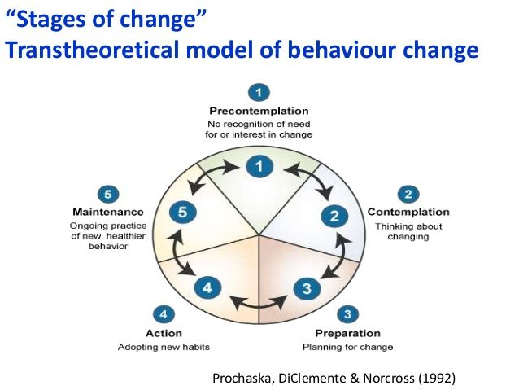
Self-medication: However, self-medication may become a legitimised strategy that is colluded with when distress is not resolved.”

Music can be used in Mental Health for supporting goals in:
- Basic cognitive and social skills
- Emotional regulation
- Empathy
- Flexibility and ability to cope
- Function in social roles
- Body-mind connections

Music-centered Psychotherapy: Musical interventions are supported with verbal discourse
How might music therapy engage the whole person in a non-clinical encounter?:
- The importance of the nervous system
- Self-medication and stages of change
- Redefining successful engagement
Class 8 webinar: Music Therapy and Mental Health

What is Mental Health:

Why is MT effective in managing symptoms of mental health?
- There is no health without mental health･
- The definition of health in the WHO : "Health is a state of complete physical, mental and social well-being and not merely the absence of disease or infirmity.”
- Mental health can be conceptualized as a state of well-being in which the individual
  - realizes his or her own abilities
  - can cope with the normal stresses of life
  - can work productively and fruitfully
  - is able to make a contribution to his or her community

Article: Performance in Music Therapy experiences in five dimensions (Baltic St. band)
- Purpose: to develop a language that could be understood between therapists but also clients
- Importance of community: had weekly performances at a club affiliated with the hospital community music therapy (allowing community to make a change)
  - Used this to defeat the stigma
  - Music unites them, but within the music they hold onto their own identity
- Challenges of MT group issues of the Baltic street band
  - Compromises
  - Different individual needs and abilities
  - Facilitating process
- 2004 MT developed a new group: Music Therapy Performance Group (for those in the band)
  - Personality problems interfered with working environment of band rehearsals
  - MT and rehearsals both compromised
  - MTPG in addition to rehearsals
  - Safe space to process issues in the bands, worked through tehm in the MT space
- Setting & participants
  - The music therapy performance group was used to gather data to facilitate a common language that could be used between patients and MT
  - Setting: room mimicked performance space
- 5 dimensions relationships between things
- Musician & music played
- Performing musicians and how they feel together on the stage
- Performer and Audience
- Performer and his/her own thoughts while performing
- Enhancing the feeling state of the performer
- When all in maximum synergy = peak experience

- Goals of MT
  - Identify conflicts within dimensions 1-4 effect #5
  - Performance psychopathology – identifying patterns/disconnections within dimensions
  - Helps to managing mental health symptoms
- Evaluation: these areas were evaluated by the in patients themselves and the music therapist by perceiving the changes in the dimensions and the changes were recorded by self-report and first-hand observations.
- Dimension 1: musician connecting to the music
  - Is the musician choosing music which is within their ability to achieve success or failure.
  - Individuals who were making these choices in the band were also making these choices in the MT band, also made them in real life
- Dimension 2: Performers connecting with each other
  - Musician connecting with other musicians
  - Members start to think unconsciously about other band members, and think they have had other experiences with them (like family see someone as a father figure)
    - Changes the way we react to their comments
- Dimension 3: Connecting to the audience
  - Goal: establish stable emotional conditions with the performer to promote musical consistency in performance
  - Only feels successful if the audience responds well
  - Self-worth is tied to the applause received… this is replicated in real life as well
  - Goal: Individuals feels good about performance, despite the crowd
- Dimension 4: relationship the individual has with voice inside head
  - Unhealthy when voice is predominantly criticizing and providing negative thoughts
  - Replace negative with positive
- Dimension 5: both the MT and musicians can talk about the 4 different dimensions and work on them to become healthier. The 4 dimensions are aligned and healthy.

Class 9: Music Therapy and Palliative Care

- Philosophy of palliative care: end of life care to precent suffering and relieve pain, it is guided by the wishes of the patient.
- Goal of palliative care: to make the end of life process as pleasant as possible and less painful as possible
- Hospice of life
- Family is involved with the care and making chouces
- Patient directed
- Don’t always do whats best for the patient, for example doing bloodwork may elongate person’s life but the patient may not want to do this
- Video about MT and palliative care
  - Allows for letting go
  - Music helps them communicate
  - Allows opportunity to process
  - When we use creative art form, it provides another way to express how you feel, sometimes words aren’t enough
  - Studies: individual/patients self-administer pain medication less when they engage in music therapy
    - Could just be distraction
      - But even with other distractions, music therapy was the most effective
- What does MT in palliative care look like?
  - Enhanced mood decreases pain perception
  - Music’s positive connotations
  - Patients can choose to engage
  - The environment motivates him to pick up harmonica(instrument)
  - Palliative care is outside of our control
  - Opportunity through MT to provide control to these individuals
  - Family members are also impacted
  - MT sessions can support the family members too
- Who benefits?
  - All ages who are terminally ill, family and friends also benefit htrough the session, and the health care team (hospital setting) also benefits.
- MTs can focus the interventions across physical, emotional, spiritual, cognitive or social needs. Can be any of these or even multiple.
- Can pe passive: recipient (ex. Listening) or active: engaged (ex. Listening)
- Is non-invasive and inexpensive
- Goals
  - Most common: pain management
- Most common approach is biopsychosocial everything is integrated
- Interventions: Music listening, Improvisation, Singing, Song Writing, Music Playing, GIM guided imagery, Lyric analysis, MAR (Music Assisted Relaxation)
- Using music to keep patient awake:
  - Prevent a coma with a health condition that may induce it
  - Have problems with sleeping MAIN REASON
  - Sleep cycles
  - During the day may feel overwhelming and individual sleeps all day long and wakes up at 10pm
  - When awake at night, at a hospice less staff, less OT/physio/MT and overall less service to be provided. The isolation gets enhanced to improve quality of life.
- Palliative care includes the family
- Children in palliative care are able to take command and feel a sense of control when they get everyone to sing.
- Palliative care is flexible
  - Need of person changes over time and MT needs to adapt to the change
  - Singing, music listening, song choice is adaptable to all ages and levels of functioning.

Class 9: reading Music Therapy & Palliative Care

- Hospice (when death is anticipated in 6 months or less) vs Palliative care (for anyone dealing with terminal illness whether or not they have a six-month prognosis).
- Palliative care is a team-oriented approach, enhancing comfort and QL (not providing a cure), guided by the wishes of the patient.
- Who benefits? All ages of people who are terminally ill, friends and family, health care team.
- Passive (client just listening) vs active (client is playing instrument/singing).
- Bereavement happens after the death of a loved one (or sooner?).
- Can combine different goals (physical, spiritual, etc) within a single MT session.
- Children can communicate pain in a nonverbal way- become withdrawn, changes in sleep/eating patterns, ↑ irritability.
- Pain Assessment Tools
  - Numeric Rating Scale (NRS) and faces: rate pain on a numeric scale + pick a face that reflects pain severity.
- Instrument playing, singing, improvisation = facilitate expression of emotions.
- Live music/instruments with vibrotactile nature = good distraction from pain etc.
- Music is most effective when: (1) it is patient-preferred, (2) live music opposed to recorded music, (3) when experiencing mild to moderate pain (not severe).
- Autogenic muscle relaxation (repetition of a set of visualization, focused on body awareness) vs progressive muscle relaxation (tensing and then relaxing the muscles).
- Jean- arthritis: MT used iso-principle (match mood with music).
- MAR and GIM are only used for clients who are cognitively able.
Case Study
1. Jean- dementia + arthritis: Goal is pain management. MT used iso-principle (match mood with music). Distract her with music to unclench her hand.
2. Bud- ALS: weak, difficulty in swallowing, anxious (due to labored breathing), provided him with guitar to reduce anxiety + improve social interaction etc.
3. Dan- sleep problems: non-responsive. Falls asleep. Used music to keep him awake.
4. Emily- inoperable tumor: music was an outlet for creativity. Sang with her family/everyone around her. Made recordings for positive memories.

Class 10 – Lecture: Community Music Therapy

Examples of 3 definitions of culture no universal definition

- Example 1: is that complex whole which includes knowledge, belief, art, morals, law, custom, and any other capabilities and habits acquired by each person as a member of society.’
  - Tyler (British anthropologist) 1870: 1; cited by Avruch 1998: 6

- Example 2: ‘Culture consists of the derivatives of experience, more or less organized, learned or created by the individuals of a population, including those images or encodements and their interpretations (meanings) transmitted from past generations, from contemporaries, or formed by individuals themselves.’
  - T.Schwartz 1992; cited by Avruch 1998: 17

- Example 3: ‘Culture is a fuzzy set of basic assumptions and values, orientations to life, beliefs, policies, procedures and behavioural conventions that are shared by a group of people, and that influence (but do not determine) each member’s behaviour and his/her interpretations of the ‘meaning’ of other people’s behaviour.’
  - Spencer-Oatey 2008: 3

Can music therapy work with all people regardless of differences of culture?
- Music is a universal phenomenon but how it is used, is different around the world
- If the cultural differences don’t impede the therapeutic process, then it’s not an issue between MT and client
- Well-being of client comes first
- MT must be cognoscente in the cultural differences
- Community music therapy: challenged traditional boundaries and definitions of music therapy. It takes seriously how the culture informs our ways of perceiving therapeutic needs, it seeks to develop new perspectives, role identities and ways of doing music therapy.
  - Over the time of sessions, the goals may change
  - Individuals come together for a need is larger than the individual goals of the individual, the group may serve as a way to provide a positive way to influence the youth
    - Reduce gangsterism
  - Goal: larger social goal social change
  - Culture could be hospital setting, society etc.
  - Very flexible approach and to impact change within the individual and beyond to the society

Community music therapy
- Not ONE definition of CMT
- Main points of CMT: impacting social change, recognizing culture, recognizing the social context, and the system the MT is working in and the system the clients are part of.
- An approach gradually evolving in the field of music therapy.
- It is a way of doing and thinking about music therapy where the larger cultural, institutional and social context is taken into consideration.
- The approach involves an awareness of the system music therapists are working within, it means that music therapy is not only directed towards the individual, but often aimed at changing the system that is sometimes part of the situation of the client.
  - Even Ruud: MT that has written about CMT

PhD research example
- Supervisor Dr. Laurel Trainor
- Community Music Therapy – Effective for managing stress and anxiety in undergraduate students?
  - Why is this community music therapy as opposed to group? does not need referrals, no assessments, no individual goals or objectives, group collectively works together to manage stress and anxiety
  - CMT groups are aimed to impact social change
  - Hypothesis: individuals don’t seek out support to manage mental health possibly due to negative stigma to seek out help for mental wellness. By providing CMT groups on campus, the goal is to change the negative stigmas around mental health using via music (a term not associated with a negative stigma) it is believed this may change how individuals view seeking out support. Individuals use universal and we all collectively engage in. proactively aims to change wellbeing via music
- Most of community care is verbal and this study wants to collect data that CMT is equally affective

- Psychological, Physiological and Biomarkers collected for verbal and then CMT group

- Want to see how many people attend CMT vs verbal therapy group.

Bigger Picture Goals in addition to specific health goals
Typical Community Music Therapy Goals
- provider of vitality, i.e. emotional stimulation and expression,
- tool for developing agency and empowerment,
- resource in building social networks,
- way of providing meaning and coherence in life (see Ruud, 1998).
- https://www.youtube.com/watch?v=SWCwjK80qCo
- CMT with refugees.
  - May ask how is this different from a musician engaging in music in these scenarios? the background training they bring, knowledge of emotions that they are evoking, watching and observing how its stimulating individuals and are

Collaborative Work: Negotiations between Music Therapists and Community Musicians in the Development of a South African Community Music Therapy Project

Music Therapy Community Clinic (MTTC)
- Non-for profit, founded 2003, 2 MT’s
- Aims to provide MT & music making to disadvantaged communities in Cape Town SA
- Issues: poverty, unemployment, gang violence, HIV, AIDS, --fragmentation and disintegration of many communities
- Employs 4 MTs, 4 Community Musicians, 5 projects
- https://www.youtube.com/watch?v=PU8PgJrSr70
  - (capetown. drugs, gangsters)

Project: Heideveld & Nyanga Townships
- Started MT at a school in Heideveld , 2003
- Weekly group/individual MT sessions
- Referrals from teachers for those who needed the most support (from all 9 schools in area)
- Traumatization through exposure to gang violence
- Children who have been abused, lost family members (gang violence, HIV/AIDS, drugs), parents in jail
- Led to realization –need for after school positive social group experience (music groups) -MFL

Music for Life (MFL) Project
- After school music activities outside of MT (reach more kids) -2007
- Broader Aim – keep kids off the streets – providing a socially healthy alternative – open to all
- Importance of collaboration – musicians who were localto the community who understood the children and they lead with MT support who faciliatetd the group
- Negotiation
- MFL – Musician group leader, MT support/facilitate

Heideveld
- large interest from children and local musicians
- Choir 80 members (2 MTs)
- 2 Drumming Circles (led by drummer)

Nyanga – MFL project
- African Music Group (musicians), gum boot dancing, drumming, singing, playing the marimba
- All co-facilitated or supervised by a MT

The Research Question
- Logistics of collaborating resources for meeting the large need of the children in these communities (as seen by response to the choir in Heideveld)
  - Talks about the music for life program
  - Talks about if it should continue to have MT and musicians collaborating to run the group does it make sense financially or logistically
- Best use of resources? should the MT and musicians run the groups separately

Method
- Interviews with musicians 2 musicians
- Interviews with music therapists 1 MT

Musicians’ Perspectives comments from musician
- Cares about the MUSIC itself and wants to see and end product of music
- I think my role in the group is to teach them (the children in the African music group) what I have, and to be able to make them...create their own thing.
- That's what I'm focusing on.
- But at first I need to show them, this is how you play the drum, this is how you sing.
- Then at the end of the day...the person can be able to be creative and they can compose her or his own song.

Musicians’ Perspectives
- Main point: Musician recognized the challenge of teaching music, they also want to see the result and that was difficult because they weren’t as trained to teach. The goal for the musician wasn’t to create the clients into musicians but more so to give them the experience

- Main point: Musician thought that the music therapist already built a relationship and repour with the clients/children. However, this is just the training of the MT as they are taught to connect to the kids.

MTs’ Perspectives
- Mt noticed the cultural knowledge that the musician had – through music they could empowering cultural identity
- Local musician were music teachers and role models, a black Xhosa man, his role moves beyond teaching music skills.
- Local musician was able to be a male role model and show them that they had other alternatives than gangs.
- Opportunity to reconnect with traditional Xhosa music, cultural knowledge and values.
Role of MT
- MT were integral part in handling and facilitating behaviours/dynamics/difficult situations
- Knowing the kids – Guidance (kids and musicians*)
- Individuals needs within group dynamic
- Maintain group cohesion/strength
- Members learn skills such as resilience or turn taking were skills that that will help them outside of music group (connect with teachers / family / arrange performance opportunity

Finding the Balance
- Musicians wanted Performance/Musician self-need for product
- Regularly perform at community events
- MT saw this as a great opportunity to travel & perform at other communities that they would not have otherwise
- Balance between process (MT) and performance (musician facilitators) this fulfilled the overall goal for music for life program.
- MT’s not masters of cultural music
- MTs learned cultural music but western ‘ear’ difficult to hear/catch/replicate polyrhythms, harmonic structures, melodies/language
- Goals of the musician and MFL were integrated together and educated each other on what they found and felt was best for the group

Results
- Collaboration is key in meeting all the needs of the Music For Life Program
- Is this a good use of resources to have both musician and MT?
  - Yes, the collaboration was integral.
  - They both offered unreplaceable talentd

Secondary OUTCOMES
- Musicians were all male presence and became male role models which was rare for the children
- (death (gangs/AIDs)/jail/travel for employment) children saw alternatives to gangsterism.
- Mothers/grandmothers, raising children
- MTs all white women in program
- Mr.Fat – admired and esteemed, grew up in a similar community
- Rap – describe/express lives
- Rap – offer hope to others, see alternate choices to gangs

Culture/identity
- Townships form a melting pot of influences from different generations and cultures
- Culture is not a static entity
- Creating a new culture that allows traditional values and more contemporary norms to live side by side.
- Music can reproduce legacy of another and allow the performance of the self.
- Empowerment – highlighting role as active agents in development of their culture/community.

MTCC Workshops – For Musicians
- MT techniques for musicians to use MT techniques
- Sensibility to children/adolescents
- Goals MFL

MTCC Workshops – MTs
- Language to speak and understand
- Culture the experience of living in township
- Music to further participate in musical experience of the group

Summary of benefits of MFL
- Importance of collaboration
- Cultural awareness
- Male role models
- Social change – additional options to gangs
- Self-Identity

Is this model Music Therapy?
- Is MFL music therpay?
  - Main individual is a musician, and is facilitated by a musician
  - Yes it is music therapy. But not a clinical approach
- 'what do I need to do, here, now?'" (p. 30). Brynjulf Stige (2004) notes that community music therapy cannot be defined by procedures, but there is rather a set of values and assumptions that underly the work that takes place.
- Community music therapy work is defined by context. Whilst the main aim or goal of the work could be social change, the way this is carried out can take on many different forms.

MT Approaches Used
- Aesthetic music therapy
  - Comes from eh drive from the musician
  - The product of the music is not the intent of the group, but having the music sound good has a positive impact on the group .
- Community music therapy
Overview
- Goal?
- Approach?
- Interventions?
- Data Collected?

Class 11 – Lecture: Music and Wellness

Learning objective
- To learn about the role of singing / voice work in promoting wellness
- To understand practical and theoretical rationale underpinning community singing / support groups
- To learn about potential implications for community singing groups in clinical settings

“Words make you think. Music makes you feel. A song makes you feel a thought.”
- Yip Harburg

Singing across the lifespan
- Singing is a primal human connection.
- Singing is a way people connect and come together.
- It has a positive effect on our mood/state, strengthens interpersonal relationships and connects us to our environment

Health benefits of singing
- Singing has a positive impact on affect/mood, breathing, immune responses
- Increases motivation, confidence, perceived feelings of social support/belonging
- Decreases anxiety, isolation
- Motivates personal growth, feelings of vitality, and sense of safety within a community

Singing well: bereavement support group
- 2013: “Singing Well” clinical pilot project launched.
- 18 sessions held prior to launch of our study in 2015.
- Program evaluation: Protocol for our study guided by participants’ feedback.
- Why study this? To set benchmark for provincial & national hospice services. A program informed by “research in context” lends credibility to the work.
- Create evidence informed guidelines for an innovative effective program which can address needs &/ gaps in service.

Significance and need: theoretical
Why singing & bereavement? provides different way to bereave
- Use of voice creates pathway to access & release feelings; helps synthesize physical, sensory, emotional responses
- Use of metaphor & symbolism in song material (safety through symbolic distance; songs as “containers”)
- Can express feelings without needing to share/talk about them
- Singing together = support
- Less focus on cognitive processing, more focus on experiencing feelings.
- Music/singing can facilitate grieving processes in culturally specific ways.
- Summary:
- Singing serves multiple biopsychosocial, spiritual, & practical functions; potentially a valuable & unique coping strategy for bereaved persons. More research needed to formulate best practice guidelines.

Singing Well program
- Supportive care group who have lost a loved one
- Explore and sing about feelings (less talking)
- Singing has cardiorespiratory benefits and immune function benefits

Participants and design
- Convenience sample: 7 Caucasian females; 51 to 80 years old.
- Interpretative Phenomenological Inquiry
- The uniqueness of each person’s experience is of key importance.
- Analysis of individual cases.
- Themes identified among participants’ experiences.

Data collection
- Six singing groups occurred over three months.
- Clinically informed session protocol.
    - Verbal check in
    - Breathing/Relaxation/Vocal Warm ups
    - Chanting/Vocal Improvisation
    - Sharing individual’s song compositions/meaningful songs/recordings
    - Group singing/selection of songs
    - Closing song
    - Participants could submit written feedback after each session.
- Semi-structured individual qualitative interviews within 24 hours of final session.
- Researchers made analytic memos throughout data collection & analysis processes.
Data analysis
- Interviews transcribed. 6/7 participants reviewed.
- Qualitative analysis procedures.
- Seven narrative summaries. Represent explicit/ implicit aspects of each individual’s experience of singing/voicework in this context.
- Overarching categories/themes. Represent group’s lived experience of singing/voicework in this bereavement support music therapy group context.

Group categories/themes
Category 1: Group singing experiences/the Singing Well context:
  - Helped foster various feelings of connection.
  - Evoked a wide range of feelings; often experienced physically.
  - Helped participants express inner feelings in ways that were different & sometimes better than talking.
  - Gave participants permission to enjoy themselves & freedom to explore their voices.
  - Motivated participants to attend; felt accepting and non-judgemental.
  - Evoked feelings of compassion among participants.
  - Worked well because of the personal/professional qualities of MTA.

Category 2: Vocal warm ups, breathing and relaxation exercises:
- Mixed feedback.

Category 3: Songs (precomposed/original):
- Reflected/validated experiences of grief & loss.
- Evoked memories; release of emotions.
- Meaningful song(s) chosen by one was meaningful experience for all.
- Act of choosing songs important.
- Song writing: a forum through which to express grief/other emotions; overwhelming for some

Category 4: Improvised vocal experiences (chanting, toning, humming, creating melodies, harmonies):
- Felt liberating; experienced physical sensations of floating or flying.
- Sense of togetherness and independence at the same time.
Category 5: Overall experiences of Singing Well:
- Sense of commitment to group.
- Motivated participants to make changes, explore new/revive previous interests in their daily lives.
- Helped participants to move forward in their lives.
- Difficult to express in words.

Selected Implications
- Aligned with dual process of grief
- Singing “as” therapy. A viable alternative/adjunct to other forms of bereavement support.
- Need for singing & health groups outside of the hospice context.
- Examine role of relationship with the music therapist and role of previous music [therapy] experience.

Sing it Girls

Purpose: to support girls to develop and trust their strong voice and inner resilience

Benefits of group singing
- Singing has physical, psychological, social, musical and educational benefits for children
- Confident and healthy voice use links to a positive self-concept and an ability to communicate
- Successful singing promotes self-esteem, general confidence and self-efficacy
- Creating a space for girls to hear the whispers of their songs can enrich their experiences in therapy in nurture their psyche

The problem today
- In early adolescence, girls:
  - Are more stressed than boys
  - Are more depressed
  - Have lower self-esteem
  - Have more eating disorders
  - Have more body dissatisfaction

The reality is…
- 1 in 5 people will experience a mental illness at one point in their life, most common being anxiety.

The science behind sing it girls
- Girls deserve to feel strong and confident, and to feel connected to their peers and community.
- Self-esteem and self-worth can be nurtured in girls so that they may grow to be confident young women and leaders.
- Singing improves learning outcomes
- Singing connects us to one another

Gender specific programming
- Gender specific to emphasize the connection between girls and women, which is different form the connection between mixed gender group. To speak freely and relate to one another.
- Self-esteem and self-efficacy are the most common traits found in resilient people predictor of depression among girls
- The needs of the girls are:
  - a safe space to be themselves
  - a supportive environment with peers
- The risks of this include:
  - are more stressed & self-conscious than male counterparts
  - have lower self-esteem

Class 11 Webinar – Music Therapy in NICU

What is NICU?
- Video about NICU
  - Baby learns to suck through a music activated pacifier, where everytime the baby sucks, the lullaby plays
- For infants who are born prematurely
- In Neurological MT and entrainment, it was learned infants suck better to regular beat of music. MT impacts the breathing, nutrition/sucking behavior and heart rate can be impacted as that can improve O2 saturation.
- Infants can listen to music by sucking on the pacifier

How can music therapy be effective in NICU?
- Beneficial for both premature infants and parents
- Music must be used with caution as it can over-stimulate the infant
- The MT intervention is tailored to the individual needs of the premature infant and can change base d on the infants stage of development

What about the Parents?
- Caregivers are often neglected in traditional health care settings yet are integral to the well-being of whom they are caring.

Music Therapy Self-Care Group for Parents of Preterm Infants in the Neonatal Intensive Care Unit: A clinical Pilot Intervention,
Esteban Roa & Mark Ettenberger

- Wanted to understand the parental needs of the parents that was separate from the needs of the infant
- Self-expression was key! live music making

Why this work is important?
- NICU interrupts transition into parenthood
- Parents can experience feelings of hopelessness
- Psychological distress, anxiety
- Symptoms of depression
- Financial demands
- PTSD
- Gender stereotypes

Family Centered Care (FCC)
- Family recognized as the patient’s primary source of support/wellbeing. Implementing music therapy provides parents with an active role. Focus on parent & infant wellbeing.
- Principles: information sharing, honoring differences, partnership & collaboration, negotiation
- Focus is on parent and infant well-being

Class 12: Music Therapy & Parkinson’s Disease & Pain Perception

What is Parkinson’s disease?
- A chronic progressive neurological disorder involving degeneration of the dopaminergic system
- Motor and non-motor symptoms
  - Physiotherapy is main treatment
- Impacts individuals differently (symptoms and their severity), and there is no cure.

Best MT model or approach:
- impacts individual physically and emotionally. There is no one approach to work with someone with PD. Neurologic MT is effective, may benefit from constant beat to facilitate gait and initiating movement may occur from NMT.
- Playing music may not be effected by PD challenges. Also, helps with range of motion.
- Singing facilitate fluid speech

MT and Pain
- MT is an intervention for pain perception
- Used for pre and post-surgical care
- Follows the biopsychosocial model
  - Bio: nociceptors
  - Psycho: emotions and environment
  - Social: interact with others
- Music and pain share similar pathways when being processed in the body

Applications
- Used pre and post-surgery in order to reduce pain perception and anxiety

