Verification of Boyle’s Law

Ryan Zuba
CHM 1311
Ying Sun | Dr. Rashmi V.
Tuesday, September 26th, 2017
Introduction:

Boyle’s law is defined as a variation of the Ideal Gas Law. (1) This means that the law Robert Boyle theorized had direct correlation with the Ideal Gas Law with modification under certain parameters. These parameters allow Boyle to test his theory: that the pressure of a gas is inversely proportional to the volume of the vessel that contains it, multiplied by the factor of a calculated constant.

According to the Ideal Gas Law, PV=nRT, which means that the product of the pressure and the volume of a gas is equal to the amount of gas being tested multiplied by the temperature of the environment and a gas constant. So, if one looks at the Ideal Gas Law and derives it to become a function of pressure of a gas at a certain volume, the equation will look like this:

P = $\frac{nRT}{V}$

Robert Boyle decided in order to test the relation of a gases pressure to its volume, the amount of gas stays consistent through the system and remains one temperature. This is ensuring that there would be no deviations to obscure results. So, if nRT is kept constant as Boyle wanted, the equation can be derived further, exemplifying Boyle’s theory:

$$P=\frac{C}{V}$$

At extreme pressures and temperature, the ideality of the gas becomes obsolete, and one is unable to use it. But in most scenarios, and more importantly in this experiment, the ideal gas law and its derivation are essential in attempting to verify Boyle’s law, which is the purpose of this laboratory. In order to do this, LabQuest 2 and a gas pressure sensor are necessary materials, and graphing software must be utilized to record data. LabQuest 2 is a device that contains the software necessary to record and plot the data readings taken, and a gas pressure sensor is an apparatus that analyzes the pressure of a gas and sends the data to the software. A syringe is also needed in order to change volumes, therefore increasing or decreasing the pressure readings in the sensor.

Though this experiment mimicked a perfect or ideal scenario, it is impossible to truly complete the experiment in a closed system. However, through this experiment, one has the ability to visually and mathematically see how Boyle derived his theory, providing an important learning opportunity in which one can see how everyday gas like the air we breathe are subject to the Ideal Gas Law, and Boyle’s Law.

Purpose:
The purpose of this experiment is to verify the math behind Boyle’s Law, and to analyze gases at constant temperature with varying pressures and volumes.

Materials:
- LabQuest 2
- Vernier Gas Pressure Sensor
- 20 mL gas syringe
- USB key

Procedure:
- A gas pressure sensor was connected to LabQuest 2.
- The plunger of the syringe was corrected to a chosen volume of 10 mL, and connected to the gas pressure sensor.
- LabQuest 2 had settings that were changed to data collection mode – event with entry.
- Values of pressure were measured at each interval of change in volume, data was adjusted to account for the volume (0.8 mL) inside the gas pressure sensor.
- Data and pressure readings at each interval of volume were kept and recorded into a table using LabQuest 2.
- Data was plotted on a graph and analyzed using the Curve Fit function on LabQuest 2 and observations were made on the characteristics of the curve.
- Data from LabQuest 2 was saved for personal records.
- Trial 1 was complete.
- Steps 1 to 7 were repeated until three trials were complete.

Observations/Data/Results:

Analyzing Relationships of Pressure and Volume

Trial 1:
Figure 1. (Below) Validation of Boyle’s Law: Trial 1.
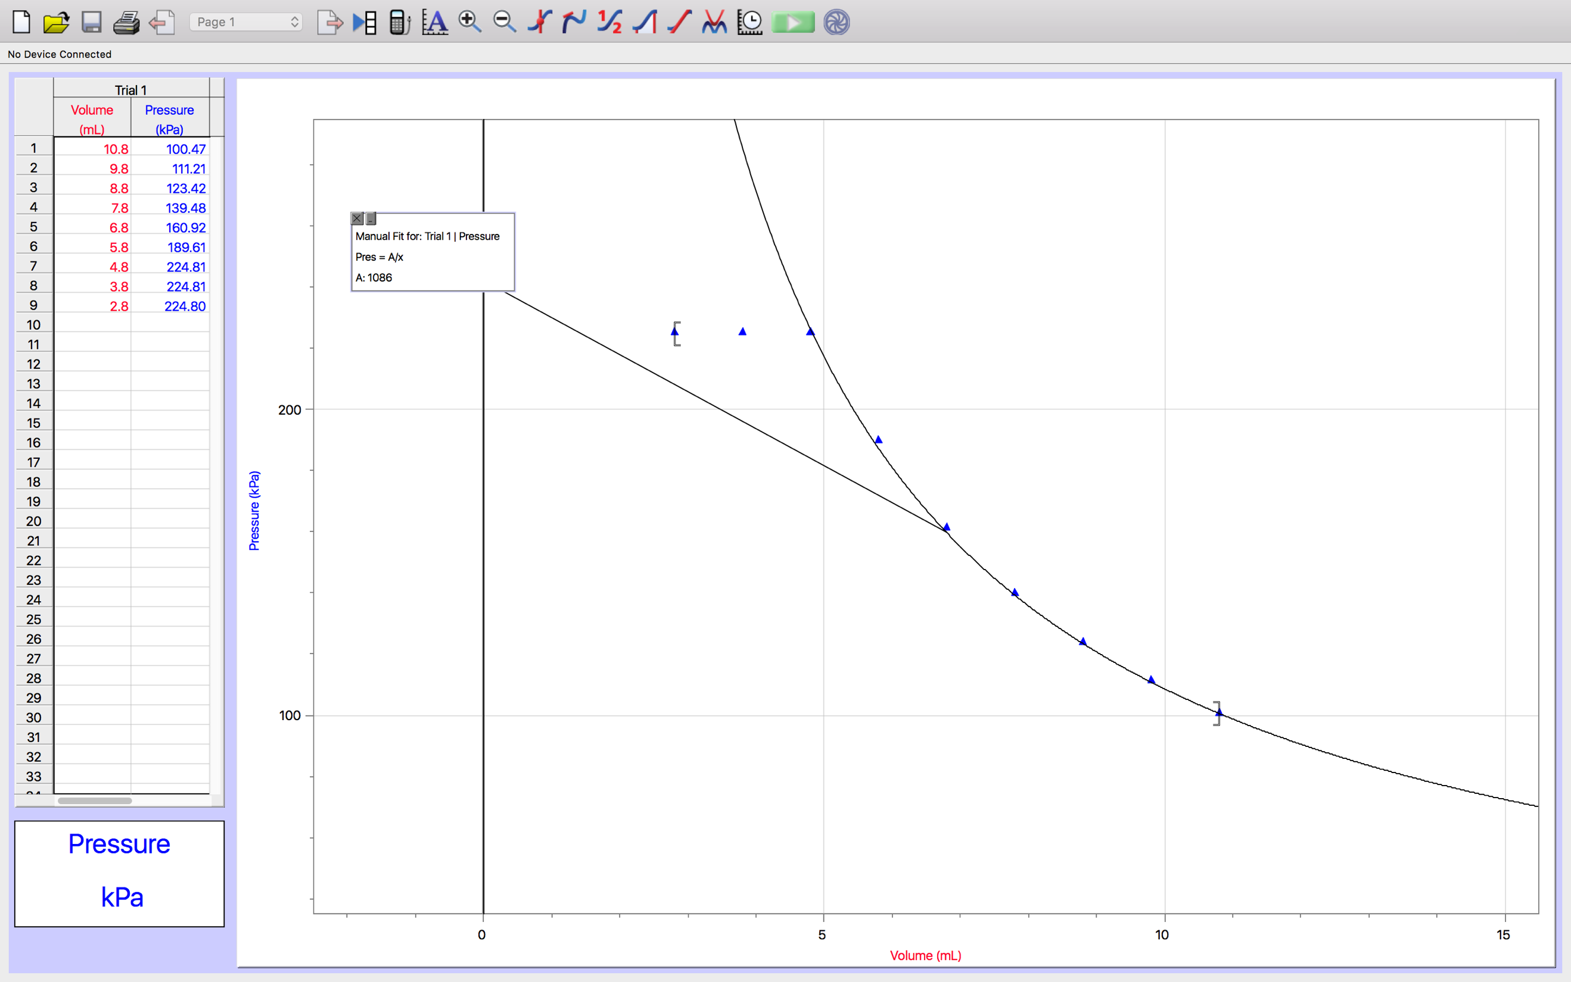

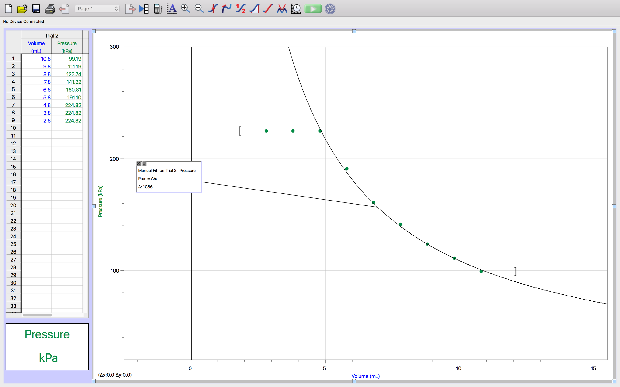
Trial 2:
Figure 2. (Below) Validation of Boyle’s Law: Trial 2.

Trial 3:
Figure 3. (Below) Validation of Boyle’s Law: Trial 3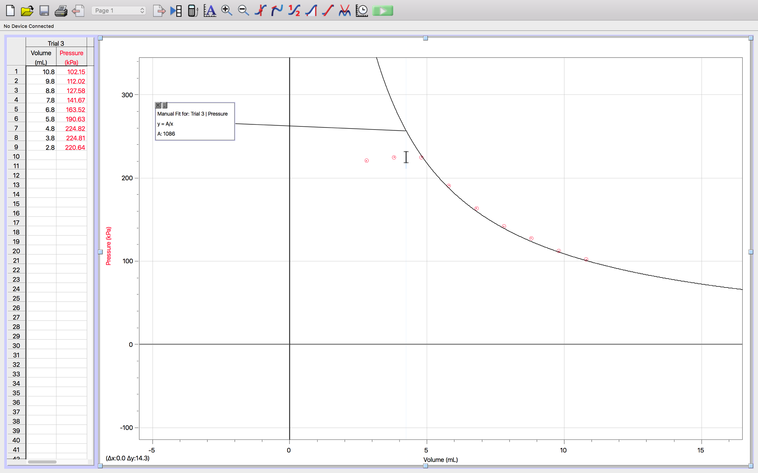

Calculations/Discussion:
- P_{n}V_{n} = nRT Constant value (C_{n})
NOTE: P_{n}V_{n} = C_{n} *such that n belongs to a set of data* [Ex. P_{T1}V_{T1} = C_{T1} (Trial 1)]

- C_{T1} = P_{T1}V_{T1}
C_{T1} = (100.47 kPa)(10.8 mL)
C_{T1} = 1085.1 kPa • mL

- C_{T2} = P_{T2}V_{T2}
C_{T2} = (99.19 kPa)(10.8 mL)
C_{T2} = 1071.3 kPa • mL

- C_{T3} = P_{T3}V_{T3}
C_{T3} = (102.15 kPa)(10.8 mL)
C_{T3} = 1103.2 kPa • mL

- C_{av} =$\frac{(CT1 + CT2 + CT3)}{3}$
C_{av} =$\frac{ [(1085.1 kPa • mL) + (1071.3 kPa • mL) + (1103.2 kPa • mL)]}{3}$
C_{av} = 1086.5 kPa • mL

- P_{n}(V_{n}) = $\frac{Cav}{Vn}$

P_{n}(V_{n}) = $\frac{1086.5}{Vn}$

Using the formula above, one can calculate the pressure in kilopascals given any volume, as long as the amount of gas measured remained constant, and was kept at a constant temperature. This proves the law in which Boyle states: Pressure is inversely proportional to volume. (2) As shown in the calculations, the value of this constant was averaged at 1086.5 kPa • L. I decided to use the average of the three trials, also shown in the calculations, because the averaged value would provide a more natural curve fit to each of the three graphs. This would ensure to omit as many sources of error as possible, and also minimizing deviations that would cause problems to the integrity of the experiment, such as manually fitting exact curves to each set of plotted data, which does not happen in nature. However, deviations in the data occurred at 2.8 mL and 3.8 mL as the sensor reached a limit of 224.8 kPa of pressure measured, which plotted points that did not fall on the curve of the function, ultimately obscuring the validity of the observations.

The mathematical relationship observed was an inverse function dependant on the volume, multiplied by the value of the constant, this can be proven by examining the relationship shown in Calculation 3.

Multiple readings at the same volume were advised to be taken for a few important reasons, one mainly being to validate the integrity of the trial. It is important to achieve similar initial and final readings to ensure that the procedure was followed correctly and there were little sources of error present in the experiment. In my trials, I omitted the final initial reading because it was very similar to my first initial reading at the same volume, which means I had little percent error, rendering the final initial reading obsolete due to its repetitive nature.

In order to test Boyle’s Law properly, variables such as the measurements of the amount of gas must be kept constant through the experiment as accurately as possible. This proved to be the greatest source of error encountered, considering the reading in each trial at a chosen volume was not perfectly identical. This is because of the human inability to perfectly match the plunger of the syringe to each desired measurement of volume affecting the pressure reading, since each trial may not have been taken at the identical volume. Also, as pressure increased, it became increasingly difficult to keep the plunger at a desired volume because of the amount of reaction force the pressure in the syringe gives back, skewing results on the basis of human inability to keep the volume perfectly level.

Conclusion:

In conclusion, the purpose of this experiment was successfully completed, and data and graphs followed expectations almost exactly. This experiment proved the thought that Boyle had so famously presented. The validation of Boyle’s Law, that the pressure of a gas is inversely related to its volume, was completed as accurately as possible, with human error playing a small part in any deviation found in the trials conducted. Overall, observations provided clear and concise conclusions mimicking that of which Boyle himself discovered. The trials completed were simple, yet proved to be effective in attempts to verify the various properties of gases encountered in everyday activity.

Reference:

Olmstead J., Williams G., Burk R., Chemistry, Wiley, 2016

(n.d.). Retrieved September 25, 2017, from https://www.grc.nasa.gov/www/k-12/airplane/boyle.html


