This lab worksheet can be submitted either on an individual basis or in pairs. If only one name is mentioned, it will be presumed that the document was submitted on an individual basis.

Once completed, the present worksheet is to be submitted in the appropriate submission box of your Virtual Campus as a PDF format (if you use Word, select File Save As, Save As Type then PDF).

Due to technical constrains with the Virtual Campus, each of the two partners MUST individually submit a copy of the same worksheet, though the TA’s will be correcting only one of the two submitted copies. The same grade will be assigned to each of the two partners and only one of the two partners will be given access to the filled out assessment rubric. If you cannot access to the assessment rubric on your Virtual Campus, it is your responsibility to contact your partner to consult the completed assessment rubric. Once the worksheets and reports have been evaluated by the TA’s, the assessment rubrics with comments will be available via the section Class Progress of your Virtual Campus.

Lab 3. Photosynthesis

ONE STEP AT A TIME
PART 1 - Photosynthetic rate of Cabomba: Effects of Light Intensity and Illumination Spectrum

Table 1. Effects of light intensity and light spectrum on the photosynthetic rate of a ‘stem’ of Cabomba sp. immerged in a sodium bicarbonate solution.
 | Manometer height (mm)
 | Exp. 1. Distance between the lamp bulb and the test tube (cm) |  |  | Exp. 2. Filter Colour (Max l) at a distance of 20 cm
Time (min.) | 20 | 30 | 40 | Blue (410 nm) | Green (535nm) | Red (650 nm)
0 | 0 | 0 | 0 | 0 | 0 | 0
2 | 1.4 | 0.7 | 0.4 | 1.3 | 0.3 | 2
4 | 2.8 | 0.9 | 0.7 | 2.3 | 1.5 | 2.2
6 | 4.9 | 1.4 | 0.9 | 4.6 | 2.3 | 2.2
8 | 7.1 | 2.8 | 1.1 | 5.1 | 2.8 | 2.4
Total volume of O₂ released (mL)* | 0.05576 | 0.02199 | 0.00864 | 0.04005 | 0.02199 | 0.01885
Photosynthetic rate  (mL O₂/min) | 0.00697 | 0.00275 | 0.00108 | 0.00501 | 0.00275 | 0.00236
*Volume of manometer tube = πr²h; 1 mL = 1 cm³ ; inner diameter of the capillary tube of the manometer = 1 mm.

The stoichiometry of photosynthesis predicts that photosynthesis is linearly related with the intensity (W/cm²) of light. Are you results consistent with this assumption?
From the raw data, the photosynthesis rates so far indicate that light intensity increases with an inverse relationship to distance. Where distance increases, the light intensity decreases, and vice versa. For Exp 1, the results of the photosynthesis rate along with distance appear consistent so far.

To answer this question, you first need to figure out how the intensity of a lamp bulb varies with distance. We will come back to the relation between light intensity and photosynthetic rate later.
The light source used is a 150 watt bulb, but the baffle focuses the light beam into a smaller and more intense area suggesting an equivalent source of 500 watts. The figure above shows that light intensity, which is an estimate of the number of photons moving across a surface unit (W/cm²), is decreased by four when the distance is doubled. Establish the mathematical equation of the light power (W) per surface area (cm²). Refer to your equation to estimate the light intensity in W/cm² at the three distances that you assessed in the laboratory, which are 20 cm, 30 cm and 40 cm. By how much is the light intensity in W/cm² reduced at a distance of 40 cm compared to the intensity at a distance of 20 cm?
Insert your answer. Justify your answer and make your reasoning explicit and easy to understand for the reader.
The relationship between light intensity and distance is known as the inverse square law. This relationship is depicted as $\frac{1}{d{}^{2}}$, where d is the distance in cm. This exponential relationship indicates that light intensity and distance are inversely proportional.
A source of 500 watts from a distance of 40 will be $\frac{500}{{40}^{2}}$, which results in a light intensity of 0.1325 W/cm². The relationship here shows that as the distance doubled, the light source decreases by a factor of 4.
Whereas a source of 400 watts from a distance of 20 will be $\frac{500}{{20}^{2}}$, which results in a light intensity of 1.25 W/cm². Again, distance has doubled, and the light source decreases by a factor of 4.
The difference in the two distances demonstrates that the closer the plant is to the light source, the higher the light intensity will be, therefore a higher rate of photosynthetic activity will be observed from the plant.

Generate a plot displaying your photosynthetic rates (units on the Y axis are ml O₂/min) as a function of the distance (units on the X axis are cm⁻¹). Is the linear trend line passing through your three data points? Should photosynthetic rate decrease linearly with distance?
Insert your plot with the linear equation and its r² value. Explain and justify your answer.
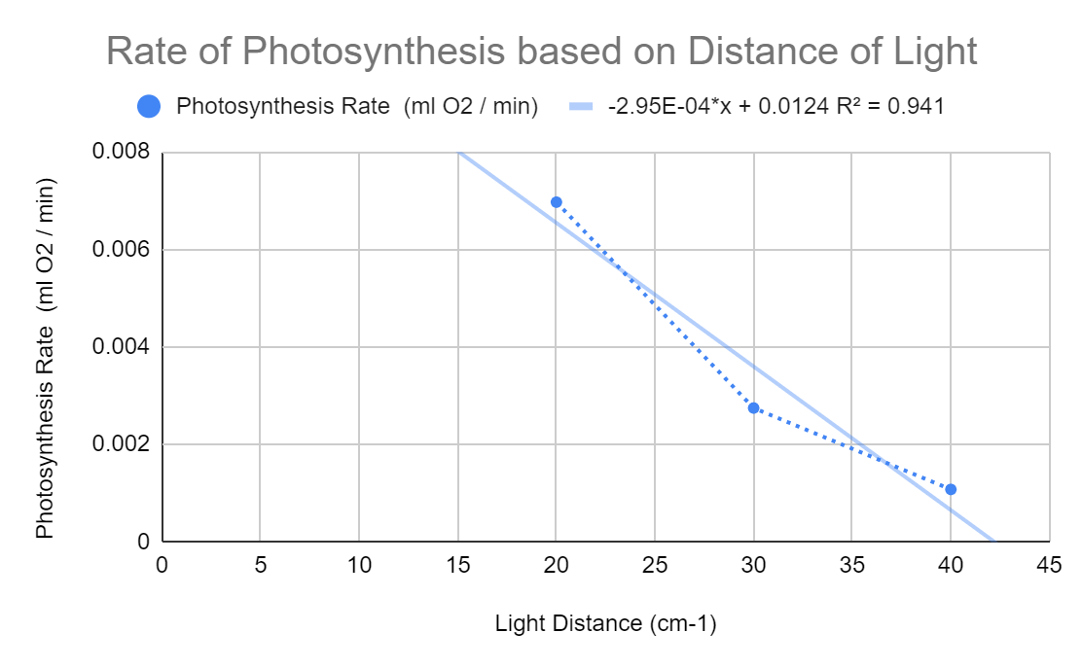

R² = 0.941
The following graph demonstrates the relationship between photosynthetic rate and the distance between the light bulb and the plant. A linear, decreasing trend is examined, where as the distance increases, the photosynthetic activity of the plant is reduced. The trend passes between the three data points, but nonetheless shows an accurate relationship between distance and photosynthesis rate.
The photosynthetic rate should decrease linearly with distance, because the light intensity that the plant experiences is decreasing the further it is away from the light source. Therefore the lack of an intense light source due to increased distance reduces photosynthesis activity of the plant.

Generate a second plot displaying your photosynthetic rates (units on the Y axis are ml O₂/min) as a function of the square of inverse distance (units on the X axis are cm⁻²). Is the linear trend line passing through your three data points? Should photosynthetic rate decrease linearly with the square of the distance?
Insert your plot with the linear equation and its r² value. Explain and justify your answer.
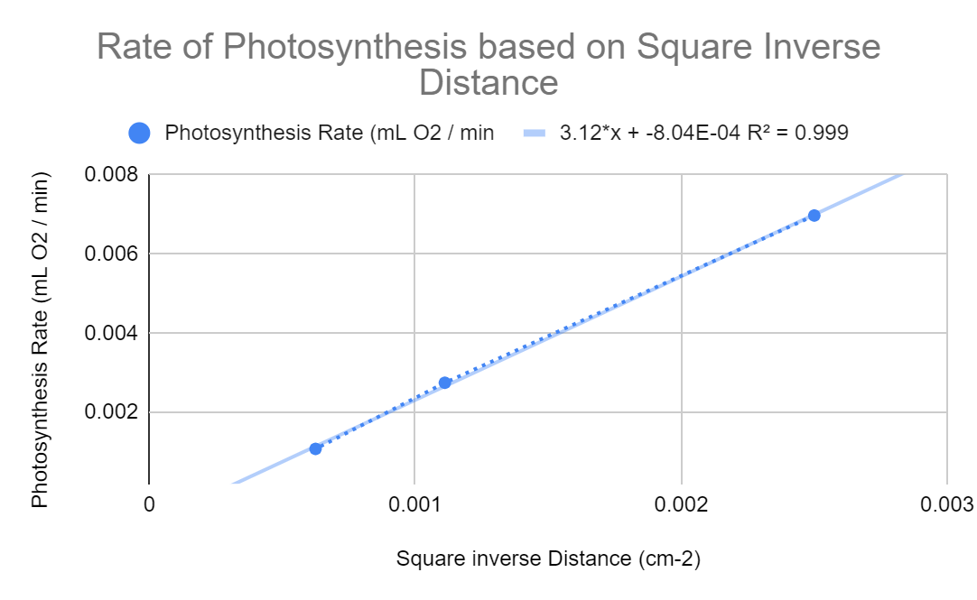
R² = 0.999

The following graph depicts the relationship between photosynthetic rate and the inverse, squared distance between the light bulb and the plant. A linear, increasing trend is observed and does indeed pass through all three data points.
The photosynthetic rate should decrease linearly with the squared distance, because as the distance increases between the plant and the light source, the more the photosynthetic rate will decrease.
Whereas the inverse value of squared distance will create a directly proportional relationship with photosynthesis rate, where as the square inverse distance increases, the photosynthetic rate will increase.

Generate a third plot displaying your photosynthetic rates (units on the Y axis are ml O₂/min) as a function of the light intensity you previously estimated for the distances 20 cm, 30 cm and 40 cm (units on the X axis are W/cm⁻²). Is the linear trend line passing through your three data points? Should it be the case?
Insert your plot with the linear equation and its r² value. Explain and justify your answer.
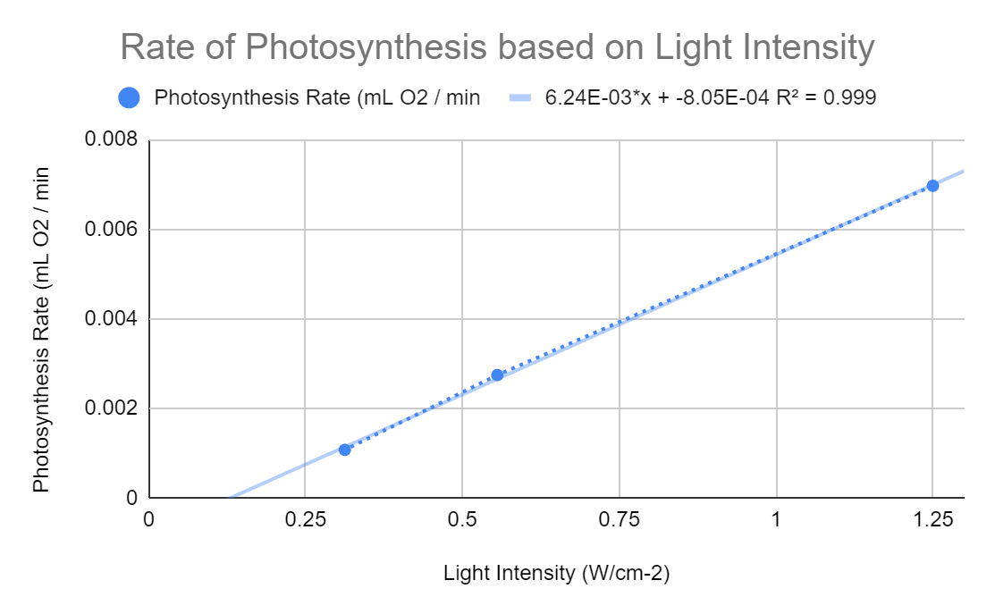
R² = 0.999

The following graph depicts the relationship between photosynthesis rate and light intensity. A linear, increasing trend line is depicted. All 3 data points appear to be passing through the trend line.
Photosynthetic rate and light intensity should demonstrate a directly proportional relationship. Because as light intensity increases (where the distance between the plant and light source decreases), the photosynthetic activity of the plant should increase as well. Therefore as light intensity increases, photosynthetic activity increases as well.

You should now be able to address the important question that was initially asked: Is photosynthesis linearly related with light intensity?
Explain and justify your answer.
Yes, photosynthesis is linearly related with light intensity. When the intensity of light that the plant experience increases, the distance between the light source and the plant decreases. The closer they are to each other, the greater the light intensity will reach the plant.
Due to this relationship, the photosynthetic activity of the plant will increase in response to greater light intensity, taking in more CO₂ from the bicarbonate solution and producing O₂ in its surrounding container.

Convert the photosynthetic rates reported in Table 1 from mL of oxygen per minute into millimoles (mmol) of C₆H₁₂O₆ per min. Provide your explanation and full calculation for one sample, then fill out the rest of the table.
 | Exp. 1. Distance between the lamp bulb and the test tube (cm) |  |  | Exp. 2. Filter Colour (Max l) at a distance of 20 cm
 | 20 | 30 | 40 | Blue (410 nm) | Green (535nm) | Red (650 nm)
Photosynthetic rate  (mL O₂/min) | 0.006970 | 0.002749 | 0.001079 | 0.005007 | 0.002749 | 0.002356
Photosynthetic rate  (mmol of O₂/min) | 0.000284 | 0.000112 | 0.000044 | 0.000204 | 0.000112 | 0.000096
Photosynthetic rate  (mmol of C₆H₁₂O₆/min) | 0.000853 | 0.000337 | 0.000132 | 0.000613 | 0.000337 | 0.000289

Sample Calculation:
Volume of O₂: 0.007854 mL
Mol of ideal gas: $\frac{1 mmol}{24.5 mL}$
$0.007854 ×\frac{1}{24.5}$= 0.0003206 mmol of O₂ / min

Photosynthetic Rate: 0.0003206 mmol of O₂ / min
C₆H₁₂O₆ = 3x O₂
3(0.0003206) = 0.0009617 mmol of C₆H₁₂O₆ / min

The first calculation was determined by using the formula for a mmol of ideal gas occupying a volume of 24.5 mL at room temperature. Using the original value for photosynthetic rate at mL O₂ / min and the ideal gas formula, it was possible to calculate it at mmol O₂ / min.

The second calculation was determined by multiplying the mmol O₂ / min by 3 to get the mmol C₆H₁₂O₆ / min, this is because in a molecule of glucose, there are 3 O₂ molecules within it.

The different color filters impact photosynthesis by attenuating light transmission at and around the two absorption peaks of chlorophyll a (455 nm and 665 nm) and b (430 nm and 642 nm). Refer to the transmission plots provided by the manufacturer to estimate the expected mean ratio of light transmission at the photosynthetically active wavelengths for each of the three filters used in the experiment.
 | Plexiglass alone (from experiment 1) | Plexiglass and blue filter | Plexiglass and green filter | Plexiglass and red filter
Ratio of light transmission at photosynthetically active wavelengths | 1.00 | 0.35 | 0.20 | 0.29

Complete the table below and discuss your results. What filter colour would you recommend for optimal photosynthesis? Explain your reasoning.
 |  | Exp. 2. Filter Colour (Max l) at a distance of 20 cm
 | Plexiglass alone (from experiment 1) | Plexiglass and blue filter | Plexiglass and green filter | Plexiglass and red filter
Photosynthetic rate  (mL O₂/min) | 0.00697 | 0.005007 | 0.002749 | 0.002356
Ratio of light transmission at photosynthetically active wavelengths | 1.00 | 0.35 | 0.20 | 0.29
Based on the table above, the best filter to use to gain an optimum photosynthesis rate would be to use the blue filter. When comparing all 3 filters, the least effective is the green filter, because green light passing through the green filter and reaching the plant is being reflected by the plant. The plant absorbs red and blue light, but reflects green light, and uses light within those two wavelengths for photosynthesis.
Comparing the red and blue filters, the results in the table indicate that blue light correlates to a higher photosynthetic rate than red light. This could possibly be because the frequency of visible light is highest near the violet end of the spectrum, and thus leads to a higher rate of photosynthesis.
Generate a plot displaying your photosynthetic rates (units on the Y axis are ml O₂/min) as a function of the light transmission at photosynthetically active wavelengths (Units of the X axis is % of light transmission at photosynthetically active wavelengths). Do you get a linear relation between photosynthesis and transmission of photosynthetically active wavelengths?
Insert your plot with the linear equation and its r² value. Explain and justify your main conclusion.
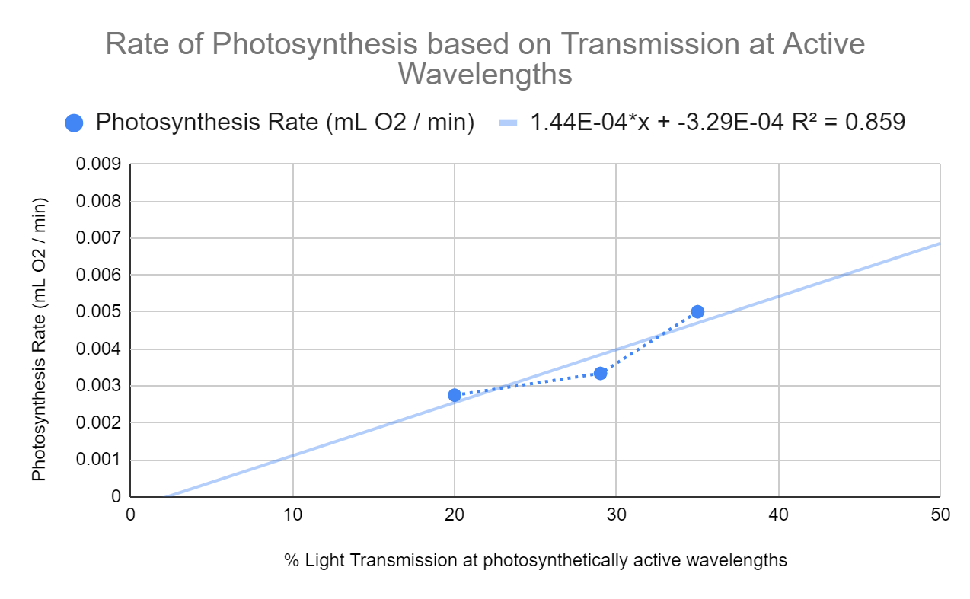
Blue
Red
Green
R² = 0.859

The following graph depicts the relationship between photosynthesis rate and light transmission at 3 different wavelengths. A linear, increasing trend is observed and the trend line passes between the three points.
Light transmission at the 3 different wavelengths (Blue (410), Green (535), and Red (650)), appears to be directly proportional to photosynthetic activity. The green light has the lowest transmission because green light is reflected by the plant and not absorbed for photosynthesis to take place, resulting in a low photosynthesis rate. The blue light has the highest transmission because blue light is absorbed and used more preferably for photosynthesis, therefore it has the highest photosynthesis rate out of the 3.
Overall, a blue filter will be more preferable for the plant, as it would result in an optimum rate of photosynthesis, and will produce the most oxygen over time.

PART 2 - Absorption Spectrum of a Cabomba Extract
Table 2. Comparison between the absorbance and transmittance of an acetone extract of Cabomba sp. and the absorbance of chlorophyll a and b.
Wavelength (nm) | Absorbance | Transmittance (%) | Average relative absorbance of chlorophyll a and b | Abs. Cabomba/ Abs. chlorophyll a and b
400 | 2.813 | 0.1 | 0.66 | 4.2
420 | 3.208 | 0.1 | 1.00 | 3.2
440 | 3.253 | 0.1 | 0.60 | 5.4
460 | 2.632 | 0.2 | 0.84 | 3.1
480 | 1.497 | 3.2 | 0.04 | 37.4
500 | 0.309 | 49.1 | 0.04 | 7.7
520 | 0.186 | 65.1 | 0.07 | 2.7
540 | 0.244 | 57 | 0.08 | 3.1
560 | 0.293 | 50.8 | 0.08 | 3.7
580 | 0.483 | 33 | 0.14 | 3.5
600 | 0.634 | 23.2 | 0.16 | 3.9
620 | 0.896 | 12.7 | 0.22 | 4.1
640 | 1.082 | 8.3 | 0.40 | 2.7
660 | 2.483 | 0.4 | 0.76 | 3.3
680 | 1.275 | 5.3 | 0.04 | 31.9
700 | 0.086 | 82 | 0.01 | 8.6

How does the absorbance of the acetone extract of Cabomba sp. vary in comparison to the absorbance of chlorophyll a and b? Is the ratio between the two variables (last column) relatively constant? If yes, what can you conclude? If not, how could you explain any significant divergence in the ratio values? Does the acetone extract contain only chlorophyll a and b?
Insert and justify your answers.

­­­­­­­­­­­­­­­­­­ The absorbance of the acetone extract of Cabomba sp. is much lower when compared to the absorbance of chlorophyll a and b, which is clearly displayed by the values located in table 2.
The ratio between the two variables is relatively constant. This is because it correctly follows the photosynthetically active wavelengths and only shows inconsistencies when the type of wavelength changes, for example shifting from blue to green.
Lastly, the acetone extract does not only contain chlorophyll a and b and we know this due to the fact that it also contains a composition of the whole plant.

