Lab BCH 2333

Section: C01 (Wednesday morning)

Lab 2: Amino Acids

Nathaline Haidar Ahmad

June 3rd, 2020

5

Sarah Khatib
300062670

Purpose
The primary objective for this lab is to determine the structure, and therefore the presence, of particular amino acids. The first experiment involves the use of ion exchange chromatography to successfully separate Glycine, Lysine, and Aspartic Acid. To elute the amino acids, the pH is increased gradually from 4.0 to 12.5 in order to deprotonate and elute the three amino acids in order of increasing pI, with Aspartic acid being first, Glycine second, and Lysine last. After the elution, ninhydrin is used to assay the contents and take pH measurements. The second experiment involves determining the molecular weight (MW) of an unknown protein in well #6 using electrophoresis on a polyacrylamide gel in the presence of SDS. By measuring the distance observed in the electrophoresis, the MW can be determined from the unknown protein.

Results & Discussion
R1
- Aspartic Acid
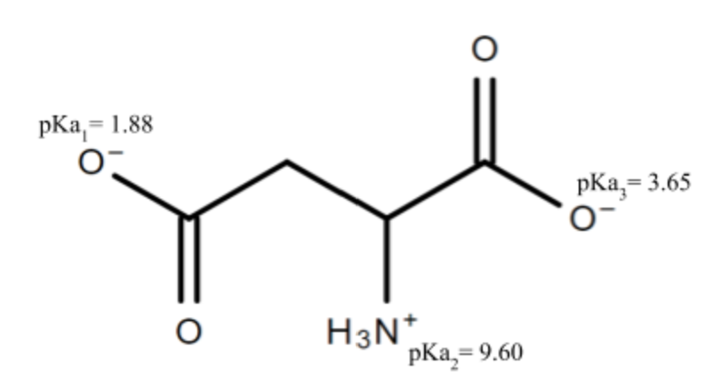
pI = 0.5(pKa₁ + pKa₃)
pI = 0.5(1.88+3.65)
pI = 2.77 at pH 3.9

- Glycine
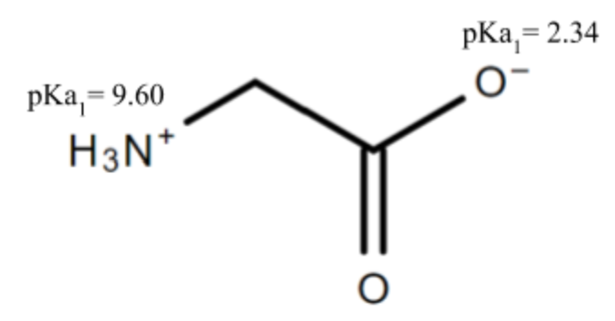
pI = 0.5(pKa₁ + pKa₂)
pI = 0.5(9.60+2.34)
pI = 5.97 at pH 3.9
- Lysine
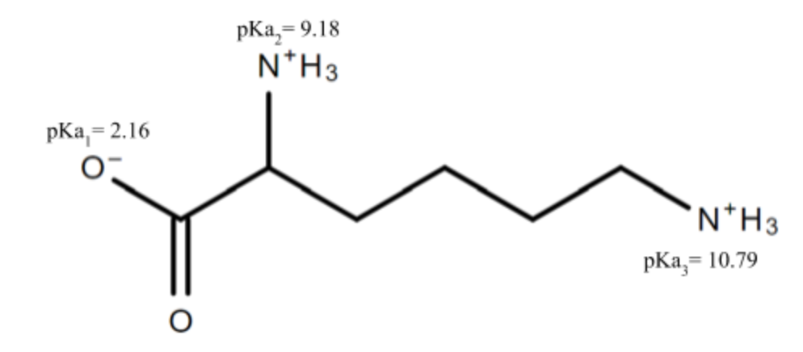
pI = 0.5(pKa₂ + pKa₃)
pI = 0.5(9.18+10.79)
pI = 9.99 at pH 3.9

R2
Fraction # | Elution Volume | pH | A₅₇₀ | A₅₇₀ Corrected | Concentration  (mM) | umoles  (mol)
1 | 4.7 | 4.12 | 0.056 | 0.034 | 0.0466 | 2.19x10⁻⁷
2 | 9.4 | 4.10 | 0.079 | 0.057 | 0.0781 | 3.67x10⁻⁷
3 | 14.1 | 4.02 | 0.202 | 0.18 | 0.247 | 1.16x10⁻⁶
4 | 18.8 | 4.01 | 0.934 | 0.912 | 1.249 | 5.87x10⁻⁶
5 | 23.5 | 4.04 | 0.365 | 0.343 | 0.469 | 2.204x10⁻⁶
6 | 28.2 | 4.06 | 0.239 | 0.217 | 0.297 | 1.396x10⁻⁶
7 | 32.9 | 5.56 | 0.470 | 0.448 | 0.482 | 2.265x10⁻⁶
8 | 37.6 | 6.59 | 0.419 | 0.397 | 0.427 | 2.01x10⁻⁶
9 | 42.3 | 6.79 | 0.294 | 0.272 | 0.293 | 1.38x10⁻⁶
10 | 47 | 7.23 | 0.210 | 0.188 | 0.202 | 9.49x10⁻⁷
11 | 51.7 | 7.78 | 0.159 | 0.137 | 0.148 | 6.96x10⁻⁷
12 | 56.4 | 9.22 | 0.217 | 0.195 | 0.290 | 1.363x10⁻⁶
13 | 61.1 | 10.92 | 0.583 | 0.561 | 0.835 | 3.925x10⁻⁶
14 | 65.8 | 11.49 | 0.399 | 0.377 | 0.561 | 2.64x10⁻⁶
15 | 70.5 | 11.58 | 0.249 | 0.227 | 0.338 | 1.59x10⁻⁶
16 | 75.2 | 11.65 | 0.229 | 0.207 | 0.308 | 1.45x10⁻⁶
Table 1. Ion exchange results for glycine, lysine, and aspartic acid. Resin is suspended in 0.1M of NaH₂PO₄ at pH 4.0 and poured into DOWEX column while avoiding trapping air bubbles inside the column. A volumetric flasks is then prepared with the NaH₂PO₄ solution diluted to 50 mL. 0.1 M of NaH₂PO₄ at pH 4.0 is poured into the capillary tube and the communication tube, in addition to 10 mL of phosphate solution added to capillary tube. 4 mL of the amino acid solutions (2.5 mM of Glycine, Lysine, and Aspartic Acid) are added to column, with an addition of 0.5 mL NaH₂PO₄ to rinse the syringe. In the gradient maker, the exit compartment is filled with 35 mL of NaH₂PO₄ of 4.0 pH, and the second compartment is filled with 35 mL of NaH₂PO₄ of 12.5 pH. The column is eluted, and collected in 16 fractions, the average volume of the fractions is 4.7 mL. 100 µL of ninhydrin (20mg/mL ninhydrin, 3mg/mL hydrindantin, 75% DMSO and 1M lithium acetate) is added to each fraction then incubated, they are then cooled with 2.5 mL of ethanol water (1:1 v/v) and the contents are assayed with a spectrophotometer at a wavelength of 570. The absorbance readings gathered are 1.095 for Aspartic Acid, 1.393 for Glycine, 1.008 for Lysine, and 0.022 for the blank reading.

Calculations
- Elution Volume for Fraction 8
Average Fraction Volume = 4.7 mL
Fraction # = 8

Elution Volume = (Average Volume)$⋅$(Fraction #)
Elution Volume = $(4.7)⋅(8)$
Elution Volume = 37.6 mL

- A₅₂₀ Corrected Absorption for Fraction 8
A_{blank} = 0.022
A₅₇₀ = 0.419

Correct A₅₇₀ = A₅₇₀ - A_{blank}
Correct A₅₇₀ = 0.419 - 0.022
Correct A₅₇₀ = 0.397

- Aspartic Acid Concentration (1-6) for Fraction 4
A_{Abs}= 1.095
A_{Corrected} = 0.912
C_{Abs} = 1.5 mM

c4 = $\frac{( A(corrected) ⋅C(Abs) )}{A(Abs)}$
c4 = $\frac{( 0.912 ⋅ 1.5)}{1.095}$ = 1.249 mM

- Glycine Concentration (7-11) for Fraction 7
A_{Abs}= 1.393
A_{Corrected} = 0.448
C_{Abs} = 1.5 mM

c4 = $\frac{( A(corrected) ⋅C(Abs) )}{A(Abs)}$
c4 = $\frac{( 0.448⋅ 1.5)}{1.393}$= 0.482 mM

- Lysine Concentration (12-16) for Fraction 12
A_{Abs}= 1.008
A_{Corrected} = 0.195
C_{Abs} = 1.5 mM

c4 = $\frac{( A(corrected) ⋅C(Abs) )}{A(Abs)}$
c4 = $\frac{( 0.195 ⋅ 1.5)}{1.008}$= 0.290 mM

- Aspartic Acid Molarity for Fraction 4
V_{Avg} = 4.7 mL = 4.7x10⁻³ L
c4 = 1.249 mM = 0.001249 M

c4 = $\frac{n4}{V(avg)}$
n = $V(avg)⋅c4$
n = $4.7x{10}^{-3}⋅0.001249$
n = 5.87x10⁻⁶ µm

- Glycine Molarity for Fraction 7
V_{Avg} = 4.7 mL
c7 = 0.482 mM = 0.000482 M

c7 = $\frac{n7}{V(avg)}$
n = $V(avg)⋅c7$
n = $4.7x{10}^{-3}⋅0.000482$
n = 2.265x10⁻⁶ µm

- Lysine Molarity for Fraction 12
V_{Avg} = 4.7 mL
c12 = 0.290 mM = 0.00029

c12 = $\frac{n12}{V(avg)}$
n = $V(avg)⋅c12$
n = $4.7x{10}^{-3}⋅0.00029$
n = 1.363 x10⁻⁶ µm

R3
Figure 1. pH and concentration (mM) values against the 15 fraction elution volumes (mL). Preparation of ion exchange chromatography requires 4 mL of the amino acids (2.5 mL of Glycine, Lysine, and Aspartic Acid) to the DOWEX column. With the gradient maker, the exit compartment is filled with 35 mL of 0.1 M of NaH₂PO₄ at pH 4.0 and the second compartment is filled with 35 mL of 0.1 M of NaH₂PO₄ at pH 12.5. The elution process involved continuously adding 0.1 M of NaH₂PO₄ in the two compartments of the gradient maker and increasing the pH gradient to 12.5. The average volume of the fractions is 4.9 mL. Upon completion of eluting the fractions, all 16 were added with 100 µm of ninhydrin and then heated at 100º C. After 15 minutes of incubating, each fraction were cooled down with 2.5 mL of ethanol-water (1:1, v/v) and the absorbances read at a wavelength of 570. The readings from the spectrophotometry were 1.095 for Aspartic Acid, 1.393 for Glycine, 1.008 for Lysine, and 0.022 for the blank reading.

Explanation and Analysis
The graph above demonstrates 3 prominent peaks at 18.8 mL (Fraction 4) for Aspartic Acid, 32.9 (Fraction 7) for Glycine, and 61.1 (Fraction 13) for Lysine. Each peak indicate that the 3 amino acids have separated quite clearly. Aspartic Acid has the steepest peak due to complete protonation, but Glycine and Lysine are not as prominent, and it is also noticeable that Glycine has the lowest peak height. This is likely because the pH difference was not great enough to cause them to deprotonate completely. A cause for this low pH difference could be that elution occurred too quickly for the difference in pH to be more significant. Regardless, deprotonation is evident in the figure.
A method to improve the quality of these results would be to assay more than 16 fractions, to obtain a more precise result, carrying out more than 16 fractions can also reduce intermediate data showing merging between the amino acids. To increase accuracy, the elution process should be carried out more slowly to ensure the pH increases at a pace where separation is observed in the data. Finally, decreasing volume (less than 120 droplets per fraction) could reduce intermediate data observed between the steep points, which will also increase accuracy.

R4
- Aspartic Acid Recovery Yield
C₁ = 2.5 mM = 0.0025 M
V_{i} = 4 mL = 0.004 L

N_{theoretical} = C₁ $⋅$V_{i}
N_{theoretical} = $0.004⋅0.0025$
N_{theoretical} = 0.00001 µm

N_{actual} = $\sum_{1}^{6}{ni}$
N_{actual} = 1.12x10⁻⁵ µm

% Yield = $\frac{Nactual}{Ntheoretical}⋅100$
% Yield = $\frac{1.12x{10}^{-5}}{0.00001}⋅100$
%Yield = 112.16 %

- Glycine Recovery Yield
C₁ = 2.5 mM = 0.0025 M
V_{i} = 4 mL = 0.004 L

N_{theoretical} = C₁ $⋅$V_{i}
N_{theoretical} $=0.004⋅0.0025$
N_{theoretical} = 0.00001 µm

N_{actual} = $\sum_{11}^{7}{ni}$
N_{actual} = 7.3x10⁻⁶ µm

% Yield = $\frac{Nactual}{Ntheoretical}⋅100$
% Yield = $\frac{7.3x{10}^{-6}}{0.00001}⋅100$
%Yield = 73 %

- Lysine Recovery Yield
C₁ = 2.5 mM = 0.0025 M
V_{i} = 4 mL = 0.004 L

N_{theoretical} = C₁ $⋅$V_{i}
N_{theoretical} = $4⋅2.5$
N_{theoretical} = 0.00001 µm

N_{actual} = $\sum_{15}^{12}{ni}$
N_{actual} = 1.097x10⁻⁵ µm

% Yield = $\frac{Nactual}{Ntheoretical}⋅100$
% Yield = $\frac{1.097x{10}^{-5}}{0.00001}⋅100$
%Yield = 109.68%

Analysis
The recovery yields for Aspartic Acid, Glycine, and Lysine are 112.16%, 73.0% and 109.68% respectively. Aspartic Acid and Lysine both have an improbable recovery yield, as a value more than 100% is not possible. The ultimate source of error was likely the elution, where the T-valve was not closed in time to get an exact volume, and this increased NaH₂PO₄ volume. This would caused our absorbance readings to be higher than usual and affected the concentration and moles as well.
Another source of error could be a human error with pipetting, as it was likely that 100 uL was not accurately removed from each fraction, and resulted in higher concentration inside each fraction than what was desired. When reading the absorbances at 570, this higher concentration created a higher absorbance value.
In the case of Glycine, which has the most probable value that was expected. This means that 27% of the amino acid was lost during elution or it became stuck within the ion exchanger column. A source for this loss could be the presence of impurities in the Glycine fractions or another human error.
From these values, it can be concluded that an expected recovery yield of Glycine remained in the fractions, whereas an improbable recovery yield of Aspartic Acid and Lysine indicates that there was not an exact concentration of the amino acid added to the fractions.

R5
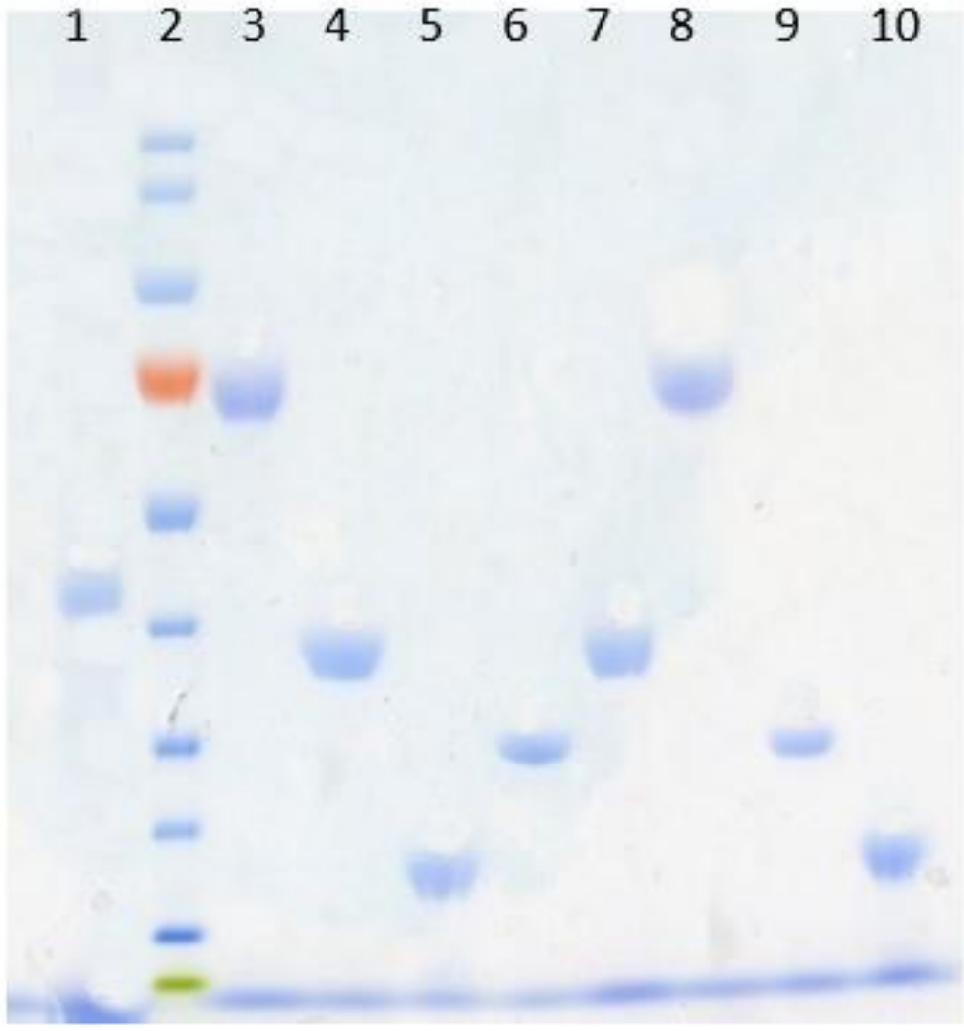

170
130

95

72

55

43

34

26

17
10

Figure 2. Gel from SDS polyacrylamide gel electrophoresis (SDS-PAGE). Using precast slab gels (10% acrylamide) assembled on the clamped gel sandwiches. The outer chamber is filled with running buffer of 7.7 pH (50mM Tris base, 50mM MOPS, 1mM EDTA and 0.1% SDS) and the inner chamber is filled with the running buffer until it reaches the top of gel. 5 µL of the marker (EZ-RunTM Rec) is placed in all of the wells, and 10 µL of unknown amino acid sample is added into lane #6. The chambers of electrophoresis apparatus were closed and then administered 200 V until the bromophenol travels down to the edge of the gel. The migration distance for the aliquot in well 6 is 6.1 cm.

Molecular Weight (kDa) | Molecular Weight (Log) | Migration Distance from Well (cm)
170 | 2.23 | 0.1
130 | 2.11 | 0.7
95 | 1.98 | 1.6
72 | 1.86 | 2.7
55 | 1.74 | 3.9
43 | 1.63 | 4.8
34 | 1.53 | 6.1
26 | 1.41 | 7
17 | 1.23 | 8.2
10 | 1 | 8.6

Figure 3. Log MW plotted against Migration Distance (cm) in SDS-PAGE. 5 µm of unknown mixture 8 was placed into well 6 of gel 2. The migration distance observed in Figure 3 demonstrates the distance the molecules travelled, smaller molecules are capable of travelling longer distances and larger molecules move short distances. The linear regression line, linear equation, and the R² value are all depicted in the graph. The 170 Kda and 10 Kda data points were removed from the graph in order to improve the regression line value. The value within the linear equation will be be necessary to calculate molecular weight of the unknown mixture in lane #6.

Calculations
y = mx + b
x = 6.1

y = -0.1115 (6.1) + 2.1739
y = 1.483715

Log MW = 10^{y}
Log MW = 10^{1.483715}
Log MW = 30.46 kDa

The unknown sample on Well 6 is predicted to have a MW of 30.6 kDa

