Question 1. Highway (3 marks)
This question involves the application of Little’s Law. While driving in a highway, you note that your average speed of travel is about 60 miles per hour. Moreover, the traffic report states that there is an average of 24 cars going in your direction on a one-quarter mile part of the highway. What is the flow rate of the highway (going in your direction) in cars per hour?

$$Little^{'}s Law:I=RT$$
$$R=\frac{I}{T}$$
$$R=\frac{24 cars}{(60 miles per hour×\frac{1}{4}mile) }$$
$$R=1.6 cars per hour$$

The flow rate of the highway (going in my direction) is 1.6 cars per hour.

2. LaVilla (5 marks)
LaVilla is a village in the Alps. Given its enormous popularity among Swiss, German, Austrian, and Italian skiers, all of its beds are always booked in the winter season and there are, on average, 1,200 skiers in the village. On average, skiers stay in LaVilla for 10 days.
a) How many new skiers are arriving—on average—in LaVilla every day?
b) A study done by the largest hotel in the village has shown that skiers spend on average $50 per person on the first day and $30 per person on each additional day in local restaurants. The study also forecasts that—due to increased hotel prices—the average length of stay for the 2020/2021 season will be reduced to five days. What will be the percentage change in revenues of local restaurants compared to last year (when skiers still stayed for 10 days)? Assume that hotels continue to be fully booked!

- $$Little^{'}s Law:I=RT$$
$$R=\frac{I}{T}$$
$$R=\frac{1200 skiers}{10 days}$$
$$R=120 skiers per day$$
There are 120 new skiers arriving on average in LaVille every day.

- $When skiers stayed for 10 days: \$50+\$30\left(9\right)=320$
$$When skiers stayed for 5 days:\$50+\$30\left(4\right)=170$$

$$Percentage change in revenues: \frac{(170-320)}{320}×100=-46.88$$
The percentage change in reviews of local restaurants compared to last year decreases by 46.88%.

Question 3. Kroger Company (3 marks)
The Kroger Company is an American retail company. The following provides 2012 financial information for Kroger (in Million $s):
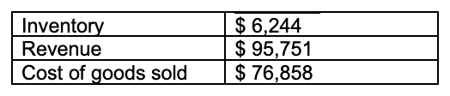
In 2012, what were Kroger’s inventory turns?

$$Inventory turns= \frac{Revenue}{Average inventory}= \frac{95,751}{6,244}=15.33 inventory turns per year$$
Kroger’s inventory turns for the year 2012 is 15.33 turns per year.

Question 4. BCH (3 marks)
BCH is, a large consulting firm in the United Kingdom, has a consulting staff consisting of 400 consultants at the rank of “associate”. On average, a consultant remains at the associate level for 2 years. After this time 30% of the associates are promoted to the rank of “engagement manager”, and other 70% have to leave the company. In order to maintain the consulting staff at an average level of 400 associates, how many new consultants does BCH have to hire each at associate level?

$$I=RT$$
$$R=\frac{I}{T}$$
$$R=\frac{400 consultants}{2 years per consultant}$$
$$R=200 consultants per year$$
BCH has to hire 200 consultants per year to retain an average level of 400 associates.

Question 5. Utilization and efficiency (4 marks)
a) A college program has the facilities and faculty to handle an enrolment of 2000 new students per semester. However, to limit class sizes to a “reasonable” level (under 200, generally), the college’s registrar placed a ceiling on enrolment of 1500 new students. Although there was ample demand for business courses last semester, conflicting schedules allowed only 1450 new student to take business courses. What is the utilization of this system?
b) A hospital emergency room has been designed for 110 emergency patients per day. However, in an effort to space optimization, the hospital’s manager placed a ceiling on admission of 90 patients per day. In a rainy day, only 65 emergency patients received care and treatment. What is the efficiency of this the hospital in this rainy day?

$$Utilization=\frac{Actual output}{Design Capacity}=\frac{1450}{2000}=72.5\%$$
The utilization of this system is 72.5%.

$$Efficiency= \frac{Actual Output}{Effective Capacity}= \frac{65}{90}=72.22\%$$
The efficiency of this hospital on this rainy day is 72.22%.

Question 6. Bagel Store (10 marks)
Consider a bagel store selling three types of bagels that are produced according to the process flow diagram outlined below. We assume the demand is 180 bagels a day, of which there are 30 grilled veggie, 110 veggies only, and 40 cream cheese. Assume that the workday is 10 hours long and each resource is staffed with one worker.
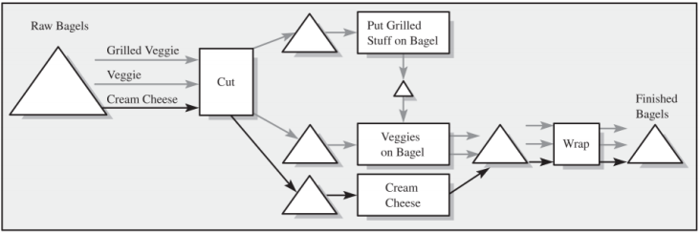
Moreover, we assume the following Processing times:
Processing times are independent of which bagel type is processed at a resource (for example, cutting a bagel takes the same time for a cream cheese bagel as for a veggie bagel).
a) Where in the process is the bottleneck?
b) How many units can the process produce within one hour, assuming the product mix has to remain constant?

- The bottleneck is putting the grilled stuff on the bagel because it’s the operation with the with the longest (slowest) process time. With that being said, the grilled stuff takes 10 minutes, while the rest are faster and do not take as much time. Even if the other processing times operate with greater speed, the time for putting grilled stuff on bagels will still remain; there will be an overload of bagels in the inventory waiting to have grilled stuff put on them.
- $Capacity= \frac{60 minutes/hour}{10 minutes/bagel}=6 bagels per hour$
The process can product 6 bagels per hour.



