2a

Number of Requests(demand) | Count | MPF | CPF
65 | 2 | 0.038461538 | 0.03846154
66 | 4 | 0.076923077 | 0.11538462
67 | 5 | 0.096153846 | 0.21153846
68 | 6 | 0.115384615 | 0.32692308
69 | 2 | 0.038461538 | 0.36538462
70 | 10 | 0.192307692 | 0.55769231
71 | 9 | 0.173076923 | 0.73076923
72 | 5 | 0.096153846 | 0.82692308
73 | 5 | 0.096153846 | 0.92307692
74 | 3 | 0.057692308 | 0.98076923
75 | 1 | 0.019230769 | 1
Sum | 52 | 1

- First, we copy and paste the whole column of Number of Requests and delete the duplicate numbers.
- Than we use COUNT to count how many times each request appears.
- Finally, we use the appearing times of each request divided by the total amount of count, we get the mass probability function and the cumulative probability function

2b
- Use MS Excel RAND() function to get a series of 50 numbers uniformly distributed in the interval [0,1] and then use IF() function to decide the number belongs to which demand
- Chose six amounts of demand from (a) randomly and name them r. (r = 68, 69, 70, 71, 72, 73).
- Calculating demand of discount price room by “= 140 - r”
- Calculating demand of full price room by “MIN(r, demand(column H))”
- Calculating profit by “= demand of discount price room*discount price + demand of full price room*full price”
- Calculating E(Profit) by “=AVERAGE(K4:K53)” for example
Probability a = 1 – 0.95 = 0.05, degree freedom = 50 -1 =49
- For example, Calculating the error bar value by “= TINV (0.05,49)*STDEV(K4:K53)/SQRT(COUNT(K4:K53)) ”
- Creating a scatter chart by using r as X values and E(profit) as Y values. Select r and E(profit) as data range. Add error bar to the chart and customize the error bar value by ± value
Result: the protection level (number of rooms sold at full price) should be 68 because we see the highest E(profit) when r = 68.

2c
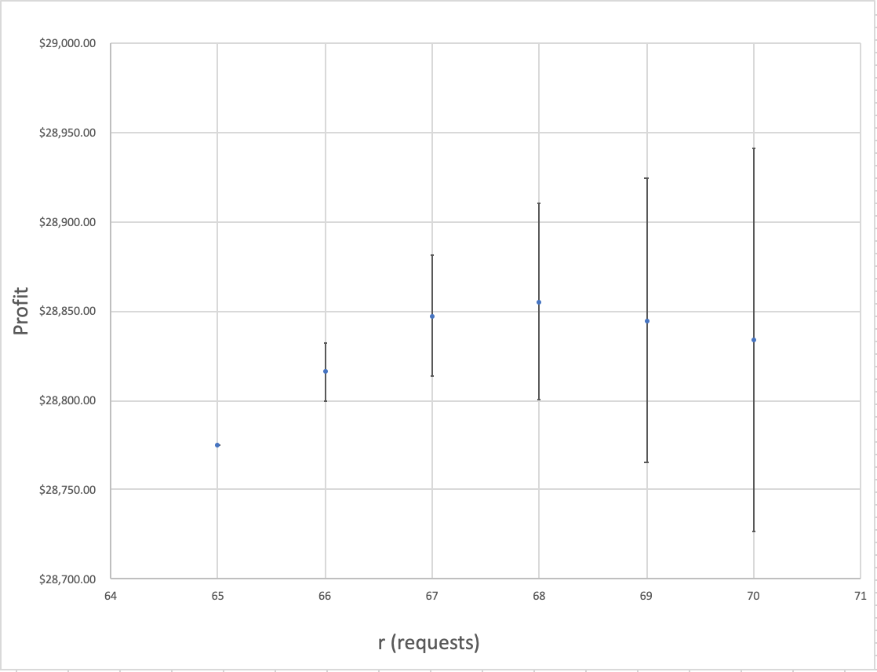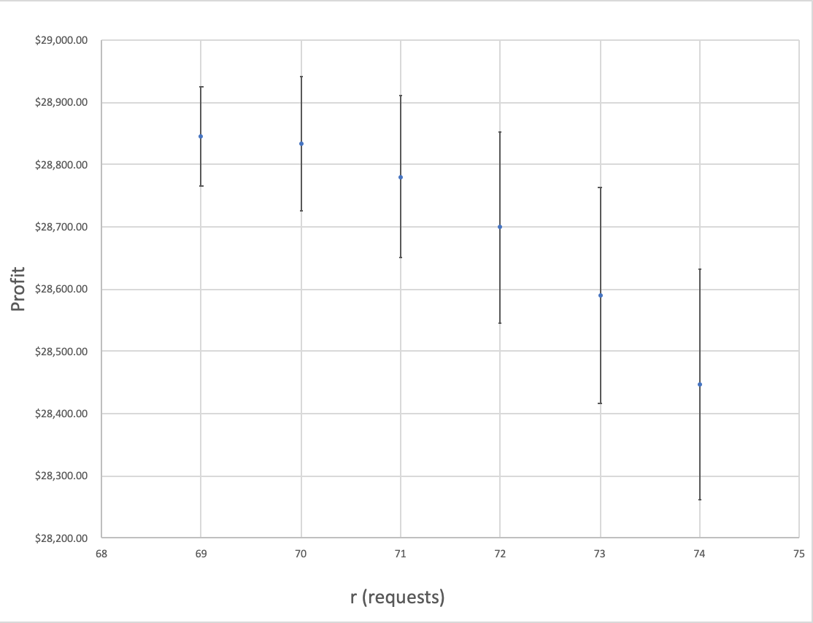

According to this chart, we can tell that when r = 68, the hotel may have the highest average profit. And for r belongs to (0, 68), with the increase of r(requests), the average profit is increasing, for (69,140), the opposite. So, booking limit for discount room is 72.
2d
For original business customer demand belongs to (0,68], when there is fewer customers, the hotel will get a lower profit than before. For original business customer demand belongs to [69,140], when there is fewer customers, the hotel will get a higher profit than before.
2e
For original business customer demand belongs to (0,68], when there are more customers, the hotel will get a higher profit than before. For original business customer demand belongs to [69,140], when there are more customers, the hotel will get a lower profit than before.

