DVM 2106 – FINAL EXAM
Module 1: Poverty (first set)
- G &G
  - Investment in innovation, science and technology
  - Investment in education
  - Investment in health
  - Investment in agricultural productivity

- Income approach vs multitactical approach or IDH
- Narrow vs Broad conceptualizations, Absolute and relative poverty, objective and subjective measures, human agency and social structure.
- Extreme poverty has decreased in China and India and increasingly in many countries in Africa but it gets more and more concentrated in the most challenging places. It is predicted that by 2050 the 40% of the extremely poor are projected to live in two countries: The Democratic Republic of Congo and Nigeria.
- A
- Functioning, capabilities and freedom and development. Development involves the expansion of human capabilities and enrichment of human lives
- The RBM (result-based measurement) influenced the idea of eradication of global property in three ways. It determined the structure of the MDG (SMART: stretching, measurable, achievable, realistic, time-bound). It shaped the specification of goals and it was based on measurables (saying human rights and participation are non mesurable)
(Second set)
- 6 biases
  - Spatial bias: urban, tarmac and roadside
  - Project bias
  - Personal bias: elite, male, user and adopter, active present and living
  - Dry season bias
  - Biases of politeness, and timidity
  - Professional Bias
- Person bias
  - Elite
  - Male
  - User and adopter
  - Active, present and living
- Yes, I have faced this bias before
- It is important to do a great research and stop seeing just it has already been studied but further and realist
- Effective strategies to reduce bias behavior
  - Rewards: prestige and promotion
  - Reversals: Learning from and working with
  - In-service research as training
    - Surveys
    - Poverty -focused research
    - Groups, workshops and seminars
  - Games and Role play
  - Rapid Rural appraisal (RRA)
  - Tactics for tourists
    - Spending longer
    - Offsetting the anti-poverty bias
    - Listening and learning
    - Being unimportant
- Monetary approaches:
  - The Welfare measure looks at how much money does an individual have at his/her disposal and its measured at a household level also how much someone spends or consumes.
  - The Poverty line divides de population into the poor and non-poor based on their welfare level. Absolute poverty line is based on the minimum consumption basket
  - The poverty measures (FGF):
    - The headcount index: indicates what proportion of the population lives in poverty. Divides the number of people under the poverty line and the total population.
    - The poverty gap index: provides and insight of how deep poverty is. Uses the monetary resources and its distance to the poverty line of every poor household
    - The poverty severity index gives an indication on how severe poverty is. It takes among the poor into account by giving them a greater weight to those who are further again from the poverty line.
- The headcount index is the poverty measure more intuitive and widely used
- The poverty gap provides and insight on how deep poverty is.
- The severity poverty index can measure how severe poverty is.
- IDH works with three dimensions: life expectancy (have a long and healthy life), basic education (being knowledgeable) and having a decent standard of living. (4 indicators: one for health, two for education and one for living standards)
- It is important for policy-making because it gives information about the living standards, education, health, life expectancy at birth an many other useful information to better the life of the society.
- The GNH index is a philosophy created and actively used by the government of Bhutan. It measures the collective happiness and well-being of the population. Its four pillars are:
  - Sustainable and equitable development
  - Environmental conservation
  - Preservation and promotion of culture
  - Good governance
Module 2
- Food security dimensions: Food availability, economic and physical access to food, food utilization and stability over time.
- Wasting is a short-term inadequate food intake, an illness or infection. Whereas, stunting is a prolonged inadequate food intake, repeated illness and infection episodes and undernutrition.

Module 6
- 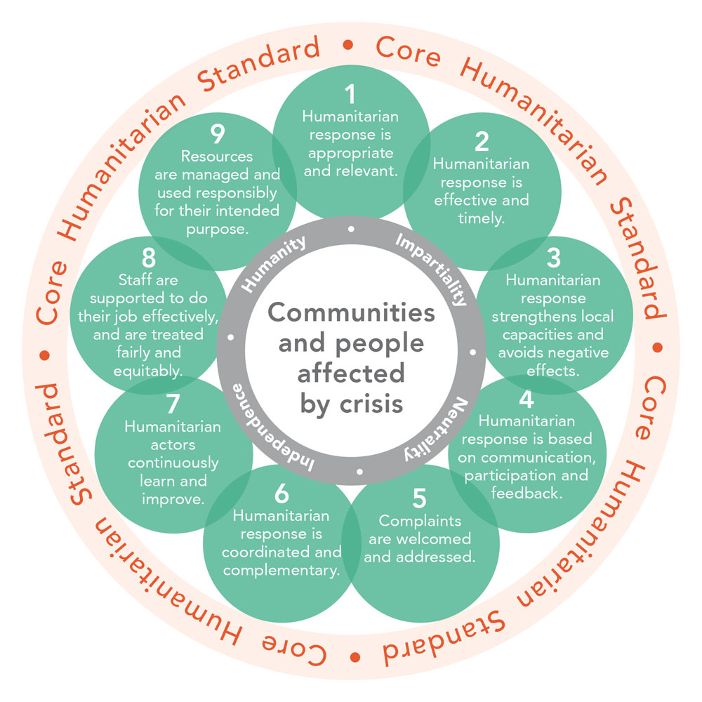
- Humanitarian aid is designed to save lives and alleviate suffering during and in the immediate aftermath of emergencies, whereas development aid responds to ongoing structural issues, particularly systemic poverty, that may hinder economic, institutional and social developmentin any given society.

- A
- A
- A
- A
- a

