Why Psychology and Science?
- Psychology seeks to understand and predict human behaviour.
- It is a system of thought that leads us to a rational explanation of how things work in the world and a process of getting closer to truths and further from myths, fables, and unquestioned or intuitive ideas about people.
- Although human behaviour may sometimes seem intuitive, relying on intuition alone can lead to erroneous conclusions.
Why Can’t We Trust Intuition?
- Intuition depends too much on myth, stereotype, prejudice, and received but unchecked wisdom.
- When faced with a new problem, we tend to stick with what we know, rather than exploring alternate explanations.
- This can lead us to accept an “obvious” answer that may, in fact, be incorrect.
- To fully understand human behaviour, a scientific approach is needed.

Science: Not a Subject but a Way of Thinking
- Science is a systematic way of thinking that leads to rational and testable explanations of what we observe in the world around us.
- These explanations are referred to as theories and we use scientific research to test our theories.
- This is a process you already engage in, albeit in a less formal way.

Never Use the Term Prove
- It is important to note that scientific research does not prove theories true.
- Rather, research generates evidence that might support or contradict a theory.
- Scientists avoid the term “prove” because there may be another possible explanation for the findings observed.
So What Is This Scientific Method?
- The scientific method is a systematic approach to investigating research questions.
- It is based on the empirical method (observation) and the hypothetico-deductive method (logical reasoning).

The Empirical Method
- The empirical method involves two processes:
  - Observation: gathering of data directly with no preconceptions as to how they are ordered or what explains them.
- Observation
  - Scientists must be objective; they must only record observable behaviours and avoid making assumptions.
  - Objective observation requires training because we have a tendency to use our existing knowledge to explain and predict human behaviour.

  - Induction of patterns within the data; that is, to see what relationships appear to exist within our data.

- Induction
  - If we compare enough data about observed events, we will eventually perceive some patterns or laws about human behaviour.
  - Moving from particular instances to a generalized pattern is induction; and the resulting statement about the observed patterns is called a theory.
Eg: Most women don't like spiders. Pam is a woman. Pam does not like spiders.

Theory, Hypothesis, Research Question, and Prediction
- A theory needs evidence to support it. That evidence comes from the development of one or more hypotheses that can be tested.
- A hypothesis is a precise statement about the assumed relationship between variables; it aims to answer a specific research question.
- The hypothesis outlines precise research predictions about how variables should be related in data analysis.
- These research predictions are expressed in terms of observable measures.
- When we specify how a variable is to be measured, we are “operationalizing” that variable.

The Hypothetico-Deductive Method
- Refers to a method in which theories are evaluated by generating and testing hypotheses.
- This process of moving from theory to observations is called deduction.

Replication
- Results from one experiment alone are not sufficient evidence to support a theory, as the result obtained may be due to other unknown factors.
- This is especially likely in psychology where we are investigating human behaviour, which is highly varied and flexible.
- To be more certain that a demonstrated psychological effect is a real one, we need several psychology researchers to be able to replicate (or repeat) the study results.
- Replication provides evidence to support a theory and also helps guard against fraudulent claims, which can occur from time to time in science.
- Replications are not done for all studies; more likely in cases where the results have important implications.
- Replications do not have to be exact repeats of the original study.
- Researchers can vary the sample, the task participants must complete, and also the measurement scale used.

Disconfirming Theories
- Researchers are not only interested in confirming theories; they also try to challenge or disconfirm findings and to demonstrate the limitations of an effect.
- Learning more about situations in which a theory applies and does not apply helps us better understand the phenomenon.

Falsifiability
- Because scientific research is often about eliminating possible explanations, theories must be phrased in terms that make them falsifiable.
- This does not mean that the theory must be falsified, only that we can do tests that would show it to be false if indeed it is the case.
Methods of Knowing and Acquiring Knowledge

- Nonscientific approaches
  - Method of tenacity
  - Method of intuition
  - Method of authority
  - Rational method
  - Method of empiricism
- Scientific method
  - Goal is to obtain better-quality answers

Methods of Tenacity
- What is tenacity?
  - Information accepted as true because it has always been believed or because superstition supports it
  - Limitations: potential inaccuracies; no method for correcting erroneous ideas
Methods of Intuition
- What is intuition?
  - Information accepted on the basis of a hunch
  - Limitation: no method for separating accurate from inaccurate knowledge

Methods of Authority
- Relies on information or answers from an expert in the field
- Good starting point—often quickest and easiest way to obtain answers
- Some limitations:
  - Does not always provide accurate information
  - Often accepts expert’s statements as fact (method of faith)
  - Not all “experts” are experts
  - Generalization…

The Rational Method
- What is an example of seeking answers by logical reasoning?
  - All 3-yr-old children are afraid of the dark
  - Amy is a 3-yr-old girl
  - Therefore, Amy is afraid of the dark
- In the above argument
  - First two sentences are premise statements
  - Final sentence is a logical conclusion based on the premises
Limitations to the Rational Method
- Logical conclusions are only valid if the premise statements are true
  - The rational method “assumes” the premise statements are true
- People are not very good at logical reasoning
  - Sometimes the argument does not logically support the conclusion

The Empirical Method
- Also known as empiricism: answering questions by direct observation or personal experience
  - Based on the philosophy that all knowledge is acquired through the senses
- Limitations
  - Observations can be misinterpreted (Fig.)
  - Sensory experience can be swayed by beliefs
    - Confirmation biais
    - Belief perseverance (Goodwin & Goodwin, 2017)
  - Time-consuming and sometimes dangerous

The Horizontal-Vertical Illusion

Summary of Nonscientific Methods of Acquiring Knowledge

The Case of Dr. Eben Alexander: A True Story

Heaven and death

How Psychologists Actually Do Scientific Research
- The research process begins with deciding on a research question.
- Inspiration may come from many sources, but you ought to choose something that really interests you.
- Once you have an idea in mind, you should conduct a literature search.
  - This is a survey of the current scientific literature in a given area; usually done via online databases.

Using Databases
- There are a number of useful databases you can consult when conducting a literature review.
- Most psychology students and investigators focus on four databases in particular:
  - Psycinfo
  - Psycarticles
  - PubMed
  - Google Scholar
Identifying and Using Keywords Effectively
- To search the databases effectively, you will need to identify appropriate keywords.
- The mechanics of searches vary from database to database, but in general, combining keywords is often the best strategy.
Evaluating the Literature
- Primary source articles are written by the researcher(s) who actually undertook the research published.
- A key strength of these articles is that they provide the methodology, analyses, results, and conclusions of the study.
- Review articles summarize findings from a large number of primary source articles.
- They provide a critique of the research and point out gaps in the current knowledge base.
- Meta-analyses are review articles that use statistical techniques to mathematically analyze the results of many primary source articles simultaneously.
- These analyses are designed to determine the effect size of a given variable on another set of variables.
- Meta-analyses are an invaluable tool for bringing clarity to research areas with many studies of varying quality and with inconsistent results.

Evaluating a Research Article
- Consider the author’s level of expertise and also the journal’s impact factor.
- This refers to the amount of influence the journal holds in the scientific community.
  - The higher the impact factor, the more prestigious the publication.
- When assessing the quality of research article, consider the following questions:
  - Does the literature review contain current information and does it includes key references?
  - Is the research design appropriate?
  - Was the study executed correctly?
  - Were the statistical analyses appropriate?
  - How significant and meaningful are the results?
  - Do the conclusions make sense given the study findings?
The Main Features of a Psychological Investigation
- Variables: What human characteristics or behaviour will we study and under what conditions?
- Samples: Whom will we study?
- Design: How will the hypothesis be tested?
- Analysis: What sort of evidence will be obtained and in what form?

Qualitative Data
- Not all data gathered in psychological research studies are numerical or quantitative.
- Researchers can also gather qualitative data, i.e., verbal or written information that has not been converted to a numerical score.

Funding Scientific Research
- Research funds come primarily from one of the following sources:
  - University or hospital units
  - Government agencies
  - Private companies
  - Charitable institutions or foundations
  - Private benefactors.

At the federal level in Canada, there are four major agencies:
- Social Sciences and Humanities Research Council (SSHRC)
  - Funds university-based research in the humanities and social sciences; including social, environmental, and organizational psychology.
- Natural Sciences and Engineering Research Council of Canada (NSERC)
  - Funds university-based basic research in the natural sciences, engineering, technology, and mathematics; includes neuroscience, neurophysiology, cognitive science, and human–computer interaction.
- Canadian Institutes of Health Research (CIHR)
  - Funding for university- and hospital-based health research (especially translational research); includes neuroscience, clinical psychology, and health psychology.
- Canadian Foundation for Innovation (CFI)
  - Funding for infrastructure, including state-of-the-art equipment, laboratories, databases, specimens, scientific collections, computer hardware and software.
Grant applications for all agencies are subjected to peer-review in which experts assess the merit of your proposal.
Each grant application is scored using a standardized scale, and it must achieve a minimum score to be considered for funding.

Conducting Your Study
- Getting a study off the ground requires a lot of work and it can be a daunting task.
- Research labs are often comprised of a team of individuals (e.g., hired research assistants, undergraduate thesis students, and volunteers) who are working on a given study.
- Major tasks involved include preparation, data collection, data analysis, and report-writing.
- Time to completion depends on the nature of the investigation, but generally lasts from one to four years.
Writing Your Results
- The whole point of conducting research is to advance current knowledge in a given field.
- In order to achieve this, the research conducted needs to be written up with a view to having it published.
- A research manuscript follows a specific protocol and in comprised of the following components:
  - Title
  - Keywords
  - Abstract
  - Introduction
  - Method
  - Statistical analyses
  - Results
  - Discussion
  - Limitations

Finding a Publisher
- Deciding where to publish your work takes many factors into account:
  - The journal’s impact factor of the journal
  - The likelihood of being published
  - The timeframe for publishing
  - Peer review (preferable)
- When you submit your article, the journal’s editorial board will determine the project’s importance and worth.
- Reviewers provide written feedback and may accept that article as is, reject it altogether, or suggest some revisions be made before the article can be published.

Ch3: Ethical Issues in Psychological Research
Research Ethics
- All research in Canada must meet certain basic requirements before it can use participants and resources from society.
- These requirements are expressed at various levels of regulation, moving from the rigid and strict to the more flexible.
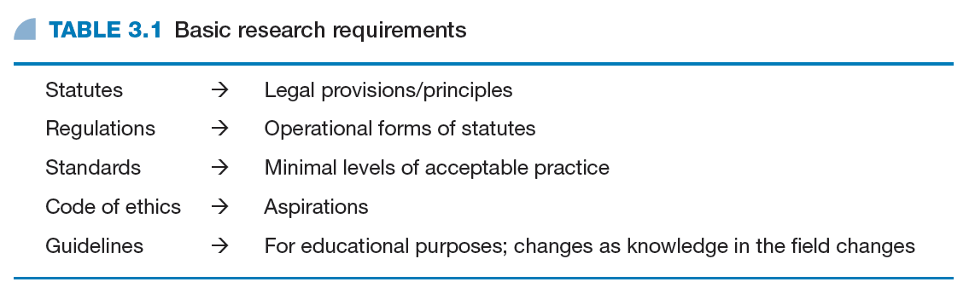
Canadian Code of Ethics for Psychologists
- Psychology researchers in Canada adhere to the code of ethics established by the Canadian Psychological Association (CPA).
- The code revolves around four key principles that outline the standards and expectations for conduct.
The four key principles of the code are:
  - Respect for the Dignity of Persons
  - Responsible Caring
  - Integrity in Relationships
  - Responsibility to Society

Principle I: Respect for the Dignity of Persons
- Emphasizes the basic human rights of participants and addresses issues such as:
  - Consent and coercion
  - Privacy and confidentiality
  - Fairness and inclusivity

Principle II: Responsible Caring
- Emphasizes the duty to minimize harm and includes standards related to:
  - Competency
  - Right to withdrawal
  - Debriefing of participants
  - Terminating research
  - Humane animal research

Principle III: Integrity in Relationships
- Emphasizes the need for researchers to show integrity in their work, and includes issues such as:
  - Accuracy and honesty
  - Transparency and openness
  - Objectivity and minimization of bias
  - Avoiding conflicts of interest

Principle IV: Responsibility to Society
- Applies to the professional conduct of a psychologist, and addresses:
  - Knowledge transfer
  - Reporting ethics violations
  - Researching relevant problems
  - Responsible reporting of results

Tri-Council Policy Statement: Ethical Conduct for Research Involving Humans
- Canada’s three federal research agencies (CIHR, NSERC, and SSHRC) have established a joint research ethics policy.
- The document outlining the policy is called the Tri-Council Policy Statement (TCPS).
- The TCPS outlines three core principles:
  - Respect for persons
    - Researchers must respect the autonomy of participants and ensure consent is free, informed, and ongoing.
  - Concern for welfare
    - Researchers must protect the welfare of participants, balancing the relative risks and potential benefits of doing a study.
  - Justice
    - Researchers must treat people fairly and equitably, ensuring that no group is unduly burdened by the harms of research or denied the benefits of the knowledge generated from it.
The Role of the Research Ethics Board
- Universities, hospitals, and other settings where research occurs have committees that review research proposals to ensure they adhere to ethical principles outlined by the TCPS.
American Psychological Association Ethical Guidelines
- The American Psychological Association (APA) also has guidelines on the ethical issues involved in psychological research concerning:
  - Beneficence and non-maleficence
  - Fidelity and responsibility
  - Integrity and justice
  - Respect for people’s rights and dignity

Publication and Access to Data
- Researchers are expected to make their methods and data accessible, thus allowing the research community to verify, evaluate, and replicate their results.
- Researchers must also ensure that the journals in which they wish to publish do not have a hidden agenda in terms of study selection.

Research with Human Participants
- Researchers must
  - avoid deceiving participants,
  - debrief participants,
  - prevent stress and discomfort for participants,
  - give participants the right to withdraw or not participate,
  - not take advantage of the special power of the investigator,
  - ensure confidentiality, anonymity, and privacy of participants,
  - not interfere in the lives of involuntary participants,
  - carefully consider the ethical implications of intervention.
Deceptionخداع: telling them you are 30 when you are 40
- Deception or lying to participants (either through commission or omission) is common in psychology experiments.
- Whenever deception is used, researchers have an obligation to debrief participants immediately at the end of the study.
Debriefing
- Debriefing involves revealing to participants the true nature of the study and why it was necessary to deceive them.
- The aim is to reverse any negative effects of the study and to ensure participants feel the same about themselves when they leave as when they arrived.
- Investigators are obligated not only to debrief but also to attempt to remove any long-term negative effects of psychological research procedures.
Stress and Discomfort
- The CPA’s ethics code urges investigators to inform participants of procedures for contacting them should stress or other harm occur after the research study.
- In any research where discomfort might be expected, the investigator must seek opinions and advice from professional colleagues before proceeding.
- The balance between the risks to the participants and the benefits of the research is something that will be assessed by the REBs.

The Right to Withdraw or Not Participate
- In all research that involves human participation, the investigator is obliged to:
  - provide participants with full information regarding possible discomfort;
  - emphasize the voluntary nature of the exercise and the right to withdraw at any time;
  - remind the participant of this right to withdraw at any point that discomfort appears to be higher than anticipated;
  - terminate the procedure when discomfort is excessive.
The Need for Consent
- Researchers must obtain informed consent from participants as evidence that they agree to participate in the study, fully understanding the research context and their rights.
- In research with children, informed consent of parents or guardians must first be acquired.

The Special Power of the Investigator
- Researchers must not abuse the position of power that comes from being the investigator.
Confidentiality, Anonymity, and Privacy
- Researchers must also be careful to respect their participants’ anonymity and not reveal their identities in published work.
- If the possibility of identifying a participant exists, as in a video recording, the researcher must first seek permission from that person.
- Researchers can break the anonymity rule when the research reveals a situation where there are clear dangers to human life.
- Confidentiality, which has more to do with the treatment of individual data, is maintained by reporting group data only.
Involuntary Participation
- Sometimes individuals are part of a research study without agreement or knowledge of the study.
- This type of involuntary participation is common in participant observation studies and in naturalistic (covert) observation.
- Consent is not required in situations where there is no expectation of privacy.
Interventionتدخل قضائي
- Sometimes researchers carry out intervention studies that make some alteration to people’s lives beyond the specific research setting.
- In such cases, debriefing is not sufficient and researchers must follow-up with participants to ensure the manipulation poses no long-term harm.

Research with Animals
- The use of animals in research is one that creates a lot of controversy and there are valid arguments on both sides of the debate.
- Those in favour of point to the fact that with animals we can exert greater experimental control and use methodologies that would be impossible or unethical to carry out with humans.
- Those who are against using animals in research claim that extrapolating from the animal model to the human model is flawed and can lead to inaccurate conclusions.
- They also highlight how some of the research methodologies used are inhumane and unnecessary.

CH4: Measuring People: Variables, Samples, and the Qualitative Critique
Variables
- A variable is an observable event that can change and whose changes can be measured.
- The essence of scientific research is to relate changes in one variable to changes in other variables.
- Variables can be categorical, in which cases are merely placed into independent, separate categories (e.g., single or married).
- Variables can also be measured, in which cases are placed on some sort of directional scale (e.g., extent of agreement).

Psychological Constructs
- In psychology, we are often interested in abstract or hypothetical constructs (e.g., anxiety or self-esteem) that are not directly measurable.
- Because we can only measure the observable, we must find a way to operationally define the construct in measurable terms.
- Sometimes researchers use psychometric tests to capture particular constructs (e.g., intelligence).

Psychological Questionnaires, Tests, and Measurement Scales
- Researchers can use a number of methods, including tests and questionnaires to obtain information about a particular construct.
- Whatever the method chosen, it is important that it be valid (measures what it claims to measure) and reliable (will yield similar results with repeated testing under similar conditions).

Open and Closed Questions
- Measurement instruments can be comprised of open questions (provide your own response) or closed questions (choose from a set of responses).
- Closed questions have the advantage of producing quantifiable measures, but they also force respondents to choose an answer that may not necessarily represent how they really feel.

Disguise تمويه

- Sometimes knowing the true nature of a study can have a undesired effect (e.g., social desirability) on participant responses.
- To avoid this and to encourage honest answers, particularly when issues are highly sensitive or potentially embarrassing, researchers will disguise the true nature of the instrument.
Attitude Scales
- Attitudes are relatively enduring beliefs we hold towards certain things or issues in the world that impact on our emotions and influence our behaviour.
- Psychologists are often interested in measuring attitudes but these may be difficult to assess directly—various attitude scales can be used to get around this problem.
The Thurstone Scale
- The Thurstone scale has raters assess the relative strength of various items; respondents then indicate their agreement with each item and receive the average scale value for it.

The Likert Scale
- With the Likert scale, respondents select from an ordered range or response options, such as strongly disagree (1) through to strongly agree (5).
The Semantic Differential
- The semantic differential scale has respondents selecting a point between bipolar adjectives (e.g., honest/dishonest) according to the position they feel the target holds for them.
The Visual Analogue Scale
- The visual analogue scale is similar to the semantic differential scale except that respondents mark their position between two polar opposites on a continuous line.

Central Issues in the Use of Psychological Scales
- When responding to questions, people sometimes show a tendency to agree with the statements presented; this is called response acquiescence set.
- One way to get around this issue is to present an unpredictable mixture of positive and negative statements about the attitude object.

Scale Items: What to Avoid in Statement Construction
- When constructing a scale, you want to avoid ambiguity and instead for clarity, such that the respondent is clear about which answer to give.
- Avoid long and complex sentences, technical jargon, double-negatives, and leading questions.
- Double-barrelled items (two questions at once) are also problematic.
Projective Tests
- With a projective test, participants respond to various stimuli (e.g., Rorschach ink blot), thereby revealing information about their personality.
- Another example is the Thematic Apperception Test (TAT) in which participants are shown a set of pictures and asked to describe what is happening.

Intelligence and Personality Tests
- Intelligence and personality tests are commonly used in in job selection, clinical diagnosis, and educational assessment.
- For this reason, these types of tests have undergone a high degree of standardization and scrutiny for validity and reliability.
- Even so, some instruments, such as the intelligence test, need periodic revision.
Factor Analysis
- Sometimes an instrument can be measuring several inter-related aspects or factors of a construct at the same time.
- To find out how many factors are being tapped into, researchers can carry out a type of statistical test called a factor analysis.
- Simply put, the factor analysis assesses the correlations between the various factors.

Samples
- The participants in your study make up your sample; it is important that they be representative of the group you wish to generalize your results to.
- Your participants will be drawn from a target population (or sampling frame) and selected in a manner that minimizes sampling bias.

Equal Probability Selection and Random Sampling
- One way to avoid biased sampling is to use an equal probability selection method (EPSEM) which allows for every person in the target population to have an equal chance of being selected.
- Once all members of the population are known, a random sampling procedure can be used to select participants.
Probability-Based Sampling Methods
- Simple random sampling
- Systemic random sampling
- Stratified sampling
- Cluster sampling

The Simple Random Sample
- With this method, all names are entered and each person has a chance of being selected—like pulling a name out of a hat.
- Participant selection can also be guided using a random numbers table or a computer program that generates random numbers.

The Systemic Random Sample
- For this procedure, we select every nth case from the population, where n is any number (e.g., every fifth person).
To select every 5th case, we choose at random a number between 1 and 5 (e.g., 3) and then select the 8th case, the 13th, the 28th, . .

Stratified Sampling
- With this method, the sample is selected so that subgroups will appear in numbers proportional to their size in the population.
- Once the cases for each subgroup are identified, they are randomly selected within that subgroup (or stratum) to make up the sample.
Cluster Samples
- This method provides an alternative to stratified sampling that is often more convenient and time-efficient.
- Rather than randomly selecting cases within a stratum, researchers randomly select a stratum and keep all cases within that subgroup.

Non-Probability-Based Sampling Methods (Non-EPSEM)
- Quota sampling
- Self-selecting sampling
- Opportunity and haphazard sampling
Quota Sampling
- Similar to stratified sampling, people are chosen from categories in proportion to their occurrence in the general population.
- The difference is that cases are not selected randomly but rather to meet a specific quota within a stratum (e.g., 25 males, 25 females).

The Self-Selecting Sample
- This refers to people who just happen to be present when the researcher is collecting data, as in observational research.
Opportunity and Haphazard Samples/ convenience sampling
- These types of samples consist of members who were selected because they were easily available for testing.
- This method is also referred to convenience sampling because the researcher is just picking whoever is willing to participate.

Purposive Samples
- These are non-random methods where individuals are selected on the basis of specific characteristics they have that are relevant to the study. They include:
  - Snowball sampling
  - Critical cases
  - Focus groups

Sample Size
- In general, larger samples are better because they reduce they likelihood of sampling bias (when random sampling is used).
- Also, larger samples increase the power of statistical tests, that is, the likelihood of finding an effect if there really is one.
- Large samples are not without their problems, however. Some of the drawbacks to having too large a sample include:
  - Obscuring a weak design
  - Obscuring participant variables
  - Being costly and time-consuming
  - Yielding insignificant differences

The Quantitative/Qualitative Debate

- Quantitative and qualitative research approaches stem from different philosophies about how to best explore human phenomena.
- This divergence in philosophies and ensuing methodologies has been the source of much debate in the literature and the two designs have often been pitted against one another.

- Quantitative research stemsينبع from positivism, which holds that the only phenomenon that is relevant to science is that which can be measured or quantified/ objective/ statistical analysis

- Qualitative research is more phenomenological in its approach and emphasizes the meanings that people ascribe to their life experiences/ subjective(feelings)/ summary

- Each of the methods has its merits and researchers need not choose one approach over the other, but rather select the one that is most appropriate to the research objectives.

- Qualitative approaches can be thought of as being more exploratory in nature, while quantitative methods are more suited to confirmatory pursuits (e.g., theory testing).

Levels of Measurement

- Experimentation generates a large amount of raw data that researchers must find a way to summarize and analyze.
- The manner in which the data are presented depends in part on the type of variable used in the study.
- There are two major classes of variables used in research: categorical and measured.

- With a categorical measure, data are placed in categories that carry no order or magnitude; this is a nominal level measurement.
- With measured variables, we go beyond mere categorization of the data, and use one of three levels of measurement: ordinal, interval, or ratio.

- With ordinal level measurement, data are arranged in terms of order and magnitude.(hot, hottest.. low high)
- Interval level data also have order and magnitude plus equal intervals separating the units of measurement.
- Interval scales do not have a true zero point, and some have argued that because of this they should be called quasi-interval scales.

- The term “quasi” is more accurate because what seem to be equal intervals are not necessarily measuring equal amounts of the construct.
- Ratio level measurements are interval-type scales that do have a true zero point.
- As a result, one can make meaningful comparisons of proportions (e.g., 60 is twice as large as 30).
- 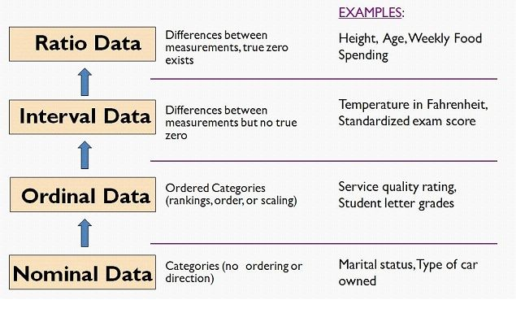

- It is important to note that the level of measurement cannot be changed after the data are collected.
- Also, the level of measurement selected dictates the type of statistical analyses you can perform on your data.
- Thus, you need to be clear about the research question you are trying to answer and select your measurement scale accordingly.

The Role of Experiments in Gathering Evidence

- An experiment is a study in which an independent variable is manipulated.
- It is one of the most powerful ways of gathering evidence to support theories because it can demonstrate cause-and-effect relationships.
- Experimentation also allows researchers to rule out alternative explanations that might account for observed findings.

Alternative Explanations:
- With non-experimental designs, which involves observation rather than manipulation, there is always the possibility that an alternative explanation exists for the findings observed.
- Because there is no manipulation of variables, we cannot confidently point to a clear cause-and-effect relationship between events.

Features of the True Experiment
- In a true experiment, the researcher:
  - manipulates an independent variable,
  - holds all other variables constant, and
  - measures changes in the dependent variable.
- This allows the researcher to have complete control over the independent variable and all other relevant variables.

- Experimental control is essential to demonstrating cause-and-effect relationships, and also to eliminating the influence of confounding variables, which can obscure these relationships.
- Confounding variables are factors other than the independent variable that may cause a result

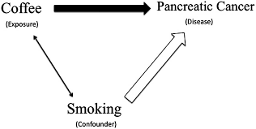

Levels of the Independent Variable

- An independent variable (IV) represents what you will manipulate (e.g., caffeine) in your experiment.
- Sometimes in an experiment, you want to examine the effects of variations of that IV (e.g., amount of caffeine) on your participants.
- In such cases, you would expose your participants to different levels (e.g., doses of caffeine) of the IV.

Control Groups

- To determine whether a treatment has had an effect on our participants, we need to compare their results with the results of those not receiving the treatment.
- This latter group of participants is called a control group and they to act as a baseline measure of behaviour without treatment.

Placebo Groups
- A placebo group is a special type of control group that is included in a study for the purposes of comparison.
- Whereas the control group receives nothing, the placebo group receives an inert version of the active level of the IV.

Eliminating Causal Directions

- Simply knowing that two variables are related, while interesting, does not help us fully understand the nature of the relationship between those variables.
- One strength of the experiment over observational methods is that it helps define the direction of cause and effect relationships observed among variables.

Brief Critique of the Experiment

- Because of the need to control many variables at once, the experimental setting can be highly artificial and not entirely reflective of the real world phenomenon.
- There is also the potential for reactivity effects in which participants alter their behaviour because they are in a psychological experiment.
- Experiments are not appropriate or ethical in all situations (e.g., sensory deprivation in children).

Simple Experimental Designs

1)Independent Samples Design(between)
- In this design, each condition (or level) of the independent variable is experienced by only one group of participants.
- Other terms for this type are: independent groups, unrelated groups design, between groups, and between subjects.

2)Participant Variables and Non-Equivalent Groups
- In experimental design, it is important to control for participant variables and non-equivalent groups, which can be confounds.
This can be achieved through random allocation to groups or representative
allocation based on pre-testing

3)Repeated Measures Design(within)
- With this design (also called within subjects/groups), each participant experiences all levels of the independent variable.

Order Effects
- A possible confound a repeated measures type of design is order effects (e.g., practice or fatigue), which may be caused by experiencing one condition and then another.

Dealing with Order Effects
- One strategy for minimizing order effects is to counterbalance the order in which participants experience the various levels of the IV.
  - For example, where there are two conditions, A and B, you can have one group do the AB order while the other group does the BA order.
- In situations whereر asymmetrical order effects are likely, one can use complex counterbalancing.
  - For the two conditions A and B, all participants experience them in the order ABBA, with the scores for A and B averaged across conditions.
- Where there are a number of conditions to contend with, researchers can randomize the condition order or the presentation of the stimulus items.
- Another alternative is to let sufficient time elapse between conditions for any learning or fatigue effects to dissipateشتت.

Comparison of Repeated Measures and Independent Samples Designs
- Both the independent and repeated measures designs have strengths and weaknesses.
- The repeated measures design has the problem of possible order effects, whereas the independent samples design does not.
- On the other hand, individual differences is not an issue with repeated measures designs but is a problem with independent samples designs.

- Because the same participants are tested across conditions, fewer participants are needed with repeated measures designs.
- More participants are required with independent samples designs because separate groups of participants are needed for each condition of the independent variable.

- Although there may be advantages to using repeated measures designs, they are to be avoided when:
  - order effects cannot be eliminated;
  - the same participants cannot be used in more than one condition;
  - you are studying group differences;
  - an equivalent control group is essential.

Matched Pairs Design
- One design that combines the advantages of both independent and repeated measures designs is the matched pairs design.
- With this design, participants in one condition are paired on a specific variable (e.g., gender) with participants in another condition; changes in behaviour can be monitored across time.

Single Participant Designs

- Some studies are carried out on only one participant who is tested in several trials at all levels of the independent variable.
- These single participant designs can extremely useful in the investigation of the effects of specific events or circumstances, such as a medical condition.

Small n Designs
- With the small n design, there is only a small number of participants.
- This type of design is commonly found in clinical or counselling psychology where differences in treatment are investigated on small numbers of clients.

Related and Unrelated Designs
- In a related design, a score in one condition (e.g., hot) is directly paired with a score in the other condition (cold).
- This technique applies to repeated measures designs and not independent designs, which are considered unrelated designs.

More Complex Experimental Designs
- Sometimes we wish to examine more than one independent variable in a given study because it is more lifelike.
- Designs such as these are called multi-factorial designs, where each independent variable is referred to as a factor.

CH6:How to Evaluate Research Critically

Reliability, Validity, and Standardization
- Three important concepts in psychology research are reliability, validity, and standardization.
- A measure needs to be consistent (reliable) and it has to be capable of measuring what it is intended to measure (validity).
- A measure must also be applicable to populations beyond those participating in a study (standardization).

Reliability
- Reliability refers to the consistency of a measure either across testing at different times (external) or within itself (internal).
- One method for assessing external reliability is to test the same group of people once and then again some time later on two parallel forms of the same test.
  - The scores obtained from the two administrations of the test are then correlated to yield a measure of test–retest reliability.
  - Correlations between 0.75–0.80 would suggest high external reliability.

- Internal reliability is a method that is used to test whether a scale is consistent within itself.
- One method for assessing internal reliability is to calculate a split-half correlation on two equal parts of a test.
  - Correlations of .75 to 1 indicate high internal consistency, implying that respondents answered related items in similar ways.

- Another way to assess internal reliability is to measure how people vary on individual items in relation to overall variance on the scale.
- The statistic for estimating a test’s internal reliability is called Cronbach’s alpha with good reliability represented by alpha values between 0.75 and 1.

- Scale reliability can be increased by removing items that keep the reliability (alpha) low.
- There are a number of methods available to determine which of the items should be removed.
- One approach is to conduct an item analysis to determine how much alpha would change if that item were deleted.

- Another method is to examine the correlations of participants’ scores on each item with their score overall, and to discard those with the lowest item–total correlations.
- Finally, reliability can be increased by removing those items that discriminate poorly between people scoring high on the test and those scoring low.

Validity
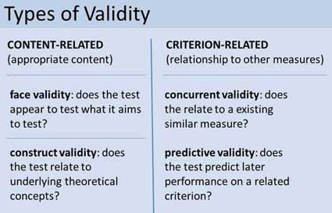

- Showing a test is reliable is good but it is not enough—a test may have high reliability but still not measure what was originally intended.
- The test must also be valid for it to be useful to researchers.
- The simplest measure of validity is face validity, which refers to the extent that the measure on the surface looks like it is a good measure of the phenomenon in question.
- On its own, face validity is not an adequate كافmeasure of test validity.
- A more sophisticated version of face validity is content validity, where experts are asked to evaluate a test’s content to ensure that it represents the area it is intended to cover.
- Another approach is to assess criterion validity, which is the extent to which scale scores successfully relate to other known scores in ways that could be predicted.
- With concurrent validity, test scores are assessed in terms of their conformity with scores from another test assumed to measure the same construct.
- A related concept is predictive validity, which is the extent to which test scores can be used
to make a specific prediction on some other variable.
- Construct validity is a more sophisticated that extends beyond a simple one-off procedure that will yield a numerical value for a scale’s validity.
- Construct validity refers to development of evidence for a psychological construct through hypothesis testing.

Standardization
- In order for test scores to make sense, they need to be standardized; tests are standardized by developing norms for them.
- To establish norms, a test must be administered to a large sample of the population.
- This will allow us to determine the overall average for that group and the extent to which people vary around this score.

- Once norms are established, we have a basis for comparing test scores on a given scale.
- An important point to bear in mind is that a test standardized on a particular population can not be used with confidence on a different population.

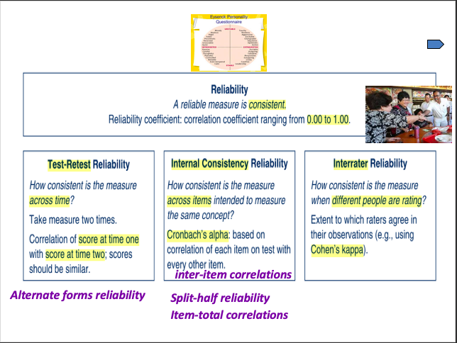

From GRT
The first characteristic of a good operational definition is reliability. Reliability refers to the consistency or stability of a measure of behaviour. Something that is reliable will give you the same, or a very similar result, time after time.
- Example: For example, if your bathroom scale is reliable, it should give you the same reading every time you step on it provided nothing has changed. If you stepped on it 10 times within a 10 minute time frame, the reading of your weight should be the same those ten times. If this is the case, you can say that your scale is reliable. If, on the other hand, the readings changed over those ten times, you would say your scale was unreliable. The greater the difference among the readings, the less reliable your scale.
Similarly, a reliable measure of a psychological variable such as intelligence will yield the same result each time you administer the intelligence test to the same person under the same conditions. If you measure a person’s IQ before university and then again afterwards, you might expect some change. That doesn’t mean the scale is unreliable, the person you are measuring has changed, not the scale.
It is important to keep in mind that any measure that you make can be thought of as comprising two components: (1) a true score , which is the person’s real score on the variable, and (2) measurement error.
Every time we measure something true score and error affect our score. No matter how reliable your measure, there will always be some degree of error in what you are observing. Measurement error is inversely related to reliability. In other words, the greater the degree of reliability, the smaller the degree of measurement error. By increasing the reliability of a measure, you can reduce the amount of error associated with that measure.
Reliability is crucial for any operational definition. Trying to study behaviour using unreliable measures is a waste of time; conclusions will be meaningless, and results will not be able to be repeated.

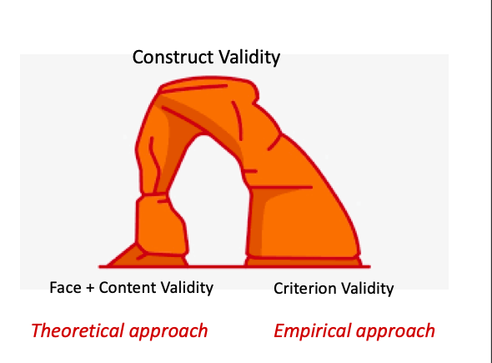

CH7: Observational Methods: Watching and Being
with People

Observation as Technique
- Observation is a procedure for gathering data.
- It may be used as a technique within a traditional experimental design, as in the work of Milgram or Bandura.
- It can also form the basis of an observational design, which does not involve experimentation, but instead records naturally occurring behaviour.

Observation as Overall Designs
- Observational designs have a number of strengths and weaknesses.
  - Strengths:
    - Immediately accessible data
    - Useful when experimentation is not possible
    - Behaviour likely to be more natural
  - Weaknesses:
    - Possibility of reactivity effects
    - Cannot determine cause and effect
    - Can be time-consuming

Participant and Non-Participant Observation

- Two major types of observation are participant and non-participant; the difference being the extent of the involvement of the researcher.
- With participant observation, the researcher becomes a part of the group of individuals being observed.
- With non-participant observation, the researcher remains outside the group of individuals being observed.

Structured (or Systematic) Observation
- Structured observation is non-participant, and it involves a systematic approach to recording behaviour.
- A coding system is developed a priori and it is used by the researchers to guide their observations and the recording of behaviours.
- Observations can be direct or indirect (e.g., audio or tape-recordings).

Coding Behaviour
- The research question will dictate the structure of the observation.
- Researchers use event coding when they are interested in recording the number of occurrences of a specific event.
- If the aim is to record behaviours occurring during a specific period of time, researchers use interval coding.

- Sometimes, it is not necessary to record all observations all the time.
- A researcher may instead want to record behaviours occurring during specified non-continuous time intervals.
- This is referred to as time-sampling, and the researcher alternates between periods of recording and of not recording behaviours.
- One specific type of event coding is sequential analysis.
- Here the focus is to record observations in such a way that they help reveal the sequential patterns in the behaviour of interest.
- This is a useful technique when the research hypothesis concerns the behaviours that tend to follow or precede a specific event.

Reliability of Observational Techniques
- One way to ensure observations are reliable is to have multiple observers code the same behaviours and then calculate the extent of agreement between them.
- The greater the inter-observer agreement, the more reliable the results.

Problems with Structured Observation

- Structured observation has been criticized for being too rigid and lacking in contextual information that can further the understanding of human behaviour.
- The data may be reliable but they are lacking in richness; we know what people did but not why they did it or what it means to them.

- 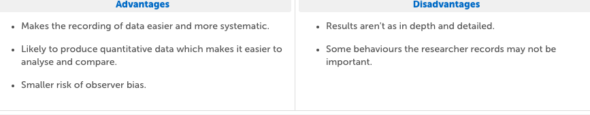

Controlled Observation
- Observations can be controlled through structure or by the environment in which they take place.
- Labs have high amounts of environmental control.
- Naturalistic observations can be coded using standard coding, but the data can be from the field.

Reactivity Effects
- Regardless of the method used, researchers must be mindful of reactivity effects, where the knowledge of being watched can alter people’s behaviour.
- Reactivity effects can be reduced by using secret recording methods or by allowing participants the time to get used to the presence of the researcher.

Qualitative Non-Participant Observation
- Non-participant observation is qualitative in that it generates a lot of raw data in qualitative form.
- However, when it comes to analysis, the data can be reduced to quantitative terms (e.g., frequency of occurrences) or it may be analyzed qualitatively, looking for themes and categories.

Role Play and Simulation
- One technique for generating data is to have participants engage in role play, which can be active or non-active.

Active Role
- In active role play, participants are asked to simulate a social interaction that would be difficult to observe in the real world (e.g., juror decision-making).

Non-Active Role
- With non-active role play, participants watch a simulated performance and then report on their reactions, or indicate how they would behave in the same situation.
- Sometimes a participant is filmed in a role-play scenario and then asked to view the film from either their perspective or that of their partner.
- This technique is useful when studying social psychology phenomena, such as attributional style.

Weaknesses of Role Play and Simulation
- A major criticism levied against the role play technique is that it produces socially desirable and artificial behaviour.
- Critics doubt that people behave in realistic manners when engaging in simulations.
- That being said, the behaviour of the participants in Zimbardo’s prison experiment closely paralleled that of real life prisoners and prison guards.

The Diary Method
- Another approach to collecting observational data is to have participants record relevant events in a diary on a regular basis.
- The diary entries can then be content-analyzed to draw out the major themes and motivational forces underlying the behaviour observed.
- Analyzing the diaries of married couples, for example, can shed light on marital life.

Participant Observation
- With participant observation, the researcher becomes a member of the group being observed.
- Some researchers believe that by living the same experiences as the study participants, they will be able to produce more authentic results.
- The extent of researcher involvement varies along a continuuه, with four distinguishable types.

Degrees of Participation

- In full participant observation, the true research role is hidden and the observer is taken as an authentic member of the group.
- The participant as observer, group members are aware of the observer’s role but do not see it as the main reason for the participant’s presence.
- With the observer as participant type, group members are aware of and accept the participant’s role
- As for the full observer type, this is more like non-participant observation where the researcher is an uninvolved observer.

Ethical Issues in Undisclosed Participant Observation
- Non-disclosure of one’s role as an observer poses some ethical challenges.
- Researchers must at the end of the observation reveal their true purpose and seek consent from participants.
- Participants should also be allowed to view material for publication and to veto material they feel threatens their anonymity.

Disclosed Participant Observation
- It may be tempting to think that disclosing one’s role as a researcher may hamper the ability to obtain useful data.
- But this is a technique that has been used successfully in numerous ethnographic studies.

Strengths of Participant Observation
- Participant observation has the benefit of being a very flexible approach, allowing the researcher to adapt and modify data gathering as needed.
- Also, full immersion in a setting allows the researcher to understand a phenomenon from the perspective of group members.
- Participant observation may sometimes be the only way to discover what truly makes groups members tick.
- In terms of the length of time one should be engaged in participant observation, it has been argued that longer is better.
- Disclosed observation may alter behaviour at first but with time people will revert back to the behaviour that is natural for them.
- The researcher is also likely to hear from other group members when someone’s behaviour is uncharacteristic

Difficulties with Participant Observation
- One of the difficulties with participant observation is that note-taking usually occurs after the fact, and is therefore prone to memory loss and distortion.
- Also, the researcher is the only observer present and the events observed are unique; thus, there is no inter-observer reliability.
- For this reason, conclusions can only be loosely generalized to similar situations and groups.

Case Studies
- A case study involves gathering detailed information about an individual or a group that is unique or unusual.
- Case study data can be gathered through printed records, unstructured in-depth interviewing, naturalistic observation, and questionnaires.

Advantages of the Case Study
- The case study can be retrospective, examining a past event or prospective, following individuals as they prepare for an upcoming event.
- The value in studying cases that are unique is that they can inspire a paradigm shift or a new theoretical approach to an old problem.
- Because the cases are unique much of what will be discovered could not have been predicted or studied in any preplanned way.
- Sometimes the results from cases studies can be pooled together in an effort to identify common factors related to certain experiences.
- The amassing of case studies of special circumstances may lead to later, more formal, structured and quantitative studies.
- Even though it is not aimed at testing a hypothesis, a case study can still contribute to advancing knowledge about the human condition.

Disadvantages of the Case Study
- Because of their highly individualized nature, case studies are very low in reliability and generalizability.
- The data gathering process is interactive and the results obtained will depend on the nature of the relationship that develops between the researcher and the observed.
- A good relationship can result in very rich data, but it can also seriously interfere with the researcher’s objectivity.
- Case study research generates a large volume of data and researchers have to be selective in terms of which findings to present.
- Thus the results are not the whole picture but rather what the researcher thinks is relevant.

Indirect Observation
- Another method for obtaining research data is through indirect observation.
- With this method observations are not made on people directly but instead through the use of available records, including historical sources government information, or the media.
- Information obtained from public records and used as evidence is referred to as archival data.
- Another approach to indirect observation is to use verbal protocols.
- With verbal protocols, researchers use audio-recordings of participant’s speech when they have been asked to talk or think aloud during a task, such as solving a problem.
- The results can provide insights into a cognitive process and can also be used to compare performance on a task (e.g., experts vs. novices).

CH7-B case study
- Detailed analysis of single individual or event
  - Incorporates other methods (e.g., observation, psychometric tests)
  - Individual
    - Usually clinical cases…
    - Research Example
      - Effects of head trauma in boxer
      - Demonstrated targeted treatment plan for speech problems, independent of cognitive functioning
- Detailed analysis of single individual or event
  - Individual
    - Non-clinical cases too…
      - The mind of a mnemonist
      - Unusual memory sheds light on normal memory
- Detailed analysis of single individual or event
    - Studies of social groups, workers, religious groups, etc.
- Detailed analysis of single individual or event
  - Event
    - Ractions to events like Three Mile Island and 9/11
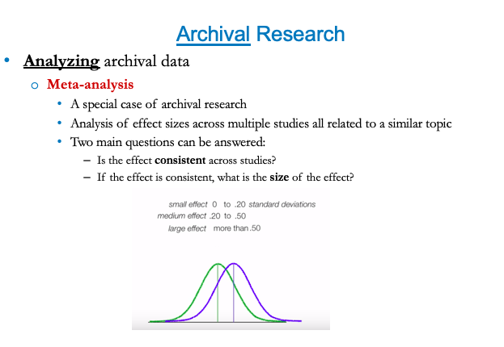
Archival research is research involving primary sources held in an archives, a Special Collections library, or other repository. Archival sources can be manuscripts, documents, records (including electronic records), objects, sound and audiovisual materials, or other materials.
Situation Sampling
- Study of behavior in different locations, and under different circumstances and conditions
- It increases the external validity of observational findings
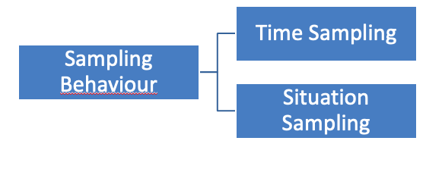

Time Sampling: observing same subjects at different time intervals
Situaton sampling: observing different subjects in many different locations, and under different circumstances and conditions

CH8: Interview and Survey Methods
Self-Report Methods
- Any method that asks participants to report on themselves (e.g., questionnaires, psychological assessment scales, interviews, verbal protocols) is a self-report method.
- The focus for this lecture is data-gathering done through direct questioning, which can be face to face, by telephone, by mail, or via the Internet.
Structured Interviews
- Interviews may be structured or unstructured.
- With structured interviews, questions and procedures are identical for every respondent.
- These types of interviews are quick to administer, the results are more generalizable, and they are less influenced by characteristics of the interviewer.
- In terms of disadvantages, one major drawback to the structured interview is that it places constraints on both the interviewer and the respondent.
- Interviewers are not free to stray from the script to explore interesting issues that may arise during the interviews, and respondents may not be able to fully explain their point of view.

Unstructured Interviews
- Unstructured interviews, on the other hand, offer greater flexibility on both the part of the interviewer and the respondent.
- With these interviews, a conversational style with open-ended questions is used, the atmosphere is more informal and natural, and richer data are generated.
- The process is greatly influenced by interviewer characteristics; however, and the results may not be highly generalizable.

Effects of Interpersonal Variables in Interviews
- In any research setting, the respondent will be influenced somehow by the researcher; this tends to be even more acute with interviews.
- Characteristics of the interviewer’s style and presentation may affect the quality of information obtained.
- Factors such as gender and ethnicity of both the interviewer and respondent can have an impact on the interview process.
- Other factors that may also affect the outcome of the interview include:
  - the formality inherent in the roles of interviewer and respondent
  - the personal qualities of both parties
  - social desirability
  - evaluative cues given by the interviewer
Types of Interviews:
- Non-directive
- Informal
- Semi-structured
- Structured but open-ended
- Fully structured
- Clinical
- Non-Directive
- In a non-directive interview, the interviewer does not direct the discussion, but instead just listens to the respondent and remains non-judgmental.
- This approach may be used in collecting data that form part of a case study, and the insights gained may form the basis of a model or theory.
- Informal
With the informal interview, the atmosphere is relaxed and the interviewees can express themselves in their own terms.
The interviewers job is to keep the interviewee on topic, and use prompts to solicit more detailed information.
- Interviews are more effective when the interviewer listens patiently, makes intelligent comments, responds appropriately, and is non-judgmental.
- When an interviewer tries to remain objective by being cool, distant, and impersonal, it can make the interviewee anxious and uncomfortable.
- Semi-Structured
The semi-structured interview is informal but guided in that the interviewer has an outline of topics to be covered.
The aim with this type of interview is not to ensure all questions in the interview guide are asked but rather to ensure all information is obtained.
- Structured but Open-Ended
In the open-ended interview, the interviewer gives pre-set questions in a predetermined order to every interviewee.
The interview is structured but the respondent is still free to answer in any way he or she chooses.
- Fully Structured
The fully structured interview also follows a pre-set and ordered list of questions, except in this case, there answers options are fixed.
This approach makes analysis easier but it can be somewhat limiting because respondents don’t have the opportunity to explain their answers.
- Clinical
The clinical interview has clear goals, such as testing a hypothesis, but uses a non-standardized procedure in order to do so.
A common strategy with clinical interviewing is to ask respondents similar questions in multiple ways.
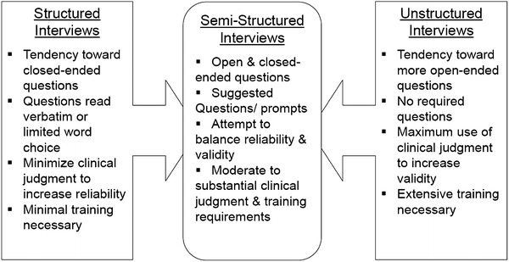

Gathering Qualitative Data
- With qualitative research, the interviewer is not a passive recipient of information but rather an active participant in the research process.
- Unlike a regular conversation, a qualitative interview requires that the interviewer actively analyze the dialogue in relation to the research objectives.
- A common occurrence with qualitative interviewing is the emergence of a point not mentioned in previous interviews.
- This new point is then incorporated into subsequent interviews and whenever possible previous interviews are revisited.
- Although there are no specific rules for qualitative interviewing, the following guidelines can be beneficial:
  - Let participants know what to expect.
  - Ensure anonymity and confidentiality.
  - Establish and maintain rapport .
  - Use the participants’ language.
  - Maintain neutrality.
  - Listen attentively.
  - Show interest.
  - Respond to non-verbal communication.
  - Employ natural questioning.
Recording the Interview
- Interviewers have three common ways of saving data: note-taking, audio recording, and visual recording.
- Note-taking can be distracting for both the interviewer and the respondent and it can make the encounter feel less like a conversation.
- Audio-recording an interview allows the interviewer to become more engaged in the interview process; it can, however, cause respondents to feel inhibited.
- It is important for the interviewer to explain why it is necessary and to also assure respondents that the conversation will remain confidential.
- The pros and cons with video-recording are similar to those of audio-recording, although video-recording can be even more off-putting for participants.
- One solution is to keep the device out of view—it is essential, however, that participants be informed that they will be recorded.
Surveys
- A survey typically involves administering a structured questionnaire or interview to a large sample of individuals.
- A survey can seek to describe what people think or do and to what extent, or it can be analytical where the aim is to test a hypothesis.
Survey Design
- Two types of samples commonly used in survey work: the panel and the focus group.
  - A panel is a specially selected group of people who can be asked to provide information each time it is required.
  - A focus group is a group of individuals with a common interest who are brought together for a collective interview.
- A focus group is efficient in that it can generate a large amount of data in one session, saving the need for multiple one-on-one interviews.
- Another advantage of the focus group format is the cross-stimulation of ideas among participants.
- Focus groups need to be managed carefully, however, to ensure that all participants have the opportunity to contribute to the discussion.
The Interview Medium
- There are many avenues through which respondents may be questioned and each has its advantages and disadvantages.
- Telephone interviews are good for reaching busy people; they provide greater anonymity, are cost effective, and respondents are less likely to be influenced by the interviewer.
- The interviewer, however, is not able read the respondents’ non-verbal cues.
- Conducting surveys electronically via email or the Internet can also be can also be time-saving and cost efficient.
- The major criticism levied against these methods is that they are likely to yield a biased sample, as users may differ from the general population in significant ways.
- With mail surveys, respondents may be less concerned about social desirability and may thus provide more honest answers.
- Unlike face-to-face interviews, however, the researcher cannot clarify questions for respondents or ask for further elaboration.
- Also, the return rate with mail surveys can be rather low.

CH9: Experimental Design 1: Between Subjects Designs
Between Subjects Design
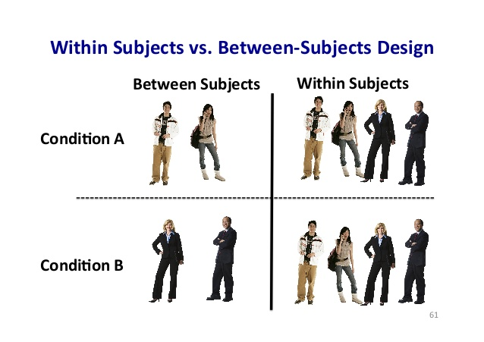
- Between subjects’ designs are used to compare different groups of individuals who have been exposed to an experimental manipulation.
- For example, with this design you could look at how your treatment group and control group differed in their response (DV) to receiving a specific drug (IV).
Advantages of Between Subjects Design
- With the between subject design, a different group of participants is needed for each level of the IV used in the study.
- Having separate groups ensures independence of scores, meaning that participants each have only one score and that score is independent of all others in the data set.
- An advantage to having separate group of participants is that you don’t have to worry about carry-over effects or participant attrition .
- Any differences between the groups are due to the differing treatments.
- It is almost always possible to assign an individual to one of several treatment conditions.
- ““The major advantages of the between subjects design is that the researcher can be confident that any differences between the groups are due to the differing treatments rather than to other treatment factors that can occur when the same individual is measured more than once. That is, there are no practice, carryover, or contrast effects from exposure to multiple treatment conditions
- “Another advantage is that it is almost always possible to assign an individual to one of several treatment condtions...it is not always possible to expose the same individual to multiple treatment conditions.””
Disadvantages of Between Subjects Design
- On the downside, the need for independence means that you require a large number of participants for your study.
- With this type of design, individual differences across groups can pose a threat to validity.
- There are a number of strategies researchers can use to minimize individual differences and ensure the groups are equal:
    - Random assignment to groups
    - Matched assignment to groups related to a particular variable we think that could have an effect on the DV. i.e. if it is the IQ variable, to make sure that in each group we will have a participant having similar IQ
    - Constant variables; for example, we choose to work only with girls if we think that the variable gender could have an effect on the DV (and gender is not our IV)
    - Large sample size in order to reduce individual differences between our groups
- It is also important to treat the participants across the different groups equally.
- One strategy that is effective in this regard is to have the researchers blind to which condition participants have been assigned to.
- Researchers also have to manage environmental factors to ensure that participants are tested under similar conditions.
- There are other threats to validity that are inherent in the between groups design:
  - Compensatory equalization occurs when a control group demands to receive the same treatment (e.g., experimental drug) as the experimental group.
  - Compensatory rivalry occurs when the control group tries to match or outperform the experimental group.
  - Resentful demoralization occurs when the control group underperforms, they feel that the treatment group has an advantage that cannot be overcome.
Interpreting the Results of Between Subjects Design Experiment
- When interpreting the results of a between groups study we must consider not only the difference in the group means but also the variability of the scores within each group.
- As discussed earlier, this is achieved by using random selection, matching procedures, and large sample sizes.
- Researchers strive to have large between-group differences and small within-group differences.
- The more variability there is within the groups, the harder it will be to detect an effect if one is indeed present.
- The t-test is a statistical test that compares group means while taking within-group variances into account.
- 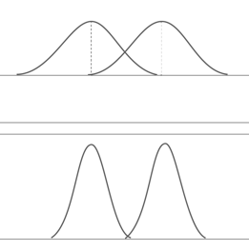
- These graphs have to do with the psychotherapy study we have seen previously.
- In both cases, we have a similar difference between means, but the variability within each group is smaller in the second case, where the statistical difference will then be higher.
Between-group differences are related to the difference between means we have seen in the previous slide, and within-group differences have to do with the variability within each group.
- Remember this study. Even if the difference between the means in both cases would be similar, the t-tests of statistical difference would be different because of the smaller variability in the second case.
- T-test or ANOVA (Analysis of variance)?
- The t-test is used when you have only 2 levels for the IV (for example, the treatment or experimental group, and the control group). ANOVA is used when you have 3 or more levels for the IV
- In fact, the t-test is also an analysis of variance and it can be considered as a particular case of ANOVA. So we can also use this latter program in designs with just two groups (so instead of the t-test).
Single-Factor Multi-Group Design
- The single-factor multi-group design is one with more than two levels of the independent variable, and thus requires a greater number of participants.
- With this design, we use an f-test or ANOVA to calculate the ratio of the variance between treatments and the variance within treatments.
- Remember, with two levels of the IV (i.e. experimental group and control group) we could use either the t-test or ANOVA.
- With three levels of the IV (i.e. treatment A group, treatment B group, and a control group, see slide 27) or more, we cannot use the t-test anymore. But ANOVA yes!
- (IV = Independent Variable)
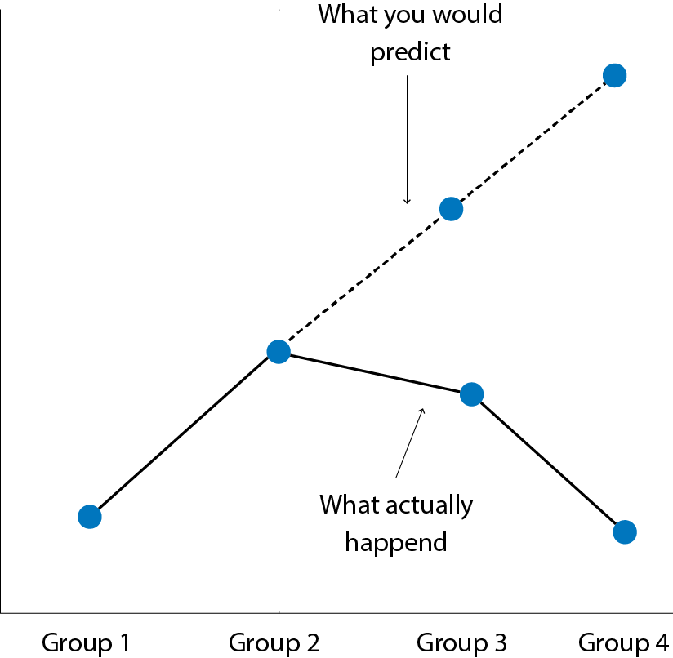
In this example (p. 175), the IV has to do with a specific drug given in different conditions (different doses). The control group (group 1) can be a placebo one.
The problem of having different groups for the IV is that it is quite expensive (you need more subjects for each additional group). And the more groups you have, the less obvious is the equivalence among them…
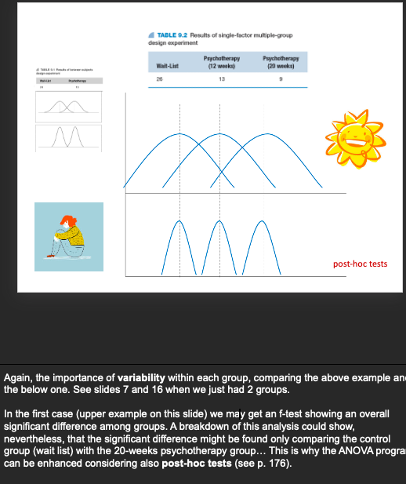
Factorial Designs
- Rather than using a single IV with varying levels, a factorial design employs two or more IVs with varying levels.
- A factorial design is an efficient way to examine multiple IVs at the same time and to test not only main effects but interactive effects as well.
- Main effects have to do with the individual effects of the IVs on the DV, whereas interactive effects consider the combined impact of the IVs on the DV.
- The factorial design allows the researcher to determine if the effect of IV(1) on the DV depends on what is going on with IV(2).
- To analyze the results for a factorial design, we run an ANOVA, which will yield an f-score for all the interactive and main effects examined.
- Interpretation begins with looking at the interactive effect first; if it is statistically significant and meaningful, there is no need to move onto the main effects.
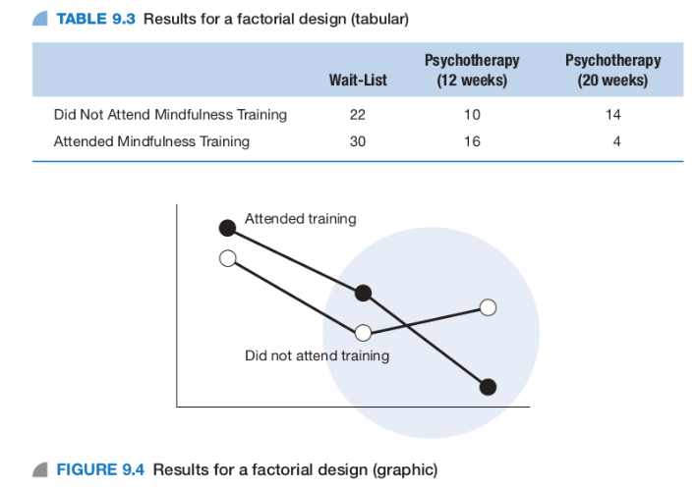

Here we have two IVs: Psychotherapy and Mindfulness Training. The DV is the participants’ level of depression.
If we had just the two first levels for the psychotherapy IV (wait-list and 12-weeks psychotherapy), there would not be interaction with the other IV (mindfulness training): on the diagram, the corresponding lines are almost parallel. The interaction is obvious, nevertheless, with mindfulness training and psychotherapy considering the two last levels of this latter one (12 weeks and 20 weeks). On the diagram, the lines clearly cross each other. In fact, it is not necessary for the lines on the diagram to cross each other: the simple fact of not being parallel indicates the presence of an interaction. But is this interaction a significative one? ANOVA tells us if it is the case!
Similar advantages and disadvantages we have seen for between-groups designs. Some disadvantages can be overcome considering a mixed factorial design

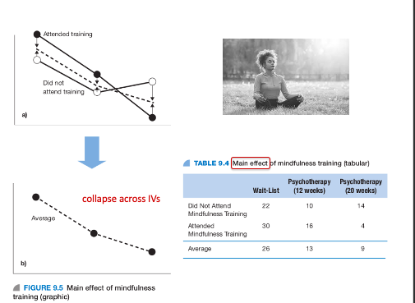
In this example, we consider the main effect of one variable collapsing the effect of the other one. We don’t consider possible interactions between IVs. This is the opposite of “unpackaging” the effect of two or more possible IVs.
- To analyze the results for a factorial design, we run an ANOVA, which will yield an f-score for all the interactive and main effects examined.
- Interpretation begins with looking at the interactive effect first; if it is statistically significant and meaningful, there is no need to move onto the main effects.
William of Ockham
https://www.youtube.com/watch?v=9XEA3k_QIKo
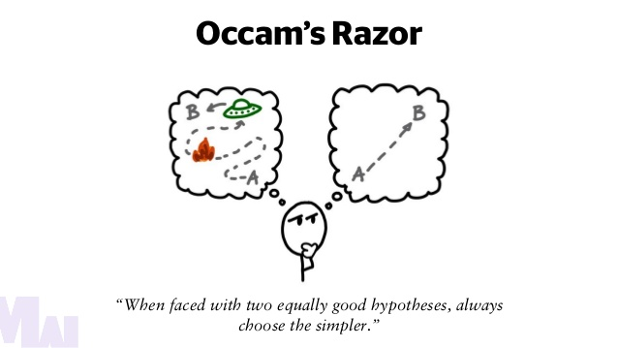

CH10: Experimental Design 2: Within Subjects Designs

Within Subjects Design
- A within subjects design, also know as a repeated measures design is one in which participants are exposed to all the conditions in a study.
- Each participant is measured in every condition to determine if there has been a change in the DV across conditions.
Advantages of Within Subjects Designs
- Participants serve as their own control or baseline, thus eliminating the problem of individual differences inherent in between subjects designs.
- With this potential source of error out of the way, there is a better chance of detecting an effect if one is indeed present.
- The within group design is thus more powerful than the between subjects design.
Disadvantages of Within Subjects Designs
- The within group design does have its drawbacks:
  - Demand characteristics
  - Attrition
  - Carry-over effects
  - Progressive error
  - Confounding by time- and environmental-related factors
- Demand characteristics are aspects of the experiment that help participants become aware of the researcher’s intent.
- With repeated exposure to treatment conditions, participants may be able to deduceيستنتج the intent of the study and alter their behaviour accordingly.
- This is undesirable because it creates confusion about what actually caused the change in the DV.
- Attrition refers to participant dropout from the study; researchers generally expect to lose between 10 per cent and 20 per cent of participants at each measurement interval.
- If attrition rates are too high (e.g., more than 50 per cent) this can be a threat to external validity as the remaining participants may no longer be representative of the population of interest.
- Carry-over effects occur when being tested in one condition of a study affects participant behaviour in subsequent conditions.
- These undesirable effects can be attributed to the nature of the conditions (the treatment itself) or to progressive error, which may be caused by practice, fatigue, or boredom.
- Progressive error may cause IMPROVEMENT (because of practice) or DECLINE (because of fatigue)
- “Technically, carryover effects and progressive error are two different phenomena. Carryover effects are changes in a participant that can be attributed directly to the lingering aftereffects of an earlier treatment (or treatments). Progressive error is a change in the participant that can be viewed as aspects of the same basic problem: Participant’s scores are influenced by factors other than the immediate treatment.

- Fluctuations in environmental factors such as the noise level, temperature, and lighting at the testing time may influence your data in unwanted ways.
- It is important to ensure that the factors most likely to influence your findings are held constant throughout your study.
- Time-related factors can also pose a threat to internal validity and thus need to be considered in your research design and the interpretation of results.
- Instrumentation has to do with the reliability of your measure; it is essential that the manner in which you measure your DV remains consistent across time.
Time-related factors: instrumentation, regression to the mean, maturation, and history.
About the instrumentation threat, let’s consider two examples:
- You are using two different versions of a specific test (i.e. for the pretest and the posttest), but they are not truly equivalent.
- Your design uses observation as a technique, but your observers don’t have exactly the same criteria.
- Instrumentation can be a threat to internal validity because it can result in instrumental bias (or instrumental decay). Such instrumental bias takes place when the measuring instrument (e.g., a measuring device, a survey, interviews/participant observation) that is used in a study changes over time

- Another time-related effect is regression to the mean, which is a tendency for extreme scores to revert to ones closer to the mean on subsequent measurements.
- This tendency can create the illusion of an effect when one is not present.
- Whenever extreme scores are present, it is a good idea to take a closer look at individual data points.

- Depending on the time frame between testing sessions, maturation can be an issue.
- Participants may undergo physiological or psychological changes over time as part of the natural course of development.
- Of course, you cannot prevent your participants from maturing, so the best course of action is to try to reduce the time between testing sessions.
- If you are interested in cognitive development in children, for example, their cognitive operational level (cf. Piaget) could change if your study takes several months.

- Another time-related factor that can confound a result is history, which refers to important events occurring between testing sessions.
- Again, this is a factor that you will not be able to control or prevent, thus its best to measure it and consider it in the interpretation of your results.
- Can we really measure the effect of this factor? Or just acknowledge its presence…
- There are many examples we can imagine illustrating this factor: a war, an earthquake, a terrorist attack, or what we are experiencing right now: the challenging of the coronavirus pandemia.


Interpreting the Results of Within Subjects Design Experiment:
- The null hypothesis in the within subjects design assumes that there is no difference between the means sampled across the various treatment conditions.
- The statistic for testing the differences across conditions is the repeated measures t-test, which computes a ratio comparing actual difference to that caused by chance.
- Sometimes, you may want to include more than two conditions or levels of the IV in your study.
- In such cases, the appropriate statistic for testing the differences across conditions would be the repeated measures f-test (ANOVA).
- If your f-score is significant, you have to go back and detect which groups differ from one another using post-hoc tests.
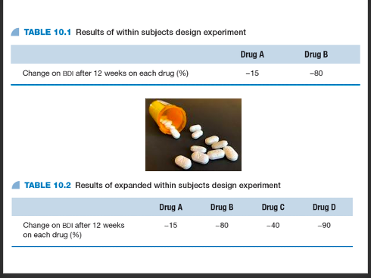

- BDI: Beck Depression Inventory
- Do you find an issue trying to interpret the effect of different drugs considering always the same group of people? What kind of threat could we have here?

Disadvantages of Within Subjects Designs
- An example of this:
- In Seeking Wisdom, Peter Bevelin offers the example of John, who was dissatisfied with the performance of new employees so he put them into a skill-enhancing program where he measured the employees’ skill:
- “Their scores are now higher than they were on the first test. John’s conclusion: “The skill-enhancing program caused the improvement in skill.” This isn’t necessarily true. Their higher scores could be the result of regression to the mean. Since these individuals were measured as being on the low end of the scale of skill, they would have shown an improvement even if they hadn’t taken the skill-enhancing program. And there could be many reasons for their earlier performance — stress, fatigue, sickness, distraction, etc. Their true ability perhaps hasn’t changed.
- “Our performance always varies around some average true performance. Extreme performance tends to get less extreme the next time. Why? Testing measurements can never be exact. All measurements are made up of one true part and one random error part. When the measurements are extreme, they are likely to be partly caused by chance. Chance is likely to contribute less on the second time we measure performance.
- “If we switch from one way of doing something to another merely because we are unsuccessful, it’s very likely that we do better the next time even if the new way of doing something is equal or worse.”

Using Mixed Measures Designs
- Mixed measures designs employ both within subjects variables and between subjects variables.
- By combining designs we can benefit from the advantages associated with each one and get a more realistic picture of how a group of variables interact.
- This is wonderful! Mixed measures designs allow to overcome several drawbacks specific to between-subjects designs and to within-subjects designs. Nevertheless, do you think that, in some cases, mixed measures designs could rather cumulate the drawbacks specific to between-subjects designs and to within-subjects designs?

CH12: Quasi-Experiments, Non-Experiments, and Comparison Studies
True Experiments and Field Experiments
- Whenever we talk about laboratory experiments, we are referring to situations in which a researcher exercises experimental control.
- Such contrived experiments are high in internal validity but they can also produce artificial behaviours.
- For this reason, researchers sometimes prefer to study behaviour in a more natural setting.
- The trade-off to studying behaviours in the field is the loss of control over extraneous variables.
- Also, with this research approach, the researcher cannot randomly assign participants to conditions.
- As a result, the groups in the study are non-equivalent.
The Quasi-Experiment
- When full experimental control of the IV and random assignment to conditions is not possible, you no longer have a true experiment.
- What you have is a quasi-experiment, which attempts to examine cause-and-effect relationships in spite of the above.
- With non-equivalent groups, though, there is always the possibility that differences observed are caused by initial group differences.
- Quasi-experimental studies can provide valuable insights into human behaviour in spite of not being true experiments.
- They are particularly useful for investigating situations where it is impossible or unethical for researchers to assign participants to groups.
- Also, the inherent problem of non-equivalent groups and threats to validity can be minimized by taking pre- and post-measures of the DV.
Interrupted Times Series Designs
- One such type of experiment is the interrupted time series design in which the DV is measured at several points in time.
- The interruption, in this case, refers to the introduction of an IV that separates the multiple measures of the DV.
- Having this type of pre- and post-data allows researchers to rule out the influence of confounding variables, to a certain extent.

Non-Experimental Research/ group difference studies/ observational studies
- The non-experimental design is similar to the quasi-experiment except that it attempts to compare groups ex post facto.
- In other words, the researcher takes measures “after the fact” and compares two contrasting groups on an existing variable.
- These types of studies are also called group difference studies.

- Be careful! Non-experimental studies and correlational studies are not the same.
- With correlational studies, researchers examine how much one IV influences another.
- With non-experimental studies, researchers compare two levels of an IV (e.g., men versus women) on a DV (e.g., assertiveness).
- Sometimes non-experimental studies are referred to as observational studies.
- This can create confusion because observation is a technique that can be used in a true experiment or in a situation that is non-experimental.
- An observational study can, for instance, include observations of existing groups, as in group difference studies.
- In general, all studies can fall into one of three classifications: true experimental, quasi-experimental, or non-experimental.
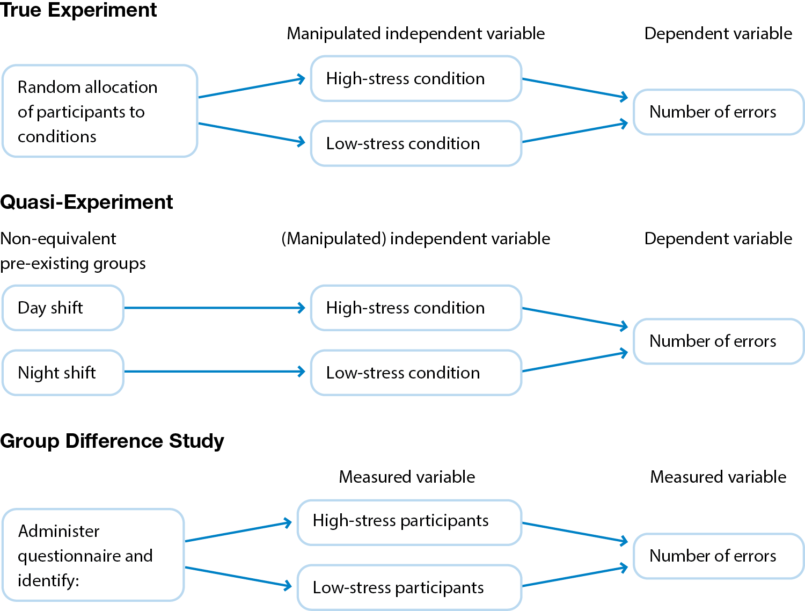

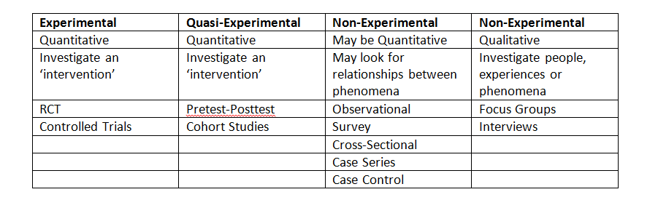

Control and Validity
- True experimentation demands careful control of all variables and this is best achieved in a laboratory setting.
- Laboratory work has been criticized, however, for narrowness of the IV and DV, the inability to generalize, and artificiality.
- Because of the strict control required, we may only be able to study a very narrow aspect of a phenomenon in a given study.
- Another problem is that what is observed in the laboratory setting may not necessarily reflect what happens outside the laboratory.
- The unnaturalness of the laboratory setting can result in what is called a laboratory artifact.
- An artifact may look like a true effect but it is in fact an unintentional effect caused by the experimental setting.
- Although laboratory experimentation has its drawbacks, it is still extremely useful and effective, particularly where basic research is concerned.
- Experimental control allows researchers to rule out alternative hypotheses that might account for observed results.
- The findings from highly controlled experiments can help refine theories and point to further hypotheses to be explored.
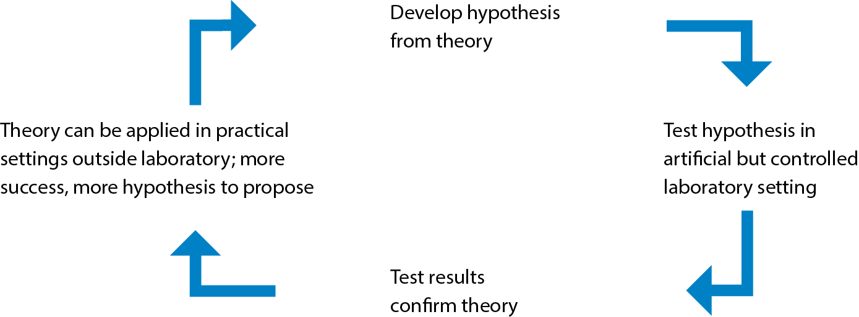
- Mundane realism, in which the experiment resembles everyday life, is not always necessary in research. External validity
- What is necessary, however, is experimental realism, where the study evokes experiences or behaviours one would see in everyday life.
- Laboratory experiments strive for experimental realism; field experiments strive for mundane realism but can be designed to be high in both.

What Are Comparison Studies?
- Sometimes, researchers want to compare different groups of individuals across subgroups or cultures, or to follow them across time.
- These are comparison studies and there are three major types:
  - Cross-sectional studies
  - Longitudinal studies
  - Cross-cultural studies

Cross-Sectional Studies
- A cross-sectional study compares samples drawn from separate distinguishable subgroups within a population at the same moment in time.
- Groups can be compared based on variables such as age, socioeconomic status, or disability, for example.
- Cross-sectional data are commonly used to support developmental theories.
Longitudinal Studies
- With a longitudinal study, one group or several groups of individuals are followed over a period of time and tested at different time periods.
- These types of designs are effective for understanding how people change over time and the factors that affect those changes.
- Members of a group who move through time together are referred to as a cohort.

Evaluation of Longitudinal and Cross-Sectional Studies
- Each design type has its advantages and disadvantages.
- Cross-sectional studies are quick to do and there is a low risk of attrition; they can, however, be plagued by cohort effects.
- Also, because the groups are made up of different members, we cannot observe how people change over time.
- Longitudinal studies are time consuming and expensive; and the risk of attrition is very high.
- They do offer, offer valuable insight, into the process of change within the same individuals.
- Also, because the same individuals are followed across time, cohort effects are eliminated with this design.

Lagged Designs
- Sometimes cohort effects are precisely what researchers are interested in studying; lagged designs offer an effective way of doing just that.
- With a time lag study, different groups with similar characteristics are selected at different periods in time and measured on the same DV.
- A panel study measures the same group of individuals at two or more different times (waves), generating a series of cross-lagged correlations.
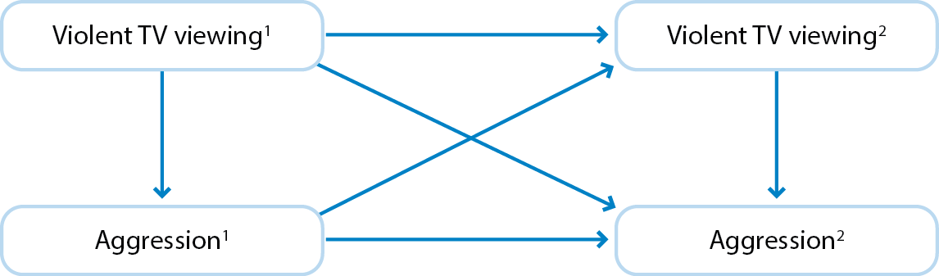
Cross-Sectional, Short-Term Longitudinal Study
- It is possible to combine study designs in an attempt to benefit from the advantages that each one offers.
- With a cross-sectional short-term longitudinal study, for example, researchers can study a cross section of groups at different intervals over a short period of time.
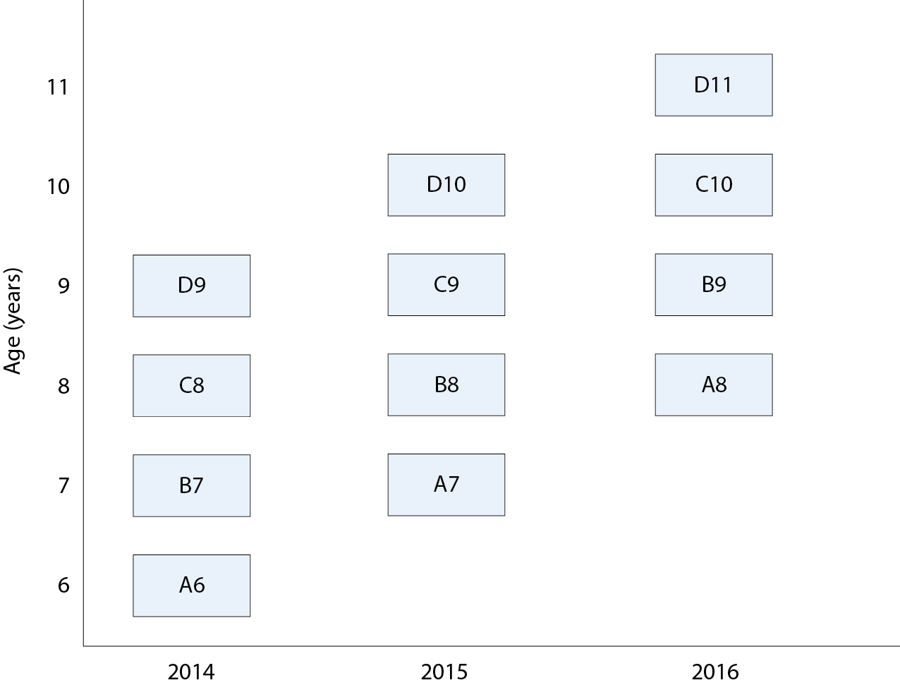

Cross-Cultural Studies
- The findings that emerge from a research study must always be considered within the bounds of the cultural background of the study participants.
- To determine if the findings can extend to other cultures, one must engage in cross-cultural research.
- Cross-cultural research involves comparing two or more different societies or social/ethnic subgroups on different variables of interest.
- Cross-cultural research can shed light on the universality of psychological concepts, while highlighting cultural factors that moderate different phenomena.
- One has to be mindful of ethnocentrism, however, which is a biased view of another cultural in comparison to one’s own.
- Ethnocentrism can result in false interpretations of behaviour.
- Recent cross-cultural research has moved away from ethnocentrism, adopting instead a stance of cultural relativity: is the idea that a person's beliefs, values, and practices should be understood based on that person's own culture, rather than be judged against the criteria of another.
- This approach has led to an appreciation of the individualistic and collectivist dimensions as a means of framing cultural differences.
- Individualist societies favour independence, while collectivist societies favour interdependence.

The Emic–Etic Distinction and Psychological Constructs
- Cross-cultural researchers have also highlighted the need to be mindful of the use of emics and etics when describing psychological constructs.
- An emic psychological construct is one that is unique to one culture, whereas an etic psychological construct is thought to be universal.
- It is imperative that the interpretation of findings be driven by derived etics(culture) and not imposed etics ( universal).
- A pretest-posttest is a quasi-experiment where participants are studied before and after the experimental manipulation

