Rehabilitation Psychology

- Which people in society are most likely to injure themselves, especially in athletes?
- Is there a possibility for you to intervene in order to help them or possibility prevent them from injuring themselves?

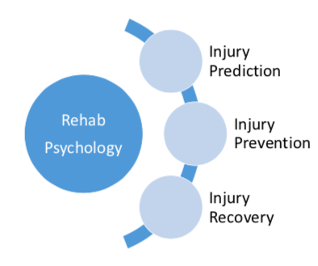

Injury prediction…
- How stress plays a role…

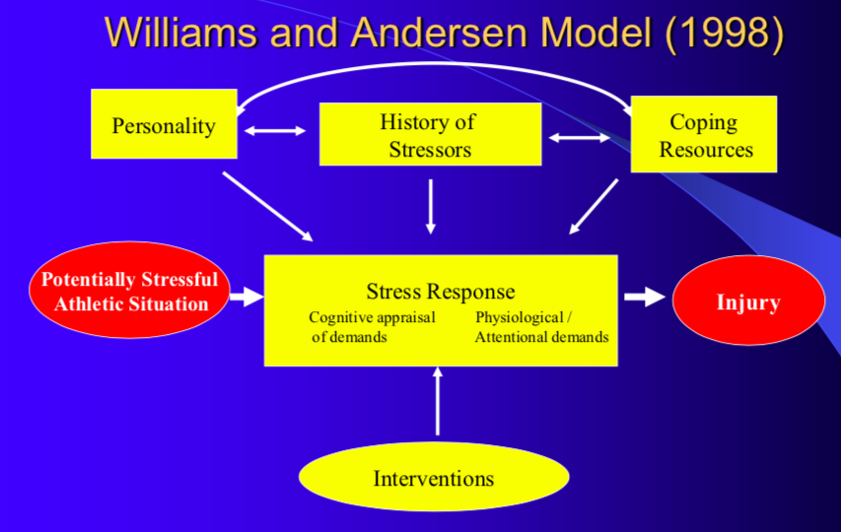

Stress response: broken into two sections however, there is no dominant affecter thus if the demands exceed their resource capabilities they are likely to injure themselves
- Cognitive appraisal: the way we think about something, in order for stress to occur the demands of the situation exceed their resource capabilities
- Physiological demands: the response of the body due to stress (tense up, increase in cortisol levels) however, everyone has different ways in reacting to stress
- Attentional demands: ‘tunnel vision’ can occur due to stress thus they have a narrow focus and they are not picking up the ques, either by their body or around them leading to injury

Coping resources: support from others to help cope with the stress (mentors, friends, family etc.) however there is individual methods to dealing with the stress

Personality: knowing when to pull back, type A personality (aggressive, competitive and outgoing) have a difficult time dealing with the stress thus they are at a higher risk of hurting themselves whereas type B personalities (relaxed, calm) are better at dealing with stress

History of stressors: likely to respond to a new stressful situation at a high level but aware of the pain and recovery of the injury

-Through using this model, we are able to show whether it has a utility in predicting sport injury

Moderator variables
A moderator variable is a quantitative variable that affects the nature, the direction or the strength of a relation between an independent or predictor variable and a dependent variable

STUDY
Ronald, Smith, Small & Ptacek: Life stress, social support and coping skills, and adolescent sport injuries

- Subjects where female and male high school varsity athletes aged 14-19 years (basketball, wrestling, gymnastics)
- Selected these sports to provide a range of individual, team, contact and noncontact sports
- Athletes completed a series of questionnaires in a group setting in the week prior to the beginning of the sport season
-Included measures of recent life events, levels of social support experienced by the athlete and self-perceived adequacy of psychological coping skills

- Injury data was collected over the course of the season
- Found that with High levels of social support and high levels of coping skills resulted in the least time lost after a negative life event
-Results: when athletic injuries are considered to be influenced mainly by physical and biomechanical factors leaving less room (variance) to be accounted for by psychological factors
- As life stress increases there is a higher chance that the person is going to injure themselves
- R value –squared it represents the coefficient of termination which is another way of expressing the relationship between life stressor and the time loss
- Social support and coping in a conjunctive manner influence the relationship between life-stress and subsequent athletic injury to youth athletes

Injury assessment
-A sports injury was defined as a medical problem resulting from athletic participation that restricted subsequent participation for at least 1 day beyond the day of its occurrence

Implications of the study: the results are encouraging when athletic injuries are considered to be influenced mainly by physical and biomechanical factors leaving less room (variance) to be accounted for by psychological factors

Injury prevention: It is important to reduce the stress thus posing the question: “What role can psychology offer to prevent that from happening?”

Take home message
- Social support and coping operate in a conjunctive manner to influence the relationship between life stress and subsequent athletic injury in youth athletes.

- Only athletes low in both coping and social support exhibited a significant stress-injury relation, and in that vulnerable subgroup, negative major life events predicted up to 22% of injury occurrence scores.

- Psychology plays a role in who might or might not hurt themselves in physical activity.
- When this is compared to other methods like biomechanics of the movements psychology still comes up par.

Summary for Injury Prediction
- When looking at a profile of athletes that have a low social support system and low coping support, then the occurrence of injury increases
- The combination of social support and coping both operate in a conjunctive manor to influence the relationship between life stress and subsequent athletic injury in youth athletes
- If some form of intervention in a meaningful way could be used to prevent the athlete from injuring themselves that way

Injury prevention…
- Reducing stress …

Stress response most important
-Cognitive appraisal is the personal inspiration
-Least modifiable is personality, history of stress and most modifiable is coping resources

Reducing stress
-It is suggested through the model that in order to prevent injuries caused by stress, the intervention should focus on
1) alteration of the cognitive appraisal of potentially stressful events
2) modifying the physiological and attentional aspects of the stress response
-In addition, interventions may be used to directly influence the moderator variables under coping resources and personality factors
Changing someone’s views of the stressful events, try and encourage them that it can be a new challenge
-Paying attention to how your body is reacting

STUDY
Kerr, Goss: The effects of a stress management program on injuries and stress levels

Rationale for study
-If athletes were taught to better manage or cope with their stress, would the occurrence of injury be reduced?

- 24 international and national gymnasts (16 males and 8 females ages between 14 – 25) were used to conduct a randomized trial
o Time 1: pre-season and pre-intervention measures (athletic stress)
o Time 2: four months after Time 1 and represented mid-season
o Time 3: four months after Time 2 and represented peak season (National
Championships)
o Dependent measure: ​ injury occurrence – any physical harm occurring as a result of training or complete absence from training

2 arms= 2 groups treatment group and no treatment group
Measuring these variables are 3 different times

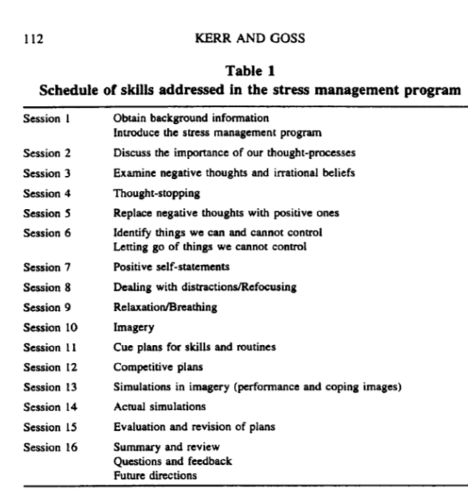
*Delivered bi-weekly over the eight months. Each session lasted 1 hour

- Meichenbaum
- Client has a fear of flying, shows photos of airplanes/airport
- Next drives around airport, sitting in airport. Slowly getting the individual to slowly train themselves to deal with stress “baby steps”
- These steps are used to help the gymnasts slowly learn to cope with stress (Know general idea)

Injury Data
- Each gymnast incurred at least one injury over the 8-month period of study is indicative of the prevalence pf injuries in gymnastics
- Each gymnast had one injury over the time period of the study but most of the injured interfered with training for two weeks or less – these injuries appeared to be minor
- Major injuries (chronic use) interfered with training for 8 weeks or more however these gymnasts indicated a level of acceptance

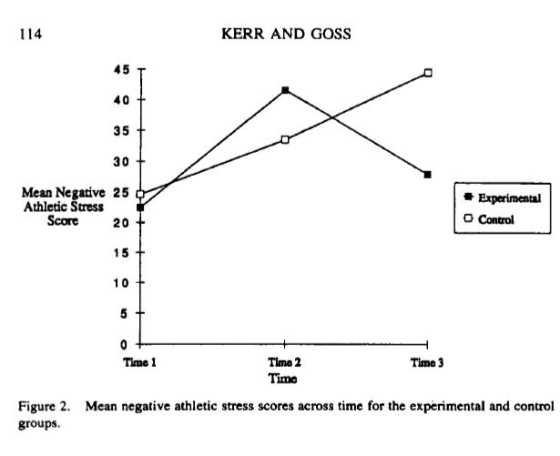

-y axis mean negative stress score
-x axis time period
-Two groups are not that much different from start to time 2
-To time 3 those in the experiment groups stress went back to the baseline (start) and those in the control group went up
-The two treatment groups are acting different at different times

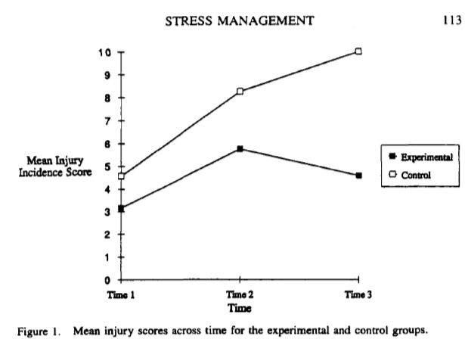

In both groups, they are experiencing an elevation in injury, from time 2 to 3 in the experimental group has gone down. but those who are not getting the training (control) has gone up
(Both charts are acting the same)

Take home message
- The incidence of injury can be reduced in athletes (gymnasts) when negative athletic stress is reduced
  - Injury can be reduced in gymnasts when the stress is reduced, if you can reduce stress the injuries can be prevented or amount of injuries can be reduced

Injury Recovery…
-psychology plays a role in injury as not being patient, confidence in the tasks can make injuries more prone, consistency with rehab
-If you add psychology rehabilitation to traditional rehabilitation will there be more benefits

STUDY
Cupal, Brewer: Effects of Relaxation and Guided Imagery on Knee Strength, Re-injury Anxiety and Pain Following Anterior Cruciate Ligament Reconstruction

Cupal/Brewer look at ACL injuries
-Adding relaxation and guided imagery will that add to knee strength, reinjure anxiety and pain

Guided Imagery
- Participants- 30 patients who had completed ACL reconstructive surgery; no evidence of other acute lower extremity trauma; expected to engage in a 6-month post-surgical rehab
ACL injury-common injury

Measures
o Re-injury Anxiety: ​concern for re-injuring reconstructed knee once normal physical
activity is resumed
o Pain: ​ subjective experience of pain
o Knee Strength: ​ Cybex isokinetic dynamometer- ratio in foot pounds of performance on
the injured knee compared to the uninjured knee

(Study Measures-Contextual information, do not need to know exact measures but know the results)

Procedure
-Participants were randomly assigned to either treatment, placebo, control conditions
-Measures of re-injury anxiety and pain were assessed at 2 weeks and 24 post-surgery
-Measures of knee strength was assessed 24 weeks’ post-surgery

Randomized control study
->Treatment, placebo and, control.
->Nonspecific treatment may be just as good as specific treatment
->Measured paid and anxiety at 2 weeks and 24 post-surgery and knee strength at 24 weeks

o Treatment group: ​10 individual sessions of relaxation and guided imagery – sessions were spaced two weeks apart over 24 weeks & normal course of physiotherapy
o Placebo group: ​ received attention, encouragement and support from the clinician at the sports medicine facility & normal course of physiotherapy
o Control: ​ followed a normal course of physiotherapy

When randomizing individuals, you create an equal playing field on factors that or known or unknown that may influence the outcomes
->Randomized control trials comes from farmers

Results

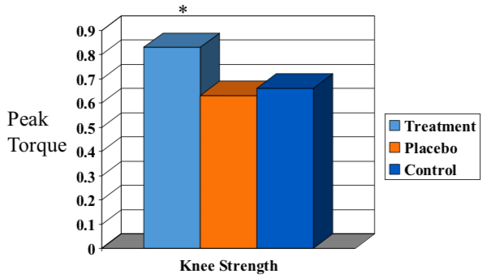
Peak torque and knee strength
Treatment group was doing better at 24 weeks with strength

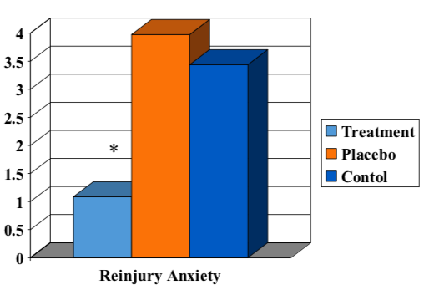

-Treatment group has the lowest reinjure anxiety
-In both situations both placebo and control did not do too well in both

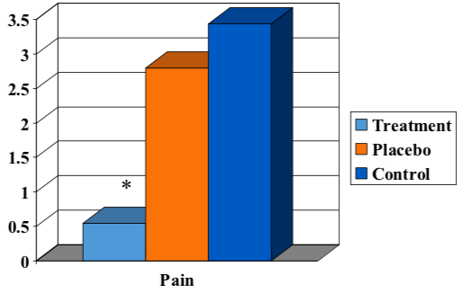

Those in the treatment group are doing much better when it comes to pain compared to placebo and control groups

Relations between PAIN, RE-INJURY ANXIETY and KNEE STRENGTH

As knee strength goes up scores on reinjure anxiety go down
-All 3 variables are related in logical fashion

- Knee strength was correlated with both re-injury anxiety and pain reduction

Why does imagery work?
o Psychological mechanisms: ​personal control, motivation
o Physiological mechanisms: ​ reduce stressbetter immuneinflammatory response􏰂
promotes tissues regeneration and repair

-Psychological base interventions can enhance treatment outcomes for the patients

We don’t know why imagery/relaxation works so well... they do not show WHY but they show evidence that it does work

->Mechanisms to why it might work psychological having
personal control and motivation

->Going though imagery helps reduce stress which leads to better immune inflammatory response which can help promote tissue regeneration and repair at a greater rate ... To test this pathway, you have to measure stress

Take home message
• Psychological-based interventions can enhance functional and related cognitive outcomes during rehabilitation

Observational Learning/Modeling

“A picture is worth a thousand words.”

“Modeling....to be one of the most powerful means of transmitting values, attitudes, patterns of thoughts and behavior.”
(Bandura, 1986)

Learn by seeing

Bandura’s Model

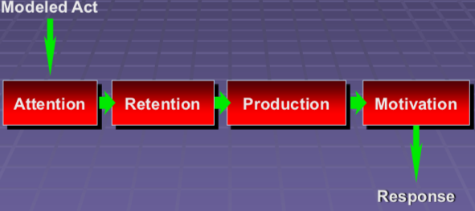

Attention-Get the attention of the individuals

Information Sources

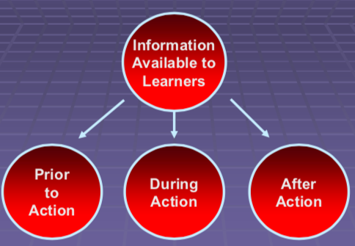

Obtain information prior to an action

Research and Applications of Modeling in Rehab Psychology

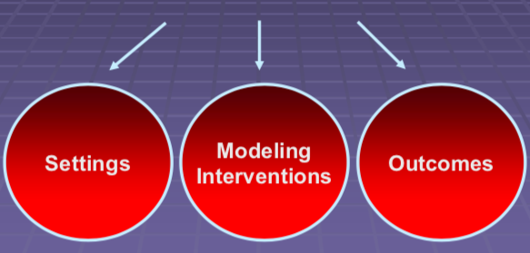

-Setting is the rehab
-Different types of modeling, some people gravitate towards certain types of modeling
-Outcomes from the modeling can be different depending what you looking for

Outcome Measures

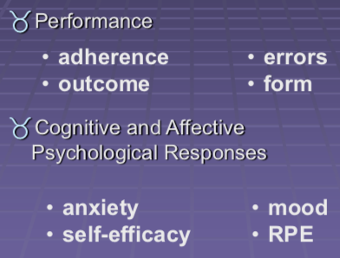
-RPE- rating of perceived exertion
-How hard you are doing the task (think of FHP labs)

Types of Modeling Interventions
- Mastery versus Coping models
- Imagery versus modeling as a vicarious experience
- Self-modeling

Mastery modeling is pure and perfection, when you watch someone do the action you are looking at something that is exact how it should be done (watching a rehab stretch that is done VERY well emphasis o how well)
Coping model does not care about perfection but how the individual is coping with the exercise and things they are doing to stay “calm” (positive thoughts, self-motivation) when feeling down in rehab process
Imagery is imagining yourself do the activity
Vicarious experience is doing the activity (Very high cliff, watch other people go and see how they like it.)
-Self-modeling is trying to learn how you like to do things (this is the most used)

Mastery versus Coping Models

Mastery Models
- Demonstrate errorless performance
- Verbalize confidence
- Demonstrate positive attitude
- Verbalize low task difficulty
Coping Models
- Display decreasing distress as they struggle with difficulties or threats
- Demonstrate strategies for dealing with different situations
- Voice progressively self-efficacious beliefs
- Approach or achieve mastery

The Medical Literature
Dowrick
(1991)
“A Practical Guide to Using Video in the Behavioral Sciences”
Parrish & Babbitt
• reviewed the literature on video-mediated instruction in medical settings

Using videos that have a modeling type of evidence to help with rehabilitation but not many have used this

Prehabilitation and Injury
-Pre-habilitation and injury: the preparation for surgery which can influence the outcomes post-surgery
-Pre-rehabilitation: treat and train an injury/associated muscles in preparation for an anticipated stressor – both physical and psychological
Prehab increases function and there is a shorter recovery time including after surgery that is below minimal function level
Similar recovery trajectory without prehab however prehab is quicker to pre-op level Why it might work – train specific systems such as muscle groups that will be affected by the stressor
This is done so that there is a build-up of function reserve to compensate for depletion due to the stressor
-Elective surgery or longer wait times for necessary surgery results in longer prehabilitation window
-Prior to surgery: conditions continue to get worse, patients become more sedentary (limited movement, sitting or lying down), treatment options have been exhausted – there is no active care and patients feel like they are not doing anything
-After surgery: get mobile as soon as possible preferably the day of surgery as there is a risk associated with bed rest (wound closure and is done to prevent infection)

Sport Injury
Andrei Markov
April 30 2010- torn ACL
Possible to play with bracing
Eventual need for surgery

Immediate Care
- First Aid
-Assessment
-Elevation, Ice, NSAIDs (nonsteroidal anti-inflammatory drugs)
- Rest
-Crutches

Immediate care-standard protocol

Before surgery
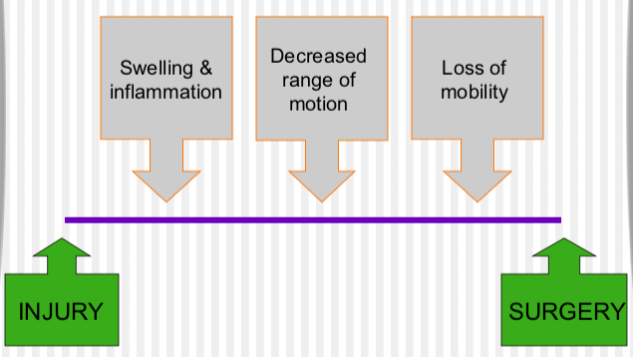

Things that happen between injury and surgery

After surgery
- Intensive rehabilitation
-Physiotherapy exercises
-Cryotherapy
-Muscle stimulation
-Maintain overall fitness
- Takes up to 6 months to recover

Recovery Timeline
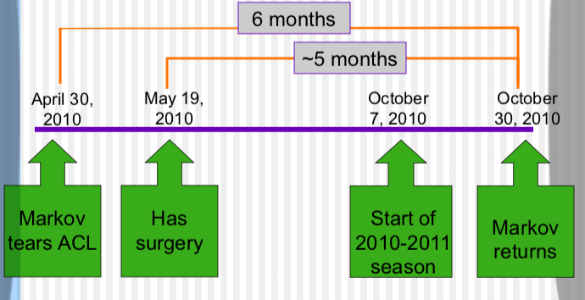

Psychological Reaction to Injury
- Injury-relevant processing
-Information about pain, extent of injury, how it happened, negative consequences
- Emotional upheaval & reactive behaviour
-Agitation, emotional depletion, isolation, shock, disbelief, denial, self-pity
- Positive outlook & coping
-Acceptance, coping efforts, optimism, relief with progress
- Identity loss
-Especially if no longer able to participate
- Fear & anxiety
-Recovery? Reinjury? Be replaced?
- Lack of confidence
-Decreased physical status
- Performance decrements
-Less confidence, lack of practice, deconditioning, expectations

-Injury-relevant processing- thinking that athlete goes though that can help or delay when trying to get back to the competition
-These things can be looked at and documented to see how they affect the return

-Identity loss- am i going to return, will someone take my place, what will happen to my career
-Fear and anxiety of not recovering, not being able to perform the same (reactions to injury)

What do we know about stress?

- Definition:
-Substantial imbalance between demand and response capability
-Under conditions where failure to meet demand has important consequences
- In an injury context:
-Stress can contribute to injury occurrence
-Injury is a stressor (physical & psychological)
-Rehab can be a stressor as well

-rehab can be a stressor in itself

Stress and Injury Recovery
- Most salient when recovery < expectations
- Period immediately post-injury characterized by greatest negative emotion
- High stress may = poor adjustment
-Obsession with return to play
-Denial
-Guilt about letting team down
-Withdrawal
-Slower healing
high stress can lead to poor adjustment

What is Prehabilitation?
- “Pre-rehabilitation”
- Definition:
Training/treatment in preparation for an anticipated stressor
Can be physical (for physical stressors), psychological (for psych stressors), or combo
pre-rehabilitation
-preparing an individual for an anticipated stressor, can I fine-tune myself to deal with the surgery and recovery

The Theory- Topp et al. (2002)

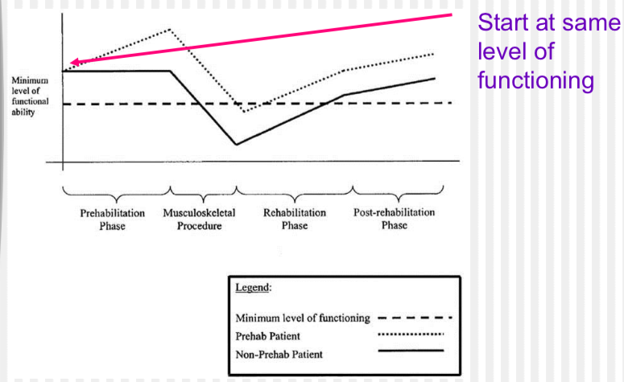
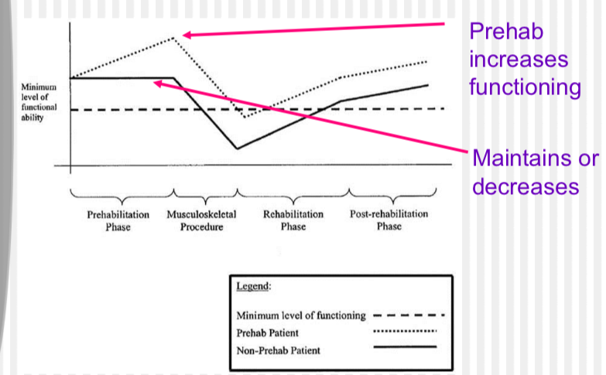
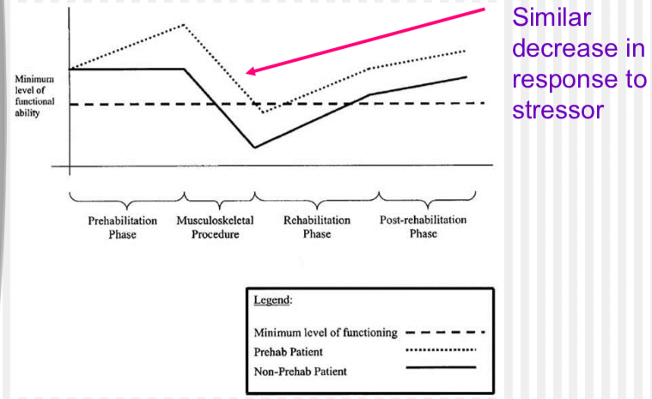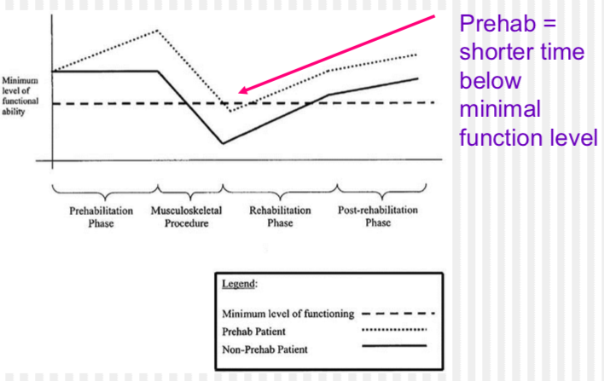
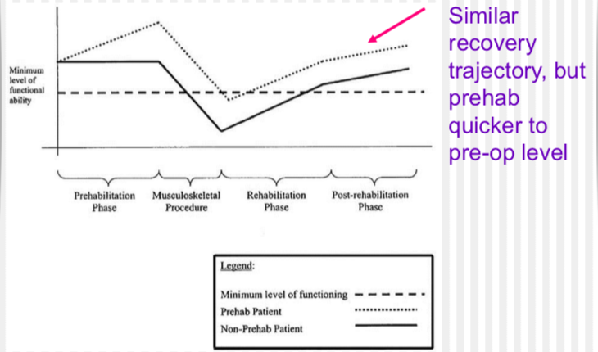

Why might it work?
- Train specific systems that will be affected by the stressors(specificity)
-Ex. Build muscle strength if the stressor will cause strength loss
- Build up a functional reserve to compensate for depletion by the stressor
- training specific systems that will be affected by stressor

Recovery Timeline

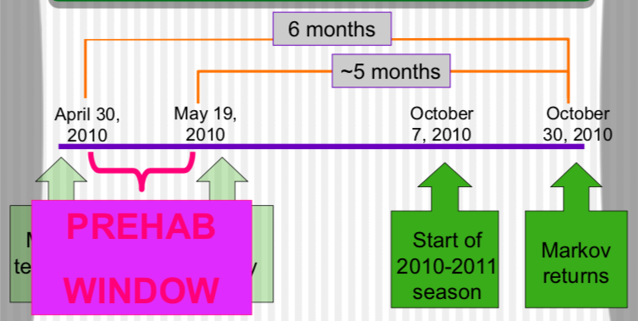

Chronic Conditions
- EX: Osteoarthritis (OA), Coronary Artery bypass grafting (CABG)
- Elective surgery or longer wait times for necessary surgery= larger prehab window

Before Surgery
- Condition continues to get worse
- Patients become more sedentary
- Treatment options have been exhausted
-No active care
-Patients feels like they are “not doing anything”

After surgery
- Get mobile ASAP
-Out of bed day surgery
-Risks with bed rest (stores, atrophy, lethargy)
- Wound closure, prevent infection
- Strength, independence, range of motion

milestones you try to achieve
-rehabilitation starts

Sport Injury VS. Chronic Condition

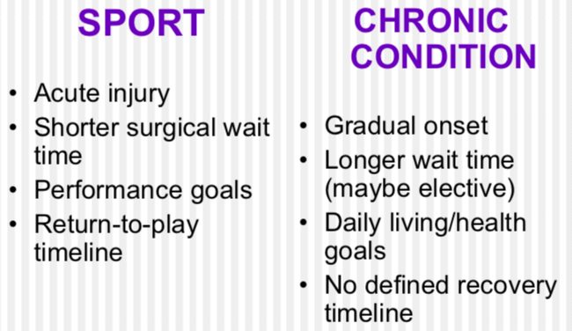

TYPES OF STUDIES
systematic review - has to follow certain procedures
meta-analysis- try to standardized all the study’s

STUDY
Wang, Lee, Zhand, Moodie, Cheng, Martin
“Does preoperative rehabilitation for patients planning to undergo joint replacement surgery improve outcomes? A systematic review and meta-analysis of randomized controlled trails”

Introduction
- finding potentially useful ways to offer patient care…
- Total joint replacement surgery is considered as one of the most successful medical interventions with significant pain relief and improvement in physical function and quality of life for patients with severe osteoarthritis.
- Looking for ways to better improve timelines and extent of recovery for patients undergoing total joint replacement

Design
- Searched databases for randomized controlled trials that compared prehabilitation versus no prehabilitation before joint replacement surgery
- Postoperative pain and function scores were converted to WOMAC pain and functions subscales (0-100, high scores indicate worse outcome)

measures pain and function higher score indicates worse outcome
Weighted mean different - prehab vs non-prehab

Prehab Interventions
- Physiotherapy supervised exercise vs usual care

Outcome Measures
-primary and secondary outcomes
postoperative pain and function scores, time to resume activities of daily living, quality of life, length of hospital stay, total cost, patient satisfaction postoperative complications, any adverse events and discontinuations

- primary outcome womac and secondary outcomes -economic benefits to stay in hospitals

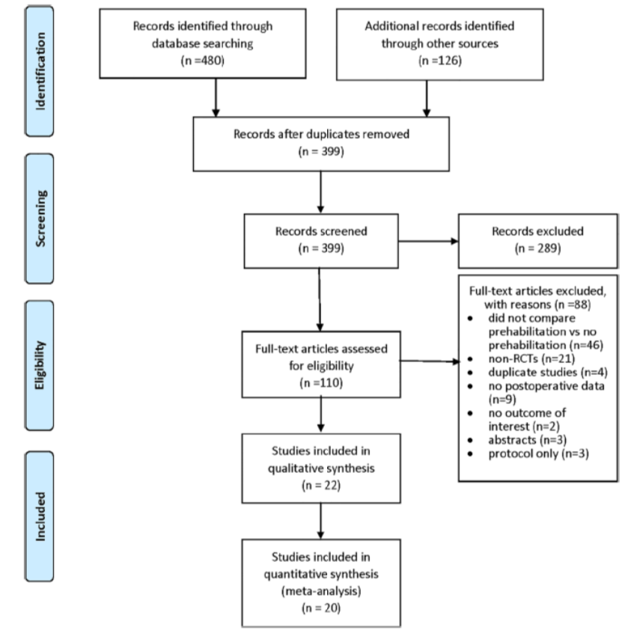
PRISMA flow diagram for selection study
how/why they passed their net and the screening they used to be able to pass their study

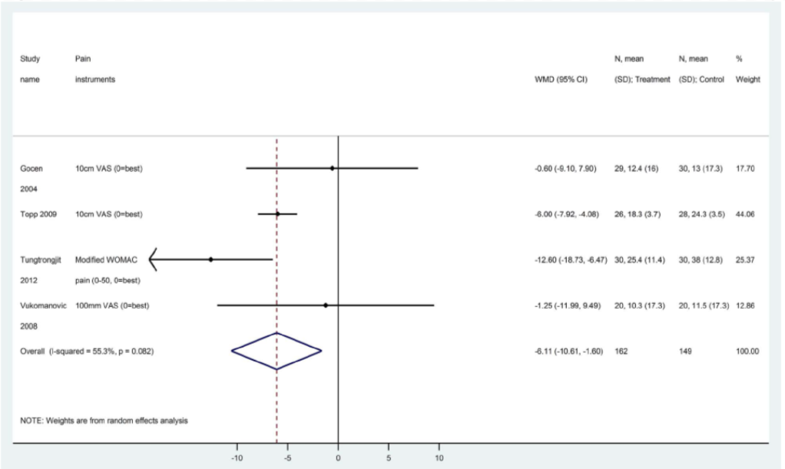
pain scores at week 4

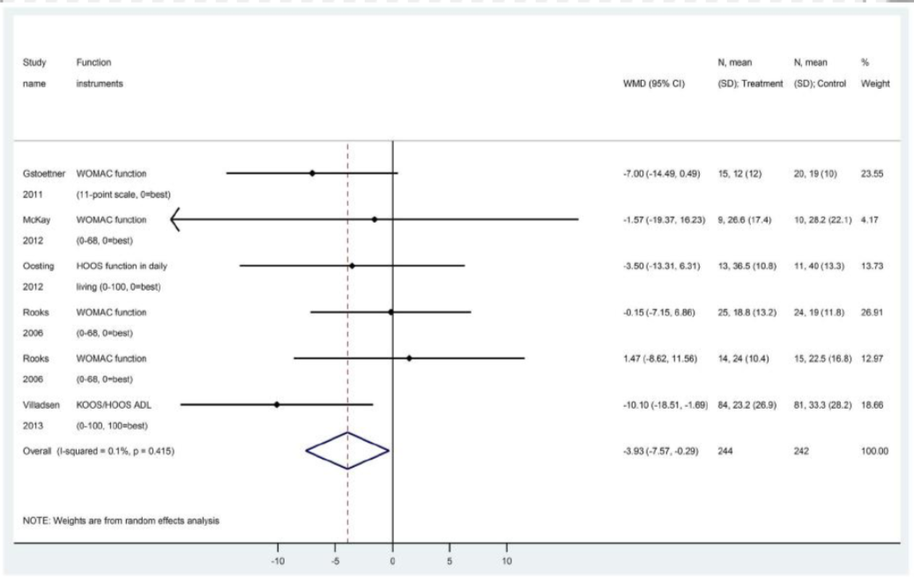
function at 4-6 weeks
average for prehab benefits is 4 points in favor than non-prehab

-4 favor prehab

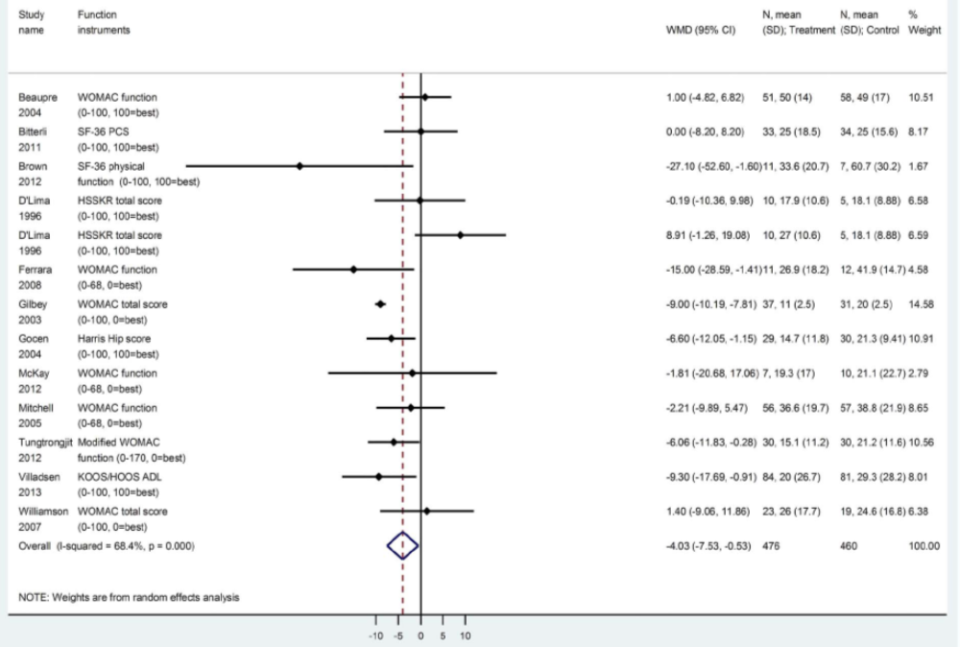
functional score 12 weeks
average of studies is -5

Favors prehab but not by allot

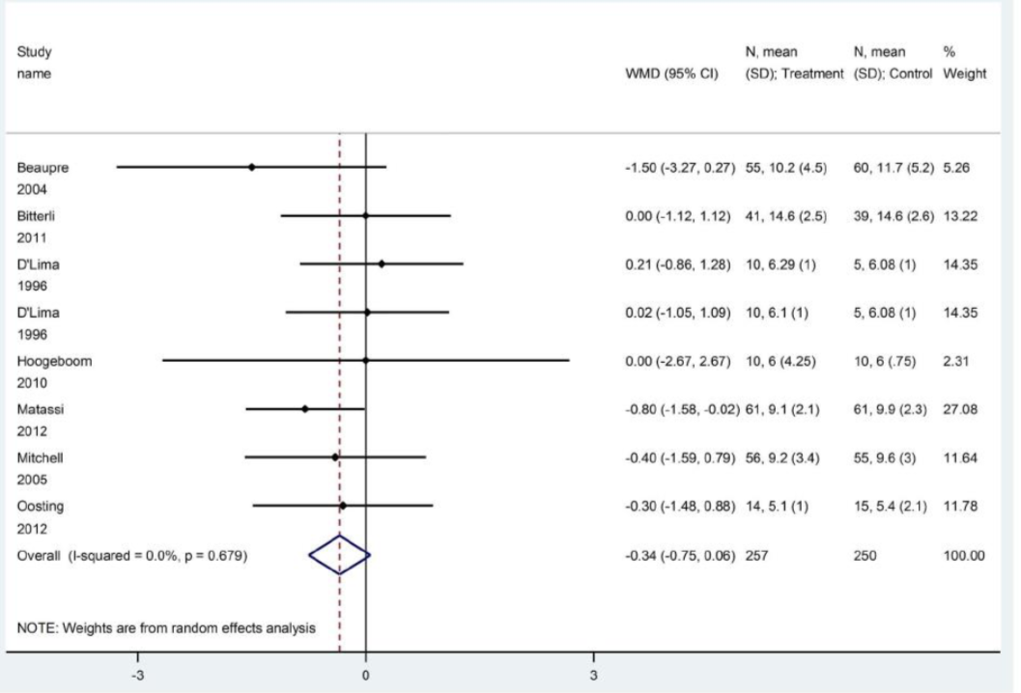
hospital length stay average is favoring prehab
-spending half a day less in hospital

Conclusions
- Existing evidence suggests that prehabilitation may slightly improve early postoperative pain and function among patients undergoing joint replacement; however, effects remain too small and short-term to be considered clinically-important, and did not affect key outcomes of interest (length of stay, quality of life, costs)

Strengths and Limitations
- Strength:
-Converted outcomes to a standardized measurement of WOMAC (Western/McMasters Osteoarthritis index)
- Limitation:
-Compliance was not reported in a number of studies
-No physical measure of function

-strength had objective measure and standardized it limitation***
compliance was not reported in number of studies

-did people actually follow prehab as it was supposed to be no evidence of this people isn’t working the prehab like it’s supposed to be results being understand as they don’t know if results are “legit”

-no physical measure of function but is a self-measure

Another Example
Psychological Prehabilitation before Cancer surgery
prehab not only in injury
been looked at in other domains such as going through prehab before cancer surgery

Rehabilitation Psychology
Response to treatment
Sub-themes
does psychology have a role to play in injury and prevention of injury
stress model of William and Anderson

When someone does get an injury how does psychology help
-imagery and modeling
-watching model with same injury and watch them do the rehab is there added benefit

-last one placebo
Surgical procedure

Placebos
-Placebo (“I will please” in Latin)- the measureable, observable, or felt improvement in health not attributable to treatment
-why would an inert substance (sugar pill) or a fake surgery or therapy be effective?

not getting specific treatment but getting something else
-drug trials. to prove efficacy, have to compare drug with another drug to see there’s is better

- Psychological theory- belief in the treatment or to a subjective feeling of improvement
- The critical factor “is our beliefs about what’s going to happen to us”

hook for placebo -you believe that what u are being given is going to help you

The process-of-treatment theory
- Placebos cause the brain to release endogenous opioids, or endorphins, that reduce pain……
- Showing attention, care, affection etc.…, to the patient/subject triggers physical reactions in the body which reduce stress and promote healing (better immune system response) ……

(placebos can create things in the brain)

Expectation and conditioning
-power of the placebo lies in the expectations of the individual taking them.
-The expectation may cause a DROP-IN STRESS HORMONES or cause them to categorize their symptoms.
-Example a “sharp pain” might instead be perceived as an “uncomfortable tingling”
-On the other hand, if the individual does not expect the drug to work, expects there to be side effects, the placebo can generate negative outcomes

-This can be referred to as nocebo

expectation and conditioning can lead to drop in stress hormones

The placebo effect and the brain
-Brain imaging studies have found measurable changes in the neural activity of people experiencing placebo analgesia. Areas that have been implicated include parts of the brain stem, spinal cord, nucleus accumbens, and amygdala
-Strong placebo responses have also been linked to increases in dopamine and opioid receptor activity
-Both of these chemicals are involved in reward and motivation pathways in the brain. Conversely, nocebo’s have been found to reduce dopamine and opioid receptor activity

-This can be referred to as nocebo

Psychoneuroimmunology
-Psychoneuroimmunology is a relatively new area of scientific study

-It studies the direct effect of brain activity on the immune system

“Just as a dog can be conditioned to salivate at the sound of a bell, so can mice be conditioned to restrain their immune system when presented with a specific stimulus”

dealing with immune system and inflammatory response
-placebo if working will suppress a chronic inflammation

-Expecting improvements in health can impact the efficacy of an individual’s immune system
-The pathway by which the brain impacts the immune system are complex

Evolved health regulation
-body of a mammal has developed helpful physiological responses to pathogens
-fever helps remove bacteria and viruses by raising the internal temperature
-The evolved health regulation in theory suggest that a strong belief in a medication or intervention might relieve symptoms. The brain “decides” it does not need to mount the appropriate response, such as fever or pain

placebo is strong it I will help determine if the body diverts energy

-number of explanations to help us understand placebo

Interesting evidence to support the placebo effect
– Doctors in one study successfully eliminated warts by painting them with a brightly colored, inert dye and promising patients the warts would be gone when the color wore off (Talbot, 2000)

– Patients suffering pain after wisdom-tooth extraction got just as much relief from a fake application of ultrasound as from a real one, so long as both patient and therapist thought the machine was on (Talbot, 2000)

warts- as long as they believed the treatment would help them go away it worked

wisdom tooth- ultrasound machine as long as individual thought machine was on it helped with pain

Further evidence
Even when patients are told a medication they are getting is a placebo, it still can ease symptoms and pain. Prof. Kaptchuk (Director of the Program in Placebo Studies and Therapeutic Encounter at Beth Israel Deaconess Medical Center in Boston) says he found this to be true in a randomized controlled trial of 80 patients with irritable bowel syndrome published in the journal PLOS One in 2010, and in a 2014 study in Science Translational Medicine involving 66 migraine patients.

FUN FACTS ON PLACEBOS

The placebo effect has been measured in thousands of medical experiments, and many doctors admit to regularly prescribing placebos.

Drug companies must show that their new drugs work better than a placebo before the drugs are approved.

Placebos have been shown to affect a range of health conditions.

The color of a tablet can alter the strength of its placebo effect, and larger pills induce a stronger effect than smaller pills.

One review of multiple studies found that even the color of pills made a difference to the placebo results.

"Red, yellow, and orange are associated with a stimulant effect, while blue and green are related to a tranquilizing effect."

measured many times
-drug companies must show drug is better than placebo before being approved
-affected wide range of health conditions
-looked at in granular level (can the color of pill make a difference)
red, yellow, orange stimulant effect
blue green tranquilizing

Placebos have been shown to produce measurable, physiological changes, such as an increase in heart rate or blood pressure. However, illnesses that rely on the self-reporting of symptoms for measurement are most strongly influenced by placebos, such as depression, anxiety, irritable bowel syndrome (IBS), and chronic pain.

Placebo interventions vary in strength depending on many factors. For instance, an injection causes a stronger placebo effect than a tablet. Two tablets work better than one, capsules are stronger than tablets, and larger pills produce greater reactions.

measure changes in heart rate and blood pressure
vary in strength
depending on lots of factors

STUDY: Moseley A controlled trail of arthroscopic surgery for osteoarthritis of the knee

surgery in knee very common
shame surgery …create scenario where individual thinks that they are getting the surgery

Knee surgery vs. sham surgery
- Osteoarthritis (breakdown of cartilage in the joints) afflicts more than 20 million Americans
- Arthroscopic surgery-damaged cartilage is scraped (debridement) or flushed out (lavage) with the aid of a viewing scope is a common option
- Surgery is performed approximately 200,000 per year

ETHICS?
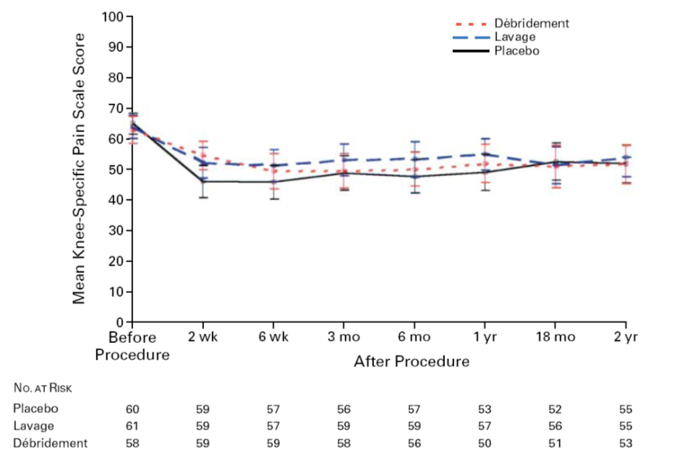

y axis mean knee specific pain vs timeline

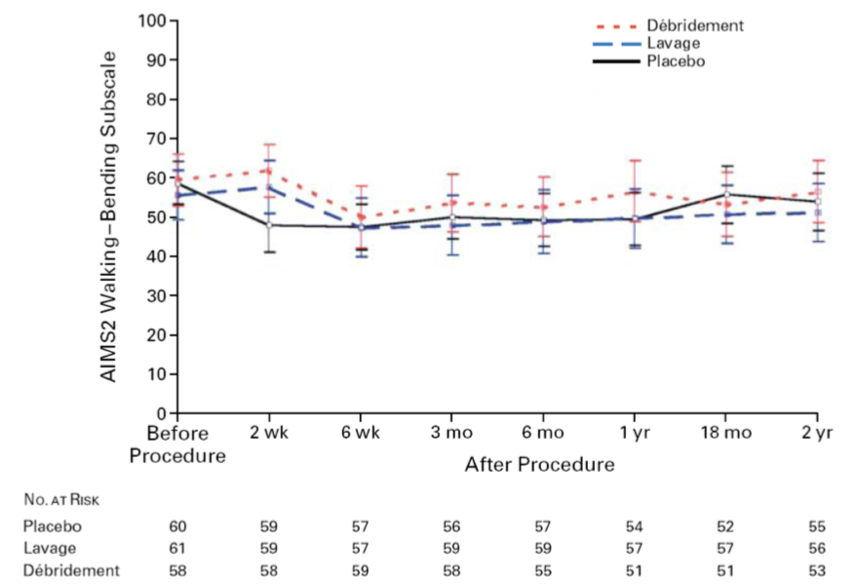
mean values for walking-bending subscale
-people with knee pain give scores for activities -difference is not any different between 3

J. Bruce Mosely – A Controlled Trial of Arthroscopic Surgery for Osteoporosis of the Knee
􏰀
Patients that suffered from osteoarthritis (the breakdown of cartilage in the joints) in the knee received arthroscopic surgery to remove the damaged cartilage (debridement) or flushed out (lavage) with the aid of a viewing scope a common option
􏰀Used a placebo surgery as well as both treatments to determine whether it was the patient’s expectancy that the treatment would improve their condition or if it was the actual treatment – results were measured over two years to determine the effectiveness of the treatment
Placebo group compared to the patients that had received the actual treatments demonstrated that they experienced a decrease in pain similar to the patients that had received the actual treatment. There was a decrease in the walking/bending scale and the result

patients feel less pain not because of surgery but because of placebo

- Summary: patients feel less pain and can function better due to the placebo effect not the surgery
- Implications:
o Ethical: the deceit of sham (fake) surgery vs. false benefits of the actual surgery – is it ethically right to do a treatment that is considered fake but has real results
o Insurance: should the insurance companies continue to cover the cost of the surgery even though it is a sham and the results are based on the patient’s beliefs?

Treatment is not the sole contribution to feeling better, it is a combination of treatment and the patient’s belief that it will work

Important Message: Placebo’s are very powerful!

Depression and Mental Health

Depression: there is a need to understand the treatment as a means to help the person, looking at the health and exercise as a means of treatment

A person that experiences feelings of depression often feels like they are in a physical state of exhaustion
- Depression affects bout 1212 million people worldwide
- 13% of Americans experience major depression over the course of their life
- 7% suffer from a major depressive disorder in an given year
- Fewer than 25% of those affected have affect to effective treatment
- Women experience depression more than men as women are more expressive and in-tune with Their emotions thus they are at a greater risk to experiencing depression in their lifetime

Depression is the leading cause of disability as measured by years lived with disability and is the fourth leading contribute to the global surge of disease

GBD: the sum of years of potential life lost due to premature mortality and the years of productive life lost due to their disability

Anxiety and depression are not accepted as a disease as there is no biological test to determine if a person suffers with it

The affect depression has on the family
Mood: a specific short-term feeling state or emotional tone which can be either positive or negative
Anxiety: an unpleasant feeling state and physiological reaction that occurs when fear is provoked – affective, physiological, cognitive and behavioral aspects
- Trait anxiety: underlying current resulting in an anxious individual
- State anxiety: the situation that you are in determines how much anxiety you experience

Depression: the state that eventuates from perception of an important loss of the threat of such a loss
- Affective, physiological, cognitive and behavioral aspects
- Characterized by avoidance withdrawal, diminished activity

Diagnosis for Depression
-Since there is no biological marker/test that is available to determine whether someone is suffering from depression or not a diagnosis is determined by a psychologist

-DSM-IV: medical experts have established 2 core and 9 other symptoms associated with depression, four of which are psychological and five physical
- 􏰀 In order for someone to have depression they must have at least one of the core symptoms and five or more of the other symptoms present in the same two-week period within the last month

Core symptoms:
1.Depressed most the day nearly every day
2.Interested in pleasure in all or almost all activities most of the day nearly every day

Other symptoms:
1.Feeling guilty, hopeless and worthless
2.Recurring suicidal thoughts
3.Having trouble sleep or sleeping too little/much
4.Trouble concentrating
5.Feeling little energy or unexplained tiredness
6.Agitation or slowing down of body movement

Other types of depression:
Bipolar disorder: alternating episodes of emotional highs (mania) and lows (depression)

Dysthymia: mild depression symptoms that last two years or longer

Postpartum depression: a type of depression that occurs in the mother after her baby is born
Seasonal affective disorder (SAD): a major depression that occurs during seasons with low sunlight

Depression can co-exist with other health problems such as anxiety disorders, alcohol or substance abuse, heart disease, stroke, cancer, HIV/AIDS

Measuring Depression
Depression can be measured by using psychometric scales which can determine if people are at risk for developing depression

Beck Depression Inventory: used to assess the presence and the intensity of depressive symptoms in psychiatric populations
􏰀
-- This is a self-report assessment in which there are 21 items to assess the symptoms, attitudes and intensity of depression
--Uses a scale from 0-3 for intensity, 3 being the highest
--The sum of the score determines the intensity of depression
- 0-9 = none, 10-18 = mild, 19-29 = moderate and 30-63 = severe

Center for Epidemiological Studies Depression Scale: used to assess presence and intensity of depressive symptoms in the general population
- Self-report or 20 items
- 6 domains of symptoms
- Scored 0-3 from ‘rarely’ to ‘all the time’
- Summed to give total score
- >16 = depression

Hamilton Rating Depression Scale (HRDS):
- Self-report
- 21 items on a 0-4 scale
- Depressed mood, feelings of guilt, suicide, insomnia, work and activities, psychomotor retardation, agitation, anxiety (psychological and somatic), libido, hypochondriasis, loss of weight, insight, diurnal, paranoid, obsessional and compulsive symptoms

Causes of Depression
Researchers believe that specific brain chemicals, nerve connections, nerve cell growth and the functioning of nerve circuits have a major impact on depression but the understanding of the neurological underpinnings of mood is incomplete

The causes of depression are not well known however there is a combination of genetics, biological, environmental and personal factors that are at work

Neurotransmitters: a chemical signal that passes along from one nerve cell to another in the brain – this is done by the chemicals dopamine, serotonin and norepinephrine
Serotonin: receptors may be insensitive to serotonin causing their response to it to be inadequate
􏰀 Message might be weakened if the originating cell pumps out too little serotonin or it could be overly efficient thus the original cell will uptake the extra serotonin that didn’t bind to the receptor
􏰀 By keeping serotonin levels that allow communication between nerve cells strengthen circuits to the brain which regulate mood When faced with sadness, relapsing patients showed more activity in a frontal region of the brain known as the medial prefrontal gyrus
􏰀 Responses in the frontal region are also linked to higher rumination scores and the tendency to think obsessively about negative events
􏰀 Dr. Norman Farb: ‘For a person with a history of depression, using the frontal brain’s ability to analyze and interpret sadness may actually be an unhealthy reaction that can perpetuate the chronic cycle of depression
􏰀 Dr. John Krystal: ‘Relapse is one of the most vexing problems in depression treatment. Having a biomarker for relapse could guide a new generation of treatment research’ Depression can be associated with the loss of volume in parts of the brain, namely the hippocampus which belongs to the limbic system (the emotional center of the brain) and is important in the consolidation of information form short-term memory to long-term memory
􏰀 The more severe the depression, the greater the loss of brain volume Hormonal imbalance: the postulated mechanism behind this atrophy is cortisol-mediated neurotoxicity
Hypothalamic-pituitary-adrenal (HPA) axis 􏰁 distress 􏰁 hypothalamus-produces corticotrophin releasing factor (CRF) 􏰁 stimulates pituitary-gland to release stress hormone cortisol
Setiawan: Role of Translocator Protein Density, a Marker of Neuroinflammation in the Brain During Major Depressive Episodes
Inflammation is the body’s immune response to infection and trauma thus one theory is that depressed patients may have been exposed to an infection or trauma and their brain has yet to cool off from the experience
Neuroinflammation: PET scans use a radiopharmaceutical that binds to the translocator protein (TSPO) in microglia cells. Level of protein is increased in activated microglia cells = elevated translocator density
􏰀 Positron emission tomography (PET): uses small amounts of radioactive materials called radiotracers, a special camera and a computer to help evaluate your organ and tissue functions
Microglia: type of glial cell that are the resident macrophages of the brain and spinal cord and thus act as the first and main form of active immune defense in the central nervous system (CNS)
Macrophages: type of white blood cell that engulfs and digests cellular debris, foreign substances, microbes
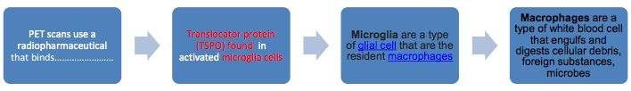
Design: Case-control in which 20 patients with a major depressive episode (MDE) secondary to major depressive disorder and 20 healthy controls
Implications: brain inflammation and more specifically microglia activation is implication in major depressive episodes
􏰀 Unable to determine whether the Neuroinflammation occurs before depression or because of it
􏰀 Suggests that treatments should be designed to reduce microglia activation in depressive patients Capsi et al 2003: Depression tends to run in families so researchers believe that certain genes may be associated with developing it
􏰀 If someone has a parent or sibling with major depression, that person has a 2 or 3 times greater risk of developing depression (20-30%) compared with the average person (10%)
􏰀 It one twin developed depression the other twin also suffered from depression is 46% for identical twins compared to 20% for fraternal twins Researchers at Wisconsin and Otago analyzed the type of 5-HTT gene carried by 847 adults – the 5-HTT gene helps regulate serotonin 􏰀 There are two forms of the 5-HTT gene, the long and the short – an individual can inherit two copies of the long form, two of the short 􏰀 The short version of 5-HTT is not as effective in controlling the serotonin flow as the long version 􏰀 Researches focused on subjects who has traumatic life events over a five-year period o Patients with at least one copy of the short form of 5-HTT were more at risk of depression: 33% diagnosed with depression after experiencing four traumatic events o Patients with only the long 5-HTT gene were more resistant to depression: 17% diagnosed with depression after experiencing four traumatic events Stressful events such as the loss of a loved one, a major life change or a serious illness have been known to trigger depression

Environment
• Stressful events such as the loss of a loved one, a major life change, or a serious illness, have been known to trigger depression

Individual Differences (personal- negative thought processing)
(Burns et al., 2002)
• Pessimistic—attributional style (internal, stable, and global)—hopeless
• Optimistic—attributional style (external, unstable, and specific)—hopeful

Other personality styles
“shy” people who are often this way due to having been bullied or humiliated in their early years. They often view social interactions with others as threatening in comparison to the safety of their own company

those who are “hypersensitive” to judgement by others. This could be praise or feeling (perhaps inappropriately) they are being rejected or abandoned. These people often respond by sleeping more and craving certain foods that may settle their emotional dysfunction
“self-focused” individuals who are hostile and volatile with others, blame others when things go wrong and priorities their own needs. When depressed, they tend to show a “short fuse” and create collateral damage for those around them

perfectionists who are prone to self-criticism and a loss of pride. They may also have a limited range of adaptive strategies to stress.

Take home message
The causes of depression are multifaceted

Eating Disorders

Differentiate between eating disorder and disordered eating
eating disorder is something that has actually been clinically diagnosed

disordered eating can be behaviors that you are doing that can put you at “risk” for an eating disorder
-unhealthy eating habits that may dispose a person to an eating disorder

What is the DSM IV diagnostic criteria for Anorexia Nervosa?
DSM manual operational criteria for being diagnosed with eating disorder

Provides guidelines and criteria for mental disorders

Anorexia Nervosa
The DSM-IV criteria for Anorexia Nervosa is as follows:

A. A refusal to maintain body weight at or above a minimally normal weight for age and height (e.g. weight loss leading to a maintenance of body weight less than 85% of that expected (BMI of 17.5 or lower), or failure to make expected weight gain during period of growth, leading to body weight less than 85% of that expected).

B. Intense fear of gaining weight or becoming fat, even though underweight.

C. Disturbance in the way in which one's body weight or shape is experienced, undue influence of body weight or shape on self- evaluation, or denial of the seriousness of the current low body weight.

Anorexia Nervosa
It is the refusal to maintain body weight at or above a minimum, 85% of that expected
There is an intense fear of gaining weight or becoming fat even though they are underweight
The influence of body weight or shape on self-evaluation or the denial of the seriousness of the current low body weight

Someone with clinical training needs to be able to determine if the criteria is followed
-for anorexia nervosa (AN)

Specify type:

Restricting Type: During the current episode of Anorexia Nervosa, the person has NOT regularly engaged in binge-eating or purging behaviour (i.e. self-induced vomiting or the misuse of laxatives, diuretics or enemas)

Binge-Eating/Purging Type: During the current episode of Anorexia Nervosa, the person has regularly engaged in binge-eating or purging behaviour (i.e. self-induced vomiting or the misuse of laxatives, diuretics or enemas).

Anorexia vs. Bulimia: What’s the Difference? Is there a difference?
Anorexia and bulimia are both eating disorders. They can have similar symptoms, such as distorted body image. However, they’re characterized by different food-related behaviors.

For example, people who have anorexia severely reduce their food intake to lose weight. People who have bulimia eat an excessive amount of food in a short period of time, then purge or use other methods to prevent weight gain.

Bulimia- have similar symptoms but are different
AN-Severely reduced intake of food to lose weight
Bulimia- Eat excessive amount of food in short periods of time then purge in way to prevent weight gain
*Important different

Anorexia
Anorexia often stems from a distorted body image, which may result from emotional trauma, depression, or anxiety. Some people may view extreme dieting or weight loss as a way to regain control in their lives.

There are many different emotional, behavioral, and physical symptoms that can signal anorexia.

One reason that individuals gravitate to food intake is they have good control

The physical symptoms anorexia can be severe and life-threatening. They include:
severe weight loss insomnia dehydration constipation weakness and fatigue dizziness and fainting thinning and breaking hair bluish tinge to the fingers dry, yellowish skin inability to tolerate cold amenorrhea, or absence of menstruation downy hair on the body, arms, and face arrhythmia, or irregular heartbeat

Someone with anorexia may exhibit certain behavioral changes before physical symptoms are noticeable.
This includes:
•skipping meals
•lying about how much food they’ve eaten
•eating only certain “safe” — usually low-calorie — foods
•adopting unusual eating habits, like sorting food on the plate or cutting food into tiny pieces
•talking badly about their body
•trying to hide their body with baggy clothes
•avoiding situations that could involve eating in front of other people, which can result in social withdrawal
•avoiding situations where their body would be revealed, like the beach
•extreme exercising, which may take the form of exercising for too long or too intensely, like an hour-long jog after eating a salad

behavioral changes - don’t need to know but be able to see the kinds of behaviors that are typically associated with someone with this condition
-exercise in anorexic framework is bad not good at all

Emotional symptoms of anorexia may increase as the disorder progresses.
They include:
- poor self-esteem and body image
- irritability, agitation, or other mood changes
- social isolation
- depression
- anxiety

Bulimia
Someone with bulimia may develop an unhealthy relationship to food over time. They may get caught up in damaging cycles of binge eating and then panic about the calories they’ve consumed. This may lead to extreme behaviors to prevent weight gain

About weight gain not weight loss, Go through cycle of binging and purging

- There are two different types of bulimia. The attempts to purge are used to differentiate them. The new edition of the diagnostic and statistical manual of mental disorders (DSM-5) no refers to attempts to purge as “inappropriate compensatory behaviors”
Purging bulimia: someone with this type will regularly induce vomiting after binge eating. They may also misuse diuretics, laxatives, or enemas.
Non-purging bulimia: Instead of purging, someone with this type may fast or engage in extreme exercise to prevent weight gain after a binge

- Many people with bulimia will experience anxiety because their eating behavior is out of control
- As with anorexia, there are many different emotional, behavioral, and physical symptoms that can signal bulimia

Control issues as well
-different from anorexia as they are LOSING control as they can’t control the binge/purging
but with AN they can control their eating to the point that it is dangerous
AN-Strong need to control and BU there is a loss of control

The physical symptoms of bulimia can be severe and life-threatening. They include:
•weight that increases and decreases in significant amounts, between 5 and 20 pounds in a week
•chapped or cracked lips due to dehydration
•bloodshot eyes, or eyes with busted blood vessels
•callouses, sores, or scars on the knuckles from inducing vomiting
•mouth sensitivity, likely due to eroding tooth enamel and receding gums
•swollen lymph nodes

Someone with bulimia may exhibit certain behavioral changes before physical symptoms are noticeable. This includes:
•constantly worrying about weight or appearance
•eating to the point of discomfort
•going to the bathroom immediately after eating
•exercising too much, especially after they’ve eaten a lot in one sitting
•restricting calories or avoiding certain foods
•not wanting to eat in front of others

Emotional symptoms may increase as the disorder progresses. They include:
•poor self-esteem and body image
•irritability, agitation, or other mood changes
•social isolation
•depression
•anxiety

Although eating disorders aren’t specific to age or gender, women are disproportionally affected by them. About 1 percent of all American women will develop anorexia, and 1.5 percent will develop bulimia, according to the National Association of Anorexia Nervosa and Associated Disorders (ANAD).

Overall, ANAD estimates that at least 30 million Americans are living with an eating disorder such as anorexia or bulimia.

percentage is allot lower
1 percent of all American women will develop anorexia

•Some studies have found that young men represent about 10% of individuals with eating disorders (Steiger and Séguin, 1999).
•Men are more likely to be affected by binge eating disorder than any other type of eating disorder (Public Health Agency of Canada, 2002).

Perfectionism

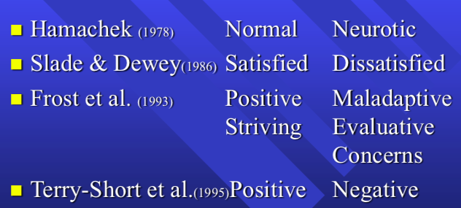

Theoretical distinction of perfectionism
Terry-short et al. (1995)
Based on behavioral theory (achieving positive consequences vs avoiding negative consequences)

psychological concept of perfectionism

UNHEALTHY PERFECTION-Neurotic dissatisfied maladaptive evaluative concerns negative
HEALTHY PERFECTION-normal satisfied positive striving

Scale that shows neg. perfectionism and pos. perfectionism
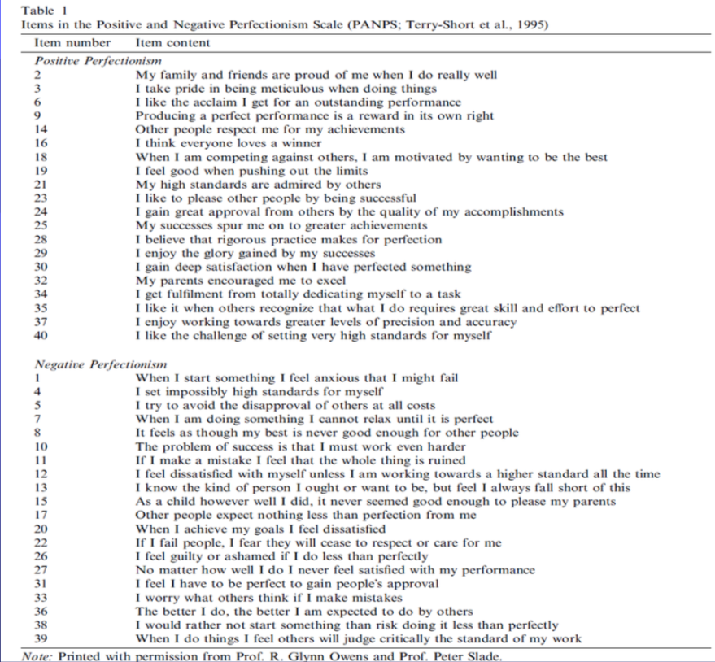

Eating disorder
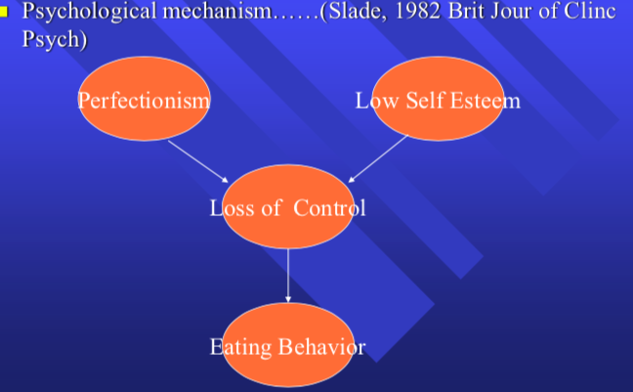

Loss of control-feel that world is spinning out of control things that contribute to this (mostly women)
-> Low self esteem
-> High amounts of (negative) perfectionism
-> Eating behavior

- Physiological mechanism… (Kaye & Strober, 1999 Eating Dis Rev)
-Eating disorder patients have abnormally high levels of serotonin (neurotransmitter that regulates mood and emotion)
-controlling (restricting) food intake lowers serotonin levels to make patients feel better (makes them feel less anxious)

physiological mechanism
-serotonin -> neurotransmitter that regulates mood and emotion
patients with depression have high levels of serotonin
-engaging in behaviour as the restricted eating (controlling) is helping them lower their serotonin levels which makes them feel better
***know this

Prevalence of Eating Disorders in Athletes
Athletes may share many of the same psychological factors that have been implicated in the development of eating disorders within clinical populations. These psychological factors include high levels of competitiveness (Borgen & Corbin, 1987), high emphasis on control (Slade, Newton, Butler, & Murphy, 1991)
and perfectionist tendencies (Taub & Benson,1992)

Athletes may also represent a high-risk population for disordered eating behavior because it is assumed they are exposed to body shape and weight pressures unique to sport (Leung, Geller, & Katzman,1996)

STUDY: Borgen & Torstveit : Prevalence of eating Disorders in Elite Athletes is Higher Than in the General Population

comparing athletes who are involved in sports that put an emphasis on figures

studies have suggested higher frequency of eating problems in athletes compared to nonathletes especially in those competing in sports that emphasize leanness or a low body weight
some studies suggest a similar or lower risk for eating disorders compared to controls for female athletes in aesthetic sports and running and female athletes of lower competitive level.
few studies included male athletes some indicate an increased risk for eating disordered in male athletes competing in weight class sports such as wrestling and rowing and lower risk for EDs in male figure skaters and swimmers

Design: A 2 step study with self-reported questionnaire and clinical interview
Setting/Participants: entire population of Norwegian male and female elite athletes and controls was evaluated for the presence of eating disorders
Main outcome Measurement: based on results of questionnaire, all athletes and controls classified as risk for EDs and a representative sample of athletes and control classified as healthy participated in the clinical part of the study to determine the number of subjects meeting the diagnostic and statistical manual of mental disorders-IV criteria for EDS

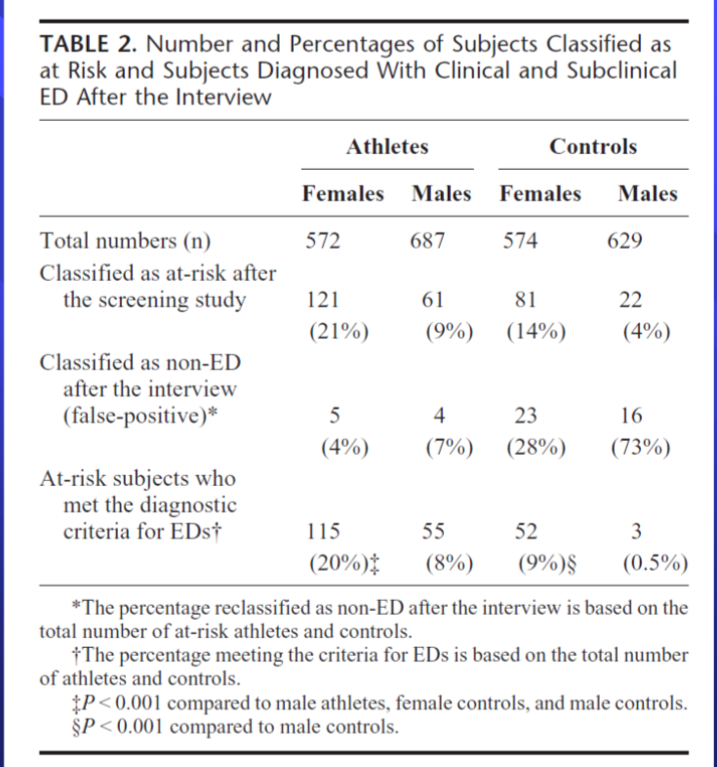

Total number of female and male athletes and control group
-number and percentage
-ignore false positive
-least at risk male control
-male athletes have same risk as female control
-athletes are at higher risk female or male

Results: More athletes (13%) than controls had subclinical or clinical EDs. The prevalence of EDs among male athletes was greater in antigraviton sports (22%) than in ball game (5%) and endurance sports. The prevalence of EDs among female athletes competing in aesthetic sports (42%) was higher than that observed in endurance (24%), technical (17%) and ball game sports (16%)
antigravitation sports -gymnastics
males are higher than in endurance sports
(higher in sports that put an emphasis on sports that involve leanness-dependents and weight dependent sports)
Conclusions: The prevalence of EDs is higher in athletes than in controls, higher in female athletes than in male athletes, and more common among those competing in leanness-dependent and weight-dependent sports than in other sports. A collaborative effort among coaches, athletic trainers, parents, physicians and athletes is optimal for recognizing, preventing, and treating EDs in athletes

EDs in sports that indivduals are very concerned about thier leanness and weight for the sport

STUDYS: Hasse, Prapavessis, Owens: Perfectionism and Eating Attitudes In rowers: the moderating effects of body mass, weight classification and gender

‘Leanness’ VS. ‘Non-Leanness’ Sports
Athletes may be at greater risk of developing an eating disorder in sports where leanness is emphasized

Psychological factors among athletes
- Similar characteristics to eating disorder patients
- Perfectionism

Perfectionism relating to eating disorders
- How do positive and negative perfectionism relate to disturbed eating attitudes among athletes?
- What conditions and/or factors influence that relationship?

Participants
- New Zealand and Australian national rowers

Measures
- Positive and negative perfectionism scale
- Eating attitudes test 40
- Body mass index (BMI= weight/height)

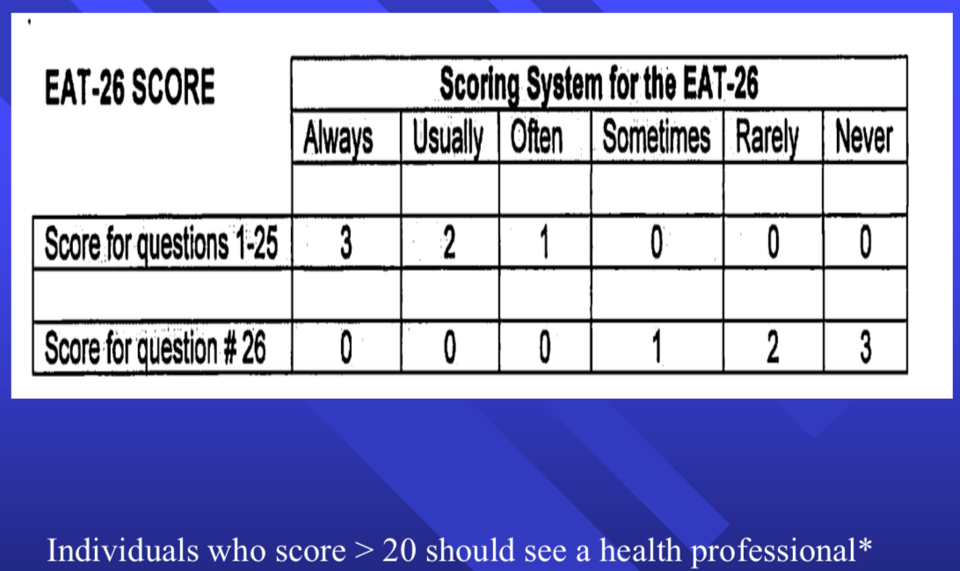
For the EAT-26 what is the number that needs to be surpassed to be associated with ED
(20)
10
25

Negative perfectionism-EAT relations in Female lightweight Rowers with High and low BMI
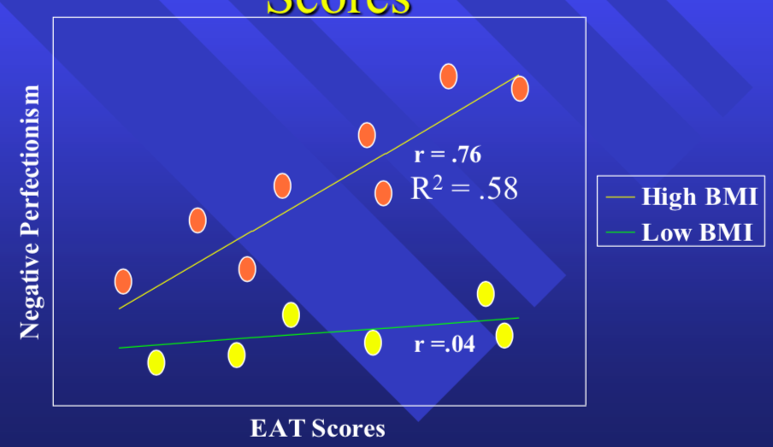

y axis
neg perfectionism
x axis EAT scores
relationship that shows as their neg perf. goes up is related to their EAT score
Individuals with High BMI and low BMI
(female lightweight rowers)
when female LW rowers with lower BMI profile are looked at the relationship with NEG perf. and EAT score is very low not much
BUT when female LW rowers with high BMI the relationship of NEG perf. with EAT scores is high
-Very different profiles
depending on BMI high vs low
-No data for male athletes, as these findings don’t apply to male LW rowers but only females
-if you substitute Pos Perf. there is nothing
when in relation to EAT scores
-As positive perfectionism is not but cannot be too much of it

Conclusions
- Negative perfectionism is positively related to disturbed eating attitudes
- Positive perfectionism is unrelated to disturbed eating attitudes
- Body mass, weight classification and gender moderate relations between Negative perfectionism and disturbed eating attitudes
- Specifically, Negative perfectionism--- disturbed eating attitudes relations are maximized for lightweight female rowers with greater body mass

Future Recommendations
Underlying mechanism for conjunctive moderator effect- need for control
Lack of relations between positive perfectionism and disturbed eating attitudes---(suggest an avenue for intervention)
Translation in to psychopathology

Prevalence
Approximately 1% of the population has/had an eating disorder
Prevalence rates of anorexia and bulimia appear to increase during the transition from adolescence to young adulthood
Young men represent about 10% of individuals with eating disorders 􏰀
  - They are more likely to be affected by binge eating disorders than any other type of eating disorder

Anorexia Nervosa has the highest mortality rate of any psychiatric illness
  - 􏰀 10% of individuals with Anorexia Nervosa will die within 10
years of the onset of the disorder

Influence
28% of girls in grade 9 and 29% in grade 10 engage in weight-loss behaviors

37% of girls in grade 9 and 40% in grade 10 perceive themselves as too fat even amount students of normal BMI 19% believe that they are too fat

Grades 7–12, 30% of girls and 25% of boys reported teasing by peers about their weight, teasing has been persistent at home
  - 􏰀 29% of girls and 16% of boys reported having been teased by a family member about their weight

Body-based teasing can have a serious impact on girls’ attitudes and behaviors 􏰀
  - According to one study, girls who reported teasing by family member were 1.5x more likely to engage in binge-eating and extreme weight control behaviors give years later

Treatment
Psychotherapy: emphasis is placed on thoughts, emotions, behavior, patterns of thinking, motivations and relationships

Family approaches: to treat the person with the eating disorder, while support and educating the entire family about how to provide appropriate care
  - 􏰀 Focus can also be placed on strengthening family relationships and improving the family dynamic

Nutritional management: provided by a dietitian or nutritionist during treatment, they can also sometimes be provided by a GP
  - 􏰀 Has been designed to ensure that the person with the eating disorder is receiving the right level of vitamins and minerals throughout the treatment process and to help develop normal and beneficial eating habits and behaviors

Medication: often vital when someone with an eating disorder also has another type of disorder or illness such as depression, anxiety or insomnia
  - 􏰀 This is known as co-morbid disorder
  - 􏰀 Medications can be prescribed by psychiatrists or by medical doctors and should only be used in conjunction with another treatment approach

