GREEK MYTHOLOGY LECTURE NOTES

Primary Sources and Greek Identity

Lecture Topics
· Intro (contexts, sources, meaning)
· Creation Myths
· The Divine being
· Heroic Exploits
o Whether achieved by mortals or divine beings
Creation Myths
· Creation of the first element, then divine beings, and then humans
· Images will be a part of exam
· Image of Aphrodite being born from a sink
· Divine beings are not born like humans
o Athena popped out of Zeus’s head
· Creation of humans (different versions)
o The God of fire (created the first woman) out of earth
Battle of the Gods
· Against the titans, giants, etc
· Athena the goddess of war and wisdom battling a giant
Acts of gods and goddesses
· A lot of rape
· Acts that we heavily condemn today (Greeks were not morally perfect, but were physically perfect)
· 19thcentury painting of Zeus and Hera (maneuvering of Hera and how she deceived Zeus)
· Chase of Apollo of Daphne
Mortal Heroic beings and fabulous creatures
· Hercules – hero of Greece
· Not just monsters
· Human beings that defy the norm – fighting women
· Amazons don’t behave like other women in ancient Greece
The Trojan War
· 3 Goddesses having a contest of who’s the most beautiful
· Slaughter of Hector by Achilles
The Odyssey
· Odysseus is very cunning and finds different ways to survive
· Titan Goddess, daughter of Uranus
· Wants to listen to the creatures (sirens) – tied to the mast
Mnemosyne – Titan goddess of memory
· Memorize names and myths, plots and variation
· She represents the idea of memorisation required to preserve the stories of history
· She was attacked by a bird who took the form of Zeus
· She had 9 daughters (9 muses) – spirits of inspiration that inspired many things
Goddesses of poetry and oral tradition

Assignment:
· Narrate the myth in your own way
· Find 2 articles or chapters related
· 2 images (1 ancient) and 1 modern and how they portray the myth or hero
· Connect the myth or hero to the modern society, pop culture, or literature, products

Primary Sources of Greek Mythology
- Primary sources of greek mythology include written (ancient texts) and visual (ancient art images) sources
- Ancient texts were written by ancient writers
  - Literature, historiography, philosophy
  - Written on papyrus (papyri, plural)
- Homer composed two poems: the Iliad and the Odyssey
  - His book was found from the 13th century and is an example of a primary source of Greek mythology
- Other texts include: Theogony, Works and Days, Homeric Hymns, Tragedies, Metamorphoses (transformation of humans to animal)
- Visual sources of Greek mythology include pottery, statues (free standing or on temples), buildings, coins, rings...etc.
- Visual sources serves as a source of conversation so people could talk about the myths in private or public settings
  - Greek culture was very visual, objects such as vases portrayed myths
- Excavators found these myths because even if the bases and pots were broken the myths could be pieced together (cannot do this with cloth or paintings)
- On visual representation of myths, figured were either black or red
- Completely black figures were said to be male as they would be darker since they worked outside.
- Figures that were whilte were predominantly women, because they didn’t work outside
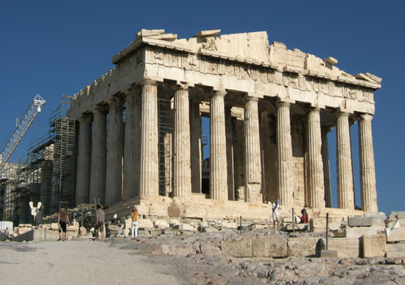
- Metopes = section on temples that had some myths sculpted
Context of Myth telling
- Myths were told in private (home, meetings, parties (symposia)...etc.) or public (epic poetry, choral poetry and drama) settings
  - Performances were used as a way to narrate myths
- Symposia → Sym = together, Posia = drink
- Myths were told in public (performances; epic poetry, choral poetry and drama)
  - Epic poetry = long, follows a certain beat (do not rhyme but follow a particular beat based on the length of the syllables) and lists certain achievements of heros (why they are so long)
  - Choral poetry = performed when praising a god
  - Drama = ancient theatre, comedies and tragedies
- Recited by professional bards to the accompaniment of a musical instrument
- Ay public events (festivals or at king’s court)
- The earliest written texts:
  - Iliad: 15,000 lines
  - Odyssey: 12,000 lines
  - Arranged in 24 books each
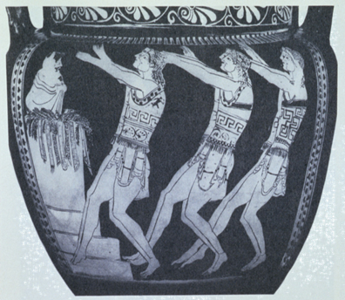 | In this image you can see a choir of men in front of an altar (object where you perform sacrifices or there’s a statue of a god). The choir is singing a song about the achievements of the god.
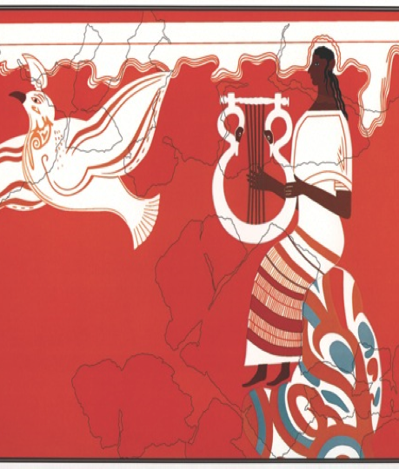 | In this image, an Epic poet is depicted and he is singing and playing an instrument. We know the poet is male because the skin is completely dark. The bird signified the poet’s words. Words were often described as winged because they fly out of your mouth. One of the first images of an epic poet.
Myths performed:
- The Epic Poetry
- Homer (ca 750 BC) = Iliad and Odyssey
- Hesiod (ca 700 BC) = Theogony and Works of Days
- The Homeric Hymns = A collection of 33 poems dedicated to individual gods and goddesses
  - These were once thought to have been written by Homer (thus the name), however they are not; written by various people
- An epic poem is a long, narrative poem that is usually about heroic deeds and events that are significant to the culture of the poet.
- Performers sang and danced and narrated or sang with a certain beat. The figure shown men in front of altar worshipping a certain God and singing about the achievements of the God.
- Choral Poetry
- At festivals (ex: Pindar’s praise of victorious athletes)
- A group of men worshipping a god
- Most of the time these were performed at athletic competitions
- During these songs, athletes were compared to gods and goddesses
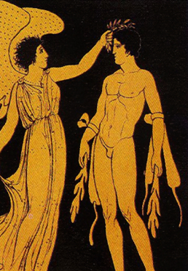 | In this image you see an athlete being crowned by Nike (goddess of victory)

- Drama
- Tragedies
- Comedies
- Satyr Drama
- The ancient Greeks built open-air theatres where the public could watch the performances of Greek comedy, tragedy, and satyr plays.
- Satyr plays were an ancient Greek form of tragicomedy. were rife with mock drunkenness, brazen sexuality (including phallic props), pranks, sight gags, and general merriment

Myths and dramatic performances
- Aeschylus
- Sophocles (tragic playwright)
- Euripides (tragic playwright)
- Aristophanes (comic playwright)
- Myths: the source for the dramatic plot
- Dramatic performances: means to express political, philosophical views to the audiences
  - People who watched the tragedy are influenced because the writer has the opportunity to express their views onto them (modern day social media)
- In tragedies the myths were the source of the plot

Actors from a satyr drama holding their masks

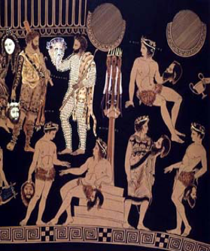 | Insert description of picture  In this picture you can see people wearing masks and shorts which show that this performance was a satyr
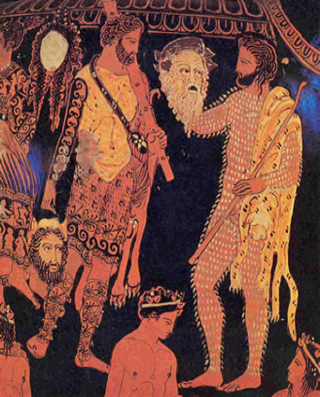 | The Pronomos Vase  Depicting an entire theatrical chorus and cast along with the celebrated musician Pronomos  It is considered the single most important surviving piece of pictorial evidence for theatre from ancient
A modern map of Greece
- Sea - islands, mountains and valleys
- Climate: Hot/dry summers and mild/rainy winters
  - The climate was very neutral which made it good for socializing
- Limited agriculture and land resources: olives, vines and cereal
- Characteristics of the land determined the characteristics of the people:
  - When there is a storm people need refuge
  - Sea provided a means of communication (sea on three sides of Greece)
- Independent communities: small scale farmers
- Limited agricultural and land resources
- Seafaring, trade - Greek people became good traders, seamen and merchants
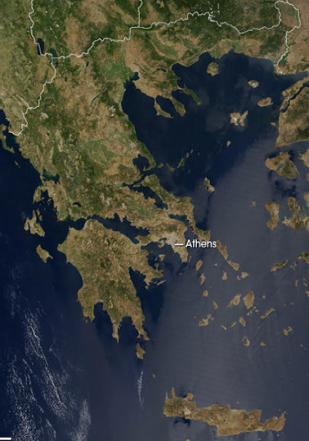
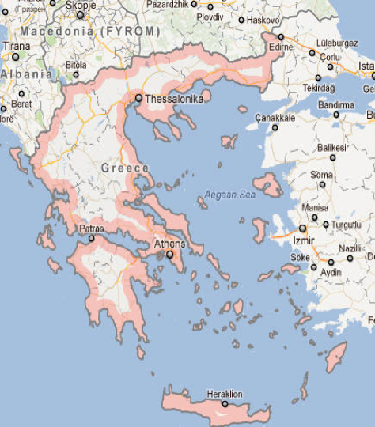
- Communication
- Migration

Expansion of Greek culture
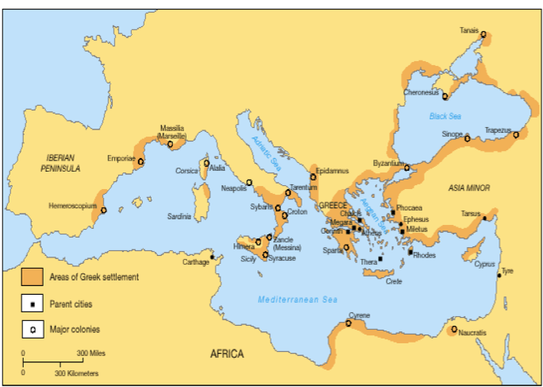

- People started travelling more towards the east first, which is shown as there are more areas of Greek settlement in the east compared to the west.
- Brown areas are Greek settlements.
- In terms of mythology we have myths taking place in these areas (Jason went to black sea.)
- Bonds create common identity

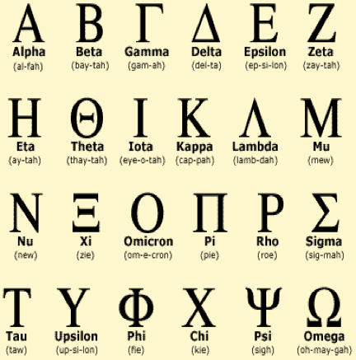
Common Identity
- One common bond is language
- 24 letters, different from the English alphabet
- There were different dialects of Greek but most of the time everyone could understand each other

Spelling Greek names
- Transliterating the Greek or the Latinized way (Romans)?
- ΗΡΑΚΛΗΣ(Greek)
- HERAKLES/HERACLES (Latin)
- HERCULES (English)
- ΚΡΟΝΟΣ (Greek)
- KRONOS/CRONOS
- CRONUS

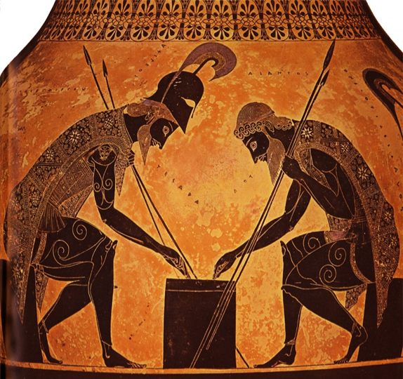 | Two ancient soldiers playing a game similar to Backgammon. People are fully dressed for fighting, yet they are playing a game. The picture depicts Achilles and Patroclus (Achilles first cousin).

Common Identity
- Language
- Religion
  - Based on the “twelve” Olympian gods and goddesses and the worship of heroes
  - Each house or city has their own divinities, however everyone worshipped Olympian
  - Every city had temples and festivals to worship these Gods
- Festivals
  - Another aspect Greeks shared with one another was the festivals they attended in order to celebrate the gods and goddesses (ex: olympic games)
- Homeric epics
  - All Greeks also had familiarity with Homer.
  - The existence of Homer is involved in the Homeric problem (a problem that cannot be solved). The scholars are fighting about whether Homer existed or if he even composed the poems.
  - For the ancient Greeks, Homer existed as did the Trojan war because these myths tell a story of their ancestors
  - In schools myths are what they learned, which helped recite the ethics
  - Homer created the religious attitudes
- Name (“Hellenes”)
  - Name was not from the beginning but only the 5th century BCE
  - Defined as belonging to the group
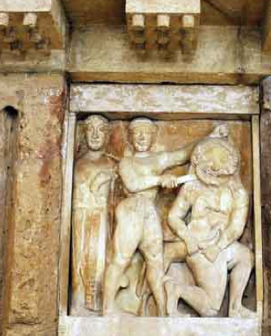 | Athena associated with the killing of medusa
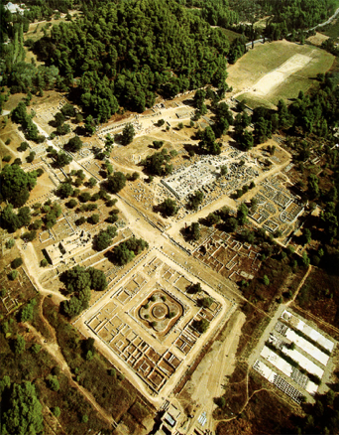 | Olympic games at Olympia

