Table of Contents
Week 1 Lecture 1 3
Textbook summary 1.1. 8
Week 1 Lecture 2 8
Textbook summary 1.2: Overview of Computer-Base IS 10
Summary in textbook page 34 10
Textbook summary 1.3: How does IT affect organizations? 12
Textbook Summary 1.4: Importance of IS to Society 12
Study guide revision 12
Social Computing 12
Textbook summary 9.1 14
Textbook summary 9.2: Fundamentals of Social Computing in Business 15
Textbook summary 9.3: Shopping 15
Textbook summary 9.4: Marketing 15
Textbook summary 9.5: Customer relationship management 16
Textbook summary 9.6: HR 16
Week 2 Lecture 3 16
Week 2 Lecture 4 18
Social commerce 18
Social Media Strategy: Components 20
Objectives: 20
Tactics 20
Metrics 20
Social Media Strategy: Examples 22
Social Media Strategy: Criterion-based Selection of Tools 22
Strategic Social Media Management: Key Success Factors 23
Study guide questions 24
Textbook summary module II 24
Textbook summary 1.1: Models and modeling 24
Textbook summary 1.2: The role of spreadsheets 25
Textbook summary 1.3: The real world and the model world 25
Textbook summary 1.4: Lessons from expert and novice modelers 25
Textbook summary 1.5: Organization of the book 25
Textbook summary chapter 11 25
Study guide revision 26
Textbook summary module III 26
Textbook summary 5.1: Managing Data 26
The difficulties of managing data 26
Textbook summary 5.2: The Database Approach 27
The Data hierarchy 27
Database Management Systems 27
Textbook summary 5.3: Big data 27
Defining big data 27
Issues with Big Data 27
Managing Big Data 27
Putting Big Data to Use 27
Big Data Used in the Functional Areas of the Org 28
Textbook summary 5.4: Data warehouses and Data Marts 28
Characteristics of Data Warehouses and Data Marts 28
A generic data warehouse environment 28
Textbook summary 5.6: Fundamentals of Relational Database Operations 28
Query languages 28
Entity-Relationship Modelling 28
Normalization and Joins 28
Summary pg 140 29
Textbook summary: An introduction to Database Development 29
Study guide revision 29

Week 1 Lecture 1
- What is an Information System?
Purpose: To provide accurate, timely and useful information
▪ Each element must be present and all of the elements must work together
An Information System consists of FIVE PARTS, including:
▪ People,
▪ Procedures (instructions for combining IT components to process info and generate output)
▪ Software (programs that enable hardware to process data e.g. excel, gglsheets)
▪ Hardware (processor, monitor, keyboard, printer), and IT
▪ Data
Information system (IS) = IT plus procedures, and people that produce & utilize
information.
❑ Information Technology (IT) = Hardware + Software + Data, including:
▪ Products
▪ Methods
▪ Inventions
▪ Standards
Avoid a common mistake:
❑ Do not try to buy an IS; you cannot do it.
You can buy IT: (laptop, tablet)
❑ Buy or lease hardware, license programs and databases, even obtain predesigned
procedures. Ultimately, people execute those procedures to employ that new IT
(Challenges of a new systems) Any new system requires training tasks, overcoming employees’ resistance to change, and managing employees as they utilize new system.
Information Systems aid the Decision-Making Process: (Role of IS in the decision making process)
❑ Improve productivity
❑ Monitor organizational performance
❑ Planning and decision-making
❑ Enhance Competitive Advantage
- Information Systems Elements: Data & Information
Information system: (functions)
❑ Set of interrelated components
❑ Collect, process, store, and distribute information
❑ Support decision-making, coordination, and control
Data versus Information: (The difference between data and information)
❑ Data are streams of raw facts: elementary descriptions of things, events, activities, and transactions that are recorded, classified, and stored but are not organized to convey any specific meaning. Data items can be numbers, letters, figures, sounds, and images. E.g. collections of numbers (3.11,2.96) and characters (B,A,C,A).
❑ Information is data shaped into meaningful form. A GPA by itself is a data item, but a student name with GPA is information. Recipients interpret the meaning and draw conclusions and implications from the info.
Knowledge is data and info that have been organized and processed to convey understanding as they apply to a current business problem. For example, a company found that students w gpa >3.0 have the greatest success in its management program. Based on this accumulated knowledge, that company may decide to interview only those students w gpas > 3.0. This is an example of knowledge because the company utilizes information- GPAs- to address a business problem- hiring successful employees.
▪ Example: Raw data from a supermarket checkout counter can be processed and organized to
produce meaningful information, such as the total unit sales of dish detergent or the total sales
revenue from dish detergent for a specific store or sales territory.
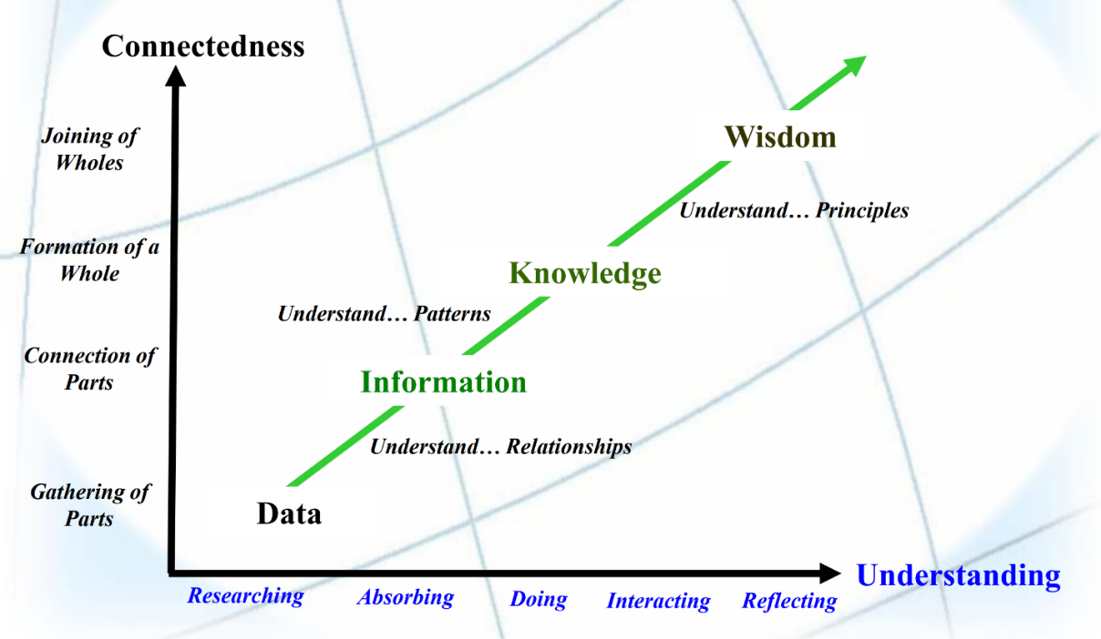
- A “Systems” perspective of IS
Three core activities of information systems:
❑ Input: Captures raw data from organization or external environment
❑ Processing: Converts raw data into meaningful form
❑ Output: Transfers processed information to people or activities that use it
Example: HR gets ppl’s resume -> check their qualifications with what is needed -> interview processing -> output
Advanced information systems also incorporate one additional functionality: (sth that only advanced system has but normal system doesn’t)
❑ Feedback: Output returned to appropriate members of organization to help evaluate or correct input stage
These functionalities are not limited to technologies
Management context example?
Information Systems > Technology
Technology is a subset of Information Systems (relationship btwn tech and IS)
▪ Using information systems effectively requires an understanding of the organization, management, and information technology shaping the systems.
▪ An information system creates value for the firm as an organizational and management solution to challenges posed by the environment.
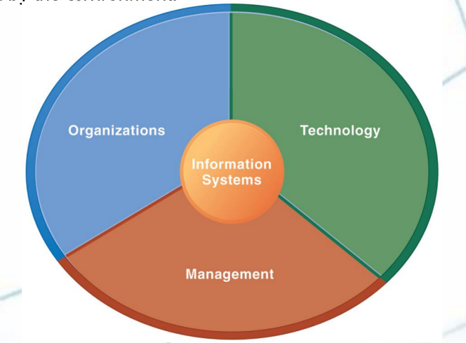
Management Information Systems & Analytics:
❑ MIS: Study of People, Technology & Organizations
❑ Analytics: Tools & Techniques for Data-Driven Decision Making
Benefits of an MIS education for a management student:
❑ In today’s workplace, it is imperative that IS work effectively and reliably.
❑ IS managers DO NOT only work with the IT dept.:
▪ IS will be part of your job in other business functions such as Marketing, Operations, HR, Finance, Accounting etc.
❑ As an IS manager for your business function, you will play a vital role in the implementation and administration of technology within your divisions and for the benefit of your organization.
▪ You will plan, coordinate, and direct research on the computer-related activities of firms.
▪ You will consult with other managers, help determine the goals of an organization and then implement technology to meet those goals.
▪ You will coordinate with pertinent people about the technical aspects such as software development, network security, and Internet operations.
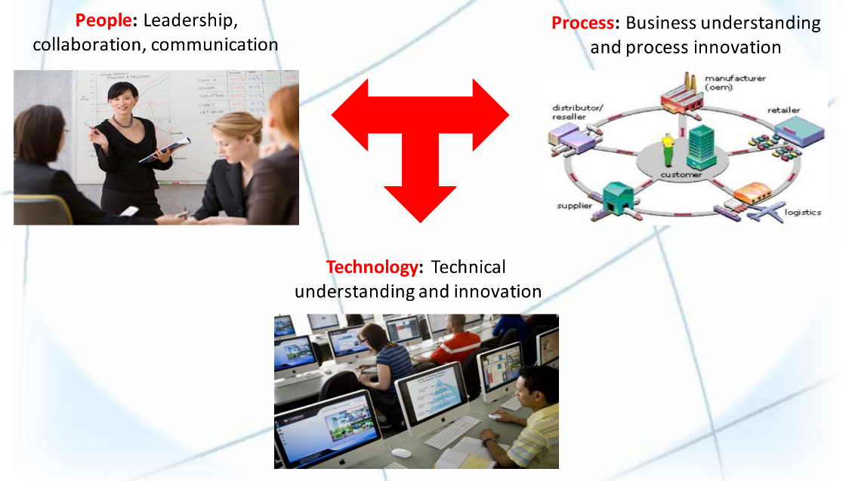
Process example: Porter’s 5 forces model
MIS as a business computing degree:
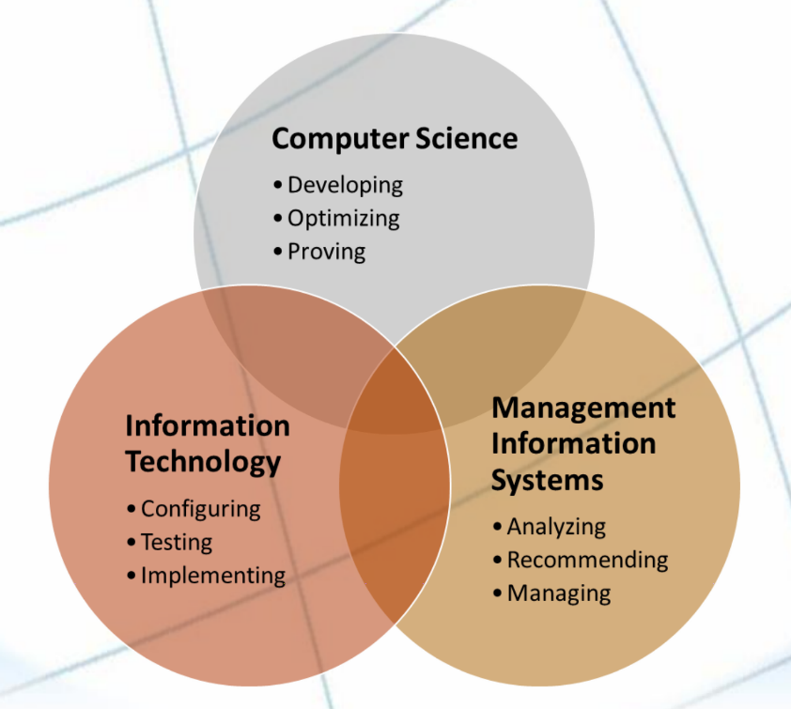
^ different activities for different degrees
IS Courses Map Well to Various Learning Goals in a Business Education:
▪ Demonstrate Critical Thinking and Decision Making Skills
▪ Provide Value to the Business Community in a chosen Area of Specialization
Computer science | IT | MIS
Why does the Technology Work? | How Does the  Technology Work? | What Technology Would  Work Best?
Technology-Focused | Deployment Focused | Business-Focused
Theory Oriented | Use Oriented | Application Oriented  Cross-Functional  (e.g. How many ppl you gonna put on this floor?)

Based on Robert Reich (former US Secretary of Labour):
❑ Four Skills required for most future job roles: Abstract reasoning skills, systems thinking skills, collaboration skills, experimentation skills
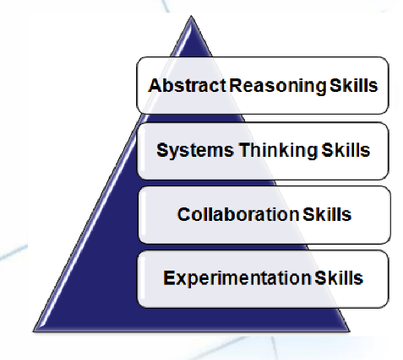
❑ A good IS education is comprehensive across these skills.

Textbook summary 1.1.
(11) SAMS chaos
(13) Examples of you using more IT in daily life
Benefits of being an informed user
(14) CIO role
Complexities in managing IF – difficult, complex task: firms rely on them, expensive to acquire, operate, and maintain, the evolution of the MIS function: the rise of end-user computing (end-user data entry and end-user development)
(15) List of IT jobs
Co-operation between MIS department and users
Division of responsibility btwn the 2 based on a multitude of factors. MIS department responsible for corporate-level and shared resources, users responsible for departmental resources.
(16) Users function in MIS
Traditional functions: managing systems development and infrastructure planning.
(New) Consultative MIS function: you have the primary responsibility, advised by the MIS department.
Changing role of the IS department table.

Week 1 Lecture 2
Digital firms use information systems to enable the seamless flow of information between different parts of the organization as well as between the organization and its suppliers and customers.
Conducting business electronically enables new levels of efficiency, competitiveness, and profitability (i.e. strategy): ‘Digital Economy’.
‘Digital Persona’ of Business
❑ How businesses, customers, suppliers etc. interact in the digital era
▪ often changes the landscape of how business processes are done.
▪ impacts many things including marketing, branding, communicating and relationship
building.
Socio-Technical View of Information Systems:
▪ Includes issues and insights contributed from technical and behavioral disciplines.
❑ Technical Approach:
- Emphasizes mathematically based models
- Computer science, management science, operations research
❑ Behavioral Approach:
- Behavioral issues (strategic business integration, implementation, etc.)
- Psychology, Economics, Sociology
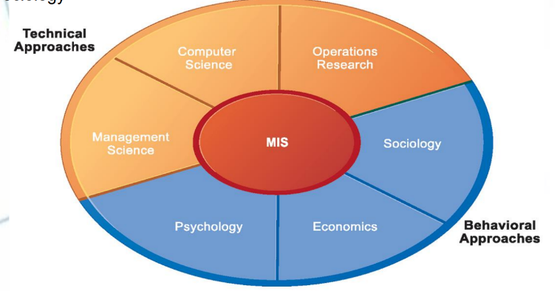
Why Study Information Systems?
Become a more proficient, competent and informed end-user.
End-User Computing in Organizations:
❑ Use of technology applications across the organization.
❑ Data Entry, Reporting, Searching, Organizing etc.
❑ End-User Development:
- Specific / Advanced form of End-User Computing.
- Development of functional applications by end-users (non IT-specialists) by using lightweight programming tools or multi-purpose end-user applications.
Types of Information Systems
Intra-Organizational and Inter-Organizational Information Systems
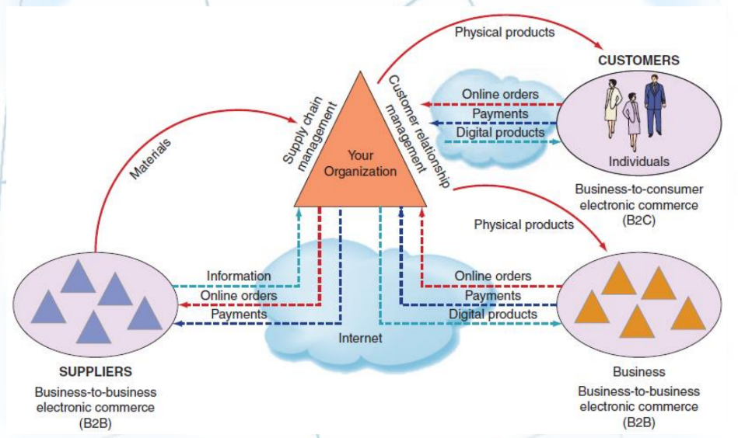

Textbook summary 1.2: Overview of Computer-Base IS

Summary in textbook page 34
(18) MIS deals with the planning for- and the development, management, and use of- IT tools to help people perform all the tasks related to information processing and management. Recall that IT refers to any computer-based tool that ppl use to work with information and to support the information and information-processing needs of an organization.
(19) Components of IS (as above)
(20) IT services inside an organization illustration
(21) Major capabilities of IS table.
IS performs tasks through apps (definition). Each functional area or department within a business organization use dozens of apps. The collection of these apps in a single department is called departmental IS (aka functional area information system). Collection of apps in HR is called HRIS (example in txtbk). Other areas also have a collection of application programs.
(22) The use of IS across various areas e.g. acct, fin, mkt, HR.
Enterprise resource planning (ERP) systems integrate functional areas IS, which are usually stand-alone systems and did not communicate effectively with one another, via a common database.
Transaction processing system supports the monitoring, collection, storage, and processing of data from an org’s basic transactions e.g. checking out an item at Walmart = a transaction. In accounting, a transaction is anything that changes a firm’s chart of accounts. When a student transfers from one course to another, it’s a transaction to the uni IS, but not to the uni accounting department (tuition is the same). Collects data in real time. (Difference between OLAP and OLTP pg 122)
(23) Interorganizational information system. An organization’s supply chain is the flow of materials, information, money, and services from suppliers of raw materials through factories and warehouses to the end customers.
An explanation of the supply chain figure.
Electronic commerce systems (Warby Parker), definition in page 35.
(24) Types of employees and the work they do: clerical workers, low level managers, middle managers, knowledge workers, executives.
Office automation systems (OASs) support the clerical staff, lower and middle managers. OAS is used to create documents (word processing and desktop publishing software), schedule resources (electronic calendars), and communicate (email, voice mail, video referencing and groupware).
Functional area info systems summarize data and prepare reports for middle managers and lower managers. These reports typically concern a specific functional area, so report generatours (RPGs) are an important type of function area IS.
Business Intelligence systems: complex, nonroutine decisions used with a data warehouse to enble users to perform their own data analysis.
Expert systems: attempt to duplicate the work of human experts by applying reasoning within a domain e.g. navigation system
Dashboards provide direct info in the form of reports. Executive dashboards are tailored to info needs of executives.
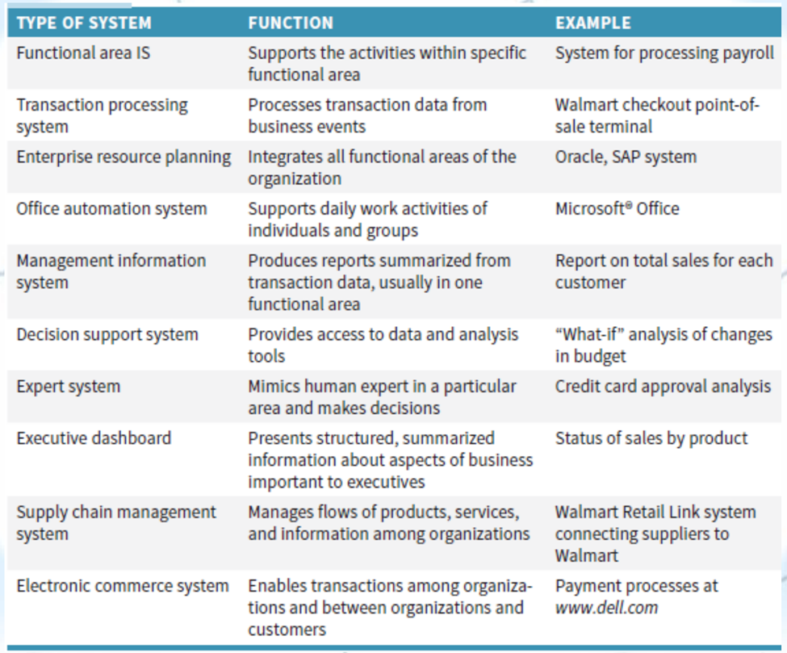

Textbook summary 1.3: How does IT affect organizations?
(26-27) industries IT is changing
(28) IT reduces the number of middle managers IT makes managers have less time to make decisions/ Remote supervision will become a thing. IT leads to layoffs but also create new categories of jobs.
(29) IT affects employees’ health (sitting in front of the computer for too long)
(30) IT provides opps for ppl with disabilities.

Textbook Summary 1.4: Importance of IS to Society
Just look at qn 4 (pg 34)

Study guide revision
- Benefits of IS (textbk table pg 21)

Social Computing
Social Media platforms and applications have changed how we communicate, socialize, access and use information, and shop. but… these tools are the means to doing things and not the ends. As business managers we need to know how to leverage their potential to achieve strategic advantage.
Social Media
❑ A group of Internet-based applications that build on the ideological and technological foundations of Web 2.0, and that allow the creation and exchange of User Generated Content. (Kaplan & Haenlein, 2010)
Web 2.0 & User-Generated Content as a foundation:
Web 2.0:
❑ term first used in 2004.
❑ software as a continually-updated service that gets better the more people use it, consuming and remixing data from multiple sources, including individual users, while providing their own data and services in a form that allows remixing by others, creating network effects through an architecture of participation. (O’Reilly, 2005).
User-Generated Content
❑ term popularized in 2005.
❑ various forms of media content that are publicly available and created by end-users.
❑ 3 basic requirements for UGC: (OECD, 2007)
- needs to be published either on a publicly accessible website or on a social networking site accessible to a selected group of people.
- needs to show a certain amount of creative effort.
- needs to have been created outside of professional routines and practices.
Characteristics of Web 2.0:
❑ The ability to tap into the collective intelligence of users.
❑ Data is made available in new or never-intended ways.
❑ Relies on user-generated and user-controlled content and data.
❑ Lightweight programming techniques and tools let nearly anyone act as a Web site developer.
❑ The virtual elimination of software-upgrade cycles makes everything a perpetual beta or work-in-progress. Application can be designed quickly to meet changing needs.
Types of Social Media:
Relationship Networks: Facebook, LinkedIn, Twitter
Media Sharing: Flickr, Instagram, YouTube, Vimeo
Online Reviews: UrbanSpoon, TripAdvisor, Airbnb
Discussion Forums: Quora, Digg, Reddit
Social Publishing: FB Notes, LinkedIn Pulse, Medium, Tumblr, Blogger
Social Bookmarking: StumbleUpon, Pinterest, Flipboard
Interest-Based Networks: LinkedIn/FB Groups, Google+ Circles, GoodReads, HelpfulGardener
Social Commerce: Etsy, Polyvore, Airbnb
Trend:
❑ Social media has led to the Convergence of Information and Communication:
▪ More Channels for Communication as well as Media Consumption.
▪ Lines between personal communication and media consumption becoming blurry.
▪ Social media being used for many other purposes than were originally intended or envisioned
Social Media for News:
❑ 60% get “some” news through social media.
- News Stories that broke on Twitter before the mainstream news media:
- The Hudson River Landing
-The Bin Laden Raid
- Boston Marathon Bombing
Downside: Fake news (Rihanna’s Australian fire)
Implications for Business:
❑ Reach out and engage with customers, prospects, partners, and your network.
❑ Create opportunity by communicating and sharing information.
❑ Manage your reputation and discover new business through monitoring information.
- The South Africa KFC proposal that went right! Family Feud Canada.
Adopting a Social Business Aptitude:
❑ Maximize the potential of social media by using it across business functions.
❑ Rather than using social media as an inside-out promotional medium, leverage the outside-in conversations as well.
❑ Harness big social data to glean insights for product research, competitive analysis and prediction of customer needs.
❑ Update corporate governance policies and guidelines.
➔ An “Integrated Social Media Strategy” (ISM)

Textbook summary 9.1
(39) Social computing is a type of IT that combines social behavior and IS to create value, focused on improving collaboration and interaction among people and encouraging user-generated content. Social information is not anonymous.
(40) Makes socially produced information available to anyone (e.g. Rottentomatoes). Users control content, transforming the power relationships within organizations as employees and customers gain more influence. Different circumstances btwn customers, employers, employees and prospective employees. Business should refrain from making comments that suggest they were trying to profit from other people’s misery. Gaining popularity worldwide.
(41) Web 2.0 IT tools: tagging, RSS, blogs, microblogs, and wikis.
Major types of Web 2.0 sites: social networking sites, enterprise social networks, and mashups.
Web 1.0: the creation of websites and the commercialization of the Web. Users have minimal interactions and only passively receive info. Web 2.0 encourages user participation, social interaction, and collaboration. Web 2.0 often harness collective intelligence (wikis), deliver web services, feature remixable applications and data (mashups).
Tagging: (def) a basis of folksonomies, which are user-generated classifications that use tags to categorize and retrieve web pages, photos, videos, and other web content. Geotagging involves tagging information on maps e.g. google maps.
(42) Really simple syndication (RSS): A technology that allows users to receive the info they want, when they want it, without having to surf thousands of websites. + function. Example CBC.ca
(43) Blogs: (def) bloggers, blogosphere (64). Companies listen to consumers in the blogosphere who express their views on companies’ products. Consumer-generated media. Provides info faster than traditional media outlets, may be inaccurate.
(44) Microblogs (def) Twitter.
Wikis: A website made up entirely of content posted by users. Wikipedia.
Social networking sites: (def of social network) Social networking is any activity performed using social software tools (blogging) or social networking features (media sharing). + function.
(45) social graph def. social capital def. +function
Enterprise social networks: Corporate social networks functions. Processes: networking and community building, social collaboration, social publishing (posting content), social views and feedback, social intelligence and analytics.
Mashups: a website that takes different content from a number of other websites and mixes it tgt to create a new kind of content. E.g. tim hortons map of all Canada store locations.

Textbook summary 9.2: Fundamentals of Social Computing in Business
(47) Social computing/social commerce, is the delivery of electronic commerce activities and transactions through social computing. + function + examples (Disney, Pesico)
(48) Potential benefits of social commerce and risks (summarized in page 63)

Textbook summary 9.3: Shopping
(49) social shopping def. Rating, reviews, and Recommendations
(50) Sources of reviews: customer ratings and reviews, experts, sponsored reviews, conversational marketing.
(51) group shopping (groupon deals)
(52) Can shop together virtually in real time.
Shopping communities and clubs (luxury brands at heavily discounted price)
(53) Social marketplaces help members market their own creations (kijiji, etsy)
Peer-to-peer shopping models encourages collaborative consumption (def), also called the sharing economy
(54) Collaborative consumption includes person-to-person sharing (Uber, Airbnb) and business-to-business sharing.

Textbook summary 9.4: Marketing
(55) Social advertising is advertising formats that make use of the social context of the user viewing the ad. 2 categories: social advertisements (ads placed in paid-for media space on social media), social apps (nike+). Viral marketing (word-of-mouth advertising) + example.
Market research more accessible.
(56) conversational marketing enables customers to supply feedback via blogs, wikis, online forums, and social networking sites.
(57) Conducting market research through social networks: the monitoring, collection, and analysis of socially generated data, and the resultant strategic decisions, are combined in a process known as social intelligence.
(58) using fb, twitter, and LinkedIn for market research.

Textbook summary 9.5: Customer relationship management
Summary in pg 63 qn 5

Textbook summary 9.6: HR
Summary in pg 64 qn 6

Week 2 Lecture 3
The power of social media:
❑ Groundswell (Li & Bernoff, 2008): “… spontaneous movement of people using online tools to connect, take charge of their own experience and get what they need – information, support, ideas, products, and bargaining power – from each other.”
New way of thinking is captured in a list of 95 statements called the Cluetrain Manifesto.
❑ Short Summary:
- Markets are conversations.
- These networked conversations are enabling powerful new forms of social organization and knowledge exchange to emerge.
- As a result, markets are getting smarter, more informed, more organized. Participation in a networked market changes people fundamentally.
- People in networked markets have figured out that they get far better information and support from one another than from vendors.
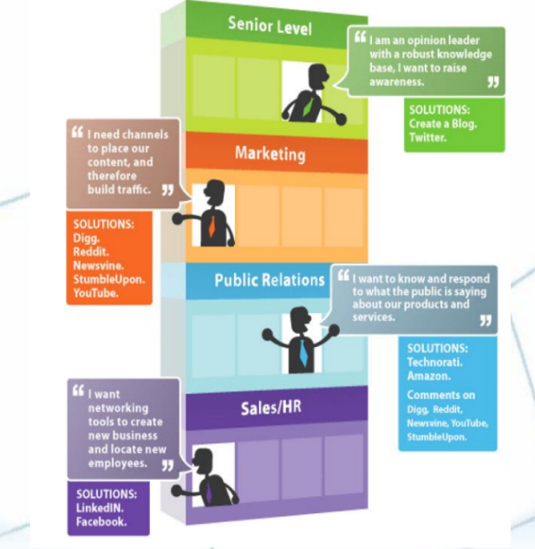
Structured vs Unstructured Data:
❑ Structured data refers to information with a high degree of organization, such that inclusion in a relational database is seamless and readily searchable by simple, straightforward search engine algorithms or other search operations.
❑ Unstructured data is essentially the opposite. The lack of structure makes compilation and analysis a time and energy-consuming task.
Social Media & Big Data
Traditional Approach
Structured & Repeatable Analysis
Business Users determine what question to ask. IT structures the data to answer that question. E.g. Monthly sales reports, Profitability analysis, customer surveys.
Big Data Approach
Iterative & Exploratory Analysis
IT delivers a platform to enable creative discovery. Business Users explores what questions could be asked. E.g. Brand sentiment, Product strategy, Maximum asset utilization
Challenges to overcome:
❑ The 4 Vs: Volume, Variety, Velocity, Veracity.
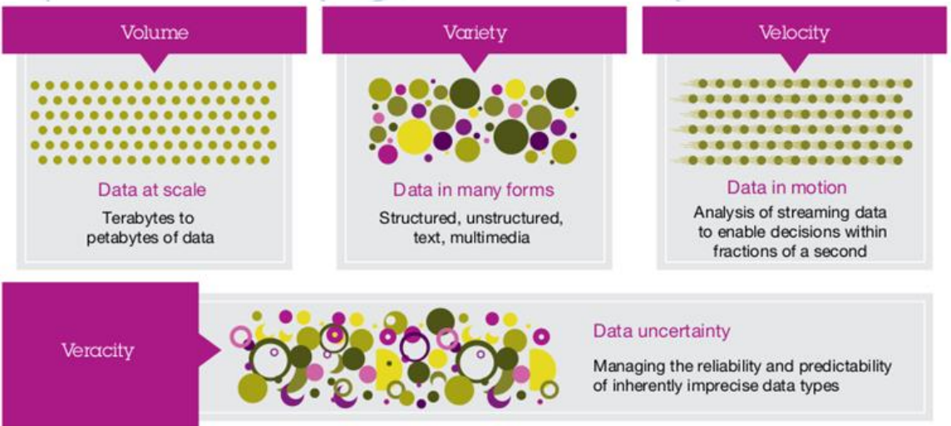
Social Network Analysis (SNA):
❑ the mapping and measuring of relationships and flows between people, groups, organizations, computers, or other information or knowledge processing entities.
❑ the nodes in the network are the people and groups, whereas the links show relationships or flows between the nodes.
❑ SNA provides both visual and mathematical analyses of relationships.
Social Network Analysis (SNA):
A network is:
▪ an arrangement of intersecting horizontal and vertical lines.
▪ a group or system of interconnected people or things.
▪ connect as or operate with a network.
Components of a network
▪ Actors (nodes, points, vertices):
– Individuals, Organizations, Events …
▪ Relations (lines, arcs, edges, ties): between pairs of actors.
– Undirected (symmetric) / Directed (asymmetric)
– Binary / Valued
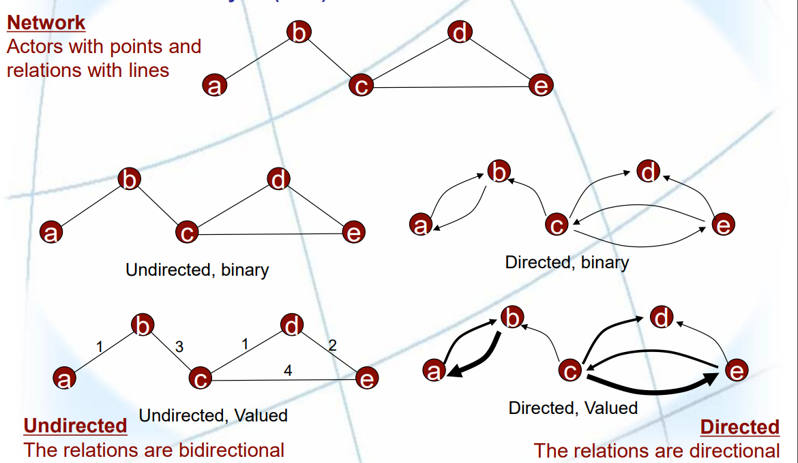

Week 2 Lecture 4

Social commerce
❑ use of social computing by businesses in innovative ways.
❑ delivery of electronic commerce activities and transactions through social computing.
❑ social interactions and user contributions allow customers to participate actively in the marketing and selling of products and services in online marketplaces and communities.
❑ individuals can collaborate online, obtain advice from trusted individuals, and find and purchase goods and services.
Feature of Social Commerce:
❑ Ratings and reviews for the products and services by users.
❑ Recommendation technology features enables getting product recommendations based on one owns interests, preferences etc.
❑ Customers likely to check online for reviews prior to making a purchase.
❑ Online users generate new ideas, advertise, and create added value at virtually no cost.
❑ Increases efficiency by understanding customer needs, identifying potential customers & building customer loyalty.
❑ Better Understanding of the Consumer’s behavior.
❑ Instant Personalization of the user experience.
❑ Brand Growth.
Social Media is always in a flux due to three factors:
❑ End-Users, Use Cases, Functionality
Implications:
❑ Strategies and tactics used to manage social media have to constantly adapt.
PDCA Framework: (also known as the Deming Cycle)
❑ Plan: Creating a social media strategy.
❑ Do: Implementing tactics and campaigns aligned with the social media strategy.
❑ Check: Regular (daily, weekly, monthly, quarterly, etc.) review of metrics created as part of the strategy to determine if business ROI in social media has been sufficiently achieved or not.
❑ Act: (or Adjust) Fine-tuning the social media strategy, tactics, plans for campaigns, and even potentially refining or changing metrics or how measurements are performed.
❑ It is a never-ending cycle because of the changing nature of social media sites and services, and how we use them.

Social Media Strategy: Components
Strategy needs to be formulated in terms of objectives, tactics, and metrics (components of a Social Media Strategy). Corporate governance issues such as policies and guidelines need to be considered.

Objectives:
▪ Link to corporate strategy
▪ Ways to extend brand’s strengths online
Classic objectives:
• increase sales, decrease expenses, improve ROI etc.

Social objectives:
• engagement, influence, advocacy, personalization etc.

Tactics

Customers:
▪ Target demographic group and focus
▪ Assess type of users

Sharing:
▪ What social tools will be used
▪ What type of content will be shared

Who:
▪ Who will lead the effort

Brand Alignment:
▪ Guidelines, Tone of voice, Media usage

Metrics

Monitor:
Listening to customers, Activities monitoring, Measuring success
Effective Social Media Management depends on data-driven measurements, or metrics
❑ Metrics include activity metrics, ROI, tactical metrics, strategic metrics

Activity Metrics
❑ Pageviews
❑ Unique number of visitors
❑ Posts
❑ Comments and trackbacks
❑ Time spent on site

Return on Investments (ROI) Metrics
❑ Sales and marketing
▪ Cost per number of prospects
▪ Number of leads per period
▪ Cost of lead
▪ Conversion of leads to customers
▪ Customer lifetime value (CLV)
❑ Product Development
▪ Number of new product ideas
▪ Idea to development initiation cycle time
❑ HR
▪ Hiring and training costs
▪ Employee attrition

Tactical Metrics
❑ Increase traffic to our Web site by 10%
❑ Increase requests for product information via our Web site by 15%
❑ Increase number of people who create a user account on our Web site by 12%

Strategic Metrics
❑ Listening: Pay attention to what customers are saying online
❑ Talking: Communicate with your customers by engaging in conversations
❑ Energizing: Encourage customers and fans to spread the word through ratings,
reviews and other positive “buzz”
❑ Support: Provide information and online resources, such as user forums, knowledge
bases and other tools
❑ Embracing: Invite customers to generate ideas for new products and services
Example of Social Media Strategic Metrics:
❑ Customer Dialog Metrics:
▪ Genuine Dialog provides the basis for building awareness and word of mouth: Share of voice, audience engagement, conversation reach.
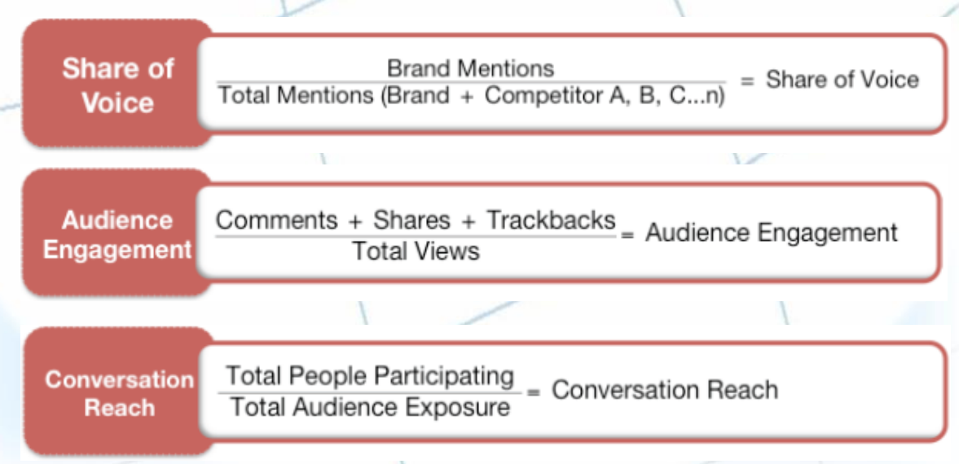

Social Media Strategy: Examples
Mercedes-Benz’s #mbphotopass campaign:
❑ Company “passes” access to their Instagram feed to social influencers, journalists, photographers and team members to curate content for the account for certain periods.
❑ influencers are also given the keys to a Benz to drive around while they are taking pictures and curating the company's Instagram account.

Social Media Strategy: Criterion-based Selection of Tools
Honeycomb of Social Media (Functionality & Implications) (Kietzmann et al., 2011)
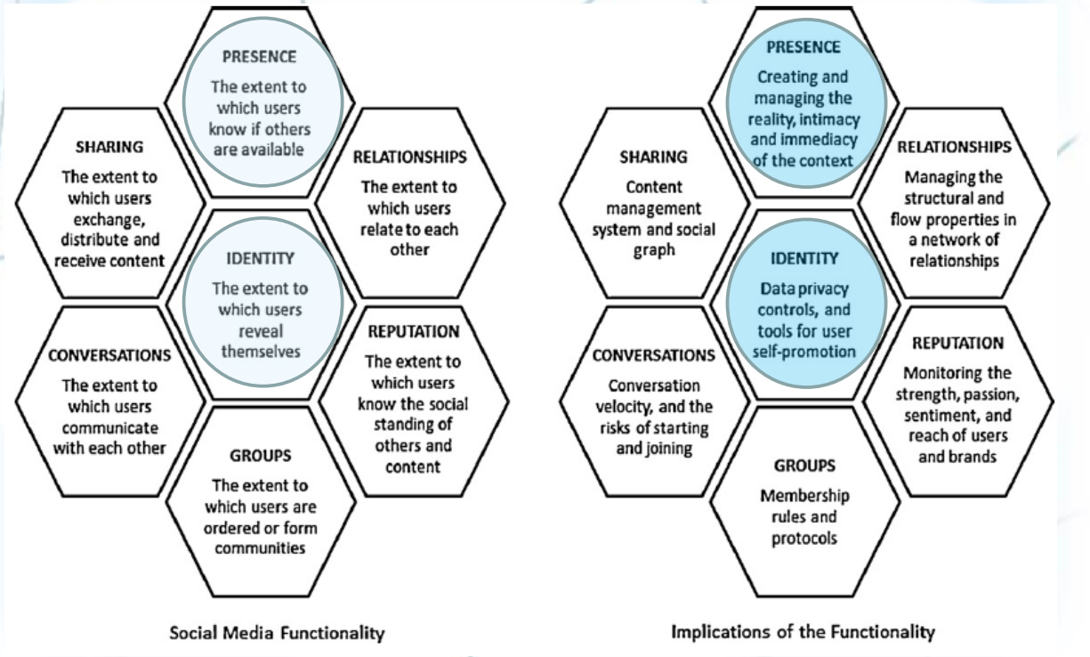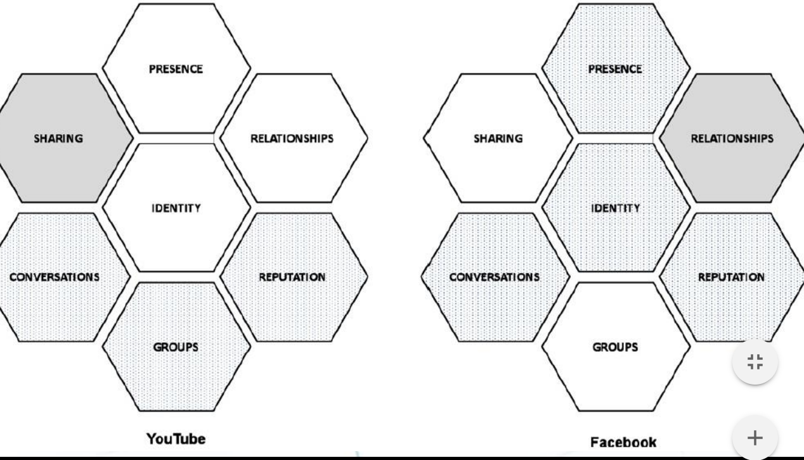

Strategic Social Media Management: Key Success Factors
Strategy:
❑ a comprehensive, company-wide social media strategy, and all functions and business units adhere to a uniform set of strategic directives.
Organization:
❑ employ dedicated FTEs in different functions and set aside budgets specifically for social media activities.
Criteria-based platform selection:
❑ select appropriate social media platforms based on clear criteria to match social media strategy.
Integration:
❑ integrate and leverage social media activities along the entire value chain.
Awareness:
❑ created a significantly higher awareness for social media throughout the company.
Leadership:
❑ make social media activities a priority for top management and ensure senior executives are highly involved.

Study guide questions
- Types and examples of Web 2.0 tools
(5 types- qn 1 ph 63) example on pg 41 onwards
- Examples of Social Media use – cases in different department
Marketing market research (pg 55), Human Resources LinkedIn for recruiting (pg 60), customer service (kfc proposal/ morton’s steakhouse pg 59).

Textbook summary module II

Textbook summary 1.1: Models and modeling
(69) Modeling is the process of creating a simplified representation of reality and working with this representation to understand or control some aspect of the world. Takes a lot of different forms: mental, physical, mathematical, spreadsheet, etc.
Mental models primary basis for decision making. Visual models include maps. Physical models in archi.
(70) Primary purpose of modeling is to generate insight to make better decisions. Model is a lab in which we can experiment and learn.
One-time decision models: used once, usually under time pressure, involves the user intensively.
(71) Decision-support system: Tie tgt models, data, analysis tools, and presentation tools into a single integrated package. Intended for repeated use.
Embedded models: those contained within computer systems that perform routine, repeated tasks with little or no human involvement e.g. inventory replenishment system.
Models in business educations. Stylized models are frequently used to provide insight into qualitative phenomena, not necessarily producing numerical results.
Benefits: Inexpensive, explore the impossible, timely, reduce costs, room for trial to improve business intuition.

Textbook summary 1.2: The role of spreadsheets
(72) Spreadsheet models are mathematical models. More accessible now than before.
(73) Spreadsheet errors are costly.
(74) Challenges for spreadsheet users

Textbook summary 1.3: The real world and the model world
(75) Modeling provides a structure for problem solving through a process of abstraction/simplification, in which the essence of the problem is captured in a simplified form.
(76) Model formulation process involves: Decisions, outcomes, structure, data. Decisions: controllable variable e.g. quantities to buy. Outcomes: consequences of the decision e.g. profit. Structure: logic and maths. E.g. price = revenue – cost. Data: numerical assumptions (raw data) in the real world e.g. interest rates.
(77) Analysis process: use the model to test ideas and evaluate solutions using logic.
Translate the model into the real world through process of interpretation.

Textbook summary 1.4: Lessons from expert and novice modelers
(77) Technical skills (how to use the NPV function in Excel) are easy to teach but craft skills are not (e.g. what to include and exclude from the model).
(78) Five topics important to modelers: problem context, model structure, model realization, model assessment, model implementation.
(79) Issues of novice modelers: overreliance on given numerical data, use of shortcuts to an answer, insufficient use of abstract variables and relationships, ineffective self-regulation, overuse of brainstorming than structured problem solving.

Textbook summary 1.5: Organization of the book
(80) Set of skills: spreadsheet engineering, modeling craft, data analysis, management science

Textbook summary chapter 11
(85) The data layer – Flat data table and Tabular data set
(87) The analysis layer + benefits. The presentation layer.
(88) Data model best practices: avoid storing excess data, use tabs to organize data model + add a data model map, test the data model before building presentation component
(91) Data delivery formula. Lookup tables def. The Vlookup function finds a specific value in the first column of a lookup table and returns the corresponding value in a specified table column.
(95) Hlookup
(97)Using the SUMPRODUCT function to filter data based on criteria.
(99) CHOOSE function
(102) Converting a range to an Excel table

Study guide revision
- Model formulation process and steps: txtbk pg 76, diagrams from week 8 lecture 13
- Elements of a spreadsheet model: decisions, outcomes, structure, data.
- Layers of spreadsheet model: data, analysis, presentation
- Best practices for data models: txtbk pg 88, slides 20 from week 8 lecture 13.
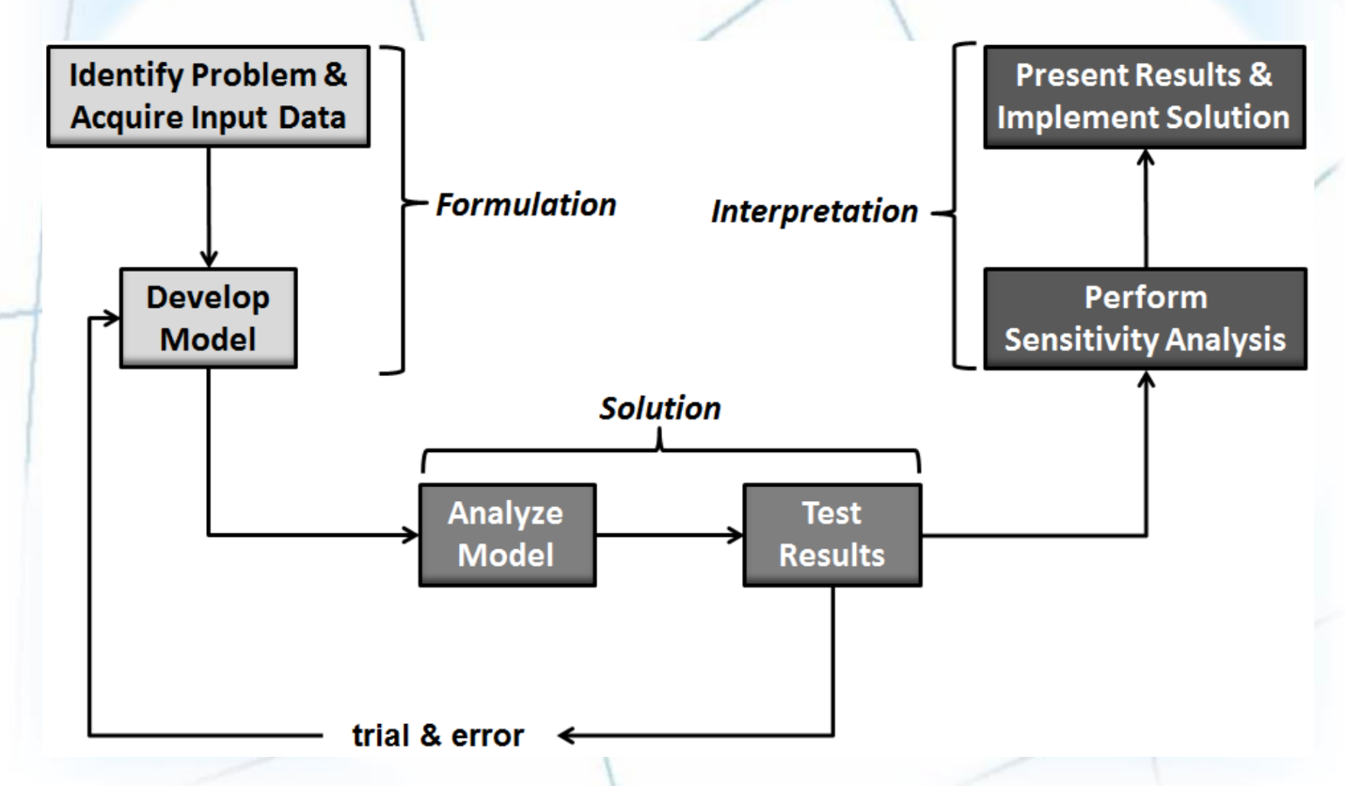

Textbook summary module III

Textbook summary 5.1: Managing Data

The difficulties of managing data
(109) Data increases exponentially with time. Data are scattered throughout organizations. Data are generated from multiple sources: internal sources, personal sources, and external sources. Data also come from the web in the form of clickstream data (data that visitors and customers produce when they visit a website and click on hyperlinks). New sources of data are constantly being developed. Data degrade over time. Unique requirements of data, inconsistent data within the enterprise.
(110) Data governance: an approach to managing information across an entire org. + function.
Master data management def -> single version of truth.
Master data are a set of core data, such as customer, product, employee, vendor, geographic location, and so on, that span the enterprise info systems. Difference between master data and transaction data.

Textbook summary 5.2: The Database Approach
(110) In the past, file management environment. Now, benefits of database: minimize data redundancy, data isolation and data inconsistency; maximize data security, data integrity, and data independence.

The Data hierarchy
(113) A byte. A field. A logical grouping of related fields (e.g. student name, courses taken, date, grade) composes a record. A grouping of the records from a particular course constitute a data file for that course. A logical grouping of related files constitutes a database.

Database Management Systems
(113) DBMS def. Other database models such as the hierarchical and network models. Popular examples of relational databases are Access and Oracle. Based on the concept of two-dimensional tables, not a flat file. Records are listed in rows and attributes are listed in columns. A data model is a diagram that represents entities in the database and their relationships. An entity, and instance of an entity definition. E.g. STUDENT is an entity. An instance of this entity would be a particular student. Characteristic or quality of a particular entity is called an attribute.
(114) primary key. Second-key. Foreign key.

Textbook summary 5.3: Big data

Defining big data
(115)
(116) Consists of traditional enterprise data, machine-generated/sensor data, social data, images.
Characteristics(3V): Volume, Velocity, Variety.

Issues with Big Data
(117) Big Data can come from untrusted sources, data quality problem, big data changes.

Managing Big Data
(117) Organizations employ NoSQL databases to process Big Data.
Traditional databases such as Oracle and MySQL store data in tables organized into rows and columns, but NoSQL databases can manipulate structed as well as unstructured data and inconsistent or missing data.

Putting Big Data to Use
(118) Making Big Data Available, microsegmenting customers, creating new business models, being able to analyze more data.

Big Data Used in the Functional Areas of the Org

Textbook summary 5.4: Data warehouses and Data Marts

Characteristics of Data Warehouses and Data Marts
(122) Organized by business dimension or subject, use online analytical processing (OLAP), integrated, time variant, nonvolatile, multidimensional.

A generic data warehouse environment
(123) Source systems.
(124) Examples of source systems: operational/ transactional systems, ERP systems, website data, third-party data and more. Difference between relational database and multi-dimensional data warehouses and marts.
(126) Data integration (ETL). Storing the data through one central enterprise data warehouse or independent data marts. Data mart not as effective. Another warehouse architecture is the hub and spoke.
(127) Metadata. Data quality: improved with data cleansing software. Governance requires that ppl, committees, and processes be put in place. BI users include information producers and information consumers.
Benefits of data warehousing: End users can access needed data quickly and easily via web browsers, end users can conduct extensive analysis with data in ways that were not previously possible, uders can obtain a consolidated view of organizational data.

Textbook summary 5.6: Fundamentals of Relational Database Operations

Query languages
(132) SQL, QBE

Entity-Relationship Modelling
(133) Entity-relationship diagram. Need to identify business rules. Data dictionary def. ER modelling is valuable because it allows database deigners to communicate with users throughout the org to ensure that all entities and the rs among entities are represented. Relationships: unary, binary, ternary. Here, we only discuss binary rs. Connectivity, cardinality. Examples of entities and instances of entities.
(134) Entities have attributes, or properties, that describe the entity’s characteristics e.g. attributes for STUDENT are Student Name and Student Address. One to one, one to many rs.

Normalization and Joins
(135) Normalization def. Functional dependency def. Non-normalized data table: several attributes of each record have null values.
(136) First normal form: contains repeating groups and describes multiple entries -> data redundancy and lack of data integrity, flat file difficult to use.
Second normal form has not eliminated all the data reduncdancy but are separated into smaller tables.
Third normal form is completely free of data redundancy and all foreign keys appear where needed to link related tables.
(138) The join operation combines records from two or more tables in a database to obtain info that is located in diff tables.

Summary pg 140

Textbook summary: An introduction to Database Development
(145) Database def.
(146) Differences between a relational database and a mual filing system.
(147) Tables = entities. A datasheet is divided into rows (records) and columns (fields).
(148) Benefits of Relational Database.
(150) Forms and reports. Reports are in PDF style formatting.
(152) A five-step design method: requirements gathering, report design, data design, table design, form design.

Study guide revision
- Data governance and data quality.
Data governance is an approach to managing information across an entire organization.
It involves a formal set of business processes and policies that are designed to ensure that data are handled in a certain, well-defined fashion. That is, the organization follows unambiguous rules for creating, collecting, handling, and protecting its information.
The objective is to make information available, transparent, and useful for the people who are authorized to access it, from the moment it enters an organization until it is outdated and
deleted.
❑ Example of Data Governance Practice:
▪ Master Data Management provides companies with the ability to store, maintain, exchange, and synchronize a consistent, accurate, and timely “single version of truth” for the company’s master data.
Master Data:
▪ consistent and uniform set of identifiers and extended attributes that describe the core entities of the enterprise such as customer, product, employee, vendor, geographic location etc.
Transaction Data:
▪ Generated and captured by operational systems, describe the business’s activities or transactions.
Advantages of Master Data Management:
❑ improves search effectiveness
❑ increases accuracy
❑ streamlines new product entry into the database management system
❑ facilitates processing of transactions
Ensuring data quality:
❑ More than 25% of critical data in Fortune 1000 company databases are inaccurate or
incomplete
❑ Most data quality problems stem from faulty input
❑ Before a new database is in place, you need to:
▪ Identify and correct faulty data
▪ Establish better routines for editing data once database is in operation
Corporate initiatives to improve data quality:
❑ Data quality audit:
▪ Structured survey of the accuracy and level of completeness of the data in an information system
– Survey samples from data files, or
– Survey end users for perceptions of quality

❑ Data cleansing:
▪ Software to detect and correct data that are incorrect, incomplete, improperly formatted, or redundant
▪ Enforces consistency among different sets of data from separate information systems
Low-quality information example:
(slides)
Some sources of low-quality information include:
❑ Online customers intentionally enter inaccurate information to protect their privacy
❑ Data or information from different systems have different entry standards and
formats
❑ Call center operators enter abbreviated or erroneous information by accident or to
save time
❑ Third party and external information contains inconsistencies, inaccuracies, and
errors
Potential business effects resulting from low quality information include:
❑ Inability to accurately track customers
❑ Difficulty identifying valuable customers
❑ Inability to identify selling opportunities
❑ Marketing to nonexistent customers
❑ Difficulty tracking revenue due to inaccurate invoices
❑ Inability to build strong customer relationships
- Relational DBMS Concepts:
A DBMS separates the logical and the physical view of the data
Physical view
❑ How data is organized, specified and stored.
Logical View
❑ How data appears to the end-user
Design Components of a DBMS
Data definition language (DDL)
❑ Defines each data element
❑ Used by programmers and database administrators in creating database
DDL ➔ Data Dictionary
❑ Definitions of data elements and their characteristics.
Data manipulation language (DML)
❑ Query & Reporting Capability in DBMS
❑ Used to manipulate data (e.g. SQL)
❑ Used to get data into (e.g. INSERT operation) and out of (e.g. SELECT operation) a
database.
Data Dictionary:
❑ An automated or manual file that stores definitions of data elements and their
characteristics.
Definitions of data elements and their characteristics.
▪ Example: Design View of Tables in MS Access provides controls such as Field Size, Input Mask, Validation Rule, and Mandatory/Optional Inputs.
Operations of a Relational DBMS
❑ Three basic operations used to develop useful sets of data
❑ SELECT: Creates subset of data of all records that meet stated criteria
❑ JOIN: Combines relational tables to provide user with more information than
available in individual tables
❑ PROJECT: Creates subset of columns in table, creating tables with only the
information specified
The SELECT, JOIN, and PROJECT operations enable data from two different tables
to be combined and only selected attributes to be displayed.
3. Relational Database Design Concepts (slides)

