PSY3108C Final

Hearing I: Sound & the Ear

Response compression in auditory system

Pure tone: simplest form of sound wave; pressure variations are sinusoidal
Can be defined by 1. Amplitude (µPa) = subjective loudness
2. Frequency (Hz) = subjective pitch

- 2 waves w/ the same frequency but different amplitudes - larger amplitude = subjectively louder
- 2 waves w/ same amplitude but diff frequencies - higher frequency, higer pitch

Amplitude

- Amplitude: difference in sound pressure between high and low peaks of wave - tallness
- Sound pressure (P) is measured in micropascals (µPa)
- Sound intensity: square of pressure (I = P²) and is more directly related to subjective loudness
- Usually, we speak in terms of the ratio of sound intensity to some reference (I_{s} / I_{r}) or we can speak in terms of ratio of squared pressures (P_{s}² / P_{r}²)
- Reference pressure (P_{r}) is typically 20 µPa - this is the lowest pressure variation amplitude detectable by an average human at 1000 Hz = SPL Sound Pressure Level

Decibels

- We take the log₁₀ of intensity ratios [log10(Is / Ir)] to get bels to handle the range
- Bels make for a coarse range, so we take tenths of bels to get decibels (dB)
  - dB = 20 X log₁₀(Ps / Pr)
  - Most often use dB_{SPL} = 20µPa = P_{r}
- Each increase by a decibel yields approx the same increase in subjective loudness; log nature of the decibel scale compensates for response compression of auditory system
  - Have a linear relationship bw subjective and objective if we define the objective as decibels ie. b is 1 for steven’s power law
  - 80 is like someone yelling, above 120 dB is painful and won’t sound necessarily louder above this but will just hurt more 140dB = pain threshold
  - Possible to have negative dBs - if p is smaller than reference

dB = 20 X log₁₀(Ps / Pr) , where Ps = the difference bw max and min pressure and Pr is an arbitrary reference pressure, usually SPL = 20µPa

Questions

Log₁₀ of 10 = 1, of 100 = 2, of 1000 = 3
Ambient reference pressure is 40microPa and a pressure wave is hitting your ear with an amplitude of 40 000 microPa. How many decibels?

dB = 20 X log₁₀(Ps / Pr)
= 20 X log₁₀(40 000µPa / 40µPa)
= 60 dB This is about average speaking voice

Ex. Ref pressure is 20microPa and a wave w. Amplitude of 20mPa is hitting your ear
= 20 X log₁₀(20µPa / 20µPa)
= 0 dB

Ex. Ref pressure is 20microPa and a P wave w amplitude 20 000 microPa
= 60 dB

Frequency

Frequency: number of amplitude cycles within a given time period
- Measured in Herts (Hz) ; 1 Hz = 1 cycle per second
- Perception of pitch is related to frequency (but there is more to it)

The Doppler Effect

- When a sound source approaches at high speed, its sound seems to increase in frequency, then decrease as it passes due to compression and expansion of sound waves
- Ie. Sirens sound high pitched at first then drop off. When sound source approaches, waves get bunched up, more frequently and the sound waves being left behind are more distantly spaced, so pitch drops (happens with waves, light too)

Complex Sounds

- Natural sounds do not have a single frequency and/or amplitude, they are made up of a complex set of combined pure tones, each with their own freq and ampl
- Fundamental frequency: the lowest frequency element of a set of tones
- Overtones: higher frequency elements of a sound
- Overtones whose frequency is a whole integer multiple of the fundamental frequency are called harmonics ex. 400 Hz, 800 Hz, 1200 Hz are all harmonics (600 Hz would not be because this is not a multiple of 400; x1.5)
- Frequency spectrum: all the tones that make up a sound; in part responsible for timbre
  - Different instruments can be playing a tone with a fundamental freq of 196 Hz (G3) but have a very different set of oure tones that add up to the same note but with different timbre; different amplitudes at different frequencies - pattern of amplitude across the frequencies is different

Attack & Decay

- Timbre is also made up of
  - Attack of tones: buildup of sound at the beginning of a tone
  - Decay of tones: decrease in sound at end of tone
  - Gradual attack and decay in most natural sounds and no attack or decay in most artificial sounds
- Diff freq elements are rising in different ways (amplitudes), timbre looks diff for diff instruments

Questions

- Natural sounds are made up of many pure tones
- Fundamental frequency: the lowest frequency element of a set of tones
Overtones: higher frequency elements of a sound
Harmonics: Overtones whose frequency is a whole integer multiple of the fundamental frequency
Timbre: the characteristic quality of sound independent of pitch and amplitude/loudness; differences in timbre are produced by the number and relative strengths of the harmonic components in a complex tone
Attack of tones: buildup of sound at the beginning of a tone
Decay of tones: decrease in sound at end of tone

Periodic and Aperiodic Sounds

- Periodic sounds: patterns that repeat across time ex. Musical notes, vowel sounds
- Aperiodic sounds: have no repeating pattern ex. hissing/fricative sounds, thumps
  - AKA “noise” - if equal energy at all frequencies, we call it “white noise”

Fourier Analysis/Synthesis

- Fourier Analysis: any function can be mathematically broken down into a series of sine wave elements ; our auditory (and visual) system do st like this w/ info they receive
- Fourier Synthesis: any function can be built up from a series of sine wave elements
  - Use sum of harmonics to create a waveform for a complex tone
- Waveform = time domain = time by pressure (from spectrum thru synthesis)
- Spectrum = frequency domain = frequency by amplitude (from waveform thru analy)

Questions

- Fourier Analysis: any function (w rlp bw x and y and only 1 y for each x) can be turned into a set of sine waves
Fourier Synthesis: any function can be built up from a series of sine wave elements
- Fourier Spectrum: the result of Fourier analysis as depicted in the frequency domain. Amplitude (y) of each sine-wave component is plotted as a function of frequency (x)
Freq Hz
Amplit
440
880
1320
Sound Transmission

- Sound waves must move thru a medium and the speed of sound depends on the density and elasticity of medium (more dense = slower transmission, more elastic = faster)
  - Think of elasticity as it’s ability to resist your attempts to change its shape - air is not at all elastic
  - Water is more dense but far more elastic so sound is faster in water

Inverse Square Law

- As sound moves out from a point source, its energy is spread over a larger & larger area
- Area is proportional to the square of the relative distance
  - 2 x distance = area of 4 which means sound spread over 4units = ¼ intensity
  - 3 x distance = 1/9 intensity

Sound and Objects

- Objects create different sounds based on their size, mass, and elasticity
- Resonant frequency: freq at which an object vibrates most strongly when a sound wave hits it; lower frequency for larger objects, and higher for more elastic objects
- Objects also absorb, reflect, transmit, or diffract sound based on their physical properties
  - Larger and denser = more it will absorb sound
  - More elastic an object is, more it will tend to reflect sound (large rock walls cause echos)
- Shape of an object is also important in how it will absorb or reflect sound; acoustic foam has a shape designed to trap sound waves - weirdly high density and low elasticity. Waves rattle around in the spikes and lose their energy
- Diffraction occurs when sound waves encounter objects
  - Tend to reform on the other side of small objects, but not larger ones

Acoustic Impedance

- Sound is reflected when it moves from one medium to another that has higher acoustic impedance ex. When moving from air to water, 99.9% of sound E is reflected
  - Elasticity of water will fight off sound waves more

Sound Illusion

Shepperd’s Glissando

- Pitch seems to drop forever; there are 2 pure tones that are moving in opposite directions and meeting, resulting in an auditory eternal staircase

Sound/Vision Illusion: The McGurk Effect

- In the video, she is saying “dada” but they are playing the sound “baba” over the video, which confuses us because we can’t see her lips touch so we hear “dada” or “lala” or something similar, when we close our eyes, we hear the actual sound “baba”

Questions

- Sound to diffract around an object: hits an object and forms around the other side; move around an object
- DIffraction (move around), reflection (bounce off new medium), absorption, refraction, et
- If sound intensity is 180 units at distance 10m, what will it be at 30m?
3 x distance = 1/9 intensity = 180/9 = 20 units

The Ear

Outer Ear

- Outer ear = pinna and auditory canal
  - Pinna helps with sound localization, especially in elevation dimensions (above + below) - horizontal dimension eval’d by comparing the difference bw the 2 ears
  - Auditory canal ~3cm long time - protects tympanic membrane at the end of it
- Resonance effect: the resonant frequency of the outer ear amplifies frequencies between 2,000 - 5,000 Hz this is where human speech lands, + our highest sensitivity
Middle Ear

- ~2cm³ cavity separating inner from outer ear
- Contains the 3 ossicles: Malleus, Incus, & Stapes
- Also Eustachian tube which equalizes pressure ie. ears popping on a plane

Functions of Ossicles

- Outer and middle ear are filled with AIR
- Inner ear filled with fluid that is much DENSER than air, needs to go from air to liquid
- Pressure changes in air transmit poorly into the denser medium (-30dB), from air to liq
- Ossicles act in 2 ways to AMPLIFY the vibration for better transmission to the fluid
- Condensation effect: eardrum is larger than stapes footplate, so force is concentrated down on a smaller area to create higher pressure; large effect at about 25dB
- Lever effect: ossicles are set up like a lever arm (malleus is longer than incus) which allows weaker force of air vibrations to move the liquid in cochlea; small effect at about 2dB; also third effect that compensates last 3dB

The Inner Ear: The Cochlea

- Fluid-filled snail-like structure set into vibration by the stapes
- Divided into 3 canals by 2 membranes: Scala vestibuli (Reissner’s membrane), cochlear duct/scala media (Cochlear partition), and scala tympani
- Cochlear partition extends from the base (stapes end) to the apex (far end)
  - Subsection of the cochlear partition is the Basilar Membrane
  - Cochlear partition is narrow at apex and wide at base
  - Basilar membane is part of cochlear partition that is the opposite; WIDE at apex and NARROW at base
  - Spiral lamina make up the rest of the cochlear partition

Questions

- Cochlea: fluid-filled snail like structure that touches stapes (oval window under foot pedal) amd divided into 3 canals by 2 membranes - round window is output port
  - Cochlear partition extends from base at stapes to apex far end and is wide at base, narrow at apex. Basilar membrane is part of cochlear partition but is narrow at base and wide at apex
- Function of the ossicles to move sound from air to fluid w/o losing it; amplify/compensate with 1. Condensation effect and 2. Lever effect
- We have pinna o help with sound localization; sound interacts w different shaped structures depending on where it is coming from
- Function of auditory canal: protect the ear drum - and amplify sound
The Organ of Corti

- Consists of inner and outer hair cells and their supporting structures; 3 sets of outer hair cells and 1 set of inner hair cells
- Rests on Basilar membrane, which vibrates in response to sound stimuli, activating hair cells - hair cells don’t actually touch tectorial membrane
- Inner hair cells: receptors for hearing
- Tectorial membrane extends OVER the hair cells
- Transduction at the hair cells takes place due to the bending of tectorial and basilar membranes
- Hair cells’ stereocilia are bent due to different fulcrum locations of basilar and tectorial membranes = shearing force

Questions

- Inner hair cells transduce sound into neural signals
- The basilar and tectorial membrane move relative to one another to stimulate the IHCs

Fundamental Concept: Theoretical Synthesis

Hegel suggested that understanding progresses through 3 stages

- Thesis: someone proposes a theory
- Antithesis: a counter-proposal is made, often apparently contradictory or even mutually exclusive of the thesis
- Synthesis: the two are brought together for a more complete model

Neural Signals for Sound Frequency

- There are 2 ways nerve fibres signal frequency
  - Place Theory: Which fibres are responding; hair cells at different points along the Organ of Corti fire to different sound frequencies
  - Frequency Theory: How fibres are firing ( rate/pattern of firing of nerve impulses

Place Theory

- Hz of sound is coded by the place on the OoC that has the greatest vibration, and thus greatest stimulation of neurons
- Bekesy provided evidence for this is 2 ways
  - Direct observation of basilar membranes from cadavers
  - Building a model of the cochlea using the phys. Properties of the BM

Bekesy’s Place Theory
- Base of basilar membrane (by stapes) is 3-4 times narrower than at the apex and 100 times stiffer than at the apex
- Therefore, the resonant frequency of the base is much higher than the apex
  - Resonant frequency of basilar membrane changes systematically from 20 to 20000 HZ from apex to base
- Bekesy suggested that sounds produce a travelling wave along the basilar membrane
  - The peak of this wave occurs at the point where the membrane resonant frequency matches that of the sound’s frequency; HCs stimulated maximally
- The peak of the envelope of the travelling wave indicates the point of MAXIMUM displacement of the basilar membrane
  - Hair cells at this point are stimulated the most strongly, leading to the nerve fibres firing the most strongly at this location
- Single travelling wave at 3 points in time; dashed line shows envelope of entire wave with point P as the point of maximum displacement = point on BM where most stim’d
- Envelope functions of BM vibration based on measurements of cadavers’ cochleas; envelopes much more sharply peaked in LIVING cochlea due to active feedback
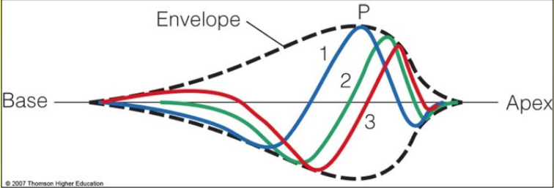

Evidence for Place Theory

- Frequency Tuning of Hair Cells
  - Record activity from single hair cell and measure how intense a sound (dB) is required to activate the cell at each frequency (Hz); ie. measure the absolute threshold for the cell across the frequency spectrum
  - Resulting function is the frequency tuning curve
  - Characteristic Frequency (CF): frequency (Hz) at which the cell is MOST sensitive (lowest threshold)
- Tonotopic Organization of Characteristic Frequencies
  - CFs of hair cells along the cochlea show tonotopic map = systematic representation of sound frequency
  - Ie. cochlea shows an orderly map of frequency response along its length
  - 20 000 Hz at base to 200 Hz at Apex

Frequency Theory

- All hair cells fire to every sound, and their rate of vibration indicates frequency of sound
- Problem: whole cochlea physically can’t vibrate across the range of 20 - 20000 Hz, so this cannot be the whole story; also, max neuron firing rate = 500 Hz
- However, action potentials from IHCs are found to be phase locked to the sound signals
  - Hair cells only fire when the sound is at its max pressure (not min pressure). Thus, there is a rlp w/ the physics of sound and the rate of fire
Phase Locking
- Phase is a characteristic of sine waves describing WHERE the wave starts
  - Wave has 360°, so at first peak = ¼ of wave = 90°, red and blue waves are 90° out of phase with one another
- Phase locked response: neural firing that has a precise timing relationship to the sound waveform, either linked to each compressive portion or spaced out every few cycles
  - Phase locked = waves peak at the same time (waves on upper of slide 82)
- IHCs spike when a pure tone is at highest compression, but max firing rate is 500 spikes/second so how to code for higher order frequencies?

Volley Theory

- No single neuron can signal each pressure maximum for tones above 500 Hz
- By aliasing and firing out of phase with one another, several neurons can TOGETHER encode high frequencies
  - Ie. each neuron will fire every five peaks since they can’t individually keep up, but together they can - thus phase locked

Synthesis

- For < 1000 Hz, only Volley theory applies; brain encodes based on HOW they fire
- For 1000 < 5000 Hz, BOTH Place and Volley theory applies; our best hearing
- For > 5000 Hz, only Place theory applies

Questions

- The hair cells are sandwiched between the basilar and tectorial membrane
- The apex of the basilar membrane codes for low frequency sounds

Transduction: Inner Hair Cells

- Hearing requires extremel rapid response; to respond to a 20000 Hz tone, cell must be able to encode changes (not fire) every 50 microseconds
- GPCRs are too slow for this, instead a direct physical mechanism is used

Inner Hair Cells

- Transduction occurs at the inner hair cells, specifically at the stereocilia
  - When stereocilia are bent, tiny filaments between their tips, tip links, are pulled
- The tip links directly and mechanically open ionic channels, causing the cell to alternately hyperpolarize and depolarize - goes back and forth many times in a second
  - Tip links are delicate, get broken down with wear, damaged with older age
  - Tips kind of act like “trap door” when bent a certain way, open for ions

Active Response: Outer Hair Cells

- OHCs do NOT transduce sound, but play an important role in boosting IHC response
- When sound stimulates OHCs, they rhythmically contract and expand like muscle cells
  - This amplifies the motion of the basilar and tectorial membrane, which in turn more actively stimulate the IHCs
- Without the Outer Hair Cell Response loop, you would be very close to death, not much would be heard - Bekesy only saw weak vibration and bending of hair cells from cadavers but in living people we have this feedback loop
  - Continuous amplification: loop restimulates basilar membrane, starting loop over
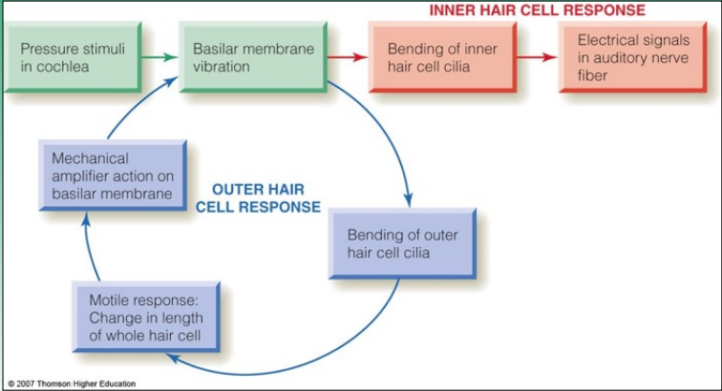

Amplitude Transduction

- Humans can sense amplitudes bw 20 and 20 000 000 µPa and Neurons can vary firing rates from about 1 to 500 spikes per second
  - So a neuron CANNOT code for the whole range
- Instead, different hair cells code for different limited ranges of amplitude
  - Ex. A codes for a low range (10 - 50dB); high resting response rate
  - B responds only to upper range, from 50 - 100 dB

The Basilar Membrane & Complex Tones

- Fourier analysis: mathematical process that separates complex waveforms into a series of sine waves
- Research on the response of the BM shows the highest response in auditory nerve fibers with characteristic frequencies (CF) that correspond to the sine-wave components of complex tones - complex sound wave → set of pure tones
  - in this sense, the BM does a Fourier Analysis of the incoming sound signal, breaking it down into component pure tones
- Some will be firing strongly, moderately, or weakly - BM breaks down wave to pure tones
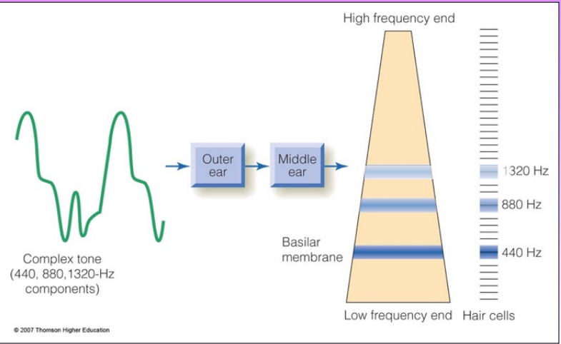
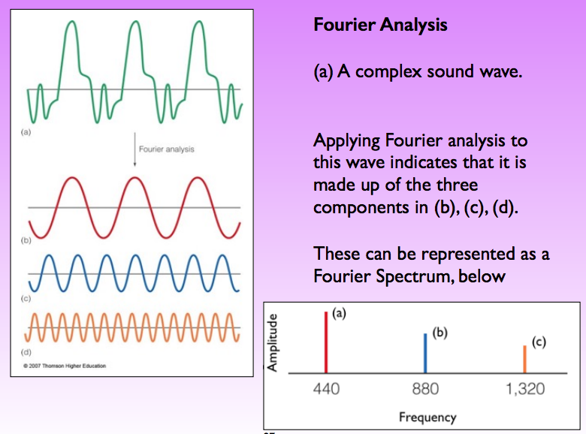

Questions

- The active response is the feedback loop produced by the outer hair cells to amplify the vibration of basilar membrane to thus increase the response of IHCs
- BM hair cells break down complex tones into simple pure tones - breaks down complex sound wave to different sine waves at different frequencies
- Frequency is coded by cochlear neurons with place (where) and frequency (how). Phase-locking is involved in frequency element - for frequencies under 1000Hz

Subcortical and Cortical Auditory Processing Areas

Pathway from Cochlea to Cortex

- Auditory nerve fibres synapse in a series of subcortical strcutures
- C? SONIC MGN is A1
  - Cochlear Nucleus each CN is only getting signal from ONE ear (no comparison)
  - Superior Olivary Nucleus (brainstem) BOTH ears involved; first integration site
  - Inferior Colliculus (midbrain)
  - Medial Geniculate Nucleus (MGN) (thalamus)
  - Auditory Receiving Area (A1 in temporal lobe)

Cochlear Nucleus
- Has tonotopic organization: ventral = low Hz, dorsal = high Hz
- Bushy cells: code for different frequencies and inhibit one another to provide sharper frequency tuning
  - Lateral inhibition: responds to certain cells and tells adjacent cells to shut up; sharpens tuning, only specific neurons firing
- Stellate cells: fire for duration of stimulus (slow adapting) with RATE indicating intensity of sound - Frequency AND amplitude
- Octopus cells: fire at sound onset/offset (fast adapting), and may provide sound timing information; localizing sounds by determining start and endpoints, ie. which ear it reaches first

Superior Olivary Nucleus
- Has tonotopic organization, and is FIRST site of binaural activity (both ears)
- First analysis of sound direction (horizontal only) which works via analysis of:
  - Timing differences between the 2 ears; sound from right arrives at right ear first
  - Intensity differences between the 2 ears; sound from right is louder in right ear

Inferior Colliculus
- Receives inputs from many higher areas such as A1 and may be a switchboard for regulating auditory ATTENTION ex. Hear a noise from your right when home alone, higher cortical areas send signals to IC to suppress sound from left and bump up right
- Also an integrating area for multi-modal perceptual responses such as startle reflexes and reflexive looking

Medial Geniculate Nucleus (MGN)
- Nucleus of thalamus ; tonotopically organized but in a COMPLEX fashion
- Processes all aspects of sound; may be the first site of complex pitch (as opposed to simple frequency) perception
- Tone height as well as tone chroma (ex. Middle C is green, and every octave C higher is a lighter/brighter shade of green)
Descending Pathways

- Connections go from ear up to cortex (afferent), AND also back down (efferent)
- Ex. Olivocochlear neurons (going from Superior Olivary down to cochlea) can turn down the gain on IHCs to allow them to process higher sound volumes
  - Send signals down to cochlea to tell hair cells to turn down their sensitivity ie. when in a construction site or somwhere noisy, if your hair cells stayed at their usual sensitivity, you wouldn’t be able to tell the difference between loud things and very loud things, etc - everything would be washed out
- Descending connections also cause contractions in small muscles attached to ossicles, causing them to be less mobile and thus “turning down the volume” on high amplitude sounds; hold the middle bones still so they don’t vibrate as much

Questions

- Sequence of subcortical nuclei that carry auditory info from ear to cortex
C? SONIC MGN is A1
  - Cochlear Nucleus each CN is only getting signal from ONE ear (no comparison)
  - Superior Olivary Nucleus (brainstem) BOTH ears involved; first integration site
  - Inferior Colliculus (midbrain)
  - Medial Geniculate Nucleus (MGN) (thalamus)
  - Auditory Receiving Area (A1
- The descending (efferent) fibres leading into the cochlea
  - Turn down the gain (sensitivity) of the hair cells
  - Flex the muscles of your ear bones so they become more stiff and don’t vibrate as much, letting really loud sound in

Auditory Areas in the Cortex

- Signals from MGN arrive in A1 primary auditory cortex
- A1 processes relatively simple sound information regarding frequency and location
- A2 processes more complex aspects of sound
- Other areas (Wernicke’s, Broca’s) process speech (comprehension and production)

Organization of A1

- A1 is organized in isofrequency sheets which run LEFT to RIGHT
  - Neurons within a sheet have the same CF
- Transverse to the sheets are aural dominance columns and suppression/summation columns

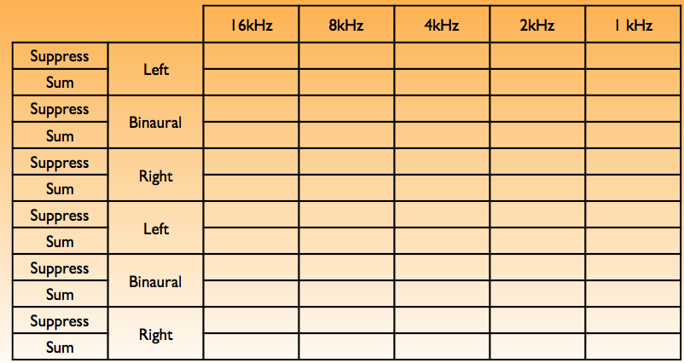
Aural Dominance columns: left, right or both ear input more important to cell?
Suppressive: subtract input from other ear to see difference
Summative: add input from other ear, fire more - spatial integration

Binaural: equal weight to both ears; for suppressive, something is right in front of you, the neurons would give 0 response

Effect of Experience on Tonotopic Maps

- Owl monkeys were trained to discriminate bw 2 frequencies near 2500 Hz
- Trained monkeys showed tonotopic maps with enlarged areas responding to 2500 Hz, compared to untrained monkeys - more tissue responding, plasticity
- Cases of humans with brain damage to this A1 show perception difficulties with pitch

What and Where Streams for Hearing

- It has been proposed that there are separate “what” and “where” processing circuits in auditory cortex
- What stream starts in the anterior portion of temporal lobe and extends to PFC
  - Responsible for identifying sounds
- Where stream starts in posterior temporal lobe and extends to parietal & PFC
  - Responsible for locating sounds
- Hearing and vision interact in complex ways due to the parts of the brain that process both auditory and visual stimuli

Questions

- An isofrequency sheet is a single layer of neurons in the auditory cortex that all display the same characteristic frequency (CF)
- Columnar organization of A1 by aural dominance columns (what ear(s)) and summation/suppression columns
- What stream identifies sounds - runs from anterior temporal lobe to PFC
Where stream locates sound - runs from posterior temporal to parietal and PFC
Hearing II: Perceptual Aspects

Intensity & Loudness

- Loudness is the subjective perceptual quality of sound related most directly to pressure or intensity; but loudness also depends on frequency of sound, among other things

Absolute Detection Thresholds

- The pressure at which loudness is greater than 0 (ie absolute threshold) varies according to frequency
- Max sensitivity at 2-5 kHz, also where human speech has most energy
  - More sensitive 1k to 5k Hz
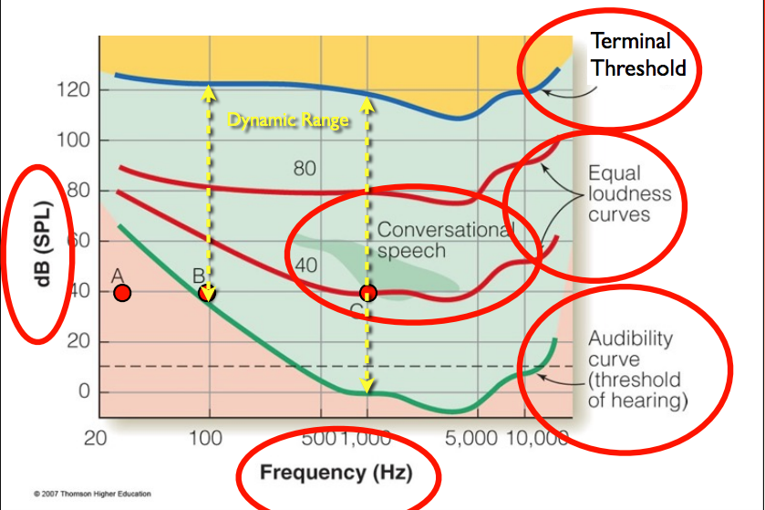
Terminal threshold: threshold of pain; max out; loudest sound you can hear where you can discriminate its loudness above 120dB it will hurt

Audibility curve: threshold of hearing as frequency varies - at high and low Hz, threshold will rise

Different Hz, even at same dB will be heard well or not
A not heard, B barely, C easily heard

Green blob = conversational speech
Dynamic range: range across which is can meaningfully vary according to amplitude, varies by frequency bw 100 and 1000 Hz ex. How many dBs of sound your computer can produce
In terms of sensitivity, across what range can your auditory system give you meaningful info in regards to differences in amplitude

Equal loudness curves: derived from studying the difference in sensitivity to different frequencies - equal subjective loudness at 40 and 80 dB

Fundamental Concept: Psychometric vs Psychophysical Functions

- Psychometric: function of physical quantity and behavior ie. physics unit vs % detected
  - shows one threshold (usually S function)
- Psychophysical: function of two physical quantities ie. Hz and dB
  - Shows how threshold on one physical quantity varies as a function of the other

Loudness

- Binaural vs monaural presentation: threshold is 6dB lower with two ears (spatial integration)
- Durating of sound: threshold increases below 200ms (temporal integration)

Fundamental Concept: Spatial & Temporal Integration

- Any sensor (bioloigcal or artificial) must integrate signals across a certain range of space and time
- Longer/larger integration provides greater sensitivity but lower acuity (details can be lost)

Questions

- The minimal audibility curve is the line at which different frequencies are audible at various dBs; psychophysical function showing how absolute threshold (measured in dBs) varies in function with frequency (Hz) - below audibility curve = negative dBs which is ok bc they are a log unit
- The dynamic range of the auditory system is the range across which the auditory system can give you info concerning changes in amplitude/subjective loudness; varies as a function of frequency bw 100 and 1000 Hz
- A psychometric function measures a physics unit and a behavioral unit
- A psychophysical function shows how a threshold on one unit varies according to the other unit *measures 2 physics units

Sound Masking Experiments

- A type of psychophysical experiment examining how one sound affects perception of another; two types
  - Tonal masking: how much does one pure tone impair perception of another
  - Noise masking: how much does aperiodic sound impair perception of tones
- Two basic methods:
  - Constant target Hz, varying masker Hz (typically used with tonal masking)
  - Varying target Hz, Constant masker Hz (typically used with noise masking)

Tonal Masking

- Typically, a test tone of fixed frequency and amplitude is chosen, say 1000 Hz at 40dB
- Then a series of masking tones of different frequencies are presented
- For each mask, observer adjusts its intensity (dB) until it JUST drowns out the test tone
- Most effective mask is at same frquency - note assymmetry of off-frequency masks
- High frequency mask is a bad mask
Noise Masking

- A constant noise mask is used; typically will be narrow-band white noise, meaning an aperiodic sound with frequencies in a certain limited range
  - Ex. Noise with energy at 410+-45 Hz = has centre frequency of 410 Hz and a bandwidth of 90 Hz
- The effect of the noise mask on the absolute threshold of pure tones is measured; done for test tones across the frequency spectrum
- Threshold is HIGHEST for test tones near the frequency of the noise; again asymmetry is seen off-frequency
- We can subtract the baseline from the masked audibility curve which gives us the threshold elevation produced by the noise mask
  - Threshold elevation shows asymmetry; the mask is more effective against higher frequencies
- The mask is more effective against higher frequency (not effective for frequencies that are lower than it)

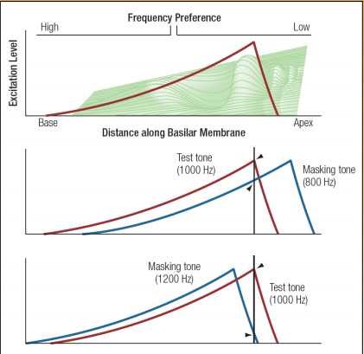
Masking Asymmetries

- Masking asymmetries occur because of asymmetries in how the basilar membrane responds to pure tones; the travelling wave builds up gradually then collapses suddenly
- Depending on frequency of sound play at you, the travelling wave will peak in different section of the basilar membrane = low Hz = peak at apex, high Hz = peak at base
- So masks that are HIGHER in frequency are NOT good because their excitation level will drop off the BM before the test tone - easy to tell the difference in response here

Questions

- A 500 Hz masking tone would most effectively mask a 500 Hz target tone
- A 500 Hz masking tone would mask a 600 Hz tone better than a 400 Hz tone
- Asymmetry in masking is due to the assymetries in travelling wave in the basilar membrane; gradual buildup and sudden collapse

Frequency & Pitch

- Relate to one another in a complex way
- As frequency increases, one aspect of pitch called tone height increases linearly
  - And another aspect tone chroma changes simultaneously in a circular fashion; don’t process chroma until the thalamus - all Cs are green just brighter
- Tone height corresponds to a tone’s frequency ie. A4 and tone chroma corresponds to the position of a note within the musical octave A4 is 440 Hz A5 is 880 Hz, A3 is 220 Hz
  - Height - do re mi fa , chroma do do do
- Same chroma level = harmony and diff = disharmoney

Auditory Localization

- Auditory space: surrounds an observer and exists wherever there is sound
- Locations in auditory space are defined by:
  - Azimuth coordinates: position left to right
  - Elevation coordinates: position up and down
  - Distance coordinates: position from observer
- On average, people can localize sounds directly in front of them more accurately than those to the side or behind them
- In audition, direction cues are NOT present on the cochlea - later on

Questions

- 3 coordinates used to describe sound location: azimuth, elevation, distance
- Most accurately judge sound location in front of us, least accurate is behind and above

Cues for Sound Localization

- Binaural cues = Interaural Time Difference (ITD) and Interaural Intensity Difference (IID)
- Monaural cue = Head-Related Transfer Function (HRTF); sound encounters head & ears

Binaural Cues

- Location cues based on the comparison of the signals received by the left and right ears
- Interaural Time Difference (ITD): difference between the times sound reach the 2 ears
  - When distance to each ear is the same, there are no differences in time
  - When the source is to the side of the observer, the times will differ
- Interaural Intensity Difference (IID): difference in sound pressure level reaching the two ears; reduction in intensity occurs for high frequency sounds for the far ear
  - Acoustic shadow: head blocks high frequency sound; reduce intensity in far ear
  - Low frequency sounds diffract around the head so no shadow for low freq
- The HIGHER the frequency of the sound, the greater the intensity difference between the 2 ears when sounds are coming from the side

- A given ITD/IID cannot, on its own, tell you where a sound is coming from; can only tell you it is coming from somewhere on a particular cone of points = cones of confusion
  - As ITD gets bigger, cone of confusion gets narrower

Monaural Cue for Sound Location: HRTF

- As sounds encounter the head, they are modified by its structures (bones, muscles, etc) ESPECIALLY the pinna
- Some frequencies are reduced in amplitude, others, due to resonance and constructive interference, are increased
- Head-Related Transfer Function (HRTF): pattern of increases and decreases in amplitude due to the head and its structures
  - HRTF differs depending on the elevation of the sound source
- The head and pinna leave a unique frequency fingerprint on sounds
  - This fingerprint varies based on the elevation coordinate helping to resolve which point on the cone of confusion is the source of sound
  - Ex. playing flat function (white noise) at a person - fingerprint changes based on where sound is coming from - elevation ie. 40 above ear, at ear, 40 below ear

Hofmann Experiment on Judging Elevation

- IID and ITD are not effective for judgments on elevation since in many locations they may be zero so Hofmann investigaged spectral cues
- Listeners were measured for performance locating sounds differing in elevation
  - They were then fitted with a mould that changed the shape of their pinnae
- Right after the mouls were inserted, performance was poor in elevation
- After 19 days, performance was close to original performance
- Once the moulds were removed, performance stayed high
  - Suggests there might be 2 different set of neurons, 1 for each set of HRTF cues

Distance Cues for Sound - not very good at it

- Spectrum: High frequencies are more quickly damped by air, so distant sources sound muffled. For sound with a known spectrum (ex. speech), distance can be estimated by degree of muffling
- Loudness: distant sound sources have a lower loudness than close ones
  - This aspect can be evaluated especially for well know sound sources
- Movement: Motion parallax can be used in acoustical perception; nearby sound sources pass faster than distant sound sources ex. Driving in car by lampposts vs mountains
- Reflection: In enclosed areas, direct sound arrives at the listener’s ears without being reflected off a wall. Reflected sound arrives later, after bouncing off a wall. Ratio between direct and reflected sound arrival times give an indication about the distance
- Comparative Sound Localization
  - Head-tilting is used in some animal to gain sound elevation information
  - Owls have asymmetrical ears, allowing IIds to be used for elevation (ITDs for az)

Questions

- IID and ITD are used for sound location in the azimuth (horizontal)
HRTF is used for elevation
Spectrum, loudness, movement, reflection for distance
- IID is the binaural cue that works for high frequencies (acoustic shadow) but not for low since low diffract around head and recreate on other side
- HRTF is the pattern on increases and decreases in amplitude due to the head and its structures; differs depending on the elevation of the sound source

Methods for Measuring Sound Location Accuracy

- Free Field presentation: sounds are presented by speakers located around the listener’s head in a dark sound-proof room
- Headphone presentation with applied IIDs, ITDs, and HRTFs

Free Field Presentation

- Sounds are presented by speakers located around the listeners head in a dark room
- Listener indivates location by pointing or giving azimuth and elevation coordinates
- Advantage: highly naturalistic stimulus properties
- Disadvantage: expensive equipment, some lack of control over exact sound contents

Headphone Presenation of Sounds

- Advantage: experimenter has precise control over sounds and much cheaper
- Disadvantage: cues from the pinna (HRTF) are eliminated, which results in the sound being internalized
- Sound can be externalized by measuring each subject’s HTRF and applying it to the presented sounds

Questions

- The two main methods od testing localization accuracy are
  - Free field presentation: more naturalistic, but more expensive, not as controlled
  - Headphone presentation” cheaper, more precise control but must apply an HRTF to the sound after
- TTD
- THat people eventually adjusted when the pinna was changed, and readjusted back to their normal level with normal pinna

Physiological Representation of Auditory Space

- Interaural time-difference detectors: neurons that respond to specific ITDs
  - Found in auditory cortex and at the first nucleus (superior olivary) in the system that receives input from both ears
- Topographic map: neural structure that responds to locations in space (not tonotopic)

Topographic Maps

- Barn owls have neurons in the mesencephalicus lateralus dorsalis (MLD) that respond to locations in space - piece of brain is like a direct map of space around owl
- Mammals have similar maps in the subcortical structures, such as the inferior colliculus but not in the cortex
- These neurons have receptive fields for sound location

The Auditory Cortex

- No topographic map in cortex, only in subcortical areas of mammals
- Instead, panoramic neurons signal location by their pattern of firing
- In general, the where stream shows more specific neural responses for location the further upstream one goes in the cortex
- Panoramic neurons fire different patterns of bursts depending on the direction from which the sound is coming

Questions

- Topographic map of sound locations means they have a map of the world around them in their brain, brain tissue laid out like the world around them
- Panoramic neuron is a neuron that signals sound location by their pattern of firing

Auditory Scene Analysis

Identifying Sound Sources

- Auditory scene: array of all sound sources in a listener’s environment
- Auditory Scene Analysis: process by which sound sources in the auditory scene are separated into individual perceptions
- Does NOT happen at cochlea: Simultaneous sounds are combined together in the pattern of vibration of the basilar membrane
- Aspects of Auditory Scene Analysis
  - Segregation of sound signal into those coming from individual sources
  - Grouping of separate sounds into those coming from a given source
  - Sound localization: same location, same sound
- Sounds from different sources are mixed together on the cochlea. Therefore, auditory scene analysis must take place entirely at later stages of audition
  - Cochlea breaks sound sources down into a set of pure tones only

Fundamental Concept: Gestalt Heuristics

- Gestalt Heuristic is a rule of them applied to organizing sensory inputs to determine
  - Which elements of a scene belong to which object, which elements represent edges between an object and its background, etc. for example
- Proximity principle = if things are grouped closely, they belong together
- Similarity principle = if things are the same/similar, they belong together

Principles of Auditory Grouping

- Like visual stimuli, sound stimuli tend to be organized according to the following heurs:
  - Proximity: sound from a single source come from one location
  - Similarity: sounds from a single source tend to be similar (pitch, timbre, loudness)
  - Smoothness: sounds from a single source tend to change (location, pitch, loudness, etc) in a smooth and continuous way ex. Walking slowly across a room
Auditory Streaming

- When sounds A and B are similar in pitch, they are grouped together in a single “galloping” sound stream based on proximity in time and timbre (A4 and B4)
- When pitches A and B are different, they are grouped into two streams: one for the low-pitched A sounds, and another for the high-pitched B sounds (A4 and B5)

Melodic Channeling
- Stimuli were two sequences alternating between the right and left ears
- Listeners perceive two smooth sequences by grouping the sounds by similarity in pitch
- The proximity and smoothness heuristics win out over reality in this case
Questions

- Proximity, similarity, smoothness are Gestalt principles that apply to ASA
- Sounds from the enviro may be grouped by similarity in pitch, timbre, location, amplitude

Wessel’s Timbre Illusion

- Demonstrates how heuristics can compete with each other
- Smoothness heuristic tries to group by smoothly changing pitch; dominates at low speeds, results in grouping across timbres
- Similarity heuristic tries to group by timbre; dominates at high speeds, resulting in grouping into two sequences in descending sets

Auditory Grouping

- Proximity in time: sounds that occur in rapid succession usually come from same source - this principle was illustrated in auditory streaming
- Good continuation: sounds that stay constant or change smoothly are usually from the same source. Demonstration by Bregman et al
  - Tones were presented interruped by gaps of silence or by noise
  - In the silence condition, listeners perceived that the sound stopped during gaps
  - In noise condition: the perception was that the sound continued behind the noise; white noise contains all the frequencies needed to invent these sounds
- Effects of Experience: heuristics can be affected by learning and knowledge
  - Dowling used two interleaved melodies (3 blind mice & Mary had a lamb)
  - Listeners reported hearing a meaningless jumble of notes
  - But listeners who were told to listen for the melodies were able to hear them by using melody schema - fill in missing bits of a tune you know

Vision & Sound :

- visual capture or the ventriloquist effect: an observer perceives the sound as coming from the seen location rather than the source for the sound
- Experiment: Balls moving across screen without sound appeared to move past e/o
  - Balls with an added “click” appeared to collide

Questions

- Bregman’s demo of rising and falling sounds interrupted with gaps or white noise demonstrated the good continuation heuristic; brain could use white noise (bc it contains all the frequencies) to fill in the gaps even tho the tone did not continue through it
- Sekular’s experiment with the bouncing/non bouncing balls demonstrated the visual capture/ventriloquist effect - how sound and vision interact
Vision I: Light, Optics, & the Eye

Light

- A form of electromagnetic (EM) radiation (along w gamma rays, UV light, radio)
- EM radiation vaires by: wavelength (1/frequency), intensity (# photons), polarity

Wavelength

- Lambda (𝛌) measured in units of distance (angstroms or nanometers)
- Visinble light to humans ranges from ~400nm - ~700nm
- Variations in wavelength give rise to colour experience, but rlp is complex
  - Long = red, medium = green, short = blue
- Natural lights made up of numerous wavelengths, each with its own intensity, a laser is a single wavelength
  - A light’s subjective color is determined (in part) by its intensity spectrum
  - Ex. Black paper spans across all wavelengths but at a much lower intensity than white paper; black, white, grey all span over all 𝛌s

Wavelength vs Frequency

Wavelength (𝛌) = 1/Frequency and therefore Frequency = 1/wavelength

Ex. Frequency of 10 cycles/meter = 1/10 = .01meters/cycle of wavelength
Ex. Wavelength of .001 second/cycle = 1000 cycles/second (1000 Hz)

- With sound we talk mostly in terms of frequency, and with vision we talk mostly in terms of wavelength
- Vision is limited to such a narrow range because this is where most of the energy in sunlight is; Also ranges are either damaging (UV) or pass through objects too easily (radio) (not useful)
- Atmosphere blocks gamma, x and ultraviolet rays, long-wavelength radio waves, and most of infrared spectrum absorbed by atmospheric gases
- Some animals have sight outside of our range ex. Pit viper sees infrared

Basic Concept: Spectral Functions

- The concept of a spectral function appears in many areas of perception, especially in vision, hearing, and touch
- A spectral function describes some property of a stimulus as a function of wavelength or frequency
  - This can be wavelengths of light sound, physical vibration, etc
- Most stimuli have a broad range of wavelengths, each w its own amplitude
- A spectral function can describe properties of emission, transmission, scatter, etc but also of detection/differentiation

Intensity

- Measured in units of power per area such as candela/m² or photons/Receptor
- Human vision can handle bw about 10⁻⁶ to 10⁷ cd/m² (beyond this damage occur)
- Variations in intensity give rise to the sensation of brightness, but rlp is nonlinear
- Absolute Threshold, under ideal circumstances, is 100 photons
- Weber fraction = .08 = 100 candela light vs. 108 candela light, just able to tell that the second one is slightly brighter
- Stephen’s Power Law exponent = .33 - .50 depending on size & duration

Polarity

- Light waves are transverse (unlike sound) and consist of an electric field and a magnetic field that oscillate orthogonally
- Polarity refers to the angle (in degrees) of the electric component
- Light from the sun is of a mixed polarity across most of the sky
- But, reflected light becomes plane polarized
- Some substances can filter out lights of a given polarity (polarized sunglasses)
- Light from the sun is highly polarized across a strip of sky that is orthogonal to the direction of the sun
- Humans cannot perceive this quality of light, but some animals can and use it to navigate ex. Desert ant navigation

Questions

- The characteristics of light are wavelength, intensity, and polarity
- These are measured in nm, cd/m², and degrees
- The rlp bw physical intensity and subjective intensity is COMPRESSIVE
Emitted Light

- Light is emitted from a source and travels in all directions until absorbed, refracted, or reflected
- Emitted light from a point source can be thought of as either
  - A series of expanding spherical wavefront coming out of light source
  - A spherical area of linear light beams pointing out in all directions from it
- At optical infinity (a sufficient distance) = 6m
  - Spherical wave fronts can be treated as flat
  - Light rays can be treated as parallel

Inverse-Square Law

- Energy from a light source is spread over an area proportional to the square of the distance; same rule as we saw with sound; it applies to any form of emitted E

Intensity = 1/d²

Light’s Journey to the Eye

- To get to the eye, light must first be emitted by a source (ex. lightbulb, sun)
- Light then goes through a number of stages, each modifies or “structures” it
  - Transmission through a medium (eg. air or water)
  - Interactions with surfaces of objects (absorbed, reflected)
  - Transmission through a medium (again) to the eye
  - Interactions with outer structure of the eye (absorbs/bounces back half of the photons; ie. eyeball is shiny and reflective)
  - Interactions with structures of the retina
- At each stage, several things can happen to the particles that make up a light:
  - Transmitted (also refracted or scattered)
  - Absorbed (re-emitted as heat)
  - Reflected (in one of 2 diff ways)
  - These are NOT mutually exclusive; several can happen w same object/medium

Light Transmission

- Can be selective by wavelength (eg. rose-coloured glasses)
- Change in medium results in refraction: an ORGANIZED change in direction (eg. prescription glasses)
- Can result in scatter: a disorganized change in direction (eg. fogged glass of bathroom)

Light Absorption

- Can be selective by wavelength
- Absorbed photons are re-emitted as heat
- Darker objects absorb more photons, therefore get hotter in the sun

Light Reflection

- Any light not absorbed or transmitted is reflected
- Usually selective by wavelength; gives rise to colors of opaque objects (in part)
- Body Reflection (Diffuse): light is scattered in all directions
  - Reflection analogue to scattering
- Specular Reflection: light is reflected at an angle opposite the angle of incidence (eg. a mirror)
- Ex. A glass ball would have light transmitted through it (transparent
  - A mirrored ball, light would be reflected back (specular reflection)
  - A white cueball, light would be diffuse reflection; can’t see a reflection

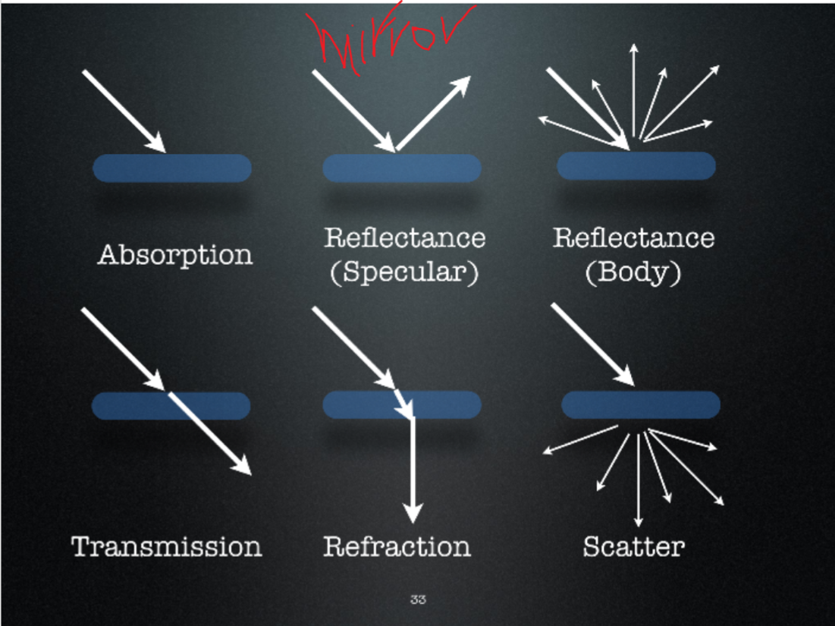Rare to get transmission w/o Refraction

Not all light makes it to retina; we lose light at each stage

Questions

- 6 different things that can happen to light: transmission, refraction, scatter, absorbed, body reflection (diffuse), specular reflection
- Specular reflection is systematic; light is reflected at an angle opposite the angle of incidence whereas body reflection light is scattered in all directions (random
- The significance that light is structured by the environment is because it gives us information about objects in the world
Anatomy of the Eye

- Fovea has densely packed cone cells (best vision, best quality of image)
- High density of cones AND rods in macula (small circular space surrounding fovea)
- As we move away from macula, lower + lower density of cones and rods near periphery
- No cones or rods at optic disc (where axons meet & leave eye) = blindspot
- Cornea: transparent layer in front of iris/pupil; lets light through and bends it so that it reaches the fovea
- Aqueous humour: clear fluid between lens and cornea
- Crystalline lens: transparent, helps to focus light on the retina; changes its shape so that you can focus on things that are close
  - Hardens with age which leads to older ppl having difficulty seeing things that are close (presbyopia) or muscles get weaker
- Vitreous humour: transparent, gelatinous tissue filling eyeball behind lens
- Sclera: white outer layer of eye; protects rest of eye
- Choroid: vascular layer between sclera and retina; very deep black and absorbs stray photons that make it through the retina
- Retina: network of neurons lining the back of the eyeball that is involved in converting light energy into neural signals; transduce light
  - Rods, cones → bipolar, horizontal, amacrine cells → Retinal Ganglion Cells
- Optic nerve fibres send signals to brain

Focus

- An acute imaging system (camera or eye) forms a sharp image on its imaging surface (film or retina)
- To do so, it must direct the light from each point in its field of view to a small patch on the imaging surface; this is accomplished by pin-hole light gathering and/or using lenses
- When the lens power is correct for the focal length and distance to the scene, you get a sharp image for each point in a scene
  - If not correct, you get a blurred image of each point in the scene
- You want the spread out cone of light coming from a point to be reversed back into a point when it gets to our eye so you can focus on things properly
- When the light coming from a point is not focused back down into a point, the point will be spread out over a larger area on the retina

Pinhole Light Gathering

- One way to “sharpen” light is to allow it to reach the image surface via a small opening
- Pinhole cameras (camera obscura) use this principle with a hole that is about .5mm in diameter - problem: this only allows in small amount of light, creating dim images
- Using temporal resolution to compensate for a lack of spatial resolution

Lenses

- Lens: transparent surface that transmits and refracts light
  - Convex: gathers light to a focal point ex. Magnifying glass, reading glasses
  - Concave: spreads light beams apart so no real focal point, but there is a virtual focal point ex. Glasses to correct myopia
- Strength: how good it is at bending light
  - Measured in diopters (dp)
  - Positive dp = convex ; focuses light to a point 1/dp meters behind lens
  - Negative dp = concave; spreads light beams out. Virtual focal point is 1/dp m in front of lens (back in direction light came from)

F = 1/dp so dp = 1/F

Combining Pinholes and Lenses

- Combining a convex (+dp) lens with a pinhole allows the pinhole to be bigger (so brighter images) while still having sharp focus
- The eye has a quite large “pinhole”, the pupil, which varies from ~2-7mm in diameter
- It also has a powerful focusing system in the form of the cornea and crystalline lens
  - Cornea and crystalline lens are convex will bring light down to a point
  - Large pinhole and convex lens = lots of light and sharp image
- Just small pinhole = dark image, large pinhole = focus is poor

Combining Lenses

- For thin lenses placed close t/g, one can add their diopters to determine the net effect
  - Ex. A +3dp lens on top of a +5dp lens = +8dp lens
  - Likewise a +3dp lens and -3dp lens would simply cancel e/o out

Questions

- Eye creates a focused image on retina with pinhole light gathering and lens
- The focal distance of a +10dp lens is .2m and for -5dp is -.2m
- A lens with +2dp produces will produce a .5m FD and -4dp = .25m
- It is important each point in the enviro be repd on the retina by a small point so we can have good, sharp focus image ; see details in enviro

Cornea & Crystalline Lens: Focusing Images on Retina

- Cornea is on average a +43dp lens
- Crystalline lens can vary its shape/power from +15 - +25 dp
- Total Focusing Power = 43+(15 to 25) = 58dp when lens is relaxed and 68dp at max accomodation 58-68dp
- Eye is about 25mm in diameter but distance from lens to retina is 18mm (1/58m)

Focus

- Emmetropic: light focused to a point on the retina; normal
- Myopic: light focused IN FRONT of retina; corrected with concave artificial lens (-dp)
  - Eyeball too long, lens too strong; blurred image of world

Accommodation

- When objects are closer than optical infinity, light rays from pts are not parallel
- Therefore, the same amount of bending as for distant objects would produce blur
- Luckily, the crystalline lens can change shape to accommodate for this (up to a point)
- The Near Point: when objects get too close, the crystalline lens cannot change its shape enough to accommodate, so image becomes defocused
  - Happens at ~10cm = near point
  - Presbyopia: as we age, the lens becomes harder and accommodation becomes limited, so the near point gets further away; convex +dp lens can correct for this

Hyperopia

- Lens is not powerful enough for length of eye, so images are blurred
- In the young, accommodation compensates but causes eye-strain; hard to diagnose in young children
- Corrected using convex +dp lenses

Vocabulary

- Emmetropia: eye whose light-bending power matches its length 6/6 vision
- Myopia: eye has too strong a lens for its length; nearsightedness
- Hyperopia: eye has too weak a lens for its length; farsightedness
- Presbyopia: older eye’s lens unable to change shape to accommodate for near targets

The Retinal Image

- Extended objects can be thought of as consisting of a large number of point sources
- These points are shown on our retina but UPSIDE DOWN and flipped left-right
- Image on retina is upside-down and backwards
  - This does not actually pose any problem in analysis of image info
- Nodal point: arbitrary point of how all the light get refracted/reflected/etc in eye
- Due to lens aberrations, the image on the retina is of higher quality in the centre than at the edges; the distribution of receptors in the retina is sparser here too
- Objects at distances other than the depth of focus are blurred (outside of area you are focusing on) ex. Hold a finger 12cm from face and another finger at arms length
- The degree of blue depends on pupil size
  - We have greater depth of field under bright conditions when pupil is small; points are focused better on retina

Questions

- Emmetropia is eye whose light-bending power matches its length 6/6 vision
- Images are defocussed in myopia when image is far away; corrected with concave lens
- Images are defocussed in presbyopia when image is near; corrected with convex lens
- A child with eye 10mm (.01m) from lens to retina, her lens needs to be 100dp for her to be emmetropic
- If her eye’s natural lens system was 95 dp we might prescribe her a convex lens (lens not strong enough)

