Module 1: Gene/Phenotype Expression
Transcription and Translation
- Transcription
  - DNA to mRNA
  - DNA template
    - Both strands of DNA can act as a template strand
    - Specific sequences of bases along the DNA strand determines where a transcription factor binds
      - They do not bind randomly to DNA
    - Both DNA of homologous chromosomes cannot be used as templates
      - They contain the same genes but may have different alleles
      - May code for different proteins
  - RNA polymerase
    - Separate double-stranded DNA
    - Adds RNA nucleotides complementary to the DNA template strand
      - 5’ to 3’ direction
  - Promoter
    - Sequence where DNA ploy erase attaches and initiates transcription
  - Terminator
    - Sequence that signals end of transcription
  - Transcription factors
    - Mediate binding between RNA polymerase and promoter
    - Determine which DNA sequences should be transcribed
    - Determine when transcription begins
  - Initiation
    - RNAP binds to the promoter
    - RNAP unwinds the DNA strands and initiate RNA synthesis
    - Different initiation points result in overlapping genes
  - Elongation
    - RNAP moves downstream
      - Unwinds DNA and elongates the RNA in 5’ to 3’ direction
  - Termination
    - RNA transcript is released
    - RNAP detaches from the DNA
  - mRNA processing
    - Alternation of mRNA ends
      - Facilitates the export of the mature mRNA from the nucleus
      - Protect mRNA form degradation by enzymes
      - 5’ cap added to the 5’ end
      - Poly-A-tail added to the 3’ end
    - RNA splicing
      - Intros are removed
        - Noncoding regions
      - Exons are joined together by spliceosomes
        - Coding regions
        - Become expressed
- Translation
  - mRNA to protein
  - Anticodons
    - Extends from the tRNA
    - 3’ to 5’ direction
    - Align with codons (5’ to 3’)
  - Codon recognition
    - Anticodon of the tRNA base pairs with the complementary mRNA codon in the A site
  - Peptide bond formation
    - rRNA of the large ribosomal subunit catalyzes the formation of a peptide bond between the amino group of the new amino acid in the A site and the growing polypeptide in the P site
    - Polypeptide from the tRNA in the P site is removed
      - It is attached to the amino acid on the tRNA in the A site
  - Translocation
    - tRNA from A site is trans located to the P site
    - Empty tRNA from the E site where it is released
- Genetic code
  - Set of rules that a cell uses to interpret the nucleotide sequence of mRNA
  - Degenerate
    - An amino acid can be indicated by more than one codon
    - Minimizes the harmful effects of mutations
  - Non-overlapping
    - Three nucleotides within a particular codon are party of that codon
Gene Expression
- Genes
  - Sequence of nucleotides
  - Codes for proteins which dictate cell function
  - Determines a trait
- Genome
  - Includes copies of all genes and noncoding DNA sequences
- Alleles
  - Variations of a gene
  - Different alleles produce different phenotypes
- Genotype
  - Set of alleles for a given trait of an organism
DNA Sequence
- Template strand
  - Noncoding or anti sense strand
- Coding strand
  - Sense strand
- DNA sequence dictates protein structure
  - Primary structure: encoded by genes – order of amino acids
  - Tertiary structure: amino acid interactions determine protein conformation
Mutations
- Changes in nucleotide sequence of an organism
- May occur in coding regions or noncoding regions
- DNA sequence
  - Changes in the primary structure of proteins can change protein folding thus alter protein function
- Inheritance
  - Germline mutations
    - Occur in germ cells (egg or sperm cells)
    - Inheritable
  - Somatic mutations
    - Occur in somatic cells
    - Not inheritable
    - Occur at some time during a person’s life
- Location
  - Mutations in promoters, introns, and untranslated regions can change when, where, and how much protein is made
- Point mutations
  - Changes one base pair to another
  - Missense
    - Results in a new triplet that codes for a different amino acid
  - Nonsense
    - Changes the amino into into a stop codon
    - Results in termination of protein translation
  - Silent
    - Changes the triplet codon but does not change the amino acid
      - Degeneracy
- Frameshift mutations
  - Insertion or deletion of one or more nucleotides
  - Causes the subsequent three-letter codons to be changes
- Loss-of-function mutations
  - Results in protein that has reduced or no enzymatic activity
  - Changes in protein tertiary structure often disrupt the enzyme active site
  - Mostly recessive
    - One wild type is sufficient to give a wild type phenotype
    - Enzyme activity is above threshold for wild type phenotype
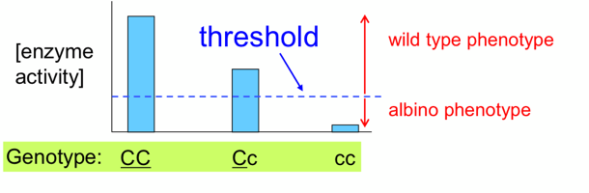
    - Carriers are unaffected
  - Example: temperature-sensitive proteins
    - Missense mutations can destabilize secondary and tertiary protein structures
    - Protein unfolds at lower than normal temperatures
    - In cats, warmer parts of the body are white and colder parts of the body are black
- Haploinsufficiency
  - One wild type copy is not sufficient to give a wild type phenotype
  - Enzyme activity is below threshold for wild type phenotype
- Dominant-negative mutations
  - Heterozygous produces wild type and mutant protein subunits
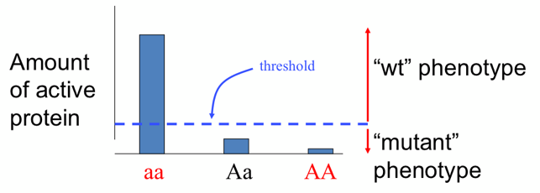
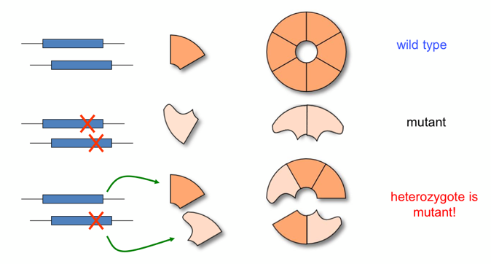
    - Protein subunit cannot assemble together into an enzyme

- Gain-of-function mutations
  - Results in protein that has new activity, is produced at the wrong time, and/or is produced at the wrong location
  - Rare
  - Usually occurs in promoter regions
  - Dominant
    - Small amount of mutant protein is sufficient to produce mutant phenotype

