CHM1321

MIDTERM 2

π bonds as electrophiles (Chapter 7 Part 1)
Reactivity of pi bonds
- Compare pKa
- Electrophile = Lewis acid = electron poor = polar bonds
- Nucleophile = Lewis base = electron rich = non-polar bonds
Electrophiles
- Electron poor
- Polar double bonds
- X = O or N
  - Aldehydes, ketones, imines, esters, etc.
Nucleophiles
- Electron rich
  - Lone pairs/anions
- Can be neutral or anionic
- Counter-ion is a metal cation
General nucleophilic addition reaction
- Nucleophilic addition reactions are governed by molecular orbital theory
- Occurs when there's an overlap of 2 p-orbitals to form a π bond
Example: MO diagram of ethene

MO diagram of C=C π bond  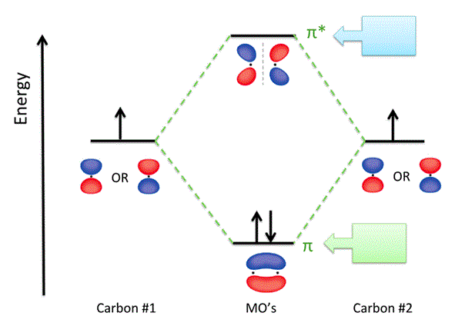 | MO diagram of C=O π bond  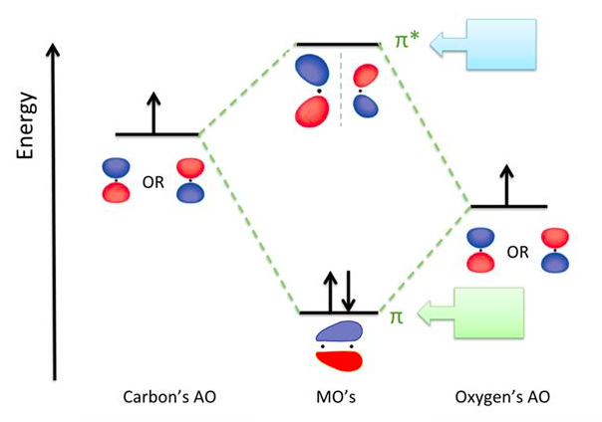
Steps to opening π bond in C=O
- π orbital is full, contains 2 e-
- π* orbital is empty
- Nucleophile has at least one lone pair of e-’s to donate
- Nucleophile’s filled orbital overlap with CO’s π* orbital

Things to remember:
- Nucleophiles are also Lewis bases
- Acid-base reactions will happen before a π bond attack
  - Especially when equilibrium favours products

To avoid this:
- Always check pKa’s
- Protic solvents cannot be used (i.e. solvents with a X-H bond)
  - Aprotic solvents are preferred
Solvent summary
Steps to ranking the relative reactivities of different C=O molecules
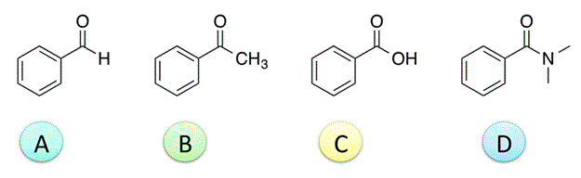
- Look at the functional groups in each molecule:
  - C is a carboxylic acid, acids will react in an acid-base reaction which is faster than nucleophilic addition
- Look at the free electrons around each atom in the molecule to determine which is the worst electrophile:
  - Since D is a molecule with electron rich sites at both the O atom and N atom, it is the worst electrophile
- Draw orbital diagrams of both to compare the electrophilicity of each molecule

∴, The fastest to slowest reaction would be C > A > B > D.
Angle of nucleophilic attack
- Symmetric ketones = achiral tetrahedral carbon
- Asymmetric ketones or aldehydes = potential chiral center
Racemic mixture
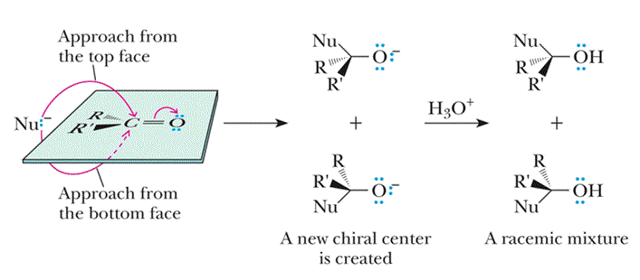
- Occurs when the nucleophile can attack from the top and bottom face

Stereoselective synthesis Forming only one enantiomer by blocking one side of the ketone/aldehyde

π bonds as electrophiles (Chapter 7 Part 2)
Types of reactions
- Adding H⁻ (hydride)
- Adding carbon nucleophiles
  - Organomagnesium
  - Organolithium
  - Hydrate formation
  - Hemiacetal formation
  - Cyclic hemiacetal formation
  - Acetal formation
  - Cyanohydrin formation
- Adding nitrogen nucleophiles
Redox reactions in organic chemistry
- In order to determine if carbon is losing or gaining electrons, look at the electronegativity of the atoms connected to the carbon
- How to determine if oxidation or reduction?
  - Inc. in # of atoms that are more e/n than carbon
    - If opposite, then reduction
  - Dec. in # of atoms that are less e/n than carbon
    - If opposite, then reduction
Type 1: Nucleophilic addition of hydride (H⁻)
General formula | - Reducing agent is the source of the hydride (ex. NaBH₄ or LiAlH₄)  - Generally:  - Oxidation = adding O atoms and/or removing H atoms  - Reduction = removing O atoms and/or removing H atoms  - As a result, the starting material is reduced (carbonyl reduction)
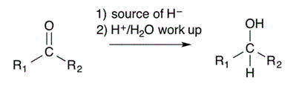
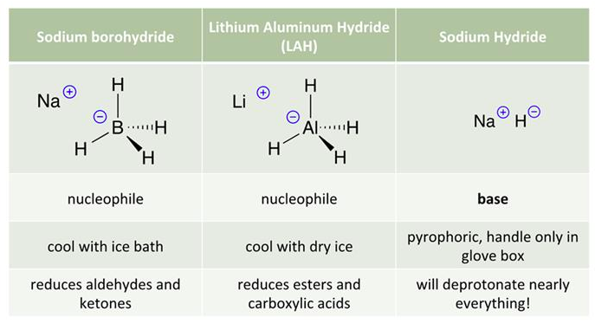
Mechanism: Carbonyl reduction

Type 2a: Organolithium compounds
Synthesis formula | - Prepared from an alkyl halide and Mg metal in an inert solvent (ether)  - Known as oxidative insertion/addition  - Strong nucleophiles = strong bases  - If any acidic H’s present, they will react first in an acid/base reaction
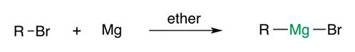
Mechanism
Step 1: Nucleophilic addition

Step 2: Aqueous acid workup

Summary of possible Grignard reactions
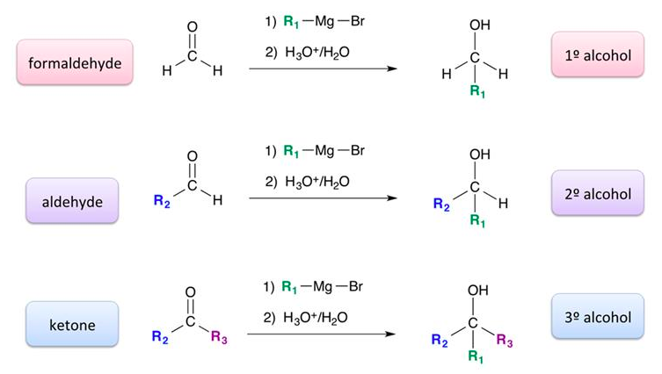

Type 2b: Organomagnesium compounds (Grignard reagent)
Synthesis formula | - More reactive than Grignard reagents, but yield poor results  - Inert atmosphere required  - Strong bases
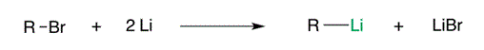
Mechanism
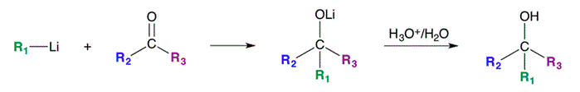

Type 2c: Hydrate formation
Base catalyzed
Nucleophile reaction | - Bases accelerate the reaction by activating the nucleophile  - Nucleophile is either a neutral species or an anion (never H₃O⁺)
sadjksand
Mechanism
Acid catalyzed
Electrophile reaction | - Acids accelerate the reaction by activating the electrophile  - Electrophile is either a neutral species or an cation (never OH⁻)
Mechanism

Type 2d: Hemiacetal formation
- Switching water with an alcohol yields hemi-acetals
- Usually equilibrium favours reactants except with cyclic hemiacetals
Mechanism
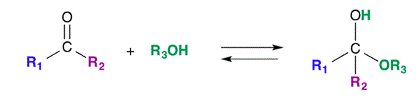
Type 2e: Cyclic hemiacetal formation
- Occurs from an intramolecular reaction to give a 5 or 6 membered ring
- Reversible and can be hydrolyzed back to starting aldehyde
Synthesis mechanism
Hydrolysis mechanism

Type 2f: Acetal formation
General formula | - Adding two equivalents of ROH, we get an acetal  - Forward reaction only possible with acid catalysis  - To favour equilibrium forward, excess alcohol and removal of water req.  - Requires acidic catalysis
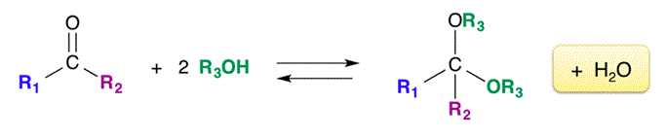
Mechanism
Step 1: First nucleophilic addition

Step 2: Second nucleophilic addition

Overall:

- Diols are often used as protecting groups to temporarily protect carbonyl groups
Example:
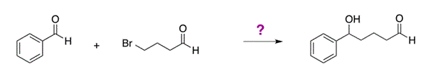

Mechanism
Step 1: Add protecting group (diol)

Step 2: Make Grignard reagent

Step 3: Nucleophilic addition

Step 4: Aqueous acid workup

Type 2g: Cyanohydrin formation
- Reaction of carbonyl compounds and cyanide
- CN⁻ = good nucleophile that will add easily
- Since HCN is dangerous, we add enough OH⁻ to raise the pH to 10+
Mechanism
Formation of carboxylic acids from cyanohydrin
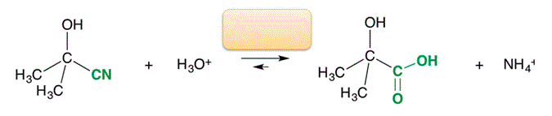

Leaving groups
- Molecule/ion that is removed in a “collapse step”
- Leaves with pair of electrons
- Good LG’s = weak bases

Type 3: Imines (Schiff bases)
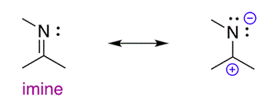 | - React like carbonyls with nucleophiles  - Since N is less EN than O, positive partial charge on C is smaller  - Weaker electrophile = less reactive, req. Stronger nucleophiles  - Imine must be activated first for nucleophilic addition
Imine formation mechanism

Imine reactions
- Will react with strong nucleophiles
- Weak nucleophiles require acid catalysis
Retrosynthesis Technique of working backwards from desired target to find beginning

