ADM 4318
Research Paper

MNCs - Culture Impact
National Culture’s Effect on Multinational Corporation’s Performance
By: Casey Descoeurs - 7717223

Dec 4th, 2019
Faculty of Telfer
University of Ottawa

Introduction
Globalization has paved the path to a large increase in multinationals across the world, as technology simplifies trade facilitations between countries so do the opportunities for firms to expand their market size. “Two-thirds of the world’s exports of goods and services are made through operations of an MNC” (Christiansen & IGI Global., p.56), granted the opportunity is present, there are several challenges associated with this strategy that must vehemently be addressed.
First off, according to several research papers and academics, the internationalization of a firm is meant to increase its performance and bottom line. The reason for this is the benefits corporations leverage and bring forth to new markets allowing them to stand apart. They transfer resources such as their specialized value chain practices, advanced technology and unique brand imaging (Halkos & Tzeremes., p.406). There are also lower costs associated to certain markets, as previously mentioned by our gest lecturer from future technologies (in our second last lecture), companies often move manufacturing across countries and continents over time as countries economically develop and shift from low cost labour to more modern day wages.
Now although firm performance is meant to increase through internationalization, this is not always the case as organizational culture, in moderation, can act as a constraint “In his several articles, Hofstede affirmed that both management theories and strategic management practices were not universally applicable, but culturally constrained” (Meekanon & Wageningen., p.50).
Unfortunately, often the national culture of an organizations headquarters significantly impacts the manner in which a corporation does business “The national culture of MNCs country of origin is prone to have a certain influence on their overseas subsidiaries globally” (Meekanon & Wageningen., p.50). It is a double-edged sword where in if properly wielded can breed success although in most cases, acts as a hindrance to optimal performance of your international entities.

In MNCs, the complexity and dynamism of the global environment makes…internal agreements on goals more difficult for MNCs than for domestic firms” (Taylor, Levy, Boyacigiller & Beechler. p.504). This research paper is meant to establish: the linkages between Hofstede’s cultural dimensions and multinationals strategies, the moderators where in which significantly impact the corporation’s performance across the globe and lastly, to analyze the criterion in which adaption allows corporations to establish themselves as successfully performing MNCs. Through this, an overarching statement will be evidenced; that a lack of cultural awareness and entrenched national culture can affect a multinational corporation’s performance in their subsidiaries across the globe. We must first begin by determining the cultural values at play that significantly influence the umbrella of organizational culture ever-so-present across multinational firms.

Hofstede Dimensions Linked to Strategy
In order to properly understand the concepts at hands when discussing Hofstede’s dimensions, we must first understand the terms utilized. Following this we can link them to firm strategies in a more manageable manner. There are six dimensions of Hofstede’s to look at.

1.1 Dimensions
Power distance - “The extent to which the less powerful members of institutions and organizations within a country expect and accept that power is distributed unequally” (Minkov, p.9). In other words, this is meant to discern differences in hierarchal tendencies and inequality that individuals choose to accept amongst countries. The lower the power distance, the more reflective it is of a society/culture that shares power (flatter hierarchy).
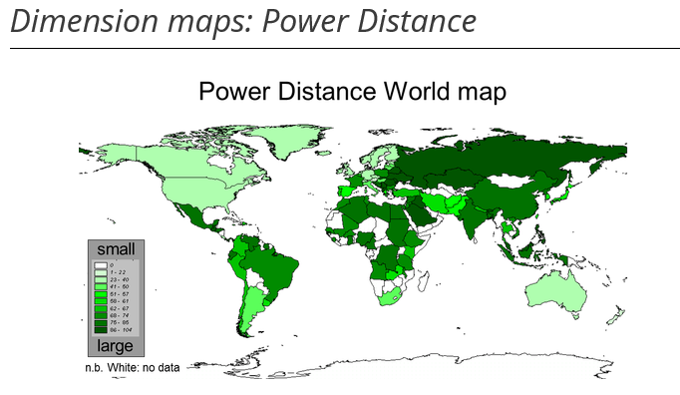
In Fig 1., we see that North American culture has a much lower power distance relative to much of the African and Asian continents. In terms of an organizational standpoint this tells us that corporations in China, Japan, and Russia have tendencies to value formalities where in the decisions made from higher management are not to be questioned and obedience is required.

Fig 1.
Uncertainty Avoidance – “The extent to which the members of a culture feel threatened by ambiguous or unknown situations” (Minkov, p.11). In other words, it determines how well different cultures deal with the idea of risk and their preference for it in relation to predictability.
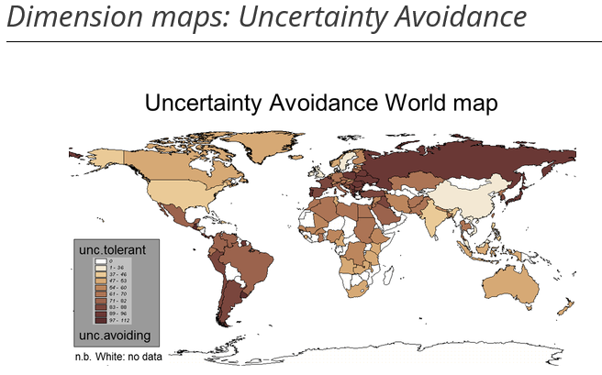
In Fig 2., we see that North American culture as well as many Asian cultures lean more towards a tolerance for ambiguity in their lives. Whereas South American and eastern Europeans cultures do not enjoy the unknown and will try their best to avoid uncertain outcomes. Therefore, in a business context, these individuals would tend to be less tolerant of any innovative solutions when dealing with

Fig 2.
work objectives. Formality would receive a higher emphasis and tasking’s would need to clear and precise. They are also more likely to remain in a job they no longer enjoy (Minkov, p.11).

Individualism & Collectivism – Minkov define the following as such:
“Individualism stands for a society in which the ties between individuals are loose: everyone is expected to look after himself or herself and his or her immediate family only. Its opposite, collectivism, stands for a society in which people from birth onwards are integrated into strong, cohesive in-groups, which throughout people's lifetime continue to protect them in exchange for unquestioning loyalty” (Minkov, p.13).
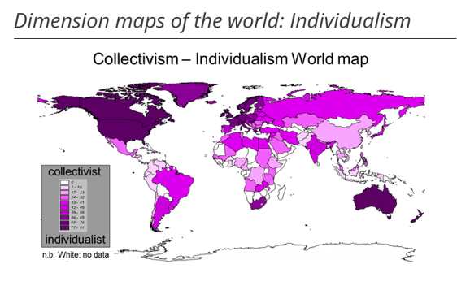
In Fig 3., Eastern European, Asian and South American cultures are much more collectivistic oriented relative to Western European and North American cultures. Individuals in a collectivist work environment value team cooperation and build emphasis on relationships rather than the tasks at hand. This ties into power avoidance as well, those who value collectivism would be less likely to undermine group opinion even if they disagree internally.

Fig 3.
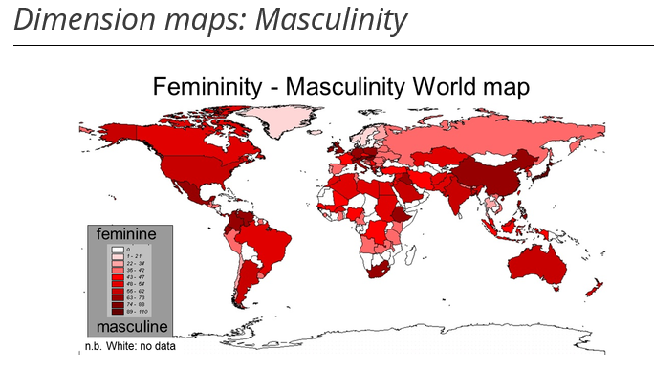
Masculinity & Femininity – Masculinity represents cultures that view this as a more aggressive domineering and assertive characteristic in which high power-driven attitude is linked to success. Whereas Femininity is attributed to cultures who believe that men and women are alike and the same character traits are valued amongst both genders, more humane traits dealing with kindness, tenderness and compassion (Minkov, p.15).
In Fig 4., we unfortunately note that many cultures are still largely oriented towards a male ideology dominated culture. China, Japan and certain European countries seem to be slightly more male dominated than most. In a work context this indicates that assertiveness and strength is admired and sought out by many. It also means although we are making strides for equal rights in workplace for women, some cultures are still less accepting and understanding of women being promoted to high powered roles.
Fig 4.
Orientation and Indulgence - The final two dimensions, through honorary mention, are long vs short term orientation and Indulgence. These dimensions have a more intangible impact on the organizational side and as such it is more difficult to determine the significance of their impacts in an organizational structure.

1.2 Strategy
Hofstede states that individuals tend to become programmed in their country of origin’s normative ways, which then largely impacts the way they logically think and make decisions. Surrounded by those in a similar environment and often unchanged this can lead to homogeneous thinking within an organization (Noorderhaven & Harzing. p.54). The two values that most strongly influence organizational strategy are the first two addressed: Power Distance and Uncertainty Avoidance.
- Power Distance – senior management hailing from high power distant cultures like Belgium, France, and the Middle East etc. are much more likely to centralize the decision-making process within the organization (Noorderhaven & Harzing. p.55). Which means employees simply adhere to management decision making, communication is restricted vertically (siloed) and employees lack discretion.
- Uncertainty avoidance – companies with high uncertainty avoidance tend to adhere more strictly to the rules, policies and principles put in place to guide the organization (Noorderhaven & Harzing. p.55). Countries like France, Chile, Italy and Spain are viewed as more loyal to the organization. Which means turnover remains low as risk and ambiguity of a change in career is not favored and authoritative figures are not questioned.
- Collectivism vs Individualism – countries like America, Canada and much of Western Europe tend to observe an employee base much less focused solely on their work life as value is given towards themselves and a healthy work life balance. Individual ideas are put fort more often as differentiated opinions is valued and breeds innovation. Whereas collectivistic organizations have a great synergy amongst employees and this strong social network allows the organization to successfully work on group projects (Gradefixers, 2018).
- Masculinity vs. Femininity – assertiveness, aggressiveness, authority, power are all characteristics to be valued in a masculine organizational culture. In china, Japan and the Middle East there has been less of a transition to more fluid roles where in the success is judged worthy through collaboration and communication rather than an employee’s status and financial worth.
Different national cultures will thus normalize different organizational strategies that tend to favour their views, perceptions and way of life. Unfortunately, as a multinational the cultural distance between the headquarters and a subsidiary will pose a major challenge if left unfettered.

Culture as a Moderator Impacting MNCs
There are overarching concepts that deal with culture and its effect on multinationals performance as well as sub elements that deal with more specific factors. Broader issues that hinder knowledge performance and more specific values embedded in an organizations national culture that can cause locational issues depending on the region.

2.1 High vs Low Cultural Distance
Cultural distance deals with “the extent to which the shared norms and values in one country differ from those in another” (Qin, Wang & Ramburuth. P.81). When an MNC looks to transfer knowledge to a newly acquired entity they look to share their practices and behaviours, incidentally their culture is embedded in these operations. Often this causes difficulties, “cultural distance may increase the causal ambiguity in skills and resources deployment and thus increase the stickiness” (Qin, Wang & Ramburuth. P.81). Companies that cannot successfully implement knowledge transfer amongst its subsidiaries will have immense difficulties aligning resources across the company to maintain/obtain a competitive edge.
According to research, mitigating factors in this case occur when subsidiaries of the company are located in similar regions, where in the knowledge gap is lower and becomes less of a necessity “positive effects of cultural distance on subsidiary performance have been mainly found…in developed western countries, where the headquarters-subsidiary knowledge gap is relatively small” (Qin, Wang & Ramburuth. P.81).
However, given the fact that globalization is only going to continue to expand across a diverse set of cultural clusters this is not a viable mitigation strategy. Empirical studies performed have shown that: “knowledge inflows have a positive effect on subsidiary performance, while the effect of cultural distance is negative” (Qin, Wang & Ramburuth. P.85). Therefore, MNCs with entrenched set of values that significantly differ from any of their host countries will struggle impart their home-based knowledge over to their subsidiaries, crippling performance. This loss of knowledge transfer between MNCs will act as a barrier to any opportune competitive edge “according to the resource-based view, organizational capabilities have been identified as one major source for the generation and development of sustainable competitive advantage” (Li & Lee. P.666).

2.2 Country of Origin Effect
The country of origin effect is more commonly known as a bias that consumers of a certain country may hold towards a product when discovering its country of origin labelling (Czinkota, et al., 2013). However, for the purpose of this research paper it’s re-interpreted as the following: “The country-of-origin effect consists of that part of the differences in internationalization strategies and international control strategies of MNCs that can be ascribed to the different national origins of these MNCs” (Noorderhaven & Harzing. P. 54). Additionally, when referring in this case to national origin it is in reference to the historical foundation of the parent company, not necessarily where they’ve relocated headquarters. The following factors about country of origin influence the MNCs and subsequently, their performance.
Homogeneity - In homogeneous national cultures there is a much stronger tendency for the cultural values to transcend into the subsidiaries and thus links back to a stronger COO effect. A strong culture mentality unfortunately means there is less room for flexibility in adaptation “In cultures that are more heterogeneous, culturally transferred practices will be more easily recognized as optional, rather than necessary” (Noorderhaven & Harzing. P. 59). With homogeneous cultures, there is a smaller likelihood of tolerance for divergence.
Cultural Values – These touch back to the cultural distance mentioned above, however in this case with regards to COOs impact on subsidiaries performance we discuss the possibility of firms being able to bridge the gap through adaptation. MNCs that can effectively adapt to local conditions and values are more likely to succeed globally. Stronger country of origin effects is in this case associated to strong power distance and high uncertainty avoidance, however, “MNCs operating in a greater diversity of cultural or institutional environments are expected to show weaker country of origin effects” (Noorderhaven & Harzing. P. 64).

2.3 Cultural Dissociation
The COO effect is also seen influenced and enhanced by complimentary factors to national culture. The internationalization originating from smaller ended economies is more likely to be linked to increased performance for said MNC. Which is to say, in this instance, that there is a beneficial relationship between a strong COO effect and international performance of an MNC when the country of origin has a small economy “a positive linear relationship was between internationalization and performance in countries with relatively small economies” (Elango & Sethi. p.369).
It’s important to note that although a strong COO effect, based on homogeneity and cultural distance stemming from differing cultural values, can have a negative impact on international performance. As mentioned directly above there is still a trade-off. Since other factors play a role as well, they must be assessed when making strategic decisions with regards to expansion and location.

3. Mitigation & Adaptation
There are multiple manners in which MNCs can mitigate challenges and impacts associated with national culture and its cascading effect on international performance. They are not exclusive; a focus should be given on all alternatives in order to be as effective as possible. “Findings suggest that MNCs cannot afford to rely solely on traditional elements to enhance their value creation capacity and need to develop capabilities tailored to the global environment” (Taylor, Levy, Boyacigiller & Beechler. p.519). Studies suggest that adaptation of following techniques will mitigate and increase MNCs performance across the globe.

3.1 Managerial Cognition
Senior management’s role is a critical success factor when integrating functions, practices and vision across a multinational corporation. For employees to adopt multicultural practices and remain passionate within their organization there must be management buy in. This has been found to be factual through international studies “Specifically, the results indicate that global orientation of top managers and a geocentric orientation are positively related to employee commitment” (Taylor, Levy, Boyacigiller & Beechler. p.519). Which means firms performance abroad relies partly on managers abilities to acknowledge the differences and similarities amongst the cultural regions they operate in and effectively integrate this into their organizational strategy.

3.2 Normative Integration
Socialization in an MNC allows employees to learn the patterns, practices, goals and vision of the corporation, it is through this mechanism that normative integration is instilled within an MNC. “Individuals’ beliefs, values, and norms of behavior actually converge through the process of socialization or normative integration” (Cicekli, p.177). A shared mindset through normative integration has its benefits:
- Integration - Decision making becomes integrated across subsidiaries rather than through a centralized approached. Employees no longer feel cut out of the decision-making process and thus value is created rather than constrained in regard to employee morale and contribution.
- Shared resourcing - “the key advantage of normative integration is its ability to pool the resources and competencies of both a headquarters and its subsidiaries so the MNC can benefit” (Cicekli, p.178). This is a well-known concept in which it is much more effective (in any type of organization) to combine resources and knowledge to diversify and further innovation and creative solutions within the organization. Normative integration on an international scale allows MNCs to optimize this concept.
The manners which an MNC can promote normative integration are vast and (Cicekli, p.180) covers some of the following:
Expatriation The idea of either bringing senior management to regional companies around the globe in order to familiarize them with the cultural diversity to help guide decision making. Alternatively, to bring in regional management to national HQ to help instill best practices in HQ from around the globe
Joint work Enticing collaboration from individuals, in the organization will help create normative integration. This could be epically crucial in cultures where collectivism is less valued.
Recruitment/Evaluation/Training selective recruitment evaluation and training of those who are struggling in an international organization can help acclimatize them to the concept of geocentric orientation and inclusive cultural diversity.

Studies maintain that organizations whom adopt these approaches to create normative integration in the MNC are thus more likely to perform well in their subsidiaries “In a study of 74 subsidiaries in 12 MNCs…Persson also found that normative integration had a positive influence on outbound knowledge transfer in the MNCs” (Cicekli, p.179).

Conclusion
As MNCs continue to proliferate across the globe, insights on the variables affecting their international performance become increasingly apparent. Given that much of firm strategy is influenced by the cultural values and norms of a country it is no surprise that organizations favor differing practices. For example, the centralized approach adopted from organizations whom are power distant and far from uncertainty tolerant. Unfortunately, this plays a large hand in how MNCs might perform on an international playing field as a large cultural distance, disagreeing cultural values and high country of origin effect tend to create challenges across the subsidiaries of an MNC which consequentially lower desired performance.
As discussed, MNCs that are more geocentric tolerant and look to adopt normative integration within the organizational culture are historically more likely to succeed relative to MNCs whom house top management that have a lack of cultural awareness and promote an organization that is fixated on their values stemming from their national culture (homogeneous culture). Further studies could be conducted in order to assess varying levels of impacts on MNC performance across specific regional and cultural clusters.

Bibliography
Peer Reviewed:
Christiansen, B., & IGI Global. (n.d.). Cultural variations and business performance contemporary globalism. Hershey, Pa.: IGI Global (701 E. Chocolate Avenue, Hershey, Pennsylvania, 17033, USA).
Li, J., & Lee, R. (2015). Can knowledge transfer within MNCs hurt subsidiary performance? The role of subsidiary entrepreneurial culture and capabilities. Journal of World Business, 50(4), 663-673.
Halkos, G., & Tzeremes, N. (2008). Does the Home Country's National Culture Affect MNCs' Performance? Empirical Evidence of the World's Top 100 East-West Non-financial MNCs. Global Economic Review, 37(4), 405-427.
Qin, C., Wang, Y., & Ramburuth, P. (2017). The impact of knowledge transfer on MNC subsidiary performance: Does cultural distance matter? Knowledge Management Research & Practice, 15(1), 78-89.
Taylor, S. (1), Levy, O. ( 2 ), Boyacigiller, N. ( 3 ), & Beechler, S. ( 4 ). (n.d.). Employee commitment in MNCs: Impacts of organizational culture, HRM and top management orientations. International Journal of Human Resource Management, 19(4), 501–527. https://doi.org/10.1080/09585190801953491
Noorderhaven, N., & Harzing, A. (2003). The "Country-of-origin Effect" in Multinational Corporations: Sources, Mechanisms and Moderating Conditions. Management International Review, 43(2), 47-66.
Meekanon, K., & Wageningen Universiteit. (n.d.). The impact of national culture in MNC's home country on the strategy making process in their overseas subsidiaries a comparison between Dutch and Japanese companies.
Minkov, M. (2013). Cross-cultural analysis: The science and art of comparing the world's modern societies and their cultures. Thousand Oaks, CA: SAGE Publications, Inc. doi: 10.4135/9781483384719
Elango, B., & Sethi, S. (2007). An exploration of the relationship between country of origin (COE) and the internationalization-performance paradigm. Management International Review, 47(3), 369-392
Cicekli, E. (2011). Antecedents of Normative Integration in Multinational Companies: A Conceptual Model. International Journal of Management, 177-183,195
Non-Peer Reviewed:
Fig. (1,2,3,4) Hofstede, G. (n.d.). The 6 dimensions model of national culture by Geert Hofstede. Retrieved from https://geerthofstede.com/culture-geert-hofstede-gert-jan-hofstede/6d-model-of-national-culture/.
GradesFixer. (2018, December 11) Collectivism vs. Individualism in organizational culture. Retrived December 3, 2019, from https://gradesfixer.com/free-essay-examples/collectivism-vs-individualism-in-organizational-culture/
Czinkota, M., Czinkota, M., Carrol, Fronczak, J., Ricardo, Leonila, … Wilusz, G. (2013, January 9). COUNTRY OF ORIGIN EFFECTS. Retrieved from http://michaelczinkota.com/2013/01/country-of-origin-effects/.

Personal Ethics Statement
Individual Assignment:
By signing this Statement, I am attesting to the fact that I have reviewed the entirety of my attached work and that I have applied all the appropriate rules of quotation and referencing in use at the Telfer School of Management at the University of Ottawa, as well as adhered to the fraud policies outlined in the Academic Regulations in the University’s Undergraduate Studies Calendar. http://www.uottawa.ca/academic-regulations/academic-fraud.html

 December 4, 2019
Signature Date

Descoeurs, Casey 7717223
Last Name (print), First Name (print) Student Number

