ADM 2304 Assignment #4

1)

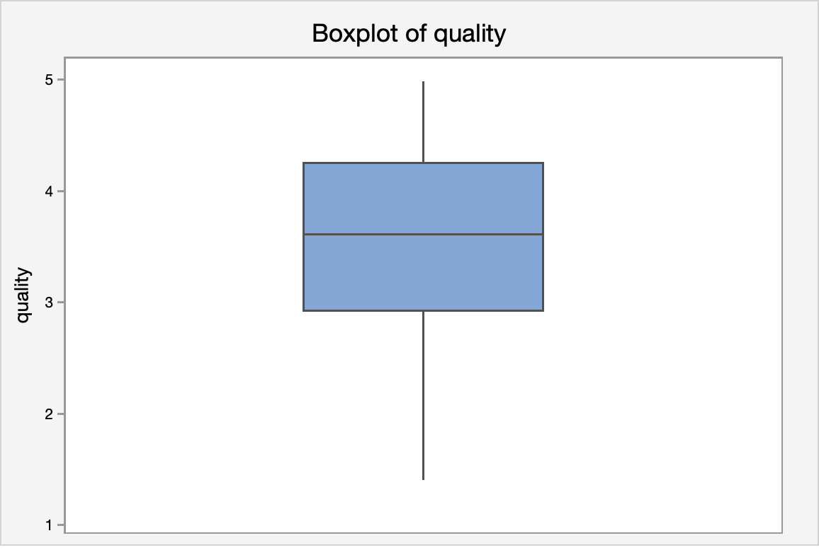

The boxplot is slightly skewed to the left with no outliers. Given the large sample size of 366, we can assume the data is not extremely skewed.

b)

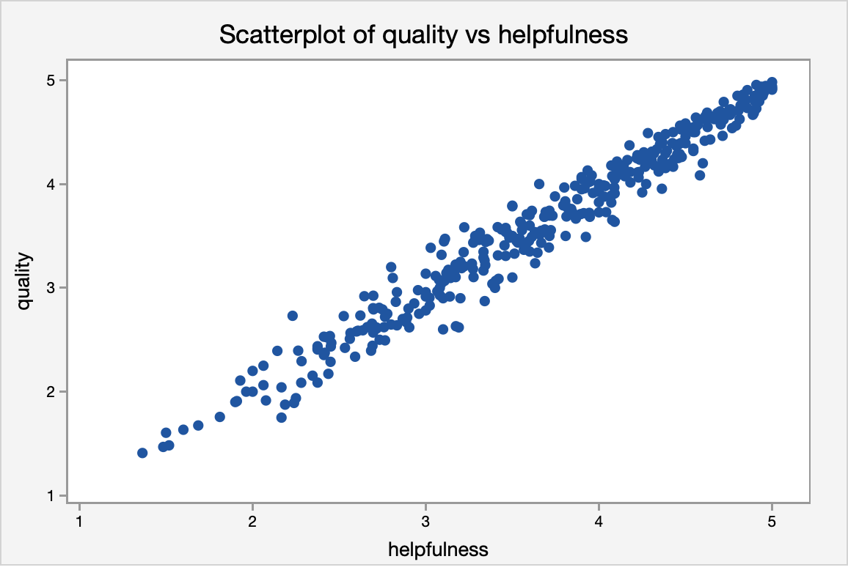

There appears to be a strong positive linear association or correlation between the variables, quality and helpfulness.

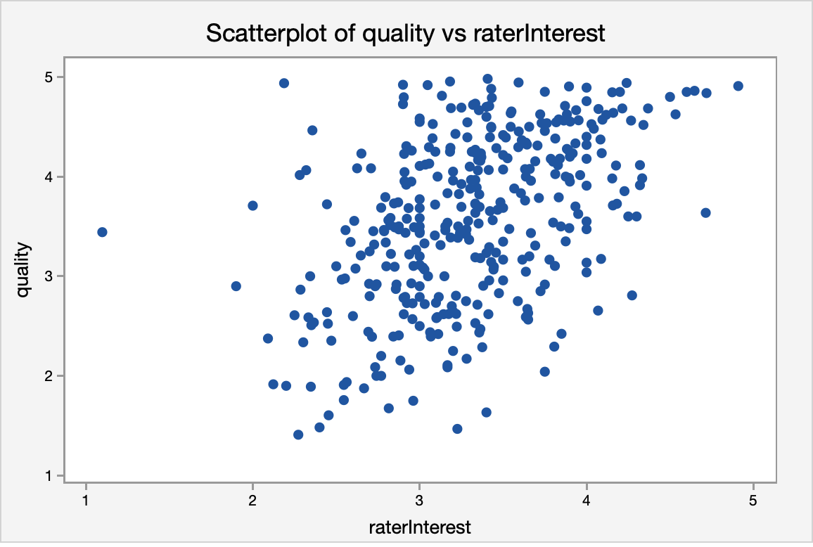

There appears to be a very weak positive linear association or correlation between the variables quality and rater interest.

C)
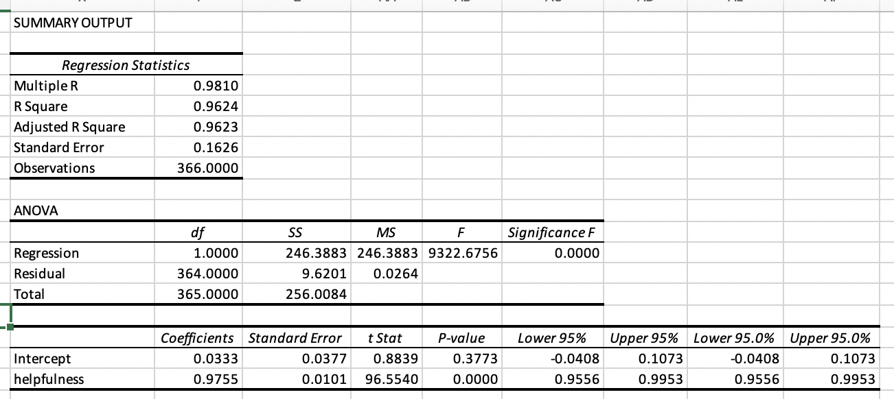

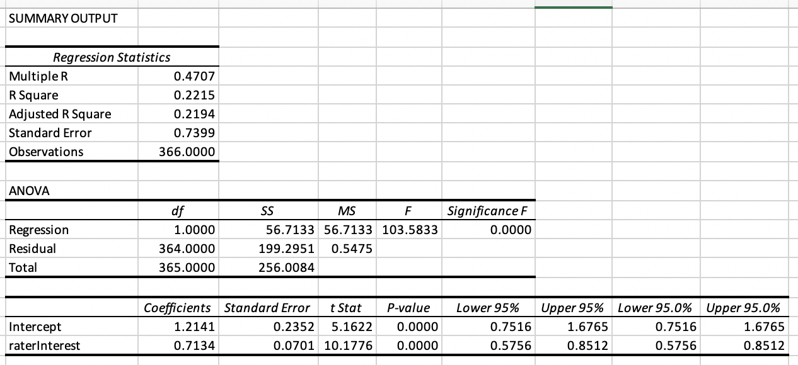

The model using the predictor variable helpfulness is a better model as it has a higher R-squared value. The R squared value of 0.9624 in Model 1 shows that 96.24% of the variability in quality can be explained by helpfulness of variable, whereas model 2, only 22.15% of variability in quality can be explained by the rater interest variable.

D)
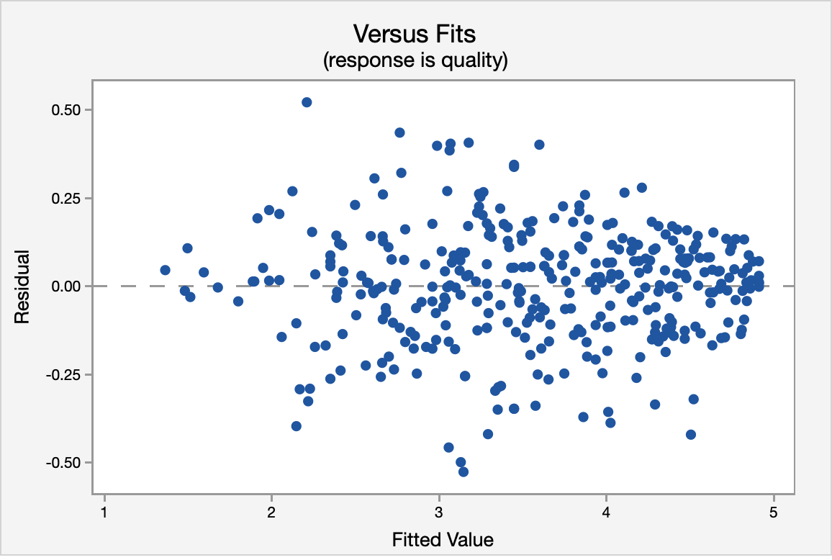

Part C. Model 1)

1)Normality -> 2SD = 2 * 0.1626 = 0.3252
No points outside 2SD, thus assumption is valid.
2) Equal Variance – the spread is relatively constant, no cone shape, assumption is valid.
3) Independence – no pattern in the data, it appears random, assumption is valid
4) linearity – there is no curved pattern in the data, it appears to be linear, assumption is valid.

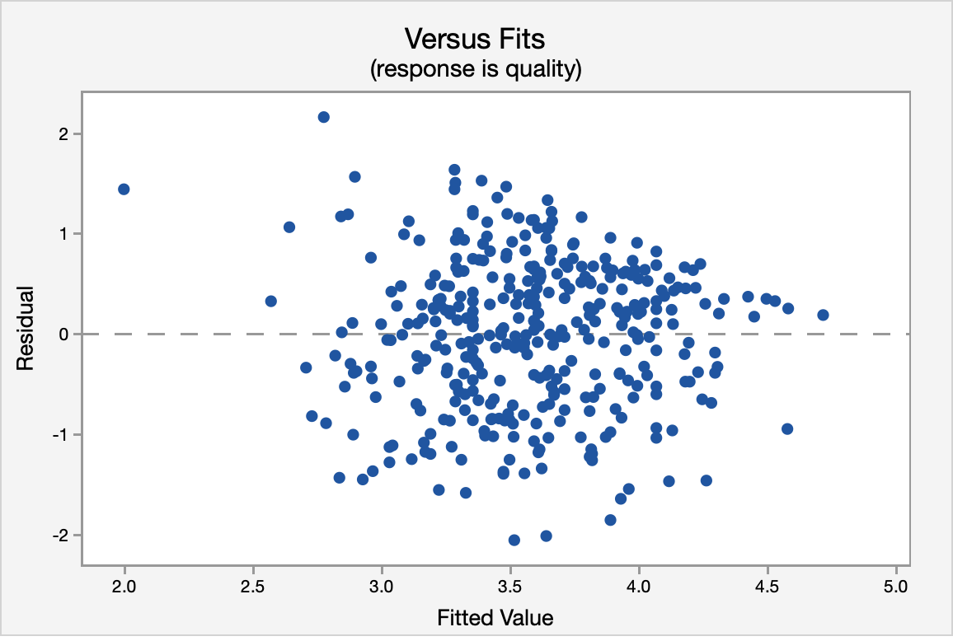
Part C. Model 2)

1)Normality-> 2SD = 2 * .7399 = 1.4798
3SD = 3 * 0.7399 = 2.2179
There appears to be one point close to 3SD away from the centre and many points beyond 2SD, assumption is not valid.
2) Equal variance – the spread is not constant, cone shape, assumption is not valid.
3) Independence - no pattern in the data, it appears random, assumption is valid.
4) Linearity – There is no curved pattern in the data, it appears to be linear, assumption is valid.

E) and F)
Prediction

Fit | SE Fit | 95% CI | 95% PI
1.49647 | 0.02314 | (1.45096, 1.54199) | (1.17355, 1.81939) | X

X denotes an unusual point relative to predictor levels used to fit the model.

E) CI – 95% sure the average quality score for all observations that have a helpfulness rating of 1.5 is between 1.45095 and 1.54199.

F) PI – 95% sure a single observation with a helpfulness score of 1.5 would have a quality score between 1.17355 and 1.81939

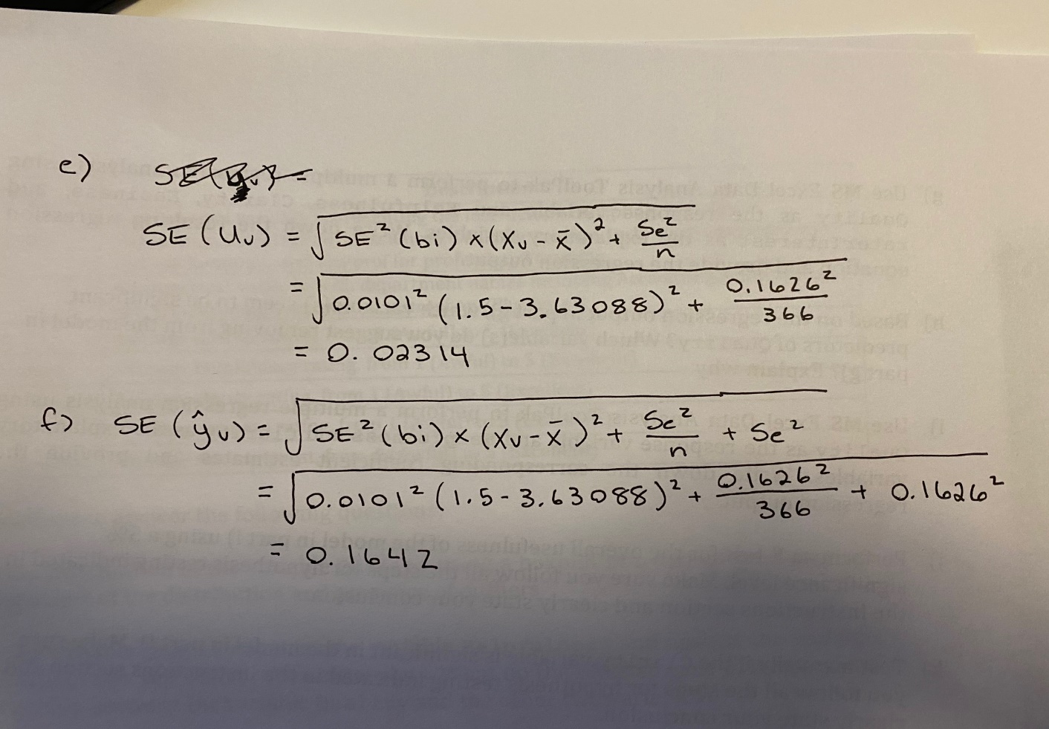

G)

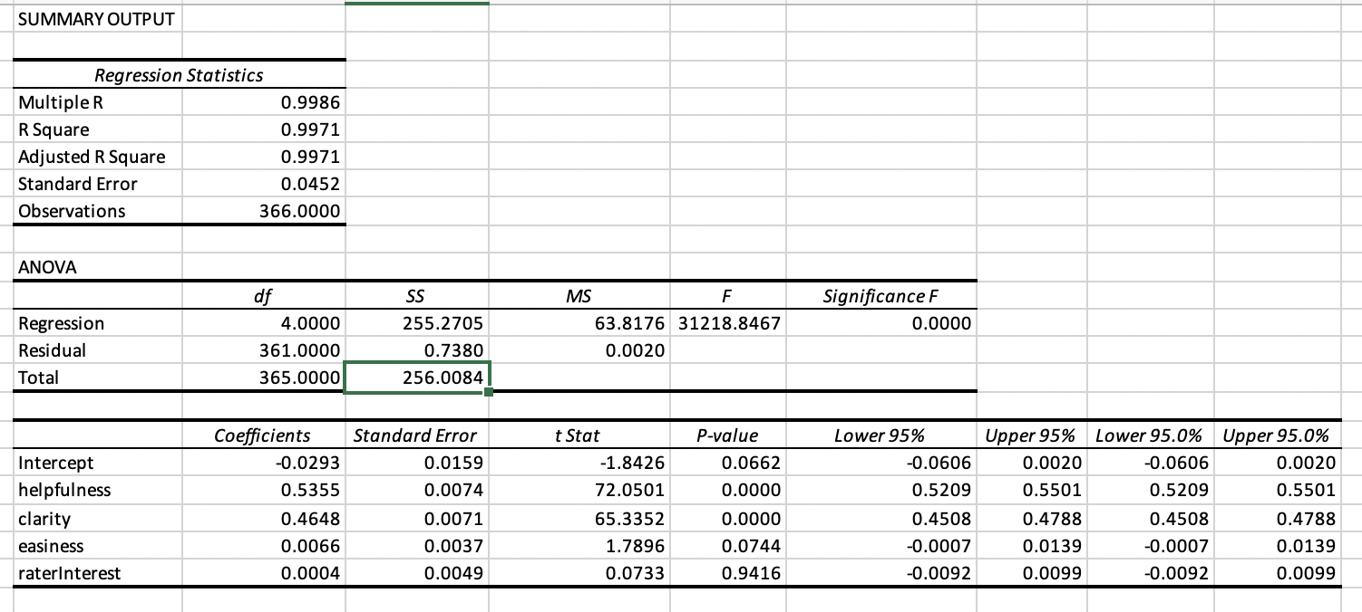
Prediction: Y = Quality = 0.0293 + 0.5355 (help) + 0.4648 (clarity) + 0.0066 (easiness) + 0.0004 (rater interest)
Actual: y = -0.0293 +…….. + 0.0004 (rater interest) + E

H)

Variables with p-values <0.05 are significant. I would start by removing the rater interest variable as it has a high p-value> alpha -= 0.05. I would also remove the easiness variable as it has a p-value > 0.05. These two variables are not significant in the model.

I)
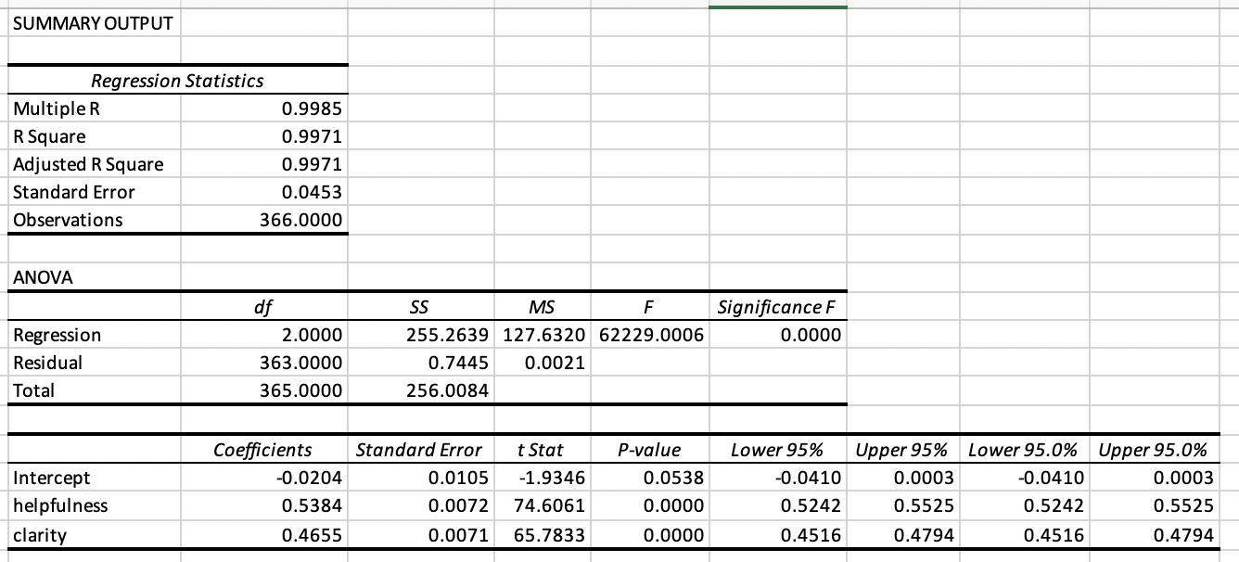

Predicted: Y = Quality = -0.0204 + 0.5384 (help) + 0.4655 (clarity)
Actual: Y = Quality = 0.0204 + 0.5384 (help) + 0.4655 (clarity) + E

J) Ho: Bh = Bc = 0
Ha: not all Bs = 0
Since Fstat> Fcrit
Fstat = 6229.0006; alpha = 0.05
Dfn= 2; Dfe = 363
Fcrit = 3.0206

Reject, Ho. There is sufficient evidence the model is significant.

K) Ho: Bc = 0
Ha: BC does not equal 0

Tstat = Bi - 0/ Sbi = 0.4655 – 0/0.0071 = 65.7833

Alpha = 0.05; Dfe = 363

Tcrit = 1.9665 Since Tstat > Tcrit, Reject. There is sufficient evidence the variable clarity is significant as a predictor of quality.

L) Model is Part C) that only used helpfulness R^2 ads = 0.9623 or 96.23%. (Ind. 1 -var.)

Model in part i) that added the clarity variable R^2ads = 0.9971 or 99.71%. (Ind. 2 -var).

The model improves with the addition of the clarity variable as the R^2ads increased uses MS.
R^2ads adjust for the # of variables in the model (complexity) where R^2 does not use SS.

Personal Ethics Agreement Form

