PSY 1102: FINAL REVIEW

Chapter 16: Therapy

Psychological therapies
Psychotherapy
- Treatment involving psychological techniques
- Consists of interactions between a trained therapist and someone seeking to overcome psychological difficulties or achieve personal growth

Biomedical therapy
- Prescribed medications or procedures that act directly on the person’s physiology

Eclectic approach
- Approach to psychotherapy that uses techniques from various forms of therapy

Psychoanalysis
- Freud’s therapeutic technique
- Believed the patient’s free associations, resistances, dreams and transferences released previously repressed feelings, allowing the patient to gain self-insight

Resistance
- Blocking from consciousness of anxiety-laden material

Interpretation
- Analyst’s noting supposed dream meanings, resistances and other behaviours and events in order to promote insight

Transference
- Patient’s transfer to the analyst of emotions linked with other relationships (ex: love or hatred for a parent)

Psychodynamic therapy
- Therapy deriving from the psychoanalytic tradition
- Views individuals as responding to unconscious forces and childhood experiences
- Seeks to enhance self-insight
- Sessions are face-to-face; take place 1-2x a week; a few weeks or months

Interpersonal psychotherapy
- Variation of psychodynamic therapy
- Aims to help people gain insight into roots of their difficulties
- Goal is symptom relief in the here and now
- Focus on current relationships and helping people improve relationship skills

Insight therapies
- Variety of therapies that aim to improve psychological functioning by increasing a person’s awareness of underlying motives and defenses

Client-centered therapy
- Humanistic therapy developed by Carl Rogers
- Therapist uses techniques such as active listening within a genuine, accepting, empathic environment to facilitate client’s growth
- Person-centered therapy

Active listening
- Empathic listening in which the listener echoes, restates, and clarifies
- Feature of Rogers’ client-centered therapy

Unconditional Positive Regard
- Caring, accepting, non-judgemental attitude
- Rogers believed it would help clients develop self-awareness and self-acceptance

3 Rogers-inspired hints
- Paraphrase
- Invite clarification
- Reflect feelings

Behaviour therapy
- Therapy that applies learning principles to the elimination of unwanted behaviours

Counterconditioning
- Behaviour therapy procedures that use classical conditioning to evoke new responses to stimuli that are triggering unwanted behaviours
- Pairs the trigger stimulus with new response that is incompatible with fear
- Include exposure therapies and aversive conditioning

Exposure therapies
- Behavioural techniques that treat anxieties by exposing people to the things they fear and avoid
- Systematic desensitization
  - Associates pleasant relaxed state w/ gradually increasing anxiety-triggering stimuli
  - Commonly used to treat phobias
- Virtual reality exposure therapy
  - Progressively exposes people to electronic stimulations of their greatest fears
  - Airplane flying, spiders, public speaking

Aversive Conditioning
- Type of counterconditioning that associates an unpleasant state with an unwanted behaviour
- Goal is substituting a negative response for a positive response to a harmful stimulus

Behaviour modification
- Reinforce desired behaviours and withhold reinforcement for undesired behaviours
- Critics
  - How durable are behaviours?
  - Is it ethical to control another’s behaviour?

Token economy
- Operant conditioning procedure in which people earn a token of some sort for exhibiting a desired behaviour and can later exchange their tokens for various privileges or treats

Cognitive therapy
- Therapy that teaches people new, more adaptive ways of thinking; based on assumption that thoughts intervene between events and our emotional reactions

Aaron Beck
- Cognitive therapist believes that changing people’s thinking can change their functioning
- Analyzed depressed people’s dreams = found recurring negative themes of loss, rejection, abandonment that extended into waking thoughts
- Reverse clients’ catastrophizing beliefs about themselves, situations and futures

Cognitive-Behavioural Therapy (CBT)
- Popular integrative therapy that combines cognitive therapy with behaviour therapy
- Changing self-defeating thinking + changing behaviour
- Behavioural change addressed first, followed by sessions on cognitive change

Group therapy
- Therapy conducted with groups rather than individuals
- Permits therapeutic benefits from group interaction
  - Saves therapist’s time & client’s money
  - Offers social laboratory
  - Enables people to see others share their problems
  - Provides feedback

Family therapy
- Therapy that treats the family as a system
- Views an individual’s unwanted behaviours as influenced by other family members
Self-help / Support Groups
- For the addicted, bereaved, divorced, seeking fellowship and growth
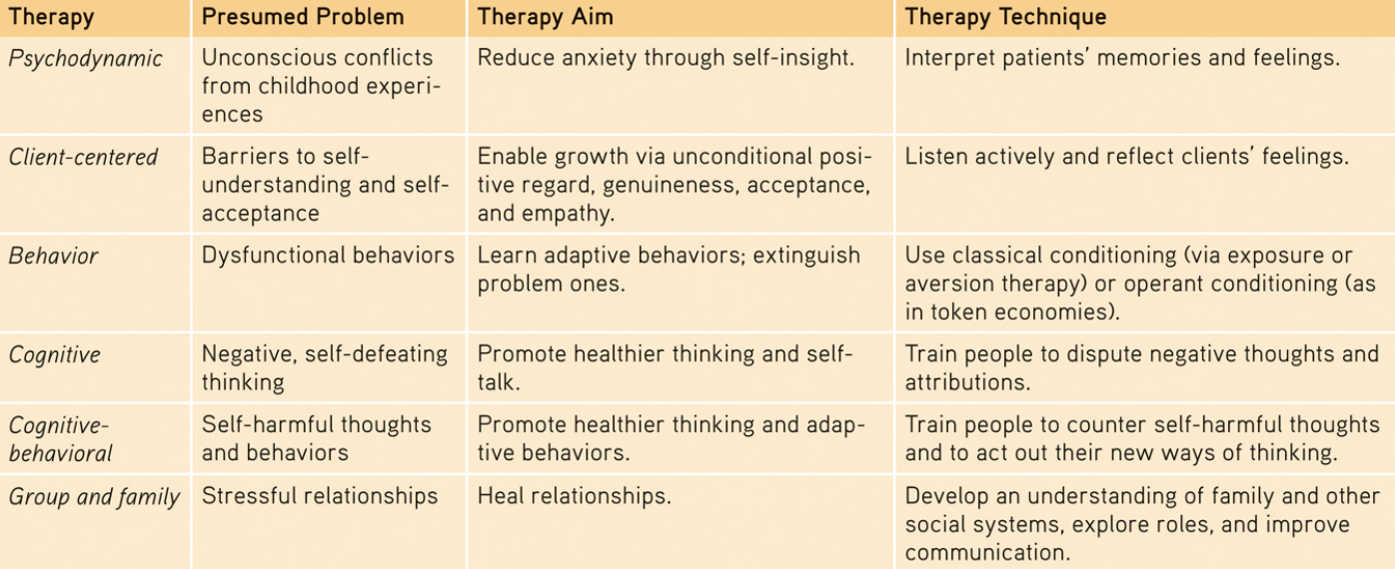

Evaluating Psychotherapies

Client Perceptions
- 89% said they were at least “fairly well satisfied”
- BUT
  - People often enter therapy in crisis
  - Clients believe that treatment will be effective
  - Clients want to believe it was worth the effort/money
  - Clients speak kindly of their therapists
- We are prone to selective and biased recall and to make judgements that confirm our beliefs

Meta-analysis
- Procedure for statistically combining the results of many different research studies
- Average therapy client ends up better off than 80% of the untreated individuals

Evidence-based practice
- Clinical decision making that integrates the best available research with clinical expertise and patient characteristics and preferences

Alternative therapies
- 57% of those with history of anxiety attacks have used alternative treatments
- Herbal medicine, massage, spiritual healing

Eye Movement Desensitization and Reprocessing (EMDR)
- Therapy adored by many and dismissed by many
- People imagine traumatic scenes while researcher triggered eye movements by waving a finger in front of their eyes
  - Supposedly enabling them to unlock and reprocess previously frozen memories
- For single trauma victims = it works
  - 3 sessions = 90-minute sessions

Light Exposure Therapy
- Give people with SAD a timed daily dose of intense light
- After 4 weeks, 61% improved (exposure in the morning)
  - 50% improved (exposure at night)
  - 32% improved (exposure to placebo)

3 elements of psychotherapies
- Hope for demoralized people
- New perspective leading to new behaviours
- Empathic, trusting, caring relationship
  - Therapeutic alliance = bond of trust & mutual understanding between a therapist and client, who work together to overcome client’s problem

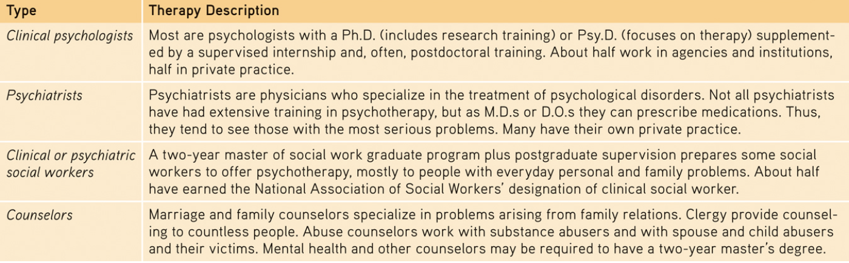

Biomedical Therapies
- Physically changing the brain’s functioning by altering its chemistry with drugs, affecting its circuitry with electroconvulsive shock, magnetic impulses, or psychosurgery

Psychopharmacology
- Study of the effects of drugs on mind and behaviour

Antipsychotic drugs
- Drugs used to treat schizophrenia and other forms of severe thought disorder
- Dampen responsiveness to irrelevant stimuli
- Help to those with positive symptoms of schizophrenia (hallucinations, paranoia)
- Side effects
  - Sluggishness
  - Tremors
  - Twitches
  - (long-term use) Tardive dyskinesia = involuntary movements of facial muscles
  - May increase risk of obesity and diabetes

Antianxiety drugs
- Drugs used to control anxiety and agitation
- Depress central nervous system activity
- Can be addictive; cause withdrawal symptoms

Antidepressant drugs
- Drugs used to treat depression, anxiety disorders, OCD, PTSD
- Ability to lift people up from a state of depression
- Increase availability of neurotransmitters (norepinephrine and serotonin) which elevate arousal and mood
- SSRIs = selective serotonin reuptake inhibitors

Mood-Stabilizing Medications
- For those who suffer emotional highs and lows of bipolar disorder

Electroconvulsive Therapy (ECT)
- Biomedical therapy for severely depressed patients
- Brief electric current sent through the brain of an anesthetized patient
- After 3 sessions every week for 2-4 weeks
  - 80% improved
  - Some memory loss, but no brain damage
- 4 in 10 patients relapse into depression within 6 months

Magnetic Stimulation
- Repetitive transcranial magnetic stimulation (rTMS)
  - Application of repeated pulses of magnetic energy to the brain
  - Used to stimulate or supress brain activity

Deep-Brain Stimulation
- Neural hub that bridges the frontal lobes to the limbic system
- 1/3 responded extremely well
- 30% moderately improved

Psychosurgery
- Surgery that removes or destroys brain tissue in an effort to change behaviour
- Most drastic and least-used biomedical intervention for changing behaviour
Lobotomy
- Psychosurgical procedure used to calm uncontrollably emotional or violent patients
- Cuts nerves connecting the frontal lobes to the emotion-controlling centers of inner brain
  - Decreased person’s misery/tension
  - BUT produced a permanently lethargic, immature, uncreative person
- No longer used

Therapeutic Lifestyle Change
- Aerobic exercise = 30 mins a day at least 3x per week
- Adequate sleep = goal of 7-8 hours a night
- Light exposure = minimum 30 mins each morning with a light box
- Social connection = less alone time, at least 2 meaningful engagements per week
- Anti-rumination = identifying/redirecting negative thoughts
- Nutritional supplements = including daily fish oil supplement w/ omega-3 fatty acids
- 77% of those who completed the program experienced relief from depressive symptoms

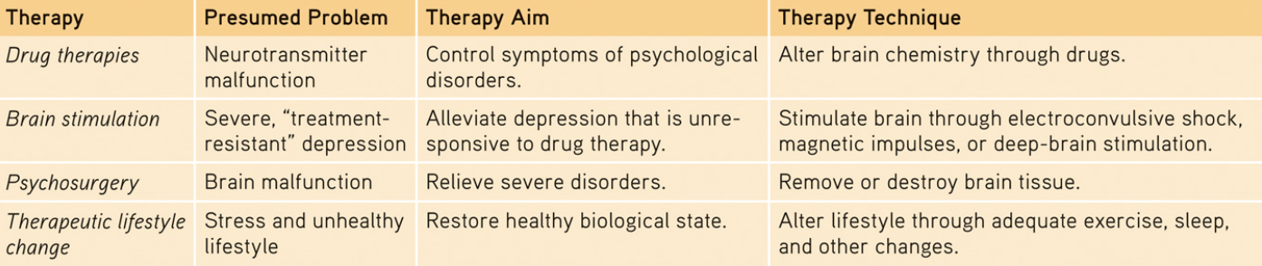

Resilience
- Personal strength that helps most people cope with stress and recover from adversity and even trauma

Posttraumatic growth
- Positive psychological changes as a result of struggling with extremely challenging circumstances and life crises

Chapter 13: Social Psychology

Social Thinking

Social Psychology
- Scientific study of how we think about, influence and relate to one another

Attribution theory
- Fritz Heider’s theory that we explain someone’s behaviour by crediting either the situation or the person’s disposition

Fundamental attribution error
- The tendency for observers, when analyzing other’s behaviour, to underestimate the impact of the situation and to overestimate the impact of personal disposition
- Factors
  - Individualist Westerners attribute behaviour to people’s personality traits
  - East Asians more sensitive to power of the situation

Attitudes
- Feelings, often influenced by our beliefs, that predispose us to respond in a particular way to objects, people and events

Peripheral route persuasion
- Occurs when people are influenced by incidental cues, such as a speaker’s attractiveness
- Doesn’t engage systematic thinking, but produces fast results

Central route persuasion
- Occurs when interested people focus on the arguments and respond with favorable thought
- Offers evidence

Foot-in-the-door phenomenon
- Tendency for people who have first agreed to a small request to comply later with a larger request

Role
- Set of expectations (norms) about a social position, defining how those in the position ought to behave
- When adopting a new role, you strive to follow social prescriptions
  - At first, behaviour may seem phony because you are acting a role
  - But with time it becomes you

Cognitive Dissonance theory
- Theory that we act to reduce the discomfort we feel when two of our thoughts are inconsistent
- Ex: when we become aware our attitudes and actions clash, we can reduce the resulting dissonance by changing out attitudes

Social Influence

Chameleon effect
- Mimicry; people unconsciously imitate others’ expressions, postures, and voice tones

Conformity
- Adjusting our behaviour or thinking to coincide with a group standard
- We are more likely to conform when we:
  - Are made to feel incompetent/insecure
  - Are in a group w/ at least 3 people
  - Are in a group in which everyone else agrees
  - Admire the group’s status and attractiveness
  - Have not made prior commitment to any response
  - Know that others in the group will observe our behaviour
  - Are from a culture that encourages respect for social standards

Normative social influence
- Influence resulting from a person’s desire to gain approval or avoid disapproval

Informational social influence
- Influence resulting from one’s willingness to accept others’ opinions about reality

Obedience
- Milgram’s experiments “teacher” shocks the “learner”
  - 60% of men aged 20-50 complied fully to the experimenter’s cruel demands
- Obedience highest when:
  - Person giving orders was close at hand & perceived to be legitimate authority
  - Authority figure was supported by prestigious institution
  - Victim was depersonalized or at a distance
  - No role models for defiance
- Strong social influences can make people conform to falsehoods or capitulate to cruelty

Social Facilitation
- Improved performance on simple or well-learned tasks in the presence of others
- What you do well, you are likely to do even better in front of an audience
- What you find difficult may seem even harder when you are being watched

Social loafing
- Tendency for people in a group to exert less effort when pooling their efforts toward attaining a common goal than when individually accountable
- 3 causes
  - Feel less accountable; worry less about what others think
  - May view individual contributions as dispensable
  - Some may slack off; people may free ride on others’ efforts

Deindividuation
- Loss of self-awareness and self-restraint occurring in group situations that foster arousal and anonymity
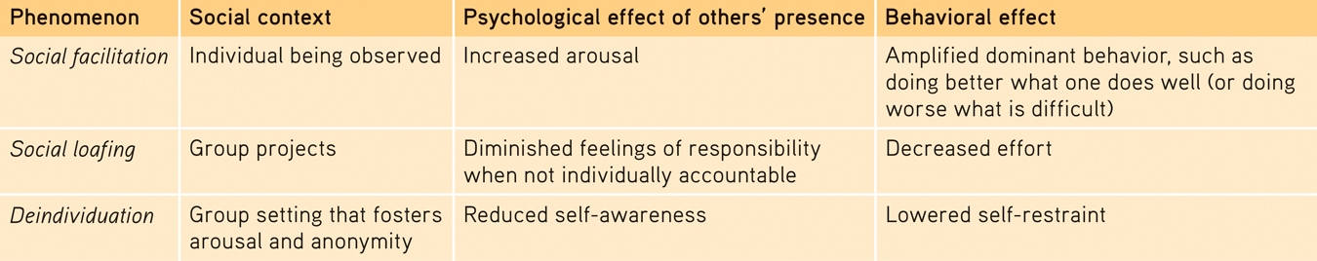

Group Polarization
- Enhancement of a group’s prevailing inclinations through discussion within the group
- The beliefs we bring to a group grow stronger as we discuss them with like-minded others
- Girls talk more intimately than boys do & play and fantasize less aggressively
- Can be positive OR negative outcomes

Groupthink
- The mode of thinking that occurs when the desire for harmony in a decision-making group overrides a realistic appraisal of alternatives
- Fed by overconfidence, conformity, self-justification and group polarization
- Prevented when a leader welcomes various opinions, invites experts’ critiques of plans and assigns people to identify possible problems

Power of Individuals
- Committed individuals can sway the majority and make social history
  - “Minority influence”

Antisocial Relations

Prejudice
- Unjustifiable (usually negative) attitude toward a group and its members
- Mixture of:
  - Beliefs (stereotypes)
  - Emotions (negative feelings = fear, hostility)
  - Predispositions to action (to discriminate)

Stereotype
- Generalized (sometimes accurate but often overexaggerated) belief about a group of people

Discrimination
- Unjustifiable negative behaviour toward a group and its members

Implicit Prejudice
- Often an automatic attitude
- Implicit racial associations
  - Even people who deny harboring racial prejudice may carry negative associations
  - 9 in 10 White respondents took longer to identify pleasant words as “good” when presented with Black-sounding names
- Unconscious patronization
  - Low expectations of black people could hinder minority student achievement
- Race-influenced perceptions
  - People more often shot a black person carrying a harmless tool than a white person
- Reflexive bodily responses
  - When people view faces of whites/blacks, implicit prejudice may show up in facial-muscle responses and in activation of their amygdala

Gender Prejudice
- Despite equality between the sexes on intelligence tests, people tend to perceive their fathers than their mothers
- However, most people feel more positively about woman than about men

Sexual Orientation Prejudice
- Anti-gay prejudice persists in Western countries

Just-world phenomenon
- The tendency for people to believe the world is just and that people therefore get what they deserve and deserve what they get
- “Good” is rewarded and “evil” is punished

Ingroup
- “Us” = people with whom we share a common identity

Outgroup
- “Them” = those perceived as different or apart from our ingroup

Ingroup bias
- Tendency to favor our own group

Scapegoat theory
- Theory that prejudice offers an outlet for anger by providing someone to blame

Other-race effect
- Tendency to recall faces of one’s own race more accurately than faces of other races
- Emerges during infancy (3-9 months)

Aggression
- Any act intended to harm someone physically or emotionally
- Biological influences
  - Genetic
    - Animal + twin studies demonstrate genes influence
    - Y chromosome
    - Monoamine oxidase A (MAOA) gene
  - Neural
    - No 1 spot in the brain that controls aggression
    - Neural systems that either inhibit or facilitate
  - Biochemical
    - Testosterone linked with neural systems that control aggression
    - High levels = irritability, assertiveness, impulsiveness, low tolerance for frustration
- Psychological influences
  - Aversive events
    - Suffering, hot temperatures, physical pain, personal insults, foul odors, cigarette smoke, crowding can evoke hostility
  - Reinforcement, Modeling, Self-Control
    - Situations where experience taught us that aggression pays, likely to be aggressive again
    - Parent-training programs advise parents to avoid modeling violence
  - Media Models for Sexual Violence
    - Repeatedly viewing on-screen violence tends to make us less sensitive to cruelty + teaches us social scripts
    - Music lyrics, pornography, videogames

Frustration-aggression principle
- Frustration (blocking of an attempt to achieve some goal) creates anger which can generate aggression

Social scripts
- Culturally modeled guide for how to act in various situations

Prosocial Relations

Proximity
- Geographic nearness is friendship’s most powerful predictor
- Provides opportunities for liking
Mere exposure theory
- Phenomenon that repeated exposure to novel stimuli increases liking of them

Speed-dating
- Influences on first impressions of potential romantic partners
  - Men are more transparent
  - Given more options, people’s choices become more superficial
  - Men wish for future contact with more of their dates, women tend to be more choosy

Physical Attractiveness
- Influences first impressions for both sexes
- Predicts how often people date and how popular they feel

Similarity
- Opposites retract
- Friends/couples more likely to share common attitudes, beliefs and interests
  - Even age, religion, race, education, intelligence, smoking behaviour)
- More people are alike, the more their liking endures

Passionate love
- Aroused state of intense positive absorption in another, usually present at the beginning of a love relationship
  - Two-factor theory of emotion = emotional arousal + cognitive appraisal

Companionate love
- Deep affectionate attachment we feel for those with whom our lives are intertwined
- As love matures, it typically becomes a steadier love
  - Flood of passion-facilitating hormones (testosterone, dopamine, adrenaline) subsides
  - Another hormone (oxytocin) supports feelings of trust, calmness, and bonding

Equity
- Condition in which people receive from a relationship in proportion to what they give to it
- Mutually sharing one’s self and possession, making decisions together, giving/getting emotional support

Self-disclosure
- Act of revealing intimate aspects of oneself to others
- Likes/dislikes, dreams, worries, proud moments, shameful moments

Altruism
- Unselfish regard for the welfare of others

Bystander effect
- Tendency for any given bystander to be less likely to give aid if other bystanders are present
- There are steps to make a decision to intervene or not
  - At each step, presence of others can turn us away from the path that leads to helping
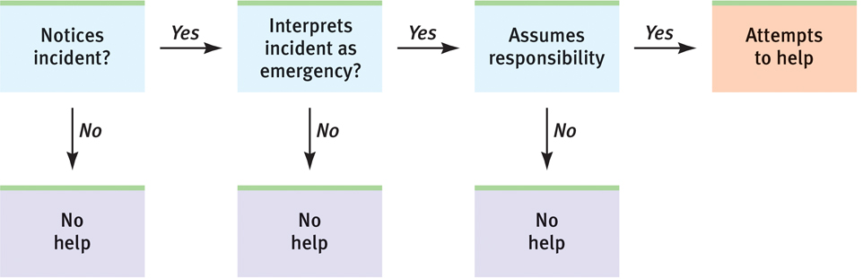
- Best odds of our helping occur when
  - Person appears to need and deserve help
  - Person is in some way similar to us
  - Person is a woman
  - We just observed someone else being helpful
  - We are not in a hurry
  - We are in a small town/rural area
  - We are feeling guilty
  - We are focused on others and not preoccupied
  - We are in a good mood

Social exchange theory
- Theory that our social behaviour is an exchange process, the aim of which is to maximize benefits and minimize costs
- Weigh the costs against the benefits

Reciprocity norm
- Expectation that people will help, not hurt, those who have helped them
- Compels us to give about as much as we receive

Social-responsibility norm
- Expectation that people will help those needing their help

Conflict
- Perceived incompatibility of actions, goals, or ideas

Social trap
- Situation in which the conflicting parties, by each pursuing their self-interest rather than good of the group, become caught in mutually destructive behaviour
- Challenge us to reconcile our right to pursue our personal well-being with our responsibility for the well-being of all

Mirror-image perceptions
- Mutual views often held by conflicting people, as when each side sees itself as ethical and peaceful and views the other side as evil and aggressive
- Can feed a vicious cycle of hostility

Self-fulfilling prophecy
- Belief that leads to its own fulfilment

Promoting peace
- Contact
  - Negative contact increases disliking
  - Positive contact typically helps
- Cooperation
  - Superordinate goals = shared goals that could be achieved only through cooperation
- Communication
  - A third-party mediator may facilitate much needed communication
  - Help each party to voice its viewpoint and to understand the other’s needs and goals
- Conciliation
  - GRIT = Graduated and Reciprocated Initiatives in Tension-reduction
  - Strategy designed to decrease international tensions

