PSY MIDTERM 2
Chapter 12: Stress & Health

- 85% of people recall experiencing stress during the last 3 months
- Entering college/university - 18% of men and 39% of women report having been “frequently overwhelmed” by all they had to do during the past year

Stress
- Process of appraising and responding to a threatening or challenging event, called stressors
- Arises less from events themselves than how we appraise them
- Short-lived or perceived as challenges, stressors can have positive effects
  - Arouses/motivates us to conquer problems
  - Mobilize the immune system for fending off infections
- Extreme or prolonged stress can harm us
  - Can damage physical health

Stressors
- 3 main types
  - Catastrophes
    - Unpredictable large-scale events (earthquakes, floods, storms)
    - After events, damage to emotional & physical health can be significant
  - Significant life changes
    - Life transitions: leaving home, divorcing, losing a job…
    - Even happy events like marriage can be stressful
    - Highest stress levels among young adults
  - Daily hassles
    - Anything from long lineups, e-mail spam, loud talkers can annoy us
    - Some people shrug off, but for some the annoyances add up and take a toll on health and well-being

Stress Response System
- Walter Cannon (1929) confirmed the stress response is part of a unified mind-body system
  - Extreme cold, lack of oxygen, emotion-arousing events all trigger an outpouring of stress hormones; epinephrine & norepinephrine from adrenal glands
  - Sympathetic nervous system arouses us, preparing body for fight or flight
    - Increased heart rate & respiration, divert blood from digestion to skeletal muscles, dulls feelings of pain, releases sugar/fat from body
- Psychologists have identified an additional stress response system
  - On orders from cerebral cortex, the outer part of adrenal glands secrete glucocorticoid stress hormones (cortisol)

General Adaptation Syndrome (GAS)
- Hans Selye (1936/1976) studied animal reactions to various stressors
  - Proposed the body response to stress is so general
- 3 phase process
  - Phase 1 = alarm, sympathetic nervous system is activated
  - Phase 2 = resistance, remain fully engaged
  - Phase 3 = exhaustion, more vulnerable to illness, collapse, death
- Although human body reacts well w/ temporary stress, prolonged stress can damage

Tend and befriend
- Under stress, people (often women) provide support to others and bond with and seek support from others
- Demonstrated in outpouring of help after natural disasters

Response to stress
- Men tend to withdraw socially, turn to alcohol, become aggressive
- Women tend to nurture and band together
  - May be due to oxytocin: stress-moderating hormone associated w/ pair bonding

Health psychology
- Subfield of psychology that provides psychology’s contribution to behavioural medicine

Psychoneuroimmunology
- Study of how psychological, neural and endocrine processes together affect the immune system and health
- Thoughts/feelings (psycho), influence your brain (neuro), influences endocrine hormones that affect immune system

Cells involved in immune system
- B lymphocytes (white blood cells)
  - Mature in bone marrow & release antibodies that fight bacterial infections
- T lymphocytes (white blood cells)
  - Mature in thymus/lymphatic tissue & attack cancer cells, viruses, foreign substances
- Macrophages (“big eaters”)
  - Identify, pursue, ingest harmful invaders & worn out cells
- Natural Killer cells (NK cells)
  - Pursue diseased cells (like those infected by viruses/cancer)

Two ways immune system reacts wrong
- Responding too strongly = may attack body’s own tissues
- Underreacting = may allow bacterial infection to flare, cancer cells to multiply

Stress & AIDS
- Stress/negative emotions speed the transition from HIV infection to AIDS
- Stress predicts a faster decline in those with AIDS
- Efforts to reduce stress could help control the disease

Stress & Cancer
- In a healthy functioning immune system, lymphocytes, macrophages and NK cells search out and destroy cancer ells
- Stress does not create cancer cells; it may affect their growth by weakening the immune system

Stress & Heart disease
- Coronary heart disease = clogging of the vessels that nourish the heart muscle; leading cause of death in many developed countries
- Pessimist 2x more likely than optimists to develop heart disease
- Depression increases the risk of death by cardiovascular disease

Type A Personality
- Competitive, hard-driving, impatient, verbally aggressive, anger-prone people
- Excess cholesterol and fat may continue to circulate in their blood, which gets deposited to their heart

Type B Personality
- Easygoing, relaxed people

Type D Personality
- Suppress their negative emotion to avoid social disapproval
- Mainly experience distress

Coping
- Alleviating stress using emotional, cognitive, behavioural methods

Problem-focused coping
- Attempting to alleviate stress directly - by changing the stressor or the way we interact with that stressor
- Tend to use when we feel sense of control over a situation and can change the circumstances

Emotion-focused coping
- Attempting to alleviate stress by avoiding/ignoring a stressor and attending to emotional needs related to our stress reaction
- Tend to use when we believe we can’t change a situation

Personal Control
- Perceiving loss of control = more vulnerable to ill health
- Losing control provokes outpouring of stress hormones
  - Blood pressure increases, immune responses drop
- Increasing control noticeably improves health and morale
- “Excess of freedom” may decrease life satisfaction, increase depression
- Tranny of choice brings info overloads w/ greater likelihood we will feel regret over some things we left behind

Learned helplessness
- Hopelessness and passive resignation a human learns when unable to avoid repeated aversive events
- A series of uncontrollable events creates a state of learned helplessness

External locus of control
- Perception that chance or outside forces beyond our personal control determine our fate

Internal locus of control
- Perception that we control our own fate
- Achieve more in school and work, act more dependently, better health, less depressed, less obesity, lower blood pressure, less distress

Self-control
- Ability to control impulses and delay short-term gratification for greater long-term rewards
- Predicts good health, higher income, better grades

Pessimists
- Expect things to go badly
- When bag things happen, they knew it at along
- They attribute poor performance to a basic lack of ability

Optimists
- Expect to have more control, cope better with stressful events, have better health
- Less fatigue, fewer coughs, aches, pains
- If one identical twin is optimistic, the other will often be as well
- Genetic marker of optimism = gene that enhances the social-bonding hormone oxytocin

Social Support
- Feeling liked and encouraged by intimate friends and family promotes happiness + health
- Calms us and reduces blood pressure and stress hormones
- Fosters stronger immune functioning
- Close relationships give opportunity for “open heart therapy”, chance to confide painful feelings

Managing Stress
Aerobic exercise
- Sustained exercise that increases heart and lung fitness
- May alleviate stress, depression and anxiety
- People who exercise suffer ½ as many heart attacks

Relaxation and Meditation
- Biofeedback = system of recording, amplifying, and feeding back the info about subtle physiological responses
- Simple methods of relaxation produce many of the results of biofeedback
- Relaxation can also alleviate headaches, hypertension, anxiety and insomnia
- Mindfulness meditation = relax and silently attend to your inner state
  - Lower levels of anxiety and depression, improved immune system functioning
  - Strengthens connections among regions in our brain
  - Activates brain regions associated w/ more reflective awareness
  - Calms brain activation in emotional situations

Spiritual communities
- Faith factor = religiously active people tend to live longer
- Predictor of health and longevity
  - Religion promotes healthy behaviours (self-control, smoke/drink less)
  - Social support (belonging to a faithful community)
  - Positive emotions

Chapter 14: Personality

Personality
- An individual’s characteristic pattern of thinking, feeling and acting

Psychodynamic theories
- View personality with a focus on the unconscious and the importance of childhood experiences
- View human behaviour as a dynamic interaction between the conscious mind and the unconscious mind

Psychoanalysis
- Freud’s theory of personality that attributes thoughts/actions to the unconscious motives and conflicts
- Techniques used in treating psychological disorders by exposing unconscious tensions
Unconscious
- Freud = Reservoir of mostly unacceptable thoughts, wishes, feelings, memories
- Today = Information processing of which we are unaware

Free association
- Method of exploring the unconscious in which the person relaxes and says whatever comes to mind, no matter how trivial or embarrassing

Freud’s view of personality
- Human personality arises from a conflict between impulse and restraint
- Personality arises from our efforts to resolve this basic conflict
- 3 interacting systems: id, ego, superego

Id
- Reservoir of unconscious psychic energy that strives to satisfy basic sexual and aggressive drives
- Operates on the pleasure principle = demanding immediate gratification

Ego
- Largely conscious “executive” part of personality that mediates among demands of the id, superego and reality
- Contains partly conscious perceptions, thoughts, judgements, memories
- Operates on the reality principle = satisfying id’s desires in ways that will realistically bring pleasure rather than pain

Superego
- Part of personality that represents internalized ideals and provides standards for judgement and for future aspirations
- Focuses on how we ought to behave, strives for perfection

Psychosexual stages
- Children pass through a series of psychosexual stages
- Each stage offers its own challenges; seen as conflicting tendencies
Oral (0-18 months)
- Pleasure zone = mouth (sucking, biting, chewing)
Anal (18-36 months)
- Pleasure zone = bowel/bladder elimination
- Coping with demands for control
Phallic (3-6 years)
  - Pleasure zone = genitals
  - Oedipus complex = boy’s sexual desires towards mother & jealousy towards father
  - Electra complex = parallel complex in girls
Latency (6-puberty)
- Phase of dormant sexual feelings
Genital (puberty on)
- Maturation of sexual interests

Identification
- Process by which children incorporate their parents’ values into their developing superegos
- Identification with the same-sex parent provides gender identity

Fixation
- A lingering focus of pleasure-seeking energies at an earlier psychosexual stage, in which conflict were unresolved
- A person orally overindulged or deprived might fixate at the oral stage
  - Could exhibit passive dependence or exaggerated denial of this independence
  - Might continue to seek oral gratification (smoking, excessive eating)

Defense mechanisms
- Ego’s protective methods of reducing anxiety by unconsciously distorting reality
- All defense mechanisms function indirectly and unconsciously
Repression = banish anxiety-arousing thoughts, feelings, memories from consciousness
  - Often incomplete, may appear as symbols in dreams or slips of tongue
Regression = retreating to infantile psychosexual stage
Reaction formation = switching unacceptable impulses into opposites
Projection = disguising one’s threatening impulses by attributing to others
Rationalization = offering self-justifying explanations for one’s actions
Displacement = shifting sexual/aggressive impulses toward more acceptable person
Denial = refusing to believe/perceive painful realities

Neo-Freudians
- Pioneering psychoanalysts adopted Freud’s interviewing technique and accepted Freud’s basic ideas:
  - Personality structures of id, ego, superego
  - Importance of unconscious
  - Childhood roots of personality
  - Dynamics of anxiety and defense mechanisms
- 2 ways they broke off from Freud
  - Placed more emphasis on conscious mind’s role in interpreting experience and coping w/ environment
  - Doubted sex & aggression were all-consuming motivations - emphasize loftier motives and social interactions
- Alfred Adler
  - Inferiority complex
  - Much of behaviour is driven by efforts to conquer childhood inferiority feelings
- Karen Horney
  - Childhood anxiety triggers desire for love/security
  - Women have weak superegos and suffer “penis envy”
- Carl Jung
  - Unconscious contains more than just repressed thoughts
  - Collective unconscious = concept of shared, inherited reservoir of memory traces from our species history

Projective test
- Personality tests that provides ambiguous stimuli designed to trigger projection of one’s inner dynamics

Thematic Apperception Test (TAT)
- Projective test in which people express their inner feelings and interests through the stories they make up about ambiguous scenes
- Assess achievement motivation

Rorschach inkblot test
- Most widely used projective test; designed by Hermann Rorschach
- Set of 10 inkblots seek to identify people’s inner feelings by analyzing their interpretations of the blots

Evaluating Freud’s concepts
- Freud did not have access to neurotransmitter or DNA studies
- His theory offers after-the-fact explanations of characteristics yet fails to predict such behaviours
- Much more to the unconsciousness

Terror-management theory
- Theory of death-related anxiety
- Explores people’s emotional and behavioural responses to reminders of their impending death

Humanistic theories
- View personality with a focus on the potential for healthy personal growth
- Ways people strive for self-determination and self-realization
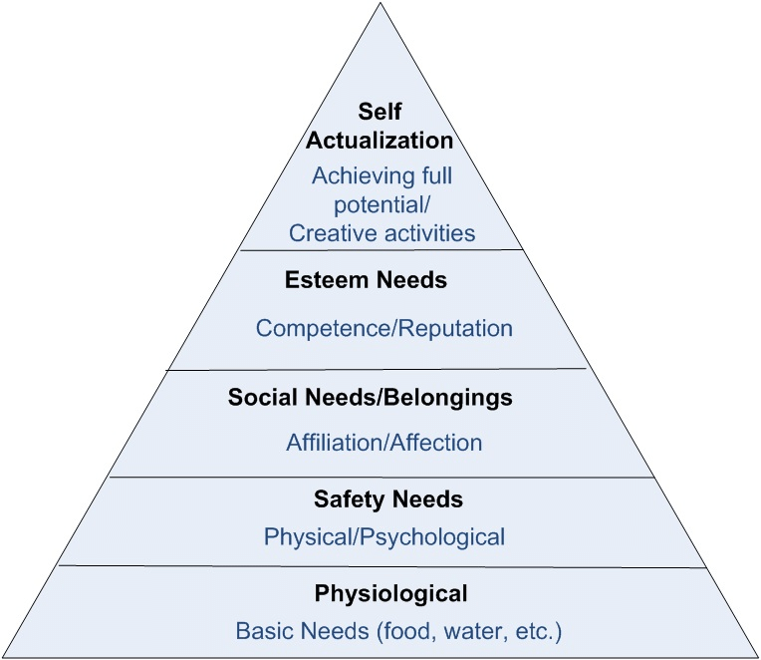
Abraham Maslow
- We are motivated by a hierarchy of needs

Self-actualization
- One of the ultimate psychological needs that arises after basic physical and psychological needs are met and self-esteem is achieved
- Motivation to fulfill one’s potential

Carl Rogers
- Person centered perspective = people are basically good and endowed w/ self-actualizing tendencies
- Growth promoting climate requires 3 conditions
  - Genuineness = open w/ their own feelings, transparent, self-disclosing
  - Acceptance = offer unconditional positive regard, free to be spontaneous
  - Empathy = share and mirror other’s feelings & reflect their meanings

Unconditional positive regard
- Attitude of total acceptance towards another person

Self-concept
- All our thoughts and feelings about ourselves
- Answer to the question Who am I?

Assess a person’s sense of self
- Questionnaire inspired by Rogers, asked people to describe themselves as they would ideally like to be and actually are
  - When ideal and actual self are nearly alike; self-concept is positive

Evaluating Humanistic theories
- Maslow + Rogers influenced counselling, education, child raising, management
- Critics:
  - Concepts are vague and subjective
  - Emphasis on individualism
  - Naïve; fails to appreciate reality of human capacity for evil

Trait theories
- Gordon Allport = describing personality in terms of fundamental traits
- Myers-Briggs Type Indicator = sort people according to Jung’s personality types

Trait
- A characteristic pattern of behaviour or a disposition to feel and act, as assessed by self-report inventories and peer reports
Factor Analysis
- Statistical procedure used to identify clusters of test items that tap basic components of intelligence
- Also used to explore traits
- Eysenck’s believed normal individual variations could be reduced to 2-3 dimensions
  - Extraversion-introversion
  - Emotional stability-instability
- Confirmed these factors are genetically influenced

Biology of personality
- Extraverts seek stimulation because their normal brain arousal is low
- Dopamine-related neural activity tends to be higher in extraverts

Personality inventory
- Questionnaire on which people respond to items designed to gauge a wide range of feelings and behaviours
- Used to assess selected personality traits

Minnesota Multiphasic Personality Inventory (MMPI)
- Most widely researched and clinically used of all personality tests
- Originally developed to identify emotional disorders -> now used for many other screening purposes

Empirically derived test
- A test developed by testing a pool of items and then selecting those that discriminate between groups
- Used with MMPI

The “Big Five” Personality Factors
- Conscientiousness
- Agreeableness
- Neuroticism
- Openness
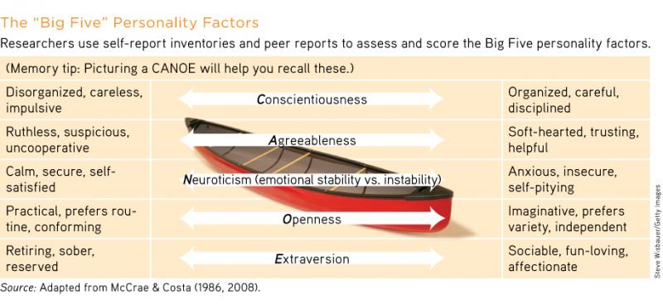
- Extraversion
Evaluating Trait theories
- Person-Situation controversy
  - Interests, careers, relationships may change
  - But most people recognize their traits as their own
  - There is inconsistency in behaviours from one situation to the next
  - Music preferences, personal spaces, online spaces, written communication

Social-Cognitive Perspective
- Views behaviour as influenced by interaction between people’s traits and their social context
- We learn many of our behaviours through conditioning or by observing and imitating others
- Emphasize importance of mental processes: what we think affects our behaviour

Reciprocal determinism
- Interacting influences of behaviour, internal cognition and environment
- 3 ways individuals & environment interact
  - Different people choose different environments
  - Personalities shape how we interpret/react to events
  - Personalities help create situations to which we react
- Gene-environment interaction = genetically influenced traits evoke certain responses

Evaluating Social-Cognitive theories
- Sensitize researchers to how situations affect and are affected by individuals
- Critics
  - Focus so much on situation, that fail to appreciate person’s inner traits

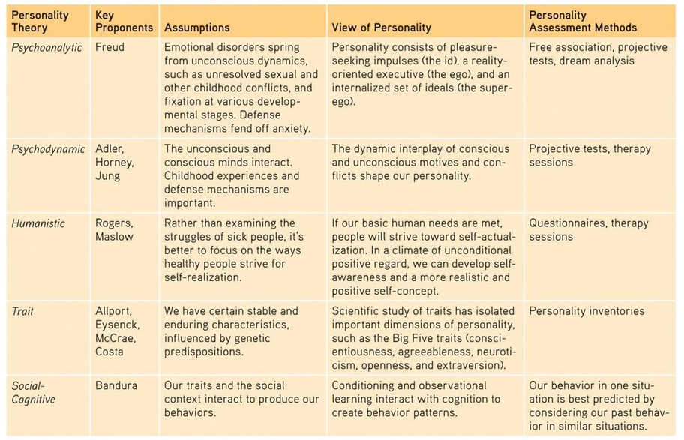

Self
- Assumed to be the center of personality, organizer of our thoughts, feelings and actions
- Possible selves = visions of the self you dream of becoming, lonely self, etc.
  - Motivate us to lay out specific goals that

Spotlight effect
- Overestimating others’ noticing and evaluating our appearance, performance, blunders
- 2 strategies
  - Simply knowing about the spotlight effect
  - Take the audience’s perspective

Self-esteem
- One’s feelings of high or low self-worth

Self-efficacy
- One’s sense of competence and effectiveness

Costs of self-esteem
- Excessive Optimism
- Blindness to One’s Own Incompetence
- Self-Serving Bias = readiness to perceive oneself favourably

Narcissism
- Excessive self-love and self-absorption

Chapter 15: Psychological Disorders

Psychological Disorder
- Syndrome marked by a clinically significant disturbance in an individual’s cognition, emotion regulation or behaviour
- Disturbed/dysfunctional thoughts, emotions or behaviours are maladaptive
  - They interfere with normal day-to-day life

Moral treatment
- Philippe Pinel opposed medical treatments
- Curing illness requires “moral treatment”
  - Boosting patient’s morale by unchaining them and talking with them

Medical Model
- Concept that diseases (psychological disorders) have physical causes that can be diagnosed, treated and in most cases cured
  - Often through treatment in a hospital

Epigenetics
- Study of environmental influences on gene expression that occur without a DNA change
- Also informs understanding of disorders
  - Environment can affect whether a gene is expressed or not, thus affecting development of various psychological disorders

Classifying Disorders
- Aims to…
  - Predict the disorders future course
  - Suggest appropriate treatment
  - Prompt research into its causes
DSM-5
- The American Psychiatric Association’s Diagnostic and Statistical Manual of Mental Disorders; Fifth Edition
- Widely used system for classifying psychological disorders

ADHD
- Attention-deficit/hyperactivity disorder
- Psychological disorder marked by extreme inattention and/or hyperactivity and impulsivity

Labels
- Subjective; once we label a person, we view that person differently
- Affect getting a job
- BUT
  - Mental health professionals use to communicate about their cases, comprehend underlying causes and discern effective treatment programs
  - Researchers use when discussing work that explores causes & treatments
  - Clients feel relieved to learn their suffering has a name, and they are not alone

Anxiety disorders
- Psychological disorders characterized by distressing persistent anxiety or maladaptive behaviours that reduce anxiety

Generalized anxiety disorders
- An anxiety disorder in which a person is continuously tense, apprehensive, and in a state of autonomic nervous system arousal
  - People worry uncontrollably, jittery, agitated, sleep-deprived
  - Concentration is difficult (attention switches from worry to worry)
- Often accompanied by depression
- Women 2x as likely as men to experience general anxiety disorder

Panic disorder
- An anxiety disorder marked by unpredictable minutes-long episodes of intense dread in which a person experiences terror and accompanying chest pain, choking or other frightening sensations
- Often followed by worry over a possible next attack & may avoid situations where previous attacks have struck
- If fear is intense enough, may develop agoraphobia - fear/avoidance of situations in which escape might be difficult
- Smokers have 2x the risk of panic disorder

Phobias
- An anxiety disorder marked by a persistent, irrational fear and avoidance of a specific object, activity, or situation
- Specific phobias may focus on animals, insects, heights, blood or close spaces
- Many people avoid triggers that arouse their fear
- Others are incapacitated by their efforts to avoid the feared situation
- Social anxiety disorder is shyness taken to an extreme
  - Intense fear or other’s negative judgements
  - Avoid potentially embarrassing social situations

Obsessive-compulsive Disorder (OCD)
- Disorder characterized by unwanted repetitive thoughts (obsessions), actions (compulsions), or both
- 1-3% of people cross the line from normal preoccupations to disorder
- Strong genetic basis
- More common among teens and young adults

Posttraumatic Stress Disorder (PTSD)
- Disorder characterized by haunting memories, nightmares, social withdrawal, jumpy anxiety, numbness of feeling, and/or insomnia that lingers for four weeks or more after a traumatic experience
- 25% of veterans returning from Iraq and Afghanistan were diagnosed w/ a psychological disorder
- Survivors of accidents, disasters, violent/sexual assaults have experienced PTSD symptoms
- 5-10% of people develop PTSD after a traumatic life experience
- Occurs in some people and not others because they might have a more sensitive emotion-processing limbic system that floods their bodies with stress hormones

Conditioning
- Through conditioning, few naturally painful events can multiply into many fears
- Stimulus generalization = occurs when a person experiences a fearful event and later develops a fear of similar events
- Reinforcement = helps maintain fears and anxieties

Cognition
- Thoughts, memories, interpretations and expectations influence our feelings of anxiety
- By observing others - we can learn to fear what they fear
- Past experiences shape our expectations and influence our interpretations/reactions
- People w/ anxiety disorders tend to be hypervigilant

Biology & Anxiety
- Genes
  - If 1 identical twin has an anxiety disorder, the other is likewise at risk
  - 17 gene variations associated w/ typical anxiety disorder symptoms
  - Can influence disorders by regulating neurotransmitters
  - “Anxiety gene” that affects levels of serotonin & glutamate (alarm centers)
  - Epigenetic marks
- Brain
  - Experiences change our brain, creating new pathways
  - Anterior cingulate cortex is likely to be hyperactive (region that monitors actions)
  - Some anti-depressant drugs dampen the fear-circuit activity
- Natural Selection
  - We seem biologically prepared to fear threats faced by our ancestors

Major Depressive Disorder
- A disorder in which a person experiences (in the absence of drugs or another medical condition) two or more weeks with 5 or more symptoms
  - At least 1 symptom being depressed mood or loss of interests or pleasure
- Adults diagnosed w/ persistent depressive disorder (dysthymia) experience a mildly distressed mood more often than not for 2 years or more

Bipolar disorder
- A disorder in which a person alternates between the hopelessness and lethargy of depression and the overexcited state of mania
- American’s are twice as likely as people of other countries to have bipolar disorder
- Symptoms may have a seasonal pattern: depression may return each fall/winter & mania may arrive with spring

Mania
- Hyperactive, widely optimistic state in which dangerously poor judgement is common
- During mania phase
  - Little need for sleep
  - Fewer sexual inhibitions
  - Positive emotions persist abnormally
  - Speech is loud, flighty and hard to interrupt
  - They find advice irritating

Understanding depressive/bipolar disorders
- Many behavioural and cognitive changes accompany depression
  - People become inactive and feel unmotivated, sensitive to negative events, more often recall negative info, expect negative outcomes
- Depression is widespread
  - More than 350 million people suffer depression
  - #1 reason people seek mental health services
- Women’s risk of major depression is nearly double men’s
  - Peak in gender gap begins in adolescence
  - Factors that put women at risk: genetic predispositions, child abuse, low self-esteem, marital problems, etc.
- Most major depressive episodes self-terminate
  - Most people recover and returns to normal
  - 20% experience chronic depression
- Stressful events related to work, marriage, and close relationships often precede depression
  - 1 in 4 diagnosed w/ depression has been brought down by a significant loss or trauma
  - People who react to minor stressors were more often depressed 10 years later
- Depression strikes earlier and affects more people
  - In developed countries
  - Young adults are 3x more likely than their grandparents

Biological Perspective on Depressive Disorders
Genetic Influences
- Depressive disorders and bipolar disorder run in families
- If one identical twin is diagnosed w/ major depressive disorder, the chances are 1 in 2 that the other twin will be too
- If one identical twin is diagnosed w/ bipolar disorder, the chances are 7 in 10 - even higher that the other twin will be
- Linkage analysis = researcher’s use this to find genes that put people at risk for depression
Depressed Brain
- Diminished brain activity during slowed-down depressive states
- More activity during periods of mania
- Left frontal lobe and an adjacent brain reward center become more active during positive emotions
- Depressed people’s MRI scans show their frontal lobes are smaller than normal
- The hippocampus is vulnerable to stress-related damage
- In bipolar disorder, there is decreased white matter and enlarged fluid-filled ventricles
- Norepinephrine - is scarce during depression and overabundant during mania
- Serotonin -
- Drugs that relieve depression tend to increase norepinephrine or serotonin supplies by blocking their reuptake or chemical breakdown
Nutritional Effects
- People who eat a heart-healthy Mediterranean diet have a low risk of developing heart disease, stroke, late-life cognitive decline, and depression

Social-Cognitive Perspective on Depressive Disorders
- Diet, drugs, stress and other life experiences lay down epigenetic marks
  - They attach to our chromosomes and turn certain genes on or off
- Depressed people view life through dark glasses of low self-esteem
  - Their negative assumptions about themselves, their situation, their future lead them to magnify bad experiences and minimize good ones
  - Their self-defeating beliefs and negative explanatory style feed depressions vicious cycle
- Negative thoughts and negative moods interact
  - Self-defeating beliefs may arise from learned helplessness
  - Depressed people who explain bad events in terms that are stable, global, and internal
  - Pessimistic, overgeneralized, self-blaming attributions may create a depressing sense of hopelessness
  - State-dependent memory = tendency to recall experiences that are consistent with one’s current good or bad mood
- Depression’s Vicious Cycle
  - Depression is a cause and effect of stressful experiences that disrupt our sense of who we are and why we are worthy human beings
  - 1) Negative stressful events interpreted through 2) a ruminating pessimistic explanatory style create 3) a hopeless depressed state that 4) hampers the way a person thinks and acts. This fuels 1) negative stressful experiences

Rumination
- Compulsive fretting; overthinking about our problems and their causes
- Relentless self-focused rumination can divert us from thinking about other life tasks and can increase negative moods

Suicide
- Those who are/were depressed have a suicide risk at least 5x greater than the general population
- The risk increases when people begin to rebound and become capable of following through
- Researchers have found
  - National differences
  - Racial differences (whites/natives kill themselves 2x as often as Blacks, Hispanics, and Asians)
  - Gender differences (women more likely to attempt, men 2-4x more likely to actually end their lives)
  - Age differences (rates increase in late adulthood)
  - Other group differences (higher among the rich, nonreligious, and single/widowed/divorced)
  - Day of the week differences (negative emotion goes up midweek)
- Social suggestion may trigger suicide
- Suicidal urges typically arise when people feel disconnected to others and a burden to them

Self-Injury
- Suicide is not the only way to send out a message or deal with distress
- Some people may engage in nonsuicidal self-injury (NSSI)
- May cut/burn the skin, hit themselves, tattoo themselves
- Tend to be less able to tolerate emotional distress, extremely self-critical, often have poor communication and problem-solving skills
- Why do they hurt themselves?
  - Find relief from intense negative thoughts through the distraction of pain
  - Attract attention and possibly get help
  - Relieve guilt by inflicting self-punishment
  - Get others to change their negative behaviour
  - Fit in with a peer group

Schizophrenia
- A psychological disorder characterized by delusions, hallucinations, disorganized speech, and/or diminished, inappropriate emotional expression
- During most severe periods, people live in a private inner world, preoccupied with the strange ideas and images that haunt them
- The word itself means “split” (schizo) “mind” (phrenia)
  - But the mind is not split into multiple personalities
  - Rather the mind suffered a split from reality
- 1 in 100 people will experience schizophrenia this year
- Men tend to be struck earlier, more severely and more often
- Example of psychosis = terms for a break or split from reality
- Positive symptoms = may experience hallucinations, talk in disorganized/deluded ways, exhibit inappropriate laughter, tears, rage
- Negative symptoms = may have toneless voices, expressionless faces or mute/rigid bodies

Hallucinations
- People w/ schizophrenia may see, feel, taste, or smell things that only exist in their minds
  - Most often sounds (voices making insulting remarks)
- They are false perceptions

Delusion
- A false belief, often or persecution or grandeur, that may accompany psychotic disorders

Inappropriate Emotions
- Flat affect state = lapse into a state of no apparent feeling
- Impaired theory of mind = difficulty perceiving facial emotions and reading others’ states of mind
- Motor behaviour may be inappropriate
  - Perform senseless, compulsive acts
  - Catatonia = remain motionless for hours

Chronic Schizophrenia (process)
- Form of schizophrenia in which symptoms usually appear by late adolescence or early adulthood
- As people age, psychotic episodes last longer, and recovery periods shorten
- Often exhibit the persistent and incapacitating negative symptom of social withdrawal
- Recovery is doubtful

Acute Schizophrenia (reactive)
- Form of schizophrenia that can begin at any age, frequently occurs in response to an emotionally traumatic event and has extended recovery periods
- Recovery is much more likely
- More often have positive symptoms that are more likely to respond to drug therapy

Brain Abnormalities
Dopamine Overactivity
- Excess of receptors for dopamine
- Hyper-responsive dopamine system may intensify brain signals, creating positive symptoms like hallucinations/paranoia
Abnormal Brain Activity and Anatomy
- Abnormally low brain activity in frontal lobes (areas that help reason, plan, solve)
- Noticeable decline in the brain waves that reflect synchronized neural firing in the lobes
- Thalamus & amygdala become vigorously active during hallucinations
- Cortex, thalamus & corpus callosum are smaller-than-normal
Prenatal Environment and Risk
- Risk factors = low birth weight, maternal diabetes, older paternal age, oxygen deprivation during delivery, famine
- Mid-pregnancy viral infections can also impair fetal brain development

Genetic Factors
- 1 in 10 odds of being diagnosed w/ schizophrenia if a sibling/parent has the disorder
- If the sibling is an identical twin, the odds increase to 5 in 10
  - 6 in 10 if twins shared a placenta
  - 1 in 10 if they did not
- Adopted children have an elevated risk if a biological parent is diagnosed
- Some genes influence effects of dopamine and other neurotransmitters
  - Others affect myelin production
- Epigenetic factors influence whether or not genes will be expressed
  - Viral infections, nutritional deprivation, maternal stress can “turn on” genes that put us at higher risk of schizophrenia

Environmental Triggers
- 20% who develop schizophrenia showed social withdrawal/abnormal behaviour before onset
- Possible early warning signs
  - Mother whose disorder was severe/long-lasting
  - Birth complications (often involving oxygen deprivation/low birth weight)
  - Separation from parents
  - Disruptive/withdrawn behaviour
  - Emotional unpredictability
  - Poor peer relations and solo play
  - Childhood physical, sexual, emotional abuse

Dissociative Disorders
- Controversial rare disorders in which conscious awareness becomes separated from previous memories, thoughts, feelings
- Result may be a fugue state - sudden loss of memory or change in identity

Dissociative Identity Disorder (DID)
- Rare dissociative disorder in which a person exhibits two or more distinct and alternating personalities
- Multiple Personality Disorder
- Psychodynamic and learning perspectives interpret DID symptoms as ways of coping with anxiety
- Some clinicians include DID under umbrella of PTSD

Personality Disorders
- Inflexible and enduring behaviour patterns that impair social functioning
- 3 clusters characterized by
  - Anxiety (avoidant personality disorder)
  - Eccentric/Odd behaviours (schizotypal personality disorder)
  - Dramatic/Impulsive behaviours (borderline, narcissistic, antisocial PD)

Antisocial personality disorder
- A person exhibits a lack of conscience for wrongdoing, even towards friends/family
- May be aggressive and ruthless or a clever con artist
- Typically, a male whose lack of conscience becomes plain before 15
  - Begins to lie, steal, fight or display unrestrained sexual behaviour
- ½ of such children become antisocial adults
  - Unable to keep a job, irresponsible, assaultive/criminal
- Sometimes called sociopaths or psychopaths
- May show lower emotional intelligence
  - Ability to understand, manage, perceive emotions
- Behave impulsively and then feel and fear little
  - Impulsivity can have violent/horrifying consequences
- Biological relatives of people w/ antisocial are at increased risk for antisocial behaviour
- Levels of stress hormones are lower than average when they were young
- Amygdala is smaller & frontal lobes less active

Eating Disorders
- Our bodies are naturally disposed to maintain a steady weight
- But sometimes psychological influences overwhelm biological wisdom

Anorexia nervosa
- ED in which a person maintains a starvation diet despite being significantly underweight
- Sometimes accompanied by excessive exercise
- Usually adolescents and 9 out of 10 times females
- They feel fat, fear being fat, remain obsessed with losing weight
- ½ display a binge-purge-depression cycle

Bulimia nervosa
- ED in which a person alternates binge eating with purging or fasting
- Mostly women in late teens / early twenties
- Overeating high calories foods usually followed by compensatory purging (vomiting or laxative use), fasting, or excessive exercise
- Marked by weight fluctuation within/above normal ranges

Binge-Eating Disorder
- Significant binge-eating episodes followed by distress, disgust or guilt but without compensatory purging/fasting in bulimia
- May be overweight

Understanding Eating Disorders
- Those with ED often have low self-evaluations, set perfectionist standards, fret about falling short of expectations, intensely concerned with how others perceive them
- Heredity
  - Identical twins share these disorders more often than fraternal twins
- Cultural/Gender components
  - Ideal shapes vary across culture and time

