Leigh Walsh
Adm 1340
Section M
2020/01/06
Basic approach to financial accounting : (5 things accounting is trying to do)
- Classify-identify the type of transaction, account based on definitions, circumstances. What type of business is this? E.g. sole proprietorship, corporate, etc. what type of asset? Asset, inventory etc.
- Measure-calculate a value to be recorded given the measurement rules, circumstances. Measurement rules on how to put a dollar value on that “asset”, “inventory” .
- Record-entre the transactions (if applicable) in the accounting system using the double-entry method (Dr & Cr)
- Summarize- compile summary financial statements to aggregate all individual transactions entered into the accounting system.
- Disclose- disclose additional relevant (required) details in the notes accompanying the financial statement.

Key Financial statements
- Statement of Financial Position (Balance sheet)
Assets = Liabilities + Shareholders’ Equity
What we own = how we pay for it
- Statement of financial Performance (aka Income Statement(specific period))
Rev-Exp= Net Income
Note: net income itself is NOT an account
Main classification: Expenses, revenues, assets, liabilities, shareholders’ equity
Double-entry accounting: for every transaction two accounts will be affected

Types of businesses
- Proprietorship
- Partnership
- Corporations
Generally accepting accounting principles:

Types of Business Activities
- Financing: raising money. Right hand side of the balance sheet
- Investing: acquiring or selling assets. LHS of balance sheet
- Operating: ongoing business, revenues and expenses. Income statement

Financial Statements:
- Income Statement: revenues- expenses = net income

CHAPTER 2
Two key statement
Assets: things we own. Investing activities
Liabilities: borrowing money.

Classified statement of financial position
- Assets:
Current:
Non-current:

- Liabilities:
Current:
Non-current:

- Shareholders Equity
Share capital:
Retained earnings: all net income that has stayed in the company

Accumulated depreciation: contra asset account, reduces the value of the asset account. The result is net book value: the original cost less accumulated depreciation.

Interest payment: is an expense. The cost of financing the building instead of the building itself.

Mortgage: is a liability.

Share capital
Prepaid expenses: unearned revenues.

Intracompany statements: within a company
Intercompany statements: between two companies
Industry average: based on averages of industries.

- Working capital (most imp) : current assets - current liabilities

- Current ratio: current assets/current liabilities.
- Debt to total assets: total liabilities / total assets
- Earnings per share: Net income/ number of shares
- Price earnings ratio: market price per share/ basic earnings per share

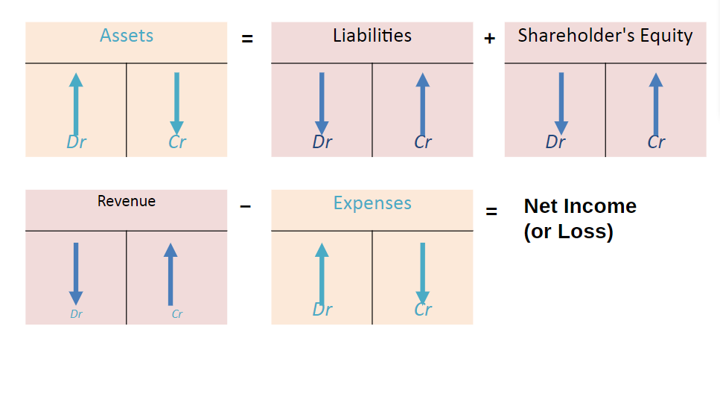

PROBLEMS TO DO CH. 2
P2-4A
P2-7A
CHAPTER 3
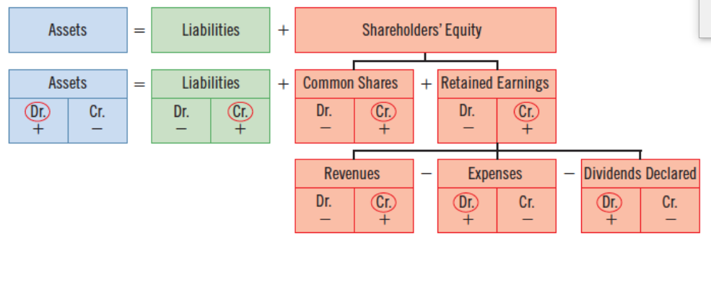

DGD # 1
Chapter 1 (on notebook)

Week 3
CHAPTER 3

E3-2 , BE3-5 , BE3-10

CHAPTER 4

- Expense recognition
- Accrual basis & cash basis
- BE4-1, BE4-3, BE4-4, E4-4
- Accrual and deferral

CHAPTER 5
- RATIOS not included in midterm
- “Gross profit” imp
- 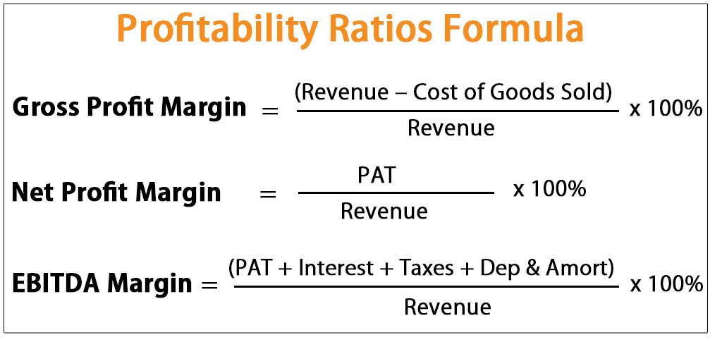
- Freight In/Freight Out record transaction
- Periodic and perpetual inventory system
- [Beg + Add - Deduct = End] Change formula
- Accruals and deferrals:
  - Cash before the event or cash after the event
  - Accrual: cash paid after the event
  - Prepaid: cash paid before
  - Prepaid expense: paying before the event
  - Accrued expense: Incurred expense that is not paid

Types of Q:
- What is a current asset?
- What is gross profit?
- Calculate an amount? Sales… calculate gross profit (current asset, gross margin etc)
- Record the transaction

Chapter 6

Inventory Costing: how to assign inventory to “ending inventory” and “cost of goods sold”.
Specific identification: [slide 9]
Average Cost/Weighted average: [what the average cost for an egg is, every week]

E6-6 E6-1

E6-6
FIFO: first one purchased will be first one sold out. I.e. the first price. Fifo is about sequencing.
Average cost: not sequence related.
price* quantity per unit.= total cost.
Weighted average: units* cost per unit.

CHAPTER 9
- Long term assets:

1. Recognize?
Definition of the asset
Definition of non current asset
Specific Accounts
Spending money: is the operating expense? or capital expense? (capital=recognized as an asset on the balance sheet)

2. Measurement of prices?
Initial measurement: purchase price. At the time that we acuqire the asset.
- Includes taxed, delivery fees, installment charges, training employees on how to use, is NOT included.
- Direct costs to acquire

- Subsequent measurement: when the time goes by
Update the asset so its more reflective of reality.
Cost of asset- current value = depreciation
- Straight Line Depreciation: (annual): (Initial value-Residual value) / Useful life of the asset
- Double declining balance:
- Units of Production: how much the item is getting used, regardless of the time unlike the other two methods.
  - (Cost - Residual value)/units

4. Derecognize: zero all the accounts
Cost : 10,000
Acc depreciation: (8000)
=2,000

*Note: Useful life: the period over which the company will use the asset.
*licensee is not a capital expense just parking tickets and gas as is insurance
*under straight line dep: there's equal amount of depreciation

Q’s: is beginning Carrying amount in DOUBLE DIMINISHING balance the same as the original cost of the asset? Yes, only for the first (beginning transaction)
Q’s: for STRAIGHT LINE DEPRECIATION, which value to start with? As in what to put for “depreciable cost”? HOW TO CALCULATE DEPRECIABLE COST? (is it the cost of asset? Or the depreciable amount value or, cost - residual value?)

2020/03/05 chapter 9 con’t
- Recognize the asset?
- Measurement? How much do we measure?
  - Initial measurement
  - (Depreciation/amortization) subsequent measurement
  - Impairment (something unexpected that causes the value of the asset or decreases furthermore). Recoverable amount
- Retirement and Disposals: 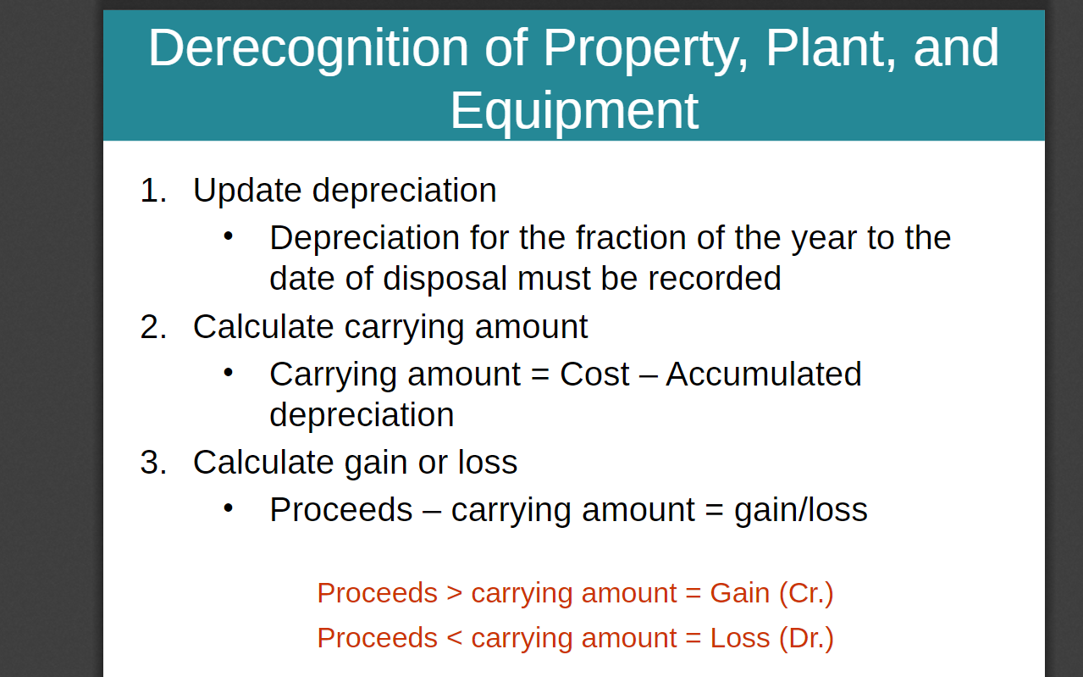
To derecognize: Cost - accumulated depreciation = carrying amount
Proceeds - carrying amount= loss or profit

Useful life: the period of time the company intends to use the asset for. Its NOT the assets economic life.

