Biochemistry 3560 Midterm Review Notes
Lecture 1 – Part A: Regulation of Protein Function
Protein Structure
Properties that interest us:
- Size (molecular weight)
- Shape (secondary structure, fold)
- Charge (+ve, -ve, patches)
- Hydrophobic/hydrophilic properties
Representing Protein Structure
Different representations emphasise different properties
Wireframe:
- Lines represent covalent bonds between atoms
Backbone and Ribbon:
- Indicates alpha helices and beta strands
Space filling:
- Each atom is represented by one sphere
Surface charge:
- Blue = positive, Red = negative
Why do we care about protein structure?
There is a strong relationship between a proteins structure and function. Understanding how a protein works can be done by examining its organization at the atomic level.
Reversible Modulation of Protein Function
Proteins are dynamic molecules; function is influenced by interactions with other molecules. These interactions can be either stable or transient
- ex: phosphorylation can be stable and transient

Prosthetic groups vs. Ligands
Stable interactions:
- a prosthetic group is a molecule that is permanently associated with a protein and required for its function
- ex: myoglobin and hemoglobin have something called heme which is added after they are synthesized and is required for their function
Transient interactions:
- a ligand is a molecule that is bound reversibly by a protein
- ex: oxygen needs to be reversible in order to be transported from one place to another
Binding Sites and Ligands
A binding site is the region of a protein surface that interacts with a ligand
Complementary to the ligand in:
- size
- shape
- charge
- hydrophobic/hydrophilic properties
Interactions are highly specific, proteins can have more than 1 binding site
Proteins are dynamic and flexible
Induced fit:
- structural adaptation between protein and ligand
- conformational change can make binding site more complementary
- ex: conformational change in hexokinase induced by binding of D-glucose (red)
Enzymes: A special case of protein-ligand interaction
Substrate (ligand):
- molecule changed by an enzyme
Catalytic site or Active site (ligand-binding site)
- binds substrate and facilitates its chemical transformation

Key Concepts in Protein-Ligand interactions:
- reversible binding
- specificity
- conformational change
- regulation
Non-enzymes can also require regulation
Why would a non-enzymatic protein need regulation?
- Binding protein: control affinity
- Protein mediated transport: modulate their transport function
Remember, not having enzymatic activity does not mean it has no function
Oxygen binding Proteins
Oxygen (O₂)
- Poorly soluble in aqueous solutions
- Inefficient diffusion through tissues
- Larger multicellular organisms require mechanisms for transporting O₂
- Interaction of “transporter” with O₂ must be specific and reversible
- O₂ is complexed with transition metals that have high affinities for O₂
  - Ex: iron and copper
- Free iron can promote the formation of highly reactive O₂ species
  - this tendency is reduced when iron is incorporated into heme, there are also 2 additional binding sites on the iron atom
heme: a prosthetic group
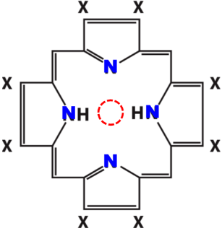
heme = protoporphyrin IX + Fe2+
Porphyrins
- Heme is one example
- 4 pyrrole rings
- Connected by methine (-CH=) bridges
- Linked into a conjugated C=C double bond system
- Substitutions at X define the type of porphyrin
  - Ex: in heme, 2 X’s are propionate groups
- 4 nitrogen atoms can bind a metal ion in the center

Heme
- Fe2+ binds O₂ reversibly
- Fe3+ does not bind O₂
- In heme containing proteins, irreversible oxidation of Fe2+ by O₂ is prevented
- Heme is buried within the protein
- One coordination bond is occupied by a side-chain N of a His residue
- O₂ binds reversibly at remaining position
Myoglobin
- Monomer, binds and stores O₂ in muscle
- Single polypeptide chain
- 153 residues (amino acids)
- 16.7 kDa
Hemoglobin
- Tetramer: 2 a-globins and 2 B-globins
- O₂ transporter
Leghemoglobin
- Found in leguminous plants
- Sequesters O₂, protecting O₂ sensitive enzymes in N₂ fixing bacteria
Globin Structure – Naming Residues
- Globin’s are globular a-helical proteins
- Their 8 a-helices are denoted: A-H (N- to C- terminus)
- Connecting loops are identified by the 2 helices they join: CD, DE, etc.
- Amino acids are identified by their relative position within that motif:
  - Ex: F8 = 8th amino acid in helix F (F8 = His93 in myoglobin, but His87 in a-hemoglobin)
  - CD1 = 1st amino acid in the loop between helices C and D
- There is no N helix so we use n to show the N terminus, format: N helix letter #
  - NA2 = the 2nd aa residue between the N terminus and helix A
  - We cannot use C to denote C terminus
Myoglobin’s Heme Binding Pocket
- The heme binding pocket is formed by the E and F helices
- Propionate side chains of heme are near the surface of globin
- The rest of the heme is surrounded by nonpolar residues, except for 2 histidine’s

Role of Two Histidine’s
- One His residue (F8) is directly bonded to Fe2+ (5th coordination bond)
  - Proximal histidine
- E7 His is close, but not bonded to heme
  - Distal histidine
- O₂ binds to Fe2+ on E7 side of the atom (6th coordination bond)
The Proximal Histidine
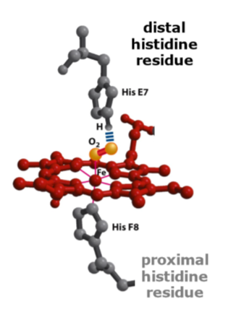
- A histidine residue at F8 (the 8th residue on helix F) is directly bonded to Fe2+
- His F8 forms a 5th coordination bond for Fe2+
- His F8 is known as the proximal histidine
The distal histidine
- A second His (E7) is close to, but not bonded, to heme
- This is the distal histidine
- O₂ binds to Fe2+ on the E7 side
- Here O₂ forms the 6th coordination bond
- The distal histidine is positioned to interact
with the O₂ molecule
(5 bonds with no oxygen, 6 bonds with oxygen)
Proximal and distal histidine residues are the same in myoglobin and both
hemoglobin chains
Mb is a simple O₂ binding Protein
Binding of O2 depends on:
- Structure around the ligand-binding site
- Flexibility of the protein
Breathing
- Small molecular motions of aa side chains on a nanosecond time scale
How does oxygen get in? (only 1 O2 binding site)
- O2 is a “marble”, wiggles through spaces in protein
- Small motions (breathing) of sidechain allow the O2 in so it can encounter the heme and iron atom

Measuring O2-binding by globin’s
The conjugated double bond system of heme causes strong absorption of visible light
- O2 binding affects electron distribution and alters absorption of light by heme
- Oxy- and deoxy- forms of heme have different absorption spectra: oxy heme absorbs more blue light and deoxy heme absorbs more red light
This property also affects the absorption of light by globin’s
- Arterial and venous blood are different colours
  - Arterial = oxygenated = red
  - Venous = deoxygenated = blue
- Can be used to experimentally measure O2 binding by globin’s
Describing ligand binding – definitions
- [P] = concentration of free protein
- [L] = ligand concentration
- [PL] = concentration of ligand-bound protein
- K_{d} = dissociation constant = [L] at which half of the ligand binding sites are occupied
- K_{a} = association constant
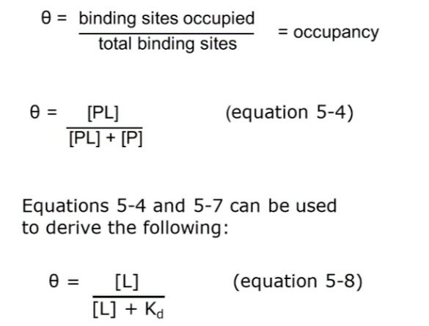
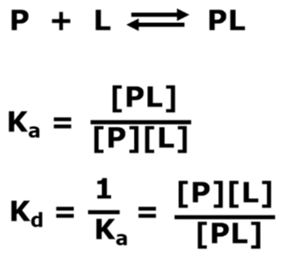
Quantitative Modeling of Reversible Protein-Ligand Interactions

Hypothetical ligand-binding curve
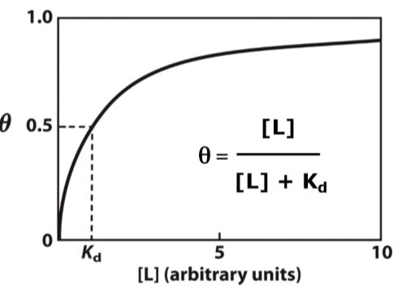
- The fraction of ligand-binding sites occupied, theta, is a hyperbolic function of ligand concentration [L]

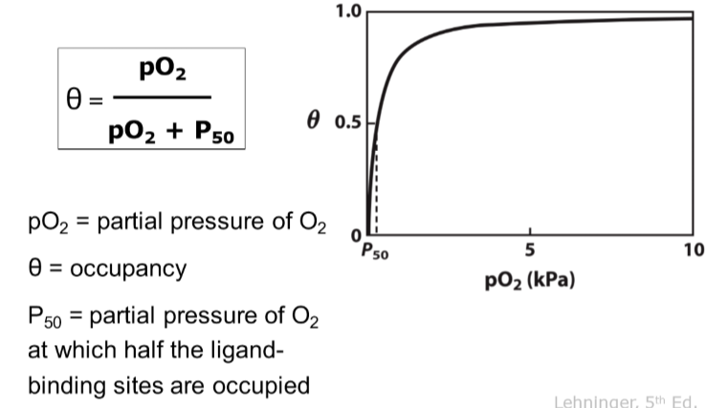
For O2-binding proteins we use the following:

Possible Q: What influences Kd on this axis?
- Affinity for proteins and ligands
Protein conformation is critical for specificity of protein-ligand interaction
- CO binds free heme with 20,000 x greater affinity than O2
- CO binds heme in Mb with only 200 x the affinity of O2 (similar effect seen in Hb), making it less likely that CO will bind
- This is due to steric hinderance between His E7 and CO, and a favourable H bond between O2 and His E7
The structural basis of Hb/Mb specificity
- CO binds heme upright
- O2 binds heme at an angle
- Mb and Hb can increase selectivity vs. heme because the protein:
  - Creates steric hindrance: between the distal His E7 and CO
  - Makes a favourable H bond between O2 and His E7
Affinity and the Effects of CO
If we only had free heme and only used it to carry O2 in our system it would get full (especially during elevated CO levels) and we would die
- The improved selectivity of Mb (and Hb) provides protection under normal conditions (where O2 >> CO)
- If our blood had free heme, standing near a road might be fatal

O2 binding by myoglobin
- Mb binds O2 with high affinity
- For a wide range Mb is insensitive to pO2, since we hit p50 at extremely low values, therefore a wide range is insensitive since it gets fully occupied very quickly (it’s a storage protein)
- pO2 in tissues is 4 kPA
- Mb is essentially saturated
Structure of Globin’s II
The tertiary structure of hemoglobin and myoglobin are similar
- The primary structure are also similar, in the sense that distal histidine always ends up in the same spot
Comparing Globin Sequences
In Mb, Hb a and Hb B F4 is always Leucine and F8 is always histidine
- In different globin’s, segments of mostly different aa form similar sturcture’s
- Out of 150 aa on 27 (18%) are identical between Mb and Hb subunits
Hemoglobin (Hb)
- Major carrier of O2 invertebrates
- Tetramer, 64.5 kDa (four polypeptide chains, 1 heme each)
- In humans, adult hemoglobin contains 2 types of globin
  - 2 a-chains (141 aa)
  - 2 B-chains (146 aa)
- Can bind 4 O2
Interfaces in hemoglobin
The strongest interactions between the subunits occur at the a1-B1 and a2-B2 interfaces
What type of interactions hold the subunits of hemoglobin together?
- Hydrophobic interactions
- Hydrogen bonds
- Ion pairs (salt bridges)
30 residues are involved in the interface between a1-B1 and between a2-B2
19 residues are involved in the interfaces between a2-B1 and between a1-B2

Ion pairs (salt bridges) stabilize the conformation of hemoglobin
Several important ion pairs occur at the a2B1 and a1B2 interfaces
- Ex: B1 subunit His HC3 forms salt bridges within the b1 subunit at Asp FG1 and with the a2 subunit at Lys C5
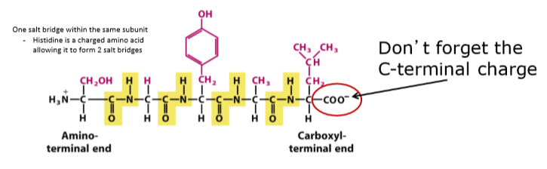
2D view of key salt bridges
Both the alpha subunits and beta subunits run antiparallel to each other
- NH3+ side changes
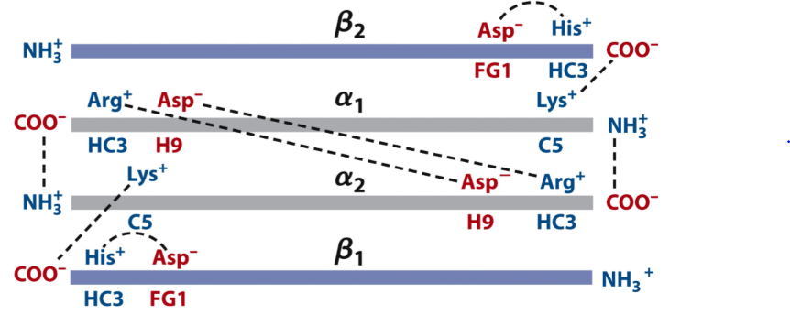

Hemoglobin is an O2 Transporter
In the lungs: pO2 = 13 kPa
In the peripheral tissues: pO2 = 4 kPa
- Mb bids O2 with high affinity – P50 ~ 0.26 kPa
- Hb binds O2 efficiently in the lungs and releases it easily in peripheral tissues – apparent p50 ~ 3.5 kPa
Hemoglobin Undergoes a Transition
- T state = tight state
- R state = relax state
Hb can undergo a conformational change from a low affinity state (T) to a high affinity state (R)
Hemoglobin Allostery
- O2 binding to one subunit of Hb alters the affinity for O2 in the adjacent subunits
- Induced conformational changes push adjacent subunits into the R state
- These sites then bind O2 with higher affinity
- This cooperative binding: an allosteric effect
O2 is not only the ligand but also the allosteric modulator
Allosteric protein
A protein in which the binding of a ligand to one site affects the binding properties of another site
- Myoglobin can’t be one since it only has one binding site

Allosteric Modulators
- Homotropic: ligand and modulator are identical
- Heterotropic: ligand and modulator are different
Can be activators (+) or inhibitors (-)
- For Hb: O2 is a ligand and an activating homotropic modulator

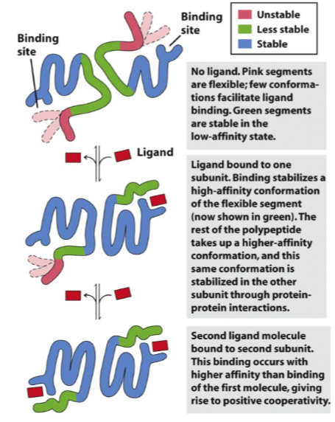
Allosteric Proteins: A general Mechanism

Binding of O2 to Hb
- Causes repositioning of the Fe2+ within heme, reducing the ‘pucker’ of the porphyrin ring
- The change in the shape of heme pulls the proximal histidine (HF8) along, causing a shift in the position of helix F
- This is one of the adjustments that triggers the T to R state transition, which includes breaking the ion pairs formed by His HC3
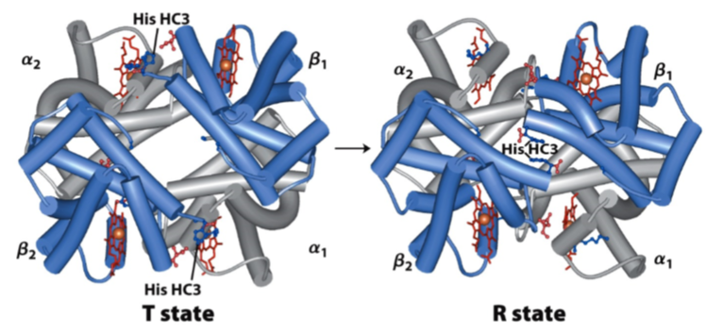
Recall: Deoxy-heme has an ion pair between His HC3 of the B subunit and both Asp FG! Of the B subunit and Lys C5 of the a-subunit

Note the position of His HC3
- Not causing all subunits to come apart, just 1 that renders all subunits more favourable to O2 binding
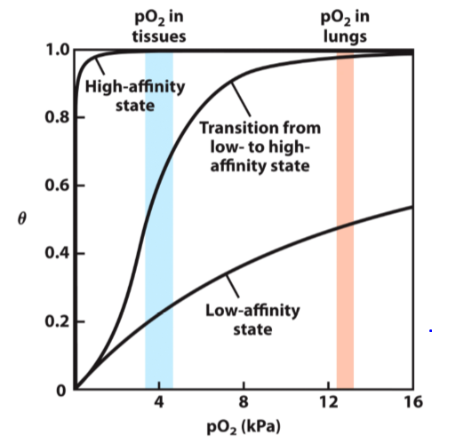
Hb has a sigmoidal O2 binding curve

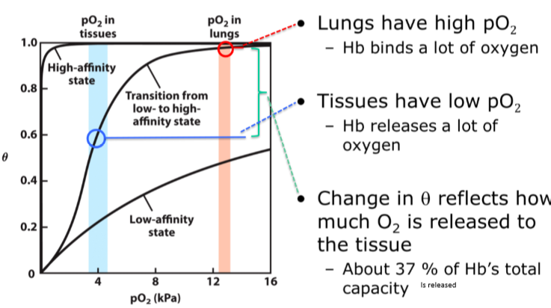
The Physiology of Hb Oxygen transport

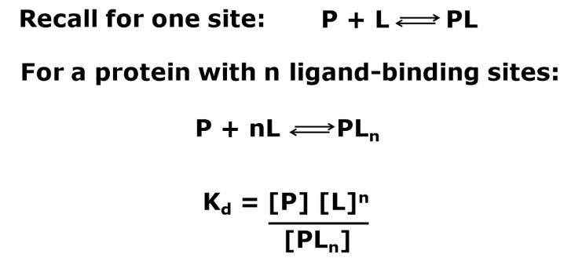
Quantitative Description of Cooperative Ligand-Binding

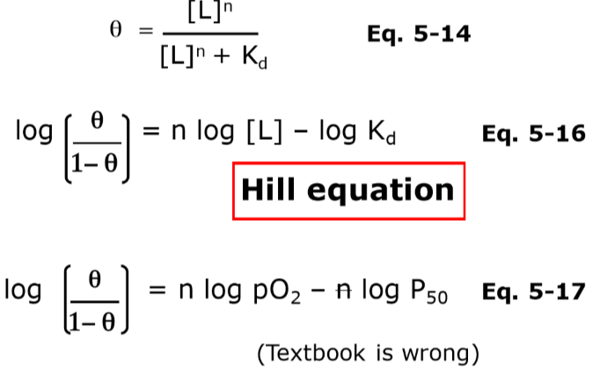

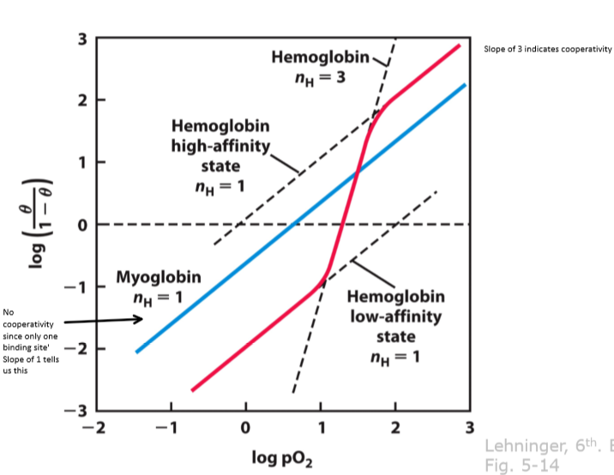
Hill Plot

Slope of Hill Plot = n_{H} (slope) vs. n (# of binding sites)
- n_{H} = hill coefficient
- n_{H} < 1 = negative cooperativity
- n_{H} = 1 = ligand binding is not cooperative
- n_{H} > 1 = positive cooperativity
- N.B. n = # of sites
- n_{H} </= n Always!
Concerted (MWC) Model
- Jacques Monod, Jeffries Wyman and Jean-Pierre Changeux (1965)
- Subunits are functionally identical
- Subunits exist in >1 conformation
- All subunits change conformation simultaneously
Sequential Model
- Daniel Koshland (1966)
- Ligand binding can induce conformational change in subunits independently
- Conformational change in one subunit promotes conformational change in adjacent subunit
The Changes in Quaternary Structure of Hb (T R transition) have Dramatic Effects on its Function as an O2 Binding Protein
The sigmoidal O2 binding curve of Hb is diagnostic of cooperative binding
Cooperative binding requires:
- >1 ligand binding site
- Interaction between ligand-binding sites
Anemia vs CO Poisoning
These curves resemble the case where we have a low affinity for hemoglobin
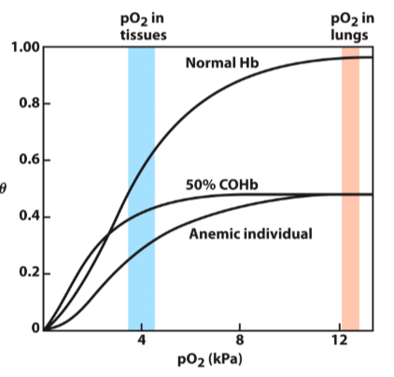
- Therefore, not an effectively release of the molecules

Hemoglobin Transports H+ and CO2
- There is an inverse relationship between binding of O2 versus binding of H+ and/CO2
- This is negative heterotropic allostery
  - Negative since lower affinity for O2, heterotropic since they’re different molecules
- The effect of pH and CO2 on O2 binding is called the Bohr effect (1904)
- In peripheral tissues:
  - pH is lower (so H+ is high) and CO2 is high
  - Hb binds H+ and CO2, decreasing affinity for O2

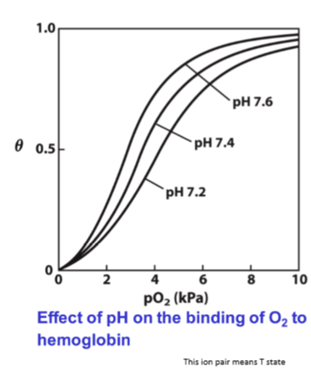
- In the capillaries of the lung:
  - CO2 is excreted and pH rises
  - Hb releases H+ and CO2, increasing affinity for O2
Hemoglobin Binding of H+
- H+ binds several side chains in Hb, including His HC3
- Protonation of His HC3 favours formation of the ion-pair
with Asp FG1
- This helps stabilize Hb in the T state
- As pH drops, adoption of the T state encourages O2 release
Hemoglobin binding of CO2
- CO2 reacts with the a-amino groups at the amino terminus of each globin chain
- The product is carbaminohemoglobin, containing a carbamate group
- Carbamate groups participate in salt bridges that stabilize the T state of Hb
- The reaction also produced H+, contributing to the Bohr effect
Carbamino Groups
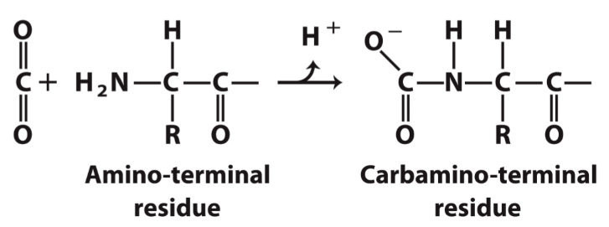
- CO2 binding at the amino termini of Hb forms carbaminohemoglobin

O2 binding by Hb is regulated by 2,3-bisphosphoglycerate (BPG)
- BPG binds in the central cavity of Hb
- It forms salt bridges with the 2 B-subunits
- BPG stabilizes the T state (deoxy-Hb)
- It therefore reduces the affinity for O2
- This is another example of heterotropic allosteric modulation
Binding of BPG to deoxyhemoglobin
Note that the BPG binding site closes up in the R-state

BPG binding alternates with O2 binding
- BPG binds to the T-state (deoxy Hb) only
- Binding of O2 to Hb pushes Hb to the R state, forcing release of BPG
- Conversely, BPG binding in lower O2 environments helps push Hb to release O2

- Hb in erythrocytes without BPG would barely release any O2 at all in tissues

Changing BPG levels aid physiological adaptation to lower pO2 at high altitude
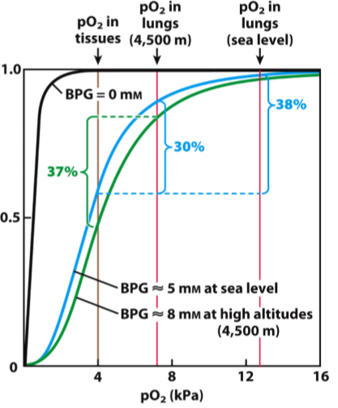
It’s the molecule that helps individuals adapt to higher altitudes
- Blue curve = Hb only works with 40% of its capacity,
since in tissues its 60% occupied and in the lungs its 100%
occupied
  - 40% release of O2 since we have 5 mM
  - At altitude our occupancy doesn’t reach the same
level as it would at sea level
- Decrease affinity of O2 to hemoglobin
  - Green curve = with more BPG allows 75% occupancy
in lungs, but 40% in tissue
  - Virtually solves issue

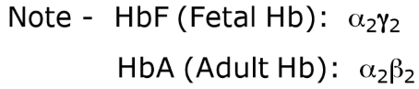
BPG plays a role in the transfer of O2 from maternal to fetal blood

HbF has lower affinity for BPG
- Kd for BPG higher than HbA
This gives HbF higher affinity for O2
- Kd for O2 lower than HbA
Therefore, fetus gets primary access

Hemoglobin Allostery
- O2, H+, CO2 and BPG are structurally different and bind Hb at separate sites
- Binding of these molecules to Hb is still interdependent
- The spatially distinct binding sites communicate via changes in the conformation of the protein
- Hemoglobin is a molecule capable of perceiving information from its environment
Sickle-cell anemia is caused by a mutation resulting in an amino acid substitution in Hb
Hemoglobin A (HbA) – normal vs. Hemoglobin S (HbS) – mutated
- In HbS, Glu A3 on B-globin (Glutamate B6) is changed to Valine
- HbS tetramer has 2 fewer negative amino acids
- Deoxy-HbS tetramers aggregate (abnormal hydrophobic interaction)
- Sickle red blood cells contain long HbS fibers
HbS Fiber Formation
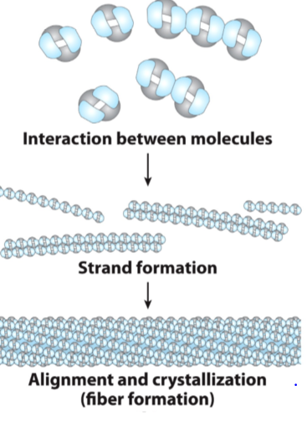
Blue are beta subunits, abnormal hydrophobic interaction due to mutation causes them to stick together

Sickle Cell Anemia is Life-Threatening
RBC containing HbS fibers are fragile
- Capillaries become clogged
- Fewer RBC = less Hb = anemia
Must be homozygous to have sickle cell, if heterozygous you become immune to malaria
- Carriers of the HbS mutation have red blood cells with normal morphology
- Infection with the malaria parasite induces “sickling” of RBC
- Because this morphology is not common in carriers, their immune system views them as foreign and eliminates them (and the parasite)
- So they produce regular and mutated beta subunits
- Sometimes start to form sickle morphology and immune system notices and destroys it
- If cell gets "infected" with malaria the cells destroys it
Myoglobin Endurance diving species
Marine animals have extra charges on the surface of their myoglobin to help repel neighboring molecules and prevent aggregation when myoglobin is at high concentrations
- Facilitates less clumping of Mb which in turn facilitates a higher concentration of Mb

Lecture 2 – Part B: Regulation of Enzymes
Brief review of Enzymes
- Recall that enzymes (E) are proteins that:
  - Catalyze the chemical transformation of a substrate (S) to a product (P)
  - Increase the rate of reaction
  - Function by lowering the activation energy of the reaction
E + S ES EP E + P
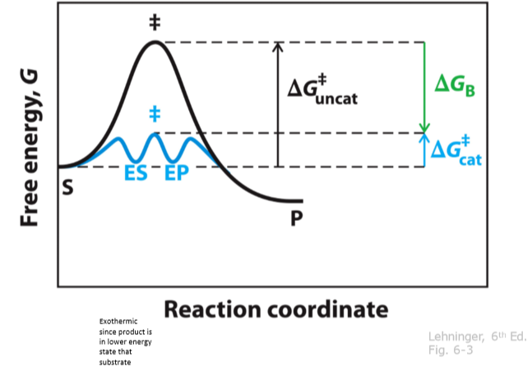

Recall the Michaelis-Menten Equation:
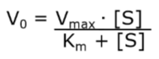
Vmax = Maximum reaction velocity, also called saturation point, become insensitive to the amount of substrate
Km = half saturation constant, concentration of substrate that gives you half of your Vmax
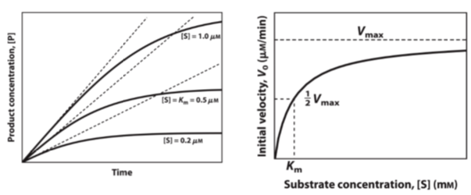
Know your Enzyme Types: Enzyme Nomenclature
- An enzyme that catalyzes the transfer of phosphate groups from high energy, phosphate donating molecules to specific substrates. This process is known as phosphorylation, where the substrate gains a phosphate group and the high energy ATP molecule donates a phosphate group
- An enzyme that uses water to cleave a phosphoric acid monoester into a phosphate ion and an alcohol. Since a phosphatase enzyme catalyzes the hydrolysis of its substrate it is a subcategory of hydrolases (undoes the work of kinase)

- Enzymes that catalyze the addition of a phosphate group from an inorganic phosphate to an acceptor (donates phosphate group, not from ATP like kinase, but from an inorganic phosphate

- Class of enzymes that commonly perform as biochemical catalysts that use water to break a chemical bond, which typically results in dividing a larger molecule to smaller molecules
Regulatory Enzymes
- Multistep metabolic pathways, contain at least one rate-limiting step
- Catalysis of rate-limiting steps is mediated by regulatory enzymes
- Catalytic rate of these enzymes is controlled by specific signals
Feedback Inhibition
- Inhibition occurs at the first step of the pathway
- No other products cause inhibition
- Isoleucine does not bind to the active site
- Instead there is a separate allosteric binding site
- Inhibition is reversible
L-Isoleucine acts as an allosteric modulator of the first enzyme, inhibiting first enzyme if levels of isoleucine become too much, controlling the rate of reaction via negative feedback
Mechanism of Enzyme Regulation
- Allostery: reversible, non covalent, binding of regulatory compounds (allosteric modulators)
- Reversible, covalent modification: mediated by a separate enzyme system
- Interaction with regulatory proteins: ex = kinases phosphorylate many enzymes in cascades, turns them on/off and increases/decreases production
- Proteolytic cleavage: sitting in cells in precursor form, proteases then cleave and activates them
Allosteric Enzyme
A regulatory enzyme with catalytic activity modulated by the noncovalent binding of a specific compound at a site other than the active site
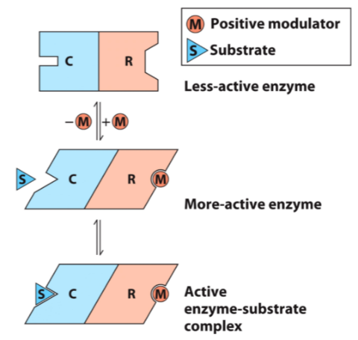
Allosteric Enzymes Undergo Conformational Changes in Response to Modulator Binding

Allosteric Enzymes have Different Properties than simple non-regulatory enzymes
- Larger, structurally more complex = usually multi-subunit
- Have regulatory (allosteric) sites = bind modulator
- Undergo conformational changes in response to modulator binding
- Do NOT obey Michaelis Menten Kinetics
Allosteric Enzymes do NOT obey Michaelis-Menten Kinetics
- Plot of Vo vs. [S] is sigmoidal
- Influenced by cooperative substrate binding and/or binding of allosteric modulator
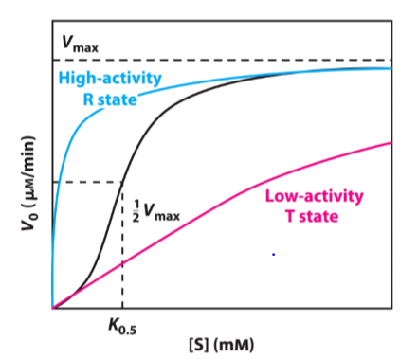
For Allosteric Enzymes, binding of allosteric modulator can dramatically influence K0.5
Note: K0.5 instead of Km
- Km = half saturation constant
- K0.5 = [S] that results in ½ Vmax
Positive modulator:
- Switch T state R state
Negative modulator:
- Switch R state T state

In some cases, binding of an allosteric modulator influences Vmax without altering K0.5
- Vmax is being changed, but K0.5 (half Vmax) is still the same
- Modulator that increases Vmax
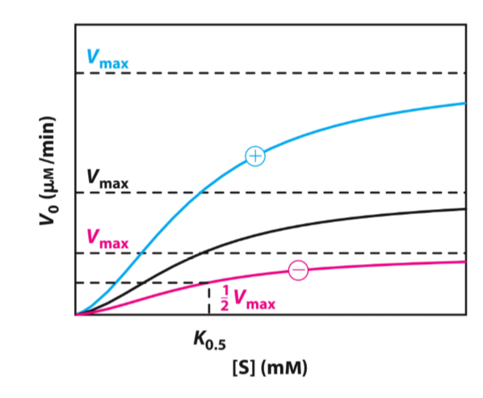
- Not changing sensitivity to substrate, changing speed at which reaction can occur

Key Points about Allosteric Modulators
Types of Modulators:
- Homotropic modulators are both modulators and substrates
- Heterotropic modulators are NOT substrates
Modulator effects:
- Modulators can have negative effects (reduce activity) or positive effects (increase activity)
- Modulators can affect K0.5 or Vmax
- For our purposes, both homotropic and heterotropic modulators have one of these effects
Aspartate Transcarbamoylase (ATCase): Structure and Function I
- ATCase catalyzes committed step in biosynthesis of pyrimidine nucleotides (ex: cytosine, thymine and uracil)
- Forms N-cabaspartate and Pi from carbamoyl phosphate and aspartate
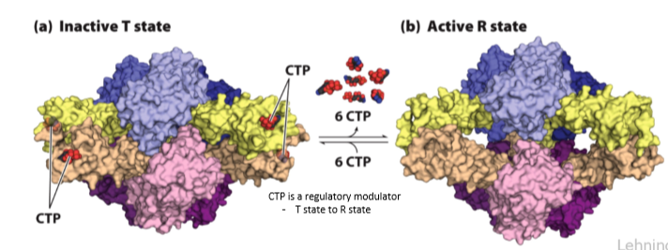

Aspartate Transcarbomoylase Reaction
- ATCase transfers an activated carbamoyl group onto the amine group of aspartate
- This is the first step for synthesizing purine rings (ex: CTP)

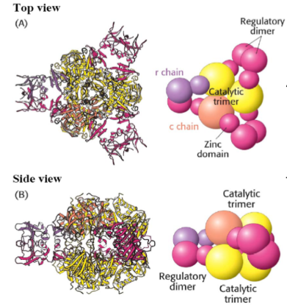
Subunit Structure of Aspartate Transcarbamoylase
ATCase has 2 distinct types of subunits:
- Catalytic
- Regulatory
The enzyme contains 12 total polypeptide chains:
- 6 regulatory (r) chains (come together as dimers)
- 6 catalytic (c) chains (come together as trimers

ATCase Subunit Structure
- 3 c chains form each catalytic trimer (c₃)
- 2 r chains form each regulatory (r₂) dimer
- The fully functional enzyme (c₆r₆) has 2 catalytic subunits (2 x C3) and 3 regulatory subunits (3 x r2)
- Subunits interact via zinc domains (of the regulatory subunit; zinc domains have cysteines coordinating a structural zinc ion)
Treatment with a Cysteine Modifying Mercury Compound and Ultracentrifugation reveals the subunit structure of ATCase
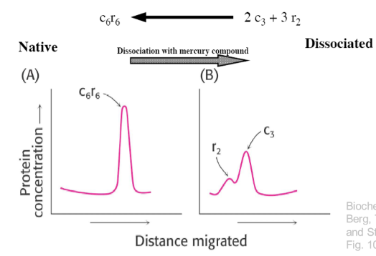

Allosteric Modulation of ATCase
- Substrate binding by ATCase is explained by allosteric cooperativity
- T R state transition
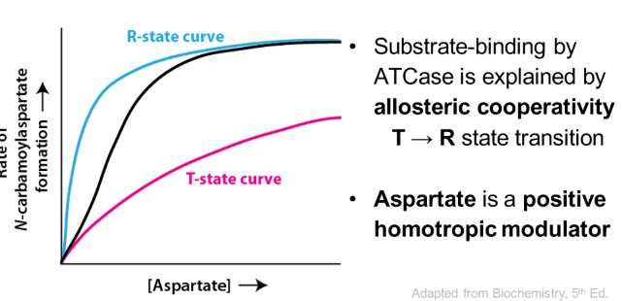
- Aspartate is a positive homotropic modulator

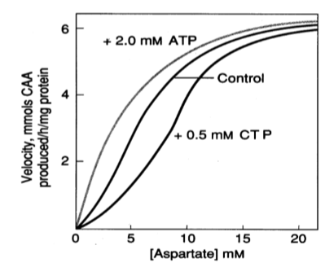

CTP and ATP are modulators
- CTP functions in feedback inhibition
- ATP and CTP bind to sites other than the active site
(on the regulatory subunit)
- ATP = positive heterotropic
- CTP = negative heterotropic

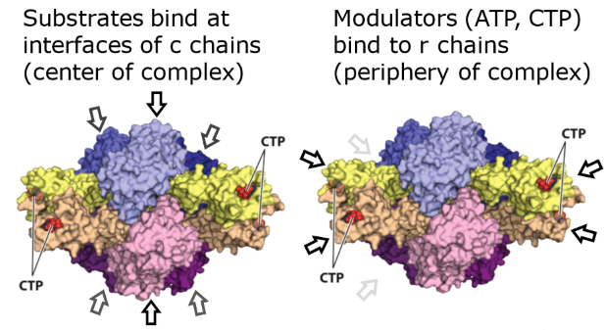
The Substrates and the Heterotropic modulators bound by ATCase bound by ATCase are structurally very different

Allosteric effects in ATCase arise from changes in quaternary structure
T state: ATCase has a more closed conformation
- This blocks active site loops from adopting a fully active conformation
R state: ATCase is in a more open conformation
- Allows active site loop to adopt an active conformation
How do we push ATCase into the r state so we can characterize its structure and properties?
- Add substrates
- Add a substrate analogue that mimics both substrates (PALA)
- Add the activator (ATP)
ATCase undergoes large changes in quaternary structure
- T state (less active), favoured by CTP
- R state (more active), favoured by substrate binding
PALA: A non-reactive bisubstrate analog that mimics the reaction intermediate of ATCase
- Structure of ATCase bound to PALA differs from the free enzyme
- Dramatic changes in quaternary structure
Structural changes during activation of ATCase
- Within catalytic subunits
  - Flexing at interfaces between C chains
- Overall
  - Catalytic trimers move apart 12 Armstrong’s and rotate relative to eachother
  - Regulatory dimers rotate
  - Change in bend between r chains
CTP binding stabilizes the T state
T R appears to be concerted (all at once)
- ATP binding can induce T R conversion in the absence of substrate

Paper: Structure of the E.coli Aspartate Transcarbamoylase Trapped in the Middle of the Catalytic Cycle
Introduction: The reaction
Events in the ATCase reaction occur in a fixed order:
- Carbamoyl phosphate (CP) binds the active site
- Aspartate then binds the active site – this leads to large changes in quaternary structure
- Condensation reaction occurs
- The product N-carbamoyl-L-aspartate (CA) is released
- Pi is released last
As long as substrate is available, the enzyme remains in the active R state
Introduction: a key residue pair
- Two charged amino acids
  - Asp236 on catalytic chain
  - Lys143 on regulatory chain
  - These interact between chains to stabilize the T state
- After mutation of either of these residues to alanine, the enzyme can no longer adopt the T state
- In the absence of ligands, WT and Asp236c ATCase have different structures
- However, in the presence of PALA, WT ATCase and Asp236c are the same
In the absence of the negatively charged R-group of D236, or the positively charged R-group of K143, an ion pair that stabilizes the T-state is eliminated
Central Question of the Paper
What can be learned by comparing the structures of D236Ac to that of WT enzyme in the presence of substrate/substrate analog compounds?:
- Carbamoyl phosphate (CP) – substrate
- Phosphonoacetamide (PAM) – non-reactive analog of CP
- Malonate = non-reactive analog of Asp
Results: Small angle X-ray scattering
Provides info on the structures overall shape (low resolution)
- In the absence of ligand, WT ATCase and D236Ac are different
- Bound to PALA, WT and D236Ac are very similar
- CP has little effect on WT ATCase
- CP mimics effect of PALA in D236Ac
When bound to PAM (an analog of CP) D236Ac adopts the R state
- This can happen even when only one of the catalytic trimers has substrate bound
Xray structures of 2 catalytic chains were superimposed, revealing local changes in conformation
Conclusions
- Asp236 mutant eliminates an ion pair that forms between Asp236c and Lys143r
- This ion pair normally stabilizes T state
- In absence of the Asp236c – Lys143r interaction (which connects c and r subunits) CP can push ATCase into the R state
- Direct interactions between the c and r subunits regulate the conformation of the enzyme by stabilizing the T state
- The net result of the D236Ac mutation is that this form of the enzyme (lacking a salt bridge between D236c and K143r) never adopts the low activity T state
- Instead it is always in the partially active state conformation
- Trapped in the middle of its catalytic cycle
Regulation of Enzyme activity by reversible covalent modification
Recall:
- Enzyme activity can be altered by the covalent addition of modifying group(s)
- Modification is reversible
- Covalent modifications and their removal are mediated by a separate enzyme system
Some Common forms of reversible covalent protein modification
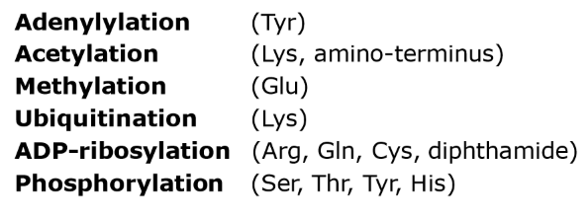
Target residues are shown in parentheses

Enzyme Regulation by reversible phosphorylation
- Amino acids modified: Ser, Thr, Tyr, His
- Attachment of the phosphoryl group is catalyzed by a protein kinase
- Phosphorylation is sequence specific
- Phosphoryl group can be removes by phosphoprotein phosphatase

Protein Kinase A (PKA) Sites
- PKA phosphorylates proteins at sites containing the sequence
  - X-R-[RK]-X-[ST]-B
  - Ex: F-R-R-L-S-I
- Substrates of PKA contain an amino acid sequence that fits this pattern
  - [RK] = Arg or Lys is acceptable
  - [ST] = Ser or Thr is acceptable (and this residue is phosphorylated)
  - X = any amino acid
  - B = any hydrophobic amino acid
PKA Peptide Binding Site
X-R-[RK]-X-[ST]-B will be recognized by the catalytic site of PKA, this sequence will then be phosphorylated on the serine or threonine residue
cAMP-dependent PKA is regulated by regulatory subunit binding
- The catalytic subunit of PKA (blue) is generally bound by a regulatory subunit (red)
- This regulatory subunit blocks the catalytic active site, inactivating PKA
Regulatory Subunits of PKA can bind, but cannot be phosphorylated
- Regulatory subunits of PKA contain the sequence K-R-R-G-A-I
- This sequence binds the catalytic subunit because it ALMOST matches the pattern X-R-[RK]-X-[ST]-B
- But it cannot be phosphorylated since Ala instead of Ser or Thr
Activation of PKA by cAMP (AKAP = A Kinase Anchoring Protein)
- Many cellular signalling events will trigger cAMP production
- The regulatory subunit will bind 2 cAMP molecules
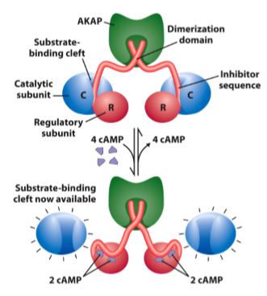
- The regulatory subunit then releases the catalytic subunit, allowing it to phosphorylate substrates

In response to cAMP, PKA regulates many cellular activities
- Glycogen metabolism
  - Glycogen synthase
  - Glycogen phosphorylase kinase
- Fatty acid metabolism
  - Hormone sensitive lipase
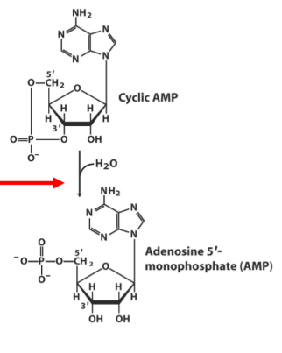
- DNA condensation
  - Histones
- Cell surface ion channels
- Glycolysis
  - Phosphofructokinase-2/fructose 2,6-bisphoephatase
  - Pyruvate kinase
cAMP is usually short lived
cAMP is hydrolyzed by cyclic nucleotide phosphodiesterase
Phosphoryl groups introduce:
- A relatively bulky group (can result in steric exclusion)
- Charge – allowing electrostatic interactions
(attraction, repulsion)
- Oxygen atoms that can participate in hydrogen bonds
- Site for protein-protein interactions
Glycogen Phosphorylase is activated by phosphorylation
- Glycogen phosphorylase catalyses the phosphorolysis (breakdown using phosphate) of glycogen (glucose storage)
- Glycogen phosphorylase has 2 distinct cellular forms
  - Phosphorylase a (active)
  - Phosphorylase b (inactive)
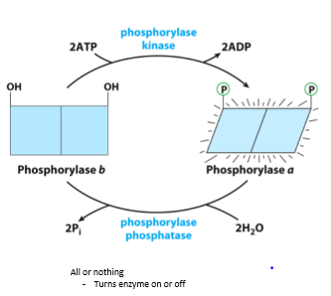
- Phosphorylase b is change into its activated “a” form by a phosphorylation by phosphorylase kinase

Glycogen Phosphorylase – Modification Site
- Phosphorylation is targeted to one specific residue, Ser14
- This stabilizes a structural transition in glycogen phosphorylase
- Phosphorylation of Ser14 favours the R sate – enzyme is active
Glycogen Synthase is inactivated by phosphorylation
- Phosphorylation
  - Can occur on multiple sites of a protein
  - Can produce different degrees of effect on the function of a protein
- PKA phosphorylates glycogen synthase at some sites
- Glycogen synthase kinase 3 (GSK3) phosphorylates GS but at different sites
- The effect of GSK3 is a more potent inhibition of glycogen synthase
- With multiple sites, activity is not simply on/off, but can be tuned up and down
Phosphorylated Sites allow new protein-protein interactions (Ex: #1)
- Interactions can promote enzyme-substrate binding as well as other interactions
- Phosphoserine-binding domains mediate autoinhibition and substrate binding of GSK3
  - Bind to phosphorylated serine’s
  - Active site is still active but cannot bind to target
Ex: #2
- Src-homology-2 (SH2) domains can bind to sites containing phosphorylated Tyrosine’s (P-Tyr)
- Protein-protein interactions, mediated by SH2 domains, are an important part of many signaling processes
  - Insulin signalling
SH2 Domain Function
- Phosphorylation of the substrate promotes kinase binding through its SH2 domain
- This allows the kinase domain to phosphorylate additional tyrosine residues
- Alternatively, the kinase itself can also be phosphorylated
- The SH2 domain then binds his internal residue, resulting in autoinhibition
Enzyme Regulation by Proteolytic Cleavage
- Some enzymes are synthesized as an inactive precursor
- These enzymes are termed zymogen if activated by a protease OR a proenzyme if activated by a non-protease
- Zymogens are activated by cleavage of specific peptide bonds
- This allows conformational changes in the enzyme to expose the active site
- Note, this form of activation is IRREVERSIBLE
Activation of Chymotrypsin
- Many digestive system proteases are activated by proteolysis
- Many of these are serine proteases (ex: chymotrypsin)
pH sensitivity of Chymotrypsin
- Like all serine proteases, the enzymatic activity of chymotrypsin is highly sensitive to pH
- His57 must be deprotonated
  - This allows His57 to act as a proton acceptor, inducing nucleophilic character in Ser195 (critical to reaction mechanism)
- a-amino group (newly formed as a result of proteolytic cleavage) of Ile16 must be pronated
- this allows Ile16 to form an ion pair with Asp194, stabilizing the active conformation of chymotrypsin
A Zymogen Cascade Mediates Blood Clotting
*come back
The Clotting Cascade
- there are 2 intertwined cascades – the intrinsic and extrinsic pathways
- Activated serine proteases cleave different target serine proteases, activating them in turn
- These are enzymes that can catalyze many interactions, so they amplify the signal
- The final protease is thrombin
- When activated, it cleaves the N-terminal ends off fibrinogen, allowing it to assemble into fibers (fibrin)
The Final Common Pathway of Clotting is Under Complex Regulation
Important promoters of Clotting:
- Vitamin K
- Ca2+
- Thrombin
- Factor XIIIa
Vitamin K is required for the Carboxylation of Prothrombin
- O2 is needed to activate CH2 of glutamate
- Vitamin K serves as an electron source in the reaction
- It is then regenerated by reductases

Carboxylation of Prothrombin
Carboxylation makes prothrombin a strong Ca2+ chelator (molecule that acts as a sponge, binding multiple Calcium ions)
Carboxylation is required for prothrombin proteolysis
- Many glutamate residues at the N-terminus of prothrombin are converted to y-carboxyglutamate
- Y-carboxyglutamate binds calcium
- Prothrombin Ca2+ is a substrate for the serine protease factor Xa
- Factor Xa converts prothrombin (zymogen) to thrombin (active protease)
Antagonists of Vitamin K reduce clotting
- Dicoumarol
- Warfarin (rat poison/blood thinner for humans)
Fibrinogen Structure
- Globular domains have high affinity for motifs in the N-terminal ends of the a and B subunits
- These ends are only exposed after proteolytic cleavage by thrombin
Fibrinogen Clotting
- Thrombin is a serine protease
- Thrombin cleaves fibrinogen fibrin
- The cleaved ends can then bind the globular domains of adjacent fibrin molecules
- Many such interactions result in a fibrin clot
Factor XIIIa Crosslinks Fibrin
- Factor XIIIa is a transglutaminase
- Activated from protransglutaminase by thrombin
- XIIIa forms an amide bond between a glutamine and lysine
- This bond covalently links fibrin monomers
- This reaction converts “soft” clots to “hard” clots (scab)
Cyclins and Apoptosis – Controlling the Cell’s Life Cycle
2 final examples: cyclin and caspases
- Cyclins are an example of a system that uses multiple levels of control (regulation through protein synthesis and degradation)
- Signals external to a cell can cause a cascade of events (ligand binding to a receptor),
  - Intracellular signals from proteins with other functions
Cyclins
Cyclin-dependent Kinases (CDKs) regulate passage through the cell cycle by phosphorylating specific target proteins
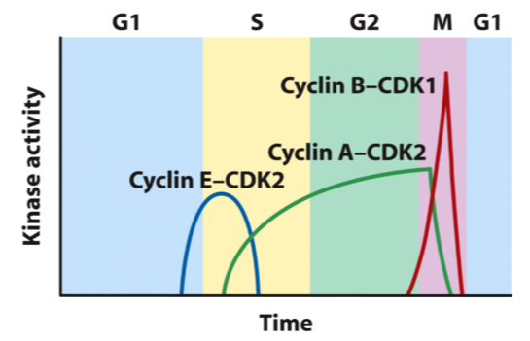
- They do so via interactions with regulatory proteins

CDK activity is under complex regulation
- Phosphorylation of CDK
- Controlled degradation of cyclin
- Regulated synthesis of CDKs and cyclins
- Binding of CDK inhibitors
CDK Structure
- Note: Amino terminal (PSTAIRE) helix (green) positions Glu51 away from the active site
- T loops (red) covers the active site
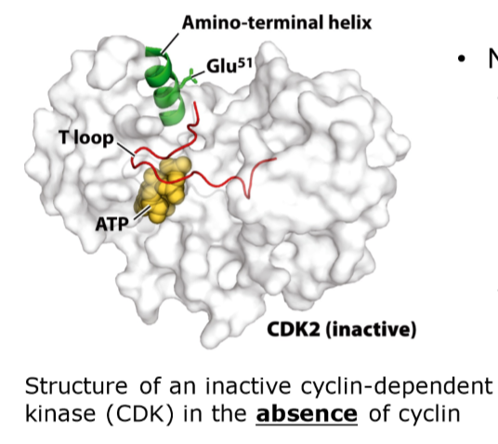

Cyclins
- CDKs function as CDK-cyclin heterodimers
- Binding of cyclin correctly positions the PSATIRE helix
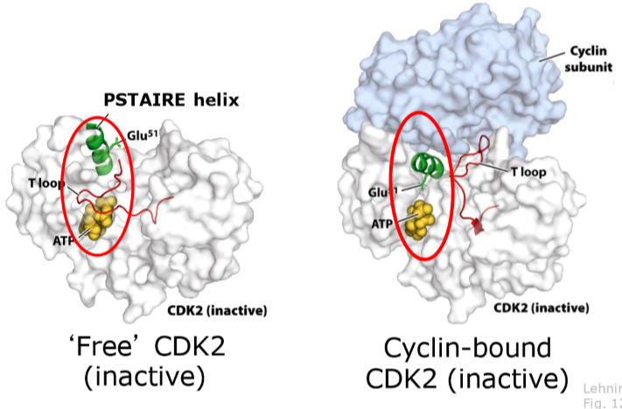
- Cyclin binding opens up the active site of CDK

Phosphorylation of Thr160 activates CDK2
- Thr160-PO4 forms ion pairs with 3 arginine’s, stabilizing the R state of CDK
Cyclins: Conformational Changes in CDK activation
- Cyclin controlled
- PSATIRE helix moves into catalytic cleft
- PSATIRE helix includes the catalytic Glu51
- T loop changes conformation and position, allows access to catalytic cleft
- Exposes threonine (Thr160) on T loop
- Thr160 phosphorylation leads to fully active CDK
Apoptosis: Programmed Cell Death
- Can be triggered to protect the organism by removing cells that:
  - Are virally infected
  - Have irreparable damage to DNA (cancer)
  - Produce anti-self antibodies (autoimmunity)
- Also part of normal development processes:
  - Shape formation of limbs and organs
  - Neuron loss during brain development
  - Seasonal leaf senescence

Apoptosis
Initial events:
- Tumor necrosis factor (TNF) is produced by immune cells
- Ligand binding promotes binding to death domain
- Fas receptor is similar to TNF receptor, and mediate parallel pathway
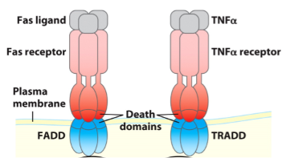
Intracellular events:
- FADD binding allows Caspase 8 to bind
- Caspase 8 then activates itself
- Leads to protein and DNA degradation
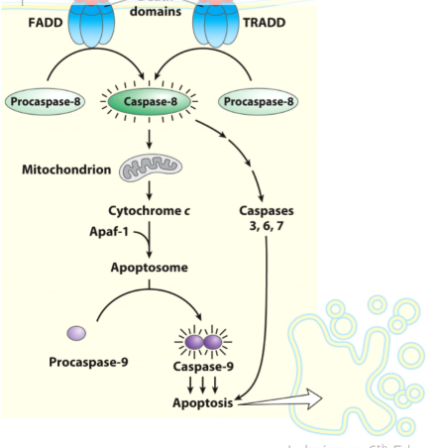
Caspases
Zymogens
- Must be proteolytically cleaved to be active
Cys in active site (so Cys proteases) cut after Asp
- Hence the name Casp-ase
2 kinds of caspases
- Initiator
- Effector
Apoptosis
Mitochondrial signal
- Caspase 8 causes cytochrome C release
- Cytochrome C assembles with Apaf-1 to
form the apoptosome (binding of cytochrome c
and ATP induces Apaf-1 to form an apoptosome
- Apoptosome activates Caspase 9
- Effector caspases mediate destruction of cell
- Other cells can then use metabolic compounds
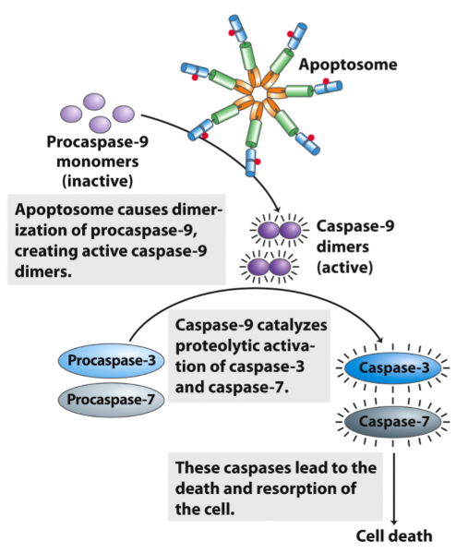
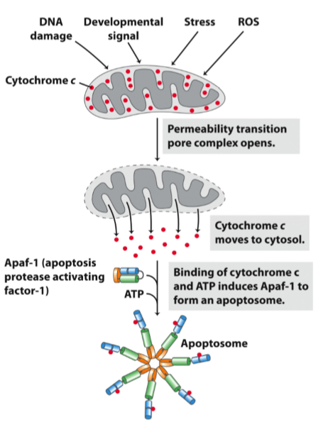

Lecture 3 – Part C: Carbohydrate Metabolism
Metabolism – Concepts
- Metabolism is the sum of chemical transformations
- Metabolic pathways involve enzyme
- Catabolism = degradation of biomolecules
- Anabolism = synthesis of biomolecules
Types of Pathways
- Converging catabolism
- Diverging anabolism
- Cyclic pathway
Rate-Limiting Steps (unregulated)
- Rates of biochemical pathways depend on the activities of enzymes that catalyze each step
- In any pathway, the rate of most steps in limited by substrate availability (enzyme is in excess)
- However, reactions catalysed one or more enzymes in any pathway will be limiting
- These rate limiting steps will set the overall speed of the pathway
  - Enzyme limited reaction = far from equilibrium
  - Substrate limited reaction = at or near equilibrium
Pathways are typically regulated at rate limiting steps
- Rate limiting steps are often exergonic and irreversible under cellular conditions
- Enzymes catalyzing exergonic, rate-limiting steps are targets of metabolic regulation
- This allows the cell to regulate the overall rate of metabolic pathways without regulating every single enzyme involved
How are enzymes regulated?
2 broad ways we can regulate an enzyme
- Can regulate its production or degradation (steps 1-5)
  - Regulate mRNA level and protein synthesis level
- Can regulate the function of the enzyme
Review – Glycolysis
- Boxed reactions are highly exergonic
- These are the steps in glycolysis that are regulated
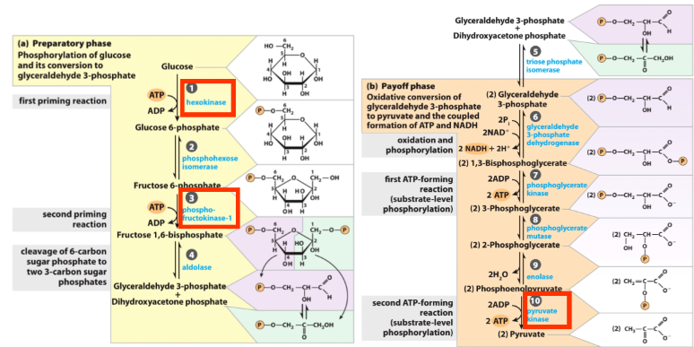

First box = not committed yet
Second box = now fully committed to glycolysis

Hexokinase is Allosterically inhibited by its product
- Hexokinase catalyzes the reaction that allows entry of glucose into glycolysis
- In muscle, hexokinase I is expressed
  - Normally has maximal activity (wants muscle to have priority access to sugars)
  - If [Glucose 6-P] increases, enzyme is inhibited (negative feedback)
- In liver, hexokinase IV (glucokinase) is expressed
  - An isozyme (different gene), lower affinity for glucose
  - Inhibited by fructose 6-P, not glucose 6-P, inhibition by fructose 6-P effected through glucokinase regulatory protein
Hexokinase IV has a relatively poor K0.5 (half of reaction velocity)
- The muscle enzyme (I) does not increase its rate when blood glucose is higher than optimal (5 mM)
- Hexokinase IV has a much higher Km (10 mM)
- With hexokinase IV, the liver responds directly to increasing blood glucose with increased turnover
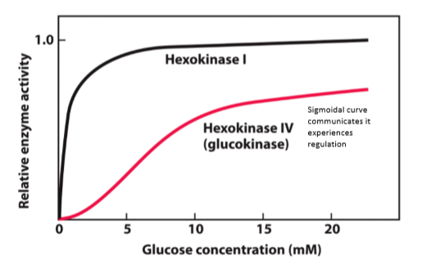

Regulation of Hexokinase IV
- When fructose 6-P is high, glucokinase regulatory protein sequesters hexokinase IV in nucleus
- High glucose weakens the enzyme/regulator interaction, encouraging cytosolic localization
  - High glucose bocks the site for regulatory protein to associate wit hexokinase IV, but nothing is bound to catalytic site so still active
  - Conformational change in regulatory protein causes a nuclear localization signal causing it to go to nucleus
  - Hexokinase IV s not turned off, its just removed from environment where glucose is found (since there is no glucose in the nucleus)
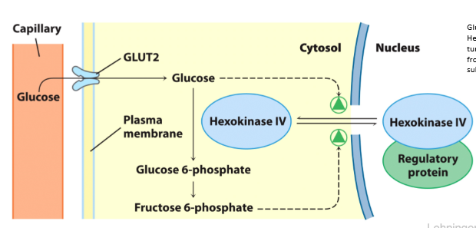

Phosphofructokinase-1 Allostery
- Glucose 6-P has several possible fates in the cell
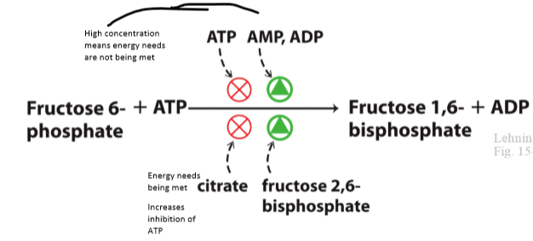
- Phosphorylation by PFK1 commits fructose 6-P (in equilibrium with G6P) to glycolysis

Allostery regulation of PFK1 is complex:
- ATP binds to an allosteric site on PFK1 and lowers affinity for fructose 6-P
- ADP and AMP relieve inhibition by ATP
- Citrate increases the inhibition by ATP
- Fructose 2,6-bisphosphate is strong activator
  - Activating PFK1 means we want glycolysis
Regulation of PFK1 by ATP
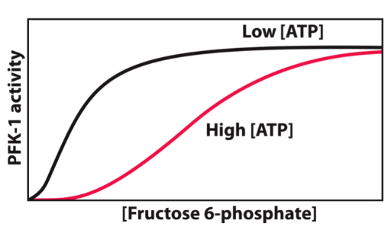
Hight ATP greatly reduces the affinity for PFK1 for fructose 6-P, when ATP is low higher F6P affinity allows PFK1 to be more active

Pyruvate Kinase is Inhibited by ATP
- Pyruvate kinase (PK) catalyzes the last step in glycolysis
- PK transfers Pi from phosphoenolpyruvate to ATP
- This yields pyruvate and a molecule of ATP
- High ATP allosterically inhibits PK, decreasing its affinity for PEP
Pyruvate Kinase Inhibition
- Acetyl-CoA and long chain fatty acids also inhibit PK
  - Important fuels for citric acid cycle
  - When plentiful, so is ATP
- Other allosteric modulators of PK:
  - Alanine (negative)
  - F 1,6-BP accumulation (+)
Summary of Pyruvate Kinase Regulation
- Note the liver isoform is also subject to inactivation by PKA phosphorylation
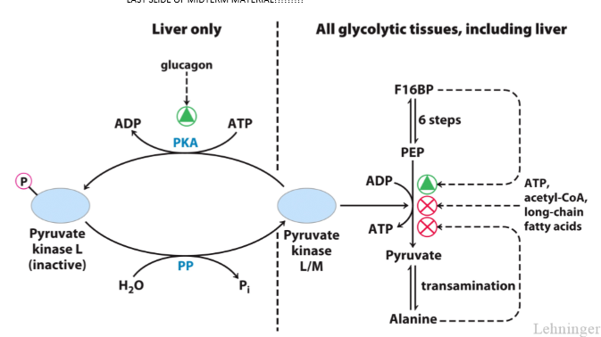
  - Hexokinase IV only in liver, different due to splice variant

