Anatomy & Physiology of the Male & Female Reproductive System

- Female system is cyclical whereas the male system is not
Cyclical – a cycle reoccurring periodically

Gross & Microscopic Anatomy of the Testes
- Testes located in scrotum: sac of skin + superficial fascia outside abdominopelvic cavity at root of penis
- Sparse hairs, more heavily pigmented
- Midline septum provides one compartment/testis
- Exterior position provides essential temperature 3º lower than core
- Layer of muscle (tunica dartos) located in the walls of the scrotum, relaxes when hot and contracts when cold
- Each testis 4cm x 2.5cm
Tunics of the Testes
- Tunica Vaginalis: outer, 2 layered, derived from
- Tunica Albuginea: fibrous capsule of testis (white coat); septal extensions divide each testis into 250-300 wedge-shaped lobules
- Each lobule = 1 to 4 coiled seminiferous tubules

Role of Dartos & Cremaster muscles in Temp Regulation
- Contraction of the dartos reduces the surface area of the scrotum and blood flow to the scrotal skin, preventing heat loss
- Dartos relation causes excess heat to be removed
- Congenital absence of the dartos leads to infertility
- Cremaster muscle lowers and raises the testis in order to control its temperature
- When a man enters an environment with a colder temperature, the muscle causes the testis to move against the body
- The more the testis presses against the body, the less it is exposed

Seminiferous tubules
->
Tubulus rectus (straight tubule)
->
Rete testes
->
Efferent ductulus
->
Epididymis

Leydig Cells
- Interstitial cells that produce androgens (testosterone)
- Interstitial – situated within but not restricted to or characteristic of a particular organ or tissue, used especially of fibrous tissues

Blood Supply
- Testicular arteries (branch from abdominal aorta)
- Testicular veins form pampiniform plexus, role in temperature regulation and venous return
- Spermatic cord: blood and lymph vessels, nerves, vas deferens
- Leydia Cells – found adjacent to the seminiferous tubules in the testicle, they produce testosterone in the presence of LH

Pathway Followed by Sperm from the Epididymis to the Exterior of the Body
- Epididymis (3.8cm)
- Head caps superior part of testis (stores sperm for maturation)
- Body and tail contain highly coiled duct of epididymis; uncoiled = 6m
- Sperm that enter epididymis -> gain ability to swim

What happens to the epididymis during ejaculation?
- During ejaculation, sperm is ejaculated from the epididymis, no the testes
- The smooth muscle in the ducts of the epididymis contracts, expelling sperm into the next segment of the duct system, the ductus deferens

What happens to sperm that do not get ejaculated for a long period of time?
- If they are held too long, epithelial cells of the epididymis eventually phagocytize them

How long can sperm be stored in the epididymis?
- Can be stored for several months

- Ductus (Vas) Deferens (1/testis)
- 45cm long
- Pathway to the point it becomes the ejaculatory duct:
- Ejaculatory duct passes into prostate gland, then into urethra
- Each vas deferens propels sperm out during ejaculation

Vasectomy – physician makes small incision into the scrotum and then cuts through and ligates (ties off) or cauterizes each ductus deferens, sperm can still be produced although can no long reach the body’s exterior

- The Urethra
- Terminal portion, serves both urinary and reproductive functions

What is the prostatic urethra?
- Portion surrounded by the prostate

What is the membranous urethra?
- Urogenital diaphragm

What is the spongy (penile) urethra?
- Runs through the penis and opens to the outside at the external urethral orifice
- Accounts for 75% of urethral length
- Its mucosa contains scattered urethral glands that secrete lubricating mucus into the lumen just before ejaculation

Structure of the Male Reproductive Accessory Glands
- Produce secretions that, along with sperm, make up semen

- Seminal Vesicles
- Posterior wall of bladder, about the size and shape of little finger
- Contribute 70% of semen volume (yellow, viscous, alkaline, fructose, citric acid, coagulating enzyme, prostaglandins)
- Yellow colour due to flavin proteins – fluoresce under UV light
- Sperm + seminal fluid in ejaculatory duct

- Prostate Gland
- Single gland, size and shape of chestnut, encircles urethra inferior to bladder
- Milky secretion (close to 1/3 semen volume; contains enzymes; role in activating sperm; also contains PSA
- Secretion to prostatic urethra via several ducts during ejaculation

- Bulbourethral Glands
- Pea-sized, inferior to prostate thick, clear mucus to spongy urethra before ejaculation
- Purpose is to produce thick, clear mucus, some of which drains into the spongy urethra where it neutralizes traces if acidic urine
- This mucus lubricates the glans penis when a man becomes sexually excited

Structural Organization of the Penis as a Copulatory Organ
- Delivers sperm into male reproductive tract
- External genitalia = penis and scrotum
- Penis = attached root and free shaft or body; enlarged tip – glans penis
- Foreskin or prepuce = cuff of skin around glans (circumcision)

Internally, penis contains;
- Spongy urethra
- 3 corpora of erectile tissue
- 2 corpora cavernosa
- 2 midventral corpus spongiosum
- Expands distally glans; proximally expands bulb of penis

Composition of Semen
Secretions Provide:
- Transport medium
- Nutrients (eg: fructose, citrate)
- Chemicals (eg: PGs, ATP, antibiotic chemicals)- protect/activate sperm or support sperm transport
- pH 7.2-7.6 neutralizes pH 3.5-4 of vagina

Semen – 2.5ml/ejaculation; (sperm) = 50-100 million/ml

Difference Between Sertoli and Leydig Cells Function
- normal rate of sperm production is 2x10⁸ sperm/day
- testis is a source of both germ cells and hormones
- testis is composed of:
- seminiferous tubules = Sertoli cells and spermatogenesis intermediates; 80% of testicular mass
- Leydig cells: synthesize androgens (testosterone)

Distinguish Steroid Hormones from Amino Acid Based Hormones
Cholesterol -> progesterone -> androstenedione -> testosterone

What cell type in testis synthesizes testosterone?
- Leydig cells, synthesize testosterone in the presence of LH

Actions of Testosterone
Gonadal
- Growth/maturation of gonads and accessory organs (puberty)
- Essential for spermatogenesis
Somatic
- Adolescent growth spurts (starts and stops tend to begin around 12-15 for about two years, by age 16 they stop growing but their muscles can continue to develop
- Growth of larynx and vocal cords
- Secretion of sweat
- Hair (face, chest, armpits, groin)
Metabolic
- Anabolic: hematopoiesis, BMR
CNS
- Maintenance of libido
- aggression

Steroid hormones are lipids – their significance in terms of interaction with cells is;
- one of which is to activate gene expression by binding to steroid receptors, proteins in the cytoplasm that, when activated act as transcription factors that initiate transcription

Describe the Hypothalamic & Pituitary Regulation of Steroidogenesis in the Male
Anterior Pituitary Hormones
- gonadotropins are glycoproteins
- water soluble
- cell surface receptors; 2nd messengers
- regulate activity of enzymes

Follicle Stimulating Hormone (FSH)
- stimulates Sertoli cells to support spermatogenesis (t required)

Luteinizing Hormone (LH)
- stimulates Leydig cells to secrete testosterone

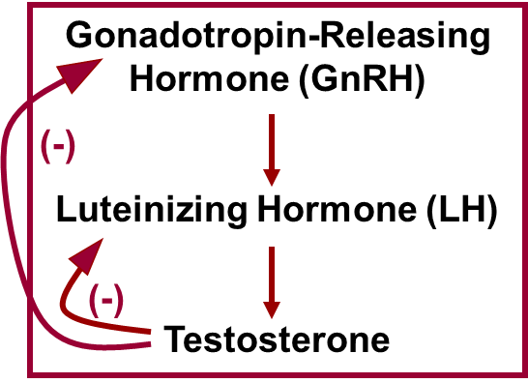

GnRH
- gonadotropin releasing hormone
- pulsatile secretion by hypothalamic neurons
- stimulates secretion of FSH and LH

Inhibin
- released by Sertoli cells inhibits secretion of ONLY FSH

Main Steps of Spermatogenesis
- starting point is spermatogonium (diploid)
- at puberty, 6 x10⁶ spermatogonia per testis; self-perpetuating (capable of continuing or renewing oneself indefinitely)
- Primary Spermatocyte: Mitosis of Spermatogonia
- Spermatogonia divide more or less continuously by mitosis and until puberty all their daughter cells become spermatogonia
- Spermatogenesis beings during puberty and from then, on each mitotic division of a spermatogonium results in two distinctive daughter cells
- Type A daughter cells: remains at the basal lamina to maintain the pool of dividing germ cells
- Type B daughter cells: gets pushed toward the lumen where it becomes a primary spermatocyte destined to produce four sperm
- First round yields 2 secondary spermatocytes/primary spermatocyte

- Secondary Spermatocyte: Meiosis
- Each primary spermatocyte undergoes meiosis I, forming two smaller haploid cells called secondary spermatocytes
- Continue to rapidly into meiosis II
- Their daughter cells, called spermatids are small round cells, with large spherical nuclei, seen closer to the lumen of the tubule
- Midway through spermatogenesis, the developing sperm “turn off” nearly all their genes and compact their DNA into dense pellets
- 2 copies of each of 23 chromatids
- 2nd division, 2 haploid spermatids

- Spermatids to Sperm
- Each spermatid has the correct chromosomal number for fertilization but its nonmotile
- Stoll must undergo a streamlining process called spermiogenesis during which it elongates, sheds its excess cytoplasmic baggage and forms a tail
- Each resulting sperm has a head, mid piece, and tail which correspond roughly to genetic, metabolic, and locomotor organs
- 22 autosomal chromatids and X or Y still a round cell

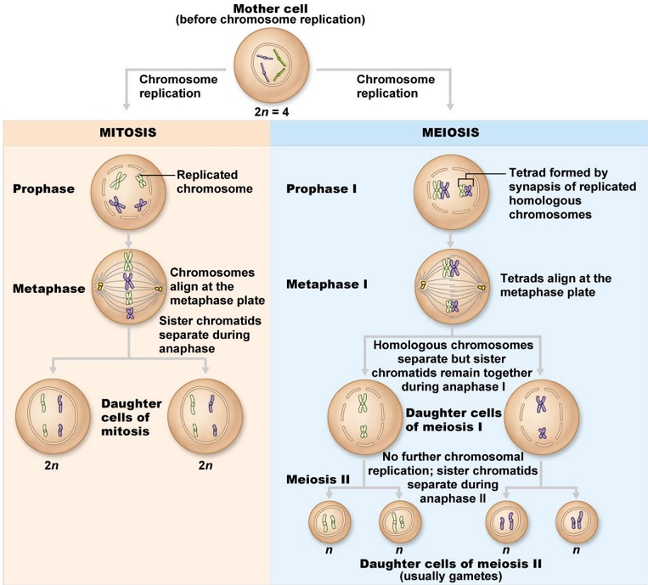
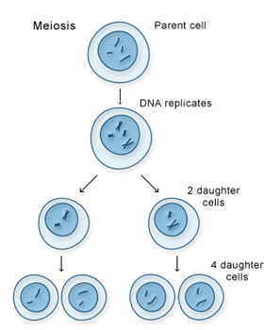

Spermiogenesis
- From 1º spermatocyte to spermatozoan take 70 days

Spermatozoan
- Conversion of spermatid to spermatozoan requires structural reorganization
- Reorganization of nucleus and cytoplasm
- Development of a flagellum
- Spermatozoa then released into lumen; still not completely mature
- In epididymis will acquire ability:

Blood Testes Barrier
- Tight junctions create barrier
- All stages after initiation of meiosis occur in avascular environment
Functions of Sertoli & Leydig Cells in Supporting Spermatogenesis
- Role of Sertoli Cells
- Spermatids and spermatocytes at various stages embedded in Sertoli cells
- Sertoli cells sit on basement membrane tight junctions create 2 compartments;
- Basal Compartment: extends from the basal lamina to the tight junctions and contains spermatogonia and the earliest primary spermatocytes
- Abluminal Compartment: lies internal to the tight junctions and includes the meiotically active cells and the tubule lumen

Sertoli Cells
- Nourish developing spermatozoa
- Secrete fluid into seminiferous tubule lumen
- Digest cytoplasm discarded by spermatozoa
- Bind FSH and testosterone
- Produce inhibin

- Role of Leydig Cells
- Located between seminiferous tubules
- Vascularized
- Receptors for LH – stimulated by LH to secrete testosterone to
- support spermatogenesis
- Support accessory organs

Functional Contributions of the Epididymis & Accessory organs to the Production of Semen
- Epididymis
- Sperm spend 20 days here
- Further maturation – membrane and enzyme changes to permit;
- Sustained motility
- Binding to egg

- Seminal Vesicles
- Secrete viscous, yellow fluid rich in fructose
- Fructose acts as a main energy source for the sperm outside the body
- Two small glands that store and produce majority of the fluid that makes up semen
- Contains PGs (function – play a role in sperm density and sperm function, as well as motility of the vas deferens and participate in decisively in flow regulation in make genitals

- Prostate Gland
- Secrete thin, milky fluid to neutralize acidity of male urethra and female vagina

- Bulbourethral Glands
- Thick, clear mucus
- Neutralizes traces of acidic urine in urethra

FSH & LH)
- Gonadotropins
- Regulate the function of the gonads (ovaries and testes)
- In both sexes, FSH stimulates production of gametes (sperm and egg)
- LH promotes production of gonadal hormones
- In females, LH works with FSH to cause an egg-containing ovarian follicle to mature
- LH then triggers ovulation and promotes synthesis and release of ovarian hormones
- In males, LH stimulates the interstitial cells of the testes to produce the male hormone testosterone
- Gonadotropins are virtually absent from the blood of prepubertal boys and girls
- During puberty, gonadotropic cells of the anterior pituitary are activated, and gonadotropin levels rise, GnRH produced by the hypothalamus prompts gonadotropin release
- Gonadal hormones, produced in response to the gonadotropins, feedback to suppress FSH and LH release

