PSY 1101/1501 Study guide

Prologue (4 questions)

Psychology: The scientific study of behavior and mental processes.

Roots of psychology:
- Rene Descartes → Dualism
-idea that the mind and body are separate entities that interact

- Plato → Nativism
-idea that certain kinds of knowledge are inborn or innate

- Aristotle → Philosophical empiricism
-idea that all knowledge is acquired through experience

Early schools of psychology:

- William Wundt
-promotes belief that experimental methods should be used to study mental processes
-establishes first psychology research laboratory in 1879, in Leipzig, Germany
-”father” of psychology

- Structuralism
-promoted by Edward Titchener, a student of William Wundt
-used introspection (looking inward) to reveal the structure of the human mind, report on sensations, & other elements of experience in reaction to stimuli

- Functionalism
-advocated by William James and influenced by Darwin
-focuses on how behaviours function to allow people and animals to adapt to their environment
-Why do we think/act the way we do? TO ADAPT.
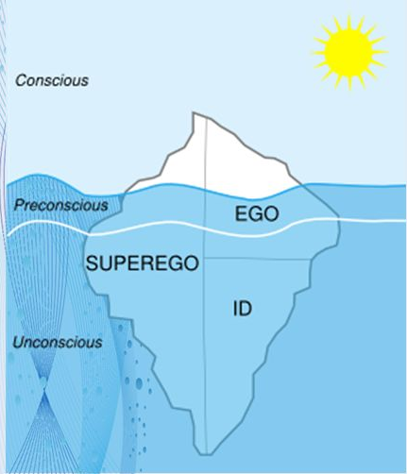
- Psychoanalysis
-Sigmund Freud
-unconscious mental processes shape feelings, thoughts, and behaviours
-Iceberg analogy →
-SUPEREGO =LAWS/PROHIBITED
-ID = LIFE (eros) / DEATH (thanos)

New schools develop:
- Behaviourism
-psychology redefined as the scientific study of observable behaviour
-the view that psychology should be an objective science that studies behavior without reference to mental processes
- Ivan Pavlov
-discovered conditioned reflexes
- John Watson
-extends approach to human behavior
- B.F. Skinner
-experiments on behaviour, learning, and conditioning
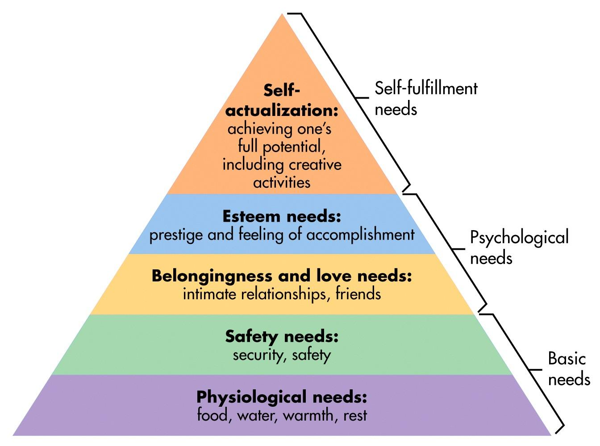
- Humanistic psychology
-historically significant perspective that emphasized human growth potential
-positive potential of human beings is assumed
emphasis on self-determination, free-will, and the importance of choice
- Carl Rogers
- Abraham Maslow
-Maslow’s Hierarchy of Needs

- Cognitive psychology
-the scientific study of how perception, thought, memory, and reasoning are processed
-the interdisciplinary study of the brain activity linked with cognition (including perception, thinking, memory, and language)

- Positive psychology: human flourishing

Psychology’s current perspectives:
- Neuroscience
-how the body and brain enables emotions, memories, and sensory reception

- Evolutionary
-how the natural selection of traits promoted the survival of genes

- Behaviour genetics
-how much our genes and our environment influence our individual differences

- Psychodynamics
-how behaviour springs from unconscious drives and conflicts

- Behaviourism
-how we learn observable responses

- Cognitive
-how we encode, store, and retrieve information

- Social-cultural
-how culture and society shape how people think, behave, and relate to each other

Chapter 1 (12 questions): Thinking Critically with Psychological Science

☆Scientific Attitude: curiosity, a passion to explore and understand without misleading or being misled. Skepticism. Humility.

Why do we need psychological science?
- Limits of Intuition (can be misleading/inaccurate)
- Hindsight Bias (I-knew-it-all-along phenomenon)
- Overconfidence (tend to think we know more than we do)
- Illusory Correlation (perceiving a relation between 2 unrelated events)
- Perceiving Order in Random Events (look for patterns to make sense of the world)

Critical thinking
- Thinking that does not blindly accept arguments and conclusions. Rather, it examines assumptions, appraises the source, discerns hidden values, evaluates evidence, and assesses conclusions.

Experimental studies
- manipulate one or more factors (independent variables) to observe/measure the effect on some behavior or mental process (the dependent variable).
- shows cause and effect relationship (variable A changed variable B)
- 2 groups: experimental (exposed to I.V) and controlled (not exposed to I.V)
- ex. placebo effect, blind/double-blind procedure

Case studies
- in depth analysis of individual or group

Naturalistic Observation
- watching and recording the natural behavior of many individuals

Surveys and Interviews
- asking people questions

Correlational Design
- measures the extent to which two factors vary together, and thus of how well either factor predicts the other
- positive and negative correlation
- positive: same changes in variables (↑↑ or ↓↓)
- negative: opposite changes in relationship (↑↓ or ↓↑)
- Correlation coefficient (r): a statistical index of the relationship between two things
- value of r ranges from: -1 ⇾ 0 ⇾ +1 (closer to +1, the stronger the relationship)

Scientific Method
- Observation: find questions by observing the environment
- Theory: an explanation using an integrated set of principles that organizes observations and predicts behaviors or events
- Hypothesis Testing: study a testable prediction
- Replication:repeat with different participants in different situations, to see whether the basic finding extends to other participants and circumstances
- Generate/Refine: based on results, generate new questions or refine existing ones

Statistically significant difference
- 2 types of statistics
- Descriptive: measure of central tendencies (typical data set outcomes)

Mean = mathematical average of a data set
- take sum of every single data and divide by # of scores

Median = score that falls in the middle of a distribution of scores
- arranged from highest to lowest, 50th percentile (half scores fall above and below)

Mode = most frequent occurring answer in set or data

Range = the difference between the highest and lowest scores in a distribution

Standard Deviation = a computed measure of how much scores vary around the mean score

- Inferential: determine if results can be generalized to a larger population
- P value: gives probability that it was due to chance (0↔️P↔️1)

Chapter 2 (12 questions): The Biology of Mind

Divisions and function of nervous system:
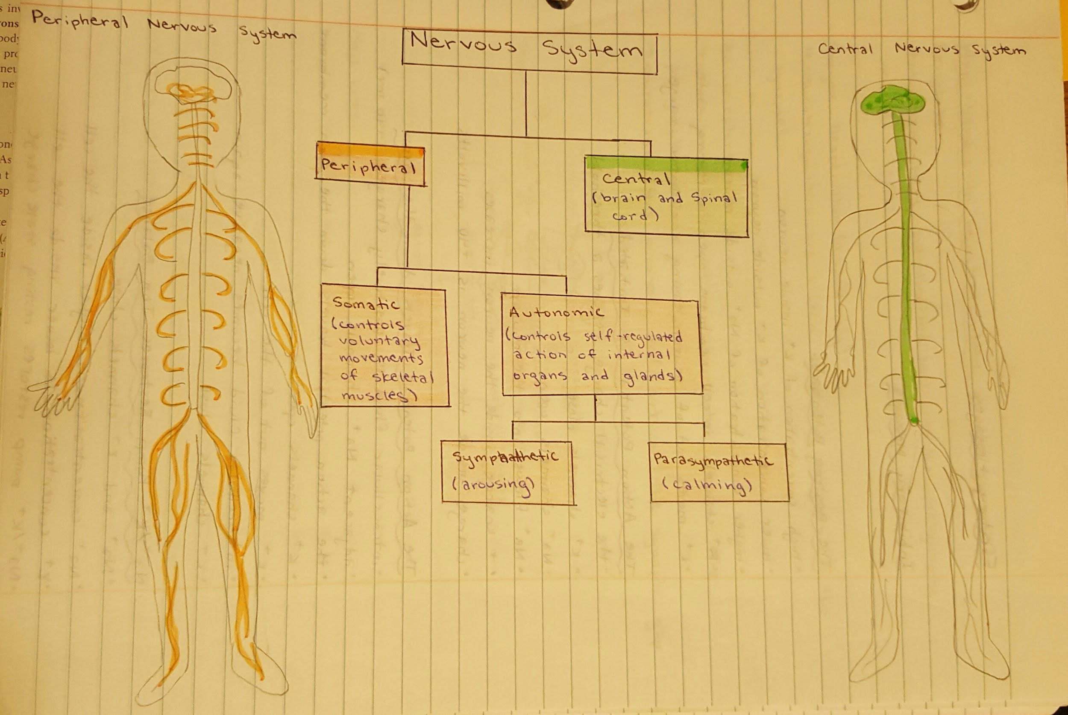
Examination of the Brain:

- EEG
-an amplified recording of the waves of electrical activity sweeping across the brain’s surface
-these waves are measured by electrodes placed on the scalp
- PET
-a visual display of brain activity that detects where a radioactive form of glucose goes while the brain performs a given task
- MRI
-a technique that uses magnetic fields and radio waves to produce computer-generated images of soft tissue
-MRI scans show brain anatomy
- fMRI
-a technique for revealing blood flow and, therefore, brain activity by comparing successive MRI scans
-fMRI scans show brain function as well as structure

Basic process of neuronal transmission:
-neurons: a nerve cell, a basic building block of the nervous system
-3 types of neurons:
- sensory (touch)
- interneurons (spinal cord)
- motor (muscle)
-a motor neuron ↓, with function of parts
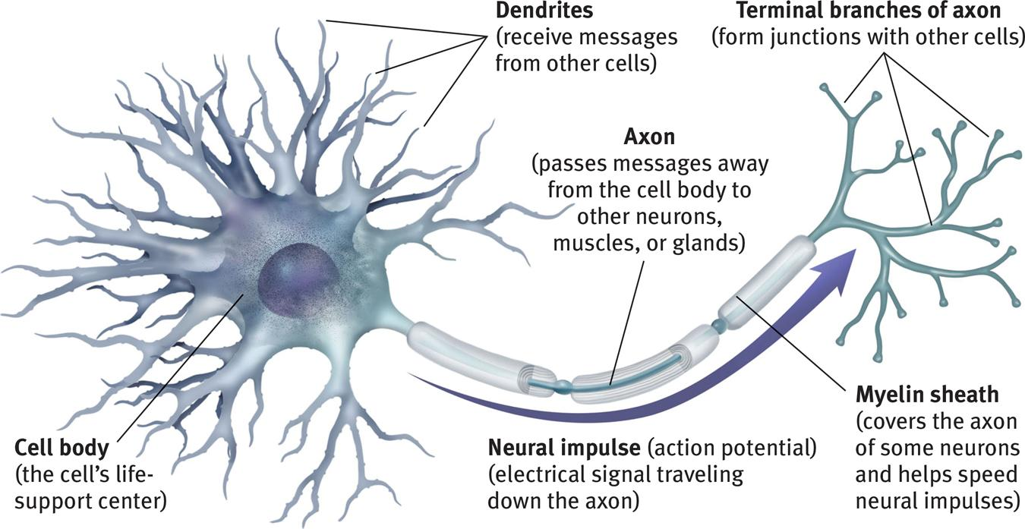

-the action potential: a neural impulse, a brief electrical charge that travels down an axon
- electrical charge is gathered by dendrites and cell body
- electrical charge travels down the axon to synapse
- stimulates the release of neurotransmitters into the synapse
- occurs when electrical signal is at a certain level (threshold)
- “all-or-none” - electrical impulses are the same no matter how much stimulation the neuron receives
- neuron returns to resting state after electrical charge is transmitted
-the refractory period:
- the time following an action potential
- another action potential can’t occur during the refractory period
- after the action potential reaches +40 mv, the neuron can generate another action potential
-the synapse:
- junction between one neuron’s axon and another’s dendrite/cell body
- neurotransmitters cross the synapse
- plays a fundamental role in the communication between neurons
-anatomy of the synapse/process:
- presynaptic neurons end in terminal buttons
- terminal buttons contain synaptic vesicles
- synaptic vesicles contains neurotransmitters
- neurotransmitters are chemicals that transmit information across the synaptic gap (cleft)
- postsynaptic neuron’s dendrites contain receptor sites
- receptor sites fit certain neurotransmitters
- neurotransmitters bind the specific receptor sites in a lock-and-key system
- key: neurotransmitters
- lock: receptor sites
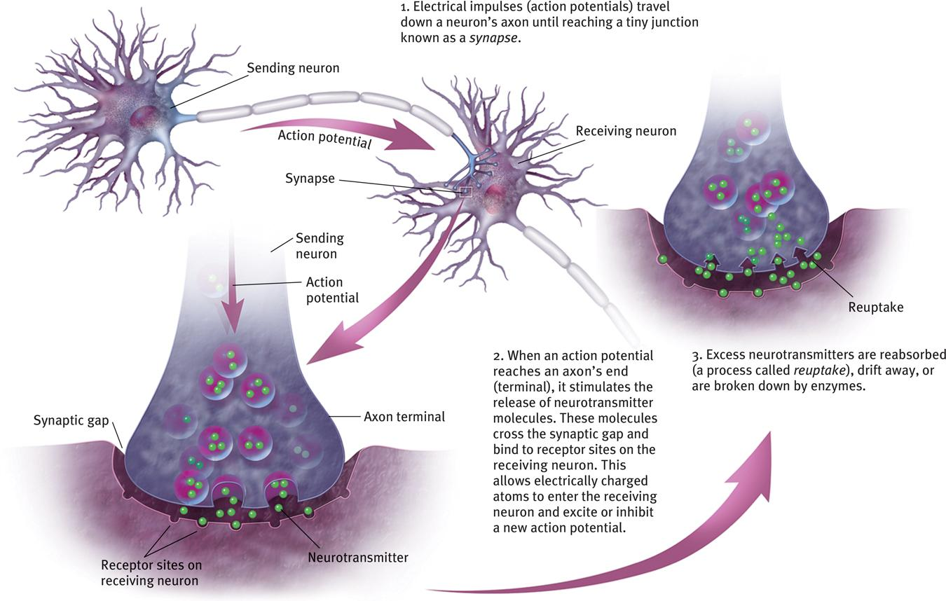
-what happens to neurotransmitters in the synapse?:
- reuptake
- neurotransmitters are absorbed back into the presynaptic neuron
- enzyme deactivation (disassembly)
- neurotransmitters are broken down by enzymes in the synapse
- autoreceptors
- neurotransmitters bind to autoreceptor sites on the presynaptic neuron
- neurotransmitters passively drift out of the synaptic gap

-types of neurotransmitters:
- acetylcholine (ACh)
- enables muscle action, learning, and memory
- with Alzheimer's disease, ACh producing neurons deteriorate
- dopamine
- influences movement, learning, attention, and emotion
- high levels linked to Schizophrenia
- low levels linked to Parkinson’s disease
- serotonin
- affects mood, hunger, sleep, and arousal
- low levels linked to depression
- norepinephrine
- helps control alertness and arousal
- low levels can depress mood
- endorphins
- boosts mood, lessens pain
- artificial opiates cause brain to stop producing endorphins
- GABA (gamma-aminobutyric acid)
- a major inhibitory neurotransmitter
- undersupply linked to seizures, tremors, and insomnia
- glutamate
- a major excitatory neurotransmitter
- involved in memory
- oversupply can overstimulate the brain, producing migraines or seizures

-endocrine transmission:
- second communication system
- secretes another form of chemical messengers: HORMONES
- hormones travel through the bloodstream and affect other tissues
- hormones act on the brain to influence our interest in sex, food and aggression
- endocrine system organs:
- hypothalamus
-brain region controlling the pituitary gland
- pituitary gland
-secretes many different hormones, regulates growth and controls over endocrine system
- thyroid gland
-affects metabolism
- parathyroids
-help regulate the level of calcium in the blood
- adrenal glands
-inner part helps trigger the “flight-or-fight” response, secrete epinephrine and norepinephrine
- pancreas
-regulates the level of sugar in the blood
- testis/ovary
-secretes male/female sex hormones

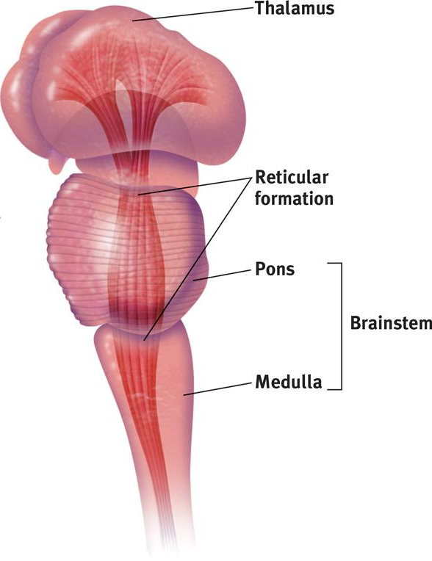
-Brain regions and localization of functions (also useful in later sections: e.g., hippocampus; corpus callosum)
- the brainstem:
-oldest and central core of the brain, supports life-sustaining bodily functions
-extension of the spinal cord, contains the...
- pons
-help coordinate movements and control sleep
- medulla
-the base of the brainstem, controls heartbeat and breathing

- the hindbrain:
- the thalamus
-the brain’s sensory control center, it directs messages to the sensory receiving areas in the cortex and transmits replies to the cerebellum and medulla
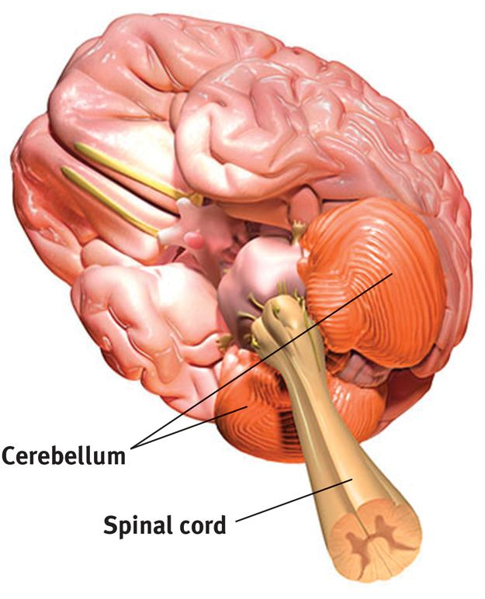
- the reticular formation
-a nerve network that travels through the brainstem into the thalamus and plays an important role in controlling arousal
- cerebellum
-the “little brain” at the rear of the brainstem
-functions include processing sensory input, coordinating movement output and balance, and enabling nonverbal learning and memory

- the limbic system:
- amygdala
-two lima-bean-sized neural clusters
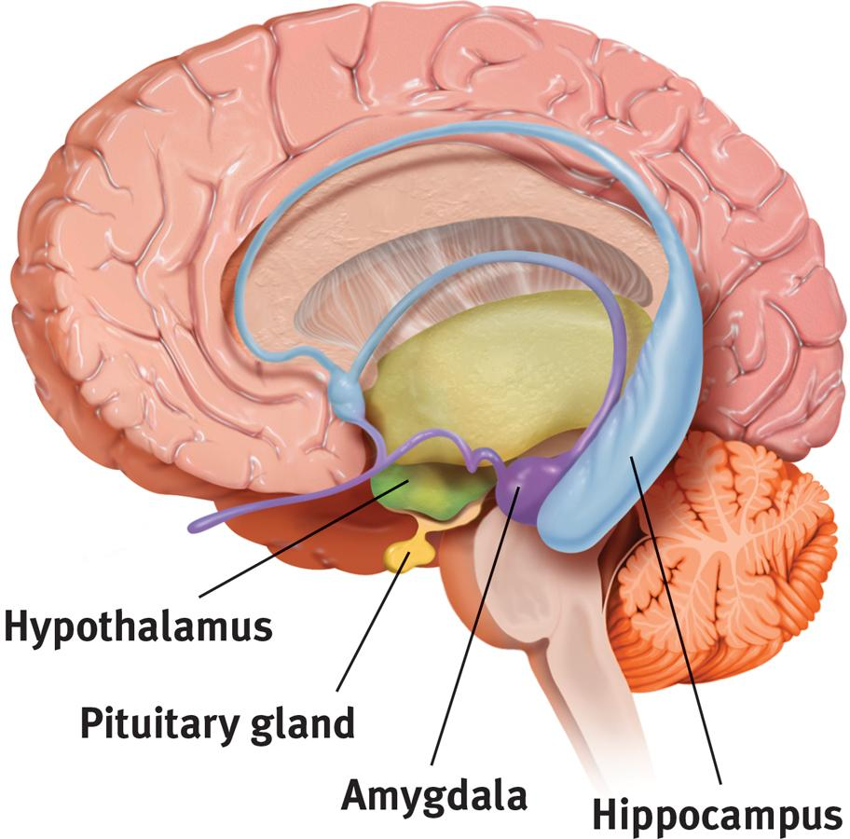
-linked to emotion
- the hypothalamus
-lying below (hypo) the thalamus
-it directs several maintenance activities (eating, drinking, body temperature)
-helps govern the endocrine system via the pituitary gland, and is linked to emotion and reward
- the hippocampus
-helps process explicit memories for storage

- cerebral cortex
-outer covering of the two hemispheres of the brain
-highest level of the brain
-the body’s ultimate control and information-processing center
- pituitary gland: master gland of the body’s endocrine system

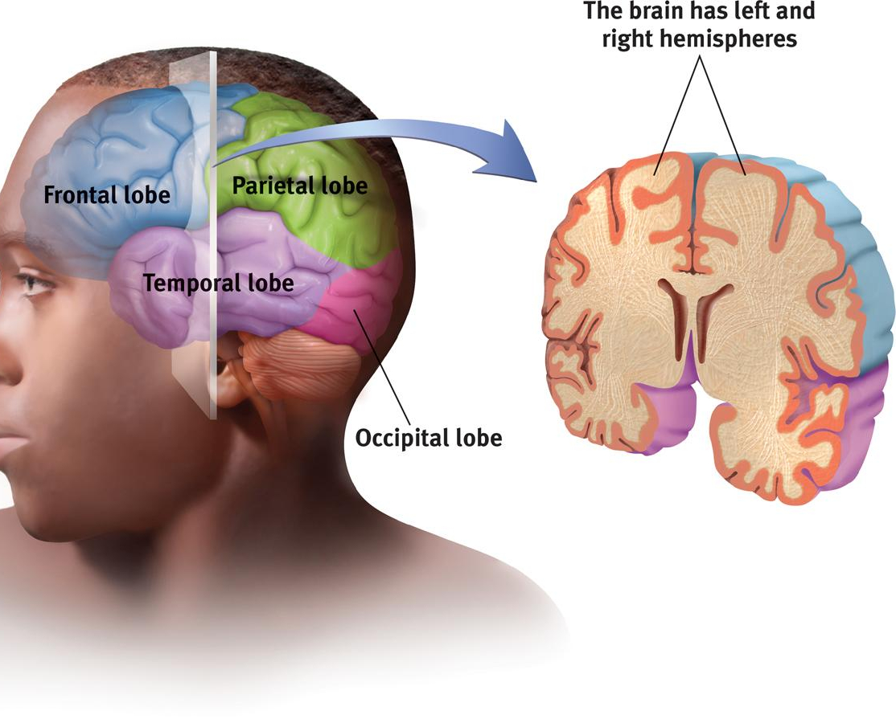
- cerebral lobes
- occipital
-visual information (visual cortex)
- parietal
-information about touch
- sensory/somatosensory cortex
-represents skin areas on the opposite side of the body
-larger areas of sensory cortex devoted to more sensitive body parts
- temporal
-hearing (auditory cortex), language (Wernicke’s area)
- frontal
-involved in speaking and muscle movements and in making plans and judgment
- motor cortex
-represents skin areas on the opposite side of the body
-larger areas of motor cortex devoted to body areas requiring precise control
-controls voluntary movement

- cerebral hemispheres
-two hemispheres that:
- control opposite sides of the body
- are connected by corpus callosum
- are functionally symmetrical in some respects
- have specialized abilities
- left brain hemisphere
-grammar
-language
-logic
-math
- right brain hemisphere
-interpretation of art and music
-perceptual tasks
-face recognition
-emotional expression
-spatial abilities

-Antagonist vs agonist effect:
- Agonists:
- molecules increase a neurotransmitter’s action.
- Agonists may increase the production or release of neurotransmitters, or block reuptake in the synapse
- Other agonists may be similar enough to a neurotransmitter to bind to its receptor and mimic its excitatory or inhibitory effects
- Antagonists:
- decrease a neurotransmitter’s action by blocking production or release
- can cause paralysis by blocking ACh release

-Phrenology:
- in the early 1800s, German physician Franz Gall proposed phrenology
- a pseudo medicine primarily focused on measurements of the human skull, based on the concept that the brain is the organ of the mind, and that certain brain areas have localized, specific functions or modules
- ex: studying the bumps on someone’s forehead revealed their mental abilities and character traits

Chapter 3 (12 questions): Consciousness and the Two-Track Mind

☆Consciousness: our awareness of ourselves and our environment

Dual Processing: brain simultaneously processes information at 2 levels
- Conscious (serial processing)
- Unconscious (parallel processing)

Different levels of sleep
- NREM-1 (experience hypnagogic sensations)
- NREM-2 (bursts of rapid, rhythmic brain-wave activity)
- NREM-3 (brain emits large, slow delta waves and you are hard to awaken)
- back to NREM-2
- REM sleep (heart rate rises, your breathing becomes rapid/irregular, eyes dart)

Circadian Rhythm
- the biological clock; regular bodily rhythms that occur on a 24-hour cycle
-evening energized owls (most 20 year old)
-morning loving larks (20+ and elderly)

Suprachiasmatic nucleus (SCN)
- a pair of cell clusters in the hypothalamus that controls circadian rhythm, in response to light SCN causes the pineal gland to adjust melatonin production, thus modifying our feelings of sleepiness

Selective attention: the focusing of conscious awareness on a particular stimulus

Inattentional blindness: failing to see visible objects when our attention is directed elsewhere

Blindsight: a condition in which a person can respond to a visual stimulus without consciously experiencing it

Change blindness: failing to notice changes in the environment

Drugs and Consciousness
☆Psychoactive drugs interfere with function of brain (alter behaviours, emotions,perception)

Addiction (acquired disease)
- compulsive craving of drugs or certain behaviors despite known adverse consequences

Tolerance
- consume more and more to get desired effect
- neuroplasticity (brain changes with experience)

Withdrawal
- discomfort and distress after discontinuing an addictive drug or behavior

Types of Psychoactive Drugs
- Depressants
-that reduce neural activity and slow body functions
- ex. alcohol, barbiturates/tranquilizers (xanax, valium) and opiates (narcotics: opium, heroin, morphine, oxycontin)

- Stimulants
-excite neural activity and speed up body functions
- ex. nicotine, caffeine, cocaine, amphetamines, ecstasy (MDMA)

- Hallucinogens
-distort perceptions and evoke sensory images in the absence of sensory input
- LSD, marijuana
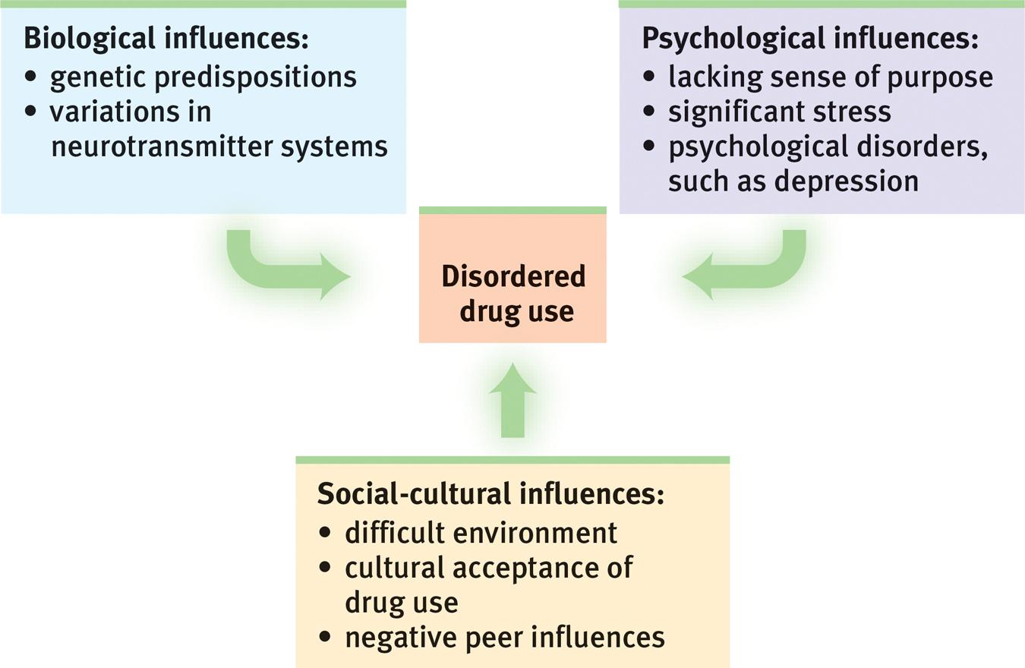
Influences on Drug Use:

Chapter 6 (12 questions): Sensation and Perception
-Sensation
- data coming in
- the detection of environmental stimuli, such as sounds, objects and smells

-Perception
- how we make sense of this data
- interpretation of sensation
- how our brains organize and interpret sounds, objects and smells

-Bottom-up processing
- sensory receptors relay information to the brain
- the brain interprets this information
-Top-down processing (e.g. priming)
- previous experience and expectations affect the detection and analysis of informations from the senses
- explains visual illusions

-Absolute threshold
- the minimum stimulus energy needed to detect a particular stimulus 50% of the time

-Difference thresholds
- minimal change in a stimulus that can just barely be detected
- Weber’s law: for a difference to be susceptible, two stimuli must differ by constant proportion, rather than amount

-Subliminal
- stimuli you can't detect 50% of the time
- below your absolute threshold for conscious awareness

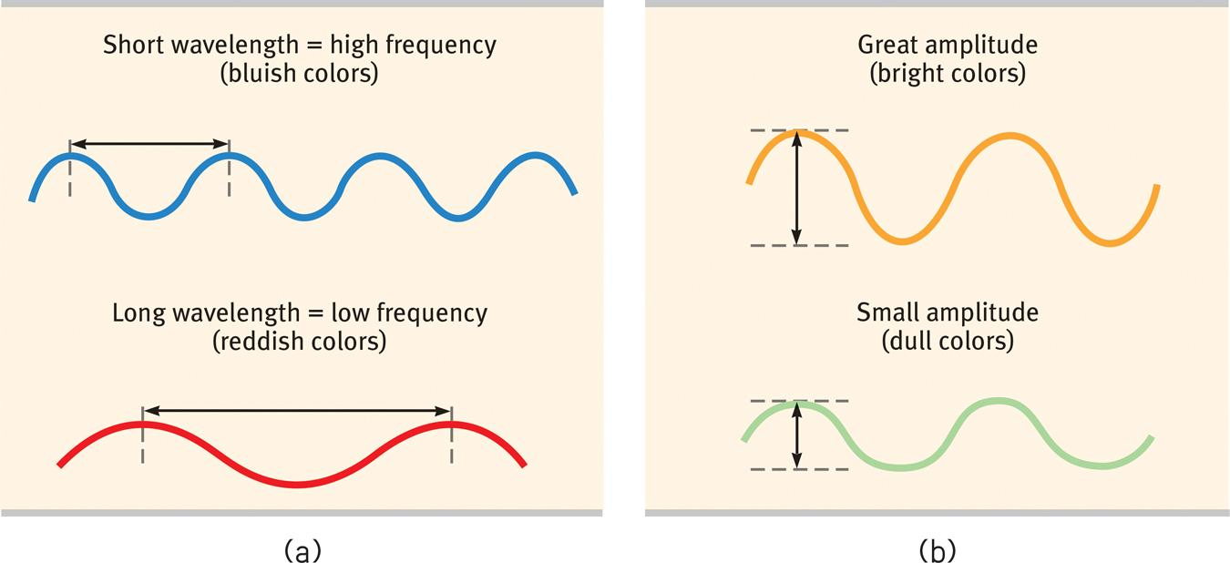
-Visual perception
- light energy
-hue: the colour experience
-wavelength: distance from one peak to the other
-intensity: determined by the wave’s amplitude

- parallel processing
-the processing of many aspects of a problem simultaneously; the brain’s natural mode of information processing for many functions
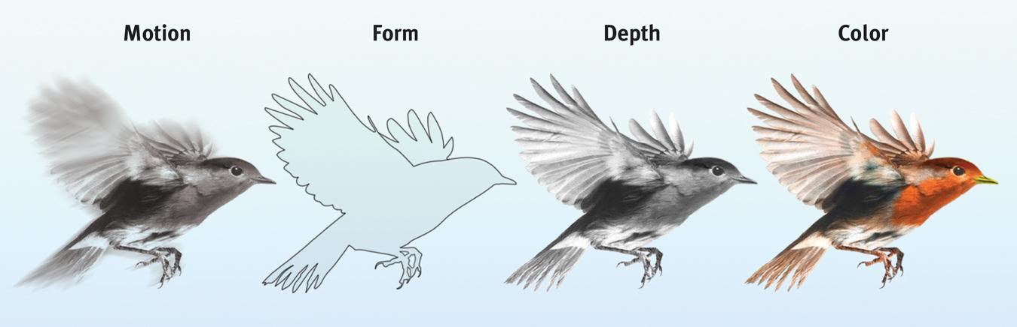
-Color processing occurs in two stages:
- The retina’s red, green, and blue cones respond in varying degrees to different color stimuli, as the Young-Helmholtz trichromatic theory suggested.
- The cones’ responses are then processed by opponent-process cells, as Hering’s theory proposed.
-Gestalt
- form perception
- part of seeing a whole
- grouping: proximity, similarity, connectedness, continuity, and closure
-depth perception
- Binocular cues: depth cues, such as retinal disparity, that depend on the use of two eyes
- Monocular cues: depth cues, such as interposition and linear perspective, available to either eye alone

-motion perception
- Our brain perceives a rapid series of slightly varying images as continuous movement (a phenomenon called stroboscopic movement)
- your brain computes motion based partly on its assumption that shrinking objects are retreating (not getting smaller) and enlarging objects are approaching
- Phi phenomenon: an illusion of movement created when two or more adjacent lights blink on and off in quick succession

-Auditory perception (cause of loudness)
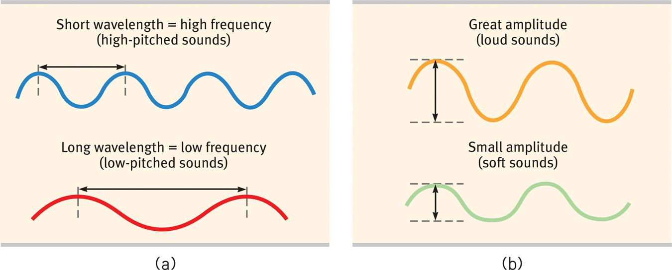

-Taste

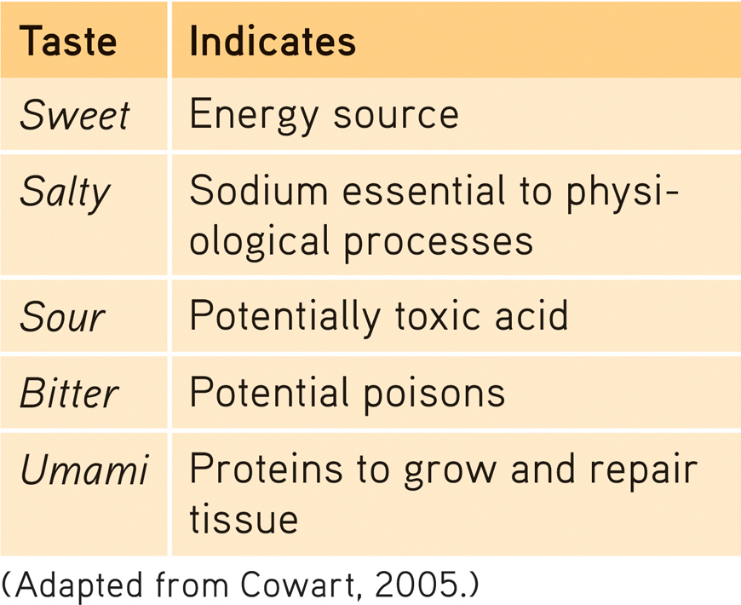
-Perceptual set
- a mental predisposition to perceive one thing and not another

Chapter 7 (12 questions): Learning

☆Learning is the process of acquiring new information or behaviors through experience

Associative learning: learning that certain events occur together, the events may be two stimuli or a response and its consequences (basis of conditioning)

Classical conditioning
- a type of learning in which one learns to link two or more stimuli and anticipate events

- Pavlov experiment
-unconditioned stimulus, unconditioned response, neutral stimulus, conditioned stimulus, conditioned response

- Acquisition: initial stage, when one links a neutral stimulus to an unconditioned stimulus
- Higher-order conditioning: conditioned stimulus in one conditioning experience is paired with a new neutral stimulus, creating a second conditioned stimulus
- Extinction: diminishing of a conditioned response
- Spontaneous recovery: reappearance of an extinguished conditioned response
- Generalization: tendency for stimuli similar to the conditioned stimulus to elicit similar responses
- Discrimination: learned ability to distinguish between a conditioned stimulus and stimuli that do not signal an unconditioned stimulus

Operant conditioning
- a type of learning in which behavior is strengthened if followed by a reinforcer or diminished if followed by a punisher

- Skinner experiments
-operant chamber (contains bar that animal manipulates to obtain reward)

- Reinforcement: event that strengthens the behavior it follows
- Positive reinforcer: add a desirable stimulus
- Negative reinforcer: remove an aversive stimulus

- Primary reinforcer: innate natural reinforcing, basic needs
- Secondary (conditioned) reinforcer: learned through experience

- Immediate reinforcer: have consequence immediately
- Delayed reinforcer: have to wait for consequence

- 2 types of reinforcement schedules:
- Continuous: reinforcing the desired response every time it occurs
- Intermittent (partial): reinforcing a response only part of the time

- Ratio
Fixed-ratio schedule: reinforce only after a specified number of responses
Variable-ratio schedule: reinforce after an unpredictable number of response

- Interval
Fixed-interval schedule: reinforce after a specified time has elapsed
Variable-interval schedule: reinforce a response at unpredictable time intervals

- Punishment: event that tends to decrease the behavior that it follows

- Positive punishment: administer something undesired
- Negative punishment: end something desired

Observational Learning
- learning by observing others
- Modeling: process of observing and imitating a specific behavior

- Bandura
-bobo doll experiment

- Mirror neurons: frontal lobe neurons that some scientists believe fire when performing certain actions or when observing another doing so

Motivations for learning
- Intrinsic motivation: a desire to perform a behavior effectively for its own sake
- Extrinsic motivation: a desire to perform a behavior to receive promised rewards or avoid threatened punishment

Chapter 8 (12 questions): Memory

☆Memory is the persistence of learning over time through the encoding, storage, and retrieval of information

Measuring Retention
- Recall - retrieve info. learned earlier
- Recognition - identify items learned previously
- Relearning - assesses amount of time saved when learning material again

Memory Models
- Encoding - get info. into brain

- Implicit memory: retention of learned skills or classically conditioned associations independent of conscious recollection
- Automatic processing: unconscious encoding of incidental information

- Explicit memory: memory of facts and experiences that one can consciously know
- Effortful processing: encoding that requires attention and conscious effort

- Spacing effect: distributed study yields better long-term retention
- Testing effect: enhanced memory after retrieving and repeating

- Levels of Processing
- Shallow: encoding on a basic level based on the structure or appearance of words
- Deep: encoding semantically, based on the meaning of the words

- Storage - retain that info

- Memory consolidation: the neural storage of a long-term memory
- Flashbulb memory: a clear memory of an emotionally significant moment or event

- Retrieval - get info. back out
- retrieval cues - hints that facilitate memory

- Priming: the activation of certain associations, thus predisposing one’s perception, memory, or response
- Serial position effect: tendency to recall best the last (a recency effect) and first (a primacy effect) items in a list
- Encoding specificity principle: idea that cues and contexts specific to a particular memory will be most effective in helping us recall it
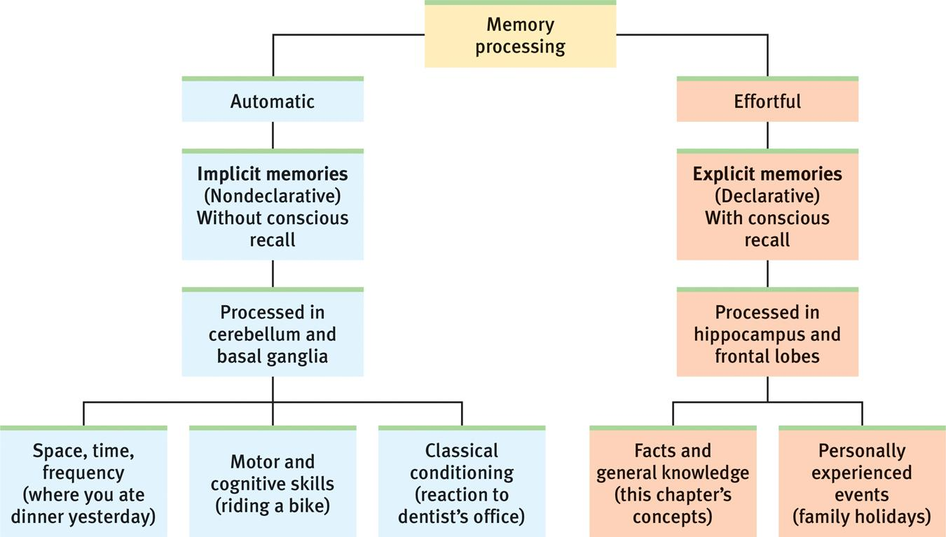
- Mood-congruent memory: tendency to recall experiences that are consistent with one’s current good or bad mood

Different Forms of Memory
- Sensory memory: immediate,brief recording of sensory information
- Iconic memory: sensory memory of vision
- Echoic memory: sensory memory of hearing/audition
- Short-Term (working) memory: activated memory that holds a few items briefly
- Long-Term memory: permanent and limitless storehouse of the memory system

Effective Memory Habits
- rehearse repeatedly
- make material meaningful
- activate retrieval cues
- mnemonic devices
- sleep more

Brain Structures Involved in Memory
- Hippocampus: newly formed explicit memory
- Frontal Lobe: explicit memory
- Cerebellum: implicit memory
- Amygdala: emotional memory
- Basal Ganglia: procedural memory

Forgetting Memory
- encoding failure, storage decay, retrieval failure

- Proactive interference: forward-acting disruptive effect of prior learning on the recall of new information
- Retroactive interference: the backward-acting disruptive effect of new learning on the recall of old information
- Repression: in psychoanalytic theory, the basic defense mechanism that banishes from consciousness anxiety-arousing thoughts, feelings, and memories

Anterograde amnesia: inability to form new memories
Retrograde amnesia: inability to retrieve information from past

Long-Term Potentiation (LTP)
- an increase in a cell’s firing potential after brief and rapid stimulation, believed to be a neural basis for learning and memory

Chapter 11 (12 questions): What Drives Us? Hunger, Sex, Friendship, and Achievement

-Theories of motivation
- intrinsic motivation
-the desire to engage in tasks that are inherently satisfying and enjoyable, novel, or optimally challenging; to do something for its own sake

- extrinsic motivation
-external factors or influences on behaviour such as rewards, consequences, or social expectations

- approach motivation
-a motivation to experience a positive outcome

- avoidance motivation
-a motivation not to experience a negative outcome

- instinct theory
-certain behaviors are innate and due to evolutionary programming

- Drive-reduction theory
-the idea that a physiological need creates an aroused tension state (a drive) that motivates an organism to satisfy the need

- self-determination theory
-optimal human functioning can occur only if psychological needs for autonomy, competence, and relatedness are satisfied

- competence motivation
-striving to be capable and exercising control

- achievement motivation
-striving to excel and outperform others

-Role of motivation in thinking
- incentive: a positive or negative environmental stimulus that motivates behaviour
- curiosity is a driving factor

-Hierarchy of needs
- Maslow’s pyramid of human needs that must first be satisfied before higher-level safety needs and then psychological needs become active
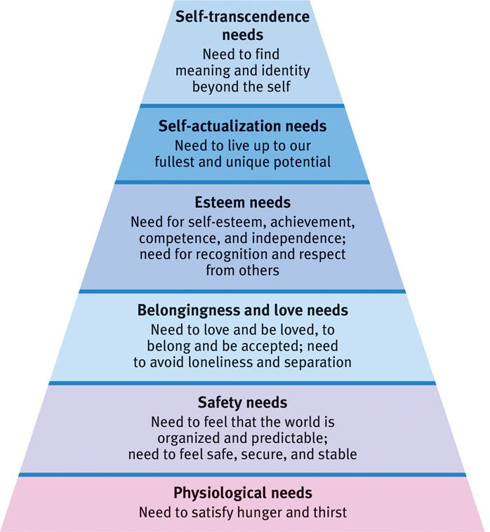

-Arousal and motivation
- arousal theory
-view that people are motivated to maintain a level of arousal that is optimal, neither too high or too low
-low arousal→boredom→motivation for stimulation
-high arousal→overstimulation→motivation for calm

-Brain regions involved in motivation (e.g., hypothalamus)
- the hypothalamus
-lying below (hypo) the thalamus
-it directs several maintenance activities (eating, drinking, body temperature)
-helps govern the endocrine system via the pituitary gland, and is linked to emotion and reward

-Sexual orientation and desire
- an enduring sexual attraction toward one’s own sex (homosexuality) or toward the other sex (heterosexulaity)
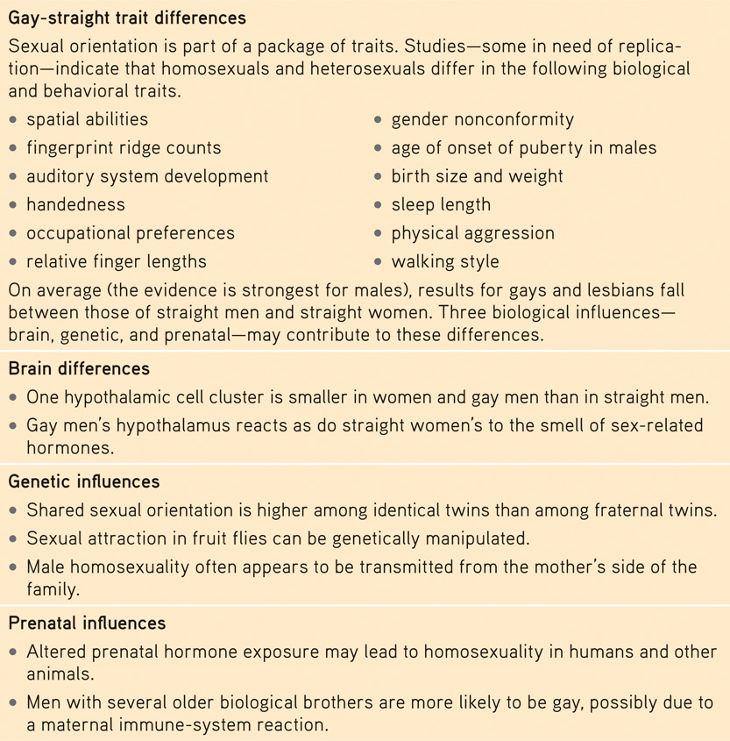

-Sexual behaviour and dysfunction
- Sexual response cycle
- the four stages of sexual responding described by Masters and Johnson—excitement, plateau, orgasm, and resolution
- Sexual dysfunction
-a problem that consistently impairs sexual arousal or functioning

-Drive for social connection
- affiliation need: the need to build relationships and to feel apart of a group
- ostracism: deliberate social exclusion of individuals or groups
- To experience ostracism is to experience real pain
- the importance of social acceptance and rejection
- Social networking tends to strengthen your relationships with people you already know, increase your self-disclosure, and reveal your true personality

-Instinct
- a complex behavior that is rigidly patterned throughout a species and is unlearned

-Yerkes-Dodson theory
- the principle that performance increases with arousal only up to a point, beyond which performance decreases
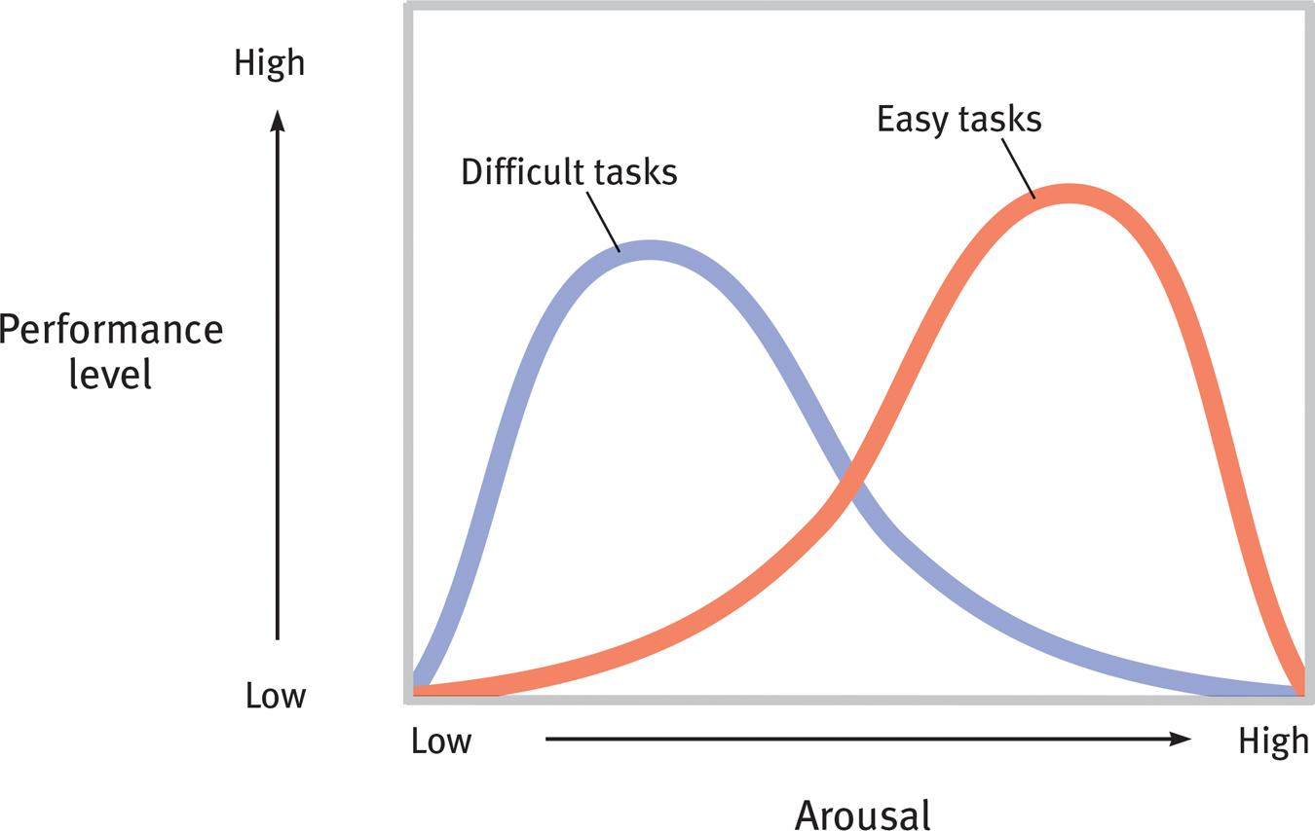

Effects of testosterone
- Testosterone
-the most important of the male sex hormones. Both males and females have it, but the additional testosterone in males stimulates the growth of the male sex organs during the fetal period, and the development of the male sex characteristics during puberty

-Birth control usage
- today’s American teens have a higher pregnancy rate—but a lower rate than their parents’ generation
- factors influencing not using birth control:
-Minimal communication about birth control
-Guilt related to sexual activity
can restrain sexual activity, but also reduce planning for birth control
-Alcohol use
Most sexual hook-ups occur among people who are mildly to very intoxicated
-Mass media norms of unprotected promiscuity
Media help write the “social scripts” that affect our perceptions and actions

Chapter 12 (12 questions): Emotion, Stress and Health

-The different theories of emotion (e.g., James-Lange vs. two-factor)
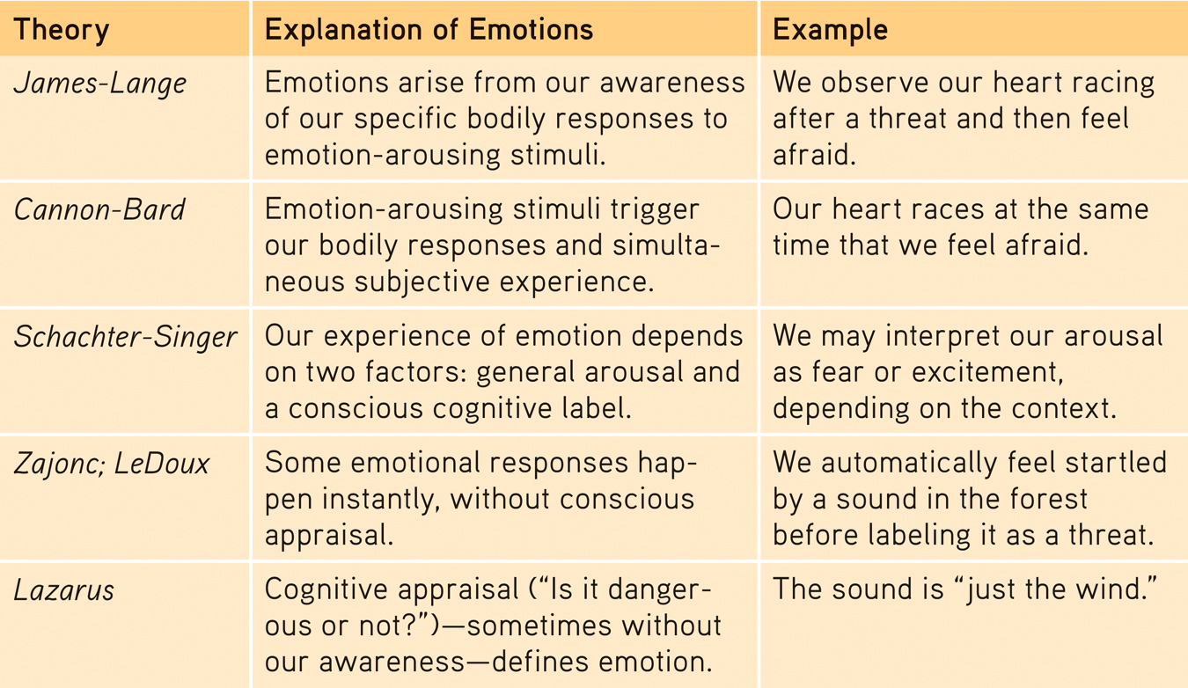

Emotion impacts on body/physiological state

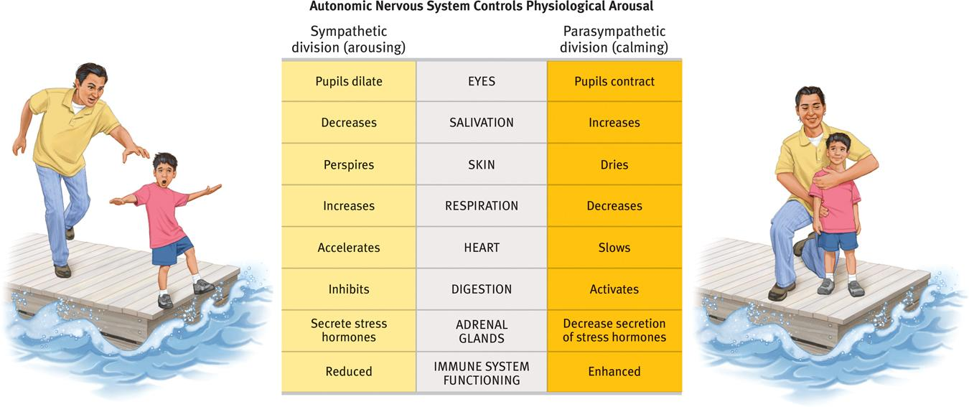

- Insula: activated by negative social emotions (disgust, lust, pride)
- Right Frontal Lobe: depression prone, negative personalities
- Left Frontal Lobe: upbeat, energized, positive moods

Reading Emotion in Others’ Faces (e.g., expressions; context)
- Facial feedback effect: tendency of facial muscle states to trigger corresponding feelings such as fear, anger, or happiness
- Behavior feedback effect: tendency of behavior to influence our own and others’ thoughts, feelings, and actions

Emotion and culture
- The meaning of gestures varies with the culture
- Facial expressions do convey some nonverbal accents that provide clues to one’s culture
- Musical expressions of emotion also cross cultures
- So we can say that facial muscles speak a universal language
- Although cultures share a universal facial language for some basic emotions, they differ in how much emotion they express

Anger and happiness
- Anger
-fear triggers flight but anger triggers fight
-Anger can harm us: Chronic hostility is linked to heart disease
-Anger boosts our heart rate, causes our skin to drip with sweat, and raises our testosterone levels
-expressing anger can be temporarily calming if it does not leave us feeling guilty or anxious
-what to do when angry: wait, find a healthy distraction or support or distance yourself

- Happiness
-levels are product of nature-nurture interaction
-twin studies: about 50% of happiness rating differences heritables
-culture: variation in group value of traits
- personal history: emotions balance around level defined by experience, happiness set point
-individual happiness level may influence national well-being
-Feel-good, do-good phenomenon: people’s tendency to be helpful when already in a good mood
-Positive psychology: the scientific study of human flourishing, with the goals of discovering and promoting strengths and virtues that help individuals and communities to thrive
-Subjective well-being: self-perceived happiness or satisfaction with life. Used along with measures of objective well-being (for example, physical and economic indicators) to evaluate people’s quality of life
-individuals with lots of money are typically happier than those who struggle to afford life’s basic needs
-Adaptation-level phenomenon: our tendency to form judgments (of sounds, of lights, of income) relative to a neutral level defined by our prior experience
-Relative deprivation: the perception that one is worse off relative to those with whom one compares oneself
-Gender and emotion
- women generally do surpass men at reading people’s emotional cues when given thin slices of behavior
- Females are also more likely to express empathy
- Women’s skill at decoding emotions contribute to their greater emotional responsiveness

-Catharsis
- Catharsis is the purification and purgation of emotions
- the process of releasing, and thereby providing relief from, strong or repressed emotions
- ”cleansing your problems”
- works short term, not a good method

