Experiment #2: The Enthalpy of Dissolution of Ammonium Chloride in Water

Experiment Title : Experiment #2: The Enthalpy of Dissolution of Ammonium Chloride in Water

Authors Name: Clinton Paul-Chinka, 300144230

Submitting Author’s Parter(s): Derek Johnson, Subah volah, Irvine Minh Duc Tran, Zijie Chen

TA (Demonstrator)’s name: TA: Ogadimma Okagu

Date Experiment performed: 2019-10-01

Date Experiment submitted: 2019-10-08

Introduction :
Chemical reactions take place when molecules interact by forming or breaking bonds. Energy is required to break bonds, but energy is released when bonds are formed. Enthalpy is the measure of the total energy in a system and indicates the transfer of energy between systems. The release of energy, usually in the form of heat or light, is referred to as an exothermic reaction. In an exothermic reaction, Energy is released because the total number of energies on the products is less than the reactants and because of this, the enthalpy change is negative. (ACS, 2018). However, in an endothermic reaction, energy is absorbed from the surroundings into the system, causing the surroundings to cool. This was so in the experiment as it was an endothermic reaction.
To cool the cup of water, dissolution of an ionic compound occurs as an endothermic reaction. The enthalpy of dissolution is determined by the lattice energy and the enthalpy of hydration. Lattice energy is the energy required to break apart an ionic solid. (Libretexts, 2019). Energy of hydration is the amount of energy released when 1 mole of an ion dissolves in a large amount of water resulting in a dilute solution. (toppr, 2018).
Lattice Energy + Enthalpy of hydration = Enthalpy of Dissolution
The two salts given for this experiment were Ammonium Chloride (NH4Cl) and Ammonium Nitrate (NH4NO3). Ammonium Chloride was chosen for the experiment because it is a much safer salt and Ammonium Nitrate is more hazardous. Inhalation of Ammonium Nitrate may cause irritation to the respiratory tract, irritation to the skin and dizziness. (atmos, 1999). As determined during the pre-lab, the Enthalpy of solid Ammonium chloride was +17kJ/mol. Through calculations it was determined that the theoretical mass required to cool down 100ml of water by 5 degrees Celsius was 12.5g (see calculations).
Procedure:
- Get a colorimeter, and a smaller metal can to put inside of it
- Fill the can with 100 mL of water. This represents the ‘drink’ present inside of the can that needs to be cooled by 5 °C in under 5 minutes.
- On the outside of the can (but still inside the calorimeter), enter the appropriate amount of volume so that the can is still surrounded but the can is not unnecessarily floating in the liquid.
- Using the volume of the water inside and outside of the can, calculate the enthalpy of change required to decrease the temperature as required; using the equation Q=mCΔT.
- Once this value (Q) has been obtained, use the equation q=-q to know the enthalpy of change of the water dilution; with either salt- NH4NO3, or ClNH4
- Using the equation q=ΔH० X n; to isolate for n and realize what the mol of salt needs to be in the experiment
- Lastly, using the equation n=m/M, you can obtain the mass of salt needed to lower the temperature of the drink by 5 °C in under 5 minutes… which presents you with your independent variable. This calculated mass may not yield the expected results however, which is why it is important to ensure that several different mass values are experimented with in order to obtain the needed results. The temperature of the drink/water in the can is the dependent variable.
- Now that the mass required has been calculated, it is time to start the actual experiment!
- Set up your labquest with the temperature sensor attached
- Begin by recording the initial temperature of the water present inside the can
- Next, starting with your first value, weigh out a certain amount of your chosen salt into a beaker. Work quickly and carefully to ensure best results with limited errors
- Drop the salt into the water surrounding the metal can, working as quickly as possible
- As soon as you’re done, close the lid of the calorimeter and begin recording. Although you only need to keep the trial running for 300 seconds, it is suggested that you go up to 400 seconds. Continue to shake the calorimeter consistently throughout the experiment, whilst being careful.
- After the 400 seconds are over, ensure that a final temperature reading is taken, and then dump the solution present inside the calorimeter out in an inorganic waste bucket; not down the sink!
- Rinse the calorimeter, and put this into the inorganic waste bucket as well. You can choose to replace the water present inside the can as well; being careful with the measurements each time
- Repeat steps 10-15 for the several different masses of your chosen salt, and record results as you proceed
- When you are completely done the experiment, ensure that you have downloaded a copy of the data onto everyone’s USB, and clean up after yourselves

Data:

Trial | Mass of Ammonium Chloride (g) | Initial Temperature of Water (℃) | Final Temperature of Water (℃) | Time (Seconds)
#1 | 7 | 22.6 | 20.6 | 300
#2 | 8.52 | 22.8 | 20.3 | 300
#3 | 12.5 | 22.6 | 17.6 | 300
#4 | 15 | 22.9 | 17.7 | 300
#5 | 18 | 22.8 | 16.6 | 300

Calculations:
Molar mass NH₄Cl = 54.491 g / mol
17 kJ/ mol NH₄Cl
175 g H₂O

Trial 1:
7 g of NH₄Cl
7 / 53.491 = .1 mol NH₄Cl
.1 * 17kJ = 1.7 kJ
-1700 J = 4.184*(ΔT)*190
ΔT = -2.1 °C

Trial 2:
8.52 g of NH₄Cl
8.52 / 53.491 = .159 mol NH₄Cl
.159 * 17 kJ = 2.70 kJ = 2700 J
-2700 = 4.184*(ΔT)*190
ΔT = -3.40 °C

Trial 3:
12.5 g of NH₄Cl
12.5 / 53.491 = .234 mol NH₄Cl
.234 * 17 kJ = 3.97 kJ = 3970 J
-3970 = 4.184*(ΔT)*190
ΔT = -4.99 °C

Trial 4:
15 g of NH₄Cl
15 / 53.491 = .28 mol of NH₄Cl
.28 * 17 kJ = 4.8 kJ = 4800
-4800 = 4.184*(ΔT)*190
ΔT = -6.0 °C

Trial 5:
18 g of NH₄Cl
18 / 53.491 = .34 mol of NH₄Cl
..34 * 17 kJ = 5.1 kJ = 5100
-5100 = 4.184*(ΔT)*190
ΔT = -7.0 °C

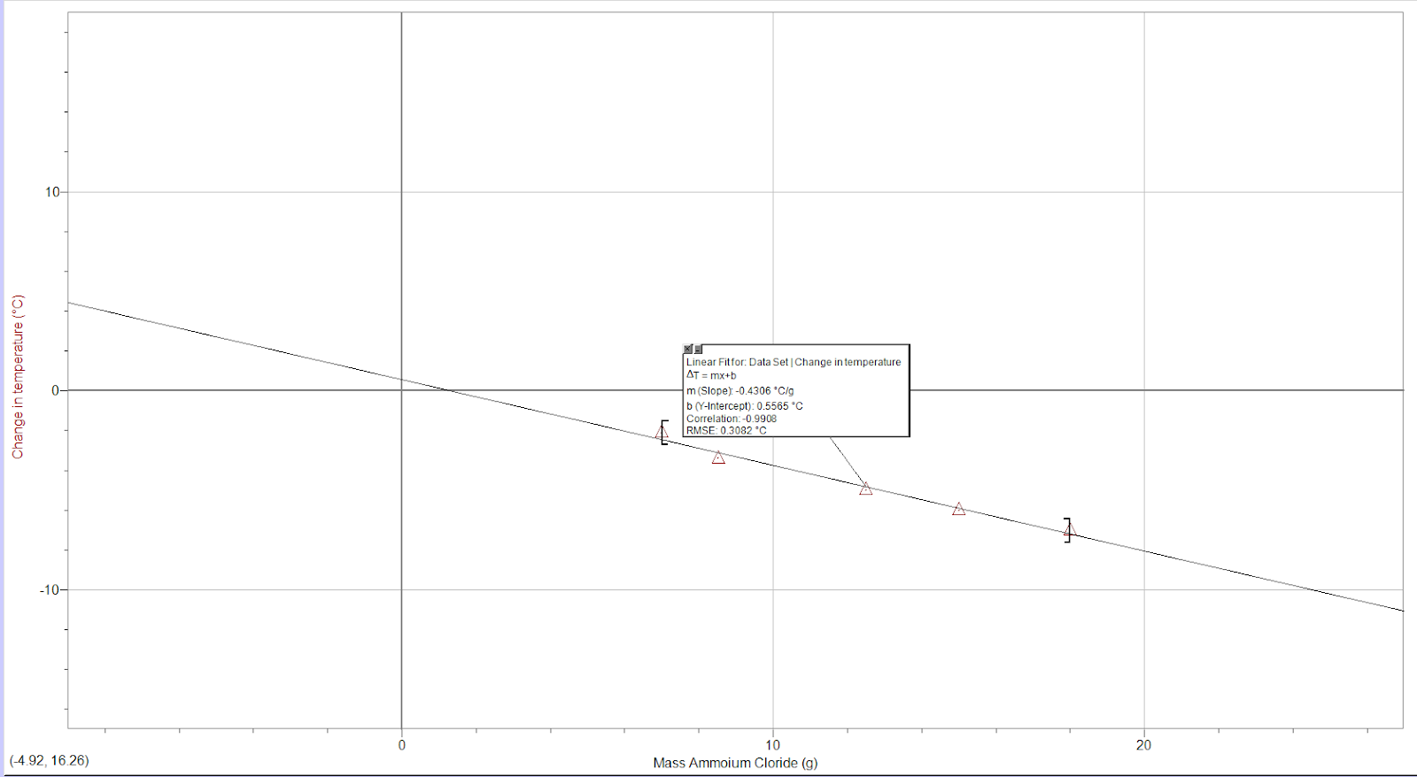
Graph of change in temperature at different masses

Discussion:
In this experiment, we use a calorimeter to check how much ammonium chloride/ ammonium nitrate was required to cool down the water by 5 °C during around 5 minutes because we need to design a product for athletes.
At first, we decided to use ammonium chloride instead of ammonium nitrate because ammonium nitrate cools down the water too fast so it may hurt athletes, and ammonium chloride is cheaper and safer than ammonium nitrate. We put 100g of water inside a can and 90g of water (proper quantity to dissolve the NH4Cl based on its solubility) in the container outside the can, then we pour the powders of NH4Cl into the water outside the can. Before that, we calculated the amount of heat that we need to cool down 175g of water by 5 °C and based on the heat when NH4Cl dissolved, we figured out the approximate mass of NH4Cl for one trial, which is 12.5g.
m=190g
c=4.18J/(g*K)
ΔT=-5°C
ΔH(NH4Cl)sol=+17kJ/mol
M(NH4Cl)=53.491g/mol

Q=mcΔT=-3971J
n=Q/ΔH=0.2336mol
m=n*M(NH4Cl)=12.5g

Then we did five trials and the mass of NH4Cl were 7g, 10g, 12.5g, 15g and 18g respectively. (Table needed)
In the first time, the temperature of water decreased 2 °C after 5 minutes of shaking. In the second time, the temperature of water decreased 2.5 °C after 5 minutes of shaking. For the third time, the temperature of water decreased 2.9 °C after 12.5g NH4Cl was added in and be shaking for 5 minutes. For the fourth time, the temperature of water decreased 5.1 °C after 15g NH4Cl was added in and be shaking for 5 minutes. For the last trial, the temperature of water decreased 6.2 °C after 18g NH4Cl was added in and be shaking for 5 minutes.

We found that the proper mass of NH4Cl for this project was 15g instead of 12.5g.
We suppose that’s because there was the loss of heat during the experiment, therefore, the heat that NH4Cl released when dissolving was not absorbed by the water inside the can completely.

Limitations:
The first limitation of this experiment is found within the calculations part of the lab. While calculating the theoretical mass of ammonium chloride, we weren’t given the heat capacity of the metal can inside the calorimeter. This is a limitation because it most likely made our calculations less accurate since the can is also able to absorb heat. We also weren’t given the heat capacity of the calorimeter and therefore had to assume it didn’t absorb any heat. Although the Styrofoam calorimeter has a very low heat capacity, it would still alter our calculations if it was included.

The second limitation of this experiment is the calorimeter itself. The calorimeter we used had a lid that wasn’t able to completely seal, which means the experiment was less isolated than anticipated. This was clearly shown while shaking the calorimeter; some water was able to escape, meaning it wasn’t completely sealed. Heat energy was most likely able to be transferred into and out of the can. This is a limitation because it decreases the accuracy of our calculations.

Another limitation to this experiment is that heat capacities vary at different temperatures. Within the background theory of this experiment, we are given the capacity of water as 4.18 J/(g*K). Although this is the common heat capacity, we know that the heat capacities of substances vary depending on their temperature. This means that technically the heat capacity of water would have changed as the temperature changed.

Conclusion:
We need approximately 15g of NH4Cl to cooled down 100g of water in the container and 90g of water used as solvent altogether in 5 minutes, when the temperature of the environment is around 22.5 degree.

Works Cited
ACS. (2018). ENERGY FOUNDATIONS for High School Chemistry. Retrieved October 8, 2019, from http://highschoolenergy.acs.org/content/hsef/en/how-can-energy-change/exothermic-endothermic.html.
Libretexts. (2019, June 5). Enthalpy. Retrieved October 8, 2019, from https://chem.libretexts.org/Bookshelves/Physical_and_Theoretical_Chemistry_Textbook_Maps/Supplemental_Modules_(Physical_and_Theoretical_Chemistry)/Thermodynamics/Energies_and_Potentials/Enthalpy.
Toppr. (2019, May 28). Hydration Energy - Enthalpy of Solvation and More! Retrieved October 8, 2019, from https://www.toppr.com/bytes/hydration-energy/.
Atmos. (1999). AMMONIUM NITRATE. Retrieved October 8, 2019, from https://www.atmos.umd.edu/~russ/MSDS/ammonium_nitrate.htm.

Appendix:
Raw data;
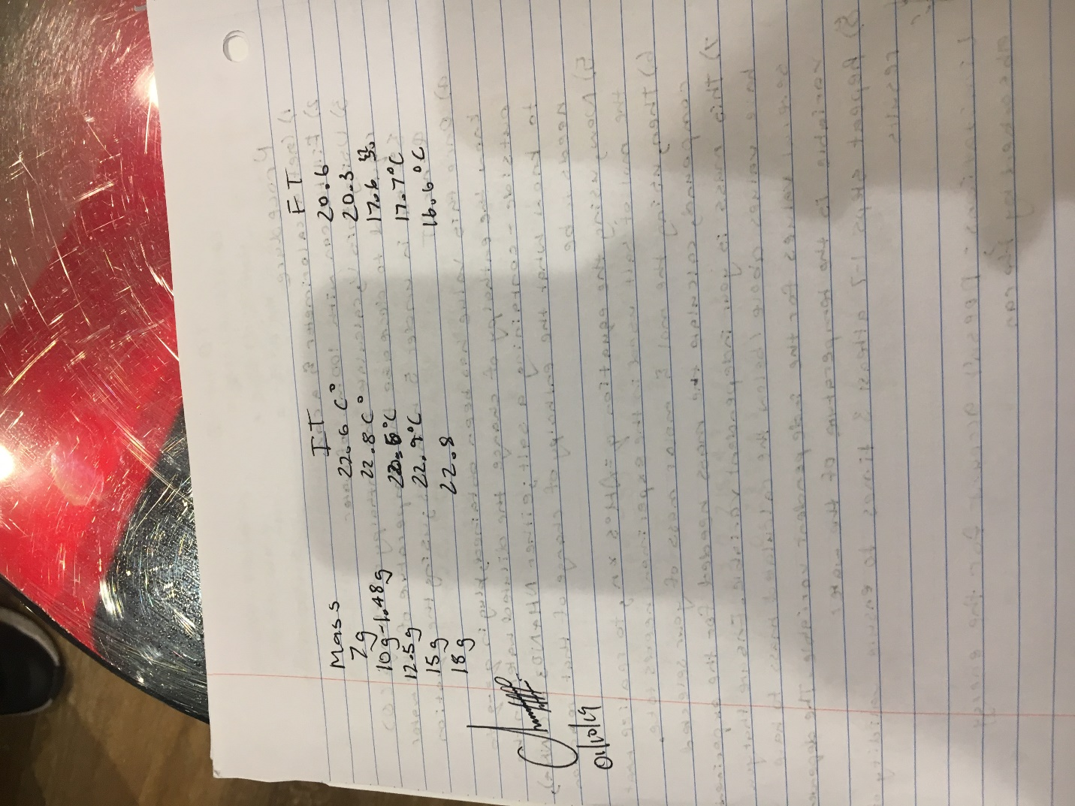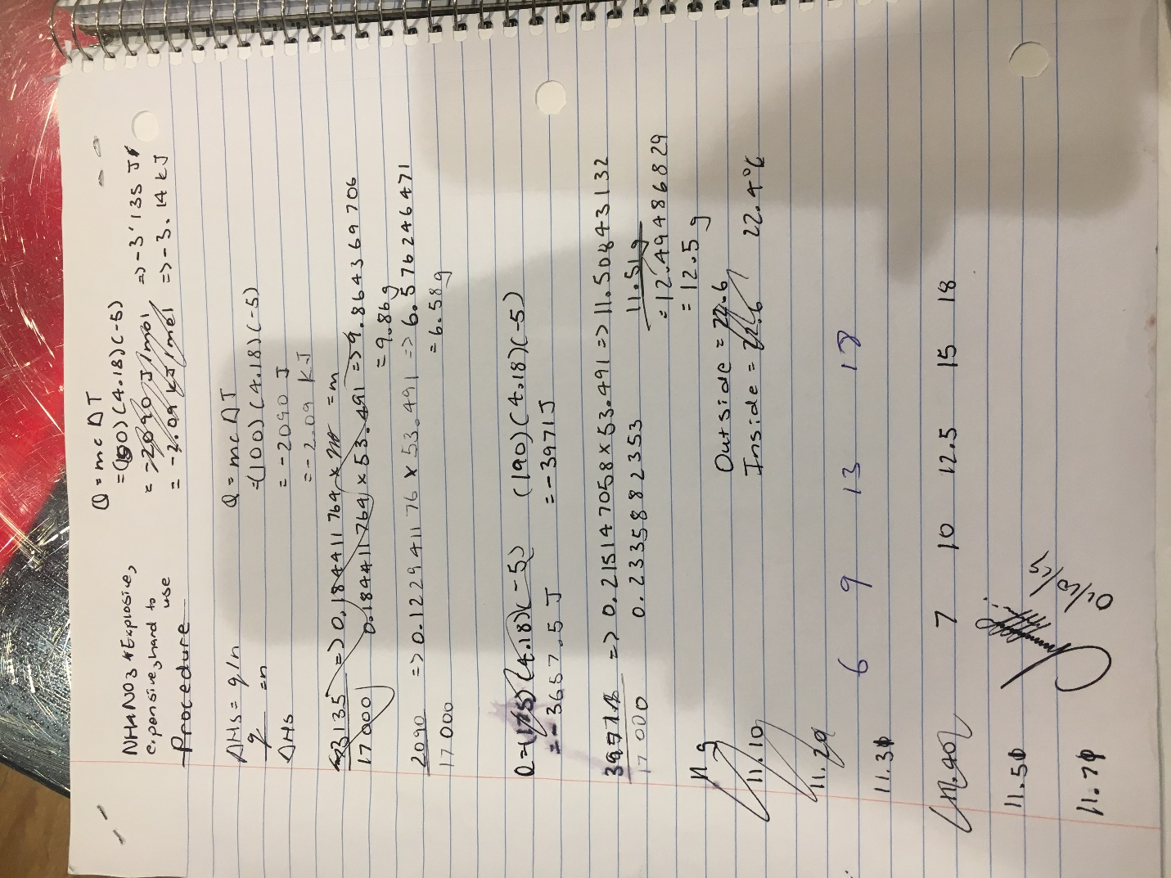

Assessment Criteria


