uChapter 4

Beginning Net Assets End of Year Net Assets

Delta (difference)
-– transactions with equity owners
= Total Comprehensive Income

- Discontinued Operations include:
- Under ASPE: an operating segment, reporting unit, subsidiary, asset group, or operations without assets
- Under IFRS: separate major line of business or geographical area of operations, or a business qualifying as “held for sale” upon acquisition

- Discontinued operations can be a profit or loss depending on the difference between the resulting operations and the cost of disposing those assets/components

- For sale assets do not depreciate

- Presented separately on balance sheet
- Under ASPE, held for sale asset retains original classification as current or non-current
- Under IFRS, held for sale assets generally classified as current

- Earnings per share is solely based on NET INCOME (not comprehensive income)

- ASPE = statement of retained earnings, IFRS = statement of changes in equity

Exercise E4-3 (pg 188)
Income from cont. Operations (100,800/(1-30%)) 144,000
Income Tax (30%) 43,200
Net Income from cont. Operations 100,800
Discontinued Operations
Results of Operations (after taxz of $1800) 4,200
Disposal of Assets (net of tax recovery of $6,000) (14,000)
Net Income $96,000

Carrying Value $25,000
Expected Proceeds 5,000
Expected Loss 20,000
Tax Recovery (30%) 6,000
Disposal of Assets cost $14,000

Exercise 4-13 (p. 192)
Quality Fabrication Limited
Multiple-Step Income Statement
Year Ending December 31, 2017

Sales Revenue
Sales $1,120,000
Less: Sales Discounts 40,000
Sales Returns and Allowances 118,000 158,000
Net Sales Revenue $962,000
Cost of Goods Sold 504,000
Gross Profit $458,000

Operating Expenses
Selling Expenses 160,000
Depreciation Expense 50,000
Administrative Expenses 80,000 290,000
Income from Operations 168,000
Other revenues and gains
Interest Revenue 70,000
238,000
Other Expenses and Losses
Interest Expense 50,000
Loss From Storm Damage 124,000 174,000
Income before income tax 64,000
Income Tax (25%) 16,000
Net Income $ 48,000
Earnings Per Share: $0.32

Exercise 4-10 (p. 191)
a.
Gottleib Corp.
Multiple-Step Statement of Comprehensive Income
Year Ended December 31, 2017

Net Sales Revenue $1,300,000
Cost of Goods Sold 780,000
Gross Profit
Operating Expenses $520,000
Selling Expenses 65,000
Administrative Expenses 48,000 113,000
Income from Operations 407,000
Other Revenues and Gains
Dividend Revenue 20,000
Interest Income 7,000 27,000
Other Expenses and Losses 434,000
Loss on Inventory due to decline in NRV
Loss on Sale of Equipment
Loss from expropriation
Income before income tax
Income Tax
Net Income
Other Comprehensive Income
Unrealized gain on FV-OCI Investments (net of $10,500 income tax) 31,500
Comprehensive Income 225,750

Chapter 5: Financial Position and Cash Flows
Statement of Financial Position (SFP) Limitations
- Most assets and liabilities are stated at historical cost
- Judgement and estimates are used in determining many of the items reported on the SFP
- SFP does not report items that cannot be recorded objectively (e.g. internally generated goodwill

- Inventory is recorded at Net Realizable Value (NRV)

- IFRS allows property, plant and equipment to be recorded at fair value

- There are no contra accounts for intangible assets ; the asset itself is credit and amortization expense is debited

- Dividends and long term debt payments go on the statement of cash flow

- Whenever an asset is increased, cash flow will decrease, and vice versa

- Whenever a liability or S/E account increases, cash flow will increase, and vice versa

- Long term assets and investment changes are always investing activities

- Changes in equity and borrowings are always financing activities

Exercise 5-8
FV-Ni investments (at fair value) – current asset
Bond investment at amortized cost – noncurrent asset
FV-OCI Investments – Other comprehensive income
Investment income or loss – other income
Accumulated depreciation (building) – contra asset
Allowance for doubtful accounts – contra (negative) asser
Interest expense – other expense
Gain on sale of land – other income (comprehensive income)
Correction of prior year error – retained earnings adjustment
Chapter 6: Revenue Recognition

- Return policies may affect revenue recognition

- “Bill and hold” transactions may also affect inventory count and revenue recognition – the customer is billed but the inventory is held

- FOB shipping point – as soon as the truck leaves the shipping point, ownership is transferred to the customer

- FOB destination – transfer of ownership does not occur until the customer receives it; inventory should be insured during transport
- There are two approaches to recognizing sales/revenues:
  - Asset-liability approach (contract based approach) – IFRS 15 (new standard)
  - Earnings approach – IAS 18 (old standard)
Asset-Liability Approach (IFRS 15):
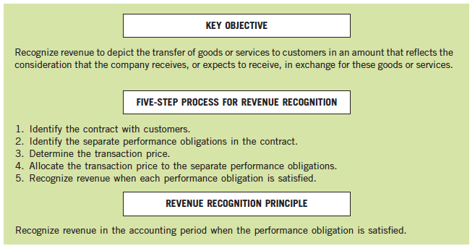
- Revenue can be recognized at different stages of the contract when performance obligations are met (ex. Warranty revenue)

- The following must be considered when determining transaction price:
    - Variable consideration
    - Time value of money
    - Noncash consideration
    - Consideration paid or payable to the customer (ex. Rebates, points, miles)
- ASPE says measure miles/rewards based on cost of the incentive (not cost of the seat because the plane is leaving either way), IFRS says measure points at fair value

- Revenue from miles/points stay as deferred revenues until they are redeemed; if they aren’t redeemed after a certain period they are automatically recognized as revenue

- Variable consideration occurs when the transaction value can change based on the occurrence of some future event (ex. Completion time bonuses/penalties for services)
  - Can be measured using either expected value (%) or most likely method (get the bonus or not)

ABC Inc sells a machine to XYZ corp for $100,000. To finance the purchase, the company agrees to finance the purchase with XYZ signing a 5-year note with a 0% interest rate. At the time of the sale, prevailing market rates are 5%
Prepare the journal entries for the first two years.
Future Value (FV) - 100,000
Time (n) - 5 Illustration 6A-2
Interest (i) - 5% .78353

YR 1
Note Receivable 78,353
Revenue 78,353
Note Receivable 3,918
Interest Income 3,918
(78,353 x 5%)
YR 2
Note Receivable 4,114
Interest Income 4,114
((78,353 +3918) x 5%)
Chapter 7: Cash and Receivables
- Overdrafts are reported as current liabilities (often reported as accounts payable)

- In general, bank overdrafts should not be offset against the Cash account
  - However, bank overdrafts may be offset against available cash in another account if both accounts are at the same bank

- Cash equivalents are reported at fair value

- Receivables can be classified as either trade or nontrade receivables
  - Nontrade receivables aren’t used in sales ratios

- Trade receivables include:
  - Accounts receivables (typically within 30-60 days)
  - Notes receivables

- Nontrade receivables include:
  - Advances to employees or other officers
  - Delayed payment terms from a purchaser
  - Receivables from the government (e.g. GST recoverable, income tax receivable)
  - Dividends and interest receivable
  - Amounts owing by insurance companies

- Two ways of recording cash discounts:
  - Gross method – records discounts when customers pay within discount period
  - Net method – records A/R net of the discount; discounts forfeited by customers are recorded when not taken
    - “Sales Discounts Forfeited” is recorded as “Other revenue” if customer does not take the discount

Chapter 8: Inventory
- Inventory is initially recorded at cost, then lower of cost net realizable value (NRV)

- Comparison of cost and NRV should be done on an item-by-item basis
  - If the NRV is higher than the initial cost, no adjustment is required (keep at cost)
  - Are reversible, but not above cost

- Recording the cost less NRV:
  - Direct Method: Cost of goods sold
Inventory
  - Indirect Method: Loss Due to Decline In NRV
Allowance to Reduce Inventory

- Gross profit method of estimating inventory is done under 3 assumptions:
- Beginning inventory + purchases = cost of goods available for sale
- Goods not sold are in ending inventory
- Cost of goods available for sale – cost of goods sold = ending inventory

- Markup on cost: 30%
- Sales: 130
- Cost of sales: 100
- Gross profit: 30
- 30/130
- Gross profit % =23.1%

Chapter 9: Investments
- There are 3 main models of accounting for investments:
  - Cost/amortized cost model (Debt/Bond investments ONLY)(require date of maturity)
  - Fair value through net income model (FV-NI)(short-term)
  - Fair value through other comprehensive income model (FV-OCI)(long-term)
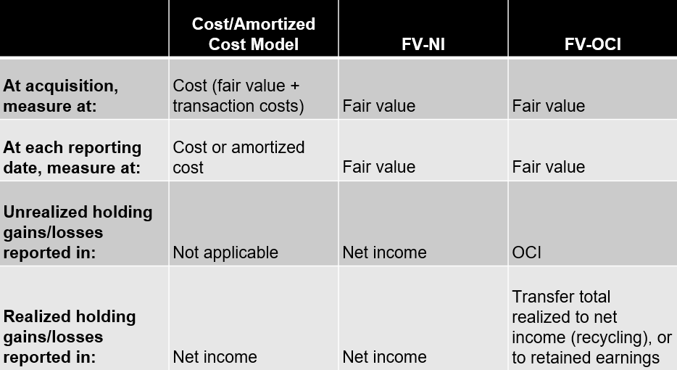
- Under the Amortized cost model, gains are only recorded when the investment is sold (excluding interest income)

- Cost model for investments in shares of another entity:
  - Recognize cost of investment at fair value (plus direct transaction costs)
  - Report at cost (unless impaired)
  - Recognize dividend income when have claim to dividend
  - When disposed, derecognize and report a gain/loss on disposal in net income

- Investment classifications are irrevocable

- Transaction fees:
  - FV-NI – charged to net income
  - FV-OCI – subtracted from value of investment

- When a FV-OCI investment is sold, transfer gain/loss in OCI to retained earnings

- Interest Income = Amortized cost of bond X Market interest rate X periods

- A=P(1+$\frac{r}{n}$)^{nt}, r = annual interest rate, n = times interest is compounded each year, t = years

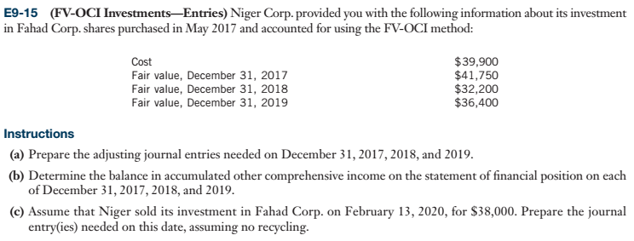
Investment Accumulated OCI
39,900 1,850
1,850 9,550 l
41,750 9.550 7,700
32,200 4,200
4,200 3,500 1,600
36,400 1,900

Dec. 31, 2017
Invest shares 1,850
Holding Gain (OCI) 1,850

Dec. 31, 2018
Holding Loss (OCI) 9.550
Invest Shares 9.550

Dec. 31, 2019
Invest Shares 4,200
Holding Gain 4,200

Disposition
Invest Shares 1,600
Holding Gain 1,600

Cash 38,000
Invest Shares 38,000

Retained Earnings 1,900
Accumulated OCI 1,900

- Under IFRS, investments in associates are accounted for using the equity method

- Equity Method:
  - Investment recorded at cost of acquisition
  - Investor takes into income its respective share of the investee net income for the year by debiting the investment account and crediting investment income
  - Any dividends are credited to the investment account
  - The accrual basis of accounting is applied

Example
Given:
- Maxi Corp. purchases 20% of Mini Corp., and exercises significant influence
- January 2, 2016 Maxi purchases 48,000 shares @ $10 per share
- For the year 2016 Mini Corp. reports a net income of $200,000; Maxi Corp.’s share is 20% or $40,000
- December 31, 2016 shares of Mini Corp. have a market price of $12 per share
- January 28, 2017 Mini Corp. declared and paid a total cash dividend $100,000
- For the year 2017, Mini Corp. reports a net loss of $50,000
Prepare all necessary journal entries, using the Equity Method

SOLUTION
January 2, 2016
Investment in Mini Corp. 480,000
Cash 480,000
(48,000 shares x $10)
December 31, 2016
Investment in Mini Corp. 40,000
Investment Income 40,000
($200,000 net income x 20%)
December 31, 2016
No entry required to reflect market price (or fair value). Investment is not impaired.

January 28, 2017
Cash 20,000
Investment in Mini Corp. 20,000
($100,000 Dividend x 20%)
December 31, 2017
Investment Loss 10,000
Investment in Mini Corp. 10,000
($50,000 net loss x 20%)

Paying more than the fair value of a company’s shares and assets
Ex. Paid $200,000 premium
Fair value – Book value
Inventory (200,000)
Land 300,000
Patent (6 yrs) 300,000
LT Debt (4 yrs) (200,000) higher market interest rates
200,000
40% 80,000
Goodwill 120,000

END YR Net Income 300,000
Dividend 150,000

Cash (150,000 x 40%) 60,000
Investment in Assoc. 60,000

Investment in Assoc. (40% x 300,000) 120,000
Investment Income 120,000

Fair Value Adjustments
Inventory (fair value < book value) 200,000
Land (no depreciation)
Patent Amortization (300,000/6 years) ( 50,000)
L-T Debt (market rates are higher) (200,000/4 yrs) 50,000
200,000

Chapter 11: Depreciation, Impairment, and Disposition
Ex. A building was purchased at a cost of $5,000,000 on Jan 2, 20x1. Part of the cost ($200,000) was allocated to the furnace which had an estimated useful life of 20 years with no salvage value

On December 31, 20x14, the furnace was replaced at a cost of $260,000. The estimated useful life od the new furnace is 13 years. Assume straight-line depreciation method is used.

Furnace – New 260,000
Cash 260,000

Acc. Dep, - Old Furnace 140,000
Loss on Disposal 60,000
Furnace – Old 200,000

- Double Declining Balance method - (1 / useful life) x 2 = % depreciated per period

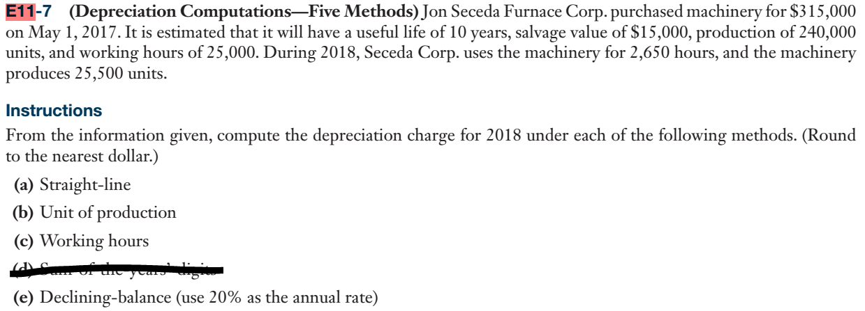
- 315,000 – 15,000 / 10 = $30,000/year depreciated

- 300,000 / 240,000 =$1.25/unit
25,500 * 1.25 = $31,875 depreciated

- 300,000 / 25,000 = $12/hour
2,650 * 12 = $31,800 depreciated
- Not needed
- 315,000 x 0.2 * (8/12) = $42,000 depreciated in 2017
315,000 – 42,000 = $273,000
273,000 * 0.2 = $54,600 depreciated in 2018

Impairment
- IFRS:

- Carrying Value (Book value – depreciation)
- Recoverable Amount:
Use Greater of:
- Value-in-use (Discount future net cash flows)
- Fair Value – Cost to dispose

- ASPE:

- If Carrying Value < Undiscounted future cash flow = NO IMPAIRMENT
Carrying Value > Undiscounted future cash flow = IMPAIRMENT

- Measurement
Carrying Value – Fair Value

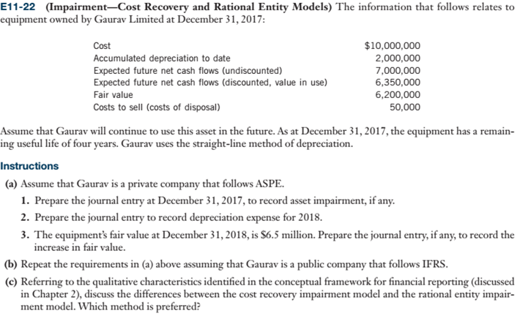a) UNDER ASPE
1. Carrying value = 8,000,000 Undiscounted cash flow = 7,000,000
Therefore we have impairment
ASPE Impairment = Carrying Value – Fair Value
= 8,000,000 – 6,200,000
Impairment = 1,800,000
2. Dep. Exp =6,200,000 / 4
= 1,550,000
There is no journal entry for part 3 because the fair value will be greater than the carrying value.

b) UNDER IFRS
1. Carrying value = 8,000,000
Recoverable amount = Greater of value in use = 6,350,000
Fair value = 6,200,000 – 50,000 (disposal) = 6,150,000
Use greater amount (recoverable or fair)
Impairment = 8,000,000 – 6,350,000
= 1,650,000

2. Depreciation = Undiscounted future net cash flows / useful life
= 6,350,000 / 4 = 1,587,500

- Discounted flows – 2018 depreciation 2018 Carrying Value
6,350,000 10,000,000
1,587,500 (2,000,000)
4,762,500 (2,000,000)
6,000,000

$1,237,500

