Lab BCH2333
SECTION: 03 (Monday afternoon 1st week)

LAB 4: LIPIDS AND MEMBRANES

TA: Sarah Osterholm

March 9, 2020

TEAM # 10
Camila Almonacid 8753583

Purpose:

The purpose of this experiment was to prepare two membrane fractions of liver tissue from a calf. The first fraction was endoplasmic reticulum enriched (microsomal fraction). This fraction then had its lipids extracted from it a separated by TLC. The second fraction was a mitochondrial enriched fraction which went under analysis to determine its lipid/protein ratio.

Results and Discussion:

R1: Attach a figure of your TLC plate with corresponding labels for all of the lipids. Prepare a summary table providing the R_{f} values of the lipid standards for each of the two solvent systems. Are the R_{f} values of all standards identical for both solvent systems? If not, explain why some differences were observed.

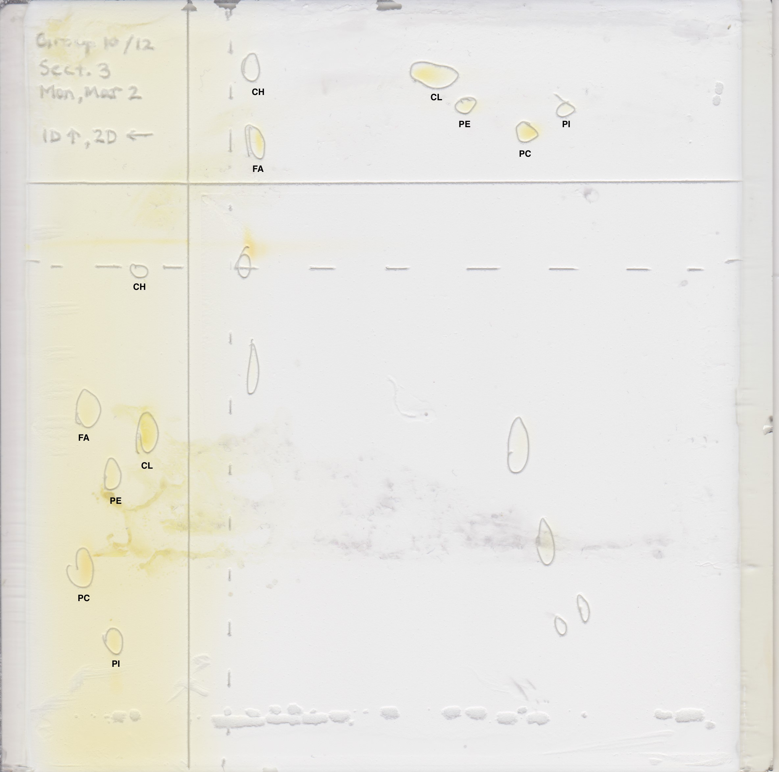

Figure 1: 2D-TLC Separation of a Microsomal Lipids Sample. A 20x20cm silica plate was activated by heating it at 100°C for approximately 1-2hours. This plate was used to run a TLC to separate the different lipids found in the microsomal membrane fraction. The TLC ran along two different dimensions, in different directions, which were marked previously to it being developed. 5μL of three different lipid standards were spotted at the TLC starting line for each dimension. The first standard was a fatty acid (FA) and phosphatidylcholine (PC) mix, the second standard was a phosphatidylinositol (PI) and phosphatidylethanolamine (PE) mix, and the third standard was a cardiolipin (CL) and a cholesterol (CH) mix. For both dimensions, at the opposite corner of were the dimensions met, 10μL of a sample solution was spotted. The plate was then developed in both an acidic and a basic solvent system (one per dimension). When dried the plate was placed in an iodine tank and then removed to have the developed spots marked.

Table 1: R_{f} lipid values on both dimensions. As stated in figure one, an activated TLC plate was spotted on two dimensions with 5μL of three different lipid standard solutions. 10 μL of a sample was also spotted at the opposing corner of where the two dimensions met. The first dimension was then developed in a tank containing a basic solvent system of CHCl3‐MeOH‐ammonia (65:35:5 v/v). Once developed and dried with a heat gun, the plate was turned 90 degrees to allow the second dimension to develop in an acidic solvent system of CHCl3‐acetone‐MeOH‐acetic acid‐H2O (10:4:2:2:1; v/v) and then dried with a heat gun. Both dimensions were developed for about 60 minutes until the solvent reached about 1cm from the horizontal line. The TLC plate was then placed in an iodine saturated tank for approximately 5 minutes and the developed spots were marked. Once marked it was possible to obtain the R_{f} values of each of the developed spots.

R_{f} Values  Lipid | Dimension 1 | Dimension 2
Fatty acid (FA) | 0.73 | 0.95
Phosphatidylcholine (PC) | 0.41 | 0.42
Phosphatidylinositol (PI) | 0.27 | 0.35
Phosphatidylethanolamine (PE) | 0.61 | 0.54
Cardiolipin (CL) | 0.67 | 0.6
Cholesterol (CH) | 0.99 | 0.95

Sample Calculations:

- R_{f} Value- Dimension 1: FA
Distance travelled _{solute (FA)} = 10cm
Distance travelled _{solvent (basic)} = 13.7cm

$$R_{f}=\frac{{Distance Travelled}_{solute (FA)}}{{Distance Travelled}_{solvent (basic)}}$$
The R_{f} value of FA in dimension 1 was 0.73.
$$R_{f}=\frac{10cm}{13.7cm}$$

$R_{f}=$0.73
- R_{f} Value- Dimension 2: FA
Distance travelled _{solute (FA)} = 13.3cm
Distance travelled _{solvent (acidic)} = 14cm

$$R_{f}=\frac{{Distance Travelled}_{solute (FA)}}{{Distance Travelled}_{solvent (acidic)}}$$
The R_{f} value of FA in dimension 2 was 0.95.
$$R_{f}=\frac{13.3cm}{14cm}$$

$R_{f}=$0.95

As can be seen from the results in Table 1, the R_{f} values for the standard vary slightly between dimensions. FA had the most difference in R_{f} values. This was due to the polarity of the solvent used in each dimension. In the first dimension the higher polarity of the solvent allowed for the solvent to remain polar. However, in dimension 2 the lower polarity protonated the FA molecule leaving it less polar. For PC and PI, the values are slightly higher in the second dimension. Meanwhile for PE, CL, and CH, the values are slightly higher in the first dimension. The silica gel on the TLC plate is polar, as well as both of the solvents used. However, the acidic solvent used in the dimension 2 was slightly less polar than the one used in the dimension 1. Due to the polarity of the plate, there is an interaction between the silica gel and the polar molecules which prevents the molecules to travel up the plate when developed in a polar solvent. Therefore, the less a molecule travelled the more polar it was. Meaning that the less polar molecules were able to travel up further dimension 2 due to the lower polarity of the solvent.

R2: From your results, rank the standard lipids by increasing order of polarity for each of the two chromatographic conditions that were assessed. Include the chemical structures of all lipid standards and, for each one, identify the polar groups. For each pair of standards, compare the polarity ranking within members of the pair. Explain your reasoning.

Table 2: Ranking of Lipids in Dimension 1 and Dimension 2. Three standards where used to separate the lipids found within them. Each standard was composed of two lipids, where one lipid was more polar than the other allowing for the separation via a TLC plate. The rankings are based on the polarity of each lipid based on the R_{f} values obtained from the TLC. The ranking is from one to six, where one is the most polar and six is the least polar. In the case of the dimension 2 the lowest ranking is five as both FA and CH have the same R_{f} values.

Lipid | Structure | Ranking: Dimension 1 | Ranking: Dimension 2
Fatty acid (FA) | 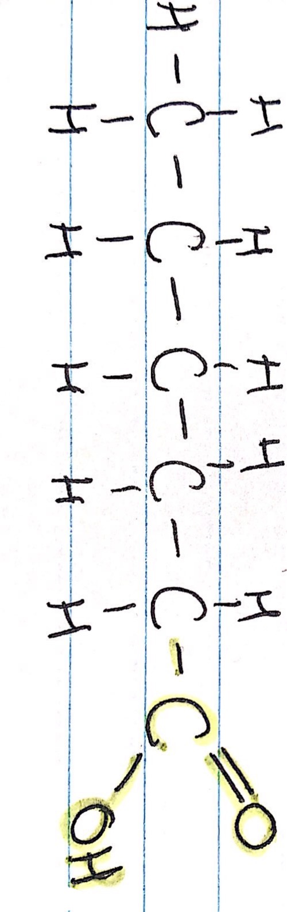 | 5 | 5
Phosphatidylcholine (PC) | 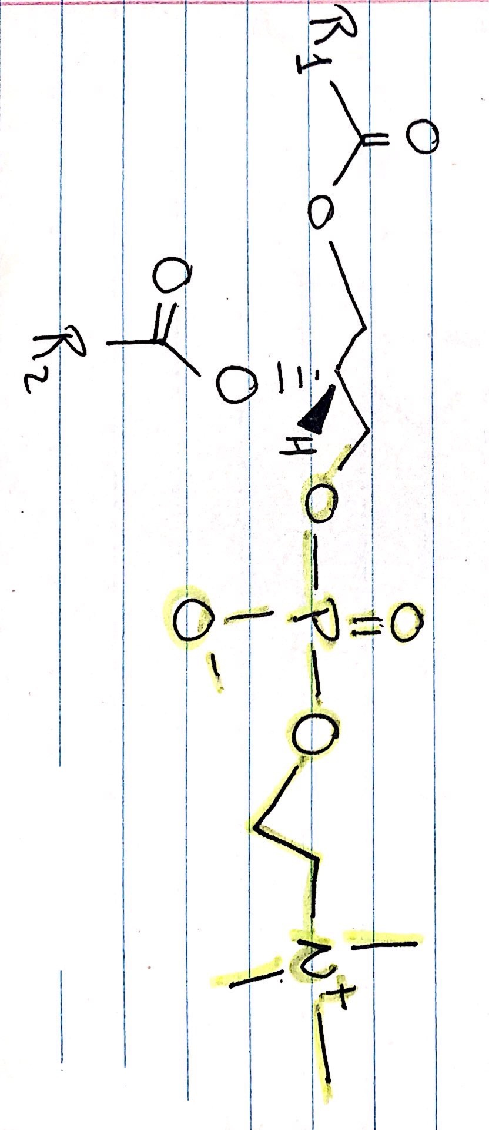 | 2 | 2
Phosphatidylinositol (PI) | 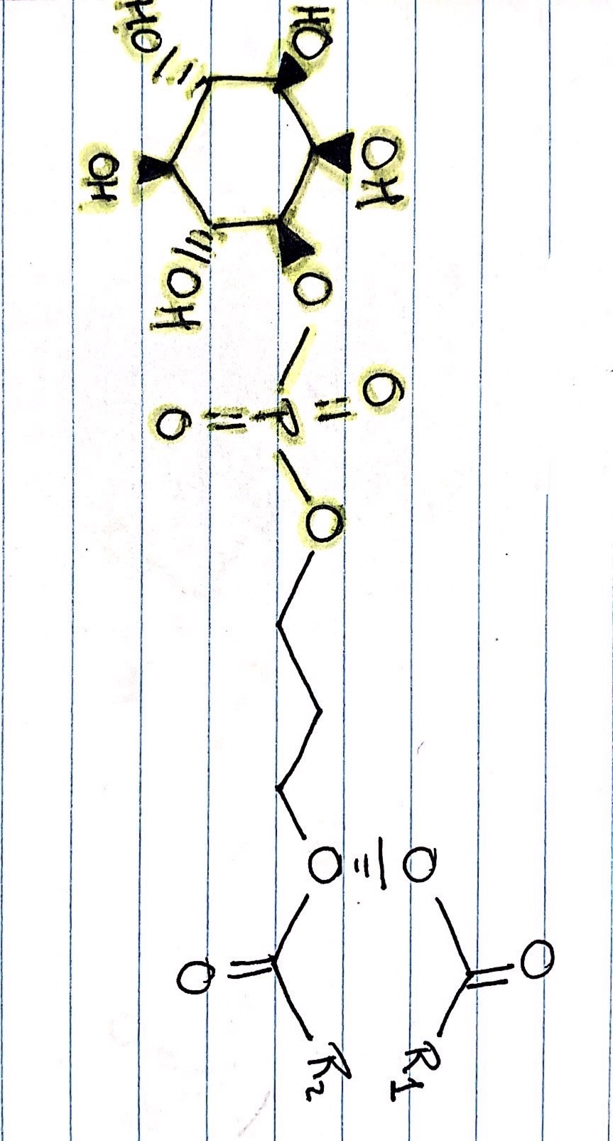 | 1 | 1
Phosphatidylethanolamine (PE) | 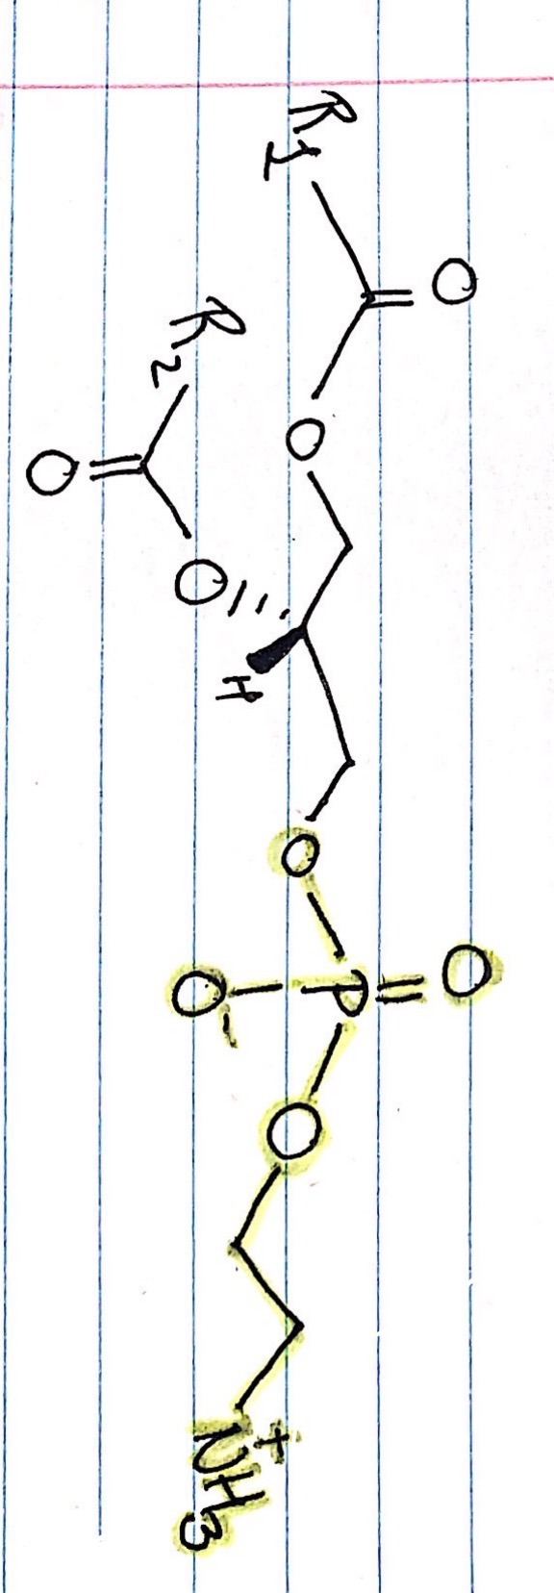 | 3 | 3
Cardiolipin (CL) | 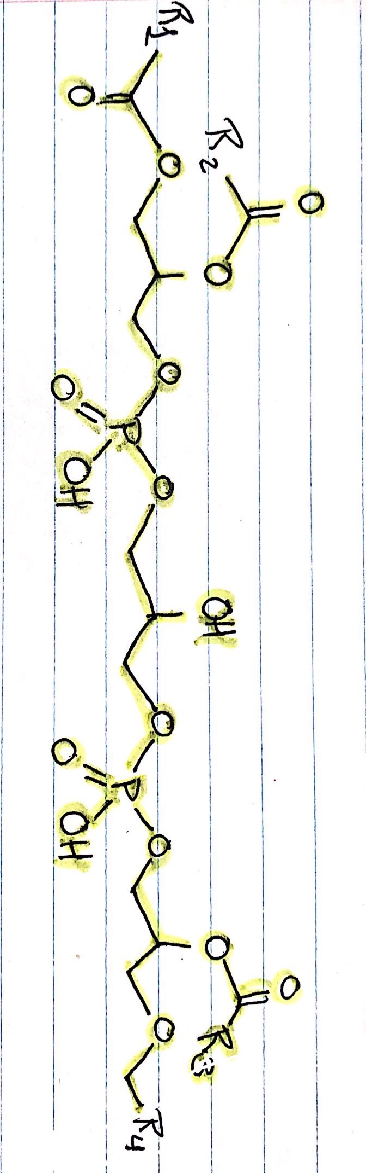 | 4 | 4
Cholesterol (CH) | 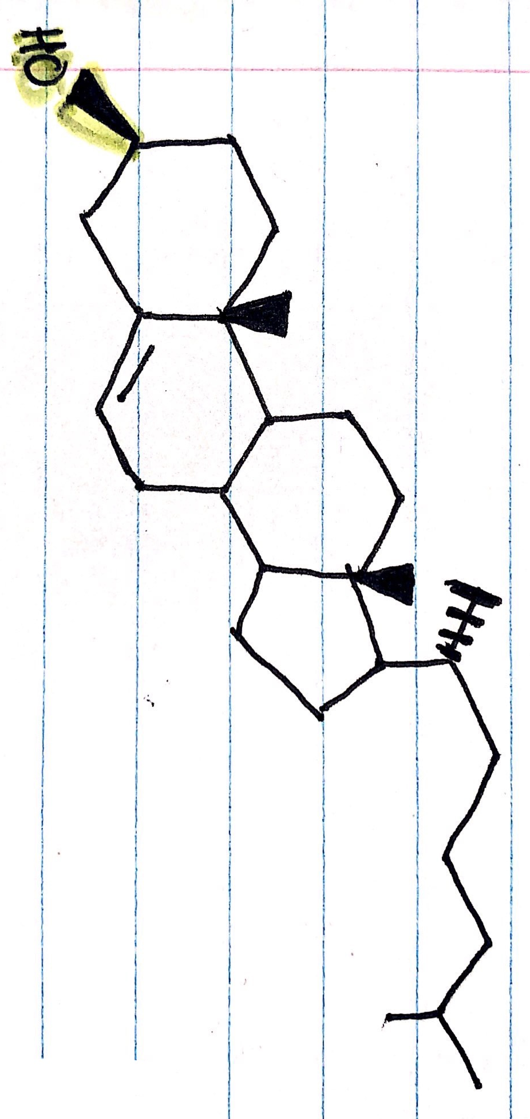 | 6 | 5

Standard 1 – FA/PC:

- PC has a higher polarity, thus a higher ranking in both dimensions. The phosphate group in PC contains a deprotonated oxygen, which makes it more polar than the carboxyl group found in FA.

Standard 2 – PE/PI:

- PI has a higher polarity, thus a higher ranking in both dimensions. PI has five hydroxyl groups and a phosphate group making it more polar than PE which only has a phosphate group and an amine group.

Standard 3 – CH/CL:

- CL has a higher polarity, thus as higher ranking in both dimensions. CL contains two phosphate groups, which each has a deprotonated oxygen. Meanwhile, CH only has one hydroxyl group. Due to the much higher number of polar functional groups found in CL, CL is more polar than CH.

R3. For each assay prepare: a) a table containing the dilution fraction and the absorbance. b) a plot of the absorbance at 559 nm (lipid assay) and at 280 nm (protein assay) against the dilution fraction, including a point for the blank (reagent alone, no sample). In the protein assay plot, your control sample should be at zero. For the lipid assay plot, the linear region of the plot is normally found within the three or four most dilute samples. These slopes represent the decrease/increase in absorbance corresponding to a dilution factor of one, that is, the undiluted sample.

Lipid Assays

a)

Table 3: Lipids Assay. Approximately 3g of calf liver were minced and then homogenized with 10mL of ice-cold homogenization buffer (10mM Tris, 0.25M sucrose, 1mM EDTA, 1 mM DTT, pH 7.5). The homogenate was then transferred to a 15mL Cortex tube and then placed in a centrifuge to be centrifuged at 4°C for a duration of 10 minutes at 1000xg. The resulting supernatant was then filtered, and the filtrate was transferred to a new 15mL cortex tube. The filtrate was then centrifuged again at 4°C for a duration of 10 minutes at 25000xg. The pellet in the supernatant was removed and set aside and the supernatant was transferred to a 15mL Falcon tube. The pellet was resuspended 10mL of the homogenization buffer and the suspension sonicated twice at 50% for 10 seconds each time. According to the calculated values in table three prior to the experiment, different test tubes were prepared and assayed. Once assayed the absorbance was read for each test tube at 559nm.

Sample | Dilution Fraction | Phosphate pH 11, 0.2 M (mL) | Water (mL) | Membrane Suspension (μL) | Brilliant Blue R 1.25 g/L (μL) | Abs_{559nm}
1) Control | 0 | 1 | 0.95 | 0 | 50 | 0.886
2) 1/200 | 0.005 | 1 | 0.94 | 10 | 50 | 0.871
3) 1/100 | 0.01 | 1 | 0.93 | 20 | 50 | 0.752
4) 1/40 | 0.025 | 1 | 0.90 | 50 | 50 | 0.550
5) 1/25 | 0.04 | 1 | 0.87 | 80 | 50 | 0.467

b)

Figure 2. Plot of the absorbance readings at 559nm vs. the dilution fraction of the lipids assay. Given the values in Table 3, the absorbance readings and the dilution fractions were plotted. There results gave a linear trendline with a slope of y = -11.319x + 0.8863. The negative slope reflects that as the dilution factor increased the absorbance decreased.

Protein Assays:

a)

Table 4: Protein Assay. Approximately 3g of calf liver were minced and then homogenized with 10mL of ice-cold homogenization buffer (10mM Tris, 0.25M sucrose, 1mM EDTA, 1 mM DTT, pH 7.5). The homogenate was then transferred to a 15mL Cortex tube and then placed in a centrifuge to be centrifuged at 4°C for a duration of 10 minutes at 1000xg. The resulting supernatant was then filtered, and the filtrate was transferred to a new 15mL cortex tube. The filtrate was then centrifuged again at 4°C for a duration of 10 minutes at 25000xg. The pellet in the supernatant was removed and set aside and the supernatant was transferred to a 15mL Falcon tube. The pellet was resuspended 10mL of the homogenization buffer and the suspension sonicated twice at 50% for 10 seconds each time. According to the calculated values in table three prior to the experiment, different test tubes were prepared and assayed. Once assayed the absorbance was read for each test tube at 280nm.

Sample | Dilution Fraction | Phosphate pH 11, 0.2 M (mL) | Water (mL) | Membrane Suspension (μL) | Abs_{559nm}
1) Blank | 0 | 1 | 1 | 0 | 0
2) 1/100 | 0.01 | 1 | 0.98 | 0.02 | 0.098
3) 1/20 | 0.05 | 1 | 0.90 | 0.10 | 0.720
4) 1/5 | 0.2 | 1 | 0.60 | 0.40 | 2.438

b)

Figure 3. Plot of the absorbance readings at 280nm vs. the dilution fraction of the protein assay. Given the values in Table 3, the absorbance readings and the dilution fractions were plotted. There results gave a linear trendline with a slope of y = 12.177x + 0.0225. The positive slope reflects that as the dilution factor increased the absorbance increased as well.

R4. Assuming an absorptivity (or extinction coefficient) at 280 nm of ε = 2.0 Lg‐1 cm‐1 for membrane proteins, calculate the protein concentration of your membrane preparation from the increase in absorption corresponding to your undiluted sample. Show your calculation.

Calculations:

- Protein Concentration:

- $A=$$y\left(x\right);when x=1$
Absorbance vs. Dilution Equation:
y = 12.177x + 0.0225

x = 1
ε = 2.0 Lg‐1 cm‐1
L = 1.0 cm

$$A=12.177\left(1\right)+0.0225$$

$$A=12.1995$$

- $A= cl$
The protein concentration of the membrane preparation is 6.099 g/L

$$c=\frac{A }{εl}$$

$$c=\frac{12.1995}{(2.0 Lg^{-1}{cm}^{-1})(1.0cm)}$$

$$c=6.099 g/L$$

R5. Assuming that 1.0 μg/mL of membrane lipids causes a decrease in Brilliant Blue R absorption at 559 nm of 0.013, calculate the concentration of lipids in the mitochondria‐ enriched fraction from decrease in absorption corresponding to your undiluted sample. Show your calculation.

Calculations:

- Lipid Concentration:
Absorbance vs. Dilution Equation:
y = -11.319x + 0.8863

x = 1
A_{control} = 0.886
A_{D} = 0.013
C_{D} = 1.0 μg/mL

- $A= y\left(x\right);when x=1$

$$A=-11.319(1) + 0.8863$$

$$A= -10.4327$$

- $A_{L}=A_{Control}-A$

$$A_{L}=0.886-(-10.4327)$$

$$A_{L}=11.3187$$

- $\frac{C_{D} }{A_{D}}=\frac{C_{L} }{A_{L}}$

$$C_{L}=\frac{C_{D}A_{L} }{A_{D}}$$

$$C_{L}=\frac{(1.0 g/mL)(11.3187)}{0.013}$$
The protein concentration of the membrane preparation is 8.7067x10⁻¹ g/L.

$$C_{L}=870.669\frac{g}{mL}=8.7067x10^{-1}\frac{g}{L}$$

R6. From your results, estimate the yield for your mitochondria preparation in mg of mitochondrial proteins per gram of liver tissue (mg/g)

Calculations:

- Yield of Mitochondrial Proteins:

- $m_{protein}=C_{protein}V_{protein}$
C_{protein} = 6.099 g/L
V_{protein} = 0.01L
m_{tissue} = 3.0g

$$m_{protein}=(6.099 g/L)(0.01L)$$

$$m_{protein}=0.06099 g=60.99 mg$$
The yield of mitochondrial proteins in the mitochondria preparation was 20.33mg/g

- ${Yield}_{mitochondrial protein}= \frac{m_{protein}}{m_{tissue}}$

$${Yield}_{mitochondrial protein}= \frac{60.99mg}{3.0g}$$

$${Yield}_{mitochondrial protein}= 20.33mg/g$$

