Chapter 3: Charles Darwin and Evolution
3.1 Charles Darwin: Education and Family
- Quit studying medicine and wanted to become a pastor << needed a bachelor of arts; developed interest in nature: taxidermy, insect collecting, botany, etc
3.2 The Voyage on the Beagle
- (3) naturalist
- Left on the Beagle (ship commissioned by British government to do the cartography of the coast of South America)
- Invited on board as a companion of the captain; became naturalist (original person dropped it)
- Traveled the world and spended time on land to sample the fauna and flora and to study South-American geology
- Expected to be a 2-year trip; lasted 5 years
- Collected things, put it in a barrel and someone else from the British government picked it up
- (4) intelligent design, Theory of Uniformity
- Brought a box of books; 2 books impacted Darwin
  - William Paley: “Theology, or evidences of the existence and attributes of the deity”
    - Paley is the father of the Theology of Nature
    - Nature is so complex that it proves the existence of God; harmony and design in nature are indicators of the existence and acts of God
    - Ex. Human eye is so complex that it could not have evolved
  - Charles Lyell: “Principles of Geology”
    - Darwin originally believed in Cuvier’s catastrophism
    - After his trip, agreed with Lyell and Hutton’s theory of uniformity
- There was an earthquake which changed the land; had to redo his cartography
- Found fossils of mollusk (?) above sea level
- (6) South America
- Why do the fauna and flora of Africa, Europe, Australia and south American have few species in common?
  - Lamarck: same environments have same species
- Idea of creation implies a lot of assumptions
- Unique fauna on the Galapagos Islands
- (8) variability
- A lot of shell variability in tortoises (depending on the island)
- Wondered why God would create tortoises only on the Galapagos Islands and create different ones for each island
- Lamarck’s theory did not make sense
- Each bird has a similar body but different beak; associated with eating habits
3.3 Evolution and Natural Selection
- (10) common ancestor
- Created a phylogenetic tree
- Species show resemblance to each other bc they share a common ancestor (not a common environment)
  - Rejects the fixity (no change) of species and Lamarck’s theory (environmental determinism)
  - Accepts the concept of descent with modifications (evolution)
  - Did not include the word evolution in his book bc evolution was associated with mankind
  - Very materialistic view of life that contradicts the religious dogma of the time
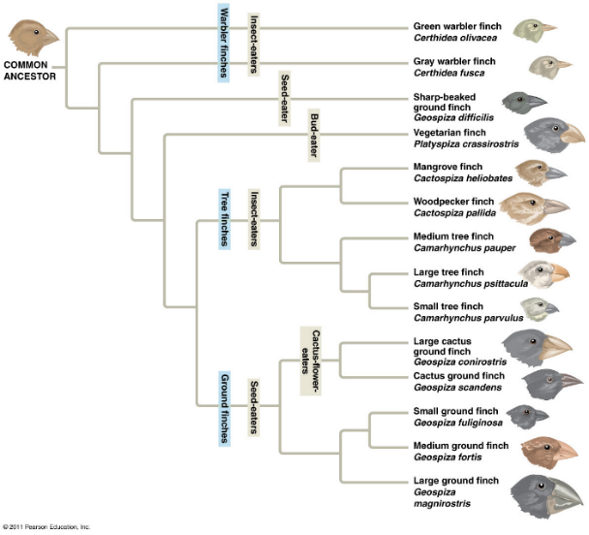
- Began the search for an evolutionary mechanism

September 19, 2018
- (11) share a common ancestor
- Finches of the Galapagos Islands show morphological similarities because they share a common ancestor
- 3 species (rock hyrax, African elephant, and dugong) have a common ancestor but are very different
- (13) 99%
- 99% of species that have lived on Earth are extinct
- Most of the evolutionary branches finish in a dead-end (extinction)
- Fossils helped to see the progression in morphology; fills the gaps
- Darwin decided to find the evolutionary patterns
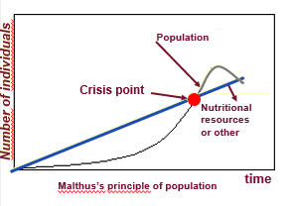
- Darwin read “An essay on the principle of population” written by economist Thomas R. Malthus
- Malthus focused on the growth of human population
- This reading inspired Darwin’s theory on natural selection
- (15) geometrically, arithmetically
  - Every human population has a tendency to increase geometrically, whereas the available resources to feed these populations increase arithmetically
- Human population increases exponentially; resources increase linearly
- People who can secure resources will survive and reproduce
- The population crashes when there aren’t enough resources
- Human population increases faster than its capacity to feed itself
  - Leads to chaos and eventually a substantial reduction in population size
- (16) chaos
- (17) offspring
- Darwin’s first observation: all species can produce more offspring than their environment can sustain and many of these offspring fail to survive and reproduce
- Puffball: only a few spores will reproduce
- (18) inherited traits
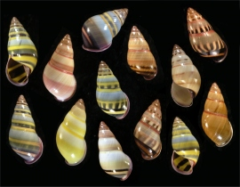
- Darwin’s second observation: members of a population often vary in their inherited traits
- A lot of variability in inherited traits
- Genetic variability: may cause advantages
- Variability is not viewed as imperfection anymore
- (19) natural selection
  - Those with higher survivability due to inherited traits reproduce and leave more offspring than other individuals
  - The unequal capacity of survive and reproduce (differential reproductive success) results in an accumulation of favourable traits in a population
- Ex. Coloured fish + duck
- Advantage: produce more offspring; those with an advantage become more abundant
- Cannot have adaptation without genetic variability
- (20) 23 years
- Wallace told Darwin about his same conclusions of the theory of natural selection
- 23 years after the Beagle, Darwin publicly released his ideas on the evolution of species
- (21) On the Origin of Species
- Darwin and Wallace presented a resume of their ideas on natural selection to the Linnean Society of London
- Darwin published his first edition of his book “On the Origin of Species”
- (22) populations, adapted
- Important notions linked with natural selection
  - Individuals do not evolve, populations evolve
    - We are carriers of genes
  - To measure evolution, you must look at the entire population
  - Only hereditary traits are subject to natural selection
  - Evolution only occurs when there is genetic variability
  - Natural selection corresponds to differential reproductive success within a population from generation to generation
  - With time, natural selection enables individuals to become better adapted to their environment
  - Environmental factors vary in time and space; selective forces are variable (ex. Changing the background of the fish)
    - Populations adapt to the environment
  - Traits in populations will change and modify the species
    - Species may change morphology through time
- (23) not random, perfection
- Darwin’s theory is valid bc:
  - Fits with Lyell and Hutton’s principle of uniformity
  - Results of natural selection are visible in nature
  - Mechanism can be verified on current populations (eg. artificial selection)
  - It is a materialistic concept (no need for divine intervention):
    - Mechanism is not random; those that are better adapted to the environment have a higher survival and reproductive rate
    - There is no perfect adaptation; evolution is not a directed process; does not lead to the appearance of “perfect traits”; organisms only adapt to their environment
- (24) artificial selection, natural selection
- Artificial selection is finalized bc of the goal, fixed well in advance, precedes the causes; end result can be obtained in a few generations
  - Ex. artificial selection with the vegetables: all come from wild mustard
- Natural selection is not finalized; can take a long time for changes to occur (geological time scale)
- Adaptation and evolution is measured by reproductive success
- Ex. Peppered moth: 2 morphs (grey and dark); environment was dark; predator would choose the grey moth bc it is more visible; in the country-side: predators choose the dark moth
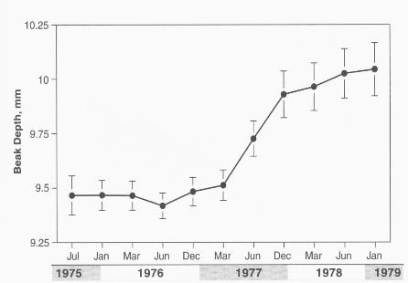
- (26) 1200, 80
- Medium ground finch: feeds on seeds
  - Trait of beak size was inherited from the parents
- Beak size of the 80 birds that survived: larger beaks; able to break large seeds (the available seeds) and survive
- (28) adaptation to altitude
- Guide had a genetic makeup that allowed him to be at high altitudes
- (29) acclimatization
- Acclimatization: body adjusts by creating more RBCs
  - almost recuperate normal respiratory functions
  - Probability of a blood clot increases
- Mutations do not occur due to environmental need
- Ex. Mutation was present in the lowland population; once they moved to a higher altitude, the mutation was favoured
- (35) adaptation
- Many regions in high altitude were independently colonized by humans
- On the Qinghai-Tibet Plateau, human adaptation to high altitude differs from the Andes
- (36) blood flow
- In the Andes: increase of [hemoglobin] (RBCs)
- In Qinghai: deeper breath, larger pulmonary capacity and increased blood flow; can pass more blood through their lungs
- Acclimation is not genetic; it is a reaction of the body to the high altitudes
- Convergent evolution: 2 different adaptations that are favoured for the same purpose
- (37) hereditary traits, reproductive advantage, natural selection
- The hereditary traits that give a reproductive advantage (ex. Adaptation) to individuals in a population will be favoured; from generation to generation, there will be a higher % of individuals carrying the adaptation; known as natural selection
- These adaptations can sometimes redefine a species and, in certain circumstances, define a new species

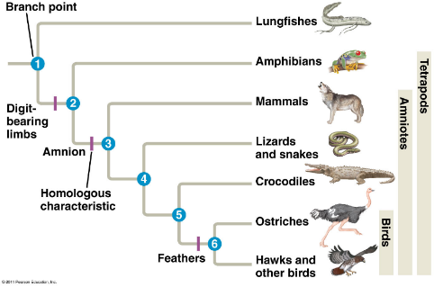
September 21
3.4 Proof of Evolution: Homology
- (38) homologous structures
- Descent with modification theory (theory of evolution) explains the resemblance between certain traits even if the functions are different (homologous structures)
- Search for homology: search for common ancestry
- There is a link between structure and function, but structures may not have the same function
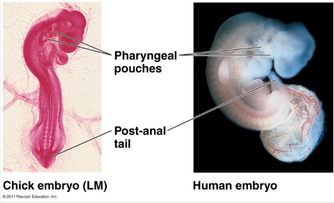
- Traits may not be evident in adults but instead in embryos
- All vertebrates have a post-anal tail
- Pharyngeal pouches: in fish, becomes gills; in humans and chicks, becomes incorporated into the throat and ear
- A structure may have evolved for a certain function, but through time the function has changed
3.4 Proof of Evolution: Fossils
- Horse: toes disappeared and teeth became longer; bc chewing on sand; used to live in the forest; modern leg allows the horses to run fast
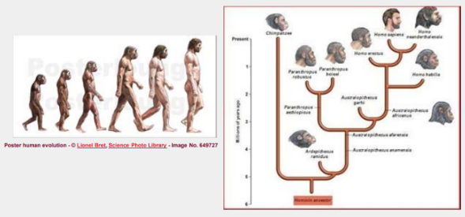
- (43) slide about humans
- Linear view of evolution may show trends that are not true
- Humans share common ancestry with chimps;
- Evolution is not linear; more like a tree
- Increase in height is not true
- Photo shows gradual linear evolution, but in the tree, there are multiple species living at the same time
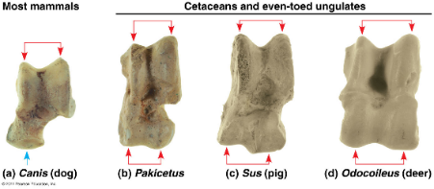
- Steer away from the idea of linear evolution
- Pakicetus: 2 bumps on the bone
- Hippos are closely related to whales
- Whales come from pakicetus (tetrapod)
- All that is left in whales is the pelvic bone that is lost in the flesh (suspended underneath the vertebral column)
- (44) vestigial structure: anatomic structure that has lost almost all of its initial function
- Bone is an indication of common ancestry (and is a vestigial structure)
- (45) appendix, goose bumps and hair
- Third eyelid is usually transparent; provides protection to the eye while ex. Flying or swimming
- Appendix is attached to the caecum; appendix may contain some bacteria but there is also bacteria everywhere else **********
- Ancestors were herbivores; symbiosis with another organism (ex bacteria) to digest cellulose
- Most of our digestion of vegetation occurred elsewhere
- Digestion of vegetation occurs in a large pouch
- Tip of fur creates a seal of air to trap warm air between the tip and the skin of the animal; protection from hypothermia
- We have all the mechanics and reflexes, but we don’t have the density of hair
- Hair did not become sparse bc of clothing
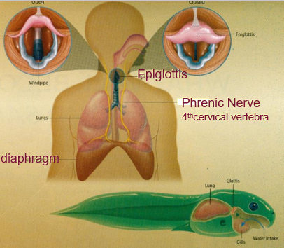
- (46) hiccups
- Contraction of the diaphragm
- The epiglottis closes
- Phrenic nerve: C4, goes through the thorax and is attached to the diaphragm
- Hiccups happen when the nerve gets squished
- How to get rid of hiccups: displace the nerve so it is not squished
- Why does this nerve originate from C4; happens in giraffes as well
- Common ancestry with fish:
  - Respiratory organs are in the throat
  - Nerve that makes it move is in the throat
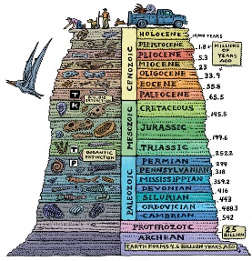
  - The nerve lengthened with the movement of the respiratory system
- Glottis evolved from amphibians
  - Prevents water from entering the lungs
- Contraction of diaphragm and closing of epiglottis happen together bc of the nerve
- (47) a fossil in the wrong place in the geological archives
- Finding a fossil in the wrong strata would refute the theory of evolution

