APSC 450 – Contract Law
Exam Hint #3
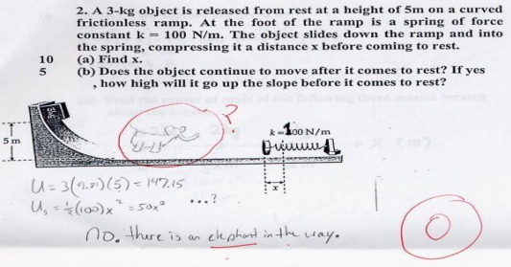
Contract Law
- A contract may be defined as an agreement between two or more persons that is enforceable at law.
- Comes into existence when the parties have established all of the elements to make it enforceable.
- Differs from tort law in that the parties are free to define their own rights and duties, as between themselves, which the law will then enforce.
Engineering Contracts
- Professional Services
- Employment
- Goods and services
Contract Law
- Elements of Valid Contract
  - Intention to create legal relationship
  - Offer
  - Acceptance
  - Consideration
  - Capacity to Contract
  - Legality
- Form
- Enforceability
- Privity
- Performance / Discharge
- Breach
Intention to Create Legal Relations
- Promise is essential to a contract but not all “promises” are enforceable
- Intention to be bound separates gratuitous promises from legally binding promises
- Intention is presumed, except when the circumstances dictate otherwise
Offer and Acceptance
Offer
- Conditional promise by offeror
- Not valid until communicated to offeree
- Not binding until condition accepted by offeree
- Open until accepted /lapsed /revoked
Offer and Acceptance
Acceptance
- Must be communicated as specified
Trans-Pacific v. Rayonier [1998] B.C.J. No. 890
- May be by conduct
Wardrop v. Lake Manitoba Band 2002 MBQB 319;
- Must be unconditional (or counteroffer)
- Inquiry is not acceptance/counteroffer
Consideration
- Bargain Theory requires that something be given for something in return. The somethings are termed “consideration”
  - money
  - a service
  - a promise to do something
  - a promise not to do something
  - a relinquishment of some right
- If no consideration – gratuitous promise (unenforceable)
Legal Capacity
No/limited capacity to contract:
- Minor / Infant
- Drunken / Insane Persons
- Corporations may have limited capacity
Burns Lake Indian Band v. Village of Burns Lake 2000 BCSC 1040
- Bankrupts

Legality
- Agreements that offend the public good are not enforceable:
  - Contracts for an illegal purpose
    - eg spying, criminal offenses
  - Contracts prohibited by statute
    - eg licencing as pre-requisite to practice
  - Contracts in Restraint of Trade
    - eg restrictive covenants
See Kathleen Still v. The Minister of National Revenue [1998] 1 F.C. 549
See Howe Sound School District v. Killick Metz Bowen Rose Architects 2008 BCCA 195
Requirements of Form and Writing
- Some contracts must be in writing (formal)
  - eg contracts for the sale of land
- Most contracts need not be in writing (simple)
- All contracts should be in writing for certainty
Failure to Create Enforceable K
- Mistake
978011 BC Ltd. v. Cornell Eng [2001] O.J. No. 1446
- Misrepresentations
- Undue Influence
- Duress
Ellis v. Friedland 2000 ABQB 657
Extent of Contractual Rights
- Privity of Contract
  - Only parties entitled to performance
- Exceptions:
  - Partners
  - Contracts for land with encumbrances
  - Assignment
  - Endorsement of Negotiable Instruments
  - Sale of Goods Act warranties
Clare v. IJ Manufacturing 2003 BCSC 856
Performance
- Tender of payment and tender of performance discharge the contract
- Discharge by other means
  - Termination as a Right
  - External Events
  - Condition Precedent
  - Operation of Law
  - Agreement
Breach of Contract
- Repudiation:
  - Express
  - Implied
- Terms:
  - Condition – essential terms (rescission);
  - Warranty – minor terms (damages);
- Fundamental Breach
Breach of Contract
- Remedies
  - Damages
  - Liquidated Damages
- Duty to Mitigate
Westland v. Carswell Collins [1996] A.J. No. 21
- Special Remedies
  - Specific Performance
  - Injunction
  - Quantum Meruit

