Harleen Grewal
EC140
Dave R. Johnson
Textbook Notes
TEXTBOOK NOTES

Midterm
- Chapter 19-22

SECTION A
CHAPTER 19 – Key Macroeconomic Variables

National Product and National Income
- National Product - The most comprehensive measure of a nation’s overall level of economic activity is the VALUE of its total production of goods and services
  - Sometimes referred to as just OUPUT
- Aggregation
  - To measure national income we add up the values of the many different goods and services produced
    - We can add the dollar value of steel production to the dollar value of bread production (two different products with different measurements)
      - Tonnes vs loaves
  - Multiple the number of units of each good produced by the price at which each unit is sold
    - This yields a dollar value of production for each good
    - Sum these values to get the quantity of total ouput/national income measured in dollars
      - Called Nominal national income
        - Total national income measured in current dollars
        - Also called current-dollar national income
        - Can be changed due to change in physical quantity or the price of the product
  - Real National Income
    - Used to determine the extent at which any change is due to quantities or prices
    - Measures the value of individual outputs, not at current prices, but as a set of prices that prevailed in some base period
    - Referred to as constant-dollar national income
      - Current output measured at constant prices
      - Reflects only changes in quantity not price

The Business Cycle
- No two business cycles are the same, they represent the ups and downs of business activity that occur around the long-term
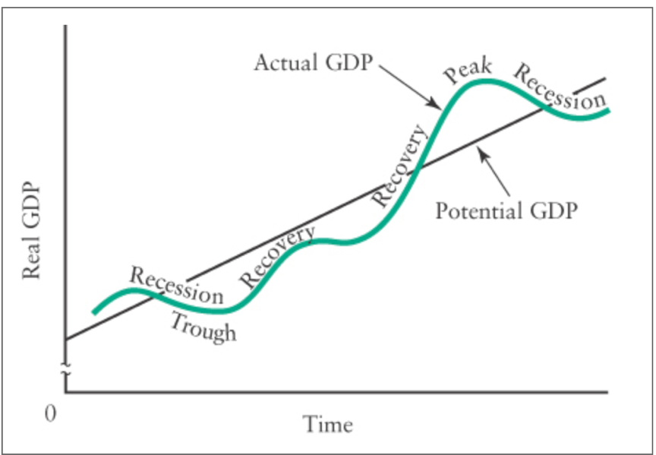
- Trough – characterized by unemployed resouces anda level of output that is low in relation to the economy’s capacity to produce
  - Business produts are low
  - Economic prospects immediately is lacking
  - Many firms unwilling to risk many new investment
- Recovery – moves economy out of a trough, characterized by…
  - Run-down or osolete equipment being replaces
  - Employement, income and consumer spending rise
  - Expectations become more favourable
  - Investments that once seemed risky may be undertaken
  - Production can be increased with ease by re-employing the existing unused capacity and unemployed labour
- Peak – top of the cycle, existing capacity is used to a high degree, labour shortages may develop, shortages of essential raw materials are likely
  - Shortages cause rises in price of inputs
  - However consequently there is a rise in prices maintaining a businesses profitability
- Recession – eventually slowdowns in economic activity
  - Down turn in economic activity
    - Fall in real GDP for two successive quarters
  - Ouput falls, emplotment and household income fall
  - Profits drop, firms encounter financial difficulty
  - Unwillingness to risk new investment as old ones appear unprogitable
    - Long ones are called depression
- GENERALLY…
  - Falling half – slump
  - Rising half – boom

Potential Output and the Output Gap
- National output represents what the economy actually produces
- If all resources were employed (land, labour, capital) is called the potential output
  - Estimated using statistical techniques, whereas actual ouput is measured direvtly
  - We use Y to denote the economy’s actual output and Y* to denote potential output
- Output gap
  - Difference between potential output and actual ouput (Y-Y*)
  - When actual output is less than potential (Y<Y*), there is a gap
    - Gap measures the market value of goods and services that are not produced because the economy’s resources are not fully employed
    - This is called a recessionary gap
  - When (Y>Y*), the gap measures the market value of production in excess of what the economy can produce on a sustained basis
    - Y can exceed Y because workers may work longer hours than normal
      - Factories operate extra shift
    - When this happens. there is often upward pressure on wages and prices
      - This is called the inflationary gap

Why National Income Matters
- Important measure of economic performance
- Real per capita national income is an important way to determine improvements in a society’s overall standard of living
- When income per person grows, each generation can expect, on avg, to be better off than preceding ones
  - Not EVERY one is better off though

Employment, Unemployment, and the Labour Force
- If more output is to be produced, either more workers must be used in production, ot existing workers must produce more
  - First implies rise in employment
  - Second implies rise in productivity
- In the short-run changes in productivity tend to be small
  - Thus, most short-run changes are accomplished through changing employment
  - Over the long run, change in productivity and employment are significant
- Employment
  - Number of adult workers 15 and over who have jobs
- Unemployment
  - Number of adult workers who are not employed but are actively searching for a job
- Labour Force
  - Total number of people who are either employed or unemployed
- Unemployment Rate
  - Number of unemployed people expressed as fraction of labour force
  - = # of people unemployed/number of people in labour force * 100

Frictional, Structural, and Cyclical Unemployment
- When the economy is at potential GDP there is Full employment
  - However, there are two reasons why there is still unemployment when at potential GDP
- 1. Frictional Unemployment
  - Constant turnover of individuals in given jobs and a constant change in job opportunities
  - New people enter workforce: some quit, some fired
- 2. Structural Unemployment
  - The economy is constantly adapting to shocks, at any moment there can be some mismatch btwn the characteristics of the labour force and the characteristics of the available jobs
  - May occur due to the labour not having the skills in demand or because the labour is not in the area where the demand is
  - Mismatch between structure of supplies and structure of demand
- Full employment occurs when the only unemployment is either frictional or structural
  - This is a situation where real GDP corresponds to Potential GDP
- Cyclical Unemployment
  - Rises and falls with the ebb and flow of the business cycle
  - Occurs with real GDP does not equal potential GDP
- Seasonal Fluctuations
  - Workers employed in the fishing industry are often unemployed during the winter
  - Ski instructors may be unemployed in the summer
  - Stat Canada seasonally adjusts the unemployment statistics to remove these fluctuations – this clearly illustrates the cyclical and trend movements in the data

Why Unemployment Matters
- Social significance of unemployment is enormous because it involves economic waste and human suffering
- If there are 18 million people who are willing to work, and only 16 million are actually employed, the one year’s potential output of 2 million workers is lost forever
- In some cases the loss of income pushes people into poverty
  - Persons spirit can be broken by a long period of unsuccessful searching
  - Crime mental-illness and general social unrest tend to be associated with long-term unemployment

Productivity
- Canadian real GDP has increased relatively steadily for many years
  - Reflects the steady growth in the country’s productive capacity
- Long-run growth has three general sources…
  - 1. The level of employment has increased significantly
    - Generally results from a rising population, but also can be due to an increase in the [proportion of the population that chooses to participate in the labour force
  - 2. Canada’s stock of physical capital – buildings, factories, and machines used to produce output – has increased more or less steadily over time
  - 3. Productivity in Canada has increased in almost every year since 1960
- Labour Productivity
  - Amount of real GDP produced per unit of labour employed workers or by the total number of hours worked

Why Productivity Matters
- Productivity growth is the single largest cause of rising material living standards over long period of time
- Changes in avg. real income have more to do with the ebb and flow of the business cycle than with changes in productivity
  - Increases in employment during an economic recovery and reductions in employment during recessions explain much of the short-run movements in avg. real incomes
  - These short-run fluctuations are dwarfed over the long term by the steady upward trend in real GDP – an upward trend that comes in large art from rising productivity
- Greater productivity comes partly comes from better physical capital with which Canadians now work and partly from their greater skills
  - The higher productivity explains why today’s workers real incomes (purchasing power of earnings) is much higher that for workers in the past

Inflation and the Price Level
- Inflation - Prices of goods and services are going up, on avg
- Price Level
  - Average level of all prices in the economy and is given my by the symbol P
- Rate of Inflation
  - Rate at which the price level is rising
- Stats Canada constructs a price index to measure the price level
  - This averages the prices of various goods and services according to how important they are
- Consumer Price Index (CPI) – measures average price of the goods and services bought by the typical Canadian household
  - The Price index is a pure number, it does not have units (expressed in dollars)
  - When we construct price index the price is a of a basket of goods at some specific time relative to the price of the same basket of goods in some base period
    - Stats Canada’s base year is 2002, which means it is sent to 100%
    - CPI in Dec 2017 = 131.7, the price of basket of good is 31.7% higher in 2017 than in 2002
    - By comparing the general price level, the CPI allows to measure the rate of inflation
- Rate of Inflation
  - CPI value in April 2018 was 133.8, in April 2017 it was 130.4
$$Rate of Inflation=\frac{New price level-old price level}{old price level}× 100$$
$$=\frac{133.8-130.4}{130.4} ×100$$
= 2.6%
Why Inflation Matters
- We measure economic values int terms of money, and we use money to conduct out economic affairs
- The Purchasing Power of Money & real value of money – amount of products that can be purchased with a unit of money
  - This is negatively related to the price level
  - If the price level doubles, your purchasing power is cut in hald
- Inflation reduces the real value of anything whose nominal value is fixed in dollar terms
- Anticipated vs unanticipated inflation
  - Anticipated
    - If fully anticipated, you can prepare for it
    - Adjust nominal prices and wages to maintain their real values
      - Ex. Both workers and firms expect 2% inflation
        - They can agree to increase ominal wages by 2%, thus leaving wages constant in real terms
  - Unanticipated
    - Leads to more changes in the real value of prices and wages
      - Ex. Workers and firms expect 2% inflation and increase nominal wages accordingly
        - Actual inflation ends up being 5%, real wages are reduced and quantities of labour demanded by firms and supplied by workers will change
  - Therefore, the economy’s allocation of resources will be affected more than when the inflation is correctly anticipated

How the CPI is Constructed
2009/2019
Product | Price | Quantity per Month | Expenditure per Month
Photocopies | $0.10 per sheet  $0.05 per sheet | 140 sheets | $14.00  $7.00
Pizza | 8.00 per pizza  9.00 per pizza | 15 pizzas | 120.00  135.00
Coffee | 0.75 per cup  1.00 per cup | 88 cups | 66.00  88.00
Total expenditure |  |  | $200.00  $230.00

- In this example the above numbers are from 2009
- In 2019…
  - Price of photocopying is 5 cents a sheet
  - Pizza is increased to 9.00
  - Coffee is increased to 1.00
- In order to find out how the cost of living has changed over this 10 year period
  - 1. Calculate total expenditure for the bundle in 2009
  - 2. Calculate the total expenditure for the bundle in 2019
    - You will notice the cost has risen from 200 to 230, which is a 15% increase
- If we define 2009 as the base year for the “student price index” and assign an index value of 100 to the avg cost of avg student
  - In 2019 the cost of the avg student is 115
- Basic Method…
  - 1. Survey the consumption behaviour of consumers
  - 2. Calculate the cost of the good and services purchased by the avg consumer in the year in which the original survey was done. Define this as the base period of the index.
  - 3. Calculate the cost of purchasing the same bundle of goods and services in other years.
  - 4.Divide the result of Step 3 (in each year) by the result of Step 2 and multiply by 100. The result is the value of the CPI for each year.
- The CPI is not a perfect measure of the cost of living because it does not automatically account for ongoing quality improvements or for changes in consumers’ expenditure patterns

Interest Rates
- Definition – the price paid to borrow money for a stated period of time
  - Expressed as a percentage amount per year per dollar borrowed
- When economists speak of “the” interest rate, they mean a rate that is typical of all the various interest rates in the economy
  - Following the movement of one rate allows us to consider changes in the general level of interest rates
- Prime Interest Rate
  - Rate the banks charge to their best business customers
  - When the prime rate changes, most other rates change in the same direction
- Bank Rate
  - The interest rate that the Bank of Canada (Canada’s Central Bank) charges on short-term loans to commercial banks such as the Royal Bank or the Bank of Montreal
- Another important interest rate is the one the Canadian government pays on its own short-term borrowing

Interest Rate and Inflation
- Nominal Interest Rate
  - The price paid per dollar borrowed per period of time
  - Ex. Your friend lends you $100 and that the loan is repayable in one year, the amount you pay her for making this loan is determined by this rate
    - If you pay $108 in a year, the nominal interest rate is 8% annually
- Real Interest Rate
  - Measures the return on a loan in terms of purchasing power
    - The more the price level rises, the worse off your friend is and the better off you are
      - Because the price level rising indicates a lesser value for each dollar
  - Definition: the nominal rate of interest adjusted for the change in the purchasing power of money.
    - Real Interest rate = nominal interest rate – rate of inflation
  - Ex. If the price level remains constant, the real rate of interest your friend ears would also be 8%, because she can buy 8% more of goods and service with what you repaid her
    - BUT… if price level rises by 8%, the real interest rate would be 0
      - This means she can buy the same quantity of goods as the $100 she originally gave up
    - If price level rises by 10%, the real interest rate is -2%
      - This means the repayment of $108 will purchase 2% fewer products than the original loan

Why Interest Rates Matter
- Changes in real interest rates affect the standard of living of savers and borrowers
  - Retirees – rely on interest earnings from their stock of accumulated sets to provide much of their income, they benefit when real interest rises
  - Borrowers – made better off with low real interest rates
- Changes in real interest rates lead to changes in the cost of borrowing, and changes in firms’ investment plans

The Exchange Rate
- Definition: the number of units of domestic currency required to purchase one unit of foreign currency
  - The number of Canadian dollars required of purchase one unit of foreign currency
- Foreign Exchange – foreign currencies or claims on foreign currencies, such as bank deposits, cheques, and promissory notes, that are payable in foreign money
- Foreign-Exchange Market – market in which currencies are traded – price expressed as exchange rate

Depreciation and Appreciation
- Depreciation
  - A rise in the exchange rate – it takes more units of domestic currency to purchase one unit of foreign currency
- Appreciation
  - A fall in the exchange rate – it takes fewer units of domestic currency to purchase one unit of foreign currency
- US-Canada
  - Since more than 75% of Canada’s trade is with the US, this is the most often discussed and analyzed exchange rate
- Trade-Weighted Exchange Rate
  - Weighted-average exchange rate between the home country and its trading partners, where the weights reflect each partner’s share in the home country’s total trade
  - Used by countries with trade more evenly spread across several trading partners

CHAPTER 20 – The Measurement of National Income

National Output and Value Added
- Production occurs in stages: some firms produce outputs that are used as inputs by other firms, and these other firms, in turn, produce outputs that are used as inputs by yet other firms
- Double counting
  - Error that would arise in estimating the nation’s output by adding all sales of all firms
SOLVED BY…
- Distinguishing between two types of output
  - Intermediate goods
    - Outputs of some firms that are used as inputs by other firms
  - Final Goods
    - Products that are not used as inputs by other firms, at least not in the period of time under consideration
- Value Added
  - The correct measure of each firm’s contribution to total output – the amount of market value that is produced by THAT firm and its workers
  - The amount of value that firms and workers add to their products over and above the costs of purchased intermediate goods
  - Individual firm’s value added is
    - Value Added = Sales Revenue – Cost of Intermediate Goods (purchased from other firms)
  - Ex. Steel Mill
    - Value Added = revenue from selling the steel it produces – the cost of the electricity and fuel oil that it uses, and all other inputs it buys from other firms
  - OR… Value Added = Payments owed to the firm’s factors of production
    - Factors of production – wages paid to workers, profits paid to owners, etc.
  - The value added is equal to the net value of its output
- Economy’s Total Output
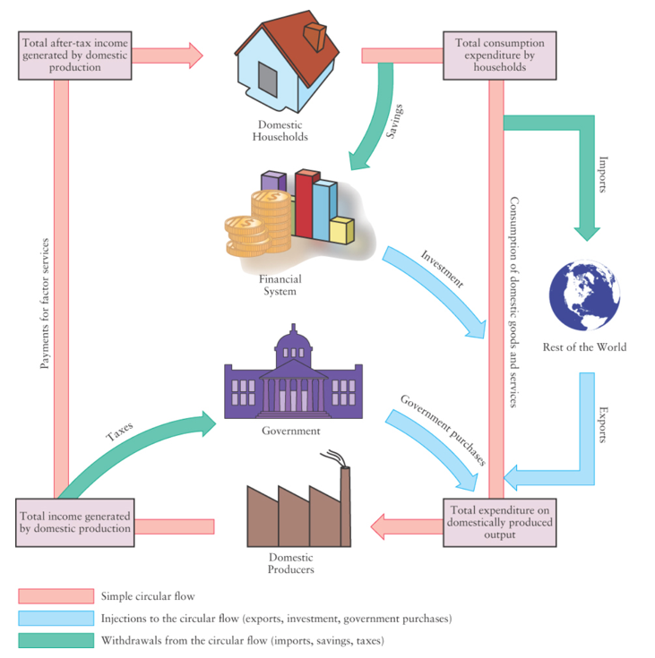
  - Sum of all values added in an economy

National Income Accounting: The Basics
- The value of domestic output (value added) is equal to the value of the expenditure on that output and is also equal to the total income claims generated by producing that output.
- The diagram to the right illustrates the circular flow of expenditure and income
- Three approaches to measuring national income:
  - 1. Add up all of value added
  - 2. Add up the total flow of expenditure on final domestic output
  - 3. Add up total flow of income generated by domestic production
    - All Yield GDP

GDP from the Expenditure Side
- Calculation: adding up the expenditures needed to purchase the final output produced in that year
- Total expenditure on final output is the sum of four broad categories of expenditure:
  - Consumption
  - Investment
  - Government Purchases
  - Net exports
- 1. Consumption Expenditure
  - Expenditure on all goods and services sold to their final users (households or businesses) during the year
  - Includes …
    - services such as – haircuts, dental, legal, phone bills
    - non-durable goods – fresh vegetables, clothing, cut flowers, fresh meat
    - durable goods – cars TVs, air conditioners
  - Actual measured consumption expenditure is denoted by the symbol C_{a}
- 2. Investment Expenditure
  - Expenditure on goods not for present consumption, including inventories of goods made but not yet sold and of inputs purchased but not yet used in production
  - Includes investment Goods…
    - Changes in inventories
    - New plant and equipment – factories, computers, machines, warehouses
    - Residential hosing
  - Changes in Inventories
    - Definition: stocks of raw materials, goods in process, and finished goods held by firms to mitigate the effect of short-term fluctuation in production or sales
    - Inventories of inputs and unfinished materials allow firms to maintain a steady stream of production despite interruptions in the deliveries of inputs bought from other firms
    - The accumulation of inventories during any given year counts as positive investment for that year because it represents goods produced but not used for current consumption
      - These are included in the national income accounts at market value
        - Includes the ages and other costs that the firm incurred in producing them as well as the profit that the firm expects to make when they are sold in the future
    - Decumulation
      - Drawing down of inventories, counts as disinvestment (negative investment)
      - Represents a reduction in the stock of finished goods available to be sold
  - New Plant and Equipment
    - All production uses capital goods, which are manufactured aids to production, such as tools, machines, computers, vehicles, office buildings, and factories
    - Capital Stock – aggregate quantity of capital goods
      - Total quantity of capital goods accumulated through past production
    - Refers to any manufactured aid to production used by firms
    - Fixed Investment - Adding to the existing stock of capital goods is an act of investment and is called business fixed investment
  - New Residential Housing
    - A house or an apartment building is a durable asset that yields its utility over a long period of time
    - The building of a new house is counted as investment expenditure rather than as consumption expenditure
      - Note: buying a previously owned house is only transfer of ownership, not investment expenditure
  - Gross and Net Investment
    - Total investment that occurs in the economy is called gross investment and divided into two parts…
      - Replacement investment
      - Net investment
    - Replacement investment
      - The amount of investment required to replace that part of the capital stock that loses its value through wear and tear – called depreciation
    - Net Investment
      - = Gross Investment – Depreciation
      - Positive = economy’s capital stock is growing
      - Negative = economy capital stock is shrinking (rarely happens)
  - Total Investment
    - Production of new investment goods is part of the nation’s total current output and their production creates income whether the foods produces are part of net investment or merely replacement investment.
    - Thus all of gross investment is included in the calculation of national income
    - Total annual investment = sum during the year of the changes in inventories, the additions to the stock of plant and equipment, and new construction of residential housing units
    - Actual total investment expenditure is denoted by the symbol I_{a}
- 3. Government Purchases
  - Definition: all government expenditure on currently produced goods and services. Exclusive of government transfer payments. Represented by the symbol G
    - Includes provided goods and services, paying public servants to design and implement social programs or soldiers to fight overseas, etc.
  - Cost versus Market Value
    - Government output is valued at cost rather than market value (cost of production)
    - Consequence: cannot measure change in productivity
  - Government purchase vs Government Expenditure
    - Only government purchases of currently produced goods and services are included as part of GDP
      - A great deal of government spending foes not count part of GDP
      - Ex. Canada Pension Plan – payment does not add to total output these are just transfer payments
    - Transfer Payment – payments to an individual or institution not made in exchange for a good or service
      - Often the recipients of these payments chose to spend on consumption goods, so the expenditure counts in some way
- 4. Net Exports
  - Imports – domestic expenditure on foreign-produced goods and services
  - Subtract from total Canadian expenditure denoted by X_{a} Exports – foreign expenditure on domestically produced goods and services
    - Denoted by X_{a} because Canadians are not using the products
    - Added to expenditure on Canadian output
  - Net Exports
    - Denoted by NX_{a} (X_{a} - X_{a})
    - Negative number – value of imports exceeds value of exports
    - Positive – value of exports exceeds value of imports
- Total Expenditures
  - GDP = C_{a} + I_{a} + G_{a} +(X_{a} - IM_{a})
  - C_{a} – consumption expenditure
  - I_{a} – investment expenditure
  - G_{a} - Government purchases
  - (X_{a} - IM_{a}) – NET EXPORTS

GDP from the Income Side
- Involves adding up factor incomes and other claims on the value of output until all of that value is accounted for
- 1. Factor Incomes
  - Definition: three components – wages and salaries, interest, and business profits (includes rent received by property owners)
  - Wages and Salaries
    - The payment for the services of labour and they include all pre-tax labour earnings…
      - Take home pay, income taxed withheld, employment-insurance contributions, pension-fund contributions, and other employee benefits
    - Represent the part of the value of production that is paid to labour
  - Interest
    - Includes interest that is earned on bank deposits, earned on loans to firms, miscellaneous other investment income
      - Excludes interest income earned from loans to Canadian governments
  - Business Profits
    - Some are paid out as dividends, rest are retained earnings
    - Dividends and retained earnings are included in the calculation of factor incomes
    - Includes…
      - Corporate profits, incomes of unincorporated businesses, rent paid on land and buildings, profits of government business enterprises and Crown corporations
  - Profit and interest together represent the payment for the use of capital (interest for borrowed capital and profits for capital contributed by owners of firms)
  - Net Domestic Income
    - Sum of wages and salaries, interest, and profits is called Net Domestic Income at Factor Cost
    - GDP – capital depreciation
    - some part of the value of final output does not accrue to the factors
- 2. Non-Factor Payments
  - Indirect Taxes and Subsidies
    - Indirect taxes – taxes on production and sale of goods and services (GST, excise tax, provincial sales tax)
      - Add up income claims to determine GDP which means the value of indirect taxes to government are added
    - Subsidies – act like negative taxes
      - Subtract their value
      - Ex. Bus spends 150 000 on operations and gets 10 000 subsidy, 140 000 selling fares, the total market value of its output is 140 000
  - Depreciation
    - Loss in value of physical capital generated during the production process
    - Part of Gross profits but not part of net profits
    - Depreciation must be added to net domestic income in order to compute GDP from income side
- Total National Income
  - Statistical discrepancy – independent measures of income and expenditure come to the same total
    - Clear indicator that national income accounting is not error-free
  - GDP = sum of factor incomes + indirect taxes (net subsidies) + depreciation

Real and Nominal GDP
- Total GDP valued at current prices is called nominal GDP.
- GDP valued at base-period prices is called real GDP
- Changes in Nominal GDP
  - Reflect the combined effect of changes in quantities and changes in prices
- Changes in Real income
  - Measured over different period by using common set of base-period prices, changes in real income reflect only changes in quantities
  - Real GDP grows more slowly in comparison to nominal GDP

GDP Deflator
- Comparing what has happened to nominal and real GDP over the same period implies the existence of a price index measuring the change in prices over that period
- GDP Deflator = $\frac{GDP at current prices}{GDP at base-period prices} × 100= \frac{nominal GDP}{real GDP} × 100$
- Most comprehensive available index of the price level because it includes all the goods and services that are produced by the entire economy
  - Ex. GDP deflator was 15.6% higher in 2017 than in base year 2007
    - Thus, for goods and services produced in 2017 the average price increased by 15.6% over the previous 10 years
- CPI movements measure change in the avg price of consumer goods
  - GDP deflator movements reflect the change in the avg price of good produced in Canada
    - Changes in price of coffee would affect CPI (Canadians drink lots of coffee) than GDP deflator as no coffee is produced in Canada

CHAPTER 21 – The Simplest Short-Run Macro Model

Desired Aggregate Expenditure
- Definition – what people desire to spend out of the resources that they actually have
- RECALL – the subscript “a” on various categories of expenditure indicate the actual values
  - For desired expenditure we use the same Categories without the subscript: C, I, G, & (X - IM)
- Four main groups of decision makers: domestic households, firms, governments, and foreign purchasers of domestically purchased commodities
  - The sum of their desired expenditure on domestically produced output is called desired aggregate expenditure (AE)
    - AE = C + I + G + (X-IM)

Desired Consumption Expenditure
- Disposable Income – household income after deducting taxes
  - Disposable income, Y_{D} = National Income, Y
- Saving – all disposable income that is not spent on consumption
- The Consumption Function
  - Definition: relationship between desired consumption expenditure and all the variables that determine it. In the simplest case, it is the relationship between desired consumption expenditure and disposable income.
  - Key factors influencing desired consumption…
    - Disposable income
    - Wealth
    - Interest rates
    - Expectations about the future
      - CAUSE SHIFTS
        - Changes in disposable income causes movement along consumption function
  - Holding other factors constant, increase in disposable income is assumer to lead to an increase in desire consumption
- Average and Marginal Propensities to Consume
  - Average Propensity to Consumer (APC) – the proportion of disposable income that households want to consume equals desired consumption expenditure divided by disposable income
    - APC falls as disposable income rises
    - APC = C/ Y_{D}
  - Marginal Propensity to Consumer (MPC) – how much of one additional dollar of income gets spent on consumption equals change in desired consumption/change in disposable income
    - MPC = $∆C/∆Y_{D}$
- Slope of the Consumption Function
- Slope is $∆C/∆Y_{D}$ or MPC
  - Positive slope shows that the MPC is positive, increases in disposable income lead to increases in desired consumption expenditure
  - Constant slope shows that MPC is same at any level of disposable income
- Break-Even Level of Income
  - 45º line, shows all points where desired consumption equals disposable income
    - When under the number where it breaks even, desired consumption exceeds disposable income (desired saving must be negative)
    - Vice versa^
- The Saving Function
  - Average Propensity to Save (APS) – proportion of disposable income that households want to save equals dividing desired savings by disposable income
    - APS = S/ Y_{D}
  - Marginal Propensity to Save (MPS) – change in desired saving/change in disposable income
    - MPS = $∆C/∆Y_{D}$
- Saving and Consumption Relation
  - APC and APS must sum to 1
  - MPC and MPS must sum to 1
    - All disposable income is either saved or spent
  - The amount of desired saving always equals the vertical distance between the consumption function and the 45º line
    - When desired consumption > income, desired saving is negative
    - When desired consumption < income, desired saving is positive

Shifts of the Consumption Function
- A Change in Household Wealth
  - Household wealth – value of all accumulated assets minus accumulated debts
  - Most common types of household assets …
    - Savings accounts, mutual funds, portfolios of stocks or bonds, RRSPs, ownership of homes and cars
  - Most Common types of household debts
    - Home mortgages, car loans, outstanding lines of credit from banks (including credit-card debt)
  - What happens to desired consumption of household wealth increases even while disposable income is unchanged?
    - Ex. Rising Stock market (bull market) leads to an increase in aggregate household wealth
      - The extent of this increase in wealth is expected to persist, less current income needs to be saved for the future, households tend to spend more
      - Increase in household wealth: Consumption function will shift up, saving will shift down
      - Decrease in household wealth: Consumption function will shift down, saving will shift up
- A Change in Interest Rates
  - Household consumption can be divided into consumption od durable and non-durable goods
  - Durable Goods – goods that deliver benefits for several years (cars, appliances)
  - Non-durable goods – only deliver benefits to households for a short amount of time (groceries, clothing, restaurant meal)
  - Fall in interest rate = reduction in cost of borrowing
    - Increases desired consumption expenditure (especially of durable goods)
    - Consumption function shifts up, saving function shifts down
  - Increase in interest rate
    - Consumption function shifts down, saving function shifts up
- A Change in Expectations
  - Expectations about the future state of the economy often influence desired consumption.
  - Optimism
    - leads to an upward shift in the consumption function; downward shift in saving
  - Pessimism
    - leads to a downward shift in the consumption function, upward shift in saving

Summary
- Autonomous Consumption – shifts in consumption function
- Induced Consumption – movement along the consumption function by changes in disposable income

Desired Investment Expenditure
- Three categories of investment
  - Inventory accumulation
  - Residential construction
  - New plant and equipment
- Determinants of Desired Investment Expenditure
  - The real interest rate
  - Changes in the level of sales
  - Business confidence
- Investment and the Real Interest Rate
  - Real interest rate – represents the real opportunity cost of using money for investment purposes
    - Rise in the real interest rate = reduction in desired investment expenditure
  - Inventories
    - Change in inventory is a small percent of private investment typically
    - Hence, the higher the real rate of interest, the higher the opportunity cost of holding an inventory of a given size. Other things being equal, the higher the opportunity cost, the smaller the inventories that will be desired.
  - Residential Construction
    - Because interest payments are such a large part of mortgage payments, variations in interest rates exert a substantial effect on the demand for housing.
  - New Plant and Equipment
    - High real interest rates lead to reduction in desired investment in capital equipment
    - Low interest rates increase desired investment
  - The real interest rate reflects the opportunity cost associated with investment, whether in inventories, residential construction, or new plant and equipment. The higher the real interest rate, the higher the opportunity cost and thus the lower the amount of desired investment.
- Investment and Changes in Sales
  - Size of inventories is typically related to the level of sales
    - So change in inventories is related to change in level of sales
  - The higher level of sales, the larger the desired stock of inventories
  - Changes in the rate of sales therefore cause temporary bouts of investment (or disinvestment) in inventories
    - Similar effect on investment in plant and equipment
- Investment and Business Confidence
  - Investment depends on firms’ expectations about the future state of the economy. Optimism about the future leads to more desired investment; pessimism leads to less desired investment.
- Investment as Autonomous Expenditure
  - Treat desired investment as autonomous – we assume it to be unaffected by changes in national income
  - I function is therefore horizontal, mainly for simplification
    - this assumption reflects the fact that investment is an act undertaken by firms for future benefit, and thus the current level of GDP is unlikely to have a significant effect on desired investment

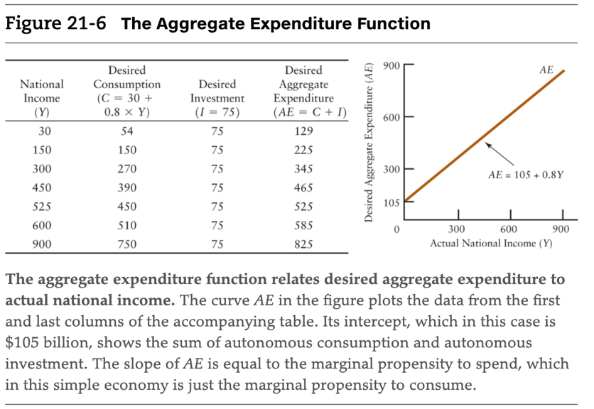
Aggregate Expenditure Function
- Definition: AE Function relates the level of desired aggregate expenditure to the level of actual nominal income (real variables)
  - AE = C + I
- How to make the AE function
  - The beginning national income is the autonomous expenditure
  - Total Autonomous Expenditure is 105 (30 + 75)
  - Induced expenditure is equal to MPC * disposable income (0.8 * Y_{D})
  - Desired AE = 105 + 0.8Y

The Marginal Propensity to Spend
- Definition: change in desired aggregate expenditure based on domestic output divided by the change in national income that brought it about
  - = $∆AE/∆Y$ – slope of the AE function
  - Denoted by symbol ‘z’, number > 0, <1 (so a fraction)
- The marginal propensity to spend is the amount of extra total expenditure induced when national income rises by $1, whereas the marginal propensity to consume is the amount of extra consumption induced when households’ disposable income rises by $1.

Equilibrium National Income
- AE function shows for any given level of actual national income, the level of desired aggregate spending
- A Demand-Determined Equilibrium
  - Demand Determined output – firms are able and willing to produce any amount of output demanded and production level changes do not require price change
  - For any level of national income at which desired aggregate expenditure exceeds actual income, there will be pressure for actual national income to rise.
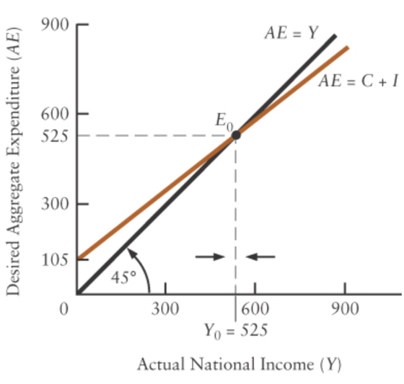
  - For any level of income at which desired aggregate expenditure is less than actual income, there will be pressure for national income to fall.
- Equilibrium: Desired AE = Actual Y
  - The equilibrium level of national income occurs where desired AE = actual Y
  - AE = Y is the 45º line aforementioned
    - Equilibrium occurs at level of income at which the AE intersects the line
    - Equilibrium of national income = Y₀
  - Consider some level of national income below Y₀
    - Desired spending exceeds actual output
    - Vertical distance between AE and the 45⁰ line reflects the size of the excess demand
  - Consider some level of national income above Y₀
    - Desired spending is less than actual output
    - Vertical distance between AE and the 45⁰ line reflects the size of the excess supply

Changes in Equilibrium National Income
- Shifts of the AE Function
  - When there is a shift in the consumption or investment function, there is a shift in AE
    - Consumption Changes
      - Interest, expectations, household wealth
    - Investment Changes
      - Interest, expectations, change in sales
- Upward Shift
  - Any increase in autonomous expenditure shifts entire AE up
  - 1. If the same increase in expenditure occurs at all levels of income
    - The AE function shifts up parallel to itself
  - 2. If there is an increase in the Marginal Propensity to Spend
    - AE become steeper (pivots)
  - Either shift increases equilibrium national income
- Downward Shift
  - 1. Reduction in desired expenditure at all levels of income
    - Shifts AE down parallel to itself
  - 2. . If there is an fall in the Marginal Propensity to Spend
    - AE become flatter (pivots)
  - Either shift decreases equilibrium national income

The Multiplier
- Determines the size of the change in national income
- The multiplier is the change in equilibrium national income divided by the change in autonomous expenditure that brought it about.
  - In the simple macro model, the multiplier is greater than 1.
- Logic of the multiplier
  - Simple Multiplier – ratio of change in equilibrium national income to the change in autonomous expenditure that brought it about, calculated for a constant price level
  - An increase in autonomous aggregate expenditure increases equilibrium national income by a multiple of the initial increase
- Size of the Simple Multiplier
  - Depends on the slope of the AE or z (marginal propensity to spend)
  - The larger the marginal propensity to spend, the steeper the AE function and thus the larger the simple multiplier.
  - $Simple Multiplier= \frac{∆Y}{∆A}=\frac{1}{1-z}$

CHAPTER 22 – Adding Government and Trade to the Simple Macro Model

Introducing Government
- Fiscal Policy – use of government’s tac and spending policies to achieve government objectives
  - Defined by plans for taxes and spending
- Government Purchases
  - Purchases of Goods and Services
    - Desired government purchases, G, are part of aggregate desired expenditure
  - Transfer Payments
    - Indirectly affects desired aggregate expenditure (payments are used for consumption)
  - Assume G does not automatically change as GDP changes
    - Note the transfer payments do change as GDP rises or falls
- Net Tax Revenue
  - Definition – total tax revenue received by the government – total transfer payments made by the government
    - Denoted as T
  - Taxes reduce disposable income relative to GDP, transfer payments raise disposable income relative to GDP
  - T = tY
    - Y is GDP
    - t is the net tax rate
      - increase in net tax revenue generated when national income rises by one dollar
- The Budget Balance
  - Definition: difference between total government revenue and total government expenditure
    - Or net tax revenue minus government purchases (T – G)
  - Net Revenues > Government Purchases
    - Budget Surplus
    - Uses excess revenue to buy back outstanding government debt
  - Net Revenues < Government Purchases
    - Budget Deficit
    - Must borrow excess of spending over revenues by issuing additional government debt in form of bonds or Treasury Bills
  - Net Revenues = Government Purchases
    - Balanced budget
- Provincial and Municipal Governments
  - When measuring the overall contribution of government purchases to desired aggregate expenditure, all levels of government must be included

Introducing Foreign Trade
- Net Exports
  - Foreign firms and households purchase Canadian-made products.
  - Changes in foreign income and international relative prices will affect Canadian exports (X), but we assume that X is autonomous with respect to Canadian national income.
  - When we construct the economy's aggregate expenditure (AE) function, we will include X since it represents expenditure on domestically produced goods and services.
    - NX = X – mY
    - m is the marginal propensity to import
      - the amount the desired imports rise when national income rises by $1
  - All components of domestic expenditure (C, I, and G) include some import content.
  - Since C is positively related to national income, imports (IM) are also related positively to national income.
  - When we construct the economy's AE function, which shows the desired aggregate expenditure on domestic products, we will subtract IM because these expenditures are on foreign products.
- Shifts in the Net Export Function
  - Changes in Foreign Income
    - Increase in foreign income (other things being equal) leads to an increase in Canadian exports
      - Causes the X curve to shift upward and therefore the NX function also shifts upwards, parallel to its position
    - Fall in foreign income leads to reduction in Canadian exports
      - Parallel downward shift in the NX function
  - Changes in International Relative Prices
    - A rise in Canadian prices relative to those in other countries reduces Canadian net exports at any level of national income
      - X curve shifts downwards
      - m will rise, so IM curve will rotate up (because relatively other countries stuff is cheaper so we import more)
      - COMBINED = NX function shifts downward and becomes steeper
    - A fall in Canadian prices increases net exports at any level of national income.
      - Shifts the X function up
      - IM function rotates down
      - COMBINED = NX function rotates up
    - Cause of change is change in exchange rate
      - Depreciation of CAD means foreigners pay less to buy one CAD

Equilibrium National Income
- Adding government and net exports changes the calculation, but concept remains the same
- Adding Taxes to the Consumption Function
  - Y_{D} = Y – T (disposable income = national income – net taxes)
  - 1. First Assume that the net tax rate, t, is 10 percent, so that net tax revenues are 10% of national income (GDP) T = (0.1)Y
  - 2. Disposable income must therefore be 90% of national income
    - Y_{D} = Y – T
= Y – (0.1)Y
= 0.9Y
  - 3. The consumption function we used last chapter is given as C = 30 + 0.8Y_{D} which tells us that the MPC out of disposable income is 0.8
  - 4. We can now substitute 0.9Y for Y_{D} in the consumption function
    - C = 30 + 0.8(0.9Y)
    - C = 30 + 0.72Y
  - THEREFORE… we can express desired consumption as a function of Y_{D} or as a different function of Y
    - In this example 0.72 is the marginal propensity to consumer out of national income, whereas 0.8 is MPC of disposable income
- In the presence of taxes, the marginal propensity to consume out of national income is less than the marginal propensity to consume out of disposable income.

The AE Function
- Now add government purchases and net exports
  - DEFINITIONS
    - C = c + MPC * Y_{D} consumption
    - I = investment
    - G = Government Purchases
    - T= tY net tax revenues
    - X – exports
    - IM = mY imports
- Desired Consumption in terms of national income
  - C = c + MPC(1 – t )Y
  - c is autonomous consumption
- Sum four components of desired aggregate expenditure
  - AE = C + I + G + (X – IM)
= c + MPC(1 – t)Y + I + G + (X – mY)
= [c + I +G+X ]+ [MPC(1 – t)- m]Y

Autonomous Expenditure Induced Expenditure
- Second bracket is Marginal Propensity to spend out of national income (z)– how much total desired spending on domestically produced output changes when national income changes by $1
  - Slope (z) = MPC(1 – t) – m
  - MPC is not = to z

Changes in Equilibrium National Income
- We took a look at how consumption and investment function change the equilibrium
- The Multiplier with Taxes and Imports
  - The presence of imports and taxes reduces the marginal propensity to spend out of national income and therefore reduces the value of the simple multiplier.
  - With foreign trade and government
    - z = MPC(1 – t) – m
    - $Simple Multiplier= \frac{∆Y}{∆A}=\frac{1}{1-z}$
= $\frac{1}{1-[MPC\left(1-t\right)-m}$
    - The higher is the marginal propensity to import, the lower is the simple multiplier. The higher is the net tax rate, the lower is the simple multiplier
- Net Exports
  - Changes in desired exports and desired imports will shift the AE function, and through the multiplier process, cause a change in equilibrium national income
Fiscal Policy: Government Spending and Taxation
- Stabilization Policy – any policy designed to reduce the economy’s cyclical fluctuations and thereby stabilize national income
- Our Simple Macro Model has two fiscal policy tools available to government policymakers
  - The net tax rate (t) and government purchases (G)
  - Reduction in net tax rate or increase in government purchases – shift AE upward, multiplier increases equilibrium national income
  - Increase in tax rate or decrease in government purchases – shift AE downward
    - Tends to decrease equilibrium national income
- Issues: timing and magnitude
  - Timing – takes uncertain amount of time for fiscal policy to have an effect on real GDP
  - Magnitude – level of potential output can only be estimated imperfectly, so the gap between actual and potential GDP is uncertain
- Changes in Government Purchases
  - Change in AE is equal to reduction or increase in government purchase
  - Equilibrium income change is calculated using the simple multiplier (Canada realistically has a simple multiplier value of 1.3)
- Changes in the Net Tax Rate
  - Slope of AE is z = MPC (1 – t) – m
  - Decrease in tax rates
    - Desired consumption rises at every level of national income, because disposable income rises in relation to national income
    - Upward rotation of the AE curve, increase in the slope
      - Increase in equilibrium national income
  - Increase in taxes
    - Decrease in disposable income, desired consumption expenditure falls at each level of national income
    - Downward rotation of the AE curve
      - Decreases the level of equilibrium national income
  - NOTE…
    - Simple multiplier is not used to tell us about the resulting change in equilibrium national income, it is used to tell how much equilibrium national income changes in response to a change in autonomous desired spending -which is a parallel shift in the AE function

Demand-Determined Output
- Equilibrium National Income
  - Level at which desired aggregate expenditure equals actual national income (AE = Y)
  - National Income > desired expenditure
    - Inventories are rising and so firms will eventually reduce production, causing national income to fall
  - National income < desired expenditure
    - Inventories falling so firms will eventually increase production, causing national income to rise
- The Simple multiplier
  - Measures change in equilibrium national income that results in the autonomous part of desired aggregate expenditure
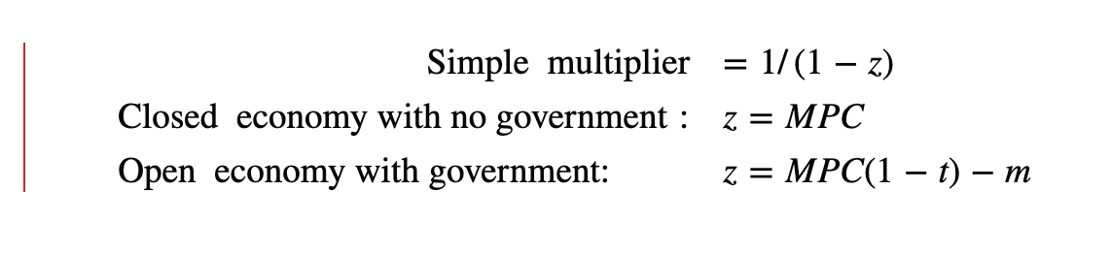

- Demand-Determined Output
  - Our model id constructed for a given price level – the price level assumed to be constant
  - National income is demand determined in two situations
    - 1. When there are unemployed resources and firms have excess capacity, firms will often be prepared to provide whatever is demanded at unchanged prices
    - 2. When firms are price setters respond to changes in demand by altering their production and sales, at least initially, rather than adjusting prices

VIEW APPENDIX 22 FOR BREAKDOWN OF VARIABLES

CHAPTER 23 – Real GDP and the Price Level in the Short Run
There is an aggregate price level that includes most goods like the CPI or the GDP deflator and, implicitly, there are two other price levels, the price level of world commodities, especially oil(energy) and a wage level, the money price of labour.

^ what that
The Demand Side of the Economy
- Exogenous Changes in the Price Level
  - AE shifts in response to change in price level (avg price of all goods and services in the economy)
  - Price level affects desired consumption expenditure and desired net exports
- Changes in Consumption
  - Our focus here is on the aggregate price level rather than on the prices of individual products
    - Price level and desired consumption are related by how the changes in price level lead to changes in household wealth and thus to changes in desired spending
  - Individuals and businesses hold money in their wallets, cash registers, or bank accounts
  - The higher the price level the fewer goods and services given amount of money can purchase
    - A rise in the price level lowers the real value of money held by the private sector. A fall in the price level raises the real value of money held by the private sector.
  - Other assets that have fixed nominal value, besides money, are government and corporate bonds
    - A rise in the price level means the repayment to the bondholder is lower in real value than it other wise would be, there is a decline in wealth for the bondholder
    - Changes in the price level change the wealth of bondholders and bond issuers, but because the changes offset each other, there is no change in aggregate wealth
  - A reduction in wealth leads to a fall in autonomous desired consumption and a downward shift in the AE function
    - A fall in the domestic price level leads to a rise in wealth and desired consumption and thus to an upward shift in the AE curve.
- Changes in Net Exports
  - A rise in the domestic price level (with a constant exchange rate) reduces net exports and causes a downward shift in the AE curve. A fall in the domestic price level increases net exports and causes an upward shift in the AE curve.
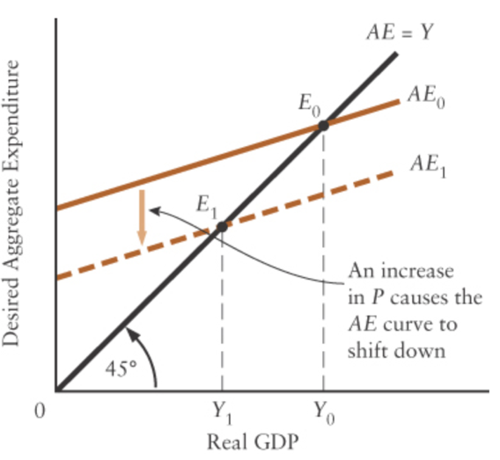
- Changes in Equilibrium GDP
  - Exogenous rise in the price level reduces both desired consumption and desired net exports, thus there is a downward shift in the AE curve
    - When the AE shifts downward, the equilibrium level of real GDP falls
  - Fall in price level, Canadian goods become relatively cheaper internationally, so net exports rise
    - Purchasing power of nominal assets increase, so households spend more
    - Increase in desired expenditure (consumption and net exports) causes AE to shift upward
      - Real GDP equilibrium rises
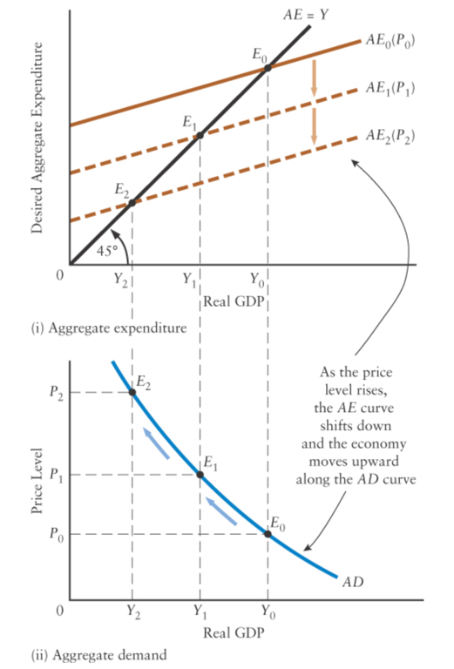
      - NOTE: from here on nominal, actual, national income are referred to as Real GDP
        - Necessary to distinguish changes in nominal GDP from changes in real GDP

Aggregate Demand Curve
- This curve represents the negative relationship between the price level and real equilibrium GDP
- Definition: curve showing combinations of real GDP and the price level that make desired aggregate expenditure equal to actual national income
- Deriving the AD curve
  - At the point where the AE₀ curve crosses the 45º line, for every price level is where the corresponding price level will have the equilibrium point plotted
  - Changes in the price level cause shifts in the AE curve are simply movements along the AD curve
- AD curve is not a Micro Demand Curve
  - 1. A rise in the price level causes the AE curve to shift downward and hence leads to a movement upward and to the left along the AD curve, reflecting a fall in the equilibrium level of GDP.
  - 2. A fall in the price level causes the AE curve to shift upward and hence leads to a movement downward and to the right along the AD curve, reflecting a rise in the equilibrium level of GDP.
  - The AD curve is negatively sloped because…
    - A fall in the price level leads to a rise in private-sector wealth, which increases desired consumption and thus leads to an increase in equilibrium GDP.
    - A fall in the price level (for a given exchange rate) leads to a rise in net exports and thus leads to an increase in equilibrium GDP.
  - Why is it different…
    - AD curve dollar value of national income is not constant as the price level changes and we mong along the AD curve
    - A change in price level does not change the relative prices of domestic goods and thus does not cause consumers to substitute between them
      - However, a change in the domestic price level (for a given exchange rate) does lead to a change in international relative prices and thus to some substitution between domestic and foreign products; this is the link between the price level and net exports that we discussed earlier.
- Shifts in the AD Curve
  - For a given price level, any factor that shifts the AE curve will cause change in equilibrium GDP, and will cause AD to shift
    - a change in desired consumption, a change in government purchases, a change in desired investment, or a change in Canada’s net exports
  - ^ This is referred to as an aggregate demand shock – any event that causes a shift in the AD curve
    - For a given price level, an increase in autonomous aggregate expenditure shifts the AE curve upward and the AD curve to the right.
    - A fall in autonomous aggregate expenditure shifts the AE curve downward and the AD curve to the left.
    - NOTE: The change in autonomous expenditure must be caused by something other than a change in the domestic price level because that leads to a movement along not a shift
- Simple Multiplier and AD Curve
  - The simple multiplier measures the horizontal shift in the AD curve in response to a change in autonomous desired expenditure

Supply Side of the Economy
- The Aggregate Supply Curve
  - Definition: curve showing relation between the price level and the quantity of aggregate output supplied, for given technology and factor prices
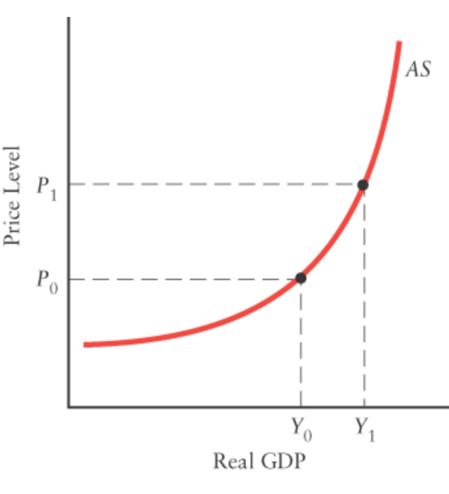
- Positive Slope of the AS curve
  - Unit Costs – cost per unit, total costs/total output
  - Unit costs tend to rise as output rises, even when tech and input prices are held constant (law of diminishing returns-why costs rise in short run as firms squeeze more ouput out of a fixed quantity of capital equipment)
  - The actions of both price-taking and price-setting firms cause the price level and the supply of output to be ­positively related—the aggregate supply (AS) curve is positively sloped.
    - In both cases, the fact that unit costs generally rise with output means that firms generally increase their production only if they are able to receive higher prices.
- Increasing Slope of the AS Curve
  - At Low levels of GDP the AS curve is relatively flat, as GDP rises, the AS curve gets progressively steeper
  - When output is low, firms typically have excess capacity
    - Increases in output generate only small increases in unit costs
  - Once output is pushed above normal capacity, however, unit costs tend to rise quite rapidly. Many higher-cost production methods may have to be adopted—such as standby capacity, overtime, and extra shifts
    - The more output is expanded beyond normal capacity, the more unit costs rise and hence the larger is the rise in price that is necessary to induce firms to increase output.
- Shifts in the AS Curve
  - Anything that leads to a change in given set of state of tech or factor prices will cause shift in the curve
    - Firms require a different price level in order to provide the same level of output
  - Aggregate Supply Shocks – any shift in the AS curve caused by exogenous force
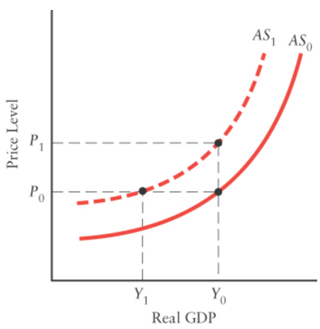
  - Changes in Input Prices
    - If factor prices rise, firms’ profits at their current levels of output are reduced, so they respond by..
    - 1. Maintaining current level of output, in which case there must be increase in price level
    - 2. Reducing level out output if price level does not change
    - OVERALL… rise in factor prices leads to an upward ( and to the left) shift
      - Decrease in AS
    - Fall in factor prices causes AS to shift downward and to the right
  - Changes in Technology
    - Improvement in technology – any change in production methods that reduces unit costs for any given level of output
      - Lead to lower prices as competing firms cut prices
      - AS curve shifts downward and to the right (increase in AS)
    - Deterioration in technology – any change in production that raises unit costs for any given level of output
      - Industries relying on weather for production – agriculture – poor weather is an example
      - Raises unit costs and causes AS curve shift upward and to the left (decrease in AS)

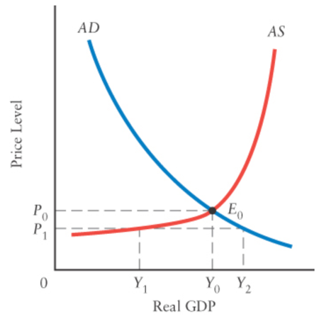
Macroeconomic Equilibrium
- Macroeconomic equilibrium occurs at the intersection of the AD and AS curves and determines the equilibrium values for real GDP and the price level.
- Only at the combination of real GDP and price level given by the intersection of the AS and AD curves are demand behaviour and supply behaviour consistent.
  - Consider what would occur at P1, total desired expenditure is Y2, but economy can only produce output of Y1 leaving excess demand
  - Vice versa applies as well
  - When price level below equilibrium – excess demand
  - When price level above equilibrium – excess supply
- Changes in the Macroeconomic Equilibrium
  - A rightward shift in AD is increase in AD, called a positive shock because at all price levels expenditure will not be consistent with higher level of GDP
    - Leftward is vice versa – called a negative shock
    - Same goes for AS
  - Aggregate demand and supply shocks are labelled according to their effect on real GDP. Positive shocks increase equilibrium GDP; negative shocks reduce equilibrium GDP.

Aggregate Demand Shocks
- Aggregate demand shocks cause the price level and real GDP to change in the same direction; both rise with an increase in aggregate demand, and both fall with a decrease in aggregate demand.
- The Multiplier When the Price Level Varies
  - Simple multiplier gives size of the horizontal shift in the Ad curve in response to a change in autonomous expenditure
  - If an aggregate demand shock leads to a change in the price level, the ultimate change in real GDP will be less than what is predicted by the simple multiplier. In other words, a variable price level reduces the value of the multiplier.
- Importance of the Shape of the AS Curve
  - Flat range – called the Keynasian range of the AS curve
    - Any aggregate demand shock leads to a change in equilibrium GDP but no change in price level
    - Price level does not change because firsm with excess capacity can adjust their ouput without generating any change in unit costs
  - Intermediate range – AS is positively sloped
    - a shift in the AD curve gives rise to appreciable changes in both real GDP and the price level. Because of the increase in the price level, the multiplier in this case is positive, but smaller than the simple multiplier.
  - Steep range – very little more can be produced
    - . This range deals with an economy near its physical capacity constraints. Any change in aggregate demand leads to a sharp change in the price level and to little or no change in real GDP. The multiplier in this case is nearly zero
  - SUMMARY
    - The effect of any given shift in aggregate demand will be divided between a change in real output and a change in the price level, depending on the conditions of aggregate supply. The steeper the AS curve, the greater the price effect and the smaller the output effect.

Aggregate Supply Shocks
- Aggregate supply shocks cause the price level and real GDP to change in opposite directions. With an increase in supply, the price level falls and GDP rises; with a decrease in supply, the price level rises and GDP falls.
- Negative AS shock could have occurred because of increase in world price important inputs such as oil, copper, or iron ore
  - Conversely positive AS shock could have occurred because of decrease in world price of important inputs

Word of Warning
- Many economic events—especially changes in the world prices of raw materials—cause both aggregate demand and aggregate supply shocks in the same economy. The overall effect on real GDP in that economy depends on the relative importance of the two separate effects.

Chapter 24 From the Short Run to the Long Run: The Adjustment of Factor Prices

Three Macroeconomic States
- The Short Run
  - Assumptions…
    - Factor prices are assumed to be exogenous; they may change, but any change is not explained within the model.
    - Technology and factor supplies are assumed to be constant (and therefore Y* is constant).
  - The short run macroeconomic equilibrium is determined by the intersection of the AD and AS curves, both of which are subject to shocks of various kinds
    - Convenient to use when analyzing economy over short periods
    - The simplifying assumption that factors are constant allows us to focus on the important role of AD or AS shocks over this time span
- Adjustment of Factor Prices
  - Assumptions…
    - .Factor prices are assumed to adjust in response to output gaps.
    - Technology and factor supplies are assumed to be constant (and therefore Y* is constant).
  - The adjustment process is assumed to take place with a constant level of potential output
    - In reality, neither technology nor factor supplies are constant over time, level of potential output is continually changing
    - our assumption throughout much of this chapter of a constant value for Y* is thus a simplifying one, allowing us to focus on our theory of the adjustment process that brings the level of real GDP back to potential output.
- The Long Run
  - Assumptions…
    - Factor prices are assumed to have fully adjusted to any output gap.
    - Technology and factor supplies are assumed to be changing.
  - after factor prices have fully adjusted, real GDP will return to the level of potential output. The second assumption implies that the level of potential output is changing (and typically growing)
    - thus, long run version of macroeconomic model focuses on the nature of economic growth – where technological change and the frowth of factor supplies play key roles
  - however the economy is probably never in the long run in the sense that shocks to AD or As occur continually
  - Useful for,,,
    - For example, if we want to understand why our children’s material standard of living will be significantly greater than our grandparents’, we should not focus on short-run AD or AS shocks or the stabilization policies that may follow; the effects of particular shocks will disappear after a few years. Instead, we will gain more understanding if we abstract from short-run issues and focus on why Y* increases dramatically over periods of several decades.

SUMMARY

Three Macroeconomic States
 |  | The Short Run | The Adjustment Process | The Long Run
 | Key Assumptions | Factor prices are exogenous.  Technology and factor supplies (and thus Y*) are constant/exogenous. | Factor prices are flexible/endogenous.  Technology and factor supplies (and thus Y*) are constant/exogenous. | Factor prices are fully adjusted/endogenous.  Technology and factor supplies (and thus Y*) are changing.
 | What Happens | Real GDP (Y) is determined by aggregate demand and aggregate supply. | Factor prices adjust to output gaps; real GDP eventually returns to Y*. | Potential GDP Y* usually grows over the long run.
 | Why We Study This State | To show the effects of AD and AS shocks on real GDP. | To see how output gaps cause factor prices to change and why real GDP tends to return to Y*. | To understand the nature of long-run economic growth.
The Long Run

The Adjustment Process
- Potential Output and the Output Gap
  - Recall… Potential Output is the total output that can be produced when all productive resources are fully employed
  - When a nations actual output diverges from its potential output, the difference is called the output gap
  - Slthough growth in potential output has powerful effects from one decade to the next, its change from one year to the next is small enough that we ignore it when studying the year-to-year behaviour of real GDP and the price level.
  - In this chapter, therefore, we view variations in the output gap as determined solely by variations in actual GDP around a constant level of potential GDP.
  - Recessionary Gap – GDP below potential output
  - Inflationary Gap – GDP above potential output
- Factor Prices and the Output Gap
  - Recessionary gap
    - Pressure on factor prices to fall because of a lower than normal demand for factor inputs
  - Inflationary gap
    - Pressure on factor prices to rise because of a higher than normal demand for factor inputs
- Output above Potential, Y > Y*
  - The boom that is associated with an inflationary gap generates an excess demand for factors that tends to cause wages (and other factor prices) to rise.
- Output Below Potential, Y< Y*
  - The slump that is associated with a recessionary gap generates an excess supply of factors that tends to cause wages (and other factor prices) to fall.
- Downward Wage Stickiness
  - Both upward and downward adjustments to wages and unit costs do occur, but there are differences in the speed at which they typically operate.
  - Booms can cause wages to rise rapidly;
  - recessions usually cause wages to fall only slowly.
- The Philips Curve
  - A.W. Philips observed that wages tended to fall in periods of high unemployment and rise in periods of low unemployment
    - This. Negative relationship between unemployment and the rate of change in wages has been called the Phillips curve ever since
- Inflationary and Recessionary Gaps
  - When real GDP exceeds potential GDP in our model, there will normally be rising unit costs, and the AS curve will be shifting upward. This will in turn push the price level up and create temporary inflation. The larger the excess of real GDP over potential GDP, the greater the inflationary pressure. The term inflationary gap emphasizes this salient feature of the economy when Y>Y∗.
  - When actual output is less than potential output, as we have seen, there will be unemployment of labour and other productive resources. Unit costs will tend to fall slowly, leading to a slow downward shift in the AS curve. Hence, the price level will be falling only slowly so that unemployment will be the output gap’s most obvious result. The term recessionary gap emphasizes this salient feature that high rates of unemployment occur when Y<Y∗.
- Potential Output as an “Anchor”
  - Following an AD or AS shock, the short-run equilibrium level of output may be different from potential output. Any output gap is assumed to cause wages and other factor prices to adjust, eventually bringing the equilibrium level of output back to potential. The level of potential output therefore acts like an “anchor” for the economy.

Aggregate Demand and Supply Shocks
- Positive AD Shocks
  - The adjustment in wages and other factor prices eventually eliminates any inflationary output gap caused by an AD shock; real GDP returns to its potential level.
  - The eventual effect of the AD shock, after all adjustment is to raise the price level but leave real GDP unchanged
- Negative AD Shocks
  - Suppose economy starts with stable prices and real GDP equal to potential, now assume there is a decline AD
  - First effect of decline are fall in output and some downward adjustment of prices
    - As real GDP falls below potential, a recessionary gap is created, and unemployment rises
    - Two cases….
      - Wages and other factor prices fall quickly in resonse to excess supply of factors
      - Factor prices fall only slowly
  - Flexible Wages
    - Suppose the first case, the AS curve would shift quickly downward as the lower wages led to reduced unit costs
      - Flexible wages that fall rapidly in the presence of a recessionary gap provide an automatic adjustment process that pushes the economy back quickly toward potential output.
  - Sticky Wages
    - AS curve shifts more slowly when wages are sticky and thus the adjustment process may not close the recessionary gap for a long time
      - If wages are downwardly sticky, the economy’s adjustment process is sluggish and thus will not quickly eliminate a recessionary gap
    - The weakness of adjustment process does not mean the recessionary gap must always be prolonged , but a speedy recovery must be generated mainly by the demand side
      - Private sector demand revives and the AD curve shifts back to the right
      - Government stabilization policy can be used to accomplish such a shift
  - Asymmetry explains
    - High unemployment can persist for quite long period without causing decreases in wages or sufficient magnitude to quickly remove the unemployment
    - Booms, along with labour shortages and production beyond normal capacity, do not persist for long without increase in wages
- Aggregate Supply Shocks
  - Exogenous changes in input prices cause the AS curve to shift, creating an output gap. The adjustment process then reverses the initial AS shift and brings the economy back to potential output and the initial price level.
  - .A negative AS shock caused by an increase in input prices causes real GDP to fall and the price level to rise. The economy’s adjustment process then reverses the AS shift and eventually returns the economy to its starting point. The economy begins at point E0E0 in part (i). The rise in input prices increases firms’ unit costs and causes the AS curve to shift up to AS1AS1. Real GDP falls to Y1Y1 and the price level rises to P1P1. A recessionary gap is created. In part (ii), the excess supply of factors associated with the recessionary gap causes wages and other factor prices to fall, possibly slowly. As factor prices fall, unit costs fall and so the AS curve shifts back down to AS0AS0. The eventual effect of the AS shock, after all adjustment has occurred, is to leave the price level and real GDP unchanged.
- Long-Run Equilibrium
  - The economy is said to be in a long run equilibrium when the adjustment process is complete and there is no longer an output gap
    - When the intersection of the AD and AS curves occurs at Y*
  - Y* vertical line sometimes referred to as a long-rnu aggregate supply curve
    - The relationship between the price level and the amount of output supplied by firms after all factor prices have adjusted to output gaps.
  - In the long run, real GDP is determined solely by Y*; the role of aggregate demand is only to determine the price level.

Aggregate Supply Shocks
- Stagflation: Real GDP falls and the price level increases

The Adjustment Process Following a Negative AS Shock
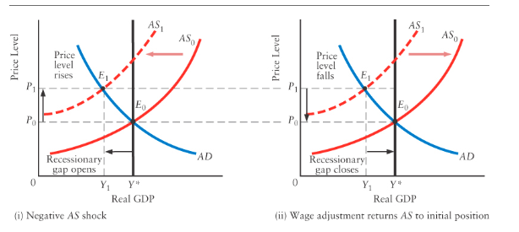

- A negative AS shock caused by an increase in input prices causes real GDP to fall and the price level to rise
- The economy’s adjustment process then reserves the AS shift and eventually returns the economy to tis starting point
- In (ii)- the excess supply of factors associated with the recessionary gap causes wages and other factor prices to fall, possibly slowly- this causes AS curve to shift back
  - The eventual effect of the AS shock, after all adjustment has occurred, is to leave the price level and the real GDP unchanged
- Overall: exogenous changes in input prices cause the AS curve to shift, creating an output gap. The adjustment process then reverses the initial AS shift and brings the economy back to potential output and the initial price level

Long-Run Equilibrium
- When adjustment process is complete and there is not output gap, the economy is in long-run equilibrium: intersection of AD and AS curves occurs at Y*
- Vertical Y* is referred to as the long-run aggregate supply curve or classical aggregate supply curve
- Long-run aggregate supply curve: the relationship between the price level and the amount of output supplied by firms after all factor prices have adjusted to output gaps

Changes in the Long-Run Equilibrium
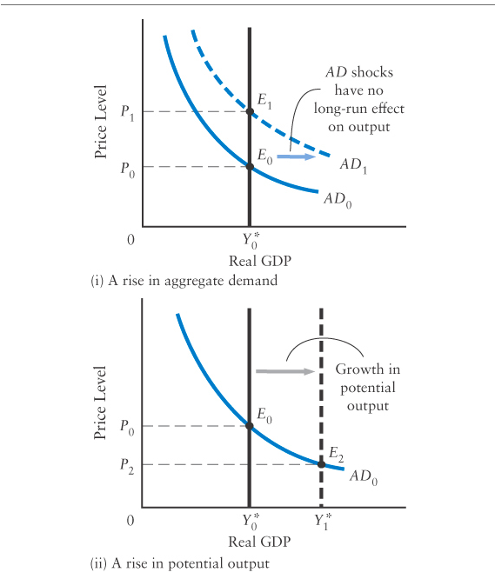

- Potential output determines the long-run equilibrium value of real GDP; given Y*, aggregate demand determines the long-run equilibrium value of the price level
- Why use this model: is useful to omit the AS curve if your focus is on the state of the economy AFTER all factor prices have fully adjusted and output has returned to Y*
  - How shocks affect the economy’s long-run equilibrium
- In the long run, real GDP is determined solely by Y*; the role of aggregate demand is only to determine the price level

The Canadian Wage-Adjustment Process: Empirical Evidence
- Difference between model and real world:
  - In the model: we assume that inflation is zero and labour productivity is constant, and so any change in nominal wages creates an equal change in firms’ costs. Also changes in firms’ costs that lead to shifts in the AS curve as part of the wage-adjustment process
  - Reality: the changes in firms’ cost depend on more than nominal wages
    - Unit labour cost: measure of the labour cost required to produce one unit of output
    - Unit labour costs rise when real wages increase because workers are expansive; but they fall when labour productivity increases because workers are able to produce more output per hour
    - Annual change in unit labour cost: growth rate of nominal wages- ration of inflation-growth rate/labour productivity

The Canadian Phillips Curve, 1991-2017
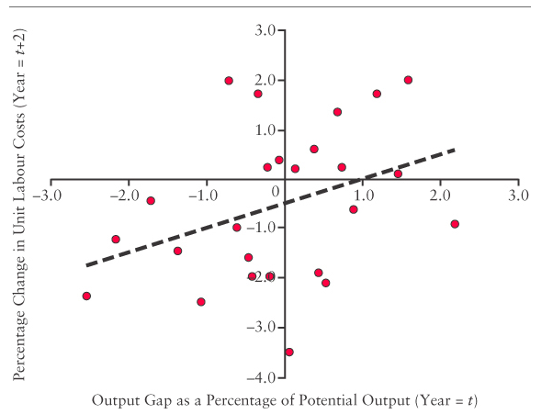
- the empirical evidence from Canada is therefore consistent with the central assumption of this chapter- that positive output gaps tend to drive wags (and costs) upward while negative output gaps tend to drive wages (and costs) downward

24.4- Fiscal Stabilization Policy

- Fiscal stabilization policy: a short-run policy
  - In response to various shocks that cause changes in real GDP, the government may use various fiscal tools in an attempt to push real GDP back towards potential output
- Alternatives to using fiscal policy: wait for the recovery of private-sector demand (a shift in the AD curve) or to wait for the economy’s adjustment process (a shift in the AS curve) to bring real GDP back to potential

The Basic Theory of Fiscal Stabilization
- A reduction in tax rates or an increase in government purchases or transfers will shift AD curve to the right, causing an increase in real GDP
- An increase in the tax rates or a cut in government purchases or transfers will shift the AD curve to the left, causing a decrease in the real GDP

The Closing of a Recessionary Gap
- The economy’s recovery process (seen above)
  - The excess supply of factors at equilibrium will eventually cause wages and other factor prices to fall, shifting the AS curve downward and resorting output to Y*
- Active policy choice: the government can use expansionary fiscal policy to shift AF curve to the right
  - This would be done by reducing tax rates, increasing transfers, or increasing the level of government purchases
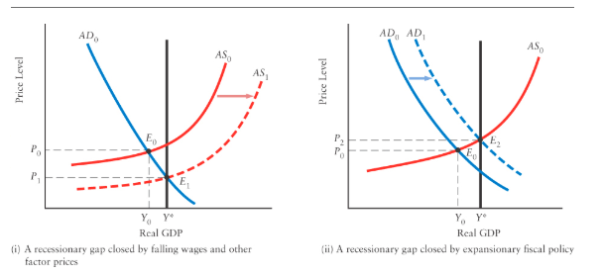

- A recessionary gap may be closed by a slow downward shift of the AS curve or an increase in aggregate demand
- Advantage of fiscal policy: substantially shortens what might otherwise be a long recession
- Disadvantage of fiscal policy: may stimulate the economy just before private-sector spending recovers on its own, as a result, the economy may overshoot its potential output, and an inflationary gap may open up
  - Fiscal policy that is intended to promote economic stability can actually cause instability

Closing an Inflationary Gap
- Economy’s adjustment process
  - Excess demand for factors will cause wages and other factor prices to rise, shifting the AS curve upward and gradually restoring output to Y*
- Contractionary fiscal policy to shift the AD curve to the left and close the inflationary gap
  - The government would do this by increasing tax rates, reducing transfers, or reducing its level of purchases

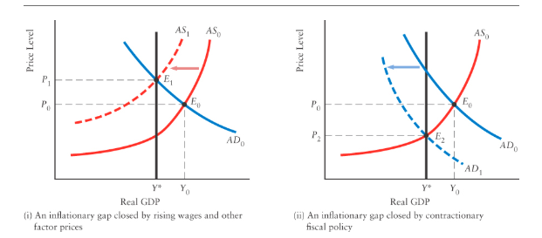

- An inflationary gap may be removed by an upward shift of the AS curve or by a leftward shift of the AD curve
- Advantage: avoids the inflation that would otherwise occur
- Disadvantage: if private-sector expenditures fall for some reason, the fiscal contraction may end up being too large and the real GDP may be pushed below potential, opening up a recessionary gap

- Key Proposition: when economy’s adjustment process is slow to operate, or produces undesirable side effects such as rising prices, there is a potential stabilization role for fiscal policy

Fiscal Policy and the Paradox of Thrift
- Paradox of thrift- the paradox being that what may be good for any individual when viewed in isolation ends up being undesirable for the economy as a whole
  - You have a good job, so you decide to save a larger fraction of disposable income. Your decision to save more today would not change your current income but these funds would accumulate and be useful in the future economic situations- if MANY PEOPLE did the same thing, the AD curve would shift to the left and REDUCE the equilibrium level of real GDP in the short run

Short Run Versus Long Run
- Paradox of thrift: shifts in aggregate demand that have been caused by changed in saving (and spending) over time
- The paradox shift ONLY applies in the short run, when the AD curve plays on important role in the determination of real GDP
- Does not apply for factor prices that have fully adjusted and the economy has achieved its new long-run equilibrium
- In the long run, the more people and government save, the larger is the supply of financial capital available for investment
  - The greater the rate of investment leads to a higher rate of growth of potential output
- Overall: The paradox of thrift—the idea that an increase in desired saving reduces the level of real GDP—is true only in the short run. In the long run, the path of real GDP is determined by the path of potential output. The increase in saving has the long-run effect of increasing investment and therefore increasing potential output.

Automatic Fiscal Stabilizers
- Policies discussed are discretionary because the government uses them to their direction
- If the government makes no active decision in changing spending or taxation, the mere existence of the governments’ tax-and-transfer system will act as an automatic stabilizer for the economy
- As real GDP increases, so does government tax revenue, this means that there are making fewer transfer payments- the rise in next tax revenues (tax minus transfers) dampens the overall increase in real GDP caused by the initial shock
  - The tax-transfer system reduces the value of the multiplier and thus acts as an automatic stabilizer
- Automatic stabilizer: elements of the tax-and transfer system that reduce the responsiveness of real GDP to changes in autonomous expenditure
- Positive demand shock: smaller shift in the AD curve than would occur in the absence of taxes and transfers
- Negative demand shock: as real GDP declines in response to the shock, the reduction in government net tax revenues dampens the overall decline in real GDP
- Overall: even in the absence of discretionary fiscal stabilization policy, the government’s tax-and-transfer system provides the economy with an automatic stabilizer
- Marginal propensity to spend: Z= MPC(1-t)-m
- Simple multiplier: 1/(1-Z)
  - the lower the net tax rate, the larger the simple multiplier and thus the less stable is real GDP in response to shocks in autonomous spending

Limitations of Discretionary Fiscal Policy
Decision and Execution Lags
- change in fiscal policy requires making changes in taxes and government expenditures
  - These changes have to go through cabinet and parliament
- Decision lag: the period of time between perceiving some problem and reaching a decision on what to do about it
- When policies are decided on there can be an execution lag
  - Execution lag: the time it takes to put policies in place after a decision has been made
Fine Tuning Versus Gross Tuning
- Fine tuning: the attempt to maintain output at tis potential level by means of frequent changes in fiscal or monetary policy
- Gross tuning: the use of macroeconomic policy to stabilize the economy such that large deviations from potential output do not persist for extended periods of time

Fiscal Policy and Growth
- Recap:
  - Increase in government spending and reductions in tax rates generally lead to an increase in aggregate demand and thus to a rightward shift of the AD curve, increasing real GDP
  - Reductions in government spending and increases in tax rates generally reduce aggregate demand and thus lead to a leftward shift in the AD curve, reducing real GDP

