CHAPTER 10: Develop Risk Response: Audit Strategy and Audit Program

Audit Strategy (How are we going to approach this audit)
- When developing the overall audit strategy, CAS 300 explains that the auditor should:
  - Identify the characteristics of the engagement that define its scope. What does our audit cover
  - Determine the reporting requirements. IFRS/ASPE/GAAP?
  - Consider the factors that are significant in directing the audit team’s efforts. Where are the risk areas, efforts are driven by where the risk is
  - Consider the results of preliminary engagement activities. Where, when and how much are we going to do
  - Determine the nature, timing, and extent of resources necessary to perform the engagement. How many people will we involve in our audit

Audit Strategy, Audit Plan, and Audit Tests
- The overall audit strategy, or the general overview of the audit, provides the basis for the audit plan.
- The audit plan includes the following:
  - The nature, timing, and extent of the risk assessment procedures;
  - The nature, timing, and extent of further audit procedures at the assertion level.
- The planning is done to get you ready for the actual execution of the audit
- Once planning is complete, you know how to approach the audit
- You can do some of the procedures before year end and some procedures have to be done after year end
- Identify risky areas/accounts (risk assessment) once you find out the account is risky you decide:
- How you’re going to test it
- When you’re going to test it
- How much will you test i.e. large sample
- All audits require procedures related to the financial statement closing process and to assess fraud risks (such as management override).
  - Need to make sure to address fraud risks around closing procedures to make sure there’s no management override of controls (supervisor, person who has access to everything)

Types of Audit Tests
- Auditors use five types of tests to determine whether financial statements are fairly stated:
  - risk assessment procedures; for entire account or particular assertions
  - tests of controls ; decide if you want to test controls then you can do less work testing the #’s
  - substantive tests of transactions; testing of #’s (can do detail testing or analytical)
  - substantive analytical procedures; and
  - substantive tests of balances.
  - Even if we don’t test controls we need to obtain an understanding of controls
1. Risk Assessment Procedures
- Risk assessment procedures are used to assess the likelihood of material misstatement (inherent risk times control risk) in the financial statements.
- Procedures to Obtain an Understanding of Internal Control—are a major subset of the auditor’s risk assessment procedures.
- Where is risk of fraud, related party trx, estimates? Identify the risky areas, use Ratio analysis
2. Test of Controls
- Tests of Controls—are audit procedures designed to verify whether the client’s controls match the auditor’s understanding of those controls.
- These tests are designed to obtain evidence regarding the effectiveness of controls—if controls can be relied upon, then substantive evidence may be reduced.
- Once you know what the control says, you know exactly how to test it i.e. every TX over $10,000 has to be approved by a supervisor
- Auditors can perform tests of controls separately from all other tests, but it’s more efficient to do them at the same time as substantive tests of transactions.
- These are called dual-purpose tests—they provide evidence of whether or not the controls being tested were operating effectively during the period and whether there are misstatements in the data produced by the accounting system.
- Testing salary expense, using detailed tests of salary payouts. All people are time sheet employees, supporting doc will be time sheet and hourly rate (Substantive tests). If testing control below, u can do this while doing the substantive one as well seeing as u are also looking at time sheets, this is dual purpose. Conducting substantive and control test at the same time
- Every time sheet has to be approved by supervisor = control, grab all time sheets and then see if this is true or not
3. Substantive Tests of Transactions
- Substantive analytical procedures involve comparisons of recorded amounts to expectations developed by the auditor.
- Auditing standards require that they be done during the planning and completion of the audit.
- Testing Numbers
4. Substantive Analytical Procedures
- If analytical procedures indicate a reasonable possibility of misstatement, additional analytical procedures or modifying substantive tests of details may be done.
  - Analytical procedures identify risky areas, they require at least 2 stages
  - Do ratio analysis before end of year and at end of year to see if there are major differences (from estimation and final #’s) if big differences then identify as a risky area
  - Then can compare to industry and prior years
5. Substantive Test of Balances
- Substantive Tests of Balances—are substantive procedures that are performed in order to detect material misstatements at the assertion level. (make sure all assertions hold)
- These are used to test the five transaction-related assertions: occurrence, completeness, accuracy, cut-off, and classification.
- Testing the assertions
Last 3 substantive testing can be used doing analytics or details (balance and transactions)

Further Audit Procedures and the Audit Risk Model
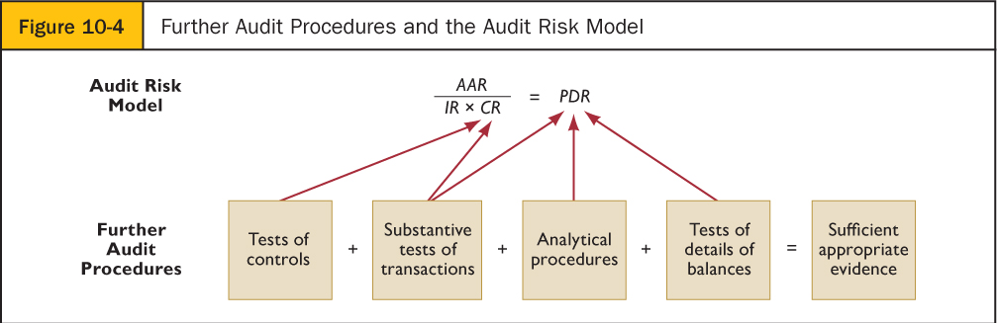
AAR= IRx CR x DR
IR x CR = RMM (risk of material misstatement)
Reduce detection risk by working hard. You conduct analytic, detailed test of balances, controls to reduce DR.

EX. P.340 10-22
Scenario #1: Good controls, due to well established internal audit department. Have small issues (2/500), expecting them to work well. COMBINED APPROACH
Scenario #2: Control environment is really good, good controls. COMBINED APPROACH
Scenario #3: Controls on paper that no one follows, no point in testing. SUBSTANTIVE APPROACH
Scenario #4: Not well trained and don’t follow procedures, if tested you would find this SUBSTANTIVE APPROACH
Scenario #5: IT crashes, IT controls will fail SUBSTANTIVE APPROACH

Selecting Which Types of Tests to Perform
- Figure 10-7 describes the audit process in detail.
- If controls are working as designed, then the auditor will conduct more tests of controls and fewer substantive tests.
- If controls are not functioning, or are too expensive to test, then the auditor will conduct more tests of details. If controls are too expensive/complex must do more work

Evidence Mix
- This leads to the question of what evidence is required and how much is needed?
- Table 10-1 summarizes the relationship between types of tests and types of evidence.
- A lot of judgment on procedures used to test numbers and controls, no algorithm to decide this. It is very judgmental

Types of Evidence (table 10-1)
- Inspection: inspect documents so you can inspect assets
- Observation: observing whether or not procedures are being performed
- Inquiries: asking the client to explain something to you
- External confirmation: call a third party to confirm something
- Recalculation: checking the math
- Reperformance: reperforming a procedure
- Analytical procedure: ratio analysis (you need to compare it if its good or bad) ie estimates

- However, be aware that there are significant variations in the extent to which the four types of tests can be used in different audits.
- Auditors use professional judgment to determine the mix of audit tests.
- As explained in Chapter 9, there is a trade-off between tests of controls and substantive tests.
- Refer to Figure 10-6, which shows the relationship between substantive tests and control risk assessment (including tests of controls) at differing levels of internal control effectiveness.
  - To show you that if you obtain some assurance from the testing controls you can obtain less assurance for testing the #’s

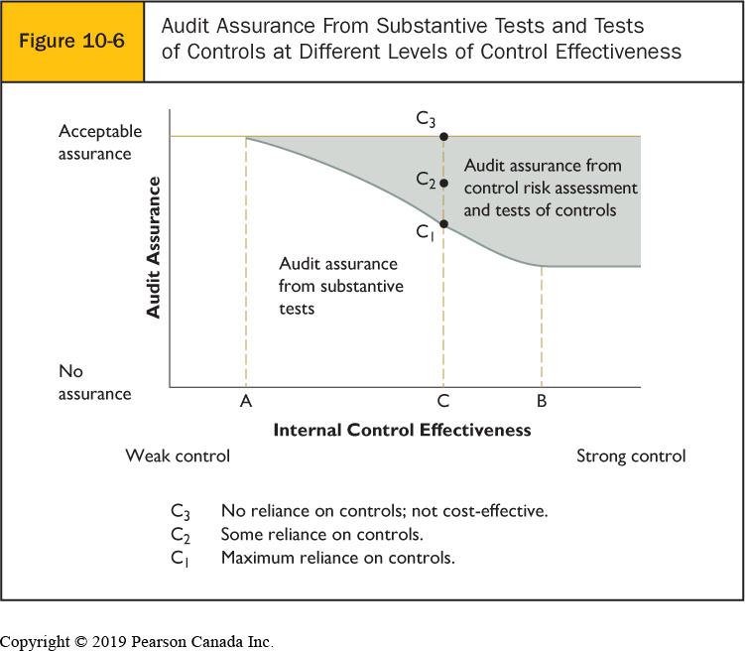
  - If you don’t test controls then grey area doesn’t exist
  - Reasonable assurance of no material misstatements come from testing the #’s
  - You can either test only the #’s or you test the controls and numbers
  - You cannot have an audit where you only tested controls (the grey area will not make up the whole graph)
  - You don’t have to test controls but if you do you need to test both #’s & controls

Relationship Between Controls and Substantive Tests
- An exception¹ in a test of control only indicates the likelihood of misstatements affecting the dollar value of the financial statements, whereas an exception² in a substantive test of transactions or a test of details of balances is a financial statement misstatement.
  - ¹An actual error found in the #’s for financials (substantive testing)
  - ²If it’s for controls it just means higher risk, doesn’t mean an error / misstatement is for sure
  - You can have horrible controls and perfect accounting, it just means the risk of a material misstatement is higher
- Likelihood of misstatement is higher if timesheets are not approved by supervisor as it is not a control. Detail test means u can see the misstatement
- A control weakness: the likelihood of a misstatement but cannot find it exactly

Relationship Between Analytical Procedures and Substantive Tests
- Analytical procedures only indicate the likelihood of misstatements affecting the dollar value of the financial statements. (AP: coming up with an estimate of what the balance should be and comparing it to the real balance)
- When analytical procedures identify unusual fluctuations, auditors should perform substantive tests of transactions or tests of details of balances to determine whether dollar misstatements have actually occurred. (do an analytic & a detail test (for substantive testing)
  - If you see a difference between the estimation and real it doesn’t mean that there is a material misstatement, you need to do further looking into it like a detail test (looking at actual docs, can see if it’s an actual error)
- Analytical does not identify actual error, EX the hotel and u estimate revenue is 1M they have 2M in books, you can’t see they are 200k off. Thus, only indicates the likelihood of a misstatement, but cannot pin point the exact MM. If analytic is materially different from actual, this does not mean it is wrong thus must do detailed testing to find the exact amount of the error. Analytic = LIKELIHOOD of misstatement

Trade Off: Substantive Tests and Tests of Controls
- If control risk is assessed as high, the auditor would follow a substantive approach; if control risk is assessed lower, the auditor could follow a combined approach.
- If the control testing reveals that the controls are not functioning, or it is very costly to test internal controls, the auditor may still end up with a substantive approach.
  - If CR increases, don’t test controls because can’t rely on them anyways, do only substantive testing
  - The point of testing controls is that if they pass, we can rely on them
  - Another reason why we wouldn’t test controls is if they were super complex and it would take you forever to do it

Comparison of Different Evidence Mixes
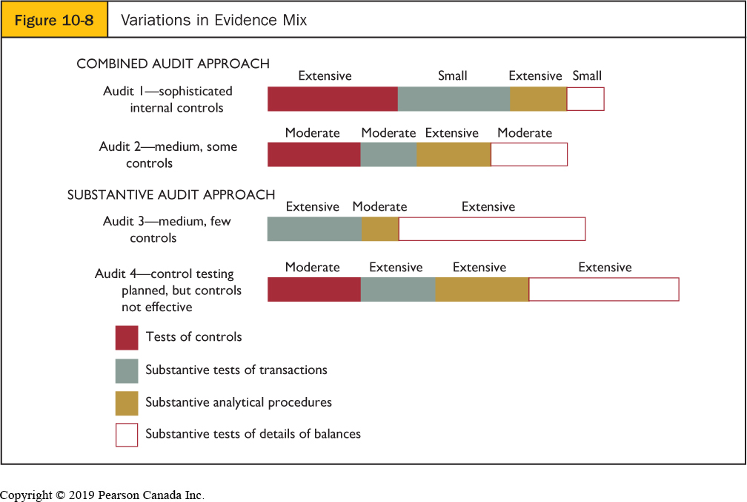

Design of the Audit Programs Detailed steps to perform test on
- The audit program is normally split into three parts:

1. Tests of controls and substantive tests of transactions (if there is no reliance on controls then only substantive tests of transactions);
  - Tests of controls are based on the descriptive section documenting the understanding obtained about internal control.
  - If cost-beneficial, tests of controls would be conducted for key controls upon which the auditor intends to rely.
  - The audit program is normally listed in a performance format (i.e., in the order in which tests will be conducted).

2. Substantive analytical procedures
Substantive analytical procedures are conducted at each phase of the audit:
  - in the planning stage to help the auditor decide the other evidence needed to satisfy audit risk; Compare ratios to prior year and industry, done before year end
  - during the audit in conjunction with tests of details of balances as part of substantive procedures; and
  - near the end of the audit as a final test of reasonableness.
    - AP are done throughout the entire audit
3. Substantive tests of balances
- The planned substantive tests of balances include audit procedures, sample size, items to select, and timing.
- Procedures must be selected and designed for each account and each balance-related audit objective within each account.
- Audit tests can be conducted throughout the year, or, for a small audit, may be conducted in a concentrated period of time (refer to Table 10-2).
- Table 10-2 shows the tests of details of balances segment of an audit program for accounts receivable.
- The format used relates the audit procedures to the balance-related audit objectives, and presentation and disclosure audit objectives.
- Audit procedures can be added or deleted as the auditor considers necessary; sample size, items to select, and timing can also be changed for most procedures.
- The audit program in Table 10-2 was developed after consideration of all the factors affecting tests of details of balances and is based on assumptions about inherent risk, control risk, and the results of tests of controls and analytical procedures.
- If those assumptions change, the planned audit program will also require revision.
  - The programs re planned and adjusted to the planning so if you’re starting to conduct your testing and you find problems then the program is going to need to be adjusted too, if something unexpected comes up, its normal for things to change
STOPPED HERE

Timing of Audit Tests
- Audit tests can be conducted throughout the year, or, for a small audit, may be conducted in a concentrated period of time.
- Roll forward—substantive work on journal entries and transactions from a date prior to the balance sheet date to the year-end. This is often done when clients want to issue statements soon after the balance sheet date so that work can be done during the interim period.
  - you can do some procedures after Dec 31st (higher risk areas) or you can do some at interim (before Dec 31st)
  - Interim usually done in the Q4 for low risky account (i.e. you’re using Q3 #’s)
  - Controls are also usually tested at interim so that you can rely on them after

Summary of the Audit Process
- In this chapter, we integrate all the different parts of the audit process, summarized in Figure 10-10, that we have studied up to this point.
  - Client acceptance, audit planning, and assess risk of material misstatement
  - Develop risk response
  - Conclusion and reporting

10-22 4 6 Based on facts in each scenario, recommend the most appropriate audit strategy (combined or substantive).
Scenario | Strategy
Big Bank is a multinational bank that operates across the globe. Each day, the bank processes billions of monetary transactions. The bank has a large well-established internal audit department. Last year, internal auditors reported to the board of directors about some control weaknesses that they had identified. These weaknesses are currently being addressed by the bank’s senior management. | combined
In the past year, after starting to work as a controller, Tony has established a strong control environment and tone at the top to ensure employees operate ethically, adhering to stated policies. Tony holds daily management meetings to review operations and financial information. Budget and actual results are also reviewed by Tony, who interprets the results and sets the direction for the next day. | combined
A year ago, LVSports Inc., a large chain of stores that carry sports equipment, hired a new controller. The controller took it upon herself to conduct a walkthrough of each accounting process. The purpose of the walk-throughs was to identify and fix any control gaps. After the gaps were fixed, the controller hired a consultant to review whether the updated controls improved LVSports’s control environment. The consultant reported back that, on paper, the updated controls were really good, but that in most cases, staff did not follow them. | Sub
Over the past 12 months, 2Fast Inc., a private consulting company, has lost half of its accounting staff to retirements. For the past six months, the company has relied on temporary staffing agencies to fill the vacant positions. Fraser, the company’s new controller, is not happy with the temporary staff provided by the agencies. They are mostly new university graduates with little prior work experience who make a lot of significant mistakes. | Sub
Emilia Inc. provides bridge design engineering services. The company has grown rapidly over the past five years. Last year, the company procured a new financial accounting IT system. After the system was installed, things appeared to be going well until the company realized that it forgot to install required weekly system upgrades. When the upgrades were finally installed, the system crashed several times and a significant amount of financial information was corrupted. Management is in the process of trying to fix the corrupted information. | Sub

10-23 2 The following are audit procedures from different transaction cycles:
- Examine sales invoices for evidence of internal verification of prices, quantities, and extensions.
- Select items from the client’s perpetual inventory records and examine the items in the company’s warehouse.
- Use audit software to foot and cross-foot the cash disbursements journal and trace the balance to the general ledger.
- Select a sample of entries in the acquisitions journal and trace each one to a related vendor’s invoice to determine whether one exists.
- Examine documentation for acquisition transactions before and after the balance sheet date to determine whether they are recorded in the proper period.
- Inquire of the credit manager whether each account receivable on the aged trial balance is collectible.
- Compute inventory turnover for each major product and compare with that in previous years.
- Confirm a sample of notes payable balances, interest rates, and collateral with lenders.
- Use audit software to foot the accounts receivable trial balance and compare the balance with the general ledger.

Required
- For each audit procedure, identify the transaction cycle being audited.
- For each audit procedure, identify the type of evidence.
- For each audit procedure, identify whether it is a test of control or a substantive test.
- For each substantive audit procedure, identify whether it is a substantive test of transactions, a test of details of balances, or an analytical procedure.
- For each test of control or substantive test of transactions procedure, identify the transaction-related assertion being tested.
- For each analytical procedure or test of details of balances procedure, identify the balance-related assertion being tested.
1) a) Revenue and collection (people owe you money)
b) Inspection of documentation (examining sales invoices, looking at docs)
c) Control (not checking #’s just checking invoice to see if there evidence of a review & checking
procedure)
d) N/A
e) Accuracy of transaction (verifying price & quantities)
f) N/A
2) a) Inventory & distribution
b) Inspection of assets (looking at inventory item)
c) Substantive (not looking to see if a procedure was done right, looking more at if a # in the
financials is right, the item has to be in the books)
d) Balance transaction
e) N/A
f) Existence (looking at a piece of inventory to see if item exists)
3) a) Acquisition & payment
b) Inspection of documentation
c) Substantive
d) Transaction
e) Accuracy
f) N/A
4) a) Acquisition & payment
b) Inspection of documentation
c) Substantive
d) Transactions
e) Existence / occurrence
f) N/A
5) a) Acquisition & payment
b) Inspection of documentation
c) Substantive
d) Transactions
e) Cut-off
f) N/A
6) a) Revenue and collection
b) Inquiry
c) Substantive
d) Balances
e) N/A
f) Valuation
7) a) Inventory & distribution
b) Analytical procedure
c) Substantive
d) Analytic
e) N/A
f) Valuation
8) a) Capital acquisition & repayment
b) Confirmation
c) Substantive
d) Balance
e) N/A
f) Existence
9) a) Revenue and collections cycle
b) Recalculation
c) Substantive
d) Balance
e) N/A
f) Accuracy

