CHAPTER 9: ASSESSING CONTROL RISK AND DESIGNING TEST OF CONTROLS

Obtain and Document Understanding of Internal Controls
(In order to identify areas where the controls are weak or no present which can lead to MM)
- CAS 315 requires that all five components of internal control be addressed when developing an understanding of internal control related to financial reporting.
- The auditor uses this understanding to identify the potential errors or fraud and other irregularities that will increase the risks of material misstatement at the overall financial statement level as well as the assertion level.
- This understanding will be used to design the audit procedures in responding to those risks.
  - Need to understand the info system the company is using & controls
  - Need to know how to capture transactions + how data flows to fina statements
  - We only test controls when we think that after the controls pass we can do less work testing the numbers
  - Need to know controls of the process and of the journal entries

Understanding the Information System and Communication
- CAS 315 requires the auditor to obtain an understanding of the information system, including:
  - The financial reporting process used to prepare financial statements, including significant accounting estimates and disclosures;
  - The nature and details of the financial reporting process followed, including procedures to enter transactions and adjustments into the general ledger; and
  - Controls surrounding journal entries, including nonstandard journal entries used to record nonrecurring unusual transactions or adjustments.
  - The major classes of transactions of the entity;
  - How those transactions are initiated and recorded;
  - What accounting records, whether electronic or manual, exist and their nature;
  - How the information system captures other events that are significant to the financial statements, such as declines in asset values;
    - Need to understand the info system the company is using
    - Need to know common transactions that the company has (environment of company to better understand the company and their controls)
    - Know common transactions and how do they record them

Methods for Documenting Understanding of Controls Activities
- Documentation of the understanding of internal controls is often done in three ways:
  - Narrative—a written description of a client’s internal controls, including the origin, processing, and disposition of documents and records, and the relevant control activities.
    - Text documenting how certain controls work
    - Explains how everything works, how to make sure nothing is missing
  - Flowchart— a diagrammatic representation of the client’s documents and records, and the sequence in which they are processed. (diagram of narrative)
    - Records every single process and document created along with their how and which procedure is implemented at every stage in a process
  - Internal control questionnaire—a series of questions about the controls in each audit area used as a means of gaining an understanding of internal control.
    - Series of questions that the auditor would ask & the answers are yes or no where it allows you to identify if everything is working properly or not

Evaluating Internal Control Design and Implementation
- The auditor must evaluate whether the controls have been implemented. This involves:
  - Considering whether the controls, when in operation, would achieve this objective;
  - Determining whether the controls have been implemented (i.e., the control exists and the company is using it); and
  - Considering whether appropriately qualified persons are intended to be carrying out the control.
    - Before you test controls, do they have enough controls?
    - After you understand objectives you need to see whether the controls are in place to achieve these objectives
    - Look at all assertions, you need to have a control that helps achieve every single assertion
- Some common methods used in performing the evaluation of implementation of controls:
  - Update and Evaluate Auditor’s Previous Experience With the Entity
  - Make Inquiries of Client Personnel
    - (1st step, ask clients about their controls, not best b/c the person can be wrong or lying)
  - Examine Documents and Records
    - Show me your list of controls
  - Observe the Entity’s Activities and Operations
    - Observe how controls are being executed
  - Perform Walk-Throughs of the Accounting System
    - Transaction walk-through
    - Good procedure, taking 1 transaction from inception and following it to the booking of the financials
  - Assess Control Risk (after all this you come up with overall assessment of control risk)

Assess Control Risk
- Before making a preliminary assessment of control risk for each material class of transactions, the auditor must decide whether the entity is auditable.
  - If management lacks integrity, most auditors will not accept the engagement or, in the case of a continuing client, will resign from the engagement.
  - If the accounting records are deficient, necessary audit evidence may not be available.
  - In complex IT environments, the auditors must assess if they have the necessary IT skills.
    - If you feel like managers lack integrity you don’t want to work with them
    - If their IT is too complex and you don’t have enough knowledge and everything they do is electronic are you sure you want to do it?

Determine Assessed Control Risk Supported by the Understanding Obtained
- The starting point for most auditors is the assessment of entity-level controls.
- Auditors generally assess entity-level and general controls before assessing transaction controls (control activities) and IT application controls.
- Once auditors determine that entity-level and general IT controls are designed and placed in operation, they next make a preliminary assessment for each transaction-related audit objective for each major type of transaction in each transaction cycle.
  - Soft control-> entity level controls (extremely vague but important)
  - Ie code of ethics (policies of compliance or ethical behaviour)->pervasive

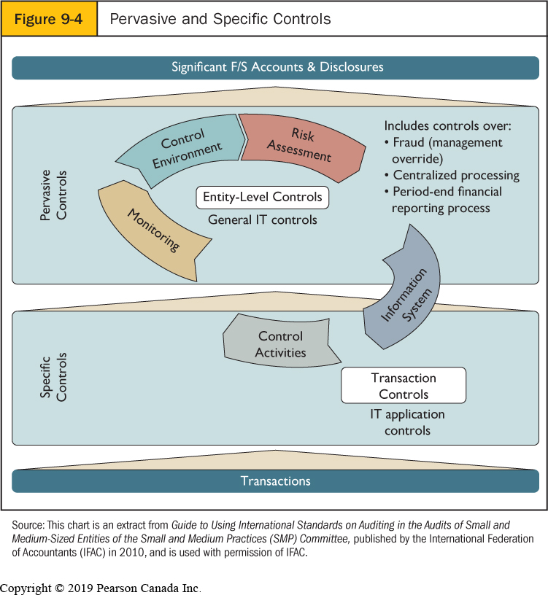
    - Affects the entire company

    - General IT control (security/back up of data)

    - Specific procedures for specific controls (can be manual or can be automated)

    - Specific for each individual procedure behaviour/transactions (can be manual or automated)
i.e. person A approves all procedures over $1000

Assess Control Risk at the Assertion Level
- Control risk matrix—a methodology used to help the auditor assess control risk by matching key internal controls and internal control weaknesses with transaction-related audit objectives.
- Many auditors use a control risk matrix to assist in the control-risk assessment process at the transaction and assertion level. The purpose is to provide a convenient way of organizing control risk for each assertion and related audit objective.
- See Figure 9-5 for an example.
  - If we test controls and they’re good, the potential risk of the #’s are lower
  - If you don’t have controls, I’m testing the #’s a lot
  - If we’re testing #’s were testing assertions
- The process of assessing control risk using the matrix involves:
  - Identifying Audit Objectives (Assertions)
  - Identifying Specific Relevant Controls
  - Associating Controls With Related Audit Objectives (Assertions)
  - Identifying and Evaluating Control Deficiencies, Significant Deficiencies, and Material Weaknesses (identify problems, 3 types that we can face as auditors)

Identify and Evaluate Control Deficiencies, Significant Deficiencies, and Material Weaknesses (3 types of problems auditors face)
- Auditing standards (CAS 265) define three levels of the absence of internal controls:
  - control deficiency exists if the design or operation of controls does not detect and correct misstatements in timely manner
    - it doesn’t work but not likely to lead to a material misstatement
  - significant deficiency exists if one or more control deficiencies exist that are less severe than a material weakness
    - control deficiency is bad but may or may not lead to material misstatement
  - material weakness exists if a significant deficiency, results in a reasonable possibility that internal control will not prevent or detect material financial misstatements on a timely basis.
    - A control problem is likely to lead to material misstatement

Evaluating Significant Control Deficiencies
- A five-step approach can be used for identifying significant and/or material internal control weaknesses.
  - Identify existing controls.
  - Identify the absence of key controls.
  - Consider the possibility of compensating (or mitigating) controls.
    - Even though anyone can make a purchase order for any amounts there’s someone to renew it daily (one control isn’t there but there is another control picking up the slack)
  - Decide whether there is a significant deficiency or material weakness.
  - Determine potential material misstatements that could result.

Tests of Controls
- The procedures to test effectiveness of controls in support of a reduced assessed control risk are called tests of controls.
- Five types of audit procedures are used to support the operation of key internal controls.
  - Make Inquiries of Appropriate Entity Personnel
  - Inspect Documents, Records, and Reports
  - Observe Control-Related Activities
    - Observe how controls are being executed
  - Test Data
    - Take your own data and make the client run it and put conditions in your data that should be picked up to verify whether the system will pick it up or not
  - Reperform Client Procedures
    - Sit down with the client and reperform their procedures to see if controls work properly
- Substantive approach: you test only the #’s
- Combined approach: testing controls & #’s (you test controls first to see how much work has to be done when testing the #’s
- always have to test #’s but you don’t need to test controls
- EX. Control risk is low, controls are good and they are very complex and take a long time to test…does not make any sense.
- Must use combined approach, for companies that have a lot of IT related controls and trx
- Most part is the control risk that drives the

Relationship of Tests of Controls to Procedures to Obtain an Understanding
- In obtaining an understanding of internal control, the procedures are applied to all controls identified. Tests of controls, on the other hand, are applied only when the assessed control risk has not been satisfied by the procedures to obtain an understanding.
- Procedures to obtain an understanding are performed only on one or two transactions or, in the case of observations, at a single point in time.
  - Testing controls happens once you have an understanding of controls & assessed your design to know your control risk
  - If control risk is high; don’t test controls if moderate to low; test controls
  - Combined approach is your choice, in CDN this is not a requirements

Understanding and Assessing Controls of Outsourced Systems
- CAS 402 requires the auditor to consider the need to understand and test the service centre’s controls if the service centre application involves processing significant financial data.
  - CSAE 3416 provides guidance to auditors who issue reports on the internal control of service organizations (service auditors).
    - Report on management’s description of a service organization’s system and the suitability of the design of controls (referred to as a Type 1 report).
    - Report on management’s description of a service organization’s system and the suitability of the design and operating effectiveness of controls (referred to as a Type 2 report).
- In many cases some companies outsource their systems (data) to a cloud company or someone else handles their data process, if we are testing our companies controls we need to make sure that whoever they are outsourcing the date to has good controls
  - EX. Payroll is outsourced to another company, payroll impacts FS. Auditor must test controls around payroll, although you are not doing it. Thus, must look at the company that does the payrolls and test their control. They reach out to the auditors of that company and receive feedback from their auditors about their controls (Payroll company

Evaluate Results, Decide on Planned Detection Risk, and Design Substantive Tests
- Performing tests of controls may be more cost efficient than performing substantive procedures in certain situations.
- In highly automated systems, the auditor has no choice but to rely upon internal controls.
- Whenever the auditor has made the decision to rely upon internal controls, they must be tested.
- Highly automated system required that controls be tested regardless

Impact of IT Environment on Control Risk Assessment and Testing
- If there are significant risks associated with the IT system, the IT specialist can:
- Assist in documenting and assessing the IT control environment; What controls are problematic
- Test general controls; High level controls
- Document and assess key automated controls; individual control
- Develop computer assisted audit techniques (CAATs) to test controls and to perform substantive tests; and
- Evaluate weaknesses and develop recommendations on how to improve IT controls.
- I need to make sure the procedure works right ie manual approval for purchases over $10,000
  - IT Controls are normally tested by another department
  - Same as manual control but with IT

Auditing in More Complex IT Environments (using tech to audit IT processes)
- Auditing through the computer—auditing by testing automated internal controls and account balances electronically, generally because effective general controls exist.
- Auditors use three approaches to test the effectiveness of automated controls when auditing through the computer:
  - test data approach, Auditor gives fake data to client and client runs it through their system and they look at the results to make sure it runs properly (can identify if trxs are in the right periods)
  - parallel simulation, and Auditor uses clients data and re-does/runs what they have done to make sure they have done it correctly (Ex. Test if supervisor approves time sheets, run them through system and programming where there is no signature missing)
  - embedded audit module approach. Real time auditing, identify transactions of interest and follow them through. Order placed by client and then follow it through to the journal entry

Auditing in More Complex IT Environments—Test Data Approach
- The test data approach is a method of auditing an IT system that uses the auditor’s test data to determine whether the client’s computer program correctly processes valid and invalid transactions.
- When using the test data approach, auditors have three main considerations:
  - Test data should include all relevant conditions that the auditor wants tested.
  - Application programs tested by auditors’ test data must be the same as those the client used throughout the year.
  - Test data must be eliminated from the client’s records.
- I.e. trying to pass a $10,000 transaction and see if its approved or not to pass

Auditing in More Complex IT Environments—Parallel Simulation
- Parallel simulation testing is an audit testing approach that involves the auditor’s use of audit software to replicate some part of a client’s application system.
  - you’re trying to replicate some of your clients activities, take a bunch of their data and run it in yourself (computer), take clients activities and do it i.e. replicating it
- Auditors commonly do parallel simulation testing using generalized audit software (GAS), computer programs used by auditors that provide data retrieval, data manipulation, and reporting capabilities specifically oriented to the needs of auditors.
  - Pick something interesting and observe how transactions run through the system

Auditing in More Complex IT Environments—Embedded Audit Module Approach
- if testing, usually done by a separate department
- The embedded audit module approach is a method of auditing transactions processed by IT whereby the auditor embeds a module in the client’s application software to identify transactions with characteristics that are of interest to the auditor; the auditor is then able to analyze these transactions on a real-time, continuous basis as client transactions are processed.
  - Attempt to do a real time audit; you create a module to identify transactions you’re interested in, in the clients records and then you observe how the transactions flow through the system
  - Ie identify transactions over $10,000 and see how they are being approved or objected by the supervisor in the system (in real time b/c tracking it as its being done)

Communications to Those Charged with Governance and Management Letters
- According to CAS 265, the auditor is required to communicate significant control deficiencies in writing to “the audit committee or equivalent.”
- The description of the internal control deficiency and recommendation is usually included in a year-end report, or internal control letter to the audit committee.
  - If material weakness or significant deficiencies go to audit committee (bad stuff)
- Management letter—the auditor’s written communication to management to point out less significant weaknesses in internal control and possibilities for operational improvements.
  - minor deficiencies in controls go to CFO/CEO in a management letter
  - If we find problems, we need to communicate them to change them
- Material weakness: control deficiency likely to lead to MM, PUT THESE IN INTERNAL CONTROL LETTER (letter to the audit committee about major control problems)
- Management letter is about smaller control problems given to management, small issues not likely to lead to MM

Reporting on Internal Controls
- For some companies, the auditor reports upon management’s assessment of internal control called Section 5925 of the CPA Canada Handbook, “An audit of internal control over financial reporting performed that is integrated with an audit of financial statements”.
- The auditor obtains an understanding of and performs tests of controls for all significant account balances, classes of transactions, and disclosures and related assertions in the financial statements.
- Those controls might or might not be tested in a financial statement audit.
  - No need to test every control as an external auditor
  - Make sure every objective holds
  - Make sure have a control for every objective/assertion
  - Pick controls that cover a lot of objectives & do a lot

E9-24 Identify the most relevant assertion(s) for each control that is listed below.
- Customer credit limits are reviewed on a monthly basis and amended in accordance with customer activity.
- Prior to paying for a purchase, supporting documentation (invoices, statements of account) are reviewed for validity.
- Paper timesheets submitted by employees for a given period are reconciled to the corresponding payroll ledger.
- During a full count of all capital assets, all assets are physically labelled with unique identification numbers and their location, description, and quantity are noted.
- The purchasing department, on receipt of the receiving report, matches it to the purchase order to ensure that all ordered goods were received.
- Prior to being entered into the payroll system, all paper timesheets are reviewed by the shift supervisor, who signs off on them.
ANSWERS:
- Valuation
- Accuracy (making sure stuff is valid, back ups)
Occurrence (making sure the purchases are going to be real)
- Completeness (making sure nothing is missing from GL)
- Completeness
- Completeness
- Accuracy (make sure calculated correctly)
Occurrence (make sure the hours are right that they worked)

9-26 1 2 7 The following are errors or fraud and other irregularities that have occurred in Fresh Foods Grocery Store Ltd., a wholesale and retail grocery company. What control would you put there to prevent this problem?
- The incorrect price was used on sales invoices for billing shipments to customers because the incorrect price was entered into a computer file.
- A vendor’s invoice was paid twice for the same shipment. The second payment arose because the vendor sent a duplicate copy of the original two weeks after the payment was due.
- Employees in the receiving department stole some sides of beef. When a shipment of meat was received, the receiving department filled out a receiving report and forwarded it to the accounting department for the amount of goods actually received. At that time, two sides of beef were put in an employee’s pickup truck rather than in the storage freezer.
- During the physical count of inventory of the retail grocery, one counter wrote down the wrong description of several products and miscounted the quantity.
- A salesperson sold several hundred kilograms of lamb at a price below cost because she did not know that the cost of lamb had increased in the past week.
- On the last day of the year, a truckload of beef was set aside for shipment but was not shipped. Because it was still on hand, it was counted as inventory. The shipping document was dated the last day of the year, so it was also included as a current-year sale.

ANSWERS:
- Independent checks of the database/master file by a manager
- Preventive control (making sure a receiving doc is matched with an invoice)
- Installing cameras at the receiving department
- Have another person count the inventory
- Make sure the salesperson have the most UpToDate price list and make them reply with confirmation

9-26 Why do we have bar scanning technology? Why do we like them?
-reduces human errors
-helps out with inventory (perpetual inventory)
-does the math for you
-very good control to prevent errors in sales, cash and inventory

