CHAPTER 8: INTERNAL CONTROL AND COSO FRAMEWORK

Internal Control Objectives
- Internal control: the policies and procedures instituted and maintained by the management of an entity in order to provide reasonable assurance that management’s objectives are met.
- Management designs systems of internal control to accomplish the following four broad objectives: Controls to make sure there are not MM in financials, if controls are tested and they all work then the risk of MM will be lower. Once the control pass you can decrease the work put into testing the numbers. There is no requirements to conduct audit of internal controls in Canada
  - Strategic, high-level goals that support the mission of the entity.
- Big strategic decisions and there are controls to make sure they are achieved ie the BOD have to approve the decision of the CEO when it comes to M&A
  - Reliability of financial reporting.
- ie CFO reviews the Bank Recs, with the objective of not having a misstatement in cash
  - Efficiency and effectiveness of operations.
- How effective/efficient the company is when it comes to doing what they do ie are they affective in selling stuff not necessarily to do with fina reporting
  - Compliance with laws and regulations
- Everyone has to comply with laws ie you sell food so have to apply food processing standards & environmental standards, there are laws in place to make sure you do that

The Responsibilities of Management and the Auditor
- Responsibilities for internal controls differ between management and the auditor.
- Management, not the auditor, must establish and maintain the entity’s internal controls.
- Also, in the case of public companies, management is required to publicly report on the operating effectiveness of internal controls over financial reporting.
- Management can’t audit controls as they are ones who establish the controls

Auditor’s Responsibilities
- Auditors are responsible for understanding the entity’s internal controls relevant to the audit, in order to achieve their objective of identifying the risks of material misstatement at the financial statement and assertion level.
- Obtaining this understanding of internal control applies to all audits, even when an auditor does not intend to place reliance on internal controls.
- Understand how controls work if you don’t test them

Auditor’s Responsibilities: Entity-Level Controls and Transaction Controls
- Entity-level controls are those controls that are pervasive in nature and do not address particular transaction cycles but may prevent or detect and correct misstatements in several cycles. Pervasive for entire company, every employee logs into employee account and read code of ethics. Done to ensure people understand the importance of ethics (affects everything)
- Transaction controls—controls that are implemented for specific transaction risks and are designed to specifically prevent or detect and correct misstatements in classes of transactions, account balances, or disclosures and their related assertions (individual procedures for individual transactions, affects one thing, ex. Time sheets are reviewed by a supervisor)

Auditor’s Responsibilities: Transaction Related Audit Objectives and Assertions
- Transaction related audit objectives and assertions—five audit objectives that must be met before the auditor can conclude that the total for any given class of transactions is fairly stated; the assertions are occurrence, completeness, accuracy, cutoff, and classification.
- Need to make sure every assertion hold and there are controls for every assertion. If controls are good it doesn’t mean there’s no MM it means RMM is lower, but still cannot conclude on the #

Five Components of Internal Control (COSO) A way to guide management to establish good controls
- Internal control as defined by CAS 315 encompasses five components:
  - Control environment: is the foundation of effective internal control. It addresses governance and management functions as well as the attitudes, awareness, and actions of those charged with governance and management concerning internal control and its importance.
  - Risk assessment: We have controls because we have risk
  - Control activities: procedures to make sure company meets objectives
  - Information and communication: Sending all info on controls to people who deal with it
  - Monitoring: making sure all these components are met
- See Table 8-1 for further explanation.
- These components, based upon COSO’s Internal Control—Integrated Framework.

Internal Controls Principles
- Principle 1: Demonstrate Commitment to Integrity and Ethical Values
- Principle 2: Board of Directors Exercises Oversight Responsibility
- Principle 3: Management Establishes Structure, Authority, and Responsibility
- Principle 4: Commitment to Competence
- Principle 5: Organization Establishes and Enforces Accountability
- Principle 6: Organization Specifies Relevant Objectives
- Principle 7: Identifies and Assesses Risks
- Principle 8: Considers the Potential for Fraud in Assessing Risk
- Principle 9: Identifies and Assesses Significant Changes
- Principle 10: Selects and Develops Control Activities
- Principle 11: Selects and Develops General Controls over Technology
- Principle 12: Deploys Policies and Procedures
- Principle 13: Obtains or Generates Relevant, Quality Information
- Principle 14: Communicates Internally
- Principle 15: Communicates Externally
- Principle 16: Selects, Develops, and Performs Ongoing and Separate Evaluations
- Principle 17: Evaluates and Communicates Deficiencies

Control Featured That Could Reduce Fraud Risks
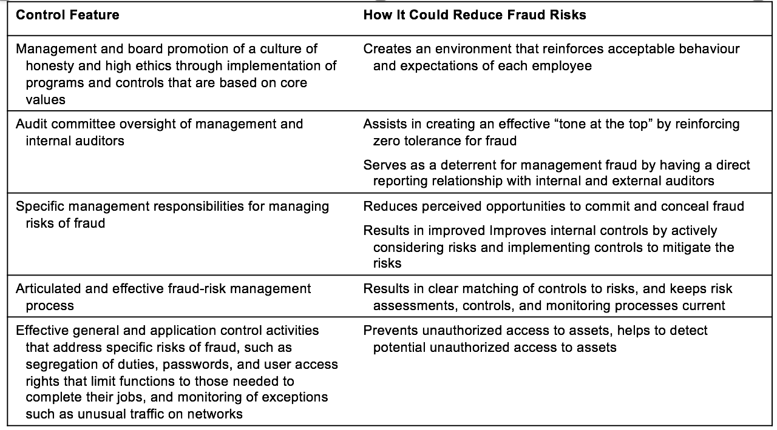

Control Activities
- Transaction controls are control activities implemented to mitigate transaction processing risk for specific business processes. The control activities should be a combination of preventive and detective controls.
  - Preventive controls—controls designed to avoid errors or irregularities.(has to occur before the event)
  - Detective controls—controls that identify errors or irregularities after they have occurred so corrective action can be taken.
    - To prevent and detect problems whether it is honest errors or fraud
    - Prevent unauthorized purchases: every purchase over 10k must be approved my manager
    - If first control fails (preventative measure) then it will be detective when the CEO reviews the numbers
    - Anything that says review is a detective control

Controls over the Business Process
- Business process: the set of manual and/or computerized procedures that collect, record, and process data and report the resulting output; also known as “application system.”
- Typical controls of the business processes would include:
  - Proper authorization of transactions and activities.
  - Adequate documents and records.
  - Physical and logical control over assets and records. (make sure nothing is stolen ie for security)
  - Adequate segregation of duties.
  - Independent checks of performance, recorded data, and actual results.

Proper Authorization of Transactions and Activities
- Every transaction should be properly authorized if controls are to be satisfactory. Authorization encompasses more than transactions; it also includes authorization of new programs and changes to programs since this affects the way that transactions are processed.
  - Not only for transactions recorded but also for IT system (shouldn’t have a situation where anyone can shoe up and change IT system)

Adequate Documents and Records
- Documents and records are paper or electronic files on which transactions are entered and summarized.
- Documents should be:
  - Prenumbered or automatically numbered consecutively to facilitate control over missing records, and to aid in locating records when they are needed at a later date (significantly affects the transaction-related audit objective of completeness).
  - Prepared at the time a transaction takes place, or as soon thereafter as possible.
  - Adequate documentation is crucial for financial reporting, if you don’t have a document, it shouldn’t be in your books

Physical Control over Assets and Records
- If assets are left unprotected, they can be stolen.
- If records are not adequately protected, they can be duplicated, stolen, damaged, or lost.
- An important type of protective measure for safeguarding physical assets and records is the use of physical precautions.
  - Making sure nothing is stolen in terms of assets
  - Making sure nothing is destroyed or tampered with when it comes to your records

Adequate Segregation of Duties
- Segregation of duties: segregation of the following activities in an organization: custody of assets, recording/data entry, systems development/acquisition and maintenance, computer operations, reconciliation, and authorization.
- These controls can reduce the opportunities for a person to be a position to perpetuate and conceal a fraud.
- In many small companies, it is not practical to segregate the duties to the extent suggested. In these cases, the auditor will likely choose to not rely upon internal controls.
  - Primary prevention of fraud, shouldn’t have one person doing everything
  - Doesn’t prevent all fraud b/c can have collusion i.e. people working together to fraud
  - To prevent collusion, implement job rotation

Independent Checks of Performance, Recorded Data and Actual Results
- The need for careful and continuous review of the other controls, often referred to as independent checks on performance or internal verification, arises because internal control tends to change over time unless there is a mechanism for frequent review.
- Computerized accounting systems can be designed so that many internal verification procedures can be automated as part of the system, such as separate addition of subsidiary files for agreement to general ledger totals.
  - Reviews to make sure something is done the way it supposed to be done

Understanding and Assessing Controls of Small Businesses
- Regardless of the size of the organization, the auditor is required to obtain an understanding of internal controls.
- For smaller clients, the auditors’ understanding of internal controls may be limited to determining whether the client is auditable, assessing management attitude, and examining the controls associated with the accounting system.
  - There are no controls because these small businesses don’t have resources to establish proper controls
  - No segregated duties for example because they don’t have enough individuals to do all tasks seperat
E8-25 Match controls with assertions
- Occurrence: If there is no shipping document there is no sale, so this ensures the sales are real (detective control) (transaction related, existence is balance related)
- Completeness: anything related to prenumbering documents
- Accuracy: sales invoice are correct
- Completeness: To make sure every single item received is recorded, then compare to what we have in bank to make sure nothing is missing
- Accuracy & occurrence: Make sure calculation was done right, make sure real work has occurred
- Occurrence & Accuracy: making sure invoice matches on cheque
- Completeness: matching all shipping docs, there was a sale so shipping docs could be incomplete
- Occurrence: it is for transactions (salary expenses)
- Accuracy: both places are on our books, making sure info is accurate

E8-28 a. What internal controls (manual, computer-assisted, and automated) are present at the restaurant? (slide 14)
1. authorization control; manually put in password to make sure they are real orders
2. Adequate docs and record; keeping receipts
3. Physical control over assets; making sure cash is kept securely + food in back not available to everyone
4. Adequate segregation of duties; cook and chef (very important for fraud)
5. Independent checks of performance; at end of day, manager would compare sales to how much inventory was used up
If no controls, the likelihood of errors and fraud is a lot higher

