Notes
Lecture 1
Module I
Introduction to Information Systems and Social Computing KEY: Information Systems= IS
Information Technology= IT

What is an Information System?
Purpose: To Provide ACCURATE, TIMELY and USEFUL information.
- Each element must be present and each element must work together.

An Information System Consists of FIVE PARTS, including:
- PEOPLE
- PROCEDURES
- SOFTWARE
- HARDWARE
- DATA
Information Systems (IS)= Info tech plus procedures, and people that produce and Utilize Information.
IT= Hardware +Software+Data
-Products
-Methods
-Inventions
-Standards

YOU CANNOT BUY IS* BUT YOU CAN BUY IT*
Any new System requires training tasks, overcoming employees’ resistance to change and managing employees as they utilize the new system.

Information Systems Aid the Decision- Making Process, by :
- Improving Productivity
- Monitoring Organizational Performance
- Planning and decision making
- Enhancing Competitive Advantage

Information System is: A set of Interrelated Components that collect, process, store and distribute information. It also supports decision making, coordination and control.

Data VS. Information
Data are streams of RAW facts.
Information is data shaped into MEANINGFUL form.
Example: Raw data from a supermarket checkout counter can be processed and organized to
produce meaningful information, such as the total unit sales of dish detergent or the total sales
revenue from dish detergent for a specific store or sales territory.

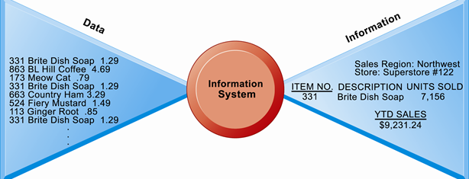

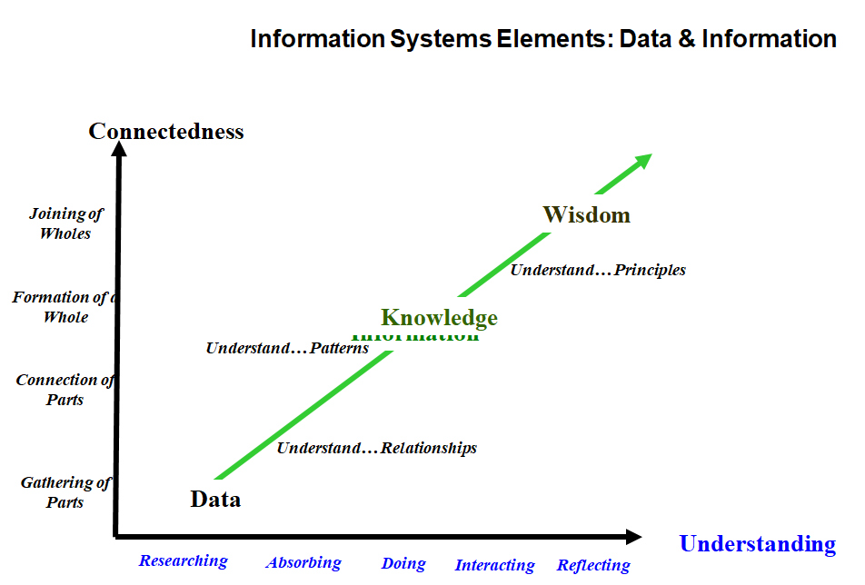
There are three core functions of information systems:
- Input- Captures raw data from organization or external environment
- Processing-Turns raw data into information( meaningful form)
- Output- Transfers processed information to people or activities that use it
Advanced Information systems also Incorporate another function:
- Feedback- the output returned to appropriate members of the organization to help correct the input stage.

REMEMBER: An Information system collects, processes, stores, analyzes and disseminates information for a specific purpose. Its PURPOSE is to provide accurate, timely and useful information.

Data
Data are elementary descriptions of things, events, activities, and transactions that are recorded classified and stored but are not organized to convey any specific meaning. For Example, a collection of numbers (3.11, 8.99, 900,7, 67,) they are just there with no specific meaning.

Information
Data that has been organized so that they have meaning and value to the recipient. For example, a GPA by itself is just a number but a GPA coupled a student’s name is now his or her GPA information

Knowledge
Consists of data and/or information that has been organized and processed to convey understanding and experience etc, as they apply to a current business problem. For example, if a company recruiting at school found that students that have an average of over 3.0 has experienced the greatest success in its management program, based on this knowledge the company may only interview the students who gained an average over 3.0. The company utilizes the information to address a business problem( hiring successful employees)

Computer-Based Information Systems

An information system that uses computer technology to complete some or all of its intended tasks.
The Basic Components of Computer-based information systems are:

- Hardware- Consist of the processor, monitor, keyboard, and printer. Together they accept, process and display information.
- Software-a program or collection of programs that enable the hardware to process data
- Database- A collection of related files or tables containing data.
- Network- A connecting system that permits other computers to share resources.
The Four Above Components are Also Known as INFORMATION TECHNOLOGY
COMPONENTS****
- Procedures- the instructions for combing the above components to process information and generate the desired outcomes.
- People- those individuals who use the hardware and software, interface with it or uses its outputs

Notes
Lecture 2
Module 1
Review from lecture 1
- Digital firms use information systems to enable the flow of information between the different parts of the organization as well as between the organization and suppliers and customers.
- Technology is a subset of Information systems, in order to use information systems effectively we need an understanding of the organization, management and information technology shaping the systems.
- Conducting business electronically enables new levels of efficiency, competitiveness and profitability(i.e strategy):’ Digital Economy’
- The ‘Digital Persona’ of Business- how businesses, customers and suppliers, etc.
interact in the digital era
- Often changes the landscape of how business processes are done
- Impacts many things including marketing, branding, communicating and relationship building

Socio-Technical View of Information Systems
- Includes issues and insights contributed from technical and behavioral disciplines.

Technical Approach
- Emphasizes mathematically based models
- Computer science, management science, operations research

Behavioral Approach
- Behavioral Issues( strategic business integration, implementation, etc.)
- Psychology, Economics, Sociology
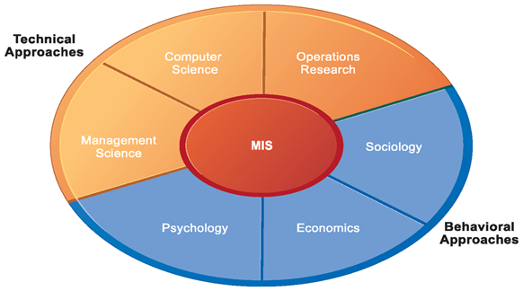

IT components, hardware, software, network(wirelines, wireless) and database form the information technology platform. IT personnel uses these components to develop information systems, oversee security and risk and manage data. These activities cumulatively are called Information Technology Services.
The IT components + IT services make composes the organization’s IT infrastructure.

Computer-Based Information Systems

Computer-Based Information Sytems | Major Capabilities  - Perform high speed, high volume, numerical computations.  - Store huge amounts of information in easy- to -access, yet small places.  - Allow quick and inexpensive access to vast amounts of information worldwide.  - Interpret vast amounts of information quickly and efficiently.

An application is a computer program that is designed to support a specific task or business process.
The collection of application programs in a single department is known as departmental information systems or functional area information systems. .For example, the collection of application programs in the human resources department(or area) is called the human resources information systems.

Types of Computer-Based Information Systems

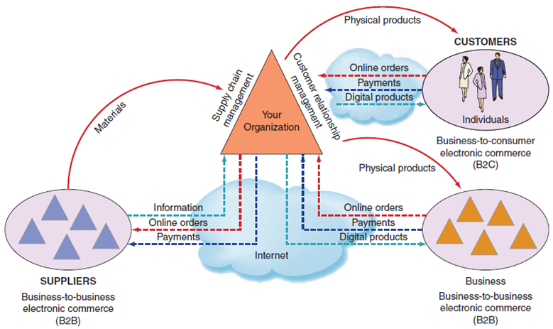

Interorganizational Information Systems are systems that link two or more organizations (IOSs). IOSs support many interorganizational operations, of which best known is the supply chain management. An organization’s supply chain is the flow of materials, information, money and services from suppliers of raw material to customers through factories and warehouses.

Digitizable products are products that can be represented in electronic form such as music and software
Electronic Commerce System is another type of interorganizational information systems. These systems enable organizations to conduct transactions called business-to-business(B2B) electronic commerce and business-to-customer(B2C) electronic commerce. E-Commerce systems are typically internet-based

Support for Organizational Employees

Knowledge Workers are professional employees such as lawyers, accountants, and financial and marketing analysts. All knowledge workers are experts in a specific area. They create information and knowledge which they integrate into business. Knowledge workers act as advisors to middle managers and executives.
Executives make decisions that deal with situations that can significantly change the manner in which the business is done. For eg. introducing a new product line, relocating operations to a foreign country.

Office of Automated Systems(OASs) supports the clerical staff, lower and middle managers and knowledge workers. These employees use OASs to develop documents, schedule resources and communicate

Business Intelligence Systems provide computer-based support for complex, nonroutine decisions primarily for middle managers and sometimes lower level managers.

Expert Systems attempt to duplicate the work of human experts by applying reasoning capabilities, knowledge and expertise within a specific domain.

Dashboards( digital dashboards) are a special form of IS that supports all level managers of the organization. They provide rapid access to timely information and direct access to structured information in the form of reports.
Dashboards that are tailaored to the information need of executives are called executive dashboards.

Two information systems that support the entire organization are:
- Enterprise Resource Planning Systems(ERP)
- Transaction Processing System

The Enterprise Resource Systems are designed to correct a lack of communications in the function area information systems by tightly integrating the functional area information systems.

The Transactions Processing System supports the monitoring, collection, storage, and processing of data from the organization’s basic business transaction each of which generates data.

How IT affects the Organization

- IT affects entire industries-
- IT reduces the number of Middle Managers- It ultimately decreases managers and experts
- IT changes the manager’s job- IT changes the way managers make decisions
- IT affects employers at work- eg loss of identity
- IT affects employee’s health and safety
- IT provides opportunities for people with disabilities.

Importance of Information Systems to Society
- It affects our Quality of Life- It can give us more time away from the office as well as give you more hours in the office.
- Improves in Health Care- Information technology can be applied to improve the efficiency and effectiveness of health care.

Social Media

Web 2.0 is a loose collection of technologies and applications plus the websites that use them. These websites enrich the user’s experience by encouraging user participation, social interaction, and collaboration.For eg wikis, web services and mashups.

Web 2.0 Tools
- Tagging
- Really Simple Syndication
- Blogs
- Microblogs
- Wikis

Tagging- A keyword or term that describes a piece of information.

Really Simple Syndication- A web 2.0 feature that allows you to receive the information you want when you want it without having to search thousands of websites.

Weblog- A personal website, open to the public in which the site creator expresses his or her feelings or opinions via a series of chronological entries.

Microblogs- a form of blogging that lets users write short stories and publish them.Example, Twitter

Wikis- A website made entirely made up of contents posted by users.

