Lesson 1:
- Summarize the evolution of theories about leadership
Leadership has long intrigued humankind and has been the topic of extensive literature for centuries. The earliest writings include philosophies of leadership such as Machiavelli’s The Prince (1531/2005) and biographies of great leaders. With the development of the social sciences during the 20th century, inquiry into leadership became prolific. Studies on leadership have emerged from every discipline “that has had some interest in the subject of leadership: anthropology, business administration, educational administration, history, military science, nursing administration, organizational behavior, philosophy, political science, public administration, psychology, sociology, and theology” (Rost, 1991, p. 45).
As a result, there are many different leadership approaches and theories. While the words are often used interchangeably, approaches and theories are different conceptually. An approach is a general way of thinking about a phenomenon, not necessarily based on empirical research. A theory usually includes a set of hypotheses, principles, or laws that explain a given phenomenon. Theories are more refined and can provide a predictive framework in analyzing the phenomenon. For example, the spiritual leadership approach is a conceptualization of leadership that does not yet have a body of empirical research to validate it, while contingency leadership theory has a refined set of propositions based on the results of multiple research studies.
Not unlike fashion, approaches to leadership have evolved, changed focus and direction, and built upon one another during the past century. To understand this evolution, a brief historical view can be helpful:
Trait Approach
The early trait approach theories were called “Great Man” theories because they focused on identifying the innate qualities and characteristics possessed by great social, political, and military leaders such as Catherine the Great, Mohandas Gandhi, Abraham Lincoln, Moses, and Joan of Arc. Studies of leadership traits were especially strong from 1900 to the early 1940s and enjoyed a renewed emphasis beginning in the 1970s as researchers began to examine visionary and charismatic leadership. In the 1980s, researchers linked leadership to the “Big Five” personality factors while interest in emotional intelligence as a trait gained favor in the 1990s. (For a discussion of emotional intelligence as a leadership skill, see Chapter 6, pages 126–127.)
Behavior Approach
In the late 1930s, leadership research began to focus on behavior—what leaders do and how they act. Groundbreaking studies by researchers at The Ohio State University and the University of Michigan in the 1940s and 1950s analyzed how leaders acted in small group situations. Behavior approach theories hit their heyday in the early 1960s with Blake and Moulton’s (1964) work exploring how managers use task and relationship behaviors in the organizational setting.
Situational Approach
The premise of this approach is that different situations demand different kinds of leadership. Serious examination of situational approach theories began in the late 1960s by Hersey and Blanchard (1969) and Reddin (1967). Situational approaches continued to be refined and revised from the 1970s through the 1990s (Vecchio, 1987). One of these, path–goal theory, examines how leaders use employee motivation to enhance performance and satisfaction. Another approach, contingency theory, focuses on the match between the leader’s style and specific situational variables.
Relational Approach
In the 1990s, researchers began examining the nature of relations between leaders and followers. This research ultimately evolved into the leader–member exchange (LMX) theory. LMX theory predicts that high-quality relations generate more positive leader outcomes than low-quality relations. Research in the relational approach to leadership continues to generate moderate interest today.
“New Leadership” Approach
When these approaches began appearing in the mid-1980s—three decades ago—they were, and continue to be, called “new leadership” approaches (Bryman, 1992). Beginning with the work of Bass (1985, 1990), leadership studies generated visionary or charismatic leadership theories. From these approaches developed transformational leadership theory, which describes leadership as a process that changes people and organizations.
Emerging Leadership Approaches
A diverse range of approaches to leadership is emerging during the 21st century:
• Adaptive leadership examines how leaders help people address problems, face challenges, and adapt to change. Adaptive leadership stresses that the leaders don’t solve the problems, but rather encourage others to do the problem solving and adapt to change.
• Authentic leadership is an approach that looks at the authenticity of leaders and their leadership and is currently enjoying strong interest.
• Spiritual leadership considers how leaders use values, a sense of “calling,” and membership to motivate followers.
• Servant leadership emphasizes the “caring principle” with leaders as “servants” who focus on their followers’ needs in order to help these followers become more autonomous, knowledgeable, and like servants themselves.
• Gender-based studies, which have gained much momentum as women continue to become more dominant in the workforce, especially on a global level, view how one’s gender affects and differentiates one’s leadership.
The historical timeline in Figure 1.1 is not intended to represent these approaches as separate and distinct eras, only to disappear from the picture when a new theory appears. Instead, many of these theories occur concurrently, building upon one another. Even when a certain approach’s period of popularity has waned, the theory continues to influence further study and the development of new leadership approaches.

- Describe the various ways in which leadership is defined –
as a trait
First, leadership is thought of as a trait. A trait is a distinguishing quality of an individual, which is often inherited. Defining leadership as a trait means that each individual brings to the table certain qualities that influence the way he or she leads. Some leaders are confident, some are decisive, and still others are outgoing and sociable. Saying that leadership is a trait places a great deal of emphasis on the leader and on the leader’s special gifts. It follows the often-expressed belief “leaders are born, not made.” Some argue that focusing on traits makes leadership an elitist enterprise because it implies that only a few people with special talents will lead. Although there may be some truth to this argument, it can also be argued that all of us are born with a wide array of unique traits and that many of these traits can have a positive impact on our leadership. It also may be possible to modify or change some traits.
Through the years, researchers have identified a multitude of traits that are associated with leadership. In Chapter 2 we will discuss some key leadership traits, and in Chapter 3 we will explain how strength-based leadership is a variation of trait leadership. Although there are many important leadership traits, what is most important for leaders is having the required traits that a particular situation demands. For example, a chaotic emergency room at a hospital requires a leader who is insightful and decisive and can bring calm to the situation. Conversely, a high school classroom in which students are bored demands a teacher who is inspiring and creative. Effective leadership results when the leader engages the right traits in the right place at the right time.

an ability
In addition to being thought of as a trait, leadership is conceptualized as an ability. A person who has leadership ability is able to be a leader—that is, has the capacity to lead. While the term ability frequently refers to a natural capacity, ability can be acquired. For example, some people are naturally good at public speaking, while others rehearse to become comfortable speaking in public. Similarly, some people have the natural physical ability to excel in a sport, while others develop their athletic capacity through exercise and practice. In leadership, some people have the natural ability to lead, while others develop their leadership abilities through hard work and practice.
An example of leadership as ability is the legendary University of California at Los Angeles basketball coach John Wooden, whose teams won seven consecutive National Collegiate Athletic Association titles. Described first as a teacher and then as a coach, Wooden implemented four laws of learning into his coaching: explanation, demonstration, imitation, and repetition. His goal was to teach players how to do the right thing instinctively under great pressure. Less visible or well known, but also an example of leadership as ability, is the unheralded but highly effective restaurant manager who, through years of experience and learning, is able to create a successful, award-winning restaurant. In both of these examples, it is the individuals’ abilities that create outstanding leadership.
a skill
Third, leadership is a skill. Conceptualized as a skill, leadership is a competency developed to accomplish a task effectively. Skilled leaders are competent people who know the means and methods for carrying out their responsibilities. For example, a skilled leader in a fund-raising campaign knows every step and procedure in the fund-raising process and is able to use this knowledge to run an effective campaign. In short, skilled leaders are competent—they know what they need to do, and they know how to do it.
Describing leadership as a skill makes leadership available to everyone because skills are competencies that people can learn or develop. Even without natural leadership ability, people can improve their leadership with practice, instruction, and feedback from others. Viewed as a skill, leadership can be studied and learned. If you are capable of learning from experience, you can acquire leadership.
a behaviour
Leadership is also a behavior. It is what leaders do when they are in a leadership role. The behavioral dimension is concerned with how leaders act toward others in various situations. Unlike traits, abilities, and skills, leadership behaviors are observable. When someone leads, we see that person’s leadership behavior.
Research on leadership has shown that leaders engage primarily in two kinds of general behaviors: task behaviors and process behaviors. Task behaviors are used by leaders to get the job done (e.g., a leader prepares an agenda for a meeting). Process behaviors are used by leaders to help people feel comfortable with other group members and at ease in the situations in which they find themselves (e.g., a leader helps individuals in a group to feel included). Since leadership requires both task and process behaviors, the challenge for leaders is to know the best way to combine them in their efforts to reach a goal.
a relationship
Another, and a somewhat unusual, way to think about leadership is as a relationship. From this perspective, leadership is centered on the communication between leaders and followers rather than on the unique qualities of the leader. Thought of as a relationship, leadership becomes a process of collaboration that occurs between leaders and followers (Rost, 1991). A leader affects and is affected by followers, and both leader and followers are affected in turn by the situation that surrounds them. This approach emphasizes that leadership is not a linear one-way event, but rather an interactive event. In traditional leadership, authority is often top down; in the interactive type of leadership, authority and influence are shared. When leadership is defined in this manner, it becomes available to everyone. It is not restricted to the formally designated leader in a group.
Thinking of leadership as a relationship suggests that leaders must include followers and their interests in the process of leadership. A leader needs to be fully aware of the followers and the followers’ interests, ideas, positions, attitudes, and motivations. In addition, this approach has an ethical overtone because it stresses the need for leaders to work with followers to achieve their mutual purposes. Stressing mutuality lessens the possibility that leaders might act toward followers in ways that are forced or unethical. It also increases the possibility that leaders and followers will work together toward a common good (Rost, 1991).
an influence process
A final way of thinking about leadership is as an influence process. This is the perspective that will be emphasized in this book.
Leadership is a process whereby an individual influences a group of individuals to achieve a common goal.
Defining leadership as an influence process means that it is not a trait or an ability that resides in the leader, but rather an interactive event that occurs between the leader and the followers. Influence is central to the process of leadership because leaders affect followers. Leaders direct their energies toward influencing individuals to achieve something together. Stressing common goals gives leadership an ethical dimension because it lessens the possibility that leaders might act toward followers in ways that use coercion or are unethical.
Finally, in explaining what leadership is, it is important to make a distinction between leadership and management. In discussing what leadership is and can be, the concepts of leadership and management sometimes overlap. Both leadership and management involve influence, but leadership is about seeking constructive change, and management is about establishing order. For example, it is often said that “managers are people who do things right, and leaders are people who do the right thing.” Since both leaders and managers are engaged in influencing people toward goal accomplishment, our discussion in this book will treat the roles of managers and leaders similarly and not emphasize the differences between them.
- Recall which leadership qualities are seen as positive, which are negative
Positive and negative leadership qualities:
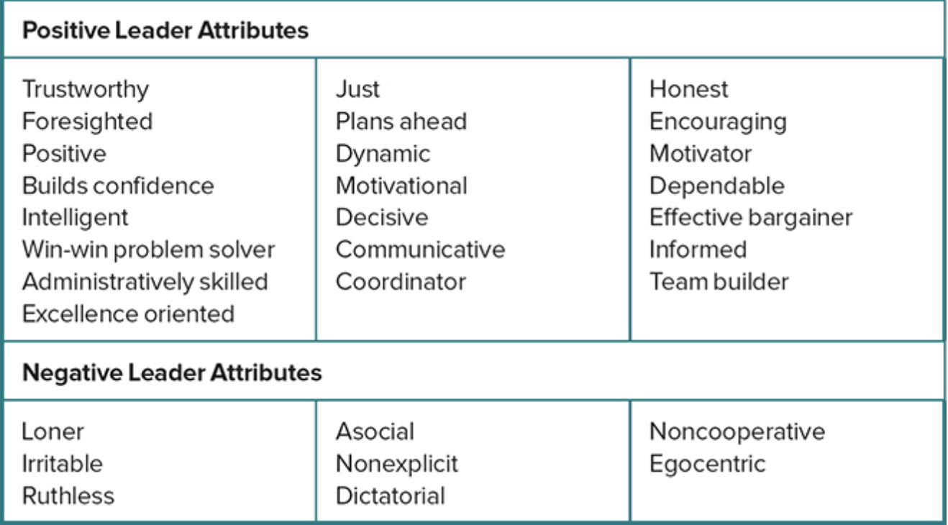
- Identify and apply the global leadership attributes to a leader
We probably all wonder at the differences in leadership around the world. Why do some countries gravitate toward the distributed leadership of a democracy, while others seem content with the hierarchical leadership of a monarchy or dictatorship? The definition and concepts of leadership outlined in this chapter are from an American perspective. If you were to travel to nations across the world, you would no doubt encounter different views of leadership specific to those ethnic and political cultures.
In 2004, Robert House led a group of 160 researchers in an ambitious study to increase our understanding of the impact culture has on leadership effectiveness. The GLOBE (Global Leadership and Organizational Behavior Effectiveness) studies drew on the input of 17,000 people in 62 countries in determining how leadership varies across the world. Among the many findings generated by the GLOBE studies was the identification of positive and negative leadership characteristics that are universally accepted worldwide (see Table 1.1).
According to James G Clawson, a leading writer on the subject of global leadership, there are eleven key skills that a global leader must possess:
- Overseas experience
- Deep self-awareness
- Sensitivity to cultural diversity
- Humility
- Lifelong curiosity
- Cautious honesty
- Global strategic thinking
- Patiently impatient
- Well-spoken
- Good negotiator
- Presence

- Articulate the characteristics of the dark side of leadership
Those same characteristics and behaviors that distinguish leadership can also be used by leaders in nonpositive ways (Conger, 1990). The dark side of leadership is the destructive side of leadership where a leader uses his or her influence or power for personal ends. Lipman-Blumen (2005) suggests that such leaders are “toxic,” where their leadership leaves their followers worse off than they found them, often violating the basic human rights of others and playing to their followers’ basest fears. Dark leadership is able to thrive when three conditions exist, according to Padilla, Hogan, and Kaiser (2007): a destructive leader, susceptible followers, and a conducive environment. Destructive leaders will prevail when the checks and balances of an organization are weak and the rules of the institution are ineffective. While many cite Adolf Hitler as the prime example of the dark side of leadership, there are many current examples in the world today from the regime of Bashar al-Assad in Syria, whose leadership has led to violent civil war that has left hundreds of thousands dead, to religious extremist groups, such as ISIS and al-Qaeda, who use their followers to engage in mass murder of innocents.
The meaning of leadership is complex and includes many dimensions. For some people, leadership is a trait or an ability, for others it is a skill or a behavior, and for still others it is a relationship or a process. In reality, leadership probably includes components of all of these dimensions. Each dimension explains a facet of leadership.
In considering these various definitions of leadership and based on the results of your Conceptualizing Leadership Questionnaire (page 14), which dimension seems closest to how you think of leadership? How would you define leadership? Answers to these questions are important because how you think about leadership will strongly influence how you practice leadership.
There is a strong demand for effective leadership in society today. This demand exists at the local and community levels, as well as at the national level, in this country and abroad. People feel the need for leadership in all aspects of their lives. They want leaders in their personal lives, at school, in the work setting, and even in their spiritual lives. Everywhere you turn, people are expressing a need for strong leadership.
When people ask for leadership in a particular situation, it is not always clear exactly what they want. For the most part, however, they want effective leadership. Effective leadership is intended influence that creates change for the greater good. Leadership uses positive means to achieve positive outcomes. Furthermore, people want leaders who listen to and understand their needs and who can relate to their circumstances. The challenge for each of us is to be prepared to lead when we are asked to be the leader.

- Be able to list and describe the types of "bad' leadership identified by Kellerman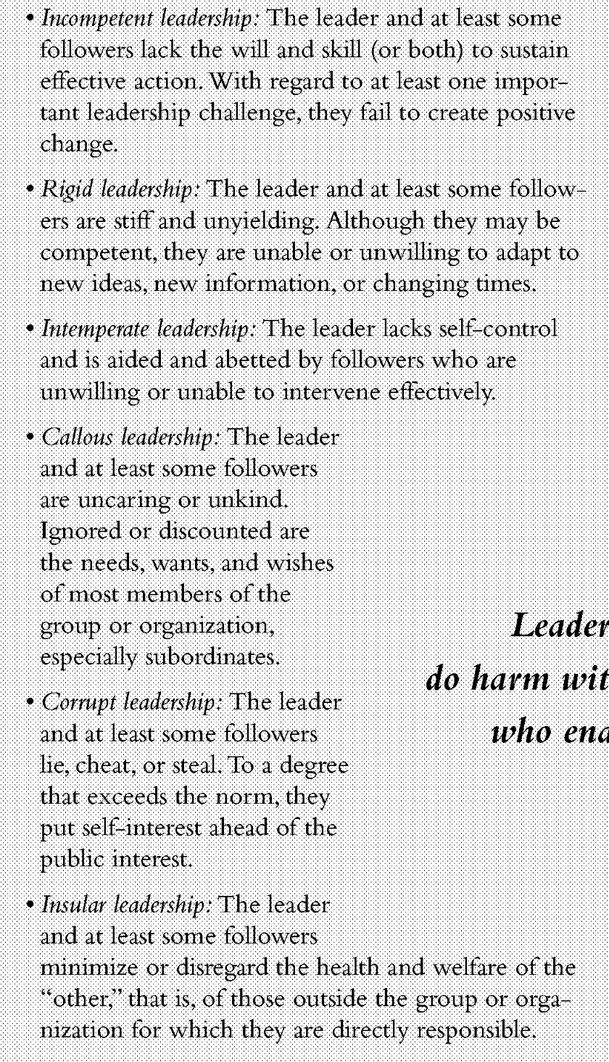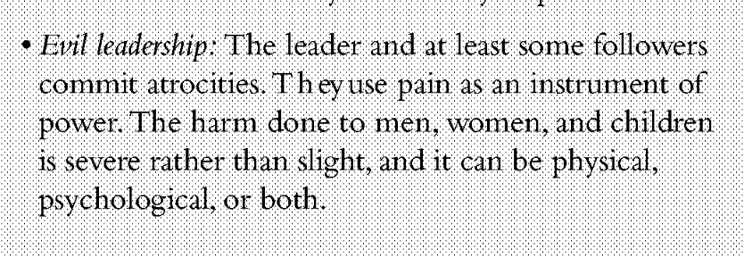
- Understand and be able to list the ways that leaders and followers can help avoid bad leadership and support good leadership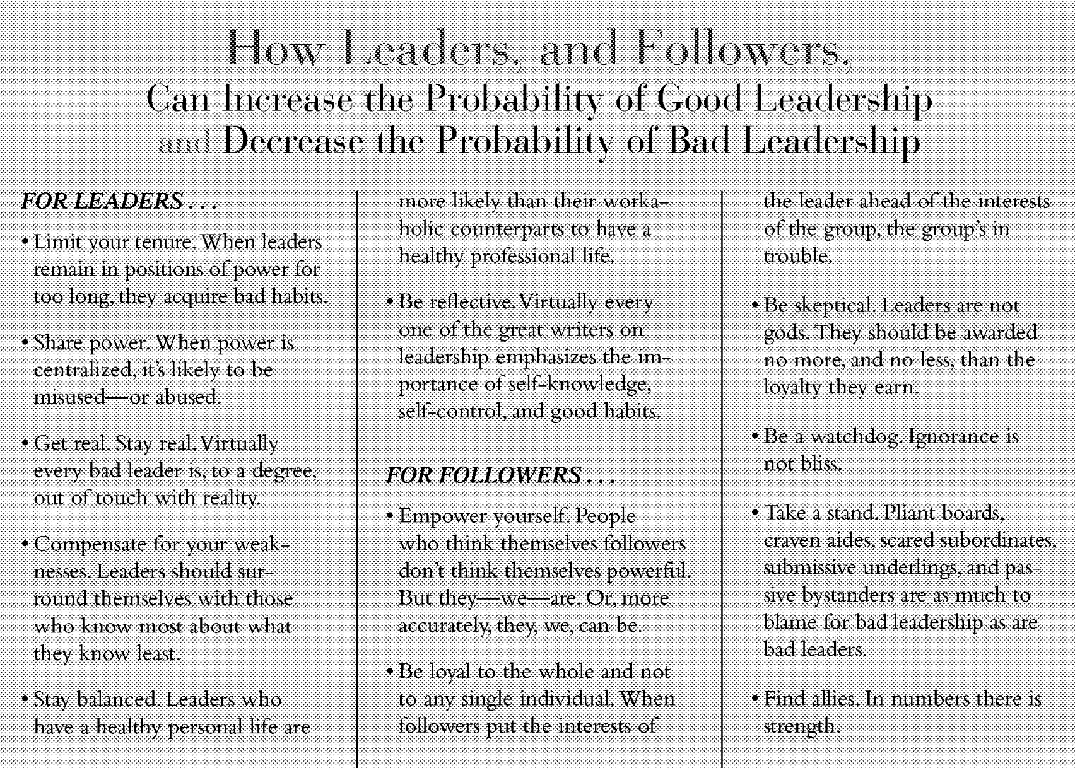
Lesson 2
- Demonstrate an understanding of how trait theory has evolved from its early focus on “The Great Man Theory” of leadership to the present summary of six key traits associated with leadership
According to Kirkpatrick and Locke (1991), “Early in the 20th century, the great man theories evolved into trait theories” (p. 48). So, starting in the early 1900s, the hunt was on for the traits associated with leaders. The traits explored included physical traits such as height, physical stature (which were seen as helpful in a military context), and psychological traits such as intelligence, etc. During these early years of trait theory, the world endured two world wars, and a great depression, so the need for military and business leaders, for example, and the capacity to identify individuals who would fulfill those leadership roles was strong.
Identifying a consistent set of key traits for leadership proved to be a challenge. Stodgill published two important papers in the leadership trait domain, one in 1948 and the other in 1970. Each of these papers included a review of hundreds of studies of leadership – all in an attempt to see if there was a consistent set of traits that had been identified as being associated with leadership. The figure below lists the traits that Stodgill’s 1948 and 1970 papers identified:
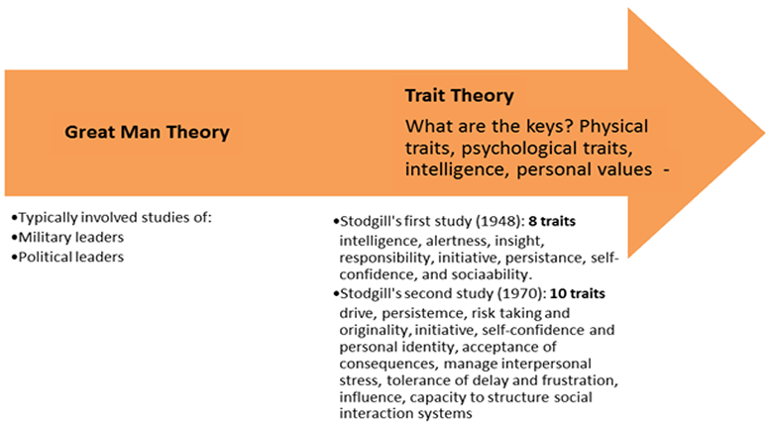
Six traits:
- Intelligence
- Confidence
- Charisma
- Determination
- Sociability
- Integrity

- Describe the qualities of each of the six traits
- Analyze how these traits are evident in a range of historical and contemporary leaders from chapter 2
Answer to questions 2 and 3
Intelligence is an important trait related to effective leadership. Intelligence includes having good language skills, perceptual skills, and reasoning ability. This combination of assets makes people good thinkers, and makes them better leaders.
While it is hard for a person to alter his or her IQ (intelligence quotient), there are certain ways for a person to improve intelligence in general. Intelligent leaders are well informed. They are aware of what is going on around them and understand the job that needs to be done. It is important for leaders to obtain information about what their leadership role entails and learn as much as possible about their work environment. This information will help leaders be more knowledgeable and insightful.
For example, a few years ago a friend, Chris, was asked to be the coach of his daughter’s middle school soccer team even though he had never played soccer and knew next to nothing about how the game is played. Chris took the job and eventually was a great success, but not without a lot of effort. He spent many hours learning about soccer. He read how-to books, instructors’ manuals, and coaching books. In addition, Chris subscribed to several soccer magazines. He talked to other coaches and learned everything he could about playing the game. By the time he had finished the first season, others considered Chris to be a very competent coach. He was smart and learned how to be a successful coach.
Regarding intelligence, few if any of us can expect to be another Albert Einstein. Most of us have average intelligence and know that there are limits to what we can do. Nevertheless, becoming more knowledgeable about our leadership positions gives us the information we need to become better leaders.
If confidence is a central trait of successful leaders, how can you build your own confidence? First, confidence comes from understanding what is required of you. For example, when first learning to drive a car, a student’s confidence is low because he or she does not know what to do. If an instructor explains the driving process and demonstrates how to drive, the student can gain confidence because he or she now has an understanding of how to drive. Awareness and understanding build confidence. Confidence can also come from having a mentor to show the way and provide constructive feedback. This mentor may be a boss, an experienced coworker, or a significant other from outside the organization. Because mentors act as role models and sounding boards, they provide essential help to learn the dynamics of leadership.
Confidence also comes from practice. This is important to point out, because practice is something everyone can do. Consider Michael Phelps, one of the most well-known athletes in the world today. Phelps is a very gifted swimmer, with 23 Olympic gold medals and the record for winning the most medals, 28, of any Olympic athlete in history. But Phelps also spends an enormous amount of time practicing. His workout regimen includes swimming six hours a day, six days a week. His excellent performance and confidence are a result of his practice, as well as his gifts.
In leadership, practice builds confidence because it provides assurance that an aspiring leader can do what needs to be done. Taking on leadership roles, even minor ones on committees or through volunteer activities, provides practice for being a leader. Building one leadership activity on another can increase confidence for more demanding leadership roles. Those who accept opportunities to practice their leadership will experience increased confidence in their leadership abilities.
Of all the traits related to effective leadership, charisma gets the most attention. Charisma refers to a leader’s special magnetic charm and appeal, and can have a huge effect on the leadership process. Charisma is a special personality characteristic that gives a leader the capacity to do extraordinary things. In particular, it gives the leader exceptional powers of influence. A good example of a charismatic leader is former president John F. Kennedy, who motivated the American people with his eloquent oratorical style (visit edge.sagepub.com/northouseintro4e to read one of his speeches). President Kennedy was a gifted, charismatic leader who had an enormous impact on others.
It is not unusual for many of us to feel challenged with regard to charisma because it is not a common personality trait. There are a few select people who are very charismatic, but most of us are not. Since charisma appears in short supply, the question arises: What do leaders do if they are not naturally charismatic?
Based on the writings of leadership scholars, several behaviors characterize charismatic leadership (Conger, 1999; House, 1976; Shamir, House, & Arthur, 1993). First, charismatic leaders serve as a strong role model for the values that they desire others to adopt. Mohandas Gandhi advocated nonviolence and was an exemplary role model of civil disobedience; his charisma enabled him to influence others. Second, charismatic leaders show competence in every aspect of leadership, so others trust their decisions. Third, charismatic leaders articulate clear goals and strong values. Martin Luther King Jr.’s “I Have a Dream” speech is an example of this type of charismatic leadership. By articulating his dream, he was able to influence multitudes of people to follow his nonviolent practices. Fourth, charismatic leaders communicate high expectations for followers and show confidence in their abilities to meet these expectations. Finally, charismatic leaders are an inspiration to others. They can excite and motivate others to become involved in real change, as demonstrated by John F. Kennedy and Martin Luther King Jr.
Determination is another trait that characterizes effective leaders. Determined leaders are very focused and attentive to tasks. They know where they are going and how they intend to get there. Determination is the decision to get the job done; it includes characteristics such as initiative, persistence, and drive. People with determination are willing to assert themselves, they are proactive, and they have the capacity to persevere in the face of obstacles. Being determined includes showing dominance at times, especially in situations where others need direction.
We have all heard of determined people who have accomplished spectacular things—the person with cancer who runs a standard 26.2-mile marathon, the blind person who climbs Mount Everest, or the single mom with four kids who graduates from college. A good example of determined leadership is Nelson Mandela, who is featured in the Leadership Snapshot in this chapter. Mandela’s single goal was to end apartheid in South Africa. Even though he was imprisoned for many years, he steadfastly held to his principles. He was committed to reaching his goal, and he never wavered from his vision. Mandela was focused and disciplined—a determined leader.
What distinguishes all of these leaders from other people is their determination to get the job done. Of all the traits discussed in this chapter, determination is probably the one trait that is easily acquired by those who lead. All it demands is perseverance. Staying focused on the task, clarifying the goals, articulating the vision, and encouraging others to stay the course are characteristics of determined leaders. Being determined takes discipline and the ability to endure, but having this trait will almost certainly enhance a person’s leadership.
Another important trait for leaders is sociability. Sociability refers to a leader’s capacity to establish pleasant social relationships. People want sociable leaders—leaders with whom they can get along. Leaders who show sociability are friendly, outgoing, courteous, tactful, and diplomatic. They are sensitive to others’ needs and show concern for their well-being. Sociable leaders have good interpersonal skills and help to create cooperative relationships within their work environments.
Being sociable comes easier for some than for others. For example, it is easy for extroverted leaders to talk to others and be outgoing, but it is harder for introverted leaders to do so. Similarly, some individuals are naturally “people persons,” while others prefer to be alone. Although people vary in the degree to which they are outgoing, it is possible to increase sociability. A sociable leader gets along with coworkers and other people in the work setting. Being friendly, kind, and thoughtful, as well as talking freely with others and giving them support, goes a long way to establish a leader’s sociability. Sociable leaders bring positive energy to a group and make the work environment a more enjoyable place.
To illustrate, consider the following example. This scenario occurred in one of the best leadership classes I have had in 40 years of teaching. In this class, there was a student named Anne Fox who was a very sociable leader. Anne was an unusual student who dressed like a student from the 1960s, although it was more than two decades later. Even though she dressed differently than the others, Anne was very caring and was liked by everyone in the class. After the first week of the semester, Anne could name everyone in class; when attendance was taken, she knew instantly who was there and who was not. In class discussions, Anne always contributed good ideas, and her remarks were sensitive of others’ points of view. Anne was positive about life, and her attitude was contagious. By her presence, Anne created an atmosphere in which everyone felt unique but also included. She was the glue that held us all together. Anne was not assigned to be the leader in the class, but by the semester’s end she emerged as a leader. Her sociable nature enabled her to develop strong relationships and become a leader in the class. By the end of the class, all of us were the beneficiaries of her leadership.
Finally, and perhaps most important, effective leaders have integrity. Integrity characterizes leaders who possess the qualities of honesty and trustworthiness. People who adhere to a strong set of principles and take responsibility for their actions are exhibiting integrity. Leaders with integrity inspire confidence in others because they can be trusted to do what they say they are going to do. They are loyal, dependable, and transparent. Basically, integrity makes a leader believable and worthy of our trust.
Grown-ups often tell children, “Never tell a lie.” For children, the lesson is “Good children are truthful.” For leaders, the lesson is the same: “Good leaders are honest.” Dishonesty creates mistrust in others, and dishonest leaders are seen as undependable and unreliable. Honesty helps people to have trust and faith in what leaders have to say and what they stand for. Honesty also enhances a leader’s ability to influence others because they have confidence in and believe in their leader.
- Apply trait theory to a case study and to self-reflection.
- Explain the five types of followers identified by Kelley
Carnegie Mellon professor Robert Kelley identified five different follower styles.

Alienated followers
Alienated followers are deep and independent thinkers who do not willingly commit to any leader.

Passive followers
Passive followers do as they are told but do not think critically and are not particularly active participants.

Conformist followers
Conformists are more participative than passive followers, but do not provide particular challenge.

Pragmatic followers
Pragmatic followers are middling in their independence, engagement and general contribution.

Exemplary followers
Exemplary followers are ideal in almost all ways, excelling at all tasks, engaging strongly with the group and providing intelligent yet sensitive support and challenge to the leader
- Create a 2x2 chart with the axes labelled according to Kelley's work and place the five types of followers on that chart
- Identify ways in which you can become a more effective follower
Thinking about the qualities of effective followers (self-management, committed to something beyond themselves, build their competence, and are courageous, honest, and credible)
- List and describe ways that organizations can support the development of effective followers
Lesson 3
Strengths-based leadership is the ability to identify and make the best use of your own and your team members' strengths.
- Describe how a strengths-based approach can enhance your personal leadership potential
A strengths-based approach can benefit your leadership and your team's performance in several ways.
First, admitting that you need help, and accepting it from your team members, promotes not only effective delegation , but also a consensual or "laissez-faire" leadership style . Asking for help is a sign of strength, not weakness, and it enables you to concentrate on what you do best.
Sharing responsibility can also stimulate creativity, innovation, and a sense of mastery and purpose within your team. When you recognize your team members' strengths, you show them that you trust their abilities. As a result, they'll likely feel more confident to speak up and express their own ideas. They'll build expert power , which can further enhance their motivation and self-worth.
Strengths-based leadership can increase team engagement and job satisfaction . A survey by Gallup found that only one percent of employees become disengaged if their managers actively focus on their strengths, while 40 percent become disengaged if their key skills are ignored.
What's more, a strengths-based approach encourages you to hire people based on their individual abilities and aptitudes, not just because their skills and experience are similar to yours. This can lead to greater team cohesion, as team members complement one another rather than compete for the same "territory." It can also produce a more diverse team, with a wider range of strengths, skill sets, attitudes, and cultural values .
- Know how you can use a strengths-based approach to support the leadership development of others
- Compare the key attributes of the measures used to assess strengths including Gallup’s StrengthsFinder, the Values in Action classification system, and the R2 Profiler Assessment
Gallup’s StrengthsFinder:
At its most basic level, the Strengths Finder approach suggests that if you possess an attribute or quality and you expend effort to develop that attribute or quality, then you have the potential to enhance that particular strength.
- Interviewed people about their strengths and what made them good at what they did
- Goal was to identify qualities of high performing individuals
- 34 patterns or themes that they thought did the best job at explaining excelled performance
- identified themes of human talent, not strengths
- from talents, strengths emerge
- Talent x Investment= Strength
- 177 item questionnaire that identifies the areas where you have the greatest potential to develop strengths finally figuring out 5 best talents
- 4 domains of leadership strengths
- executing
- influencing
- relationship building
- strategic thinking
Values in Action classification system
the Values in Action (VIA) inventory focuses more directly on an individual’s character and how individuals can become more virtuous. There are 24 strengths organized under 6 basic virtues.
- focused on what is best in people rather than their weaknesses and problems
- reviewed philosophical and spiritual literature in different types of religion
- identified 6 universal core virtues
- courage
- justice
- humanity
- temperance
- Transcendence
- wisdom
- represent basic structure around the values in action classification of character strengths
- include 24 strengths under those 6 virtues (pg.57)
Centre of Applied Positive Psychology and R2 Profiler Assessment
- rather than focusing exclusively on the identification of a specific number of strengths, these researchers created a dynamic model of strengths that emphasizes the changing nature of strengths
- strengths are more fluid than personality traits and can emerge over a lifetime through the different situations we experience
- performance- how good we are at doing something
- energy- how much vitality we get out of it
- use- how often we are able to do it
- assesses 60 strengths in relationship to 3 dimensions of energy, performance and use
- Realise2 quadrant model
- Realized strengths
- Unrealized strengths
- Learned behaviour
- Weaknesses
- Realized strengths: personal attributes that represent our strongest assets
- Unrealized strengths: personal attributes that are less visible
- Learned behaviours: represent those ingrained things we have learned throughout our life experiences
- Weaknesses: limiting attributes
- The model recommends that we try to moderate our use of learned behaviours and minimize our use of our weaknesses
- Explain why it is important to identify and address your weaknesses (we all have them!)
Leaders must not only recognize and capitalize on their strengths, but also be able to identify their weaknesses and address them (MacKie, 2016). Harvard leadership professor John P. Kotter states, “Great leadership doesn’t mean running away from reality . . . sharing difficulties can inspire people to take action that will make the situation better” (Blagg & Young, 2001).
While some of the models discussed here advocate minimizing your weaknesses, understanding them can allow you to work to improve them and to recognize situations where your weaknesses can be a liability to your leadership.
- Describe the influence of the positive psychology approach on the strengths-focused leadership and leadership development measures
At the same time Gallup’s StrengthsFinder profile was growing in popularity, a major change was occurring in the discipline of psychology. Researchers were challenging the discipline to expand its focus on not only what is wrong with people and their weaknesses, but also what is right with people and their positive attributes. This expanded focus, which was initiated by Martin Seligman in an address to the American Psychological Association in 1998 (see Fowler, Seligman, & Kocher, 1999), soon became the field of positive psychology. Since its inception a decade ago, positive psychology has grown exponentially and developed into a credible and important area of psychological research.
Specifically, positive psychology can be defined as “the ‘scientific’ study of what makes life most worth living” (Peterson, 2009, p. xxiii). Rather than study the frailties and flaws of individuals (the disease model), positive psychology focuses on individuals’ strengths and the factors that allow them to thrive (Fredrickson, 2001; Seligman, 2002; Seligman & Csikszentmihalyi, 2000). It addresses people’s positive experiences, such as their happiness and joy; people’s positive traits, such as their characteristics and talents; and people’s positive institutions, such as families, schools, and businesses that influence them (Cameron, Dutton, & Quinn, 2003).
Most prominently, positive psychology is devoted to the study of people’s positive characteristics—their strengths. This makes it invaluable for understanding strengths-based leadership. Positive psychology launched the analysis of people’s strengths into the mainstream of scientific research (Linley, 2008). Concepts and theories from the field of positive psychology directly relate to learning how strengths-based leadership works.
The following provides brief descriptions of the various strengths
Executing:
- Achiever - one with a constant drive for accomplishing tasks
- Arranger - one who enjoys orchestrating many tasks and variables to a successful outcome
- Belief - one who strives to find some ultimate meaning behind everything they do
- Consistency - one who believes in treating everyone the same to avoid unfair advantage
- Deliberative - one who proceeds with caution, seeking to always have a plan and know all of the details
- Discipline - one who seeks to make sense of the world by imposition of order
- Focus - one who requires a clear sense of direction to be successful
- Responsibility - one who, inexplicably, must follow through on commitments
- Restorative - one who thrives on solving difficult problem
Influencing:
- Activator - one who acts to start things in motion
- Command - one who steps up to positions of leadership without fear of confrontation
- Communication - one who uses words to inspire action and education
- Competition - one who thrives on comparison and competition to be successful
- Maximizer - one who seeks to take people and projects from great to excellent
- Self-Assurance - one who stays true to their beliefs, judgments and is confident in his/her ability
- Significance - one who seeks to be seen as significant by others
- Woo - one who is able to easily persuade
Relationship Building
- Adaptability - one who is especially adept at accommodating to changes in direction/plan
- Developer - one who sees the untapped potential in others
- Connectedness - one who seeks to unite others through commonality
- Empathy - one who is especially in tune with the emotions of others
- Harmony - one who seeks to avoid conflict and achieve success through consensus
- Includer - one who instinctively works to include everyone
- Individualization - one who draws upon the uniqueness of individuals to create successful teams
- Positivity - one who has a knack for bring the light-side to any situation
- Relator - one who is most comfortable with fewer, but deeper relationships
Strategic Thinking
- Analytical - one who requires data and/or proof to make sense of their circumstances
- Context - one who is able to use the past to make better decisions in the present
- Futuristic - one who has a keen sense of using an eye towards the future to drive today's success
- Ideation - one who is adept at seeing underlying concepts that unite disparate ideas
- Input - one who is constantly collecting information or objects for future use
- Intellection - one who enjoys thinking and thought-provoking conversation often for its own sake, and also can data compress complex concepts into simplified models
- Learner - one who must constantly be challenged and learning new things to feel successful
- Strategic - one who is able to see a clear direction through the complexity of a situation
Lesson 4
Theory X
- Made up of 3 assumptions about human nature and human behaviour, together they represent a philosophy of leadership that many leaders exhibit to one degree or another
- Assumption 1: the average person dislikes work and will avoid it if possible
- Assumption 2: people need to be direct and controlled
- Assumption 3: people want security, not responsibility
- With this theory, leaders tend to view workers as lazy and uninterested in work because they do not value it
- Directive and controlling
- Theory X leaders believe it is their role to motivate workers
- Theory X workers have a need for leadership
Theory X:
- Assumption 1: the average person does not inherently dislike work. Doing work is as natural as play (work is satisfying, not a punishment)
- Assumption 2: people will show responsibility and self control toward goals to which they are committed (people will make conscious choices to work on their own)
- Assumption 3: in the proper environment, the average person earns to accept and seek responsibility
- Theory Y leaders do not try to control workers; subordinates are not lazy
- Theory Y workers want to work

- List and describe the various leadership approaches and the assumptions about human behaviour that underpin those leadership approaches
Authoritarian Leadership Style
In many ways, the authoritarian leadership style is very similar to Theory X. For example, authoritarian leaders perceive followers as needing direction. The authoritarian leader needs to control followers and what they do. Authoritarian leaders emphasize that they are in charge, exerting influence and control over group members. They determine tasks and procedures for group members but may remain aloof from participating in group discussions. Authoritarian leaders do not encourage communication among group members; instead, they prefer that communication be directed to them. In evaluating others, authoritarian leaders give praise and criticism freely, but it is given based on their own personal standards rather than based on objective criticism.
p.84
Some have argued that authoritarian leadership represents a rather pessimistic, negative, and discouraging view of others. For example, an authoritarian leader might say something like “Because my workers are lazy, I need to tell them what to do.” Others would argue that authoritarian leadership is a much-needed form of leadership—it serves a positive purpose, particularly for people who seek security above responsibility. In many contexts, authoritarian leadership is used to give direction, set goals, and structure work. For example, when employees are just learning a new job, authoritarian leadership lets them know the rules and standards for what they are supposed to do. Authoritarian leaders are very efficient and successful in motivating others to accomplish work. In these contexts, authoritarian leadership is very useful.
What are the outcomes of authoritarian leadership? Authoritarian leadership has both pluses and minuses. On the positive side, it is efficient and productive. Authoritarian leaders give direction and clarity to people’s work and accomplish more in a shorter period. Furthermore, authoritarian leadership is useful in establishing goals and work standards. On the negative side, it fosters dependence, submissiveness, and a loss of individuality. The creativity and personal growth of followers may be hindered. It is possible that, over time, followers will lose interest in what they are doing and become dissatisfied with their work. If that occurs, authoritarian leadership can create discontent, hostility, and even aggression.
In addition, authoritarian leadership can become abusive leadership, where these leaders use their influence, power, and control for their personal interests or to coerce followers to engage in unethical or immoral activities. For example, a coach who withholds playing time from athletes who openly disagree with his play calls or a boss who requires salaried employees to work up to 20 hours of overtime each week or “be replaced with someone who will” are both examples of the dark side of authoritarian leadership.
While the negative aspects of authoritarian leadership appear to outweigh the positive, it is not difficult to imagine contexts where authoritarian leadership would be the preferred style of leadership. For example, in a busy hospital emergency room, it may be very appropriate for the leader in charge of triaging patients to be authoritarian with various types of emergencies. The same could be true in other contexts, such as the chaperone of a middle school canoe trip, or the coach of a high school team during the state finals basketball tournament. Despite the negatives of authoritarian leadership, this form of leadership is common and necessary in many situations.
Democratic Leadership Style
The democratic leadership style strongly resembles the assumptions of Theory Y. Democratic leaders treat followers as fully capable of doing work on their own. Rather than controlling followers, democratic leaders work with followers, trying hard to treat everyone fairly, without putting themselves above followers. In essence, they see themselves as guides rather than as directors. They give suggestions to others, but never with any intention of changing them. Helping each follower reach personal goals is important to a democratic leader. Democratic leaders do not use “top-down” communication; instead, they speak on the same level as their followers. Making sure everyone is heard is a priority. They listen to followers in supportive ways and assist them in becoming self-directed. In addition, they promote communication between group members and in certain situations are careful to draw out the less-articulate members of the group. Democratic leaders provide information, guidance, and suggestions, but do so without giving orders and without applying pressure. In their evaluations of followers, democratic leaders give objective praise and criticism.
The outcomes of democratic leadership are mostly positive. First, democratic leadership results in greater group member satisfaction, commitment, and cohesiveness. Second, under democratic leadership there is more friendliness, mutual praise, and group mindedness. Followers tend to get along with each other and willingly participate in matters of the group, making more “we” statements and fewer “I” statements. Third, democratic leadership results in stronger worker motivation and greater creativity. People are motivated to pursue their own talents under the supportive structure of democratic leadership. Finally, under a democratic leader group members participate more and are more committed to group decisions. The downside of democratic leadership is that it takes more time and commitment from the leader. Work is accomplished, but not as efficiently as if the leader were authoritarian.
Laissez-Faire Leadership Style
The laissez-faire leadership style is dissimilar to both Theory X and Theory Y. Laissez-faire leaders do not try to control followers as Theory X leaders do, and they do not try to nurture and guide followers as Theory Y leaders do. Laissez-faire stands alone as a style of leadership; some have labeled it nonleadership. The laissez-faire leader is a nominal leader who engages in minimal influence. As the French phrase implies, laissez-faire leadership means the leader takes a “hands-off, let it ride” attitude toward followers. These leaders recognize followers but are very laid back and make no attempt to influence their activities. Under laissez-faire leadership, followers have freedom to do pretty much what they want to do whenever they want to do it. Laissez-faire leaders make no attempt to appraise or regulate the progress of followers.
Given that laissez-faire leadership involves nominal influence, what are the effects of laissez-faire leadership? Laissez-faire leadership tends to produce primarily negative outcomes. The major effect is that very little is accomplished under a laissez-faire leader. Because people are directionless and at a loss to know what to do, they tend to do nothing. Giving complete freedom results in an atmosphere that most followers find chaotic. Followers prefer some direction; left completely on their own, they become frustrated. Without a sense of purpose and direction, group members have difficulty finding meaning in their work; they become unmotivated and disheartened. As a result, productivity goes down.
However, there are situations where the laissez-faire style is successful. People who are self-starters, who excel at individualized tasks and don’t require ongoing feedback, may prefer working under laissez-faire leaders.
For example, Angela is the president of a website development company who uses independent contractors from across the globe. In certain respects, you could describe her leadership style as laissez-faire. The programmers who develop the websites’ code are in Poland, the designer is in India, the content writer is in the United Kingdom, and Angela is in the United States. When developing a site, Angela maps out and communicates the basic framework for the website and then relies on all of the individual contractors to determine the tasks they need to do for the site’s development. Because their tasks can be dependent upon another’s—for example, the designer needs the programmers to write the code to make the page display graphics and images in a certain way—they do communicate with one another, but because of time zone differences, this is mostly done by email. As their leader, Angela is kept apprised of issues and developments through an electronic project management system they share, but because all of the contractors are experts at what they do and trust the other team members to do what they do best, she lets them problem-solve issues and concerns with one another and rarely gets involved.
While there are a few situations where laissez-faire leadership is effective, in a majority of situations, it proves to be unsuccessful and unproductive.
- Categorize the leadership style demonstrated by an individual in an organization
- Describe, at a basic level, the attributes of servant leaders
Servant Leaders
- Servant leaders are focused on meeting the needs of other people; derive their power and influence, not through their position, but through living their values
- The personal values of servant leaders distinguish them from other types of leaders
- Servant leaders are
- Credible – live out their convictions
- Loving, encouraging and caring to others
- Powerful because of who they are, not their position
- Empowering: focus on teamwork, equality
- This goes against “traditional” leadership styles
- In part, this is because servant leaders value
- Trustworthiness
- Honesty
- Human equality
- Humility
- Respect
- List and explain the role of values in the attributes of trust, appreciation of others, and empowerment.
trust:
According to the values in leadership literature, the essential values of good leaders include honesty and integrity. These values build interpersonal and organizational trust (Bennis, 1989; Bennis and Nanus, 1997; De Pree, 1997; Kouzes and Posner, 1993; Nanus, 1989; Neuschel, 1998; Yukl, 1998). ``Leaders with integrity inspire confidence in others because they can be trusted to do what they say they are going to do'' (Northouse, 1997, p. 18). ``Without integrity, trust is never achieved'' (Bardwick, 1996, p. 137).
Trust is an essential ingredient in servant leadership, as well as in other leadership styles (Covey, 1990; De Pree, 1989; 1997; Fairholm, 1997; 1998; Ford, 1991; Greenleaf, 1977; Melrose, 1995; 1997; Neuschel, 1998; Wilkes, 1998). Trust is ``unquestionably of greatest importance'' in establishing leader credibility and ``trust is at the heart of fostering collaboration'' (Kouzes and Posner, 1993, pp. 24, 163). Trust provides the foundation for people to follow their leaders with confidence and enthusiasm. However, trust must be earned (Fairholm, 1998). ``Trust grows when people see leaders translate their personal integrity into organizational fidelity'' (De Pree, 1997, p. 127).
Leaders who do not command our respect reduce the legitimacy of their leadership and lose our trust'' (Nair, 1994, p. 14). Conditional trust arises when people interact with contingencies, but unconditional trust develops when shared values permeate the social situation (Jones and George, 1998). Lack of trust in a work environment can lead to decreased employee satisfaction (Kuczmarski and Kuczmarski, 1995; Ryan and Oestreich, 1998). In addition, the failure to establish new levels of trust can impede the success of organizational changes (Heckscher et al., 1994). In the absence of trust, fear dominates organizations and inhibits productivity (Ryan and Oestreich, 1998). The generation of ``trust between individuals and between groups within an organization is a highly important ingredient in the long-term stability of the organization and the well-being of its members'' (Cook and Wall, 1980, p. 39).
Appreciation of others:
Servant leaders visibly appreciate, value, encourage, and care for their constituents (Batten, 1997; Covey, 1990; Crom, 1998; Greenleaf, 1977; Kouzes and Posner, 1993; 1995; Pollard, 1996; Wenderlich, 1997; Winston, 1999). They inspire hope and courage in others by living out their convictions, facilitating positive images, and by giving love and encouragement (Kouzes and Posner, 1993). Such actions reflect appropriate, unconditional love in the workplace and they build relationships (Batten, 1997; Covey, 1990; Kouzes and Posner, 1993; Manz, 1998). [ 79 ] Robert F. Russell The role of values in servant leadership Leadership & Organization Development Journal 22/2 [2001] 76±83 Appreciation of others by servant leaders reflects fundamental personal values that esteem and honor people. Whereas authoritarian leadership styles may demean followers, servant leaders respect those they serve. Winston (1999) maintains that managers should love their subordinates, peers, and superiors, as well as their competitors (pp. 70, 38). Nix (1997) argues for the application of love in order to transform the workplace into something that is better for everyone. He calls for an ``allencompassing love'' that practices patience, kindness, and forgiveness in work relations (p.14). Optimally, ``work is love made visible'' (Batten, 1997, p. 50). Kouzes and Posner (1993) identified a shift in focus from self to others among important trends in managerial values (p. 92). Showing concern for others and putting their needs and interests as priorities demonstrates empathy and elicits trust (Bennis, 1997; Block, 1993; Greenleaf, 1977; Kouzes and Posner, 1993; Snodgrass, 1993). In addition to appreciating followers, servant leaders believe in and encourage the people they lead (Pollard, 1996). Nix (1997) suggested people should practice ``intentional encouragement'' in the workplace (p. 28). Commitment to the growth of people is one of the critical characteristics of servant leadership (Spears, 1998). Listening is also a key way through which leaders demonstrate respect and appreciation of others (Greenleaf, 1977; Kouzes and Posner, 1993; Miller, 1995; Nix, 1997; Sanders, 1994). Spears (1998) identified healing, empathy, and listening among the ten essential ingredients of servant leadership.
Empowerment:
Empowerment is a central element in excellent leadership; it is especially important in servant leadership (Block, 1993; Covey, 1990; De Pree, 1989; Fairholm, 1998; Ford, 1991; Melrose, 1997; Miller, 1995; Oster, 1991; Pollard, 1996; Rinehart, 1998). Empowerment involves entrusting workers with authority and responsibility (Costigan et al., 1998). It emphasizes teamwork and reflects the values of love and equality. ``Servant leaders multiply their leadership by empowering others to lead'' (Wilkes, 1996, p. 25). In some respects, empowerment is a dependent variable; it is an important consequence of other leadership behaviors (Bennis, 1997; Bennis and Nanus, 1997). Empowerment creates a new type of leader power ± one based on trust (Covey, 1990). The goal of empowerment is to create many leaders at all levels of the organization (Bennis and Nanus, 1997; Kotter, 1990). ``Wise leaders lead others to lead themselves'' (Manz, 1998, p. 99). In essence, servant leadership involves turning the traditional organizational pyramid upside down (Blanchard, 1997). Miller (1995) suggests that servant leaders should establish vision and direction, but delegate decisions about how to reach the goals. He cautions, however, that delegation is not abdication; rather, it involves both trust and accountability (pp. 160-61). Empowerment is the opposite of the historical management practices that emphasized manipulation (Oster, 1991). Leaders have often derived power through coercion based on fear or through exploitive rewards (Covey, 1990). Empowerment is the relinquishing of traditional means of power and the delegation of decision-making responsibilities (Pollard, 1996). Leaders who genuinely empower operate from a different values foundation than do those leaders who desire to retain power and control. Servant leaders respect the capabilities of their followers and enable them to exercise their abilities and share power. ``Servant leaders share their responsibility and authority with others to meet a greater need'' (Wilkes, 1996, p. 24). Power sharing is a process of involving followers in planning and decision making (Bass, 1990). Leaders enable others to act not by hoarding the power they have but by giving it away (Fairholm, 1998; Kouzes and Posner, 1995; Melrose, 1997). According to Maxwell (1998), ``only secure leaders give power to others'' (p. 121). Servant leadership involves ``delegating responsibility and nurturing participatory leadership'' (Neuschel, 1998, p. 151). It involves offering choices and encouraging followers to take ownership of responsibilities (Fairholm, 1997; Kouzes and Posner, 1993). Servant leaders empower their employees by providing opportunities for them to do their best (Oster, 1991; Winston, 1999). Leaders can also influence and empower people by structuring their work environments in such a way that workers feel more effective and motivated (Miles, 1997; Pollard, 1996). According to Sanders (1994), ``the degree to which a leader is able to delegate work is a measure of his success'' (p. 138). Unfortunately, Argyris (1998) argues that delegation and empowerment are still mostly illusions because executives tend to undermine genuine empowerment.
Lesson 5
- Summarize and describe the continuum of task- and relationship-orientation that leaders and individuals bring to their work and relationships
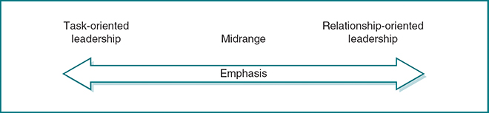
Task Leadership
Task leadership behaviors facilitate goal accomplishment—they are behaviors that help group members to achieve their objectives. Researchers have found that task leadership includes many behaviors. These behaviors are frequently labeled in different ways, but are always about task accomplishment. For example, some have labeled task leadership as initiating structure, which means the leader organizes work, defines role responsibilities, and schedules work activities (Stogdill, 1974). Others have labeled task leadership as production orientation, which means the leader stresses the production and technical aspects of the job (Bowers & Seashore, 1966). From this perspective, the leader pays attention to new product development, workload matters, and sales volume, to name a few aspects. A third label for task leadership is concern for production (Blake & Mouton, 1964). It includes policy decisions, new product development, workload, sales volume, or whatever the organization is seeking to accomplish.
In short, task leadership occurs anytime the leader is doing something that assists the group in reaching its goals. This can be something as simple as handing out an agenda for an upcoming meeting or as complex as describing the multiple quality control standards of a product development process. Task leadership includes many behaviors: Common to each is influencing people toward goal achievement.
As you would expect, people vary in their ability to show task-oriented leadership. There are those who are very task oriented and those who are less task oriented. This is where a person’s personal style comes into play. Those who are task oriented in their personal lives are naturally more task oriented in their leadership. Conversely, those who are seldom task oriented in their personal lives will find it difficult to be task oriented as a leader.
Whether a person is very task oriented or less task oriented, the important point to remember is that, as a leader, he or she will always be required to exhibit some degree of task behavior. For certain individuals this will be easy and for others it will present a challenge, but some task-oriented behavior is essential to each person’s effective leadership performance.
Relationship Leadership
Relationship leadership behaviors help followers feel comfortable with themselves, with each other, and with the situation in which they find themselves. For example, in the classroom, when a teacher requires each student to know every other student’s name, the teacher is demonstrating relationship leadership. The teacher is helping the students to feel comfortable with themselves, with other students, and with their environment.
Researchers have described relationship leadership in several ways that help to clarify its meaning. It has been labeled by some researchers as consideration behavior (Stogdill, 1974), which includes building camaraderie, respect, trust, and regard between leaders and followers. Other researchers describe relationship leadership as having an employee orientation (Bowers & Seashore, 1966), which involves taking an interest in workers as human beings, valuing their uniqueness, and giving special attention to their personal needs. Another line of research has simply defined relationship leadership as concern for people (Blake & Mouton, 1964). Within an organization, concern for people includes building trust, providing good working conditions, maintaining a fair salary structure, and promoting good social relations.
Essentially, relationship leadership behavior is about three things: (1) treating followers with dignity and respect, (2) building relationships and helping people get along, and (3) making the work setting a pleasant place to be. Relationship leadership behavior is an integral part of effective leadership performance.
In our fast-paced and very diverse society, the challenge for a leader is finding the time and energy to listen to all followers and do what is required to build effective relationships with each of them. For those who are highly relationship oriented in their personal lives, being relationship oriented in leadership will come easily; for those who are highly task oriented, being relationship oriented in leadership will present a greater challenge. Regardless of your personal style, every leadership situation demands a degree of relationship leadership behavior.
As discussed earlier in this chapter, task and relationship leadership behaviors are inextricably tied together, and a leader’s challenge is to integrate the two in an optimal way while effectively adapting to followers’ needs. For example, task leadership is critically important in a company or an organization with a large number of newly hired employees or at a charter school with a cadre of new faculty members. It is also called for in an adult fitness class when the instructor is introducing a new exercise. Or, consider the family members of a patient going home after a major heart surgery who have to learn how to change dressings and give medications; they want the health professionals to tell them exactly what to do and how to do it. In situations like these, the followers feel uncertain about their roles and responsibilities, and they want a leader who clarifies their tasks and tells them what is expected of them. In fact, in nearly every group or situation there are some individuals who want and need task direction from their leader, and in these circumstances it is paramount that the leader exhibit strong task-oriented leadership.
-------------------------------------------------------------------------------------------------------
Some individuals tend to approach their work and their work relationships with either a focus on the task, or a focus on the relationships that they have built with the people in their organization. Other individuals, however, are able to balance their task orientation with a relationship orientation.
1. Task-Oriented Leaders: Their focus?
Task-oriented individuals are very focused on:
- achieving goals
- getting the task done
- structuring the work and timelines for employees
- defining responsibilities, and
- are highly concerned with productivity and task performance.
Strengths of the Task-Oriented Leadership Approach.
Over the past few decades, various studies of the task-oriented leadership approach have yielded some interesting insights into the strengths of a task-oriented leadership style.
Research says…
Well, research suggests that task-oriented leaders:
- challenge employees to reach higher levels of performance than they might otherwise
- provide clarity for employees on how a task should be completed and deadlines for task completion
- create a “culture of productivity” (Akin and Hopelain, 1986 – cited in Bass & Stodgill, p. 498)
- lead groups that tended to show higher productivity
- demonstrate task-oriented leadership approaches when organizational profits are faltering
- may be seen by senior level management as more “promotable”
- may treat employees very impersonally, like “cogs in a machine”

- Identify the outcomes (positive and negative) of task-oriented leadership approaches
While there are many reported strengths of a task-oriented leaders, research suggests that there may be drawbacks, including lower employee satisfaction.
A few other factoids:
Task-oriented leaders may:
- Be first borns
- Feel more personal autonomy when working on tasks
Strengths of the Task-Oriented Leadership Approach.
Over the past few decades, various studies of the task-oriented leadership approach have yielded some interesting insights into the strengths of a task-oriented leadership style.
Research says…
Well, research suggests that task-oriented leaders:
- challenge employees to reach higher levels of performance than they might otherwise
- provide clarity for employees on how a task should be completed and deadlines for task completion
- create a “culture of productivity” (Akin and Hopelain, 1986 – cited in Bass & Stodgill, p. 498)
- lead groups that tended to show higher productivity
- demonstrate task-oriented leadership approaches when organizational profits are faltering
- may be seen by senior level management as more “promotable”
- may treat employees very impersonally, like “cogs in a machine”

- Identify the outcomes (positive and negative) of relationship-oriented leadership approaches
Strengths of the Relationship-Oriented Leaders.
As might be expected, the strengths of relationship-oriented leaders include:
- More likely to inspire the development of those in a followership role (Bass, 2008)
- More attentive to the needs of employees
- Seen as approachable by employees
- Lower absenteeism, employee grievances, and turnover among employees
- Seen as providing a positive work environment
- Groups led by relationship-oriented leaders may generate more ideas
There can be drawbacks to a relationship-oriented leadership approach, particularly when:
- An organization’s profit is suffering. In this case, a task-oriented leadership approach may be preferable.
- There is a concern that the manager is starting to lead others with a “country club” approach that puts productivity in the background.
Lesson 6
- List the nine (9) primary leadership skills
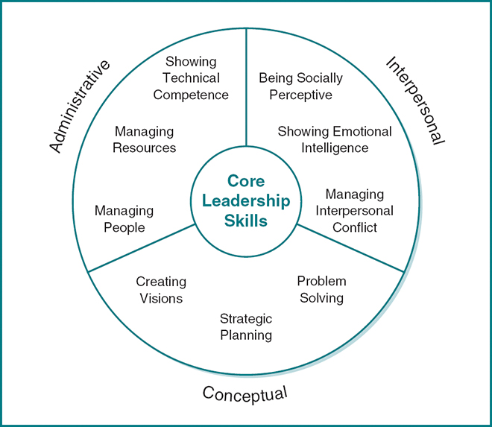
- Categorize the nine primary leadership skills into Administrative, Conceptual, and Interpersonal skills
Ans with question 1
- Discuss the relationship between leadership skills and management skills
In an often cited Harvard Business Review paper, John Kotter explored the question “What Leaders Really Do.” Kotter saw the work of leadership as different from that of management. According to Kotter:
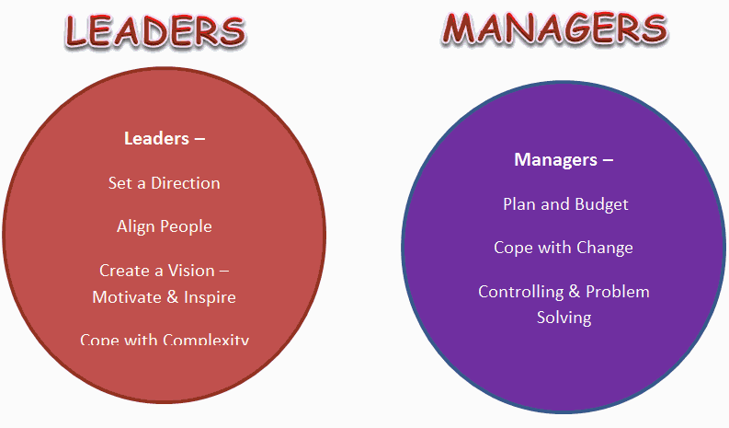

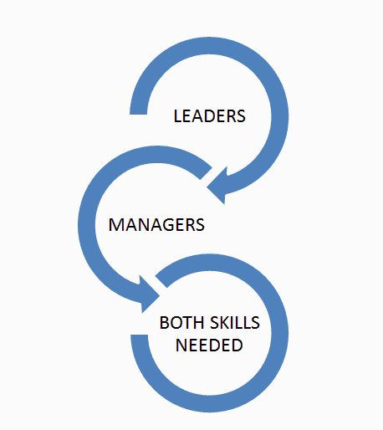
For a moment, let's think about the reality of this categorization. In smaller organizations, for instance, don't leaders also have to plan and budget? For instance, Sam Smith, Executive Director of the ABC Not-for-Profit organization had to clarify the vision for the organization, prepare a budget for reporting procedures, motivate and inspire employees as well as overseeing performance reviews.

Increasingly the relationship between the skills and activities that leaders engage in overlap with those of managers - more like an overlapping Venn Diagram. In other words, managers have to have leadership capacity and managers have to have an understanding and capacity to display leadership qualities.
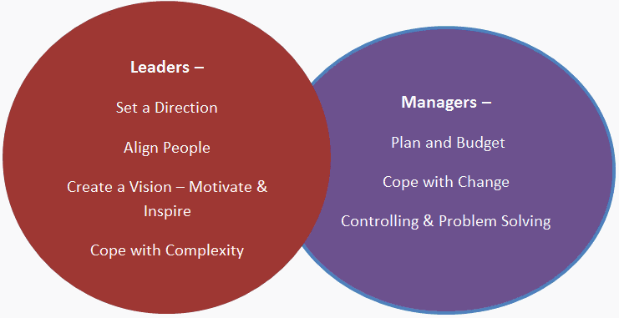

- Analyze the various interpersonal skills that contribute to Coquese Washington's success as a leader

- Describe how each of the categories of leadership skills contribute to the effectiveness of leaders
Administrative skills help a leader to accomplish the mundane but critically important aspects of showing leadership. Some would even argue that administrative skills are the most fundamental of all the skills required of a leader
Interpersonal skills are people skills—those abilities that help a leader to work effectively with followers, peers, and superiors to accomplish the organization’s goals. While some people downplay the importance of interpersonal skills or disparage them as “touchy-feely” and inconsequential, leadership research has consistently pointed out the importance of interpersonal skills to effective leadership (Bass, 1990; Blake & McCanse, 1991; Katz, 1955).
Whereas administrative skills are about organizing work, and interpersonal skills are about dealing effectively with people, conceptual skills are about working with concepts and ideas. Conceptual skills involve the thinking or cognitive aspects of leadership and are critical to such things as creating a vision or strategic plan for an organization. A leader with conceptual skills is able to conceive and communicate the ideas that shape an organization from its goals and mission to how to best solve problems.
- Apply the primary leadership skills framework to the Sweet Caroline's case

