Human Resource Management
Chapter 1

Human resource Management (HRM): The process of managing human talent to achieve an organizations objectives
Human Capital: The knowledge skills and capabilities of individuals that have economic value to an organization
Human capital is intangible and cannot be managed the way organzaitions manage jobs, products and technologies, one reason why is because employees, not the orgnaztion own their own human capital, if valued employees leave the organization they take their human capital with them.
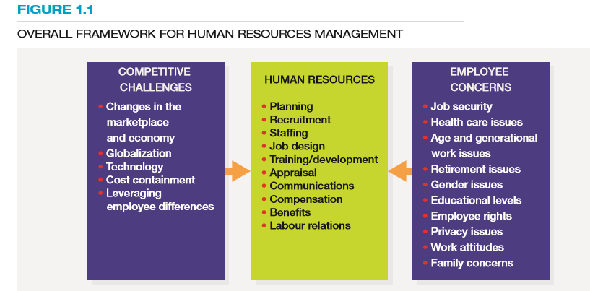

HRM practices such as selection and training can develop replacements for these people, so the real strategic advantage for organizations is high-quality HRM systems, to build human capital in organizations, managers must continue to develop superior knowledge, skills and experience within their workforces and retain and promote top performers.
“learning capability is g times g- a business ability to generate new ideas multiplied by its adeptness at generalizing them throughout the company”
Six sigma: A set of principles and practices whose core ideas include understanding customer needs, doing things right the first time and striving for continuous improvement
Reengineering: the fundamental rethinking and radical redesign of business processes to achieve dramatic improvements in cost, quality, service and speed
Downsizing: planned elimination of jobs
Outsourcing: contracting out work that was formerly done by employees
Change management: change management is a systematic way of brining about and managing both organizational changes and changes on the individual level, all strategies above require companies to engage in change management
Reactive change: changes that occur after external forces have affected performance
Proactive change: change initiated to take advantage of targeted opportunities
Organizations that have been successful in engineering change:
- Link the change to the business strategy
- Show how the change creates quantifiable benefits
- Engage key employees, customers and their suppliers early when making a change
- Make an investment in implementing and sustaining change
Globalization: The trend to opening up foreign markets to international trade and investment
Corporate social responsibility: the responsibility of the firm to act in the best interests of the people and communities affected by its activities
Issue 1 of HRM: responding strategically to changes in the local and global marketplace
Issue 2 of HRM: setting and achieving corporate social responsibility and sustainability goals
Collaborative software: Software that allows workers to interface and share information with one another electronically
Issue 3 of HRM: Advancing HRM with technology
Knowledge workers: workers whose responsibilities extend beyond the physical execution of work to include planning, decision making and problem solving
Advanced technology tends to reduce the number of jobs that require little skill and to increase the number of jobs that require considerable skill, in general this transformation has been referred to as a shift from “touch labour” to knowledge workers, in which employees responsibilities expand to include a richer array of activities such as planning, decision making and problem solving
Human resources information systems: A computerized system that provides current and accurate data for purposes of control and decision making, helps with operational level such as automating routine activities, alleviating admin burdens, reducing costs and improving productivity internal to the HR function itself such as automating payroll processing, maintaining employee records and administrating benefits programs, the second way in which IT is affecting HRM is relational in nature, connecting people with each other and with the HR data they need, an example using software to recruit people, the third effect of the HRIS is transformational in nature, changing the way HR processes are designed and executed an example would be setting developmental goals of its employees once they have been hired and to gauge how they are meeting them, employees can look online to see their own goals.
Issue 4 of HRM: containing costs while retaining top talent and maximizing productivity
HR managers have been under pressure to cut labour costs, stretching a company’s labour dollars while gaining productivity from workers is a challenge for managers
Downsizing is no longer being regarded as a shirt-term fix when times are tough, it has now become a tool continually used by companies to adjust to technological changes, globalization and the firms business direction
Advocates of a no-layoff policy often note that layoffs may backfire after taking into account hidden costs such as the following:
- Severance and rehiring costs
- Accrued vacation and sick day payouts
- Pensions and benefit payoffs
- Potential lawsuits form aggrieved workers
- Loss of institutional memory and trust in management
- Lack of staffers when the economy rebounds
- Survivors who are risk averse, paranoid and political
In contrast companies that avoid downsizing say they get some important benefits form such policies:
- A fiercely loyal, more productive workforce
- Higher customer satisfaction
- Readiness to snap back with the economy
- A recruiting edge
- Workers who are not afraid to innovate, knowing that their jobs are safe
More than one executive has concluded that you do not get dedicated and productive employees if at the first sign of trouble you show them that you think they are expendable
To approach downsizing more intelligently, some companies have made special efforts to reassign and retain employees for new positions when their jobs are eliminated , another example is offering employees a four day work week for reduced pay on a voluntary basis
Furloughing: an alternative to downsizing is furloughing which is when a situation in which an organization asks or requires employees to take time off for either no pay or reduced pay
Although furloughs might sound preferable to downsizing they have their drawbacks too, costs are not cut as significantly as they would ne with downsizing because employees generally retain their benefits while they are furloughed, employees who are not furloughed often end up with more work and feel resentful and product and service quality as well as innovation, suffer as a result of the higher workloads , and as with downsizing furloughing employees can hurt a company’s recruiting efforts when the public discovers it has resorted to such a measure, more diligent workforce planning is a better solution
The interest in outsourcing has been spurred on by executives who want to focus their organizations activities on what they do best, in fact some management experts predict that companies will one day strip away every function not regarded as crucial
Outsourcing has been one of the most prominent HR trends of the last 10 years and will continue to be
Offshoring: also referred to as “global sourcing” involves shifting work to overseas locations or the business practice of sending jobs to other countries
But hidden costs can sometimes chew up much financial gains from offshoring, including those associated with finding foreign vendors, productivity lost during the transition, domestic layoof costs, language difficulties, international regulatory challenges and political and economic instability that can threaten operations
Nearshoring: Another new trend is the nearshoring which is the process of moving jobs closer to ones home country, for example rising labour costs in china are now making it attractive for north America firms to offshore work to Mexico and central America
Yet another new way companies are both economizing and brining jobs back to their domestic markets is by “homeshoring”, call centre jobs are a notable example. When a company homeshores call centre jobs, it outsources the work to domestic independent contractors who work out of their homes
Employee leasing: As an alternative to downsizing, outsourcing, offshoring and furloughing many companies especially small ones have decided to sign employee leasing agreements with professional employer organizations(PEOs) or the process of dismissing employees who are then hired by a leasing company (which handles all HR-related activities) and contracting with that company to lease back the employees, Because PEOs can coemploy a large number of people working at many different companies they can provide employees with benefits that small companies cannot afford, such as vision care plans, in addition many PEOs offer their employees flextime, job sharing, partime employment, the value of employee leasing lies in the fact that an organization can essentially maintain its working relationships with its employees but shift some employment costs to the PEO in return for a fee

Issue 5 of HRM: Responding to the demographic and diversity challenges of the workforce
Issue 6 of HRM: Adapting to educational and cultural shifts affecting the workforce
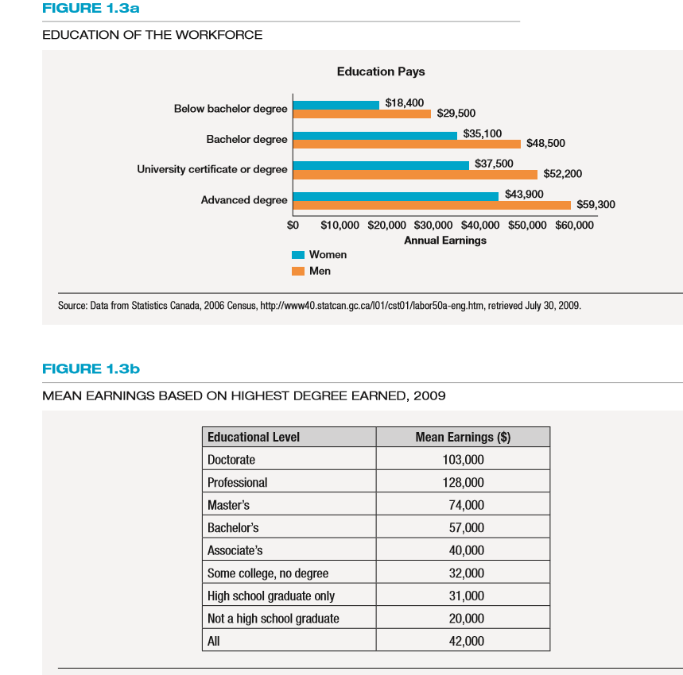

Line managers: Non- HR managers who are responsible for overseeing the work of other employees

Responsibilities of the HR manager

- Advice and counsel
- Service (recruiting, selecting, planning and conducting training programs)
- Policy formulation and implementation
- Employee advocacy (listening to employees concern and representing their needs to managers and to ensure that the interests of employees and the interests of the organization are aligned with one another
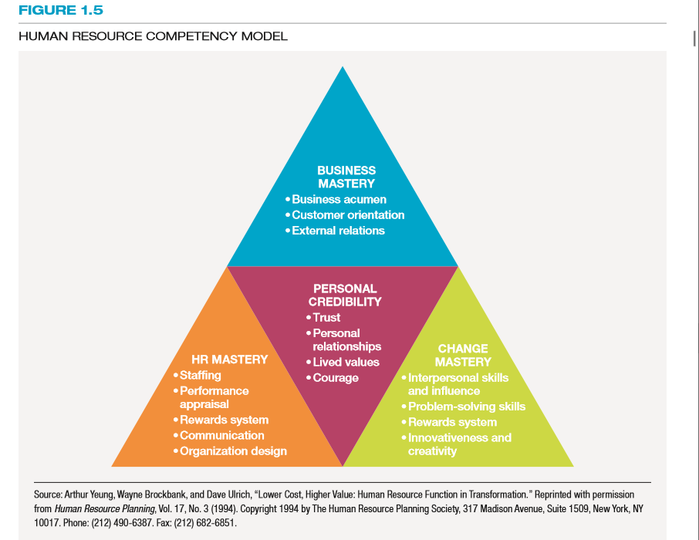

Chapter 2
Outcome 1: Why is HR planning integral to strategic planning? As an HR professional, what do you think you could do to tie the two functions together?
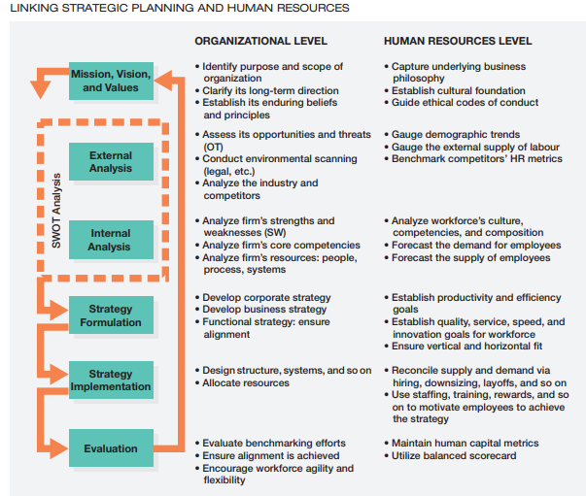
Strategic planning involves a set of procedures for making decisions about the organization’s long-term goals and strategies. In this chapter, we discuss strategic plans as having a strong external orientation that covers major portions of the organization. The plans especially focus on how the organization will position itself relative to its competitors to ensure its long-term survival, create value, and grow. Human resources planning (HRP), by comparison, is the process of anticipating and providing for the movement of people into, within, and out of an organization. Overall, its purpose is to help managers deploy their human resources as effectively as possible, where and when they are needed, to accomplish the organization’s goals. Strategic human resources management (SHRM) combines strategic planning and HRP. It can be thought of as the pattern of human resources deployments and activities that enable an organization to achieve its strategic goals.
Step 1: Mission, Vision and Values
Mission: The basic purpose of the organization as well as its scope of operations
Strategic vision: A statement about where the company is going and what it can become in the future; clarifies the long-term direction of the company and its strategic intent
Core values: The strong and enduring beliefs and principles that the company uses as a foundation for its decisions
Outcome 2: What external factors in the environment do you think firms are most likely to overlook when formulating their business strategies? How can an HR manager help the executive team get a fuller picture of the competitive environment in which it operates?
Step 2: External Analysis
Environmental scanning: is the systematic monitoring of the major external forces influencing the organization, including forces in the business environment, the remote environment, and the competitive environment, each of which we will discuss.
The Business Environment: A firm’s business environment consists of all of the external factors in the general environment—factors a firm cannot directly control but that can affect its strategy. In the next sections, we will look at these factors and how HR personnel can help their companies understand the business environment.
The Remote Environment: The remote environment is part of the business environment. It includes forces that generally affect most, if not all, firms—forces over which they have virtually no control. Changes in the economy, technological changes, demographic changes, and legal and regulatory changes are examples. By and large, a firm can only adapt to these changes rather than influence them as it can change within its own industry.
The competitive environment: The competitive environment is narrower than the remote environment, and firms have a greater ability to affect it. As Figure 2.2 shows, the competitive environment includes the firm’s customers, rival firms, new entrants, substitutes, and suppliers. Firms analyze their competitive environment in order to adapt to or influence the nature of the competition. A general rule of thumb about this analysis is that the more power each of these forces has, the less profitable (and therefore attractive) the industry will be. Let us look at each of the five forces.
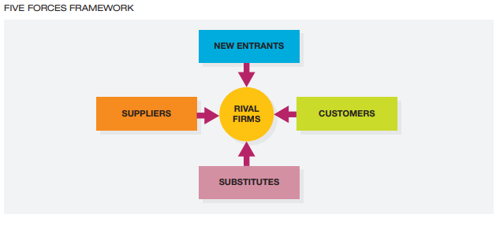
Customers: A firm’s strategy should focus on creating value for customers, who often want different things. For example, in the hotel industry, business travellers may want convenient locations with meeting facilities.
Rival Firms: Who is the competition? Often the answer is clear to everyone, but sometimes it is not. For example, for many years, Toys “R” Us viewed its main competitors to be other toy stores, such as FAO Schwarz or KB Toys. However, other retailers, such as Zellers and Walmart, soon moved into this space very successfully. This had a direct effect on HRP for Toys “R” Us. Although in the past, Toys “R” Us had been successful with a volume-based approach (i.e., “stack it high, and let it fly”), bigger retailers soon gained an advantage—who can beat Walmart’s volume and cost advantage? As a consequence, Toys “R” Us had to modify its strategy to compete more on customer service and the expertise of its employees. But did Toys “R” Us have the number and kind of employees required to compete in this way? Were its staffing, training, performance management, and compensation practices aligned with this strategy?
New Entrants: New companies can sometimes enter an industry and compete well against established firms, and sometimes they cannot. To protect their position, companies often try to establish entry barriers to keep new firms out of the industry. However, when new firms do enter an industry, it is often because they have a different— and perhaps better—way to provide value to customers.
Substitutes: At times, the biggest opportunity or threat in an industry is not from direct competition but from buyers substituting other products. In the telephone industry, for example, people are increasingly disconnecting their landline phones and instead using their mobile phones and VoIP (Voice Over Internet Protocol) services, such as Skype.
Suppliers: Organizations rarely create everything on their own but instead have suppliers that provide them with key inputs.

Outcome 3: Think about the discussion in Chapter 1 related to the auto parts makers that had to look for new business lines when GM, Ford, and Chrysler sales plummeted in the last recession. How did they assess their ability to enter new markets? Do you think they looked first at new markets and then the capabilities of their employees and external partners or vice versa?
Step 3: Internal analysis
A growing number of experts now argue that the key to a firm’s success is based on establishing a set of core capabilities—bundles of people, processes, and systems that distinguish an organization from its competitors and deliver value to customers. You can think of value creation as a cost/benefit scenario. For example, what is driving, or would drive, a customer’s willingness to buy from your firm versus another? What benefits do, or would, customers get from your firm relative to the costs they incur? In what areas does your organization excel as far as potential customers are concerned? Most firms recognize that there is a small set of three to six core capabilities that are most critical to differentiating them from competitors. Core capabilities can consist of a combination of three resources: (1) processes, (2) systems (technologies), and (3) people.
Sustaining a competitive advantage through people
- The resources must be valuable.
- The resources must be rare.
- The resources must be difficult to imitate.
- The resources must be organized.
Corporate Culture: Because managers increasingly understand that their employees are critical to their success, they often conduct cultural audits to examine the values, assumptions, beliefs, and expectations of their workforces as well. Can they make a difference in a firm’s strategy? Yes. Cultural audits can help firms decide on the strategic investments necessary to build and sustain a culture. The audits can also be used to determine if the cultures of two companies will complement each other should the firms merge
values-based hiring: The process of outlining the behaviors that exemplify a firm’s corporate culture and then hiring people who are a fit for them.
Forecasting: predicting the number and types of people an organization needs to meet its objectives. This can be done by:
Trend Analysis which is, A quantitative approach to forecasting labor demand based on an organizational index such as sales.
A qualitative analysis of forecasting:
management forecasts: The opinions (judgments) of supervisors, department managers, experts, or others knowledgeable about the organization’s future employment needs.
staffing tables: Graphic representations of all organizational jobs, along with the numbers of employees currently occupying those jobs and future (monthly or yearly) employment requirements.
Markov analysis A method for tracking the pattern of employee movements through various jobs.
quality of fill: A metric designed to assess how well new hires are performing on the job.
skill inventories: Files of personnel education, experience, interests, and skills that allow managers to quickly match job openings with employee backgrounds.
replacement charts: Listings of current jobholders and people who are potential replacements if an opening occurs.
succession planning: The process of identifying, developing, and tracking key individuals for executive positions
human capital readiness: The process of evaluating the availability of critical talent in a company and comparing it to the firm’s supply
OUTCOME 4: Think about a company that you enjoy doing business with and one that you don’t. What competitive strategy does each pursue? Do you think employees of these companies have the right skills given the strategy?
Step 4: Formulating Strategy
SWOT analysis: A comparison of strengths, weaknesses, opportunities, and threats for strategy formulation purposes
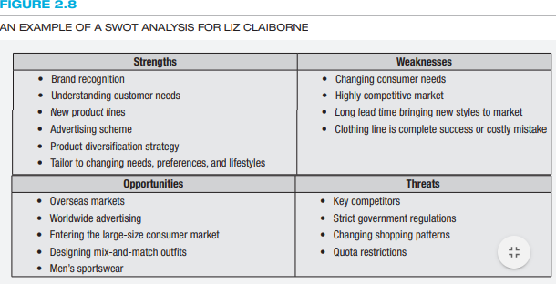
Corporate Strategy
A firm’s corporate strategy includes the markets in which it will compete, against whom, and how. Corporate strategy focuses on domain selection, that is, the markets in which it will compete. Some firms choose a concentration strategy that focuses on only a limited portion of the industry. For example, Visteon Corporation specializes in electronics, climate, and powertrain technologies for the automotive industry.
Growth and Diversification: Growth hinges on three related elements: (1) increased employee productivity, (2) a greater number of employees, and (3) employees developing or acquiring new skills. Thus, a firm’s staffing, training, and employee motivation efforts can either enable the company to grow or limit its potential.
Mergers and Acquisitions: Canada has seen a host of mergers and acquisitions in recent years, including the merger of Loblaws and Shoppers Drug Mart. However, some mergers do not go well (measured by return on investment, shareholder value, and the like). Often the failure is due to cultural inconsistencies, as well as conflicts among the managers of each firm. The failure of the merger between the German firm Daimler-Benz (the manufacturer of Mercedes-Benz vehicles) and Chrysler is an example. Although the German portion of the firm had superior technology, reportedly, it was less than eager to share its know-how with its American counterparts.
Strategic Alliances and Joint Ventures: when firms enter into international joint ventures, the issues of culture (both company culture and national culture) become paramount. On the front end, HR plays a vital role in assessing the compatibility of cultures and potential problems. As the alliance is formed, HR helps select key executives and develops teamwork across the respective workforces. In addition, HR is typically involved in the design of performance assessment and mutual incentives for the alliance.
Business Strategy
Whereas we think about corporate strategy as domain selection, business strategy is viewed in terms of domain navigation. It is more focused on how the company will compete against rival firms to create value for customers.
Low-Cost Strategy: A low-cost strategy means keeping your costs low enough so that you can offer an attractive price to customers (relative to competitors). Organizations such as McDonald’s have been very successful at using a low-cost strategy. Critical success factors for this strategy focus on efficiency, productivity, and minimizing waste. These types of companies often are large and try to exploit economies of scale in production and distribution. In many cases, their large size allows them to sell their products and services at a lower price, which leads to higher market share, volume, and (it is hoped) profits. A low-cost strategy has several links to HRP. The first has to do with productivity. A common misconception about low-cost strategies is that they inevitably require cutting labour costs. On the contrary, there are several good examples of companies that pay their employees “top dollar” but gain back cost advantages because of excellent productivity. That is, they get a terrific “bang for the buck.” The second way that low-cost strategies are linked to HR pertains to outsourcing. In some cases, companies seeking low cost may consider contracting with an external partner that can perform particular activities or services as well as (or better than) at a lower cost. This decision directly links strategic planning to HRP. Decisions such as these often result in layoffs, transfers, and the like. As noted previously, organizations need to have a clear understanding of their core processes and skills to make these decisions. Too often, firms approach outsourcing decisions based on costs alone, but this can lead to detrimental effects in the long run if the skills base of their employees suffers and their core capabilities are subsequently eroded.
Differentiation Strategy: A differentiation strategy is often based on high product quality, innovative features, speed to market, or superior service. Four Seasons Hotels’ commitment to quality and luxury, FedEx’s focus on speed and flexible delivery, Holt Renfrew’s commitment to fashion and customer service, and Apple’s emphasis on innovation and product development are all easily identifiable examples of differentiation strategies. Companies that focus on service, for example, need to identify and support ways to empower employees to serve customers better. In contrast to the company that emphasizes low cost and efficiencies, you may find that differentiating companies will bend the rules a bit more, allow more flexibility to let you “have it your way,” and customize products and services around the customer’s particular needs.
Functional Strategy: Ensuring Alignment
This involves all aspects of the business, but in particular there needs to be a clear alignment between HR and the requirements of an organization’s strategy. In this regard, HR policies and practices need to achieve two types of fit: vertical and horizontal.
Vertical Fit/Alignment: focuses on the connection between the business objectives and the major initiatives in HR. For example, as we noted earlier, if a company’s strategy focuses on achieving low cost, its HR policies and practices need to reinforce this idea by reinforcing efficient and reliable behavior on the part of employees and enhanced productivity. On the other hand, if the organization competes through innovation and new product development, then its HR policies and practices would be more aligned with the notion of fostering creativity and flexibility.
Horizontal Fit/Alignment: managers need to ensure that their HR practices are all aligned with one another internally to establish a configuration that is mutually reinforcing. The entire range of the firm’s HR practices—from its job design, staffing, training, performance appraisal, and compensation—needs to focus on the same workforce objectives. Unfortunately, often one HR practice, such as training, might be focused on teamwork and sharing, whereas another HR practice, such as the firm’s appraisal or compensation programs, reinforces the idea of individual achievement. Charles Schwab and Company faced this very situation. The company has a reputation in the financial services industry for developing a culture of teamwork that has been important to its strategy. However, when it changed its compensation strategy to provide more rewards to its high-performing brokers, the firm sent mixed signals to its employees. Which is more important: teamwork or individual high flyers?
Outcome 5: Why is it difficult to translate a firm’s strategy into HR deliverables that get the job done?
Step 5: Strategy Implementation
Strategy implementation is difficult for organizations as well. One survey revealed that about half of managers say there is a gap between their organization’s ability to develop a vision and strategy and the ability to execute it. Recently, organizations have been paying more attention to implementation and execution.
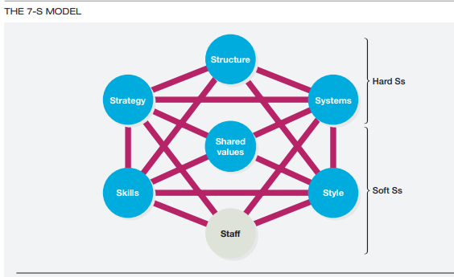
In the “Hard S” category is the strategy, which lays out the route that the organization will take in the future; the organizational structure is the framework in which the activities of the organization members are coordinated. If the strategy requires employees to be reorganized or redeployed, HR will be intimately involved. Also, in the “Hard S” category are systems and processes. These include formal and informal procedures that govern the everyday activities of a firm. As organizations redesign their processes to implement their strategies, HR managers need to help ensure that the best workflow models are in place and that employees share their advice about the changes too.
“Soft S” category are shared values, or core values, which were discussed earlier in the chapter as a guiding parameter for strategic planning. They relate to implementation as well. Strategic change often requires employees and managers to modify, or abandon, their old ways of doing things. HR managers play a central role as guardians of the corporate culture—the principles on which the company is founded and the fundamental ideas around which the business is built. This is tightly connected to the issue of style, which refers not only to the leadership approach of top managers but also the way in which employees present themselves to the outside world (to suppliers, customers, and so on). Skills and staff relate directly to HRM because at its most basic level, HR’s role in the strategy implementation process is to reconcile (1) human resources demanded and (2) human resources available.
Taking Action – Reconciling Supply and Demand
organizations strive for a proper balance between demand considerations and supply considerations. Demand considerations are based on forecasted trends in business activity. Supply considerations involve determining where and how candidates with the required qualifications can be found to fill a firm’s vacancies. In an effort to meet their HR demands, organizations have many staffing options, including hiring full-time employees, having current employees work overtime, recalling laid-off workers, using temporary or contract employees, and outsourcing or offshoring some of their business processes.
Termination: Practice initiated by an employer to separate an employee from the organization permanently
severance pay: A lump-sum payment given to terminated employees by an employer at the time of an employer-initiated termination
attrition: A natural departure of employees from organizations through quits, retirements, and deaths
hiring freeze: A practice whereby new workers are not hired as planned or workers who have left the organization are not replaced
Outcome 6: As an HR manager, how would you know if your organization’s overall strategy and HR strategy were being successfully implemented?
Step 6: Evaluation and Assessment
it might seem that assessing a firm’s effectiveness is the final step in the planning process. But it is also the first step. Planning is cyclical, of course, and although we have somewhat conveniently placed evaluation at the end of this chapter, the information provides firms with inputs they need for the next cycle in the planning process.
Evaluation and Assessment Issues:
benchmarking: The process of measuring one’s own services and practice against the recognized leaders in order to identify areas for improvement
a benchmarking team would collect information on its own company’s operations and those of other firms to uncover any gaps. The gaps help determine the causes of performance differences, and, ultimately, the team would map out a set of best practices that lead to world-class performance.
Measuring a firm’s strategic alignment:
Strategy Mapping and the Balanced Scorecard:
One of the tools for mapping a firm’s strategy to ensure strategic alignment is the balanced scorecard (BSC). Developed by Harvard professors Robert Kaplan and David Norton, the BSC is a framework that helps managers translate their firms’ strategic goals into operational objectives. The model has four related cells: (1) financial, (2) customer, (3) processes, and (4) learning.
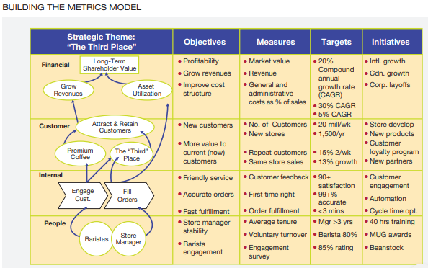
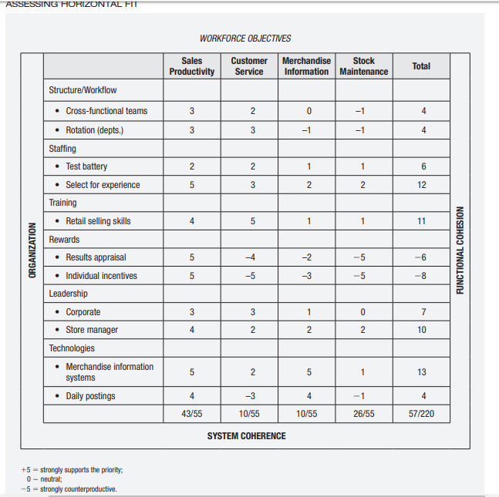
Measuring Horizontal Fit:
Recall that horizontal fit means that HR practices are all aligned with one another to establish a configuration that is mutually reinforcing.
Ensuring Strategic Flexibility for the Future:
Flexibility can be achieved in two primary ways: coordination flexibility and resource flexibility. Coordination flexibility occurs through rapid reallocation of resources to new or changing needs. Through HRP, managers can anticipate upcoming events, keep abreast of changes in legal regulations, forecast economic trends, and recognize competitor moves. With advance notice, managers can move people into and out of jobs, retrain them for new skill requirements, and modify the kinds of incentives they use. Use of a contingency workforce composed of part-timers, temporary employees, and external partners also helps achieve coordination flexibility.34 Resource flexibility, on the other hand, results from having people who can do many different things in different ways. Cross-training, job rotations, and team-based work modes are all focused on establishing a flexible workforce.

Chapter 3

Employment equity: The employment of individuals in a fair and nonbiased manner, is not just the absence of discrimination but also the proactive programs to ensure that the organizations workforce is representative of the population , employment equity legislation affects all aspects of the employment relationship.
Designated groups: 4 designated groups as recognized in the federal employment equity Act, Women, visible minorities, Aboriginal people and persons with disabilities who have been disadvantaged in employment, make up over 60% of Canadas labour force
Women tend to be concentrated in occupations that are accorded lower status and pay, gender pay gap in Canada is 0.76, every dollar a man earns a women earns 76 cents, median income for the Canadian population was 29,900 wheras the median income for aboriginal people is 18,862
Employment equity makes good business sense, it contributes to the bottom line by broadening the base of qualified individuals for employment , training and promotion and by helping employers avoid costly human rights complaints , employment equity enhances an organizations ability to attract and keep the best- qualified employees, which result in greater access to a broader base of skills and it improves the organizations image in the community.
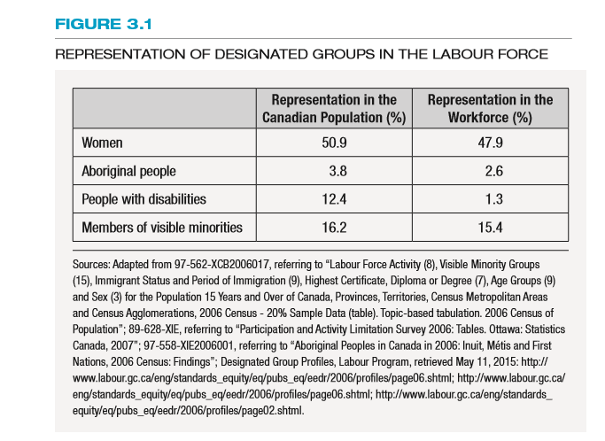
The Canadian charter of rights and freedoms, the federal Canadian human rights act (CHRA), and pay equity and employment equity acts are the governing pieces of legislation dealing with employment equity
The constitution act of 1982 , which contains the Canadian Charter of Rights and Freedoms, is the cornerstone of equity legislation. The charter guarantees some fundamental rights to every Canadian including
- Fundamental freedoms (s. 2) that comprise the standard rights of freedom of speech, press, assembly, association and religion
- Democratic rights (ss 3 to 5) covering franchise rights
- Mobility rights (s.6) concerning the right to move freely form province to province for the purposes of residence and/or employment
- Legal rights (ss.n7 to 14) conferring standard procedural rights in criminal proceedings
- Equality rights (s.15) guaranteeing no discrimination by law on the grounds of race, ethnic origin, colour, religion, sex, age sexual orientation, marital status , citizenship, aboriginal residence or mental and physical ability
- Language rights (ss. 16 to 23)

Bona fide occupational qualification (BFOQ): A justifiable reason for discrimination
based on business reasons of safety or effectiveness

The Canadian Human Rights Act was passed by parliament on July 14 1977 and became effective in march 1978. This act proclaims that every individual should have an equal opportunity with other individuals to make for himself or herself the life that he or she is able and wishes to have , consistent with his or her duties and obligations as a member of society without being hindered in or prevented by discriminatory actions

The Canadian Human Rights Commission (CHRC) deals with complaints concerning discriminatory practices covered by the Canadian Human Rights Act. The CHRC may choose to act on its own if ti believes that sufficient grounds exist for a finding of discrimination, also has the power to issue guidelines interpreting the act, if the guilty party is an employer or an employee organization, the fine can be as high as 50,000

Provincial Human rights laws are enforced in a manner very similar tot hat of the federal system, the majority of cases are resolved at the investigation stage

As a result of a 1878 amendment to the Canadian Human Rights act, pay equity became enacted as law in the federal jurisdiction.

Pay Equity is based on two principles:
- Equal pay for equal work, male and female workers must get paid the same for doing identical work
- Equal pay for similar or substantially similar work (equal pay for work of comparable worth, or equal pay for work of comparable value) , this means that male and female workers must be paid the same wage rate for jobs of a similar nature that may have different titles
Pay equality (in which employers are required to pay women the same as men doing the same job) is required by law in every jurisdiction in Canada
Pay equity is about fair pay for entire occupations which are dissimilar within an organization such as comparing nurses (as a group) to electricians. Pay equity legislation varies by jurisdiction in Canada

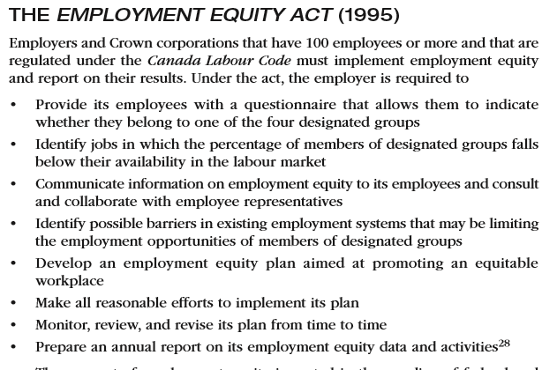

The implementation of employment Equity in organizations:
- Senior management commitment: commitment to an employment equity plan necessitates a top-down strategy. A more supportive culture is created when the CEO or owner-operator publicly introduces written policy describing the organizations commitment to employment equity, this policy must be strategically posted throughout the organization and sent to each employee
- Data collection and analysis: The development of an internal workforce profile is an important tool in employment equity planning, without this information, an organization would not be able to determine where it stands relative to the internal and external workforce, profiles must be based on stock data and flow data.

Stock Data: data showing the status of designated groups in occupational categories and compensation levels

Flow data: Data that provide a profile of the employment decisions affecting designated groups

Underutilization: Term applied to designated groups that are not utilized or represented in the employer’s workforce proportional to their numbers in the labour market

Concentration: Term applied to designated groups whose numbers in a particular occupation or level are high relative to their numbers in the labour market

- Employment systems Review: are the means by which employers carry out personnel activities such as recruitment, hiring, training and development , promotion, job classification , discipline and termination
Systemic discrimination: the exclusion of members of certain groups through the application of employment policies or practices based on criteria that are not job related
The usual test for identifying systemic barriers involves using the following criteria to assess the policy:
- Is it job related?
- Is it valid?
- Is it consistently applied?
- Does it have an adverse impact (does it affect members of designated groups more than those of dominant groups?)
- Is it a business necessity?
- Does it conform to human rights and employment standards legislation
Reasonable accommodation: Attempt by employers to adjust the working conditions or schedules of employees with disabilities or religious preferences
- Establishment of a workplan: The workforce analysis and the review of employment systems will provide the employer with a useful base which to develop a workplan with realistic goals and timetables
- Implementation: The implementation of employment equity is idiosyncratic in that no two plans will be the same. Each strategy should be designed to meet the needs of the organization
- Evaluation, Monitoring and revision: By monitoring progress, the employer will be able to evaluate the overall success of the equity initiatives used to achieve a representative workforce as well as respond to organizational and environmental changes
The two main sources of the employer’s duty to prevent harassment in the workplace are:
- Human rights legislation, which prevents harassment only on the basis of the designated grounds in the legislation (e.g. sex, race, religion)
- Common law obligation to treat workers with decency and respect. This is a fairly new development in the common law . However it applies to all forms of harassment .
According to one study only 4 of every 10 Canadian women who suffer sexual harassment at work take any formal action and only 1 of every 2 women believes that a complaint would be taken seriously in her workplace
The Ontario Human Rights code identifies three kinds of sexual harassment:
- When someone says or does things to you of a sexual nature and you do not want it or welcome it, this includes behaviour that a person should know you do not want or welcome it .
- A person who has authority or power to deny you something such as a promotion or a raise, makes sexual suggestions or requests you do not want or welcome
- A person with authority or the power to deny you something important punishes you or threatens to do something to you for refusing a sexual request
Diversity Management: The optimization of an organizations multicultural workforce to reach business objectives
The terms diversity management and employment equity are often used interchangeably but there are differences, diversity management is voluntary while employment equity is not, managing diversity is a broader , more inclusive concept , encompassing factors such as religion, personality , lifestyle and education, by managing diversity organizations hope to gain a strategic and competitive advantage by helping all employees perform to their full potential
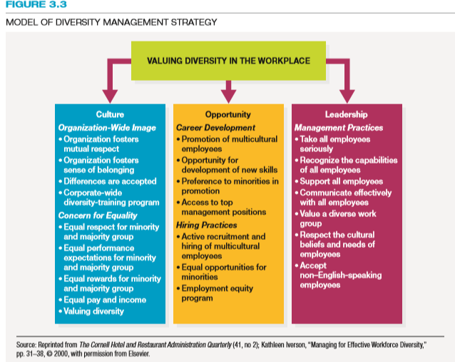

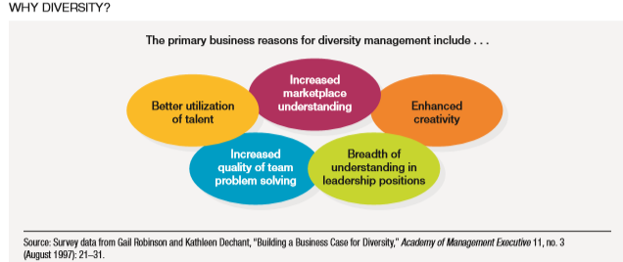

Chapter 4
The goal is to become more efficient and effective , there is on smaller scale, less hierarchy, fewer layers, and more decentralized work units, as organizational reshaping takes place , managers want employees to operate more independently and flexibility to meet customer demands, less bureaucracy speeds up the decisions making process and enables greater interaction and communication
Jobs: A group of related activities and duties
Position: The different duties and responsibilities performed by only one employee
Job family: A group of individual jobs with similar characteristics
Job Specification: A statement of the needed knowledge, skills, and abilities of the person who is to perform the job
Job descriptions: A statement of the tasks, duties and responsibilities of a job to be performed
Job analysis: The process of obtaining information about jobs by determining the duties, tasks or activities of jobs, called the cornerstone of HRM because of information it collects serves so many HRM functions
HRM functions for Job requirements:
- Strategic HRP
- Recruitment (Job specification)
- Selection (job descriptions)
- Training and development
- Performance Appraisal
- Compensation Management
- Legal Compliance
Gathering Job Information:
Interviews: The job analyst may question individual employees and managers about the job under review
Questionnaires: The job analyst may circulate carefully prepared questionnaires to be filled out individually by jobholders and managers. These forms will be used to obtain data in the areas of job duties and tasks performed, purpose of the job, equipment and materials used and special health and safety concerns
Observation: The job analyst may learn about the jobs by observing and recording on a standardized form the activities of jobholders. Videotaping jobs for later study is an approach used by some organizations
Diaries: Jobholders themselves may be asked to keep a diary of their work activities during an entire work cycle. Diaries are normally filled out at specific times of the work shift and maintained for a two to four-week period
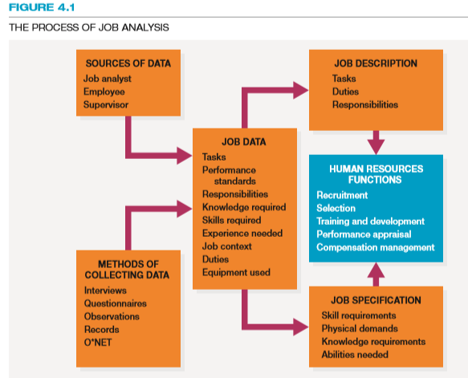
Commonly referred to as the NOC, the national occupational classification is compiled by the federal government. The purpose of the NOC is to compile, analyze and communicate information about occupations. This information can be used for employment equity , HR planning and occupational supply and demand forecasts and analyses.
Approaches to Job Analysis:
Position analysis questionnaire (PAQ): a questionnaire covering 194 different tasks that, by means of a five point scale , seeks to determine the degree to which different tasks are involved in performing a particular job, quantifiable data collection method covering 194 different worker oriented tasks. Using a 5 point scale, the PAQ seeks to determine the degree, if any to which the different tasks, or job elements are involved in performing a particular job.
Critical incident method: A job analysis method by which important job tasks are identified for job success, to identify critical job tasks, critical job tasks are those important duties and job responsibilities performed by the jobholder that lead to job success
Task inventory analysis: An organization-specific list of tasks and their description used a basis to identify components of jobs, can be considered a job-oriented type of job analysis. Unlike the PAQ, which uses a standardized form to analyze jobs in different organizations, a task inventory questionnaire can be tailor- made to a specific organization. The technique is developed by identifying with the help of employees and managers a list of tasks and their descriptions that are components of different jobs . The goal is to produce a comprehensive list of task statements that are applicable to all jobs , task statements are then listed on a task inventory survey form to be completed by the person analyzing the job under review, a task statement might be , “inventories current supplies to maintain stock levels”
Competency- Based Analysis: The traditional approach to job analysis assumes a static job environment in which jobs remain relatively stable apart form incumbents who might hold these jobs. Here Jobs can be meaningfully defined in terms of tasks, duties, processes, and skills necessary for job success. This assumption unfortunately, discounts technological advances , which are often so accelerated that jobs as they are defined today may be obsolete tomorrow, furthermore the need to respond to global change can alter the nature of jobs and the requirement of individuals needed to perform them successfully. Therefore in a dynamic environment where job demands rapidly change, obsolete job analysis information simply hinders an organizations ability to adapt to change. When organizations operate in a fast-moving environment managers may adopt a competency-based approach to job analysis. This job analysis method relies on building job profiles that look at the responsibilities and activities of jobs and the worker competenices necessary to accomplish them. The objective is to identify “key” competencies for organizational success and can be identifies through focus groups, surveys or interviews.

HRIS and Job Analysis: HRIS have frealty facilitated the job analysis process. Avaible today are various software programs designed specifically to analyze jobs and to write job descriptions and job specifications based on those analyses. These programs today normally contain generalized task statements that can apply to many different jobs. Managers and employees select those statements that best describe the job under review, indicating the importance of the task to the total job where appropriate. Advanced computer applications of job analysis combine job analysis with job evaluation and the pricing of organizational jobs.
Job descriptions are of value to both the employees and the employer, for employees job descriptions can be used to help them learn their job duties and remind them of the result they are expected to achieve. From the employers standpoint, written job descriptions can serve as a basis for minimizing the misunderstandings that occur between managers and their subordinates concerning job requirements
Job titles are important for psychological reasons , providing status to the employee, for example “sanitation engineer” sounds better than “garbage collector”, job titles should also give some indication of what the duties of the job entail and the job titles should also should indicate the relative level occupied by its holder in the organizational hierarchy titles like “senior” analyst or “junior” analyst
Job specification typically covers two areas (1) the skill required to perform the job and (2) the physical demands the job places on the employee performing it. Skills should include education, experience , specialized training, personal traits or abilities and interpersonal skills
Problems with Job descriptions:
- If they are poorly written, using vague rather than specific terms, they provide little guidance to the jobholder
- They are sometimes not updated as job duties or specifications change
- They may violate the law by containing specifications not related to job success
- They can limit the scope of activities of the job holder, reducing organizational flexibility
Job Design: An outgrowth of job analysis that improves jobs through technological and human considerations to enhance organization efficiency and employee job satisfaction
It is uncommon for managers and supervisors to confuse the processes of job analysis and job design. Job analysis is the study of jobs as currently performed by employees. It helps with the job description, which identifies job duties and the requirements needed to perform the work successfully. Job design, which is an outgrowth of job analysis , is concerned with structuring jobs to improve organizational efficiency and employee job satisfaction, it is concerned with changing, modifying and enriching jobs to capture the talents of employees while improving organizational performance
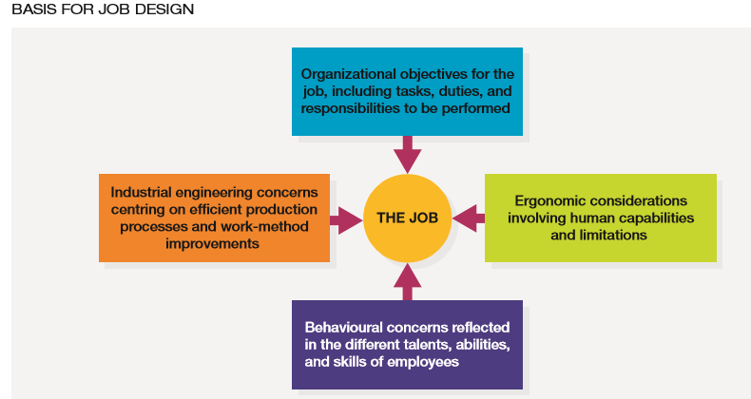

Job enrichment: Enhancing a job by adding more meaningful tasks and duties to make the work more rewarding or satisfying
Job characteristics model: A job design theory that purports the three psychological states (experiencing meaningfulness of the work performed, responsibility for work outcomes and knowledge of the results of the work performed) of a jobholder result in improved work performance, internal motivation and lower absenteeism and turnover
Herzberg 5 factors for enriching jobs and thereby motivating employees:
- Achievement
- Recognition
- Growth
- Responsibility
- Performance of the whole job versus only parts of the job
A motivated satisfied and productive employee:
- Experiences meaningfulness of the work performed
- Experiences responsibility for work outcomes
- Has knowledge of the results of the work performed
Five core job dimensions produce the three psycholical states:
- Skill variety
- Task identity: the degree to which the job requires completion of a whole and identifiable piece of work, doing a job from beginning to end with a visible outcome
- Task significance
- Autonomy
- Feedback
Employee empowerment: Granting employees power to initiate change, thereby encouraging them to take charge of what they do
Industrial engineering: A field of study concerned with analyzing work methods and establishing time standards, specifically it involves the study of work cycles to determine which , if any , elements can be modified, combined , rearranged or eliminated to reduce the time needed to complete the cycle.
Ergonomics: An interdisciplinary approach to designing equipment and systems that can be easily and efficiently used by human beings, it is the study of people at work and the practice of matching the features of products and jobs to human capabilities, preference and the limitations of those who are are to perform a job. Ergonomics focuses on ensuring that jobs are designed for safe and efficient work while improving the safety, comfort and performance of users. In short it seeks to fir the job to person rather than the person to the job. Ergonomics improves productivity and morale and yields a positive return on investment(ROI).
Flextime: Flexible working hours that permit employees the option of choosing daily starting and quitting times provided that they work a set number of hours per day or week
Flexible work schedules are not a true part of job design because job tasks and responsibilities are not changed
Compressed work week, the number of days in the work week is shortened by increasing the number of hours worked per day for example 4 day 10 hour work week. Managers cite the following reasons for implementing compressed workweek schedules:
- Recruitment and retention of employees
- Coordinating employee work schedules with production schedules
- Accommodating the leisure-time activities of employees while facilitating employee personal appointments (medical, dental, financial)
- Improvements in employee job satisfaction and morale
Job sharing: The arrangement whereby two part-time employees perform a job that otherwise would be held by one full-time employee
Telecommuting: Use of personal computers, networks, and other communications technology to do work in the home that is traditionally done in the workplace.
Telecommuting has several advantages:
- Imcreased flexibility for employees- better work-life balance
- Reduced absenteeism
- Retention of valued employees who might otherwise quit
- Reduced “carbon footprints” through minimizing daily commuting
- Increased productivity (eg. Reduced wasted office time)
- Lower overhead costs and reduced office space
Chapter 5
Employee profiles: Profiles of workers developed by studying an organization’s top performers to recruit similar types of people
Recruiting process outsourcing(RPO): The practice of outsourcing an organizations recruiting function to an outside firm, is used when employers need to hire a lot of employees or need to hire employees quickly, some firms that are too small use RPO’s
Internal Labour markets: Labour markets in which workers are hired into entry-level jobs and higher levels are filled form within
Global outsourcing: The business practice of searching for and utilizing goods and services from around the world
Branding: A company’s efforts to help existing and prospective workers understand why it is a desirable place to work
9-box grid: A comparative diagram that includes appraisal and assessment data to allow managers to easily see an employee’s actual and potential performance
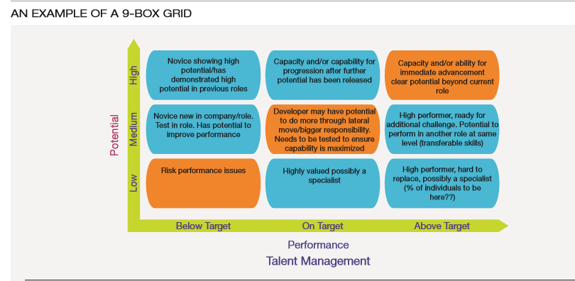
Passive Job Seekers: People who are not looking for jobs but could be persuaded to take new ones given the right opportunity
Nepotism: A preference for hiring relatives of current employees
Rerecruiting: The process of keeping track of and maintaining relationships with former employees to see if they would be willing to return to the firm
Employee leasing: The process of dismissing employees who are then hired by a leasing company (which handles all GR-related activities) and contracting with that company to lease back the employees
Realistic job preview (RJP): Informing applicants about all aspects of the job. Including both its desirable and undesirable facets
Quality of Hire = (PR + HP + HR)/N
Where:
PR = average job performance rating of new hires
HP = Percentage of new hires reaching acceptable productivity within an acceptable time frame
HR = Percentage of new hires retained after one year
N = Number of indicators

Time-to-fill metric: The number of days from when a job opening is approved to the date the candidate is selected
Yield ratio: The percentage of applicants from a recruitment source that make it to the next stage of the selection process
Applicant tracking system (ATS): A software application recruiters use to post job openings , screen resumes, contact potential candidates for interviews via email, and track the time and costs related to hiring people
Cost of recruitment:
SC/H = (AC+AF+RB+NC)/H
Where:
AC = advertising costs, total monthly expenditure
AF = agency fees, total for the month
RB = referral bonuses , total paid
NC = no-cost hires, walk-ins, non-profit agencies
H = Total hires

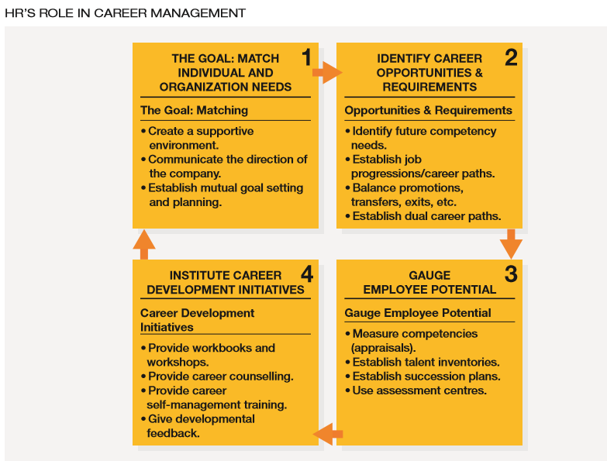

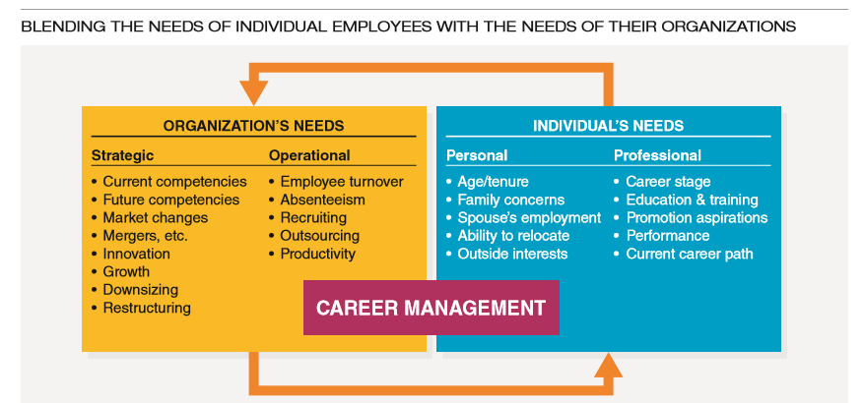
Job Progressions: The hierarchy of jobs a new employee might experience ranging from a starting job to jobs that successively require more knowledge and/or skill
Career Paths: Lines of advancement in an occupational field within an organization
Promotion: A change of assignment to a job at a higher level in the organization
Transfer: placement of an individual in another job for which the duties responsibilities, status and remuneration are approximately equal to those of the previous job
A common problem in organizations that promote primarily on past performance and seniority is called the Peter Principle. This refers to the situation in which individual’s are promoted as long as they have done a good job in their previous jobs, the situation continues until someone does poorly in his or her new job, then he or she is no longer promoted , this results in people being promoted to their level of incompetence
Relocation services: services provided to an employee who is transferred to a new location, which might include help in moving, selling a home, orienting to a new culture. And/or learning a new language
Outplacement services: Services provided by organizations to help terminated employees find a new job
Career plateau: A situation in which , for either organizational or personal reasons, the probability of moving up the career ladder is low
Sabbatical: An extended period of time in which an employee leaves an organization to pursue other activities and later returns to his or her job
The six most successful career management practices used within organizations are as follows:
- Placing clear expectations on employees so they know what is expected of them throughout their careers with the organizations
- Giving employees the opportunity to transfer to other office locations, both domestically and internationally
- Providing a clear and thorough succession plan to employees
- Encouraging performance through rewards and recognition
- Giving employees the time and resources, they need to consider short and long term career goals
- Encouraging employees to continually assess their skills and career direction
Career Counselling: The process of discussing with employees their current job activities and performance, personal and career interests and goals, personal skills, and suitable career development objectives
Fast track program: A program that encourages new managers with high potential to remain with an organization by enabling them to advance more rapidly than those with less potential
Mentors: individual’s who coach, advise and encourage individuals of lesser rank
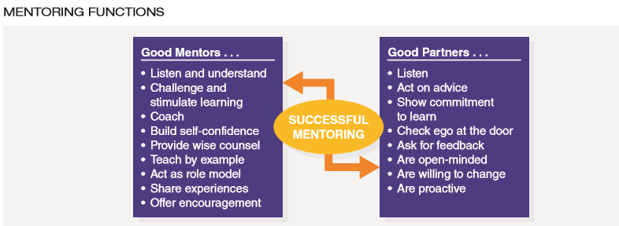

Career networking: The process of establishing mutually beneficial relationships with other businesspeople, including potential clients and customers
Chapter 6
Selection: the process of choosing individuals who have relevant qualifications to fill existing or projected job openings
Although the overall selection program is often the formal responsibility of the HR department, line managers typically make the final decision about hiring people in their unit
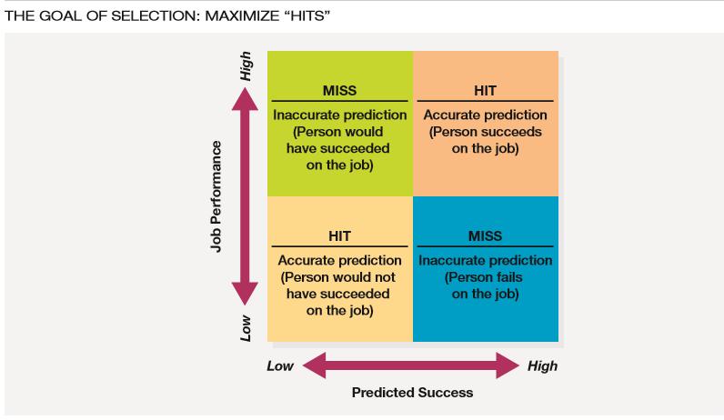
Reliability: The degree to which interviews, tests, and other selection procedures yield comparable data over time
Job specifications, in particular, help identify the individual competencies employees need for success: the knowledge, skills, abilities and other factors (KSAOs)
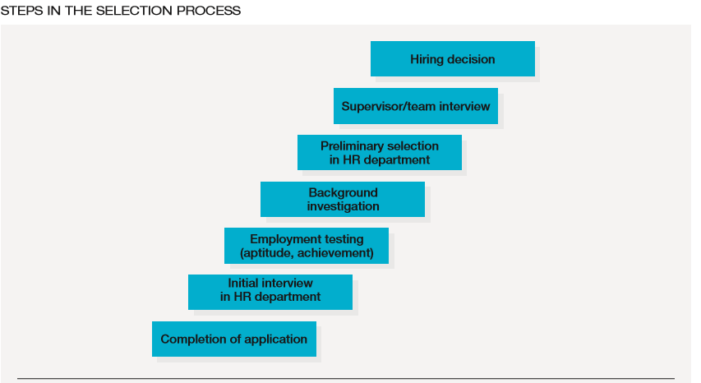
Validity: The degree to which a test or selection procedure measures a person’s attributes
There are two reasons for validating a procedure, first validity is directly related to increase in employee productivity, second, employment equity regulations require valid selection procedures
Video resumes: Short video clips that highlight applicants’ qualifications beyond what they can communicate on their resume (icanidatescreener is an example)
Managers should use the following suggestions for putting together an application form:
- Application date
- Educational background (the form should contain information about grade school, high school, college and university attendance but not the dates attended because that can be connected with age)
- Experience (virtually any questions that focus on work experience related to the job are permissible)
- Arrests and criminal convictions (questions about arrests, convictions and criminal records are to be avoided)
- Country of citizenships (such questions are not permitted, it is allowable to ask whether the person is legally entitled to work in Canada)
- References (it is both permissible and advisable that the names, addresses and phone numbers of references be provided)
- Disabilities (employers should avoid asking about disabilities or hospitalization or whether candidates have received workers compensation )
Some organizations use what is referred to as a weighted application blank(WAB). The WAB involves the use of a common standardized employment application designed to distinguish between successful and unsuccessful employees
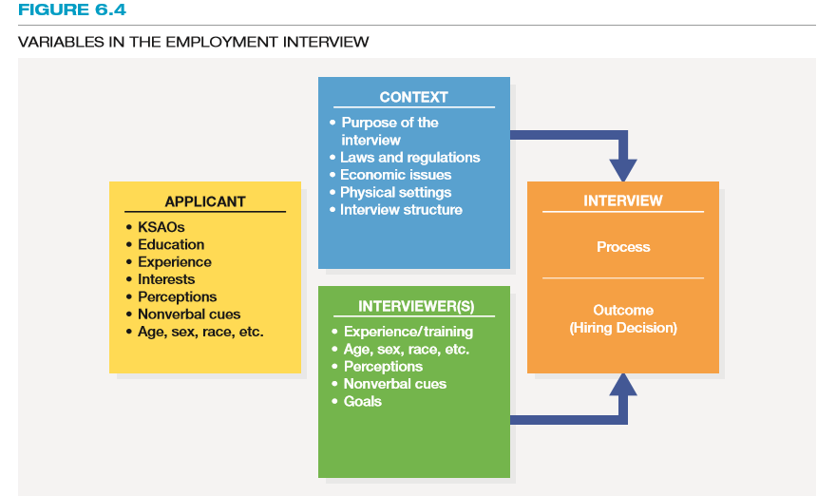
Nondirective interview: An interview in which the applicant is allowed the maximum amount of freedom in determining the course of the discussion, while the interviewer carefully refrains from influencing the applicants remarks, the interviewer asks broad, open-ended questions such as “tell me more about your experiences on your last job”, the reliability and validity of these interviews are not likely to be ask great, this method is most likely to be used in interviewing candidates for high-level positions and in counselling
Structured interview: An interview in which a set of standardized questions with an established set of answers is used (based on job analysis), according to one report , structured interviews are twice as likely as nondirective interviews to predict on the job performance and are also less likely to be attacked in court
Situational interview: An interview in which the applicant is given a hypothetical incident and asked how he or she would respond to it
Behavioural description interview(BDI): An interview in which an applicant is asked questions about what he or she did in a given situation, focuses on actual work incidents in the interviewees past, for example to assess a potential managers ability to handle a problem employee an interviewer might ask “tell me about the last time that you disciplined an employee”, research indicates that the BDI is more effective that the situational interview for hiring high level positions such as general managers and executives
Panel interview: An interview in which a board of interviewers questions and observes a single candidate, studies also suggest that if the panels are composed of a diverse group of interviews hiring discrimination is minimized, reduced interview times
Sequential interview: A format in which a candidate is interviewed by multiple people one right after another
Other types of interviews:
Video and phone interviews, computer administered (automated) interviews
Qualities that are desirable in an interviewer: Humility, the ability to think objectively, maturity, and poise
Qualities to avoid in interviewers include: overtalkativeness, extreme opinions, and biases
10 ground rules for employment interviewers
- Understand the job (interviewer understands the job and it requirement)
- Establish an interview plan
- Establish and maintain rapport and listen actively
- Pay attention to nonverbal cues
- Provide information as freely and honestly as possible
- Use questions effectively
- Separate facts from inferences
- Recognize biases and stereotypes
- Avoid the ‘halo error’ or judging an individual favourably or unfavourably overall on the basis of only one strong point (or weak point) on which you place high value
- Control the course of the interview
- Standardize the questions asked
Preemployment test: An objective and standardized measure of a sample of behaviour that is used to gauge a person’s knowledge, skills, abilities and other characteristics (KSAOs) relative to other individuals
Assessment centre: A process by which individuals are evaluated as they participate in a series of situations that resemble what they might need to handle the job
The big five:
- Extroversion
- Agreeableness
- Conscientiousness
- Neuroticism
- Openness to experience
Criterion-related validity: The extent to which a selection tool predicts or significantly correlates with, important elements of work behaviour, how well a person performs on a test, for example is compared to his or her actual production records, supervisory ratings, training outcomes
There are tow types of criterion-related validity (concurrent and predictive):
Concurrent validity: The extent to which test scores (or other predictor information) match criterion data obtained at about the same time from current employees, for example, a supervisor will be asked to rate a group of clerical employees on the quantity and quality of their performance, these employees are then given a clerical aptitude test and the test scores are compared to the supervisors ratings to determine the degree of relationship between them
Predictive validity: The extent to which applicants test scores match criterion data obtained form those applicants/employees after they have been on the job for an indefinite period, for example applicants are given clerical aptitude tests which are then filed for later study

Cross-validation: verifying the results obtained from a validation study by administering a test or test battery to a different sample (drawn from the same population) for the purpose of verifying the results obtained from the original validation study
Content validity: The extent to which a selection instrument such as a test, adequately samples the knowledge and skills needed to perform a particular job
Construct validity: The extent to which a selection tool measures a theoretical construct or trait, typical constructs are intelligence, mechanical comprehension and anxiety
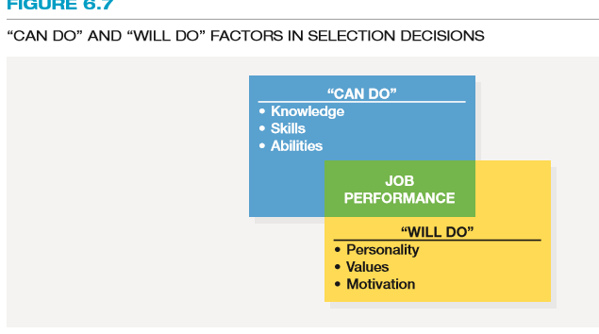

Compensatory model: A selection decisions model in which a high score in one area can make up for a low score in another area
Multiple cutoff model: A selection decision model that requires an applicant to achieve a minimum level of proficiency on all selection dimensions
Multiple hurdle model: A sequential strategy in which only the applicants with the highest scores at an initial test stage go on to subsequent stages
Selection ratio: The number of applicants compared to the number of people to be hired

