Experiment 4

Experiment Title: EXPERIMENT 4: Acid Base Titration

Author(s) Name(s): Marc-André Ouellette

Submitting Author’s Partner: Kenan Alhariri

TA (Demonstrator)’s Name: Melissa Cely

Date Experiment Performed: November 1st 2019
Date Experiment Submitted: November 8th 2019

Attach here (if required, indicate the appropriate document(s)):

Medical or other Acceptable Document: _____
Change of Lab Day Form: _____
Change of Lab Section Form: _____
Late Pass: _____

Procedure: “As described in the lab manual (Dr Venkateswaran, 2019)”

Introduction:
Acids and bases are the substances that were used during our experiment. Acids are described by the Bronsted-Lowry theory as being substances that are proton donors when placed in water. A strong acid will dissociate completely. A weak acid will barely dissociate. On the other hand, bases are substances that gain a proton when dissociated in water. A strong base will completely dissociate while on the other hand, a weak base will barely dissociate (Dr Venkateswaran, 2019).
The pH is the scale that is used to measure how acidic/basic a substance is. The scale is from to 0-14 and if a substance’s pH is between 0-7, the substance is acidic. If a substance’s pH is between 7-14, the substance is basic. If the pH is at 7, the substance is neutral (MacInnes, 1951). In this experiment, we used HCl with a 0.100 M concentration which had a pH of 2.47. This substance would thus be acidic. We also used NaOH with a .0132 M concentration which had a pH of about 13.2. We also used Maleic acid #7 which had a pH of 2.85. (Dr Venkateswaran, 2019).
In this experiment, we had to perform a titration. The first part was to dilute concentrated NaOH. We then had to perform a titration with this diluted acid. The general concept was to 1) neutralize a strong acid with a strong base to form salt and water (equivalence point) and 2) keep adding base to the solution until the pH would stop increasing. The equivalence point is when there is enough titrate added to a solution to neutralize it. The endpoint is defined as the point in a titration when the indicator that was previously added to the acid will change colours to indicate that the reaction is close to its equivalence point (Dr Venkateswaran, 2019). The indicator tends to react a bit before or after the reaction reaches its equivalence point thus, it is not the most accurate way to measure the equivalence point.
In our experiment, we neutralized two strong acids. One of the acids was HCl, a strong monoprotic acid. This means that it has one proton to donate. It will dissociate into H⁺ + Cl⁻. The base (NaOH) that will be added will gain the proton which will gain the proton donated by HCl. The other acid, maleic acid #7 is a strong diprotic acid. This means that it has two protons that it can donate (Dr Venkateswaran, 2019). Thus, Maleic acid, which we will call H₂M in this report for simplicity’s sake, will dissociate initially into HM⁻+H⁺. HM⁻ will then dissociate into M⁻+H⁺ in water. When NaOH, a base, will be added to the solution, it will accept the H⁺ initially donated by H₂M. The NaOH will then gain the other H⁺ donated by HM⁻. This will thus increase the pH of the solution.
Based on this, we can expect to see one equivalence point for HCl as HCl only has one proton to give thus, there will only be one equivalence point (equal amount of acid/base) (Dr Venkateswaran, 2019). On the other hand, we can expect to see 2 equivalence points for the titration with Maleic acid #7 since it is a diprotic acid. There will be equal amounts of Maleic acid and base at one point before all the maleic acid dissociates. The ion that is left from the dissociation of Maleic acid will then also dissociates when we will add a base, and this will then create another “equivalence point” before the ion from the first dissociation is completely dissociated (lumenlearning.com).

Discussion:
The first part of the lab consisted of diluting a strong NaOH solution into a weaker solution (Dr Venkateswaran, 2019). The initial concentration was of 6M. By adding 5.5mL of NaOH to 250mL of distilled water, we were able to get the concentration down to 0.0132M. The concentration of NaOH matters a lot during the titration. If you were to use a concentration of for example 13.2M, there would be a thousand times more NaOH molecules in your NaOH solution then if you would have 0.0132M. This happens because water dissociates into hydroxide and hydrogen ions. The hydroxide ion’s concentration then decreases. This then lowers the ph. Based on this, if you had a high concentration of NaOH, this would drastically reduce the amount of NaOH required to get to the equivalence point in a titration with an acid. Logically, it would be more difficult to see where the endpoint of the reaction would be if you used a higher concentration compared to a smaller concentration since there would be a lot more OH⁻ ions that would accept protons from the dissociated acid if you had a higher concentration compared to if you had a lower concentration. In this case, the reaction would take longer since there would be a higher volume of base needed to get to the equivalence point since there would be less OH⁻ ions to accept protons from the dissociated acid.
It is important to measure the concentration or minimum have the required measurements to be able to measure the NaOH’s concentration before using it because, this is how you will measure the NaOH’s ph. As mentioned in the introduction, the amount of NaOH that was used during the experiment had a pH of 12.1. We were able to find this value with the concentration of diluted NaOH before using it to perform a titration. Another reason why you need to have the appropriate measurements for the concentration of a base is because since NaOH is such a strong acid, it will dissociate right away in water. If you try to measure the pH of an NaOH solution experimentally (for example with LabQuest), it would probably have a pH lower then the one that was found using NaOH’s concentration since it is exposed to ambient air which contains CO₂ which is acidic (Dr Venkateswaran, 2019). This would impact the pH of the NaOH solution since CO₂ is acidic and would also dissociate in the solution. This would thus lower the pH of the solution and would also affect the calculated concentration if you were to calculate the concentration of NaOH based on the ph.
For our titration of HCl, the monoprotic acid, if we look at run 9 (view appendix for graph) which was our best run, we noticed a change of colour at 6.00mL. This is because our indicator, phenolphthalein, changed colours because of the pH increasing closer to 7. This would be described as the endpoint of a reaction. On the other hand, our data indicates that the equivalence point (the point where there is an equal concentration of acid and base) to be at 5.846mL. This means that the solution had a pH of minimum 8 at around 6mL since phenolphthalein turns pink at a pH of 8(sciencecompany.com). This means that the amount of error during this run was minimal since the equivalence point is supposed to be as close to the endpoint as possible and a measured 5.846mL is more accurate then measuring the endpoint visually (Dr Venkateswaran, 2019). On the other hand, some of our other runs were not so accurate. For example, our two other trials with HCl had bigger discrepancies between the endpoint and the equivalence point. This was reflected through our graphs not being as clear with the titration curve. Some errors that might have caused this are for example with run 1, dropping too much NaOH into the acid solution. The valve was opened too quickly, and this resulted in NaOH being added at a very quick rate. Thus, the titration curve is very small and limited in information. Also, the discrepancy between the endpoint and the equivalence point is bigger then that of run 9. Another inevitable error source is that a few drops of NaOH dissociated close to the pH meter. If you look at run 3, the pH spikes a bit before going back down and then rerising again. This could be due to a few drops of NaOH being added in one concentrated area that was close to the pH sensor. The sensor would have registered more NaOH being dissociated thus creating this rise in ph indicated on the graph for run 3. This might also be why our observed endpoint is smaller then our equivalence point. This is might possibly be because NaOH did not mix properly in the solution thus, it dissociated in one specific area and, the pH at this area was higher then the rest of the solution. From this, the indicator would’ve reacted to NaOH in one area of the solution and, the indicator would’ve then mixed with the rest of the solution.
For the titration of Maleic acid #7, using run 8 (view appendix for graph) since it was our best run, our measured endpoint was at 9.5mL and our first equivalent point (since maleic acid is diprotic), was at 4.830mL and our second equivalence point was at 10.52mL. Since maleic acid #7 is a diprotic acid and that the ionisation of H₂M will give a HM⁻ ion and an H⁺ ion ($H2M→HM^{-}+H^{+}$), the first equivalence point (where there will be equal amounts of H⁺ ions and OH⁻) will be at 4.830. Since HM⁻ can still dissociate into H⁺ and M⁻ ($HM^{-}→H^{+}+M^{-}$), there will be another point where there is equal concentration of H⁺ and OH⁻. This point was seen at the endpoint where the amount of NaOH added to the solution by that point was of 9.5mL. The equivalence point was measured to be at 10.52mL. Therefore, the indicator reacted with the solution at 9.5mL, because close to the second dissociation, this was when almost all of the acid had dissociated and had almost completely reacted with the dissociated NaOH (not completely since the second equivalence point was at 10.52mL). From this, we can see that the second equivalence point is a bit higher in pH then phenolphthalein therefore a bit higher then 8.0. This also makes sense because HM⁻ at this point is a weak acid therefore, the solution will be higher in pH because of the added NaOH. Some error sources are, not adding phenolphthalein to the solution. This happened with our 6th run and we considered it a fluke since we could not see the endpoint. Another error that could happen with this titration is like with the titration of HCl where you add NaOH too quickly. As previously mentioned, we opened the valve too much which allowed NaOH to be added to the solution too quickly. This resulted with the pH sensor not being able to properly record the volume of NaOH being added to the solution which resulted with one, an inaccurate reading of the volume of NaOH being added to the solution and two, too much base being added to the titrate. This resulted in a very quick titration and measurements that were difficult to read on LabQuest which resulted to inaccurate readings. Therefore, it is important to take properly follow the protocol of the lab report and why it is important to take your time to ensure that every step is being done properly. If you do not follow the protocol carefully, it results to having inaccurate readings and odd graphs that do not represent what really happened during the experiment. This is also why we did not include the graph for run 2. We did not include it because the pH increased to a basic level right away. Because base was being added too quickly and the run did not produce an accurate graphical representation of what happens when a strong base is being added to a strong acid during an experiment.
In the titration of the unknown acid, we initially only had Maleic acid #7 with distilled water and the phenolphthalein indicator. Then, when we were about half way to the first equivalence point, we had dissociated maleic acid ($H2M(aq)+H_{2}O(l)→HM^{-}(aq)+H^{+}(aq)$) and NaOH which is also dissociating in water and creating OH⁻ and Na⁺ ions. The Na⁺ ions are reacting with the HM⁻ ions and the OH⁻ ions are reacting with the H⁺ ions. However, there is not enough base being added to the solution to reach the equivalence point so there is still some untouched dissociate maleic acid in the solution. The maleic acid that reacts with NaOH on the other hand can be represented by the formula $H_{2}M\left(aq\right)+NaOH\left(aq\right)→H_{2}O(aq)+NaM(aq)$. So halfway through the equivalence point could be represented by these two formulas. At the equivalence point, the salt created from the reaction between NaOH and H₂M will be seen (NaM), HM⁻ will also be seen and water from the reaction between NaOH and H₂M will be seen. However, H₂M will not be seen since it has completely dissociated and reacted with the Na⁺ ion. At halfway to the second equivalence point, HM⁻ will begin to dissociate (HM⁻(aq) + H₂O(l) $→$ M²⁻ (aq) + H₃O⁺(aq)). The NaOH that keeps being added will still dissociate into hydroxide anions and sodium cations and will react with the M anions and the hydrogen cations to create a new salt, Na₂M. This will then increase the concentration of base in the solution and further decrease the concentration of acid. However, there will not be enough base in the reaction for the dissociated weak acid to completely react with the base. Essentially at this point, there will be NaOH, salt, water, M²⁻ and hydrogen ions in the solution. At the second equivalence point, there will be an equal number of moles of base and moles of acid. At this point, the reaction will also change colours because of the indicator. This shows that the solution is now basic. At this point, there will be salt, water, base and undissociated weak acid. This can be represented by the equation (HM⁻_{(aq)} + NaOH $→$ H₂O + NaM⁻). This is because the equal amounts of weak acid and NaOH will react to form water and a salt at this point which will neutralize the acid. The basic salt is also the reason why the pH of the second equivalence point is higher then 7 and also why the indicator appears at the equivalence point. This is because even if water has a pH of 7, the basic salt can react with the hydrogen ions from water which will increase the solution’s pH because there will be less H⁺ ions. When we keep adding NaOH after the second equivalence point, the pH of the solution will keep rising since there is a very minimal amount of dissociated week acid still in the solution. Thus, NaOH will have nothing to react with other then the water created at the second equivalence point. This will then increase the pH of the solution because NaOH will dissociate in the water and this will increase the concentration of OH⁻ ions and will consequently increase the pH of the solution in the beaker. This will eventually stop though because of the concentration of the NaOH used for the titration has a certain concentration. However, the creation of the basic salt during the first and second equivalence point will also increase the pH of NaOH once the solution stops to rise since they are basic salts(lumenlearning.com) and will accept the hydrogen ions still found in the water component of the solution. Therefore, the recorded pH at the end of the titration was of 13.1 which is not the pH of NaOH that we found based on its initial concentration which was of 12.1.

Conclusion:
The approximate concentration of NaOH was found to be of 0.0132M. The equivalence point of the titration of HCl was found to be at 5.846mL. With this, we calculated a concentration of .00171M. The first and second equivalence point for the titration of Maleic Acid #7 were found to be at 4.830mL and 10.52mL respectively and the concentration of maleic acid using the second equivalence point was found to be of .00804M.
Reference(s):
- “What in the World ISN’T Chemistry”, General Chemistry Laboratory Manual, Dr. Rashmi Venkateswaran, 2019.
- Duncan A. MacInnes, Scientific American, Vol 184 (No.1), 1951, 40-43
- https://courses.lumenlearning.com/boundless-chemistry/chapter/diprotic-and-polyprotic-acids/, N/A, lumen learning
- https://www.sciencecompany.com/Phenolphthalein-pH-Indicator-1-oz-P6364.aspx, N/A, science company
- https://courses.lumenlearning.com/boundless-chemistry/chapter/acid-base-properties-of-salts/, N/A, lumen learning

Appendix:
Raw Data:
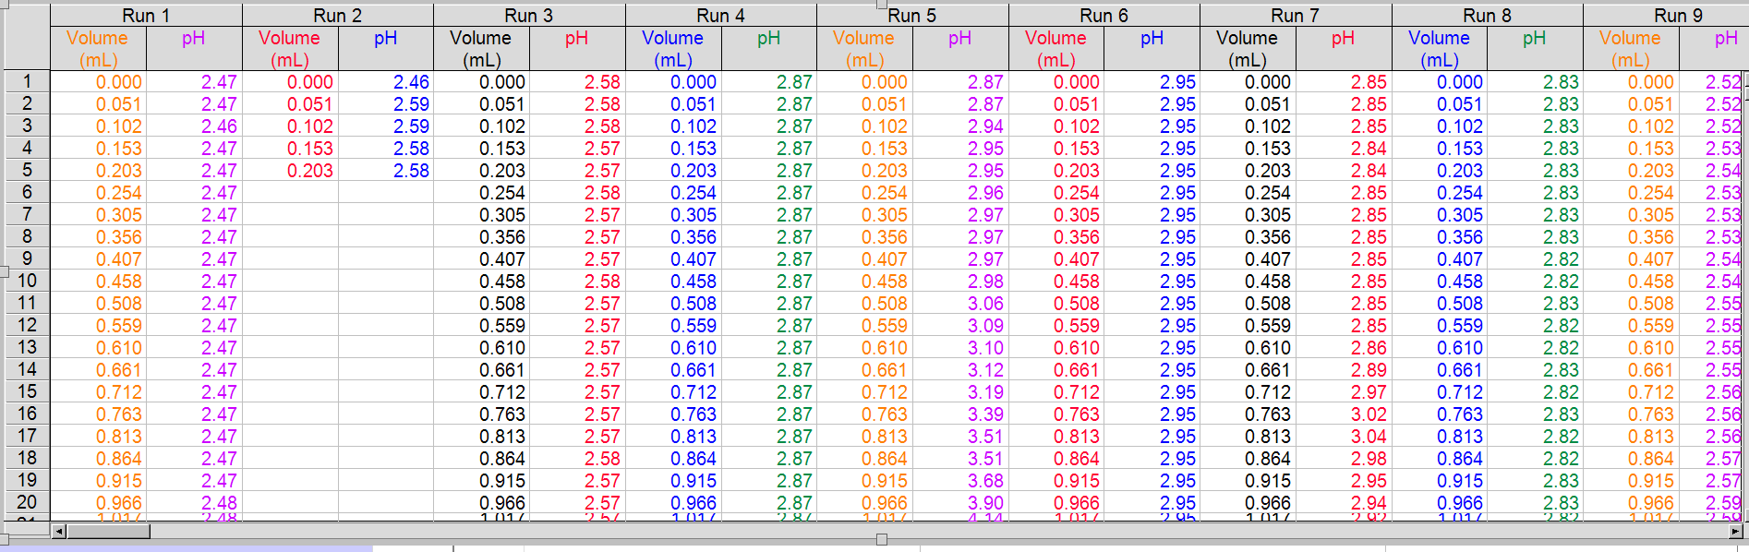
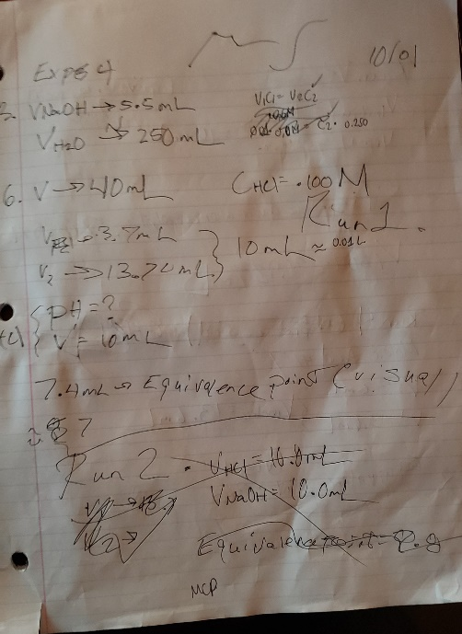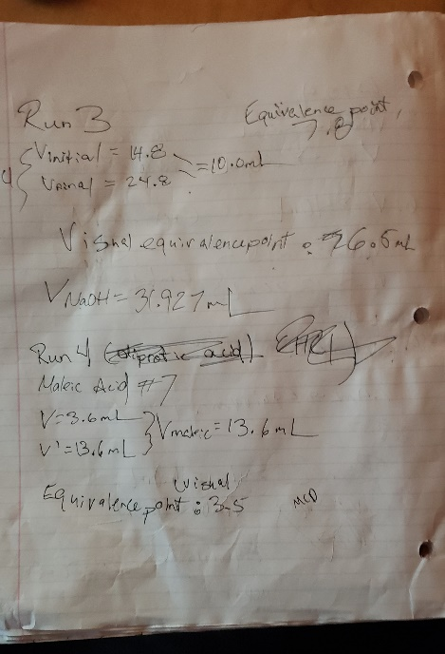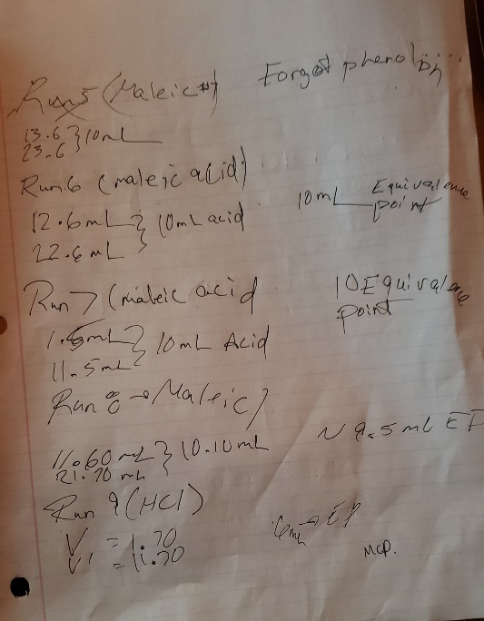

Tables:
Run 1 (HCl)
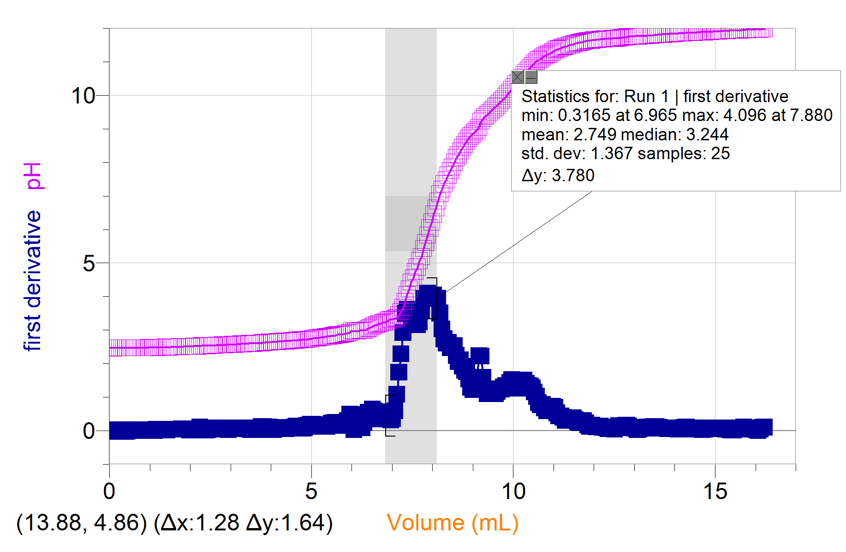

Run 3 (HCl)
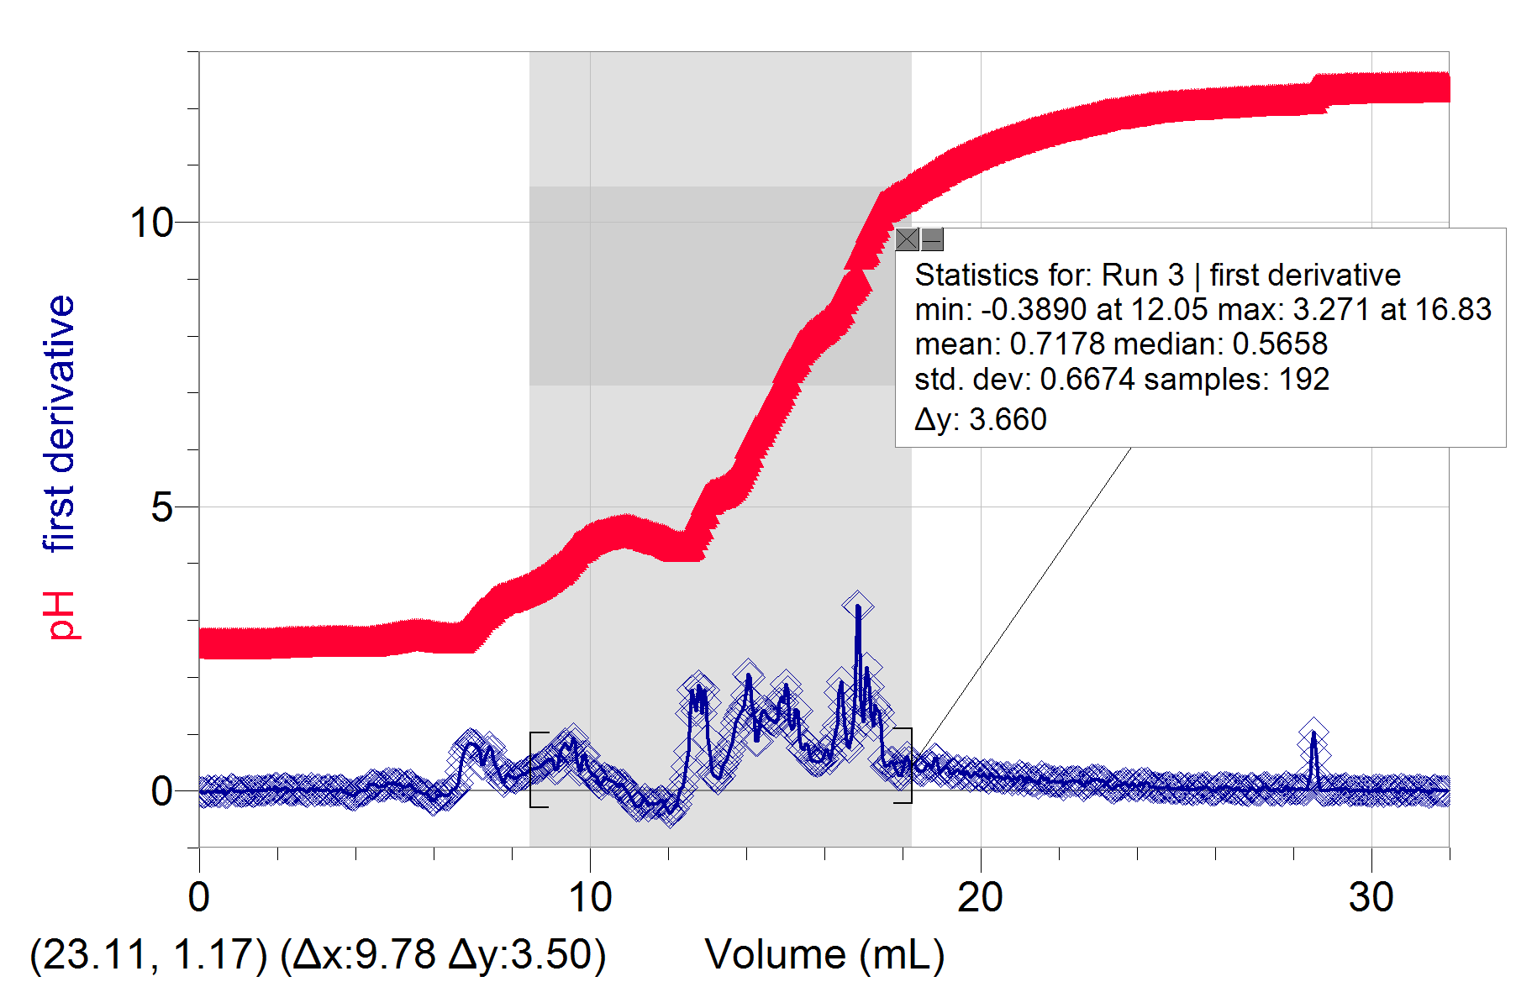

Run 4 (maleic acid #7)
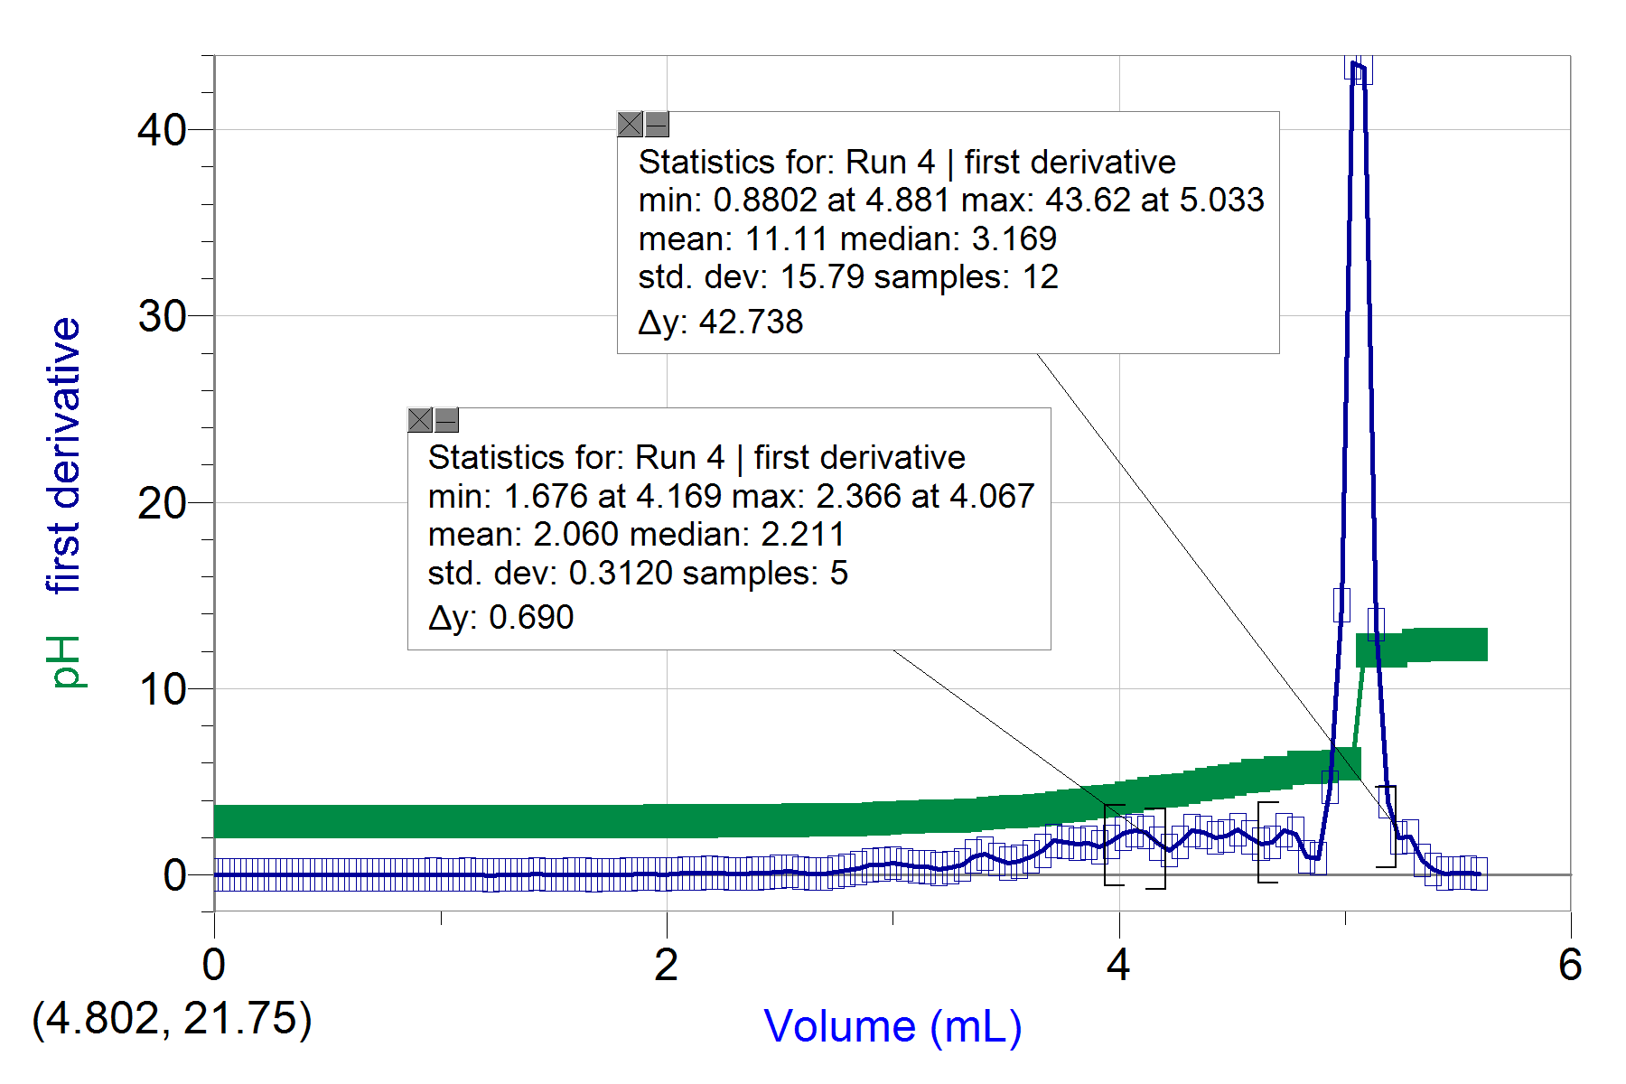

Run 5 (maleic acid #7)

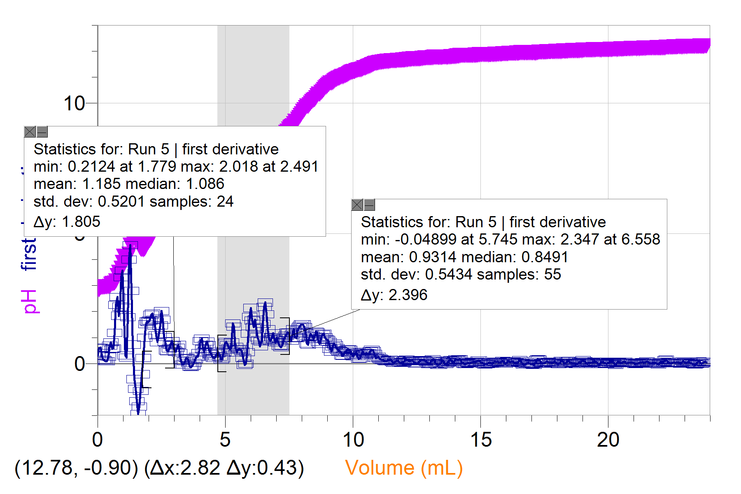

Run 6 (Maleic Acid)
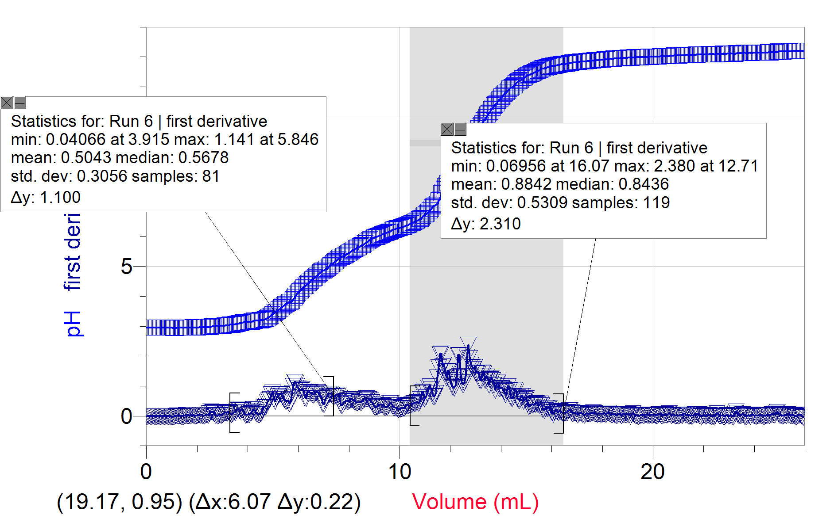

Run 7 (Maleic acid #7)
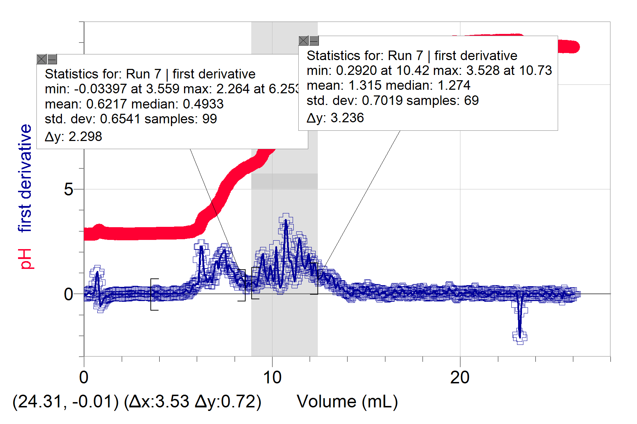
Run 8 (Maleic Acid #7)
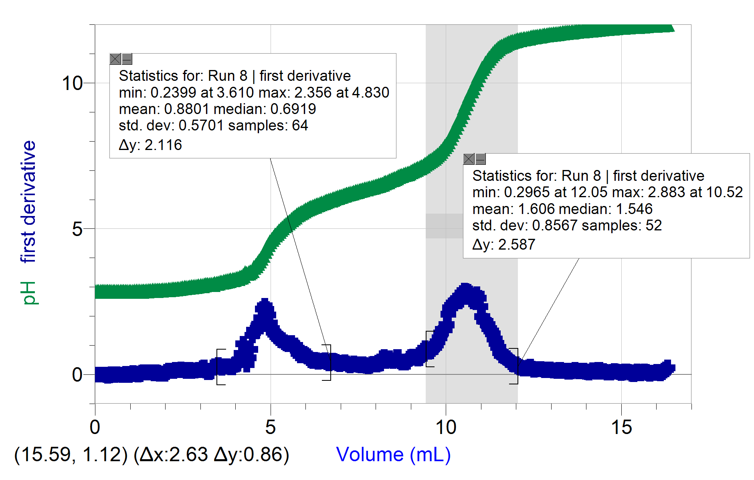
Run 9 (HCl)
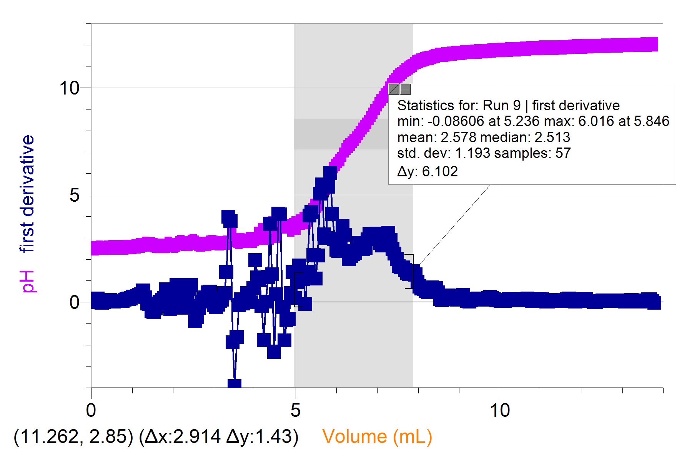

Data for dilution of NaOH
 | V | C
Initial NaOH | .00550L | .600M
Diluted NaOH | .250L | .0132M

pH of solutions
NaOH | HCl(run 9) | Maleic acid #7(run 8)
12.1 | 2.78 | 2.83

Volume of NaOH during the equivalence point and endpoint of the titration with HCl
Run | Endpoint(mL) | Measured equivalence point(mL)
Run 1 | 7.4 | 7.880mL
Run 3 | 7.8 | 16.83mL
Run 9 | 6.0 | 5.846

Volume of NaOH during the equivalence point and endpoint of the titration with maleic acid #7.
Run | Endpoint(mL) | Measured equivalence points 1 | Measured equivalence points 2(mL)
Run 4 | 3.5 | 4.067 | 5.033
Run 5 | Forgot phenolphthalein | 5.033 | 12.71
Run 6 | 10 | 5.846 | 12.71
Run 7 | 10 | 6.258 | 10.73
Run 8 | 9.5 | 4.830 | 10.52

Volume of HCl in burette reading
Run | Vfinal-Vinitial (mL) | Volume used (mL)
1 | 13.70-3.70 | 10.0
3 | 24.8-14.8 | 10.0
9 | 11.70-1.70 | 10.00

Volume of Maleic acid #7
Run | Vfinal-Vinitial (mL) | Volume used (mL)
4 | 13.6-3.6 | 10.0
5 | 23.6-13.6 | 10.0
6 | 22.6-12.6 | 10.0
7 | 11.5-1.5 | 10.0
8 | 21.70-11.60 | 10.10

Calculations:
- $V_{1}C_{1}=V_{2}C_{2}$
$$\left(0.0055L\right)\left(.6M\right)=0.250LC_{2}$$
$C_{2}=.0132M$
- Using run 9
$$CaV_{a}=C_{b}V_{b}$$
$.100M∙0.001000L=0.05846L ∙Cb$
Cb = .00171M
- Using run 8
$Cmaleicacid=\frac{(.00171M)(0.01052L)}{2(.01010L)}=0.00804M$
- Concentration of maleic acid using the endpoint of run 8
$Cmaleicacid=\frac{(.00171M)(0.095L)}{2(.01010L)}=0.00804M$
Concentration of chloric acid using the endpoint of run 9
$$CaV_{a}=C_{b}V_{b}$$
$.100M∙0.001000L=0.0600L ∙Cb$
Cb = .0.00167M

