Chapter 1 – Globalization

What is Globalization?
Globalization refers to the shift toward a more integrated and interdependent world economy
The globalization of markets refers to the merging of historically distinct and separate national markets into one huge global marketplace.

The Globalization of Markets
  - Falling barriers to cross-border trade and investment
  - Global tastes
  - Benefits small and large companies
  - Significant differences between national markets
  - Products that serve universal needs are global
  - Competitors may not change among nations

The globalization of production refers to the sourcing of goods and services from locations around the globe to take advantage of national differences in the cost and quality of factors of production (such as labor, energy, land, and capital).
- Early outsourcing was confined to manufacturing: Technology now used for outsourcing.
Robert Reich and “global products”
Impediments
  - Formal and informal barriers to trade
  - Transportation costs
  - Political and economic risk
  - Coordination

The Emergence of Global Institutions

General Agreement on Tariffs and Trade (GATT) International treaty that committed signatories to lowering barriers to the free flow of goods across national borders and led to the WTO.
General Agreement on Tariffs and Trade (GATT)
World Trade Organization
International Monetary Fund
The World Bank
The United Nations

The World Trade Organization
World Trade Organization The organization that succeeded GATT as a result of the successful completion of the Uruguay Round of GATT negotiations.
  - Polices the world trading system
  - Ensures nation-states adhere to the rules
  - Facilitates multinational agreements among members
  - 164 nations account for 98 percent of world trade
The International Monetary Fund
International institution set up to maintain order in the international monetary system.
  - Established to maintain order in the international monetary system
  - Lender of last resort
  - Requires nation-states to adopt specific economic policies aimed at returning their economies to stability and growth
The World Bank
International institution set up to promote general economic development in the world’s poorer nations.
  - Promotes economic development
  - Focused on making low-interest loans to cash-strapped governments in poor nations that wish to undertake significant infrastructure investments
The United Nations
An international organization made up of 193 countries headquartered in New York City, formed in 1945 to promote peace, security, and cooperation.
  - Peace through international cooperation and collective security
  - 193 countries
  - UN Charter – four basic purposes
    - Maintain international peace and security
    - Develop friendly relations among nations
    - Cooperate in solving international problems and in promoting respect for human rights
    - Be a center for harmonizing the actions of nations
Group of Twenty (G20)
Established in 1999, the G20 comprises the finance ministers and central bank governors of the 19 largest economies in the world, plus representatives from the European Union and the European Central Bank.
  - Finance ministers and central bank governors of the 19 largest economies in the world, plus representatives from the European Union and the European Central Bank
  - Represents 90 percent of global GDP and 80 percent of international global trade

Drivers of Globalization

Declining Trade and Investment Barriers (1)
  - 1920s-30s: Barriers to international trade and foreign direct investment
    - High tariffs resulted in retaliatory trade policies
  - GATT lowered barriers
    - Uruguay Round
Established World Trade Organization (WTO)
International trade occurs when a firm exports goods or services to consumers in another country.
Foreign direct investment occurs when a firm invests resources in business activities outside its home country.
Knowledge Society and Trade Agreements (2)
  - The value of world trade in merchandised goods has grown consistently faster than the growth rate in the world economy since 1950.
    - Trade across country borders is 2.6 times higher than world production.
    - Knowledge society has produced more informed consumers, driving demand.
    - Removal of restrictions to FDI
    - More trade agreements
Role of Technological Change (3)
  - Communications
    - Development of the microprocessor
    - Moore’s Law
  - Internet of things
    - Half the world’s population uses the Internet
    - Global e-commerce sales over $2 trillion
    - The Internet is an equalizer
Moore’s law predicts that the power of microprocessor technology doubles and its cost of production falls in half every 18 months).
Role of Technological Change continued (4)
  - Transportation technology
    - Commercial jet travel, superfreighters, and containerization
  - Implications for the globalization of production
    - Has become more economical
    - Worldwide communications network
  - Implications for the globalization of markets
    - Convergence of consumer tastes and preferences

The Changing Demographics of the Global Economy

The Changing World Output and World Trade Picture (1)
  - U.S. has experienced a relative decline reflecting the faster economic growth of several other economies
    - China and BRIC countries growing more rapidly
    - Developing nations may account for more than 60 percent of world economic activity by 2025
The Changing Foreign Direct Investment Picture (2)
  - Non-U.S. firms are increasingly investing across national borders
    - Desire to disperse production activities to optimal locations and to build a direct presence in major foreign markets
stock of foreign direct investment (FDI) refers to the total cumulative value of foreign investments as a percentage of the country’s GDP. (3)
The Changing Nature of the Multinational Enterprise
  - Non-U.S. multinationals
    - In 2003, 38.8 percent of the world’s 2000 largest multinationals were U.S. firms
    - By 2017, 27 percent of the top 2000 global firms are now U.S. multinationals, a drop of 236 firms
A multinational enterprise (MNE) is any business that has productive activities in two or more countries.
The Changing Nature of the Multinational Enterprise continued (4)
  - The rise of mini-multinationals
    - Medium- and small-sized businesses
    - Internet is lowering barriers
The Changing World Order (5)
  - Former communist countries present export and investment opportunities
  - Signs of growing unrest and totalitarianism
  - China moving to industrial superpower
  - Latin America debt and inflation are down, more private investors, expanding economies
Global Economy of the Twenty-First Century (6)
  - Barriers to the free flow of goods, services, and capital have been coming down
  - Strengthened by the widespread adoption of liberal economic policies by countries that had firmly opposed them
  - Globalization is not inevitable
    - Countries may pull back
    - Risks are high

The Globalization Debate

Antiglobalization Protests (1)
  - 1999 protests at WTO meeting
  - Detrimental effects on living standards, wage rates, and the environment.
Globalization, Jobs, and Income (2)
  - Critics of globalization argue:
    - Falling trade barriers allow firms to move manufacturing activities to countries where wage rates are much lower
      - Destroy manufacturing jobs in wealthy advanced economies
    - Services also being outsourced
      - Contributing to higher unemployment and lower living standards in their home nations
  - Supporters argue:
    - Benefits outweigh the costs
    - Free trade will result in countries specializing in the production of goods and services that they can produce most efficiently, while importing goods and services that they cannot produce as efficiently
      - As a result, the whole economy is better off
      - Companies can reduce their cost structure, and consumers benefit
  - Data suggests the share of labor in national income has declined
    - Share of national income by skilled labor has increased
    - Unskilled labor experienced a fall in income, but not necessarily standard of living due to economic growth
  - The weak growth rate in real wage rates for unskilled workers is likely due to a technology-induced shift within advanced economies
    - Technological change has a bigger impact than globalization on declining share of national income enjoyed by labor
Globalization, Labor Policies, and the Environment (3)
  - Critics argue:
    - Labor and environmental regulations
    - Lack of regulation can lead to abuse
    - Adhering to regulations increases costs
    - As countries get richer, they enact tougher environmental and labor regulations
  - Supporters argue:
    - Tougher environmental regulations and stricter labor standards go hand in hand with economic progress
Globalization and National Sovereignty (4)
  - Critics argue:
    - Shift of power from national governments toward supranational organizations
      - WTO, EU, United Nations
  - Supporters argue:
    - The power of supranational organizations is limited to what nation-states collectively agree to grant
    - These organizations exist to serve the collective interests of member states
Globalization and the World’s Poor (5)
  - Critics argue:
    - Gap between the rich and poor nations has gotten wider
      - Totalitarian governments
      - Poor economic policies
      - Corruption and lack of property rights
      - Expanding populations in developing countries
      - Debt burdens
  - Supporters argue:
    - The best way to change the situation is to lower barriers to trade and investment and promote free market policies

Managing in the Global Marketplace
Managers
  - Managing an international business differs from managing a purely domestic business
    - Need to vary practices from country to country
    - More complex decisions required
    - Need to understand the international trading and investment system, currency exchange
An international business is any firm that engages in international trade or investment.

Chapter 2 – National Differences in Political, Economic, and Legal Systems

Political Economy
Refers to the political, economic, and legal systems of a country.
  - Political, economic, and legal systems of a country are interdependent
  - They influence each other

Political Systems
Political systems:
- Collectivism vs. individualism
- Democratic vs. totalitarian
Collectivism and Individualism (1)
  - Collectivism
Refers to a political system that stresses the primacy of collective goals over individual goals.
    - The needs of society as a whole are generally viewed as being more important than individual freedoms
  - Socialism
Socialists believe in public ownership of the means of production for the common good of society.
    - Karl Marx: The few benefit at the expense of the many in a capitalist society where individual freedoms are not restricted
    - Communists vs. social democrats
      - Privatization: is the sale of state-owned enterprises to private investors.
  - Individualism
Is an emphasis on the importance of guaranteeing individual freedom and self-expression.
    - An individual should have freedom in his or her economic and political pursuits
    - The interests of the individual should take precedence over the interests of the state
    - Two tenets
      - Guarantee of individual freedom and self-expression
      - Welfare of society best served by letting people pursue their own economic self-interest
Democracy and Totalitarianism (2)
  - At different ends of a political dimension
  - Democracy and individualism go hand in hand, as do the communist version of collectivism and totalitarianism, with exceptions

Democracy refers to a political system in which government is by the people, exercised either directly or through elected representatives.
Totalitarianism is a form of government in which one person or political party exercises absolute control over all spheres of human life and prohibits opposing political parties.
  - Democracy
    - Representative democracy
  - Totalitarianism
    - Communist totalitarianism
    - Theocratic totalitarianism
    - Tribal totalitarianism
    - Right-wing totalitarianism
Representative democracy is a political system in which citizens periodically elect individuals to represent them in government.
Communist totalitarianism is a version of collectivism advocating that socialism can be achieved only through a totalitarian dictatorship.
Theocratic totalitarianism is a political system in which political power is monopolized by a party, group, or individual that governs according to religious principles.
Tribal totalitarianism is a political system in which a party, group, or individual that represents the interests of a particular tribe (ethnic group) monopolizes political power.
Right-wing totalitarianism is a political system in which political power is monopolized by a party, group or individual that generally permits individual economic freedom but restricts individual political freedom, including free speech, often on the ground that it would lead to the rise of communism.
  - Pseudo-democracies
    - Lie between pure democracies and complete totalitarianism systems
    - Authoritarian elements have captured some or much of the machinery of state and use this in an attempt to deny basic political and civil liberties

Economic Systems

Market Economy (1)
  - All productive activities are privately owned
  - Production is determined by supply and demand
  - Government encourages vigorous free and fair competition
In the archetypal pure market economy, all productive activities are privately owned, as opposed to being owned by the state. Production is determined by the interaction of supply and demand and signaled to producers through the price system.
Command Economy (2)
  - Government plans the good and services, quantity and price, then allocates them for “the good of society”
  - All businesses are state owned
  - Historically found in communist economies
  - No incentive for individuals to look for better ways to serve needs
In a pure command economy, the government plans the goods and services that a country produces, the quantity in which they are produced, and the prices at which they are sold. Consistent with the collectivist ideology, the objective of a command economy is for government to allocate resources for “the good of society.” In addition, in a pure command economy, all businesses are state owned, the rationale being that the government can then direct them to make investments that are in the best interests of the nation as a whole rather than in the interests of private individuals.
Mixed Economy (3)
  - Some sectors are privately owned, some are government owned
  - Once common in developed world, less so now
  - Government may aid troubled firms
    - U.S. helped Citigroup, General Motors

Legal Systems

Legal Systems (1)
  - Rules or laws that regulate behavior
  - Process through which laws are enforced
  - Redress for grievances
  - Influenced by the prevailing political system
The legal system of a country refers to the rules, or laws, that regulate behavior along with the processes by which the laws are enforced and through which redress for grievances is obtained.
Legal Systems continued
  - Different Legal Systems
    - Common Law
      - Tradition, precedent, custom
      - More flexible than other systems
    - Civil Law
      - Laws organized into codes
      - Less adversarial
    - Theocratic Law
      - Based on religious teachings
      - Most common is Islamic law
Common law is based on tradition, precedent, and custom.
A civil law system is based on a detailed set of laws organized into codes.
A theocratic law system is one in which the law is based on religious teachings.
Differences in Contract Law (2)
  - Governs the enforcement of contracts
  - Common law
    - Contracts are very detailed with all contingencies spelled out
    - More expensive and can be adversarial.
  - Civil law
    - Contracts tend to be much shorter and less specific
A contract is a document that specifies the conditions under which an exchange is to occur and details the rights and obligations of the parties involved. Some form of contract regulates many business transactions. Contract law is the body of law that governs contract enforcement.
  - United Nations Convention on Contracts for the International Sale of Goods (CISG)
    - Establishes a uniform set of rules governing certain aspects of the making and performance of everyday commercial contracts between sellers and buyers who have their places of business in different nations
    - Applies automatically to all contracts for the sale of goods between different firms based in countries that have ratified the convention, unless the parties opt out
United Nations Convention on Contracts for the International Sale of Goods (CISG) is a set of rules governing aspects of the making and performance of commercial contracts between sellers and buyers who have their places of business in different nations.
Property Rights and Corruption (3)
  - Property is a resource that an individual or business owns
    - Land, buildings, equipment, capital, mineral rights, businesses, intellectual property
    - Most countries protect property rights
Property rights refer to the legal rights over the use to which a resource is put and over the use made of any income that may be derived from that resource.
  - Private action
    - Theft, piracy, blackmail
  - Public action and corruption
    - Public officials extort income, resources, or property
      - Levying excessive taxation, requiring expensive licenses or permits from property holders, taking assets into state ownership without compensating the owners, redistributing assets without compensating the prior owners
      - Corruption, demanding bribes
In terms of violating property rights, private action refers to theft, piracy, blackmail, and the like by private individuals or groups.
Public action to violate property rights occurs when public officials, such as politicians and government bureaucrats, extort income, resources, or the property itself from property holders.
Property Rights and Corruption continued
  - Foreign Corrupt Practices Act (FCPA)
    - Illegal to bribe a foreign government official to obtain or maintain business over which that foreign official has authority
    - Requires all publicly traded companies to keep detailed records that would reveal whether a violation of the act has occurred
  - Convention on Combating Bribery of Foreign Public Officials in International Business Transactions (1997)
    - Allows for facilitating or expediting payments
Foreign Corrupt Practices Act is U.S. law regulating behavior regarding the conduct of international business in the taking of bribes and other unethical actions.
The Protection of Intellectual Property (4)
  - Patent
  - Copyrights
  - Trademarks
  - World Intellectual Property Organization
  - Paris Convention for the Protection of Industrial Property
Intellectual property refers to property that is the product of intellectual activity, such as computer software, a screenplay, a music score, or the chemical formula for a new drug.
A patent grants the inventor of a new product or process exclusive rights for a defined period to the manufacture, use, or sale of that invention.
Copyrights are the exclusive legal rights of authors, composers, playwrights, artists, and publishers to publish and disperse their work as they see fit.
Trademarks are designs and names, officially registered, by which merchants or manufacturers designate and differentiate their products.
World Intellectual Property Organization is an international organization whose members sign treaties to agree to protect intellectual property.
Paris Convention for the Protection of Industrial Policy is an international agreement to protect intellectual property.
Product Safety and Product Liability (5)
  - Product safety
  - Product liability
    - Greater if a product does not conform to safety standards
  - Criminal and civil laws apply
Product safety laws set certain safety standards to which a product must adhere.
Product liability involves holding a firm and its officers responsible when a product causes injury, death, or damage.

Focus on Managerial Implications
Two broad implications
  - Political, economic, and legal systems of a country raise important ethical issues that have implications for international business.
  - Political, economic, and legal environments of a country clearly influence the attractiveness of that country as a market or investment site.
  - A country with democratic political institutions, market-based economic system, and strong legal system clearly more attractive to do business in.

Chapter 3 – National Differences in Economic Development

Economic Development
  - Differences among nations
  - Attractiveness for doing business
  - Trends that foster greater economic development
    - Democratic forms of government
    - Market-based economic reforms
    - Legal systems to better enforce property rights

Differences in Economic Development

Gross national income (GNI) (1)
  - Japan, Sweden, Switzerland, and U.S. have high GNI
  - China and India have low GNI
  - GNI does not consider differences in the cost of living
    - Need to adjust GNI figures using purchasing power parity (PPP)
Gross national income (GNI) measures the total annual income received by residents of a nation.
Purchasing power parity (PPP) is an adjustment in gross domestic product per capita to reflect differences in the cost of living.
The “official” figures can be misleading (2)
  - Do not account for black economy transactions
  - GNI and PPP data are static and do not consider economic growth rates
    - China and India are currently relatively poor, but their economies are growing more rapidly than many advanced nations
    - China may become the world’s largest economy during the next decade
    - India will become among the largest economies in the world
Black economy transactions also called shadow economy transactions. These are unrecorded cash transactions or barter agreements.
Broader Conceptions of Development: Amartya Sen (3)
  - Economic development should be assessed by the capabilities and opportunities people enjoy
    - Development requires the removal of major impediments to freedom: poverty, tyranny, poor economic opportunities
  - Economic progress requires the democratization of political communities to give citizens a voice
  - The United Nations used Sen’s ideas to develop the Human Development Index (HDI) which is based on
    - Life expectancy at birth
    - Educational attainment
    - Whether average incomes are sufficient to meet the basic needs of life in a country
Human Development Index (HDI) is an attempt by the United Nations to assess the impact of a number of factors on the quality of human life in a country.

Political Economy and Economic Progress

Innovation and Entrepreneurship Are the Engines of Growth (1)
Innovation
    - Includes new products, new processes, new organizations, new management practices, and new strategies
Entrepreneurs
    - First to commercialize innovative products and processes
    - Provides much of the dynamism in an economy
Innovation refers to the development of new products, processes, organizations, management practices, and strategies.
Entrepreneurs are those who first commercialize innovations.
Innovation and Entrepreneurship Require a Market Economy (2)
  - Little incentive to develop new innovations in planned economies because the state owns all means of production and therefore, the gains
  - Strong relationship between economic freedom and economic growth
Innovation and Entrepreneurship Require Strong Property Rights (3)
  - Without strong property rights, individuals and businesses risk having innovations and potential profits stolen
  - Economist Hernando de Soto claims that inadequate property protection in many developing nations limits economic growth
The Required Political System (4)
  - Democratic regimes are probably more conducive to long-term economic growth
    - Property rights are only secure in well-functioning, mature democracies
  - Totalitarian states are detrimental to progress
    - They limit freedom
    - They suppress human development
Economic Progress Begets Democracy (5)
  - Economic growth leads to establishment of democratic regimes
    - South Korea
    - Taiwan
  - If China adopts a free market system, belief is that the country will have
    - Greater individual freedoms
    - Democracy
Geography, Education, and Economic Development (6)
  - Economist Jeffrey Sachs argues that countries with favorable geography are
    - More likely to engage in trade
    - More open to market-based systems
  - Countries that invest in education have higher growth rates because the workforce is more productive
    - Countries in Southeast Asia have offset their geographical disadvantage by investing in education

States in Transition

Political economy of nation-states is marked by two trends (1)
  - Democratic revolutions of the late 1980s and early 1990s
    - Totalitarian governments fell
    - Replaced by democratically elected governments
    - Greater commitment to free market capitalism
  - A move away from centrally planned and mixed economies toward a more free market approach
The Spread of Democracy (2)
  - Many totalitarian regimes failed to deliver economic progress to the bulk of their populations
  - New information and communication technologies
    - Reduced state’s ability to control access to uncensored information
    - Created new conduits for the spread of democratic ideals
  - Economic advances have led to a prosperous middle class that has pushed for democratic reforms
The Spread of Democracy continued (3)
  - It is naïve to conclude that the spread of democracy will continue unchallenged
    - Democracy is still rare in parts of the world
      - Sub-Saharan Africa
      - Former communist Eastern and central Europe and former USSR
      - Middle East and North Africa
    - Signs that authoritarianism is gaining ground
      - Russia, Ukraine, Indonesia, Ecuador, and Venezuela
      - Egypt
The New World Order and Global Terrorism (4)
  - Author Francis Fukuyama argues the new world order will be characterized by democratic regimes and free market capitalism
  - Political scientist Samuel Huntington argues that while many societies are modernizing, they are not becoming more Western
    - Predicts a world split into different civilizations that will be in conflict making business difficult
  - Political position is more likely to be somewhere between Fukuyama and Huntington
The New World Order and Global Terrorism continued (5)
  - Global terrorism is a product of tensions between civilizations and a clash of value systems and ideology
    - Al-Qaeda and ISIS
    - Struggle between radicalized Sunni and Shia factions within Islam
  - Former U.S. Secretary of State Colin Powell maintains that terrorism is one of the major threats to world peace and economic progress
The Spread of Market-Based Systems (6)
  - A shift from centrally planned economies to market-based economies
    - More than 30 countries in the former Soviet Union and eastern European communist bloc
    - Change also occurring in Asian and African states
  - Command and mixed economies failed to deliver the sustained economic growth achieved in market-based countries

Nature of Economic Transformation

The shift toward a market-based system involves
  - Deregulation
  - Privatization
  - A legal system to safeguard property rights
Deregulation refers to the removal of government restrictions concerning the conduct of a business
Privatization transfers the ownership of state property into the hands of private individuals
Deregulation (1)
  - Deregulation in command economies
      - Removing price controls
      - Abolishing laws regulating the establishment and operation of private enterprise
      - Relaxing or removing restrictions on direct investment by foreign enterprises
  - Deregulation in mixed economies involved the same initiatives as in command economies
      - Transition was easier due to a vibrant private sector
Privatization (2)
  - A way to stimulate economic efficiency
  - Started in Great Britain in early 1980s
  - In many nations economic activity is still in the hands of state-owned enterprises
  - Selling state-owned enterprises not enough to guarantee economic growth
  - For privatization to work it must be paired with a general deregulation and opening of the economy
Legal Systems (3)
  - A well-functioning market economy requires laws
    - Need to protect property rights
    - Mechanisms for contract enforcement
  - Adoption of a legal system requires time to function well
  - Institutional weaknesses undermine contract enforcement in most countries
  - Progress being made regarding laws on property rights

Implications of Changing Political Economy

Ideological conflict between collectivism and individualism is less prevalent today
  - Western ideology more widespread
  - Markets formerly off-limits to Western business are now open presenting a huge potential for business
  - Potential risks are large
    - Will democracy thrive during difficult times?
    - Will totalitarian regimes return?
    - Is the risk associated with investment worth it?
    - Is China’s financial system stable?

Focus on Managerial Implications

Benefits, Costs, Risks, and Overall Attractiveness of Doing Business Internationally
  - Countries are more likely to have higher sustained rates of economic growth when they have
    - Democratic regimes
    - Market based economic policies
    - Strong property rights protection
  - These markets are more attractive to international businesses
  - Benefits of doing business in a country based on
    - The size of the market
    - The current and future purchasing power of its consumers
  - First-mover advantages
  - Late-mover disadvantages
  - A country’s economic system and property rights regime good predictors of economic prospects
First-mover advantages refer to advantages accruing to the first to enter a market.
Late-mover disadvantages refer to handicaps experienced by being a late entrant in a market.
  - The costs of doing business in a country based on
    - Political system: is it necessary to pay bribes to get market access?
    - Economic level: are the necessary supporting business and infrastructure in place?
    - Legal system: how do local laws and regulations affect business decisions? Are there well-established contract laws?
  - The risks of doing business in a country based on
    - Political risk
    - Economic risk
    - Legal risk
Political risk refers to the likelihood that political forces will cause drastic changes in a country’s business environment that will adversely affect the profit and other goals of a particular business.
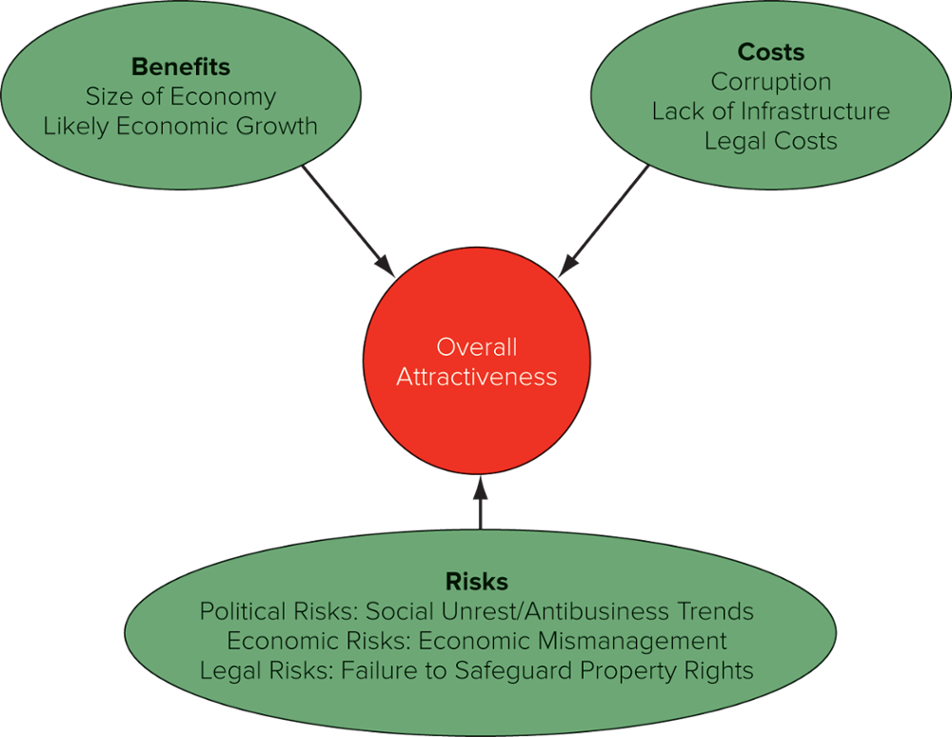
Economic risk refers to the likelihood that events, including economic mismanagement, will cause drastic changes in a country’s business environment that adversely affect the profit and other goals of a particular business enterprise.
Legal risk refers to the likelihood that a trading partner will opportunistically break a contract or expropriate intellectual property rights.
- Overall attractiveness of a potential market to international business
  - Depends on balancing the benefits, costs, and risks associated with doing business in that country
- Other things being equal, the benefit-cost-risk trade-off is likely to be most favorable in politically stable developed and developing nations that have free market systems and no dramatic upsurge in either inflation rates or private sector debt

Chapter 4 – Differences in Culture
Understanding and adapting to the local cultural is important in international companies.
  - Cross-cultural literacy is important for business success
A relationship may exist between culture and the costs of doing business in a country or region.
  - Culture
    - Is rooted in values and norms
    - Evolves over time
Cross-cultural literacy understanding how the culture of a country affects the way business is practiced

What is Culture?

Culture
  - Multiple definitions
Values
  - Shared assumptions about how things ought to be
Norms
  - Rules for appropriate behavior
Society
  - Some countries have several societies or subcultures and some societies embrace more than one country
Culture A system of values and norms that are shared among a group of people and that when taken together constitute a design for living
Values Abstract ideas about what a group believes to be good, right, and desirable
Norms Social rules and guidelines that prescribe appropriate behavior in particular situations
Society A group of people sharing a common set of values and norms

Values
  - Provide the context within which a society’s norms are established and justified
  - Invested with emotional significance
  - Often reflected in the economic systems of a society
Norms
  - Social rules that govern people’s actions
    - Folkways
      - Violations not a serious matter
      - Include rituals and symbolic behavior
    - Mores
      - More widely observed
      - Have greater moral significance than other norms
Folkways Routine conventions of everyday life
Mores Norms seen as central to the functioning of a society and to its social life
Culture, Society, and the Nation-State (2)
  - The relationship between a society and a nation state is not strictly one-to-one
  - Nation-states are political creations
  - A nation can have several cultures, and a culture can embrace several nations
  - Different levels of culture
Determinants of Culture (3)
  - The values and norms of a culture evolve over time
    - Religion
    - Political philosophy
    - Economic philosophy
    - Education
    - Language
    - Social structure

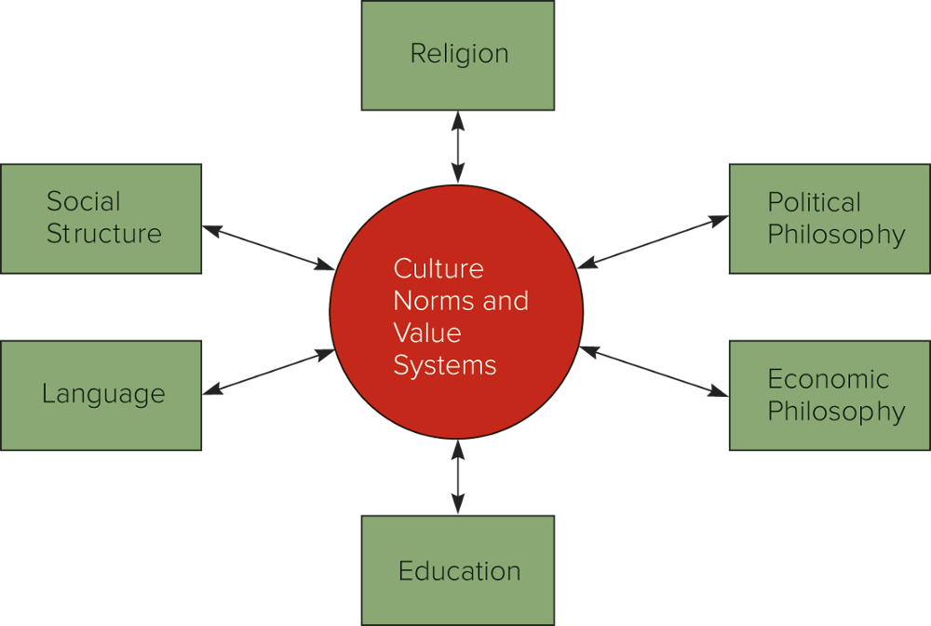

Social Structure
Social structure (1)
The basic social organization of a society.
  - Two dimensions explain differences among cultures
    - The basic unit of social organization is the individual, as opposed to the group
    - A society is stratified into classes or castes
Individuals and Groups (2)
  - The individual
    - In many Western societies, the individual is the basic building block of social organization.
      - Emphasis on individual achievement
  - The group
    - The primary unit of social organization in many non-Western societies
      - Importance of group membership/identification
Group An association of two or more individuals who have a shared sense of identity and who interact with each other in structured ways on the basis of a common set of expectations about each other’s behavior
Social Stratification (3)
  - All societies are stratified on a hierarchical basis into social categories, or social strata
    - Individuals are born into a particular stratum, which affects life chances
  - Four basic principles
    - Trait of society
    - Carries over into next generation
    - Generally universal but variable
    - Involves not just inequality but also beliefs
Social strata Hierarchical social categories often based on family background, occupation, and income
  - Social mobility
    - Varies among societies
    - Caste system
      - Social position determined by family
      - India has four main castes
    - Class system
      - Form of open social stratification
      - Position can be changed through achievement or luck
Social mobility The extent to which individuals can move out of the strata into which they are born
Caste system A system of social stratification in which social position is determined by the family into which a person is born, and change is usually not possible during an individual's lifetime
Class system A system of social stratification in which social status is determined by the family into which a person is born and by subsequent socioeconomic achievements; mobility between classes is possible
  - Significance
    - Affects business operations
    - Class consciousness
    - Makes it difficult to establish a competitive advantage in a global economy
Class consciousness A tendency for individuals to perceive themselves in terms of their class background

Religious and Ethical Systems
Religion
  - Concerned with the realm of the sacred
Ethical system
  - Most are the product of religions
    - Four dominant religions
      - Christianity
      - Islam
      - Hinduism
      - Buddhism
Religion A system of shared beliefs and rituals concerned with the realm of the sacred
Ethical system A set of moral principles, or values, that is used to guide and shape behavior
Christianity (1)
  - The world’s largest religion
  - Found throughout Europe, the Americas, and other countries settled by Europeans
  - Economic implications of Christianity
    - Max Weber, Protestant ethics, and the spirit of capitalism
Islam (2)
  - The world’s second largest religion dating to a.d. 610
  - Monotheistic, one true omnipotent God (Allah)
  - Islamic fundamentalism
    - Associated in the Western media with militants, terrorists, and violent upheavals
    - Muslims teach peace, justice, and tolerance
  - Economic implications
    - Many pro-free enterprise principles, protection of private property, concern with social justice
    - Prohibits the payment or receipt of interest
Hinduism (3)
  - Practiced primarily on the Indian subcontinent
  - Focus on achieving spiritual growth and development, which may require material and physical self-denial
  - Economic implications
    - Hindus are valued by their spiritual rather than material achievements
    - Promotion and adding new responsibilities may not be important, or may be infeasible due to the employee's caste
Buddhism (4)
  - Has about 535 million followers
  - Stresses spiritual growth and the afterlife, rather than achievement while in this world
  - Economic implications
    - Does not emphasize wealth creation
    - Entrepreneurial behavior is not stressed culturally, but still acceptable
    - Does not support the caste system, individuals do have some mobility and can work with individuals from different classes
Confucianism (5)
  - Practiced mainly in China
  - Teaches the importance of attaining personal salvation through right action
  - High morals, ethical conduct, and loyalty to others
  - Economic implications
    - Three key teachings of Confucianism - loyalty, reciprocal obligations, and honesty - may all lead to a lowering of the cost of doing business in Confucian societies
      - Guanxi
Language

Spoken Language
  - Language structures the way we see the world
  - Countries with more than one language often have more than one culture
  - Chinese is the mother tongue of the largest number of people
  - English is becoming the language of international business
Unspoken Language
  - Nonverbal communication
    - Often culturally bound
    - Personal space

Education
Formal Education
  - Medium through which individuals learn languages and other skills
  - Socializes the young into the values and norms of a society
    - Citizenship and culture
  - Provides a national competitive advantage

Culture and Business

Culture and Values in the Workplace (1)
  - Hofstede’s dimensions of culture
    - Power distance
    - Uncertainty avoidance
    - Individualism vs. collectivism
    - Masculinity vs. femininity
    - Long-term vs. short-term orientation
    - And more recently: Indulgence vs. restraint
Power distance refers to how a society deals with the fact that people are unequal in physical and intellectual capabilities.
Uncertainty avoidance measures the extent to which different cultures socialized their members into accepting ambiguous situations and tolerating uncertainty.
Individualism vs. collectivism focuses on the relationship between the individual and his or her fellows.
Masculinity vs. femininity looks at the relationship between gender and work roles.
Long-term vs. short-term orientation refers to the extent to which a culture programs its citizens to accept delayed gratification of their material, social, and emotional needs.
  - Hofstede’s work is the leading research on culture, but has received criticism
    - Assumes a one-to-one correspondence between culture and the nation-state when many countries have more than one culture
    - Research may be culturally bound
    - Research focused on a single industry
  - Global Leadership and Organizational Behavior Effectiveness (GLOBE) Instrument
    - A leader’s effectiveness is contextual
      - Embedded in the societal and organizational norms, values, and beliefs of the people being led
    - Nine cultural dimensions
      - Power distance, uncertainty avoidance, humane orientation, institutional collectivism, in-group collectivism, assertiveness, gender egalitarianism, future orientation, and performance orientation
  - World Values Survey (WVS)
    - Explores people’s values and norms, how they change over time, and what impact they have in society and business
    - Dimensions
      - Support for democracy; tolerance of foreigners and ethnic minorities; support for gender equality; the role of religion and changing levels of religiosity; the impact of globalization; attitudes toward the environment, work, family, politics, national identity, culture, diversity, and insecurity; and subjective well-being

Implications for Business Practice

Cultural Literacy and Competitive Advantage
  - Need to develop cross-cultural literacy
    - Ethnocentrism
  - Connection between culture and national competitive advantage
  - Connection between culture and ethics in decision making
Ethnocentrism is a belief in the superiority of one’s own ethnic group or culture.

Chapter 5 – Ethics, Corporate Social Responsibility, and Sustainability
Ethics
  - Accepted principles of right or wrong that govern
    - The conduct of a person
    - The members of a profession
    - The actions of an organization
  - Business ethics
  - Ethical strategy
Business ethics are the accepted principles of right or wrong governing the conduct of businesspeople.
Ethical strategy refers to a strategy, or course of action, that does not violate a company’s business ethics.

Ethics and International Business

The most common ethical issues in international business involve:
  - Employment practices
  - Human rights
  - Environmental regulations
  - Corruption
  - Moral obligations of multination corporations
Employment Practices (1)
  - Suppose work conditions in a host nation are inferior to those in a multinational’s home nation
  - Which standards should apply?
    - Home or host nation or something between?
  - Nike case
    - Nike did not break the law, but the case raised questions regarding the ethics of using sweatshop labor
  - To guard against ethical abuses, firms should
    - Establish minimal acceptable standards that safeguard the basic rights and dignity of employees
    - Audit foreign subsidies and contractors regularly to ensure standards are being met
    - Take corrective action as necessary
Human Rights (2)
  - Basic human rights found in developed nations are not universally accepted worldwide
    - Freedom of association
    - Freedom of speech
    - Freedom of assembly
    - Freedom of movement
    - Freedom from political repression
  - Apartheid system in South Africa
    - Mandated segregation and prohibited blacks from managing whites
    - Some businesses from developed countries questioned the ethics of doing business in the country
    - United Nation’s Sustainable Development Goals 2030
  - General Motors case
    - Sullivan principles
  - Many companies divested operations in South Africa
  - Economic sanctions from the United States
  - Repressive regimes still exist in the world
    - Is it ethical for multinational corporations to do business with repressive regimes?
    - Does multinational investment bring change to these regimes and foster economic growth and raise living standards?
    - Are some regimes so repressive that investment cannot be justified on ethical grounds?
Environmental Pollution (3)
  - Problems when environmental regulations differ between host nations and home nation
  - Tragedy of the commons
  - Global tragedy of the commons
  - Is it ethical for a company to escape regulations by moving production to a nation with lax regulations?
Tragedy of the commons phenomenon that occurs when a resource held in common by all but owned by no one is overused by individuals, resulting in its degradation.
Corporations can contribute to the global tragedy of the commons by moving production locations where they are free to pump pollutants into the atmosphere or dump them in oceans or rivers, thereby harming these valuable global commons.
Corruption (4)
  - Corruption has been a problem in almost every society in history and continues to be one today
  - U.S. Foreign Corrupt Practices Act (FCPA)
    - Amended to allow for “facilitating payments”
The Convention on Combating Bribery of Foreign Public Official in International Business Transactions
Foreign Corrupt Practices Act (FCPA) a U.S. law regulating behavior regarding the conduct of international business in the taking of bribes and other unethical actions.
Facilitating payments are sometimes known as speed money or grease payments. These are payments to ensure receiving the standard treatment that a business ought to receive from a foreign government but might not due to the obstruction of a foreign official.
Convention on Combating Bribery of Foreign Public Officials in International Business Transactions obliges member states and other signatories to make the bribery of foreign officials a criminal offense.
  - Ethical implications of corruption
    - Are bribes the price to pay to do a greater good?
    - Do bribes reduce businesses’ incentive to invest?
  - Some multinationals adopting a zero-tolerance policy
    - BP
    - Dow Corning
Ethical Dilemmas

Ethical obligations of multinational corporations are not always clear-cut
  - How should corporations handle ethical dilemmas regarding employment, human rights, corruption, and environmental pollution?
    - Pressure from customers and stakeholders to be transparent in ethical decision making
    - No universal worldwide agreement about what constitutes accepted ethical principles
  - This is the nature of ethical dilemmas
Ethical dilemmas refers to situations in which there is no ethically acceptable solution.

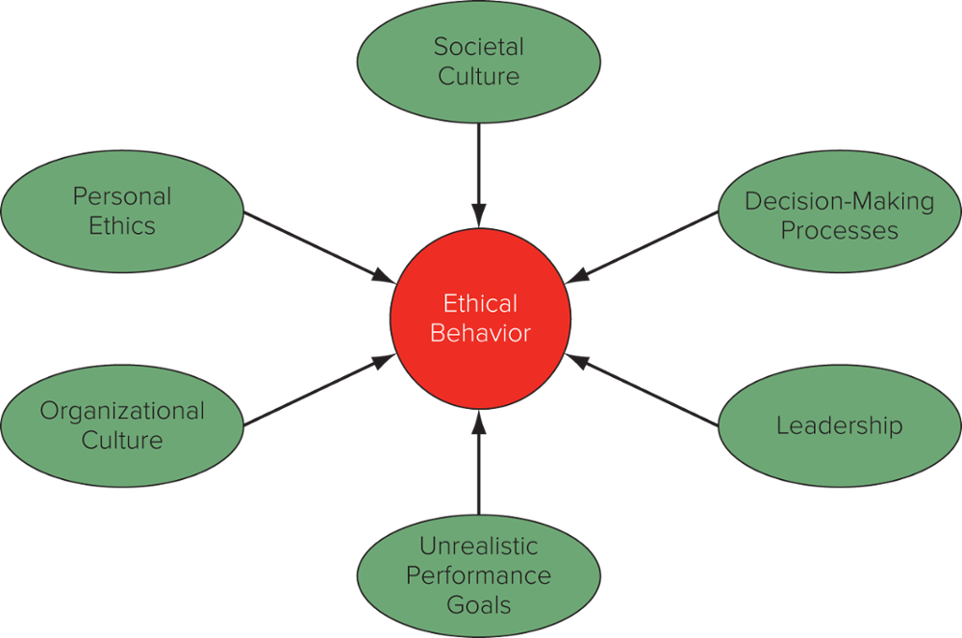

Roots of Unethical Behaviour

Why do managers behave unethically?
  - Six determinants of ethical behavior
    - Personal ethics
    - Decision-making processes
    - Organizational culture
    - Unrealistic performance goals
    - Leadership
    - Societal culture
Personal Ethics (1)
  - Formation of ethics is guided by our parents, our schools, our religion, and the media
  - Expatriate managers may face pressure to violate their personal ethics because they are away from their ordinary social context and culture
    - Parent company may pressure managers to meet unrealistic goals that can only be fulfilled by acting unethically
Personal ethics are the generally accepted principles of right and wrong governing the conduct of individuals.
Decision-Making Processes (2)
  - Businesspeople may act unethically when they fail to ask “Is this decision or action ethical?”
  - Problems arise in processes that do not incorporate ethical considerations into business decision making
  - Need to better understand how individuals make decisions that are ethical or unethical in an organizational environment
Organizational Culture (3)
  - Culture in some organizations does not encourage people to think through ethical consequences of decisions
Unrealistic Performance Goals (4)
  - Pressure from parent company to meet unrealistic performance goals by cutting corners or acting unethically
Organizational culture refers to the values and norms shared among an organization’s employees.
Leadership (5)
  - Helps to establish the culture of an organization and set the examples that others follow
  - Employees often take their cue from business leaders
Societal Culture (6)
Cultures that emphasize individualism and uncertainty avoidance are more likely to stress ethical behavior than cultures where masculinity and power distance are emphasized.

Philosophical Approaches to Ethics
Straw Men (1)
  - Offer inappropriate guidelines for ethical decision making
    - The Friedman Doctrine – “the social responsibility of business is to increase profits,” so long as the company stays within the rules of law
    - Cultural relativism – ethics are a reflection of culture
      - When in Rome, do as the Romans
Cultural relativism is the belief that ethics are culturally determined and that firms should adopt the ethics of the cultures in which they operate.
    - Righteous moralist―home-country standards of ethics should be followed in foreign countries
      - Typically associated with managers from developed nations
    - Naïve immoralist―if a manager of a multinational sees that firms from other nations are not following ethical norms in a host nation, that manager should not either
Righteous moralist claims that a multinational’s home country standards of ethics are the appropriate ones for companies to follow in foreign countries.
Naïve immoralist assert that if a manger of a multinational sees that firms from other nations are not following ethical norms in a host nation, that manager should not either.
Utilitarian approaches to ethics (2)
    - Philosophers David Hume, Jeremy Bentham, and John Stuart Mill
    - Actions are desirable if they lead to the best possible balance of good consequences over bad consequences
    - Best decisions are those that produce the greatest good for the greatest number of people
    - Drawbacks
      - Difficult to measure benefits, costs, and risks of an action
      - It fails to consider justice
Utilitarian approaches to ethics hold that the moral worth of actions or practices are determined by their consequences.
  - Kantian ethics
    - Based on the philosophy of Immanuel Kant
    - People should be treated as ends and never as purely means to the ends of others
    - People have dignity and need to be respected
    - Contemporary moral philosophers view Kantian ethics as incomplete
      - System has no place for moral sentiments such as sympathy or caring
Kantian ethics is the belief that people should be treated as ends and never as a means to the ends of others.
Rights Theories (3)
  - Rights establish a minimum level of morally acceptable behavior
    - Moral theorists argue that fundamental human rights form the basis for a moral compass that managers can use in ethical decision making
  - Universal Declaration of Human Rights
    - Article 1
    - Article 23
Rights theories recognize that human beings have fundamental rights and privileges that transcend national boundaries and cultures.
Universal Declaration of Human Rights a United Nations document that lays down the basic principles of human rights that should be adhered to.
  - Along with rights come obligations
    - Article 29 of the Universal Declaration of Human Rights
    - Obligations fall on more than one class of moral agents – any person or institution that is capable of moral action
      - A government
      - A corporation
Justice Theories (4)
  - Focus on the attainment of a just distribution of economic goods and services
  - John Rawls argued that all economic goods and services should be distributed equally except when an unequal distribution would work to everyone’s advantage
    - Veil of ignorance
    - Difference principle
Just distribution a distribution of goods and services that is considered fair and equitable.
Impartiality is guaranteed by the veil of ignorance - everyone is imagined to be ignorant of all his or her particular characteristics.
Difference principle states that inequalities are justified if they benefit the position of the least-advantaged members of society.

Making Ethical Decisions Internationally

How can managers make ethical decisions?
  - Hire and promote people with a well-grounded sense of personal ethics
    - Refrain from promoting individuals who have acted unethically
    - Try to hire only people with strong ethics
    - Prospective employees should find out as much as they can about the ethical climate in an organization prior to taking a position
  - Build an organizational culture that places a high value on ethical behavior
    - Articulate values that place a strong emphasis on ethical behavior
    - Emphasize the importance of a code of ethics
    - Implement a system of incentives and rewards that recognize people who engage in ethical behavior and sanction those who do not
  - Put decision-making processes in place that require people to consider the ethical dimension of business decisions
    - Does the decision fall within the accepted values of standards that typically apply in the organizational environment?
    - Is there a willingness to see the decision communicated to all stakeholders affected by it?
    - Would people close to me (family members, friends, colleagues) approve of the decision?
- Managers can also use a five-step process to think through ethical problems
    - Step 1: Identify which stakeholders a decision would affect and in what ways.
      - Internal stakeholders
      - External stakeholders
    - Stakeholder analysis involves moral imagination – standing in the shoes of the stakeholder and asking how a proposed decision might impact that stakeholder
Stakeholders the individuals or groups that have an interest, stake, or claim in the actions and overall performance of a company.
Internal stakeholders are people who work for or own the business such as employees, directors, and stockholders.
External stakeholders are individuals or groups that have some claim on a firm such as customers, suppliers, and unions.
  - Managers can also use a five-step process to think through ethical problems continued
    - Step 2: Determine whether a proposed decision would violate the fundamental rights of any stakeholders
    - Step 3: Establish moral intent - place moral concerns ahead of other concerns in cases where either the fundamental rights of stakeholders or key moral principles have been violated
    - Step 4: Engage in ethical behavior
    - Step 5: Audit decisions to make sure they are consistent with ethical principles
  - Institute ethical officers to
    - Assess the needs and risks that an ethics program must address
    - Develop and distribute a code of ethics
    - Conduct training programs for employees
    - Establish and maintain confidentiality of employees
    - Comply with government laws and regulations
    - Monitor and audit ethical conduct
    - Take action, where appropriate
    - Periodically reviewing and updating the code of ethics
Code of ethics refers to a business’s formal statement of ethical priorities.
- Develop moral courage
    - Enables managers to walk away from a decision that is profitable but unethical
    - Gives an employee the strength to say no to a superior who instructs employee to pursue actions that are unethical
    - Gives employees the integrity to go public to the media and blow the whistle on persistent unethical behavior in a company
- Make corporate social responsibility a cornerstone enterprise policy
    - Advocates argue that businesses need to recognize their noblesse oblige and give something back to the societies that have made their success possible.
    - Power can be used in a positive way to increase social welfare, which is ethical, or used in a manner that is ethically and morally suspect.
Corporate social responsibility (CSR) refers to the idea that businesspeople should consider the social consequences of economic actions when making business decisions and that there should be a presumption in favor of decisions that have both good economic and social consequences.
Noblesse oblige is a French term that refers to honorable and benevolent behavior considered the responsibility of people of high (noble) birth. In a business setting, it is taken to mean benevolent behavior that is the responsibility of successful enterprises.
- Pursue sustainable strategies
    - Core idea is that an organization’s actions do not exert a negative impact on the ability of future generations to meet their own economic needs
    - Actions impart long-run economic and social benefits on stakeholders
Sustainable strategies are strategies that not only help the multinational firm make good profits but that do so without harming the environment, while simultaneously ensuring that the corporation acts in a socially responsible manner with regard to its multiple stakeholders.

Chapter 6 – International Trade Theory

Overview of Trade Theory
Free trade (1)
  - Government does not attempt to influence through quotas or duties what its citizens can buy from another country or what they can produce and sell to another country
    - Adam Smith’s theory of absolute advantage
      - The invisible hand of the market
    - David Ricardo’s theory of comparative advantage
    - Heckscher-Ohlin theory
Free trade refers to the absence of barriers to the free flow of goods and services between countries.
The Benefits of Trade (2)
  - Some international trade is beneficial even for products a country can produce for itself
    - Allows specialization
  - Limits on imports are often in the interests of domestic producers but not domestic consumers
The Pattern of International Trade (3)
  - Some patterns of trade are fairly easy to understand, but not all
  - Ricardo’s theory of comparative advantage
    - Differences in labor productivity
  - Heckscher-Ohlin theory
    - Factors of production
    - Vernon product life-cycle theory
  - Krugman’s new trade theory
New trade theory suggests the observed pattern of trade in the world economy may be due in part to the ability of firms in a given market o capture first-mover advantages.
Trade Theory and Government Policy (4)
  - Mercantilism
    - Government involvement in promoting exports and limiting imports
  - Smith, Ricardo, and Heckscher-Ohlin
    - Argument for unrestricted free trade
  - New trade theory and Porter
    - Strategic trade policy

Mercantilism
Mercantilism (mid-16th century)
  - It is in a country’s best interest to maintain a trade surplus—to export more than it imports
  - Advocates government intervention to achieve a surplus in the balance of trade
  - Mercantilism views trade as a zero-sum game—one in which a gain by one country results in a loss by another
Mercantilism An economic philosophy advocating that countries should simultaneously encourage exports and discourage imports.
Adam Smith (1776) The Wealth of Nations
- Absolute advantage
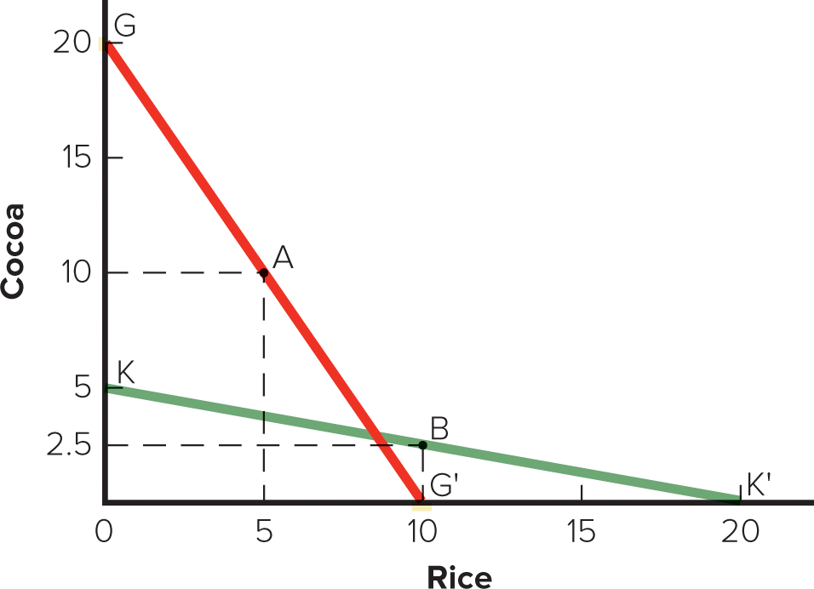
  - Countries should specialize in the production of goods for which they have an absolute advantage and then trade these goods for goods produced by other countries
  - Both countries benefit from specialization and trade
Absolute advantage refers to a situation in which a country has an absolute advantage in the production of a product when it is more efficient than any other country at producing it.

Comparative Advantage

David Ricardo (1817) Principles of Political Economy
  - A country should specialize in the production of those goods that it produces most efficiently and buy the goods that it produces less efficiently from other countries, even if it can produce those goods more efficiently itself
The Gains from Trade (1)
  - Potential world production is greater with unrestricted free trade than it is with restricted trade.
  - The theory of comparative advantage suggests that trade is a positive-sum game in which all countries that participate realize economic gains.
Qualifications and Assumptions (2)
  - Simple world with 2 countries and 2 goods
  - No transportation costs
  - No differences in price of resources
  - Resources can move freely
  - Constant returns to scale
  - Each country has a fixed stock of resources and free trade does not change the efficiency with which a country uses its resources
  - No effects of trade on income distribution within a country
Extensions of the Ricardian Model (3)
  - Immobile resources
    - Resources do not always move easily from one economic activity to another
    - Political opposition to the adoption of a free trade regime typically comes from those whose jobs are most at risk
  - Diminishing returns
    - Constant returns to specialization
    - Diminishing returns to specialization
      - All resources are not the same quality
      - Different goods use resources in different proportions
Constant returns to specialization The units of resources required to produce a good are assumed to remain constant no matter where one is on a country’s production possibility frontier.
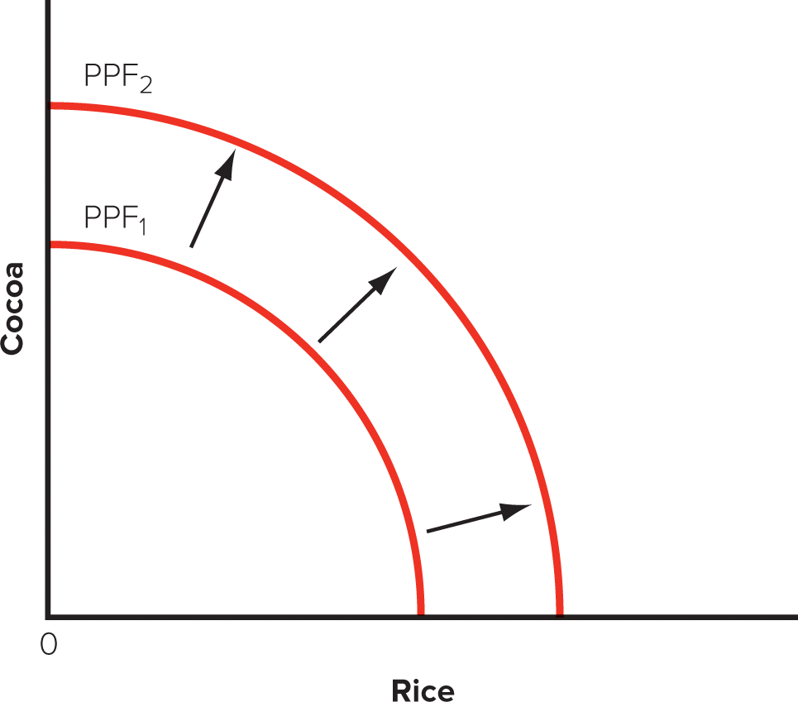
  - Dynamic Effects and Economic Growth
    - Trade can result in dynamic changes
      - Free trade might increase a country’s stock of resources as increased supplies of labor and capital from abroad become available for use within the country.
      - Free trade might also increase the efficiency with which a country uses its resources.
    - Dynamic gains in both the stock of a country’s resources and the efficiency with which resources are utilized will cause a country’s PPF to shift outward.
  - Trade, Jobs and Wages: The Samuelson Critique
    - What happens when a rich country (U.S.) enters into a free trade agreement with a poor country (China) that rapidly improves its productivity after the introduction of a free trade regime?
    - Lower prices may not make up for lower wages in the U.S.
    - Historically, free trade has benefited wealthy countries.
    - Protectionist measures may be harmful.
  - Evidence for the link between trade and growth
    - Countries that adopt a more open stance toward international trade enjoy higher growth rates than those that close their economies to trade.

Heckscher-Ohlin Theory

Factor endowments (1)
  - Comparative advantage arises from differences in national factor endowments.
  - Countries will export those goods that make intensive use of factors that are locally abundant.
  - Countries will also import goods that make intensive use of factors that are locally scarce.
Factor endowments A country’s endowment with resources such as land, labor, and capital.
The Leontief Paradox (2)
  - Raised questions about the validity of the Heckscher-Ohlin theory
  - Found that U.S. exports were less capital intensive than U.S. imports.

The Product Life-Cycle Theory

Raymond Vernon proposed this in 1960s
  - Most new products were developed and first sold in the U.S.
  - The wealth and size of the U.S. market gave U.S. firms a strong incentive to develop new consumer products.
  - The high cost of U.S. labor gave U.S. firms an incentive to develop cost-saving process innovations.
  - Over time demand grows in other countries, and price becomes competitive.
Product Life-Cycle Theory in the Twenty-First Century
  - Historically, an accurate theory
  - Now seems ethnocentric and increasingly dated

New Trade Theory

Economies of scale (1)
  - Major source of cost reductions
  - The ability of firms to gain economies of scale can have important implications for international trade.
    - Trade can increase the variety of goods available to consumers and decrease the average cost of those goods.
    - In those industries in which the output required to attain economies of scale represents a significant proportion of total world demand, the global market may be able to support only a small number of enterprises.
Economies of scale Cost advantages associated with large-scale production.
Increasing Product Variety and Reducing Costs (2)
  - World without trade
    - The variety of goods that a country can produce and the scale of production are limited by the size of the market.
  - World with trade
    - Individual national markets are combined into a larger world market.
    - Each nation can increase the variety of goods available to its consumers and lower the costs of those goods.
Economies of Scale, First-Mover Advantages, and the Pattern of Trade (3)
  - First-mover advantages
    - Can gain a scale-based cost advantage that later entrants find almost impossible to match
First-mover advantages are advantages accruing to the first to enter a market.
Implications of New Trade Theory (4)
  - Nations may benefit from trade even when they do not differ in resource endowments or technology.
  - A country may predominate in the export of a good simply because it was lucky enough to have one or more firms among the first to produce that good.
  - Luck, entrepreneurship, and innovation give a firm first-mover advantage.

National Competitive Advantage: Porter’s Diamond
Porter
  - Why does a nation achieve international success in a particular industry?
  - Four broad attributes of a nation shape the environment in which local firms compete
    - Factor endowments
    - Demand conditions
    - Related and supporting industries
    - Firm strategy, structure, and rivalry

The diamond (1)
  - Firms are most likely to succeed in industries or industry segments where the diamond is most favorable
  - A mutually reinforcing system
  - Two additional variables can influence the national diamond
    - Chance
    - Government

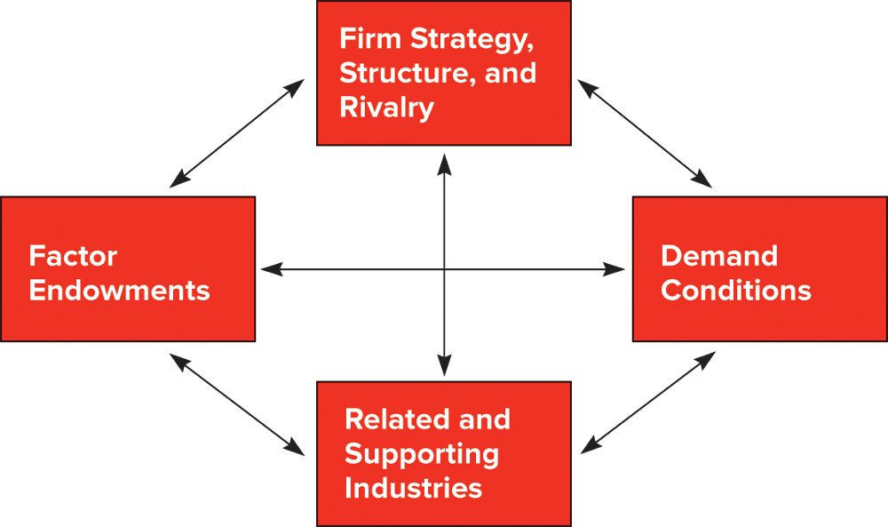
Factor Endowments (2)
- Basic factors
  - Natural resources, climate, location, demographics
- Advanced factors
  - Communication infrastructure, sophisticated and skilled labor, research facilities, and technological know-how
  - Advanced factors are a product of investment by individuals, companies, and governments
Demand Conditions (3)
- Firms gain competitive advantage if their domestic consumers are sophisticated and demanding
Related and Supporting Industries (4)
- The benefits of investments in advanced factors of production by related and supporting industries can spill over into an industry, thereby helping it achieve a strong competitive position internationally
Firm Strategy, Structure, and Rivalry (5)
- Different nations are characterized by different management ideologies, which may or may not help them build national competitive advantage
- There is a strong association between vigorous domestic rivalry and the creation and persistence of competitive advantage in an industry

Evaluating Porter’s Theory (6)
  - Government policy can influence supporting and related industries through regulation and influence firm rivalry through such devices as capital market regulation, tax policy, and antitrust laws.
  - Porter’s theory has not been subjected to detailed empirical testing.

Focus on Managerial Implications

Location, First-Mover Advantages, and Government Policy
  - Location: from a profit perspective, firms should disperse production to countries where they can be performed most efficiently.
  - First-mover advantages: it pays to invest substantial financial resources in trying to build an early advantage.
  - Government policy: according to Porter, government should invest in education, infrastructure, and basic research

