BIOL-1006 Section 3 Study Notes
DNA Stucture
1953, James Watson and Francis Crick introduced the double-helix model for the structure of deoxyribonucleic acid, or DNA, a polymer of nucleotides, each consisting of a nitrogenous base, a sugar, and a phosphate group.
Chargaff’s rules state that in any species there is an equal number of A and T bases, and an equal number of G and C bases.
- A & G are molecules called “purines” (larger)
- C & T are molecules called “pyrimidines (smaller)
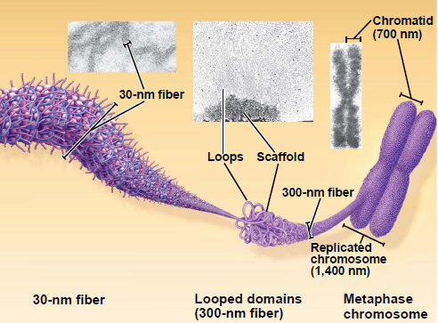
Chromatin is a complex of DNA and protein, and is found in the nucleus of eukaryotic cells. It can be organized into fibre widths.
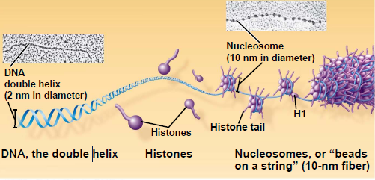

PCR – Polymerase Chain Reaction -The objective of PCR is to target and copy a specific piece of DNA. The presence or absence of these “insertions” at many different points in someone’s DNA creates a “genetic fingerprint.” For PCR you need: a DNA template, DNA primers, DNA polymerase (called “Taq” polymerase), and Nucleotides. There are 3 steps Denaturation Annealing, and Elongation.
95% of DNA is non-coding:
Introns: strands of DNA within a gene that do not code for a protein, they are removed after transcription.
Exons: are sequences of DNA that code for proteins.
DNA Replication – Semi-conservative model
Prokaryotic: (1 circular DNA) – replication begins at site called origin of replication, opening up to create a replication bubble.
Eukaryotic: (mulitiple DNA stands) - replication occurs at multiple sites, creating multiple bubbles that join together. A replication fork occurs at each end of the bubble. The enzymes at the fork are:
- Helicases: enzymes that untwist the double helix at the replication forks.
- Single-strand binding protein: binds to and stabilizes single-stranded DNA until it can be used as a template.
- Topoisomerase: corrects “overwinding” ahead of replication forks by breaking, swiveling, and rejoining DNA strands.
Enzymes that build a copy of DNA:
- Primase: Builds an RNA primer at 5’ end of leading strand and at each Okazaki fragments of lagging strand. The primer is short (5–10 nucleotides long).
- DNA polymerase III: adds nucleotides to 3’ end of RNA primer using parental DNA as a template.
- DNA polymerase I: replaces RNA nucleotides of theprimer with DNA nucleotides
- DNA ligase: joins pieces of copied DNA together.

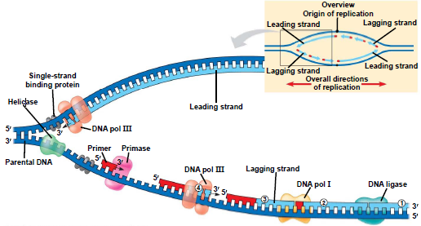
Leading Strand: the DNA strand that is replicated in the 5’to 3’ direction (new strand) in a continuous manner
Lagging Strand: the DNA strand going in the 3’to 5’ direction from the replication fork. DNA polymerase III can only replicate in the 5’ to 3’ direction, therefore this strand is replicated in short segments known as Okazaki fragments which are joined by DNA ligase.
DNA polymerases proofread newly made DNA, replacing any incorrect nucleotides. The enzyme nuclease cuts out and replaces damaged stretches of DNA.
Telomeres: Repetitive non-coding nucleotide sequences at the end of eukaryotic chromosomal DNA molecules that provide a “buffer zone” due to the loss of code where the RNA primer is placed on the lagging strand of replicated DNA. Telomerase enzyme catalyzes the lengthening of telomeres in germ cells, allowing for telomeres of correct length in zygotes.

Transcription (RNA synthesis) – occurs with the nuclear envelope. It is catalyzed by RNA polymerase, which pries the DNA strands apart at the promoter and hooks together RNA nucleotides. 3 stages:
Initiation: RNA polymerase binds to DNA segment at the promoter region, characterized by a sequence of A-T combinations called a TATA box.
Elongation: mRNA is built in the 5’ to 3’ direction as RNA polymerase moves down the DNA
Termination: RNA polymerase transcribes until it reaches a terminator sequence.
Post transcription modifications: to protect mRNA from hydrolytic enzymes, help ribosomes attach, and to facilitate export from the nucleus.
- 5’ end receives a modified nucleotide cap
- 3’ end gets a poly-A tail
- RNA splicing removes introns and joins exons. Done by spliceosomes

Translation –building of a polypeptide to create a protein. 3 steps
Initiation: mRNA enters the cytoplasm. The small ribosome unit binds to the 5’ end of the mRNA with initiator tRNA and moves in the 5’ to 3’ direction until it finds a start codon.
Elongation: A ribosome has 2 bonding sites, the A-site and the P-site. Amino acids are added one by one, carried by tRNA that enters the A-site, and form a peptide bond with the peptide chain connected to the tRNA in the P-site. The tRNA is then translocated to the P-site, and the next codon is read.
Termination: The elongation process continues until the ribosome reaches a stop codon, and the A-site receives a release factor protein, adding a water molecule to the chain, releasing the polypeptide.
tRNA: single RNA strand, 80 nucleotides long, shaped like a clover, that carries specific amino acids corresponding to an anti-codon which is complementary to codons on mRNA.
Wobble: Flexible pairing at the third base of a codon, allowing more than one code per amino acid.

Mutations – changes in the genetic material of cell.
Point mutations: change of a single nucleotide.
Base-Pair Mutations – replaces one nucleotide and its partner with another pair
Silent Mutations – have no affect
Missense Mutations – code for the wrong amino acid
Nonsense Mutations – change the codon to a stop codon resulting in an incomplete polypptide.
Insertions and Deletions – alter the reading frame of the codons producing a frame shift mutation.
Viruses –
A virus is not considered a living cell, they consist of a nucleic acid and are surrounded by a protein coat, and in some cases a membranous envelope.
Viral genomes may consist of either
Double-stranded or single-stranded DNA
Double-stranded or single-stranded RNA
Depending on its type of nucleic acid, a virus is called a DNA virus or an RNA virus.
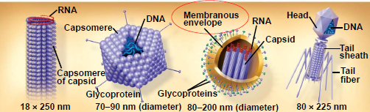
Capsid: is the protein shell that encloses the viral genome, they are built from protein subunits called capsomeres. There are various structures of capsids.
Influenza viruses are those that have a membranous envelope, derived from the host cell’s membrane, surrounding the capsids, acting a camouflage. (3rd image)
Bacterial viruses (bacteriophages) also called phages infect bacteria. They have the most complex caspid (4th image)
Host Range: the number of cells (species) that a virus can infect. Furthermore infections of eukaryotes are usually limited to specific tissues.
Viral reproduction - the virus makes use of host enzymes, ribosomes, tRNAs, amino acids, ATP, and other molecules in order to replicate.
Phages, have two reproductive mechanisms:
Lytic cycle (virulent phage)– results in the death of the host cell as the new phages digest the cell membrane to be released.
Lysogenic cycle (prophage)– replication without destroying the host. The viral DNA is incorporated into the host cell’s chromosome, passing the virus onto daughter cells.
Temperate phage – can use both lytic and lysogenic cycles.
Retroviruses – use reverse transcriptase to copy their RNA genome to DNA, called a provirus, allowing the DNA to permanently transcribe new viruses. (ex HIV/AIDS)
Viruses can damage or kill cells by causing the release of hydrolytic enzymes from lysosmes, or by causing the cell to produce toxins.
Immune system
Antigen: a protein on the surface of a virus which a lymphocyte responds to.
Lymphocyte: type of white blood cell that mediates immune responses. 2 types: B cells (y shaped) & T cells (linear shaped).
Epitope: portion of the antigen that binds with the antigen receptor on a lymphocyte.
Antibody: protein secreted by a lymphocyte cell after binding to an epitope.
Vaccine – harmless derivatives of pathogenic microbes that stimulate the immune system to create defences against the actual pathogen. (Stimulate antibody production)
Emerging viruses – those that appear suddenly. Usually caused by existing viruses expanding their host territory to humans.
“H” & “N” refer to the two viral surface proteins present on viruses:
1. “H”: hemagglutinin
16 different types
This enzyme helps the flu virus attach to the host cell
2. “N”: neuraminidase
9 different types
This enzyme helps release new virus from infected cells
H1N1 -1918 Spanish flu and 2009 Swine flu
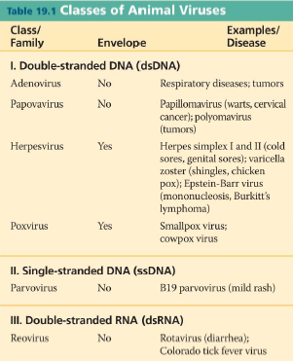
H5N1 – Avian flu
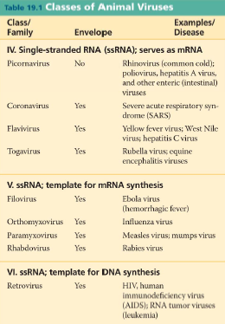

Guest lecture –
Viruses lack any intrinsic (natural) metabolism therefore they are not considered living
Types-
Sense: translated directly into proteins
Anitsense: serves as template strand to be translated
Ambisense: both
Influenza A is exclusively human

4000-8000 people die of influenza each year in Canada.
3.5 million cases of H1N1 in Canada, 428 confirmed deaths.

