Biology Mid-Term 2 Study Notes
Membranes- Exist throughout the cell enclosing most organelles. Phospholipids are Amphipathic molecules, meaning they have Hydrophilic (polar) Phosphate group (“head”) and 2 hydrophobic (non-polar) Fatty acid chains (“tails.”)
Fluid Mosaic Model – states that the membrane is in constant movement and acts as a fluid. Phospholipids move laterally across the surface and can also flip-flop which happens about once a month. This model also accounts for the movement of proteins in the membrane, however some do not move, remaining static.
Temperature affects fluidity of lipid membranes. As temperature drops the phospholipids become closely packed and solidify. Also, membranes rich in unsaturated fats are more fluid as the molecules are further apart.
Cholesterol – a fat steroid, which acts as a temperature buffer in membranes. At warm temperatures it prevents movement and at cool temperatures it prevents tight packing.
Isotonic solution - Solute concentration is the same outside cell and inside cell resulting in no net water movement across the plasma membrane.
Hypertonic solution - Solute concentration is greater outside cell than inside cell, resulting in the cell to lose water and shrivel (crentate).
Hypotonic solution - Solute concentration is less outside cell than inside cell, resulting in the cell gaining water and bursting (lysis).
Osmoregulation - Control of water balance across membrane. Living in non-isotonic environments requires adaptations, such as Paramecium which uses its vacuole as a water pump.
Selective permeability – Allows uptake of nutrients and elimination of wastes, maintaining homeostasis.
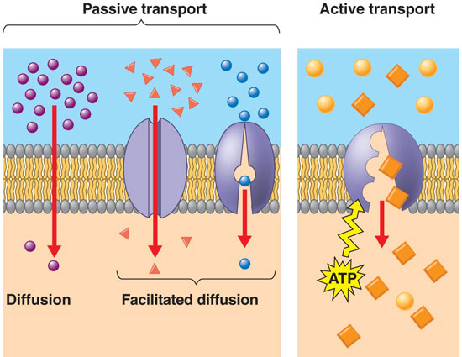
Passive transport – diffusion of a substance across a membrane with no energy investment as the movement occurs along the concentration gradient.
Diffusion: the tendency for molecules of any substance to evenly spread out into the available space as a result of thermal motion. Non polar molecules such as CO₂, Oxygen and hydrocarbons can easily pass through.
Osmosis: diffusion of water across a membrane in order to equalize the concentration of a solute. Important to note that osmosis is the movement of “free” water molecules.
- Polar molecules, (such as water and glucose) and ions cannot freely pass through a membrane and have to be transported by facilitated diffusion, using proteins.
Channel Proteins: allows direct passage through the membrane. Ex: aquaporins allow for the passage of water molecules.
Carrier Proteins: bind and change shape as they carry their cargo across the membrane.
Active Transport - Carrier proteins which move substances against the concentration gradient, requiring energy. Ex sodium-potassium pump.
Membrane potential – is the difference in concentration of electrically charged ions (ex. h⁺). The electrochemical gradient drives the diffusion of ions across a membrane. An electrogenic pump is a transport protein that generates voltage across a membrane (sodium-potassium pump in animal cells, proton pump in plant cells).
Bulk transport – large molecules such as polysaccharides and proteins cross a membrane in vesicles.
There are three types of endocytosis:
1. Phagocytosis (“cellular eating”): cell engulfs a particle in a vacuole
2. Pinocytosis (“cellular drinking”): molecules taken up when extracellular fluid is “gulped” into tiny vesicles.
3. Receptor-mediated endocytosis: molecules called ligands bind to receptors triggering vesicle formation.
Exocytosis is the opposite of endocytosis. In exocytosis, transport vesicles migrate to the membrane, fuse with it, and release their contents. Many secretory cells use this process.
Membrane proteins
Intergal proteins – integrated into the membrane.
Peripheral proteins – loosely bound to the surface.
Proteins are held in place by being attached to the cytoskeleton on the inside of the cell and by being attached to the fibres of the extracellular matrix.
- Seven major functions of membrane proteins:
1. Transport
2. Enzymatic Activity
3. Signal Transduction (receptor)
4. Cell-Cell Recognition (glycoproteins)
5. Intracellular Joining
6. Attachment to Extracellular Matrix(ECM)
7. Cell-Cell Communication
Metabolism – the sum of an organism’s chemical reactions. The transformation of matter and energy occur in multi-step processes called metabolic pathways, which begins with a specific molecule and ends with a product. Each step is catalyzed by a specific enzyme.
Catabolism: pathways that release energy by breaking down complex molecules into simpler compounds. Ex cellular respiration.
Anabolism: pathways that consume energy to build complex molecules form simpler ones. Ex synthesis of protein from amino acids. Anabolic steroids work like this.
Energy – is the ability to cause change
Thermodynamics – the study of energy transformations. Living things are open systems.
1st law of Thermodynamics / Principle of Conservation of Energy - Energy can be transferred and transformed, but it cannot be created or destroyed.
2nd law of Thermodynamics - Every energy transfer or transformation increases the entropy (disorder) of the universe.
Free Energy - The portion of a system’s energy that can do work when the temperature and pressure are uniform throughout the system, as in a living cell.
Free Energy Change (ΔG) - transformations of energy when a system changes (for example, during a chemical reaction)
Enthalpy Change (ΔH) - change of total energy in the system
Change in Entropy (ΔS) - measure of energy lost as heat (disorder).
A change in free energy (ΔG) = ΔH – TΔS *note that T = temperature measured in Kelvin
If ΔG is negative, then a reaction will occur spontaneously
An Exergonic reaction is a spontaneous reaction (does not require the input of energy). (ex. Falling)
An Endergonic reaction is a non-spontaneous reaction (requires energy). (ex. Photosynthesis)
The energy from exergonic reactions is used to run endergonic reactions. This is done by storing the energy from exergonic reactions in ATP,
Cellular work – there types driven by ATP:
Chemical, pushing endergonic reactions
Transport, pumping of substrates against a gradient
Mechanical, such as movement of cilia
ATP – adenosine triphosphate. Composed of a ribose sugar, adenine nitrogenous base and 3 phosphate groups. The bonds between the phosphate groups can be broken down by hydrolysis, releasing energy. This release of energy comes from the chemical change to a state of lower free energy, not from the phosphate bonds themselves. 1 mole of ATP releases 7.3 kcal when it becomes ADP.
ATP drives endergonic reactions by phosphorylation; transferring a phosphate group to
another molecule creating ADP. The recipient molecule is then, “phosphorylated.”
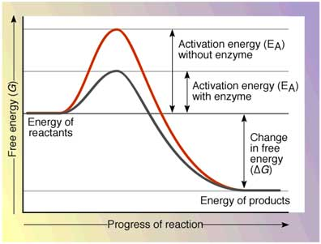
Activation Energy (E_{A}) – the initial energy needed to start a chemical reaction. This is often supplied by the surroundings. Ex. Heat from a flame igniting gasoline. Enzymes lower the E_{A} without affecting free energy in 4 ways:
1. Orienting substrates correctly
2. Straining substrate bonds
3. Providing a favourable microenvironment
4. Covalently bonding to the substrate
Enzymes
Substrate – the reactant that an enzyme acts on.
Active Site – area on the enzyme where the substrate binds.
Induced fit - substrate brings chemical groups of the active site into positions that enhance their ability to catalyze the reaction.
Factors affecting enzyme activity include temperature and pH
Cofactors – non protein enzyme helpers (include vitamins (coenzyme))
Enzyme Inhibitors – ex. Toxins, poisons, antibiotics, pesticides.
Competitive inhibitors: bind to the active site of an enzyme, competing with the substrate
Noncompetitive inhibitors: bind to another part of an enzyme, causing the enzyme to change shape and making the active site less effective.
Regulation of Enzymes – done by switching off the genes that code for the enzyme or regulating the activity of the enzyme.
Allosteric Regulation - when a regulatory molecule binds to a protein at one site and affects the protein’s function at the active site. Regulatory molecules can activate or inhibit the enzyme.
Feedback Inhibition – the end product of the pathway inhibits the pathway.
Cellular respiration – includes both aerobic and anaerobic respiration.
Redox reactions – oxidation or reduction reactions, in which a transfer of electrons takes place.
In oxidation, a substance loses electrons, or is oxidized
In reduction, a substance gains electrons, or is reduced (the amount of +ive charge is reduced)
“OIL RIG”: Oxidation is Loss – Reduction is Gain
** Note The electron donor is also called the reducing agent, and The electron acceptor is called the
oxidizing agent
The energy release during cellular respiration is due to the fact the glucose is oxidized. In order to prevent a large release of energy (explosion), Hydrogen is are not passed directly to oxygen, but initally passed to a coenzyme (NAD+)
Fermentation – production of ATP without oxygen following glycolysis, two common types are alcohol fermentation in plants and lactic acid fermentation in animals. This process uses energy but is essential to regenerate NAD+
Photosynthesis is the process that converts solar energy into chemical energy.
6CO₂ + 6H₂O + light energy → C₆H₁₂O₆ + 6O₂
The Light reactions – light is absorbed by chlorophyll causing the transfer of electrons and hydrogen from water to NADP+ producing O₂. ATP is produced in the thyakoids via photophosphorylation.
The light dependent reactions are driven by numerous pigments that absorb different wavelengths of light. When a pigment absorbs light on of the molecule’s electrons becomes excited, which is unstable creating a higher potential energy. The energy given off can be in the form of fluorescence.
Photosystem – consists of a reaction-center complex surrounded by light-harvesting complexes containing pigments that funnel photon energy to the reaction center. There are 2 types of photosystems in the thylakoid membrane, named because of the sequence of their discovery.
Photosystem II (PS II)
- Absorbs most energy with wavelength of 680nm (red light)
• The chlorophyll a at the reaction centre of PSII is called P680
Photosystem I (PS I)
• Absorbs most energy with wavelength of 700nm (red light)
• The chlorophyll a at the reaction centre of PSI is called P700
Linear electron flow -At PSII electrons are excited PSII Plastoquinone (Pq) a cytochrome complex (ATP is produced) to Plastocyanin (Pc) to PSI (electrons are excited again) to Ferrodoxin (Fd) to NADP+ reductase to form NADPH.
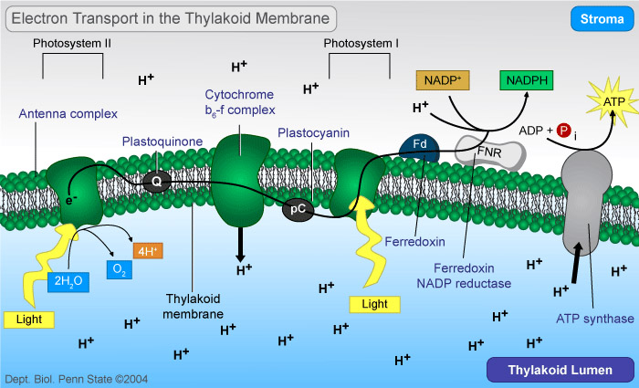
Cyclic flow – only uses PSI to generate a surplus of ATP only. This process exists because the Calvin cycle requires more ATP than NADPH.
Chemiosmosis – same as cellular respiration but protons are diffused into the stroma of the chloroplasts where as they diffuse into the mitochondrial matrix in cellular respiration.
The Calvin Cycle – starts with glyceraldehyde -3- phosphate. Cycle must go around twice to form one molecule of glucose as each round produces 3 molecules of CO₂. Products are ADP, NADP+ and Glucose.
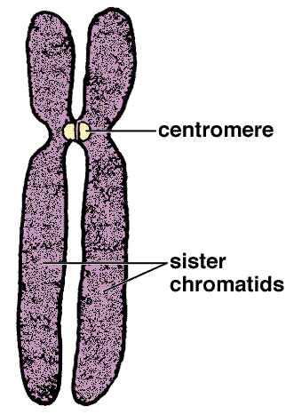
Mitosis
Somatic cells (non-reproductive cells) have two sets of chromosomes.
Human somatic cells = 23 pairs of chromosomes, 46 individual chromosomes.
Gametes (reproductive cells: sperm and eggs)
have half as many chromosomes as somatic cells
Human gametes (egg or sperm) = 23 chromosomes.
The Cell Cycle
Interphase – 90% of the cell cycle in which the cell grows and copying chromosomes are duplicated in preparation for cell division. 3 sub-phases:
G₁ Phase – considered the “restriction point” or point of no return.
S Phase – DNA replication. Centrosomes duplicated and move to opposite poles.
G₂ Phase – replication of all required machinery, cell grows to twice its size.
Mitotic Phase
Prophase – Chromatin condenses into chromosomes, early mitotic spindle microtubules form.
Prometaphase – Nuclear membrane fragments, microtubules connect to chromosomes at the kinetochore.
Meataphase – longest stage, pulling action of centrosomes line up chromosomes on the metaphase plate.
Anaphase – shortest stage, sister chromatids part, moving towards opposite ends
Telophase – daughter cell nuclei begin to form, chromosomes de-condense
Cytokinesis – not actually mitosis as the nucleuses have formed, but is the division of the cytoplasm and organelles. In animal cells it occurs by a process known as cleavage, plant cells form a cell plate.
The Mitotic Spindle – the array of microtubules that control chromosome movement. If forms in the cytoplasm during prophase, starting at the centrosome that replicates during interphase. During anaphase it shortens by depolymerization, pulling the sister chromatids apart. The depolymerization occurs at the kinetochore end of the microtubule.
Binary Fission – occurs in prokaryotic cells, because single celled organisms have circular DNA, replication occurs at the “origin of replication” and the two daughter cells actively move apart.
The Evolution of Mitosis
Believed to have evolved from binary fission as some protists exhibit an intermediate cell division. Ex:
Dinoflagellates – single celled with 2 flagella, covered with cellulose plates. Are the photosynthetic component of coral reefs and can be bioluminescent. When they divide the nuclear envelope remains intact. Microtubules pass through it attaching to the chromosomes.
Diatoms – mostly known as phytoplankton. When they divide the nuclear envelope stays intact and a microtubule spindle forms inside the nucleus.
Cell Controls
Frequency of cell division – cell cycle is driven by chemical signals present in the cytoplasm. This was found by fusing 2 cells at different stages of the cell cycle. The nucleus from the less developed cell immediately entered the same stage as the more developed cell.
Checkpoints – places in the cell cycle that can be stopped by a stimulus.
G₁ Checkpoint – “restriction point” if the cell passes the G₁ checkpoint mitosis will occur, if not the cell enters G₀ Phase, a resting phase also known as quiescence. Most adult human cells are in this phase. The cell requires signals such as the epidermal growth factor to proceed with division.
G₂ Checkpoint – insures cell is big enough and DNA is not damaged
M checkpoint – insures chromosomes are aligned on the metaphase plate.\
Signal Controls and regulatory proteins
Cyclin - concentration accumulates during interphase until it binds with:
Cyclin-dependent kinases (Cdks) – present at constant concentrations in the cell
*When Cdk and cyclin bind together, they form MPF (maturation-promoting factor), a complex that triggers a cell’s passage past the G2 checkpoint into the M phase, till the cyclin is degraded.
Other signals – density dependent inhibition: crowed cells stop dividing.
Anchorage dependence: cells must be attached to a surface to divide
Loss of Cell Control: Cancer
Cancer cells do not respond to the body’s control mechanisms. They can make their own growth factor or convey a growth factor’s signal. When cells lose control normally the will undergo apotosis, also known as “programmed cell death.” If this does not happen it becomes cancer.
Benign tumour – remains at the orginial site of transformation
Malignant tumour – invades surrounding tissues or move around body forming secondary tumours.
Chemotherapy – common drug is an anthracycline called doxourubicin, that was isolated from bacteria. It breaks DNA strands. Another is Paclitaxel or Taxol which is a mitotic inhibitor that stabilizes microtubules preventing cell division to proceed past metaphase.
Genetics: the scientific study of heredity and variation.
Autosomes – are the 22 pairs of chromosomes that do not determine gender (not X or Y)
Karyotype – analysis (picture) of someone’s chromosomes. Made by stopping the cell cycle in Metaphase and staining the chromosomes. Homologous chromosomes are paired up (one from mother one from father)
Ploidy – refers to the number of copies of each chromosome in a cell. Humans are diploid
Meiosis – Diploid 4Haploid cells
Interphase – chromosomes duplicate
Meiosis I – Separates homologous chromosomes
Prophase I – homologs pair up, called synapsis, forming a tetrad. Crossing over of alleles occurs at X shaped Chiasmata.
Metaphase I – tetrads arrange on the metaphase plate.
Anaphase I –homologs move to opposite ends of the cell by microtubules
Telophase I & Cytokinesis – cell splits into 2 haploid cells with copied DNA already replicated
Meiosis II – separates sister chromatids
Prophase II – spindle re-forms
Metaphase II – chromosomes are positioned on the metaphase plate by spindles.
Anaphase II – centromere breaks and spindles pull chromatids apart.
Telophase II & Cytokinesis – cell divides and new nucleus forms
Genetic Variation
- Independent assortment of chromosomes – homologous pairs of chromosomes orient randomly at metaphase I.
- Crossing over – produces recombinant chromosomes, creating unique chromosomes.
- Random fertilization – any sperm with any egg = trillions of combinations

