COMM 210 – MIDTERM
CONTEMPORARY BUSINESS THINKING

- Business Terms:
- Board of directors
- Bottom line
- Chief executive officer
- Emotional intelligence
- Globalization
- Knowledge workers
- Outsourcing
- R&D
- Shareholders
- Vision

- Critical thinking:
1. Identify the author’s major conclusions
2. Describe & evaluate supporting evidence
3. Uncover assumptions & values
4. Determine soundness of causal logic
5. Deconstruct use of persuasive language

CHAPTER 1: WHAT IS CRITICAL THINKING?

- Critical thinking: analyzing the validity of arguments in a text AND approach to reading, thinking and learning that involves asking questions, examining our assumptions and weighing the validity of arguments
- Qualities of critical thinkers:
- Self-aware: introspect on their own thinking processes
- Curious: explore beneath the surface of issues by challenging ideas
- Independent: listen and learn from others
- They also play a role when shifting through ideas because they are able to recognize reoccurring ideas and find commonalities
- Critical thinking can be a frame of mind
- Strategies for critical thinking are explicit
- Avoid reading like a “sponge”; to be a critical thinker one must go beyond just absorbing the information

- 5 dimensions of critical thinking: (chapter divisions in book as well) (EXPLAIN)
- Central claims (purpose)
- Quality of evidence (quality of data and reasons that claim can be supported)
- Underlying assumptions and values
- Causal claims (cause and effect)
- Techniques of persuasions

- “There is nothing so practical as a good theory” –Kurt Lewin

- Critical thinking skills + Management concepts = Business discourse = Primary outcomes + Secondary outcomes
- Critical thinking skills: claims, evidence, underlying assumptions, rhetoric
- Management concepts: organizational growth, strategy, vision, motivation, change, etc.
- Business discourse: business press, newspapers, magazines, internet
- Primary outcomes: critical reading & analysis, facility with language of business, constructing persuasive arguments, interest in current business activities
- Secondary outcome: working efficiently in teams

CHAPTER 2: CLAIMS
1. Identify the author’s major conclusions

- Claim: quick summary of article, typically found in introduction or conclusion, it is not always provided, implicit or explicit
- Claim: the major conclusion of a piece of writing that the author is trying to persuade you to accept

- Uncontested claims:
- Consistent with our own experiences and observations (things we have seen, heard, touched or subjective experiences)
- Facts independent of interpretation
- Agreement among experts or strongly supported general claims that are common sense
- Technical or mathematical claims

- Contestable claims:
- Not commonly accepted knowledge
- Often introduce new ideas that awaken curiosity
- Sometimes presented as if it were a fact
- Cannot stand on their own (must have evidence to justify)

- A contestable claim can become an uncontested claim
- A good statement of the author’s claim is the first step to evaluating it critically
- Presentation of claim: intelligible, fair summary, concept list, concept map

- Use of concept maps or list of important concepts to present claims
- Concept maps: compact way of summarizing complex material, can be boxes and arrows, diagrams, geographical maps, images, etc.
- The concept map must show the main issues and show the relationship that summarizes the author’s main point

CHAPTER 3: EVIDENCE
2. Describe & evaluate supporting evidence

- Claim + Evidence = Argument
- Claim: central idea that the author is trying to persuade you to accept
- Evidence: any statement that is a response to the question “why is this true?”
- Argument: several arguments can be present in a longer piece of writing

- Example of evidence: statistics, details of past, anecdotes, written account
- Cue words of evidence: because, as a result, in the first place, for example, in addition, etc.

- Criteria to test the quality of the evidence (APSRAC):
- Accuracy
- Difficult to judge without an independent source of information
- Independent and infallible source of info
- Precision of evidence
- Grammar or spelling mistakes
- Verification possible
- Proxy on accuracy if verification not possible
- How true is the evidence

2 ways to proceed:
- Do our own research to verify accuracy
- Use proxies to evaluate accuracy: trivial errors, grammar, spelling mistakes, inaccurate quotes or lack of precision

- Precision
- No ambiguous words
- Precise numbers
- Direct quotes
- Precision creates the impression of accuracy, can also substitute for accuracy
- Beware of over-precision

- Sufficiency
- Enough information to avoid fallacy of generalization
- If claim is wrong potential damage
- Evidence insufficient to support claim hasty generalization
- Jump to conclusions fallacious thinking
- Fallacy of hasty generalization
- To know if sufficient, judge the number of evidence by: how important the claim is (impact) AND/OR how long the text is
- How much evidence? Importance of claim and potential damage

- Representativeness
- Is the evidence representative of many people?
- Relates to population of claim
- Variety in the sources of evidence should match the variety in the population
- Fallacy of hasty generalization

- Authority
- Training, credentials, experience of others
- Classics or current writing
- Context-dependent
- Fallacy of false appeal to authority
- Fallacy of argumentation ad populum (bandwagon)
- People with training, experience, credentials
- Citation from professionals creates authority
- Context dependent
- False authority

- Clarity of expression
- Quantitative data should be interpreted, never unexplained
- Significance of evidence should be stated
- Direct quotes should be interpreted
- Be clear

- Other objections: issues of relevance related to underlying assumptions

CHAPTER 4: UNDERLYING ASSUMPTIONS
3. Uncover assumptions & values

- What is an underlying assumption?
- How do we uncover an underlying assumption?
- Ask: What must be true if the claim is to follow from this evidence? What general principle might link this particular claim to this particular evidence? What beliefs might I expect from this type of person? Could someone believe this evidence and still disagree with the claim?
- What are the types of underlying assumptions? How do we challenge each type?

- Underlying assumptions: logical link that fills the gap between the evidence and the claim
- Implicit or explicit principles that form the bases of our beliefs and reasoning
- Tell us whether evidence provided for a claim is relevant
- If an author has underlying assumptions he is usually very knowledgeable on the topic being discussed, because he assumes it is common knowledge

- 2 types of assumptions:
- Reality assumptions
- Our beliefs about reality and about the way things are
- About how things are
- Fact, can be proven

- Value assumptions
- Our ideals, our standards of right and wrong, the way things ought to be
- About values
- What is right or wrong
- Must challenge underlying assumptions:
- Reality: bring a contrary statement or fact to challenge the underlying assumption
- Value: about personal values, which are resistant to change

- Only challenge assumptions, not claims or evidence

BUSINESS THEORIES

CHANDLER (Building Successful Organizations)
“The Enduring Logic of Industrial Success” –Alfred D. Chandler (1990)

- A theory of organizational success

Chandler’s Major Claims:

- Successful firms capitalize on economies of scale and scope, create functional management structures, invest in research and development and grow from related diversification

- To benefit from economies of scale and scope, the flow of materials must be kept constant (to assure capacity utilization: relationship between output that is produced with the installed equipment, and the potential output which could be produced with it)

  - National and international marketing and distribution functions must be created (geographical expansion)

  - Teams of top, lower and middle managers need to be recruited (Management hierarchy is necessary, specifically for unrelated diversification because some will have more hands on knowledge)

Chandler’s secondary claims:
- Once a firm loses the opportunity to be a first mover, it is hard to regain competitive advantage

- Entrepreneurial companies that do not make investments to create organizational capabilities (company’s ability to manage resources, such as employees, effectively to gain an advantage over competition) cannot achieve long-term success

- Growth through unrelated diversification is a poor corporate strategy

- Business ownership patterns have diminished the likelihood of many firms’ long-term success

SIZE:

- Chandler states that there are cost advantages (firm that can produce a particular product or service at a lower cost than the competition) when the company grows

  - Economies of scale: large plants can produce products at a much lower cost than small one because the cost per unit drops as the volume of output rises AND by producing more the cost per unit will

    - As production of qty increases, price of each unit decreases (mass production)

  - Economies of scope: large plants can use many of the same raw and semi-finished materials and intermediate production processes to make a variety of different products AND using the same raw materials for different products in production

    - Using the same raw material, machineries, tools and skill sets to produce different products

- Another way that companies choose to grow: Unrelated diversification

  - Buying businesses that they have few/no knowledge of to try to give them competitive edge

- Chandler says that this is a BAD BUSINESS STRATEGY – becomes a danger for the entity

- Why?

  - Ignores the logic of managerial enterprise
  - The new businesses are not related to the company’s core activities
  - Managers have no understanding of the new businesses
  - They don’t have knowledge of experience with this new business or market
  - Could cause the company to lose money in the future and defer from their main activities that made them successful

- Companies engage in unrelated diversification according to two factors:

  - Stock Market Pressure: company focusing on making investors happy

    - Do to Business ownership pattern: can be bad for long-term success of company, since investors are looking for quick return on investment

  - Short-term thinking: companies don’t think of long run consequences, just want to make investors happy (market pressure)

BAD IN THE LONG RUN

- Good way for the company to grow: Related diversification

  - business can apply its knowledge and experience to be successful in the diversification; expanding in your field of knowledge

SIZE IS NOT ALL to exploit cost advantages of scope and scale

- Must also create national and international marketing and distribution organizations (Geographical Expansions)

- To do so, teams of managers have to be recruited (middle and lower) to coordinate the flow of products, while top managers monitor current operations and planned for future activities

- Therefore, Chandler believes in Managerial Hierarchy

  - Separation between lower/middle managers and top-level managers, which includes a CEO chosen by the board of directors

  - Especially true bcs of diversification

  - Top managers have little knowledge or experience of the division or subsidiaries they acquired

  - Bcs of newly acquired business, there is an overload of decision making at corporate level delegate work to other managers

- Chandler also talks about the importance of being First Mover and of engaging in R&D

FIRST MOVER

- First to make large investments (to invest heavily in R&D, hire managers, to grow, to move and to enter a particular market)

- They have a competitive advantage and dominate the industry because

  - Others had to capture markets that were already established
  - The first movers had already recruited a strong management team (best are already taken)
  - Others needed to build plants of comparable size
  - They confidently seized opportunities through major commitments
  - They simply had to maintain and nourish their competitive capabilities, but others were trying to catch up to them

- The opportunity to make first-mover investments and create a managerial enterprise is short-
lived. Once that opportunity is lost, it is hard to regain competitive capabilities

GREINER (Structure, Function and Growth of firms)
“Evolution and Revolution as Organizations Grow” –Larry E. Greiner (1994)

- A theory of organizational life cycles, with a focus on growth

- Greiner’s Major Claims:
- Organizations grow through a series of evolution and revolution phases that are function of the age and the size of the organization
- Management practices that work well in one phase bring on a crisis in the next

- Greiner: How Companies Grow
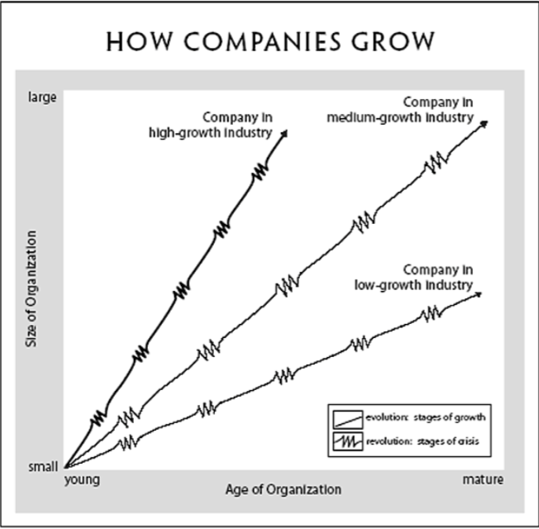

    - Evolution & Revolution: Phases begin with a period of evolution (steady growth and stability) and ends with a revolutionary period (turmoil and change)
    - If the revolutionary period is resolved, the company can move to the next stage of evolution

- Greiner’s Primary Concepts:
- Age of the organization: the same organizational practices are not maintained throughout a long-life span. Management problems and principles are routed in time

- Size of the organization: Problems and solutions tend to change with increases employees and sales revenues

- Stages of evolution: as organizations grow, different evolutionary period emerge

- Stages of revolution: practices become outdated; companies that do no change will fold or cease to grow. Solution for one crisis becomes a major problem in the next

- Growth rate of industry: speed of stages are related to the speed of the growth of the industry

- Management style
- Organizational structure

- The Five Phases of Growth: EVOLUTION
- Creativity
- Leadership (Crisis of leadership)
- Direction
- Autonomy (Crisis of autonomy)
- Delegation
- Control (Crisis of control)
- Coordination
- Red-tape (Red-tape crisis)
- Collaboration
- ?

- Creativity
- Create product
- Find market
PROBLEM: Structure needed for employees Leadership
- Direction
- Organizational structure
- Responsibilities and roles
- Structure
PROBLEM: Lower level employees are restricted and too knowledgeable Autonomy
- Delegation
- More responsibility to managers
- Profit
- Responsibilities are past down
PROBLEM: Loss of communication and control Control
- Coordination
- Bureaucracy
- Higher people come in to give direction
PROBLEM: Distrust from lower to higher managers Red-Tape
- Collaboration
- Teams focused on one thing
- Matrix structure (report to leader of project and boss)

- Evolution: stages of growth (dependent on size and age of company)
- Creativity
- Direction
- Delegation
- Coordination
- Collaboration
- Revolution: stages of crisis (dependent on size and age of company)
- Leadership
- Autonomy
- Control
- Red-tape
- ?

- Greiner’s Secondary Claims:
- Organizations should not try to skip phases
- Top managers whose style is no longer appropriate should remove themselves
- Growth is not inevitable

- Guidelines for managers of growing organizations:
- Know where you are in the developmental sequence
- Recognize the limited range of solutions
- Realize that solutions breed new problems

- Organizational Practices in the five phases of growth:
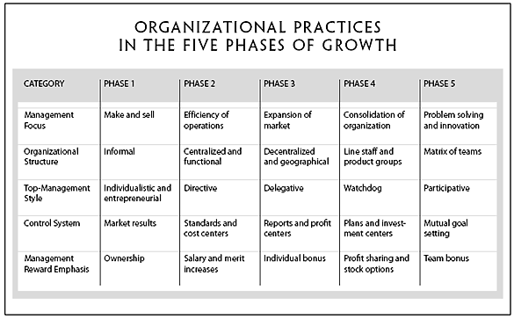

BARNEY on internal resources and capabilities
“Looking inside for competitive advantage” –Jay B. Barney (1995)

- Barney’s Major Claims:
- A firm will have a sustained competitive advantage if its resources and capabilities are valuable, rare, inimitable and organized in a way that allows it to exploit potential opportunities
- A firm will be successful if it has resources with the right attributes and characteristics
- The most careful and complete analysis of firms’ competitive environments cannot, by itself, explain their success
- Strategists also need to analyze the competitive implications of firms’ internal strengths and weaknesses

- The Firm’s Resources and Capabilities:
- Resources & Capabilities: financial, physical, human, organizational assets used by the firm to develop, manufacture and deliver products and services to its customers

- Financial: debt, equity, retained earnings, etc.
- Physical: machines, manufacturing, facilities, buildings
- Human: experience, knowledge, judgment, wisdom, etc.
- Organizational: history, relationships, trust, culture, formal reporting structure, patents, etc.

- Four Important Questions about Resources and Capabilities: VRIO
- The question of Value: Does a firm’s resources and capabilities enable it to exploit an opportunity, and/or neutralize a threat?
- The question of Rareness: How many competing firms already possess these valuable resources and capabilities?
- The question of Imitability: Do firms without a resource or capability face a cost disadvantage in obtaining it compared to firms that already possess it?
- The question of Organization: Is a firm organized to exploit the full competitive potential of its resources and capabilities?

- Imitability:
- The importance of history
- Valuable and rare resources acquired or developed through unique historical circumstances can be a source of sustained competitive advantage
- The importance of numerous small decisions
- A firm’s competitive advantage seems to depend on numerous “small decisions” (rather than big ones) through which a firm’s resources and capabilities are developed and exploited
- The importance of socially complex resources
- Reputation, trust, friendship, teamwork and culture, which are not patentable, are difficult to imitate

- SWOT Framework (not Barney’s theory) (SWOT analysis is the traditional tool for strategic analysis):
- Internal Environment (Internal resources and capabilities of firm):
- Strengths & Weaknesses
- External Environment (Business & societal trends, industry conditions and competitive environment):
- Opportunities & Threats

- Barney’s article “Looking inside for competitive advantage” provides a tool to assess the organization’s internal resources and capabilities

- Applying the VRIO Framework
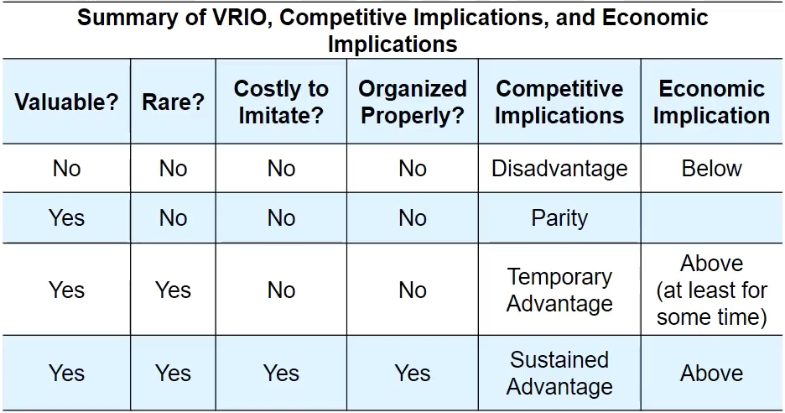

COLLINS & PORRAS on company vision
“Building Your Company’s Vision” –James C. Collins and Jerry I. Porras

- “Vision provides guidance about what core to preserve, and what future to stimulate progress toward.”

- Core Ideology: enduring character of an organization – a consistent identity that transcends product or market life cycles, technological breakthroughs, management fads, and individual leaders. Glue that holds the organization together (comes from within an organization’s discovery process)

- Core values
- Essential and enduring tenets; small set of timeless guiding principles; beliefs about what is important
- The “Code of Ethics” or “How we do business”
- Usually only 3-5 core values
- Core purpose
- The organization’s reason for being; the idealistic motivations for doing the company’s work; capture the soul of the organization
- Why do we exist?
- Usually only 1 core purpose

- Discovering core ideology:
- You do not create or set core ideology
- Description of what actually exists, not just what we wish existed
- Needs to be meaningful and inspirational only to people inside the organization
- Find people who are predisposed to share the organization’s core values and purpose
- More than just creating a perfect statement

- Envisioned Future: Creative Process
- BHAG:
- BHAG: Big, Hairy, Audacious, Goals
- 10-30 years
- Powerful way to stimulate progress
- Clear & compelling; serves as unifying focal point of effort; acts as a catalyst for team spirit
- Takes little or no explanation
- It is not a sure bet
- Beware of the “were arrived syndrome”
- Vivid Description
- Vision:


