BIOL-1006 Chapters 1-6 + 26, Mid-Term 1 – Study Notes
The Properties of Life - These are the 7 properties we associate with life
Order, Evolutionary adaption, Response to the environment, Regulation, Energy processing, Reproduction, Growth and development.
Themes in Biology
Biological Hierarchy: Biology exists from the microscopic to the global scale. Biological organization is based on a hierarchy of structural levels (10)
Biosphere: all environments on Earth
Ecosystem: all living and nonliving things in a particular area
Community: all organisms in an ecosystem
Population: all individuals of a species in a particular area
Organism: an individual living thing
Organ and organ systems: specialized body parts made up of tissues
Tissue: a group of similar cells
Cell: life’s fundamental unit of structure and function
Organelle: a structural component of a cell
Molecule: a chemical structure consisting of atoms
How Organisms interact with their Environment: includes 2 major processes:
- Cycling of nutrients, in which materials acquired by plants eventually return to the soil
- The flow of energy from sunlight to producers to Consumers
Structure and Function: Structure correlates with function at all levels of biological organization.
Ex. A bird’s wings have aerodynamically efficient shape, or infolding of membrane in mitochondria to increase surface area.
Cells The basic Unit of life: The cell is the lowest level of organization that can
perform all activities of life. The ability of cells to divide is the basis of all
reproduction, growth, and repair of multi-cellular organisms.
There are two types of cells, however all cells are enclosed by a membrane and use DNA as genetic information.
- Eukaryotic: divided into organelles; DNA in nucleus
- Prokaryotic: lack organelles; DNA not separated in a nucleus (single celled only)
Continuity of Life (DNA):Cells contain DNA, the heritable information that directs the cell’s activities. Genes are the units of inheritance that transmit information from parents to offspring.
Biological Regulation Systems: Regulatory systems ensure a dynamic balance in living systems. Chemical processes are catalyzed (accelerated) by enzymes. Many biological processes are self-regulating: the product regulates the process itself. There are two types:
- Negative feedback: the accumulation of a product slows down the process itself. Ex. Blood sugar level.
Positive feedback: is less common, as the product speeds up its own production. Ex when you cut yourself platelets in your blood begin to collect at the site releasing chemicals that attract more platelets.
Evolution accounts for the unity and diversity of life (CORE THEME!) Underlying life’s diversity is a striking unity, especially at lower levels of organization. In eukaryotes, unity is evident in details of cell structure. Ex. The same cilia found in single celled Paramecium is also found in trout cells. Charles Darwin published the On the Origin of Species by Natural Selection (1859) in which two main points were articulated:
- Descent with modification (the view that contemporary species arose from a succession of ancestors)
- Natural selection (a proposed mechanism for descent with modification)

The Tree of Life
Biologists often show evolutionary relationships in a treelike diagram. Related organisms have similar adapted features. This connects life’s unity and diversity to descent with modification. Natural selection eventually produces new species from ancestral species.
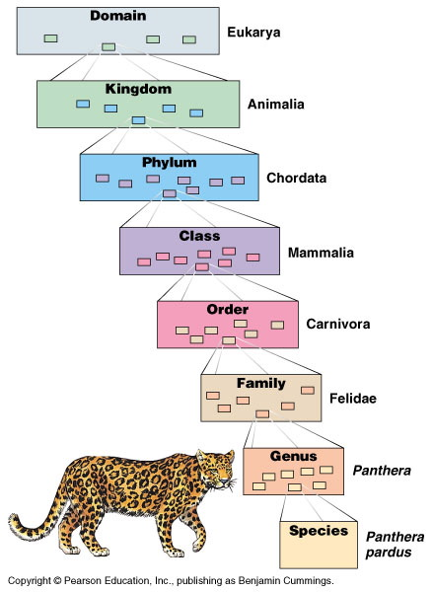
Systematics & Phylogeny
Systematics is the study of the diversity of life on Earth. It is essential to biology because it describes how organisms are related. It incorporates several ideas:
- Taxonomy: classification of organisms
- Phylogenetics: the evolutionary relatedness of organisms
Linnaean/Hierarchical classification and Binomial Nomenclature/Scientific Name
Because there are various common names for a single species and due to language barriers, biologists use an 8 category naming system. For simplicity, only the last 2 parts of the scientific name is used (genus and species). Note that the binomial name is in Latin, so they must be either italicized or underlined separately.
The 3 Domains of Life
(1)Domain Bacteria and
(2)Domain Archaea- comprise the prokaryotes.
(3)Domain Eukarya - includes all eukaryotic
Organisms

Atoms are composed of subatomic particles. Relevant subatomic particles include:
- Neutrons (no electrical charge)
- Protons (positive charge) (also the atomic number)
Neutrons and protons form the atomic nucleus
- Electrons (negative charge). Electrons form a cloud around the nucleus
Atomic mass is the sum of the protons and the neutrons (electrons have insignificant weight)
Isotopes are atoms with a different number of neutrons than protons, some are stable and others, radioactive, and thus they emit particles of energy. Used in dating fossils or diagnosing medical disorders.
Valence electrons are those in the outermost shell, or valence shell. The chemical behaviour of an atom is mostly determined by the valence electrons. Atoms with incomplete valence shells can share or transfer valence electrons with certain other atoms. These interactions usually result in atoms staying close together, held by attractions called chemical bonds.
Types of Bonds (highest energy level to lowest)
Ionic – between metal and non-metal. Atoms strip electrons from their bonding partners, the transfer of electrons the atoms are charged and called an ion (anion-negatively charged, cation-positively charged)
Covalent bond – sharing of a pair of valence electrons by two atoms
Electonegativity is an atom’s attraction for the elections in a covalent bond. Oxygen is one of the most electronegative elements thus the electrons are pulled closer to the O atom.
In a non-polar covalent bond the atoms share the electron equally.
In a polar covalent bond, one atom is more electronegative, and electrons are not shared equally.
Hydrogen Bonds – strongest intramolecular bond. Are created due to the attraction of partial positive and negative atoms in a molecule containing hydrogen (H has the lowest electonegatvity)
Van der Waals Interactions - weak attractions formed between molecules with charge differences.
Molecular Shape and function: A Molecule’s shape is directly linked to its function. This is determined by positions of atoms’ valence orbitals. Biological molecules recognize and interact with each other based on molecular shape.
Water
Without water and its specific properties, life could not exist. Because of Hydrogen Bonding water can attract 4 other water molecules. These bonds only last a few seconds, however at any instant a substantial percentage of all water molecules are bonded to another molecule creating specific properties found in water:
Cohesion: the bonds “hold” the molecules together. This is how plants transport water into the leaves through the xylem (capillary action). Water also adheres to cells, such as xylem. This property also results in surface tension.
Moderation Of Temperature: Water is an excellent heat absorber due to its high specific heat (the amount of heat that must be absorbed or lost for 1g of a substance to change its temperature by 1ºC) thus it does not change temperature easily, as it requires more energy to break the H-bonds. It minimizes temperature fluctuations in organisms and habitats.
Evaporative Cooling: As a liquid evaporates, it’s remaining surface cools. Evaporative cooling of water helps stabilize temperatures in organisms and bodies of water.
Expansion upon Freezing: Solid ice is less dense than liquid water due to water forming a lattice structure which holds the molecules further apart than in water, increasing the volume.
Temperature Gradient: water is most dense at 4ºC, and less dense as it gets colder. In the winter the bottom of a lake will always be 4ºC and colder as you go up, that is why fish can survive winter.
Solvent of Life
Solution-a liquid that is a completely homogeneous mixture of two or more substances.
Solvent- the dissolving agent of a solution.
Solute-the substance that is dissolve.
Aqueous Solution-a solution where water is the solvent.
Water easily dissolves polar compounds by forming a Hydration Shell around the elements of a solute. Water can also dissolve compounds made of non-ionic polar molecules, or large polar molecules such as proteins if they have ionic polar regions.
A hydrophilic compound is one that easily dissolves in water (polar molecules).
A hydrophobic compound is one that will not stably dissolve in water (non-polar molecules).

Disassociation of Water -A hydrogen atom in a water molecules can shift to another water molecule leaving behind a hydronium ion (H3O+), though it is often represented as H+ and a hydroxide ion (OH–).
The pH scale is a logarithmic scale based on the molar concentration of H+ or OH-. Each additional unit is 10x greater than previous unit (ex. pH of 5 is 10x more acidic than a sol_{n} with a pH of 6)
Buffers: A buffer is a compound which can accept protons (H+) when they are in excess and donate protons (H+) when they are depleted. These buffers serve to maintain a stable physiological environment in which the processes of life can occur
Carbon – anything with carbon in it is said to be organic. Carbon has 4 valence electrons (tetravalence) thus it can bond with 4 different atoms and can for single of double bonds.

Large Molecules and Macromolecules
A polymer is a long molecule made of smaller repeating molecules called monomers. Ploymers are assembles during a dehydration reaction
Carbohydrates (sugars): Monosaccharides most simple or single sugars (basic formula is CH₂O, example glucose is C₆H₁₂O₆). Disaccharides are double sugars combined with a dehydration reaction (ex Sucrose). Polysaccharides are sugar polymers of many monosaccharides put together chemical bond is called a glycosidic linkage. There are 2 types of Ploysaccharides:
Storage Polysaccharides (Energy) - easily broken down into simple sugars for energy. Ex Starch – made of alpha glucose, 2 forms Amylose (unbranched) and Amylopectin (branched). Shape is Helical because of 1-4 glycosidic linkage. Ex Glycogen – produced by animals, has a branched shape, mainly found in liver and muscle cells.
Structural Polysaccharides (Building Material) – ex Cellulose – most abundant organic compound. Similar structure to starch except uses beta glucose. Ex Chitin – used in animal exoskeletons (lobsters, & insects) and found in cell walls of fungi. Pure chitin is flexible; adding calcium carbonate (a salt) makes it hard.
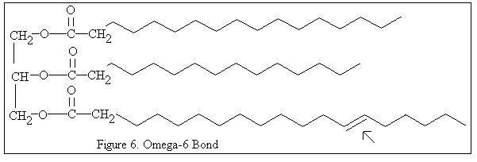
Lipids /Fats (not a polymer): Structure - 1 glycerol molecule and 3 “fatty acid” molecules, hence it is called a Triacylglycerol or Triglyceride. All cell membranes are made up of lipids. 1g of fat stores twice as much fat as sugars. There are two types:
Saturated fat has single bonds between all of the carbons in the fatty acid chains. They form solid fat.
Unsaturated fat has a number of double bonds between the carbon atoms in the fatty acid chains. They form liquid (oil) fat as the molecules are separated more
Phospholipids – Are Amphipathic molecule, meaning they have Hydrophilic (polar) “head” and hydrophobic (non-polar) “tails.” When added to water they form a bilayer which is the arrangement found in cell & organelle membranes.
Steroids – Lipids with a carbon skeleton consisting of four fused carbon rings, ex cholesterol.
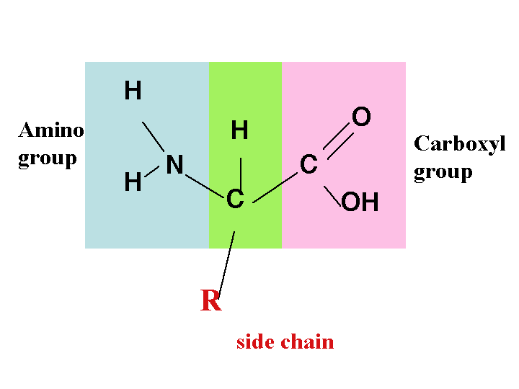
Proteins: are polymers called polypeptides. There are 20 different monomers called amino acids, which are added through a dehydration reaction forming a peptide bond. All amino acids have the same general base and different side chains represented by “R.” There are 3 groups these chains fall into: Hyrophobic, hydrophilic, and electrically charged (also hydrophilic, are an acid or base). There are four levels of protein structure, based on the amino acid sequence.
Primary Structure: The sequence of amino acids.
Secondary Structure: Initial folding of a polypeptide by hydrogen bonding. 2 forms- alpha-helix and beta-pleated sheet.
Tertiary Structure: Overall shape of a polypeptide as a result of hydrophoblic Interactions, Disulphide bridges, Hydrogen bonds and Ionic Bonds in the side chain.
Quaternary Structure: Overall structure of protein when made up of 2 or more polypeptide chains, resulting subunits.
Chaperonies: are proteins that help polypeptides fold into their correct shape.
There are 2 protein shapes:
Fibrous: Filamentous and elongated, mainly comprised of primary and secondary structure. They are often hydrophobic, ex Keratin (α-helix) and Collagen
Globular: Spherical and have a great deal of tertiary and quite often quaternary structure. They are often enzymes. Ex. Hemoglobin.

Nucleic Acids (DNA & RNA)
Deoxyribonucleic acid (DNA) and Ribonucleic acid (RNA) – are polynucleotides made up of monomers called nucleotides. Each nucleotide is made up of a Pentose sugar, phosphate base and Nitrogenous base.
DNA is the blueprint for all proteins, while RNA carries information form DNA outside the nucleus to where protein synthesis occurs.

Cell Fractioning
Process in which cells are divided into their sub-cellular components based on size. This is done by centrifugal action.
Types of Cells (Prokaryotic vs. Eukaryotic)
Prokaryotic: Organisms within the Bacteria or Archaea Domains. They have no nucleus as DNA is found in an unbound region called the nucleoid. There are no membrane bound organelles. They are often smaller than Eukaryotic cells.
Eukaryotic: All organisms of the Eukarya Domain. DNA is found within a nucleus bounded by a nuclear membrane. Membrane bound organelles are found within the cytoplasm (which includes any space between the plasma membrane and nucleus).
Parts of Eukaryotic Cells
Plasma Membrane – Selective barrier that allows passage of O₂, Nutrients and waste. It is composed of a phospholipid bilayer embedded with proteins.
Cytoplasm: Includes all liquid (cytosol) and organelles of the cell excluding the nucleus. Extends from the plasma membrane to the nucleus.
Nucleus: Contains the DNA in a eukaryotic cell. It is enclosed by a double membrane nuclear envelope which is perforated with pores allowing the entry and exit of molecules. The shape is maintained by the nuclear lamina, composed of protein. Chromatin is the material consisting of DNA and proteins, when it condenses it forms discrete chromosomes. The nucleolus, located within the nucleus is the site of ribosomal RNA synthesis.
THE ENDOMEMBRANE SYSTEM
Components of the endomembrane system:
1. Nuclear envelope 2. Endoplasmic reticulum 3. Golgi apparatus 4. Lysosomes 5. Vacuoles 6. Plasma membrane. These components are either continuous or connected via transfer by vesicles.
Endoplasmic reticulum (ER): is continuous with the nuclear envelope. The ER consists of a network of membranous tubules and sacs called cisternae. The membrane separates the internal compartment caller the ER lumen from the cytoplasm. There are 2 regions of ER:
Smooth ER: lacks ribosomes. Is essential for the synthesis of lipids, Metabolism of carbohydrates, Calcium Storage (muscle contraction) and Detoxification of drugs and poisons.
Rough ER: Studded with ribosomes which synthesize proteins chains that are then pushed into the lumen of ER and folded. Proteins formed by ER ribosome are secreted from the cell (ex. Insulin). Many are glycoproteins which a carbohydrate is added in the ER). Rough ER alos produces most of the membrane used in the cell.
Ribosomes: are rRNA-protein complexes assembles in the nucleolus, which synthesize proteins. 2 Types:
Bound Ribosomes: embedded in the ER membrane and nuclear membrane. Crates proteins that will either embedded in the membrane or secreted.
Free Ribosomes: float freely in cytoplasm and within mitochondria and chloroplasts. Create proteins that will stay in the cytoplasm.
Golgi Apparatus: Numerous flattened cisternae which receives products from the ER and ships them to the plasma membrane. These products make their way to the Golgi by transport vesicles which are received on the cis face and exit in vesicles at the trans face, during which time they may be modified.

Lysosomes (the “stomach” of the cell)
An off-shoot of Golgi apparatus. Lysosomes contain hydrolytic enzymes used to digest a variety of materials. Interior of lysosome is highly acidic, as digestive enzymes work best at low pH. Membrane of lysosome protects other cellular organelles from being digested. Two main activities:
Phagocytosis: the breakdown of food or smaller organisms from outside the cell
Autophagy: the breakdown of damaged oraganelles
Vacuoles: large vesicles derived from the ER and Golgi that are surrounded by a selective membrane called the tonoplast. They can store food created by Phagocytosis, or pump excess water out of a cell. Mature plants generally contain a central vacuole containing cell sap that nolds organic compounds, by-products, pigments and possible poisons. As the vacuole grows the cell can grow without having to develop new cytoplasm.
Peroxisomes: produces H₂O₂ and contain enzymes that break peroxide produced down to water. Breaks down macromolecules and detoxifies other harmful compounds.
Mitochondria: organelle with a smooth outer surface and folded inner membrane (cristae) surrounding the mitochondrial matrix. Enzymes that catalyze metabolic reactions are embedded in the inner membrane.
Choroplasts: member of the plastids family, which contain chorophyll. They are bonded by a double membrane and contains a third layer of membrane as part of flattened sacs called thylakoids, stacks of thylakoids are called granum.
**DNA (circular, similar to prokaryotes) and ribosomes can be found in choroplasts and mitochondria which is evidence of the Endosymbiotic theroy which states that choroplasts and mitochondria were at one point separate organisms that were engulfed by early cells that formed a symbiotic relationship.
Cytoskeleton: A network of fibres that extend throughout the cytoplasm, organizing and anchoring organelles, while helping to maintain its shape. 3 main types of fibres:
Microtubules are the thickest (25nm). They consist of a hollow tube structure made of tubulin. At one end the fibre grows and at the other it is disassembled. They grow out of a centrosome, in which each centriole has nine sets of triplet microtubules arranged in a ring. They support the cell, move chromosomes, and organelles and compose flagella and cilia. Flagella and cilia function to move the cell or move fluid over the cell. They are anchored to the cell by a basal body and covered by the plasma membrane.
Intermediate filaments are fibres with diameters in a middle range (8-12nm). They help to maintain cell shape, anchor nucleus(nuclear lamina) and other organelles.
Microfilaments, also called actin. Filaments, are the thinnest components (7nm). Forms a net throughout the cell which maintains cell structure, changes the cell shape, aids cell mobility (pseudopdia), involved in cell division and muscle contraction.
Extracellular Components – coordinate activities between cells
Cell Wall: composed of cellulose, the cell wall serves as a protective barrier, shape maintainer, prevents excessive water intake and hold up plants against gravity. Plant cells have primary cell walls, which are the thin flexible beginings of cell walls and secondary cell walls that form between the primary cell wall and the plasma membrane. A thin layer, called middle lamella, found between adjacent cells, contains pectin, a sticky polysaccharide, which holds cells together.
Extracellular Matrix (ECM) – animal cells: glycoproteins such as collagen, create elaborate matrixs which support, move and regulate the cell.
Plasmodesmata: Channels between plant cells which allow cytosol to pass between cells. The plasma membrane is continuous between these channels.

