BIO - 201, Lecture #2
Jan. 9th, 2020

- Acidity: refers to the concentration of hydrogen ions.
  - Measured in pH (based on a formula)
  - Hydrogen ion concentration
  - Lower pH, higher concentration of hydrogen ions and vise versa.

- Acid: substance that in water increases the concentration of hydrogen ions.

- Base: substance that in water increases the concentration of hydroxide ions.

- Acids and bases tend to neutralize each other.

- Occasionally water (pure) will break up, so it is just hydrogen and hydroxide ions. So water can be both an acid and a base.
  - Pure water has a pH = 7
    - pH less than 7 is considered acidic
    - pH greater than 7 is considered a base (alkaline)
    - Note that a very strong base can be just as corrosive as a very strong acid.

- Kinetic Energy :
molecules always have kinetic energy, they are moving. Temperature is just a measure of the average kinetic energy of molecules.
- Moving fast (molecules) = hot temperature
- Moving slow (molecules) = cold temperature
- Molecules move randomly, they bump into each other, which leads us to diffusion.

- Diffusion :
The NET movement of a substance from an area of high concentration to an area of low concentration.
- The individual particles are still moving at random.
- If you want to know the diffusion of water per example you can only look at water particles.
- Not everything diffuses. Sometimes you can also have a barrier only letting some particles through. Diffusion doesn’t automatically cause equilibrium on both sides.

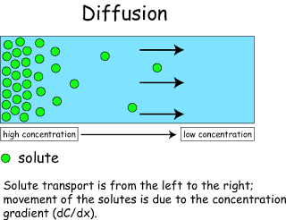

- Osmosis :
The diffusion of WATER across a SEMI-PERMEABLE MEMBRANE.
- 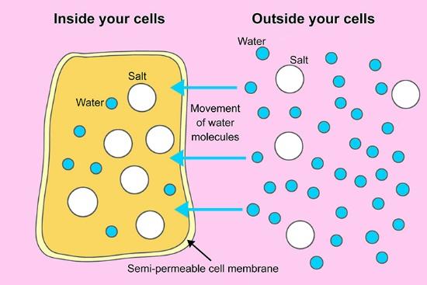

- Semi-Permeable Membrane :
Lets some things through and some not
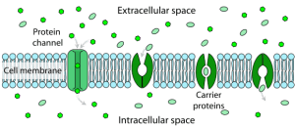

- Four Biologically Important Macromolecule :
  - Lipids
    - Oils, fats, wax…
    - Non-polar ; Hydrophobic (does not dissolve in water).
    - High in chemical energy.
  - Carbohydrates
    - Sugar, starch, cellulose.
    - Tend to be high in chemical energy.
    - Polar ; Hydrophilic (does dissolve in water).
    - Monosaccharide
      - Each molecule has a single sugar unit.
      - Ex. Glucose
    - Disaccharide
      - Each molecule has 2 sugar units.
      - Ex. Maltose, Sucrose, Lactose.
    - Polysaccharide
      - Starch, cellulose, glycogen. Polymer (glucose).
      - Long chain of smaller, simpler units. More than one
      - Polymer (a long molecule consisting of many similar or identical building blocks linked by a dehydration reactions) ; long chain of glucose.
  - Nucleic Acid
    - DNA, RNA
    - Storing genetic information and expressing genetic information.
    - Polymer of nucleotides
  - Protein
    - Enzymes, hormones, structure….
    - Also polymers of amino acids.
    - Some parts can be polar, while other parts can be non-polar.
    - 20 kinds of amino acids found in protein. Found in essentially all living things.
    - Primary Structure of a protein :
      - Sequence amino acids
    - Secondary Structure of a protein :
      - Repeated coils/ folds. Doesn't replace primary structure, just adds a layer.
    - Tertiary Structure of a protein :
      - Irregular folding of a chain of amino acids. Again, doesn't replace anything just adds another layer.
    - Quaternary Structure of a protein :
      - 2 or more chains aggregated to form a functional unit.
      - 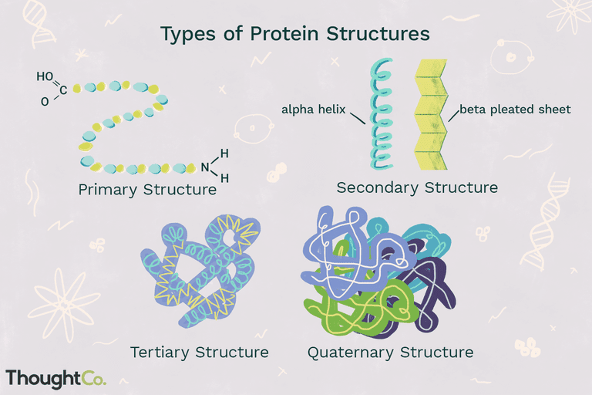

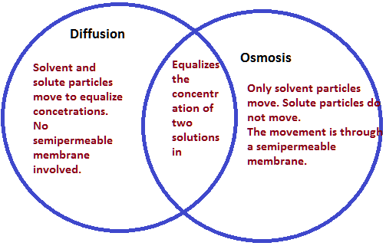

Biology

Life

- Response to environment.
- Exchange of materials with environment.
- Metabolism.
- Growth.
- Reproduction.
- Life is an emergent property of a particular arrangement of certain molecules.
  - Crystals have some properties of life.
  - Viruses are a grey area.

- Prokaryotic Cells :
  - Generally unicellular
  - NO true nucleus. Basically bacteria.
  - Typically simple.

- Eukaryotic Cells :
  - Also unicellular but can be multicellular.
  - DO have a true nucleus. Like plants, fungi, animals, etc..
  - 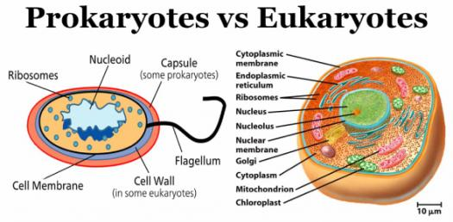

- Unicellular Organisms :
  - Each cell carries out all life processes. Each cell is its own independent unit.

- Multicellular Organisms :
  - Made up of many cells, with different cells specialized to preform different functions.

- Cells are small because they require a high surface to volume ratio to exchange materials with their environment.

- Cytosol :
  - Fills much of a cell, complex mixture of enzymes and many other molecules in water. Many chemical reactions take place here.
  - 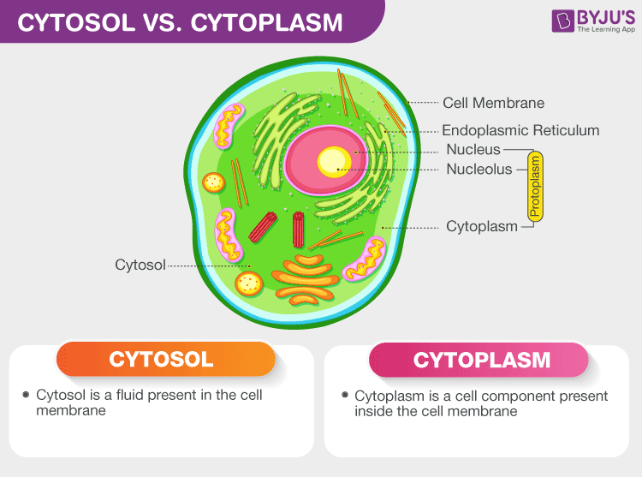

- Plasma Membrane :
  - Boundary between cell and its environment. Exchange with environment. Anything that makes it in or out of cell has to go through the plasma membrane. Non-polar tails of the molecule that makes up the plasma membrane but has a polar head. Which is called a phospholipid.
  - 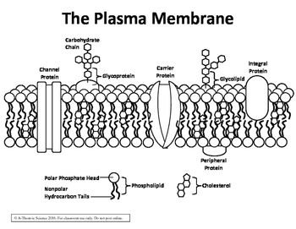

- Phospholipid Bi-Layer :
  - Primary component of the cell membrane, 2 layers of phospholipids. Polar head (phosphate head) allows head to interact with H2O (water). Non-polar (lipid tails) hate water.
  - The non-polar layer in the middle makes it relatively impermeable to polar molecules. Typically they get pulled back if they attempt to go through a non-polar area.
  - Non-polar molecules flow through freely (O2, lipids)
  - Small polar molecules (H2O, ethanol) diffuse through but much more slowly.
  - Larger polar molecules (glucose) and ions (not all polar but tend to stick to polar molecules) diffuse through hardly at all.
  - Number of proteins embedded in phospholipid bi-layer.
  - Fluid, molecules always moving. Not a hard surface.



