Introduction

The change in enthalpy is the heat flow of a reaction at constant pressure. An exothermic reaction will release heat to its surroundings. This means that the system will be decreasing in temperature. As a result, the enthalpy or heat content of the products in the reaction will be lower than that of the reactants. This indicates that the enthalpy change (ΔH), will be negative for the following reaction. On the other hand, there are also chemical reactions where heat is absorbed from the surrounding which means that the temperature of the system will increase. Thus, the enthalpy of the products will be higher than the reactants. This results in a positive enthalpy change. The overall enthalpy change of a reaction is dependent upon the number of bonds being broken and formed as well as the strength of such bonds when the reactants form the product.
Dissolution is a chemical process by which a solution is formed when a solute is dissolved in solvent, which forms a solution. Like many other reactions, this involves a change in energy. This is known as the enthalpy of dissolution. The enthalpy of dissolution is the change in energy which occurs when one mole of substance is dissolved in a sufficient amount of solid and it is dependent upon two factors; the lattice energy of an ionic compound and the enthalpy of hydration for its ions. Ionic compounds, also known as crystal lattice structures, are composed of ions held together in an ordered arrangement through electrostatic bonds. In order for an ionic compound to dissolve in water, its ions must first dissociate. The lattice energy is the energy released when one mole of an ionic compound is formed from its gaseous ions. This means that it is also the energy required to vaporize one mole of the ionic compound into one mole of its gaseous ions. This is an endothermic quantity. The second step in dissolution is hydration of the ions. The dipoles of the water molecules become attracted to the oppositely charged ions of the ionic compound. The positively charged hydrogen ends surround the anions while the negatively charged oxygen ends surround the cations. Gradually water molecules gather around the ions and form bonds with them. This process is known hydration, and the energy released upon the formation of these bonds is called the hydration energy. This is also known as the enthalpy of hydration which is the energy released when one mol of the gaseous ions are dissolved to form one mol of aqueous ions. This quantity is exothermic. The enthalpy of dissolution can therefore be found from the difference of lattice energy and the enthalpy of hydration.
Favourable conditions for dissolution result in an exothermic reaction (-ΔH_{sol}). The two salts we could choose from to manufacture our product were ammonium chloride and ammonium nitrate. Both of them are ionic compounds which are soluble in water; however, the enthalpy of dissolution for both of these salts are endothermic (+ΔH_{sol}). This means that they absorb energy from their surroundings. This is the case for ionic compounds which releases high amounts of energy upon formation. This means that their lattice energy is high and the electrostatic forces of attraction between its ions are high. The bonds are therefore stable and strong. For these salts, their hydration energy was unable to overcome the lattice energy of their ionic compounds, which resulted in an endothermic process. In other situations, where the lattice energy is lower than the hydration energy, it means that the salt will dissolve readily and exothermically.
We were tasked with manufacturing a device which would lower the temperature of water by 5.0°C over a period of 5 minutes. For our experimental design we chose to place a can filled with the 100 mL of water in a Styrofoam calorimeter. The calorimeter would contain a salt solution made from either ammonium chloride or ammonium nitrate dissolved in water. Both salts have a positive enthalpy for dissolution, meaning they dissolve endothermically. As a result, they absorb heat, causing their surrounds to decrease in temperature. This design was chosen because it allowed us to utilize the endothermic dissolution of the salt and translate it into the product. Therefore, when the salt is dissolved in the water, it begins to absorb heat from the drink, causing the temperature of water within the can to drop. The Styrofoam calorimeter would provide us with accurate readings of the decreasing temperature as it prevents heat loss. This would then allow us to more precisely gauge the amount of salt in grams needed to create the specified temperature change. The experimental goal would be achieved by finding the grams of salt needed to be dissolved in the water to absorb enough heat from the drink to create a 5.0°C drop in the temperature. The salt we chose to incorporate in our design was ammonium chloride. The ammonium chloride is acutely toxic and harmful in large quantities, but ammonium nitrate is an oxidizing agent. The ammonium nitrate could undergo a redox reaction with the aluminum can and potentially cause an explosion. Sodium nitrate is also explosive when heated to high temperatures. We cannot control the environment, so there may be other substances that could be oxidized and potentially cause a fire or explosion when in contact with the sodium nitrate as well. Since this puts an extreme safety risk on our consumers, we chose to manufacture the product with sodium chloride which is also the cheaper option.

Procedure
- Fill metal can with 100 mL of water.
- Use a 150 mL beaker to determine the amount of water that will be used to fill the calorimeter up to the point where the inflow of water makes the metal can just barely float.
- Decide which salt you will put into the water depending on their safety and price
- Use the thermochemical equations Q = mcΔt and ΔH_{sol} = Q/n to find the theoretical mass of the salt which should be put into the water to attain the 5.0°C decrease in temperature of the water within the can over five minutes.
- Write down the initial temperatures of the water in the can.
- Put the lid on the calorimeter and place the thermometer in the water within the can through the opening on the lid and attach it to the Lab Quest.
- Set the Lab Quest up to record the temperature of the water within the can for five minutes (300 seconds).
- Using a scoopula and weighting paper, measure out the amount of salt you need with a scale.
- Add the salt to the water surrounding the can in the calorimeter and then quickly cover the lid of the calorimeter and press play to record the results on the lab quests. Make sure to write down the final temperature of the water within the can.
- Repeat the process with a different mass of salt if the 5.0°C decrease was not observed. Rinse the calorimeter in between trials and dispose of the contents in the appropriate waste bin to get rid of any salt residue left behind from prior trials.
Discussion
Table 1
Trial Number | Water in the calorimeter (mL) | Initial temperature of water in can (°C) | Mass of ammonium chloride added (g) | Final temperature of water in can (°C) | Change in temperature Δt (°C)
1 | 75 | 22.7 | 11.50 | 18.6 | 4.2
2 | 75 | 22.3 | 12.50 | 18.0 | 4.3
3 | 75 | 22.4 | 15.10 | 17.1 | 5.3

The table above includes the initial and final temperatures for each trial with a different mass of the salt. The resulting temperature changes for each of the trials were also recorded after adding the salt and waiting five minutes. For the first trial, we found the theoretical mass of the ammonium chloride required to produce the desired temperature change of 5.0°C; however, it only decreased the temperature by 4.2°C. In the second trial, we increased the mass of the ammonium chloride we added by 1.0 g. This only increased the temperature change from the previous by 0.10°C. Seeing how the addition of 1.0 g only caused small difference between trial 1 and trial 2, we added another 2.60 g to get a total of 15.10 g of ammonium chloride added to the water within the calorimeter. This gave us the best trial as it brought us the closest to the 5.0°C decrease we required. The decrease in temperature for the third trial was 5.3°C. Despite being the closest to the needed results, the temperature change for this trial was a slightly too large.

Graph 1

Graph 1 describes the relationship between the mass of ammonium chloride dissolved and the resulting temperature change. Based off of this graph we can see that as the mass of the ammonium chloride is increased, the temperature change also increases gradually. This displays a direct linear relationship. In the first two trials, the mass of the ammonium chloride dissolved was too little to give us the temperature change of 5.0°C. Instead it gave us temperature changes that were lower than what was desired. In trial three we increased the grams of ammonium chloride dissolved by a to amount, which created a large jump in temperature change from the previous trials. In spite of this, the temperature change was now a little larger than the needed value at 5.0°C. Using the line of best fit we can interpolate our data and see that 15.0 g of the ammonium chloride would give us the 5.0°C temperature change we want.

Graph 2
Graph 2 looks at each of the trials and how their temperature decreased over the course of the five minutes following the addition of a specific mass of ammonium chloride. The first few seconds of each trial were lower than the recorded initial because the Lab Quest was stabilizing. During the rest of the time, the temperature of the water in the can decreased when the salt was added. This means that when the salt entered the water surrounding the can in the calorimeter, it underwent endothermic dissolution. It began absorbing the heat from its surroundings, which was the can containing the water or our hypothetical drink. This caused the temperature of the water within the can to drop. Trial 3 experienced the largest temperature decrease at 5.3°C, and was closest to the needed temperature change of 5.0°C. The data therefore indicates that our experimental design was a success as we managed to lower the temperature of the water within the can nearly to the 5.0°C within five minutes. With the corrected mass at 15.0 g of ammonium chloride which we obtained from the line of best on graph 1, we can achieve the desired temperature change.

These results show us that the procedure we made worked in terms of ensuring that we could manufacture a product which can cool drinks by 5.0°C over five minutes. However, there was some sources of error while carrying out the experiment which could have been improved upon. The first of which was that despite rinsing the calorimeter in between trials, there was still some salt residue that remained in the calorimeter. This meant that there was some inaccuracy in the masses we recorded for the amount we dissolved in each trial. Since the temperature change increases with a larger mass, this may have caused the temperature decrease in trial 2 and trial three to be larger than they should have been. In fact, this may have been the reason why our trial three temperature change slightly greater than 5.0°C. There was residue left behind from trial 1 and 2 which dissolved in addition to the mass of salt we added in trial 3. This caused the temperature decrease to be a larger than the desired temperature change. In order to tackle this, we could have rinsed out the calorimeter more than once or used a new calorimeter for each trial to avoid skewed results.
Another error was that the initial temperature of the water for each trial were different. The initial temperature of the water within the can should have been kept constant to provide a more controlled experimental study which allowed us to compare the temperature change between this initial temperature relative to the mass of the salt added between each of the trials. Due to the variance we must worry about factors such as the matter of whether or not the salt dissolved faster or in large amounts at a certain initial temperature of water as opposed to another. With the same initial temperature, we could eliminate these factors and just focus on the amount of salt dissolved and its effect. In order to improve upon this, we should have noted to make sure that all the water had the same initial temperature in the procedure. To do so, we could have used a thermometer to check the water temperature for the first trial and use the thermometer to check if the water had the same initial temperature for all the trials following.

While undergoing the procedure, we noticed some limitations which prevented us from getting the most accurate results was well. There was a limitation of speed. To get an accurate measurement of the temperature we would have to drop the salt into the water surrounding the can while also immediately putting the lid back on the calorimeter. This has to be done at the as fast as possible is to minimize any heat loss between the time the ammonium chloride is added and when the top of the calorimeter is open. During the trials, we were occasionally delayed in our movements and the lid would be open for slightly longer than it should have. This allowed heat to escape which would make the temperature change recorded less accurate. To minimize this limitation, we should have only slightly opened the lid to add our salt in order to swiftly be able to close it once dissolution began.
Finally, there was a limitation with our equipment. It’s true that Styrofoam is an inexpensive material that preserve heat fairly well; however, unlike bomb calorimeters, there will always be some heat loss. In order to prevent this, we could have added extra insulation with cotton or foil to preserve even more heat and attain more accurate measurements of the temperature.

Conclusion
During this experiment, we saw that as the amount of ammonium chloride dissolved in the surrounding water around the can increased, so did the temperature change. This shows the amount of salt dissolved is directly proportional with the change in temperature. Thus, with our experimental designed, the salt solution was able to absorb enough heat to create the 5.0°C decrease with an exact value of 15.0 g of ammonium chloride dissolved. The percent error was 31.30%.

References
^{1.} “What in the World ISN’T Chemistry”, General Chemistry Laboratory Manual, Dr. Rashmi Venkateswaran, 2019.

^{2.} Lumen Learning, “Heat of Solution”, Retrieved from https://courses.lumenlearning.com/introchem/chapter/heat-of-solution/, Accessed 2 October 2019

^{3.} Fisher Scientific, “Ammonium Chloride, Lab Grade”, Retrieved from https://beta-static.fishersci.com/content/dam/fishersci/en_US/documents/programs/education/regulatory-documents/sds/chemicals/chemicals-a/S25168C.pdf, Accessed 2 October 2019

^{4.} Encyclopaedia Britannica, “Ammonium nitrate”, Retrieved from https://www.britannica.com/science/ammonium-nitrate, Accessed 2 October 2019

Design of Can
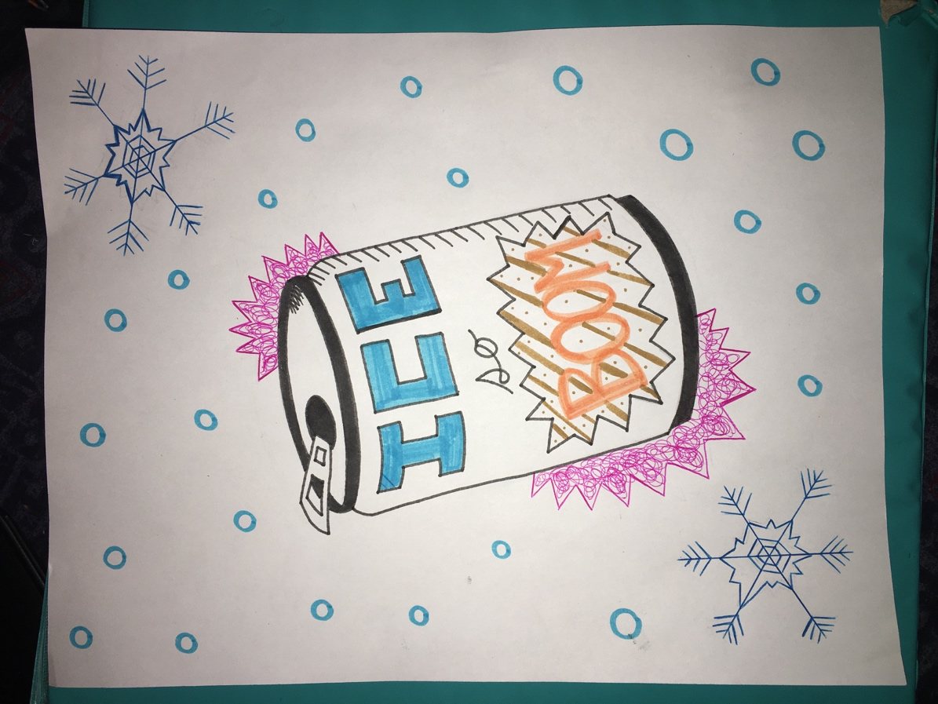

Appendix
Calculations
Find approximate mass of salt
Q = mcΔt
Q = (100 mL + 75 mL)(4.18 J/g°C)(5.0°C)
Q (175 mL) (4.18 J/g°C)(5.0°C)
Q = 3657.5 J
Q = 3.7 KJ

ΔH = Q/n
+17 kJ/mol = 3.7 KJ/n
n = 0.215 mol
n = 0.22 mol

m(NH₄CL) = nM
m(NH₄CL) = (0.215 mol)(53.49 g/mol)
m(NH₄CL) = 1.2 x 10 g

Find exact mass of salt
The line of best fit shows us that the 5.0°C temperature change occurs at exactly 15.00 g

Calculate the percent error
% error = (exact – approximate/approximate) x 100%
% error = (15.10 g – 11.50 g)/(11.50 g) x 100%
% error = 31.30%

Raw Data
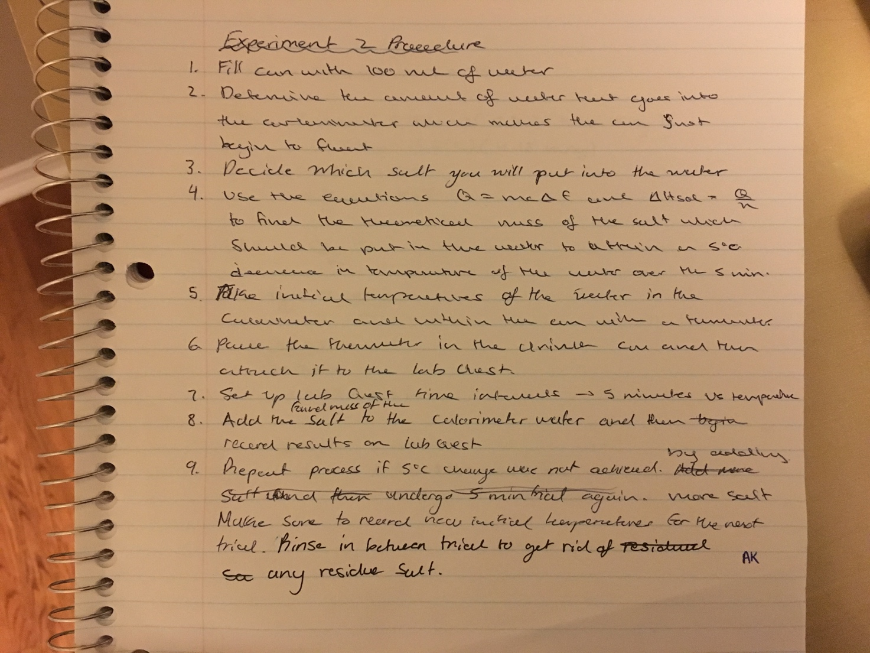

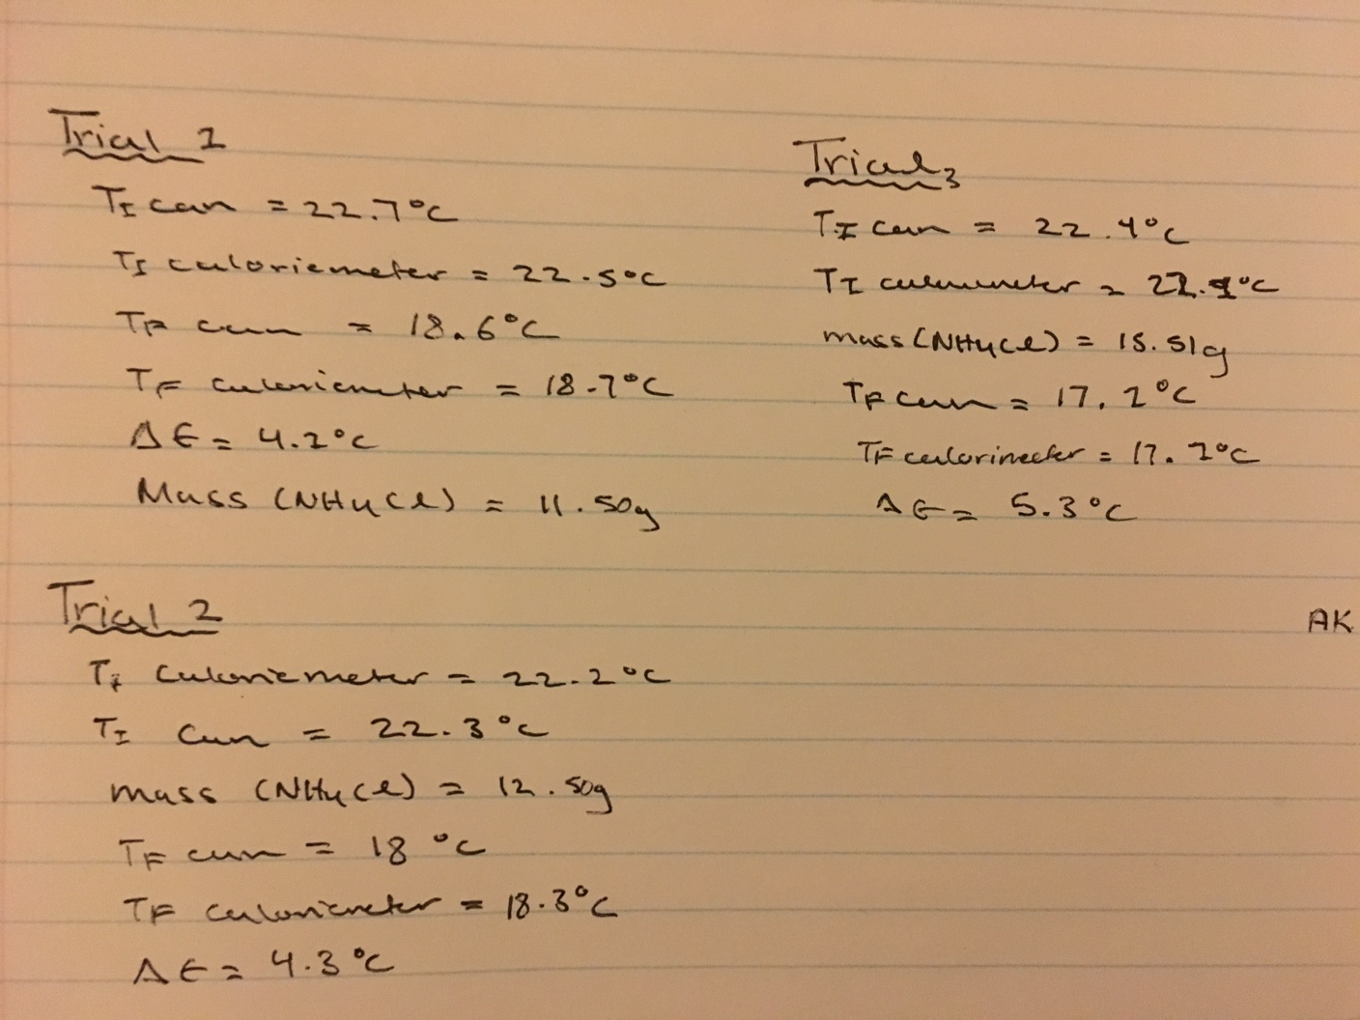

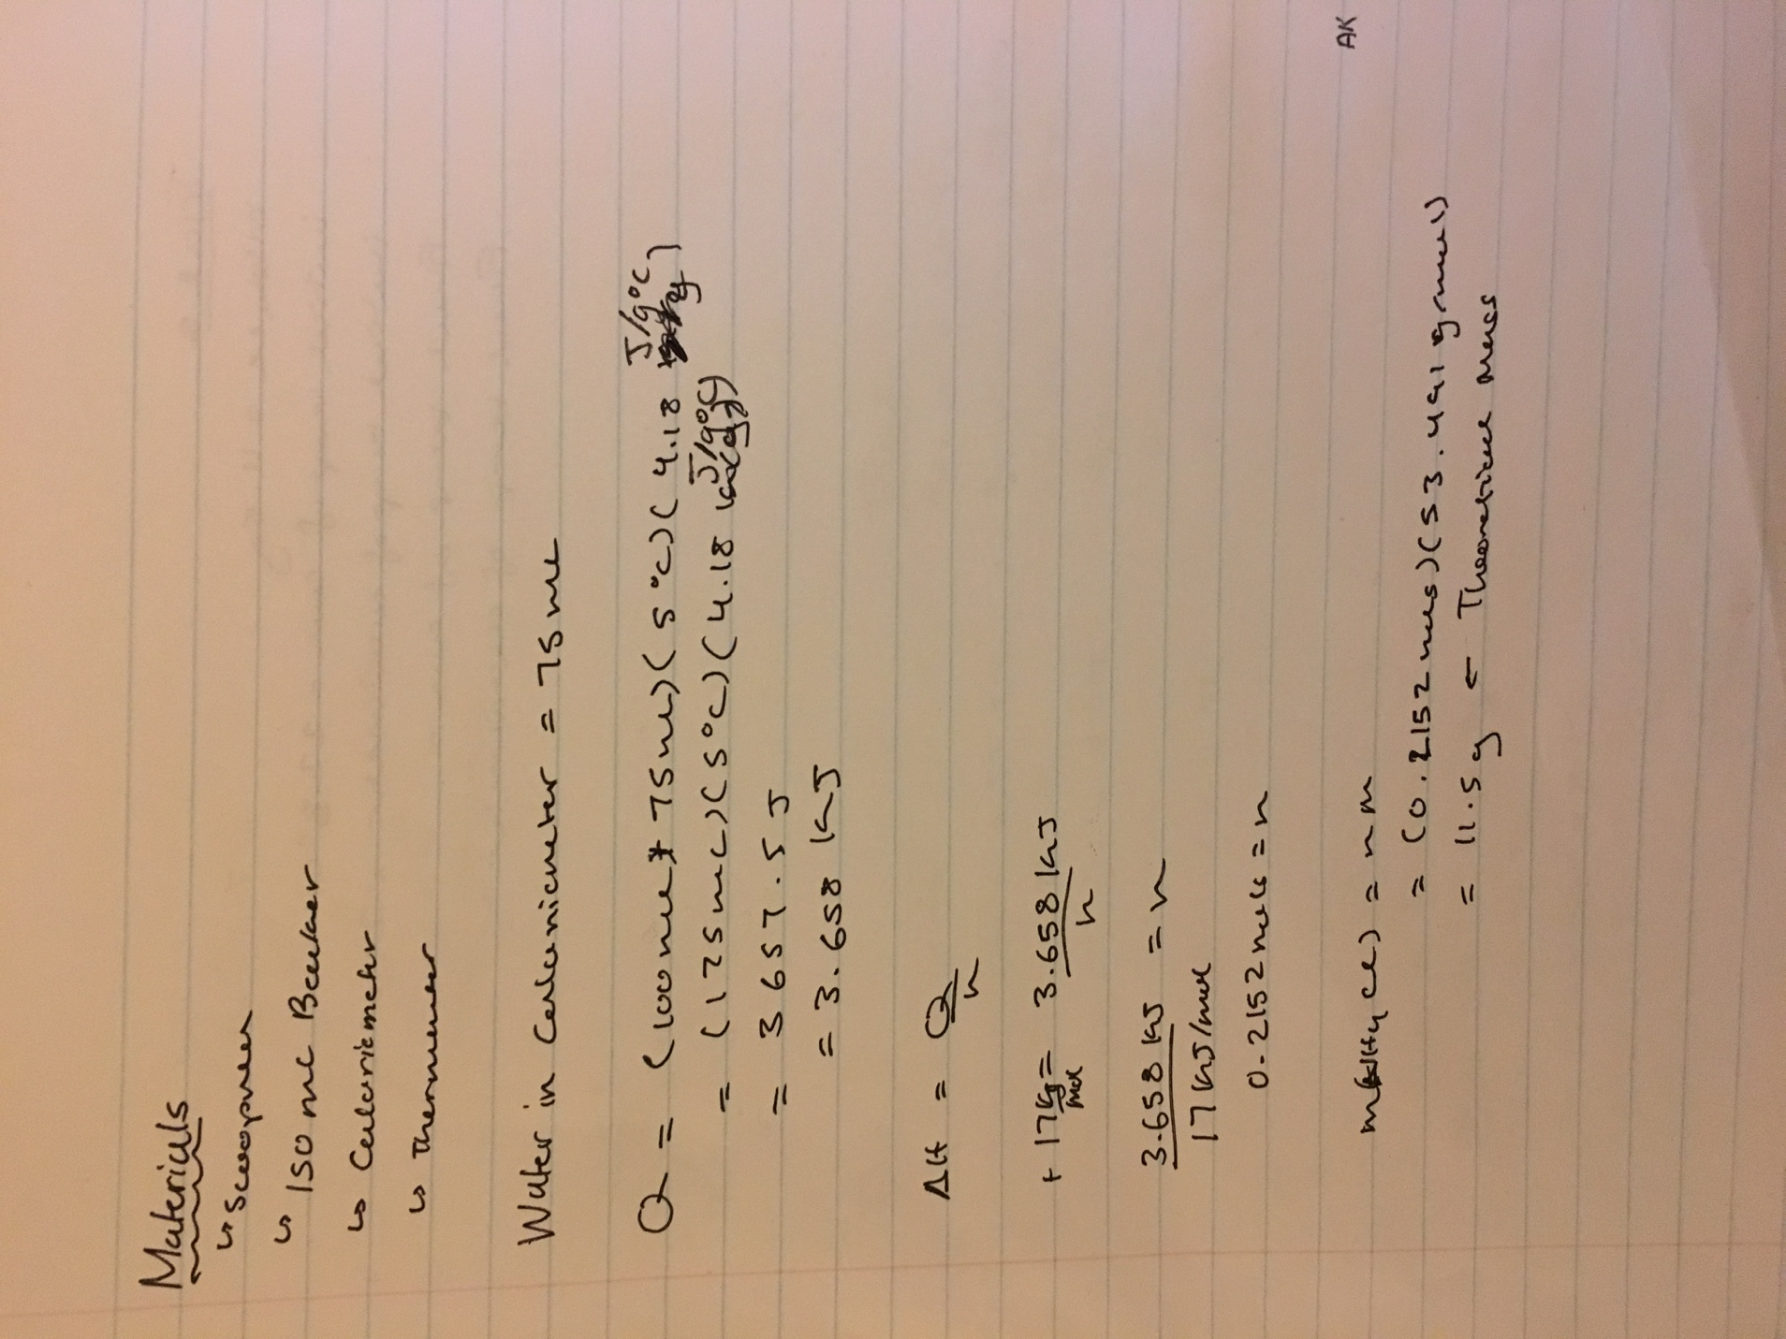

“What in the World ISN’T Chemistry”, General Chemistry Laboratory Manual, Dr. Rashmi Venkateswaran, 2019.
https://courses.lumenlearning.com/introchem/chapter/heat-of-solution/
https://beta-static.fishersci.com/content/dam/fishersci/en_US/documents/programs/education/regulatory-documents/sds/chemicals/chemicals-a/S25168C.pdf
https://www.britannica.com/science/ammonium-nitrate

