Lab1
19/20
Aziz

Objectives:
The main objectives:
o Construct simple combinational logic circuits from a schematic.
o Experimentally determine the functional operation of simple combinational logic
circuits.
o Identify equivalent logic gates to those produced by various circuit configurations
from the resulting truth table.
o Connect various gates together to create simple logic functions.
o Analyze combinational logic circuits and predict their operation.
o Construct and test more complex combinational logic circuits.
The sub-objectives:
To gain the required skills to use Quartus II to create logic circuits;

Equipment and components used:
Quartus II 13.0 Service-Pack 1
Altera DE2-115 card

Part I – Combinational Logic Circuits Construction
Circuit diagram:
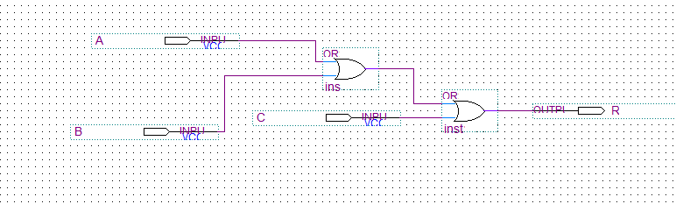
(A+B) +C=R
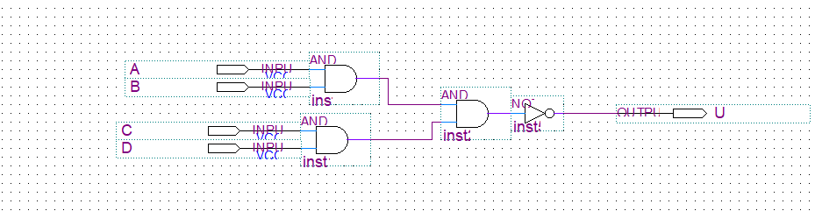
[(AB)(CD)]’=U

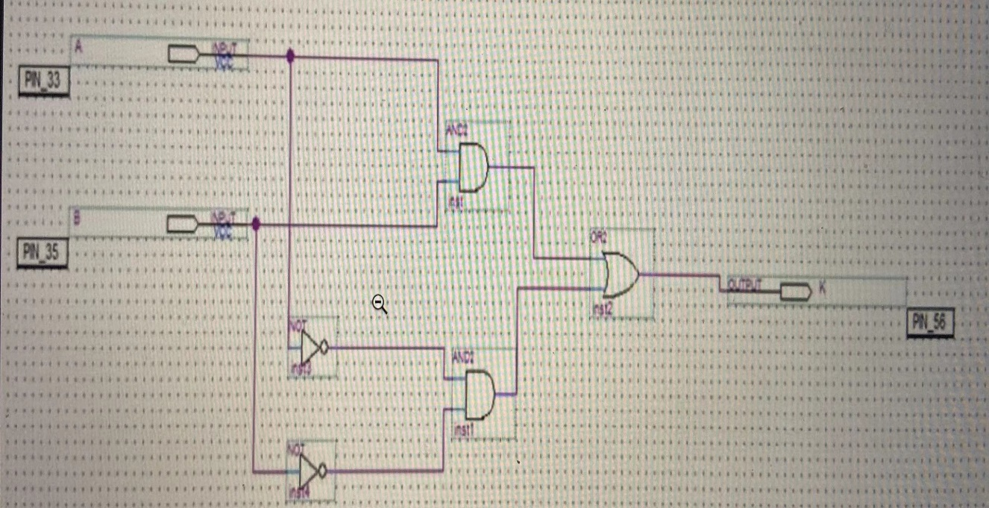
AB+A’B’=K

Experimental data and data processing:
A | B | C | D
0 | 0 | 0 | 0
0 | 1 | 0 | 1
0 | 0 | 1 | 1
1 | 0 | 0 | 1
1 | 0 | 1 | 1
1 | 1 | 0 | 1
0 | 1 | 1 | 1
1 | 1 | 1 | 1
1.1

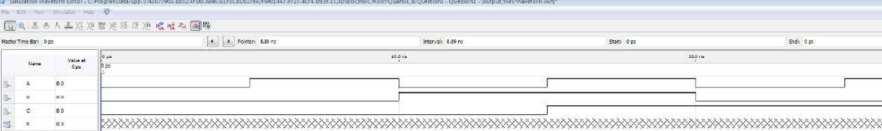

1.2
A | B | C | D | U
1 | 0 | 0 | 0 | 1
1 | 1 | 0 | 0 | 1
1 | 0 | 1 | 0 | 1
1 | 0 | 0 | 1 | 1
1 | 1 | 1 | 0 | 1
1 | 1 | 0 | 1 | 1
1 | 1 | 1 | 1 | 0
0 | 0 | 0 | 0 | 1
0 | 1 | 0 | 0 | 1
0 | 0 | 0 | 1 | 1
0 | 1 | 1 | 0 | 1
0 | 1 | 0 | 1 | 1
0 | 1 | 1 | 1 | 1
0 | 0 | 1 | 0 | 1
1 | 0 | 1 | 1 | 1
0 | 0 | 1 | 1 | 1

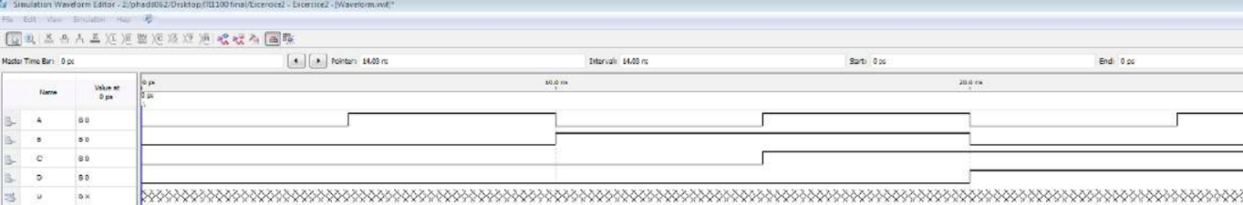
1.3
A | B | K
1 | 1 | 1
1 | 0 | 0
0 | 1 | 0
0 | 0 | 1

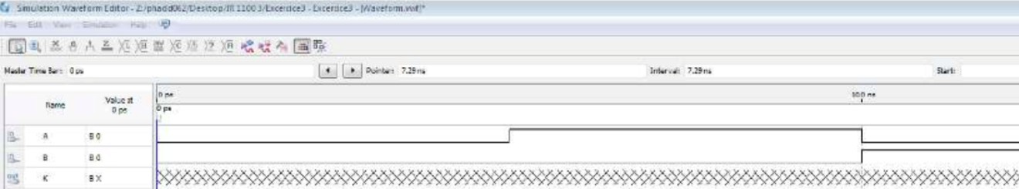

The following truth table represent the experimental data (on the left) and the expected data (on the right)
(A+B) +C=R
Experimental expected

A | B | C | D
0 | 0 | 0 | 0
0 | 1 | 0 | 1
0 | 0 | 1 | 1
1 | 0 | 0 | 1
1 | 0 | 1 | 1
1 | 1 | 0 | 1
0 | 1 | 1 | 1
1 | 1 | 1 | 1
A | B | C | D
0 | 0 | 0 | 0
0 | 1 | 0 | 1
0 | 0 | 1 | 1
1 | 0 | 0 | 1
1 | 0 | 1 | 1
1 | 1 | 0 | 1
0 | 1 | 1 | 1
1 | 1 | 1 | 1

[(AB)(CD)]’=U
Experimental Expected
A | B | C | D | U
1 | 0 | 0 | 0 | 1
1 | 1 | 0 | 0 | 1
1 | 0 | 1 | 0 | 1
1 | 0 | 0 | 1 | 1
1 | 1 | 1 | 0 | 1
1 | 1 | 0 | 1 | 1
1 | 1 | 1 | 1 | 0
0 | 0 | 0 | 0 | 1
0 | 1 | 0 | 0 | 1
0 | 0 | 0 | 1 | 1
0 | 1 | 1 | 0 | 1
0 | 1 | 0 | 1 | 1
0 | 1 | 1 | 1 | 1
0 | 0 | 1 | 0 | 1
1 | 0 | 1 | 1 | 1
0 | 0 | 1 | 1 | 1
A B C D U
1 0 0 0 1
1 1 0 0 1
1 0 1 0 1
1 0 0 1 1
1 1 1 0 1
1 1 0 1 1
1 1 1 1 0
0 0 0 0 1
0 1 0 0 1
0 0 0 1 1
0 1 1 0 1
0 1 0 1 1
0 1 1 1 1
0 0 1 0 1
1 0 1 1 1
0 0 1 1 1

AB+A’B’=K
Experimental Expected

A | B | K
1 | 1 | 1
1 | 0 | 0
0 | 1 | 0
0 | 0 | 1
A | B | K
1 | 1 | 1
1 | 0 | 0
0 | 1 | 0
0 | 0 | 1

Discussion and conclusion:
As shown above, the experimental data of our lab is the same as what we expected to have. This means that the three logical circuits we created during the lab were built correctly. Since the experimental data is the same as what we expected, that means the logic gate function is we expected is the correct logic gate function. And all the main objectives of the lab were met.

Lab data sheet:


