Chapter 4: External Environment
What is the Environment?
- Definition: the conditions that surround someone or something
- Organizational Environment: elements outside the boundary of the organization that have the potential to affect the organization
- Domain: the chosen environment field of action. It defines the organization’s niche and those external sectors in which the organization will interact to accomplish its goals
- Sector: subdivision of the external environment that contain similar elements. Each organization divides into ten sectors

Why is the environment important?
Organizations like stability and control. But no organizations are self-sufficient and self-contained – they are open systems:
  - Understanding how an organization behaves requires understanding the context
  - What threats, constraints, and opportunities come from outside sources?
Needs of an organization
  - Resources from the environment (finances, raw materials, human capital, government support...)
  - Information about the environment (competitors, customer preferences, regulations, suppliers, financiers…)
Survival = function of ability to acquire and maintain resources

The Environment Categorized
- Task Environment: sectors that have a direct impact on the organization’s ability to achieve its goals. It includes the industry, raw materials and market sectors, and perhaps the human resources and international sectors
- General Environment: sectors that have an indirect impact on the organization’s ability to achieve its goals. It includes the government, sociocultural, economic conditions, technology and financial resources sectors. Eventually, these sectors affect all organizations.
- International Context: growing importance from the international sector. The environment for all organizations is becoming extremely complex and competitive.
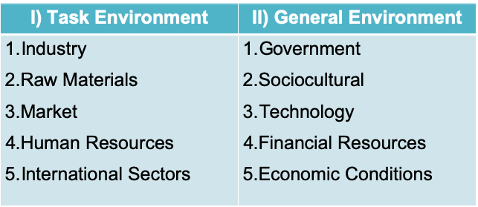

- Sectors in the Task Environment
1. Industry: competitors, industry size
2. Raw Material: suppliers, manufacturers
3. Market: consumers, clients
4. HR: employment agencies, universities, training schools
5. International: globalization (outsourcing, etc)
- Sectors in the General Environment
- Government
- Subsidy provision
- Import/Export barriers
- Taxation
- Social welfare policy
- Sociocultural
- Population demographics
- Social mobility/Income Distribution
- Level of education
- Lifestyle changes
- Technology
- Industry focus on technological efforts
- Speed of technology transfer
- Rate of obsolescence
- E-commerce
- Financial Resources
- Access to loans
- Availability of stock markets
- Venture capital
- Economic Conditions
- Business Cycle/Crises
- Access to financial markets
- Interest rates/ Money Supply
- Inflation

Environmental Uncertainty and Dependence
Many of an organization’s behaviors are attempts to reduce uncertainty and dependence:
  - Uncertainty: an inability of org decision-makers to control or predict aspects of the environment (depends on complexity and rate of change)
  - Dependence: a reliance upon an outside source for an organization to achieve its goals

- Environmental Uncertainty
Uncertainty stems from lack of information and difficulty in predicting changes. It has two dimensions:
- Environmental Complexity: Simple-Complex
  - How many of the environmental sectors does the organization have to deal with? Are they similar or diverse?
  - The number and dissimilarity of external elements relevant to an organization’s operations
  - Concerns environmental complexity, which refers to heterogeneity, or the number and dissimilarity of external elements relevant to an organization’s operations. Complex environment: organization is influenced by numerous diverse external elements. Simple environment: organization interacts with or is influenced by only a few similar external components
- Environmental Change: Stable-Unstable
  - Are these sectors changing?
  - Frequency of changes, size of changes, and predictability of changes
  - Refers to whether elements in the environment are dynamic. Environmental domains seem to be increasingly unstable for most organizations. Although environments are more unstable today, an example of a traditionally stable environment is a public utility such as a provider for water, gas and electricity
  - Stable environment: if it remains the same over a period of months or a year
  - Unstable environment: environmental elements shift abruptly. May occur when competitors react with aggressive moves

As uncertainty increases, organizations can:
- Implement planning and forecasting to prepare for uncertainty.
  - Why is this often insufficient?
- Switch from formal, centralized systems (mechanistic) to informal, decentralized systems (organic)
  - Use horizontal rather than vertical structure
  - Increasingly professionalized work force
- Create positions or even departments for each sector (increased differentiation) and hire individuals to coordinate across departments (integration)
- Introduce “boundary spanning” roles to link an org to its environment (e.g. business intelligence/brokers)
- Buffering (absorbs changes from the environment so the technical cores don’t have to) to absorb environmental uncertainty

- Environmental Change
Resource Dependence Theory
- Organizations are dependent upon their environment for survival, so they strive to gain control over critical resources in the environment. Companies want to reduce vulnerability with respect to resources by developing links with other organizations, but they also like to maximize their own autonomy and independence. Dependence on shared resources gives power to other organizations.
- Dependence is the opposite of power:
  - Orgs are vulnerable if vital resources are controlled by other organizations, so they try to be as independent as possible
- Organizations seek power in their relationships to reduce dependence and gain control over the environment
  - Reduce their own dependence on external factors
  - Increase others’ dependence on them

Critical factors of dependence (Pfeffer and Salancik, 1978):
  - Resource importance: How important is the resource to the organization? Can it function without the resource?
  - Discretion over the resource held by another social actor (possession, access, regulation, etc.)
  - Resource Concentration: Do few alternatives exist for the resource? Is it scarce?
- Dependence = the product (X) of these three factors
Dependence does not occur if…
- The resource is unimportant
- The exchange partner’s discretion over the resource is tenuous
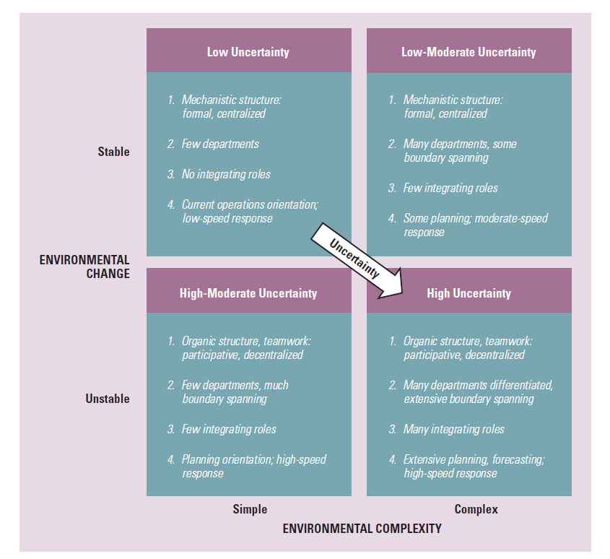
- There are many sources of supply or potential customers
Reducing Resource Dependence
Organizations try to maintain a balance between linkages with other organizations and their own dependence. They try to maintain this balance through attempts to modify, manipulate or control other organizations. There are two strategies to manage resources:
- Establish favorable linkages with key elements in the environment
- Shape the environment domain

- Establish Interorganizational Linkages | - Shape the environment domain
- Ownership | 1. Change of Domain
- Formal Strategic Alliances | 2. Political Activity, Regulation
- Cooptation, Interlocking Directorates | 3. Trade Association
- Executive Recruitment | 4. Illegitimate Activities
- Advertising, Public Relations

- Establish Interorganizational Linkages
- Ownership: when a company buys a part of or is a controlling interest in another company, this gives the company access to technology, products or other resources. Acquisition involves the purchase of one organization by another so that the buyer assumes control. Merger is the unification of two or more organizations into a single unit.
- Formal Strategic Alliances: when there is a high level of complimentarily between the business lines, geographical positions or skills of two companies, the firms often go the route of a strategic alliance rather than ownerships through merger or acquisition. This is done through contracts: license agreements that involves the purchase of the right to use an asset for a specific time or supplier arrangements that contract for the sale of one firms’ output to another. Joint ventures are a creation of a new organization that is formally independent of the parents, although the parents will have some control. Sharing of risks and costs with large projects or innovations.
- Cooptation, Interlocking Directorates: cooptation is when leaders from important sectors in the environment are made part of an organization (board of directors). Interlocking directorate is formal linkage that occurs when a member of the board of directors of one company sits on the board of another company (can influence policies and decisions). Direct interlock = this person is the direct link between two companies. Indirect interlock = when director of company A and B are both in the board of directors of company C
- Executive Recruitment: transferring or exchanging executives
- Advertising, Public Relations: traditional way of establishing favorable relationships is through advertising. Organizations spend large amounts of money to influence the tastes and opinions of consumers. It is important in highly competitive industries and in industries that experience variable demand. Public Relations is similar to advertising, but the stories are often free and aimed at public opinion. PR people cast an organization in a favorable light in speeches, on websites, in press reports, and on television. PR attempts to shape the company’s image in the minds of customers, suppliers and government officials

- Shape the environment domain
- Change of Domain: an organization may try to find a domain where there is little competition, no government regulation, abundant suppliers, affluent customers and barriers to keep competitors out. Acquisition deals with company’s in other domains
- Political Activity, Regulation: techniques to influence government legislation and regulation, like lobbyists and working with other organizations, also lobbying by CEO
- Trade Association: accomplished jointly with other organizations that
- Illegitimate Activities: certain conditions (i.e low profits, pressure from senior managers, scarce environmental resources) may lead managers to adopt illegitimate behaviour

Adapting to Environmental Uncertainty
Aspects of organizations that differ as uncertainty increases:
- Positions and departments
- Buffering and boundary spanning: buffering exists to absorb uncertainty from the environment, they support the technical core and exchange materials, resources and money between the environment and the organization. Boundary spanning links and coordinates an organization with key elements in the external environment and the purpose is to exchange info to (1) detect & bring into the organization info about changes in the environment; (2) send info into the environment that presents the organization in a favourable light. They prevent the organization from deteriorating by keeping top managers informed about environmental changes. As uncertainty increases, orgs drop buffers because they believe being well connected to customers and suppliers is more important than internal efficiency. Boundary-spanning roles are introduced to make it more fluid and adaptable.
- Differentiation and Integration becomes more specialized, frequent changes require more information processing to achieve horizontal coordination, so integrators become a necessary addition.
- Organic vs. Mechanistic Management Prcoess: we see a shift from rules, procedures and clear hierarchy to looser, free-flowing, adaptive structure

Chapter 5: Interorganizational Relationships
Organizational Ecosystems
- Definition: a system formed by the interaction of a community of organizations and their environment (Daft & Armstrong, 2017, p. 281)
- Cuts across traditional industry lines
  - Google: Open source, no strings attached services
  - Question: Who is Apple’s biggest component supplier? Samsung their biggest competitor, LG
What does this mean for managers?
- Move beyond creating org structures, defining strategies and control systems
- Think about horizontal linkages: with suppliers, distributors, customers, etc.
- Managers learn to see and appreciate the rich environment of opportunities that grow from cooperative relationships with other contributors to the ecosystem.
- Rather than trying to force suppliers into low prices or customers into high prices, managers strive to strengthen the larger system evolving around them, finding ways to understand this big picture and how to contribute

Interorganizational Framework
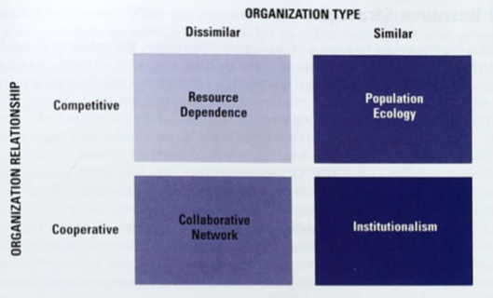

Resources Dependence VS. Collaborative Network
Resource Dependence | Collaborative Network
Organizations do best by being autonomous and independent | Cooperation is a prerequisite for greater innovation, problem solving, and performance
Dependence on another increases risks | Dependence on another company reduces risks
Dependence is the opposite of power | Organizations join together to become more competitive and share scarce resources
Orgs do whatever is needed to avoid excessive dependence on the environment to maintain control of resources and reduce uncertainty | Trust and long-term commitment can be developed among orgs

Three Structural Options
“Make or buy” decision: What are some of your options?
- Develop from scratch
  - Don’t have to share the pie, but risky
- Take over an organization with the needed resources
  - Make sure you are aware of the acquisition premium and keep the resources
- Enter into a collaborative arrangement
  - Fast, but you have to share the pie
When are each of these options attractive?
  - collaborative: unstable, risky environment, entering a new market, complex, change
  - scratch: when you’re a monopoly
  - take over: when you need the resources and have enough $$ to do so, like apple

Organizational Boundaries: Managing environmental uncertainty & dependence
- How do organizations gain control over critical resources such as functional activities, supplies, materials, and information?
- Three structural options to obtain these resources:
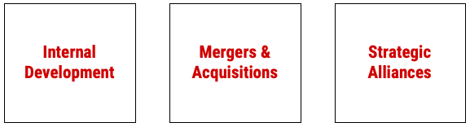

Make or Buy Decision:
Choice between in-house production and outsourcing determines the boundary of an organization:
- The question is: “Can you go it alone?”
- In-house production through internal development or M&A: Expand organizational boundaries
- Collaboration with other organizations through outsourcing: Reduce or maintain organizational boundaries
i.e Starbucks
- Despite Starbucks’ large supply needs, growing its own high-quality coffee was an option that was never seriously considered. This makes them resource-dependent and there is perhaps an issue of quality control because they don’t grow their own coffee beans.
- Why do you think this shouldn’t be a structural option for Starbucks? climate is hard to control, too much work

Organizational Boundaries
Back to our question: How do organizations gain control over critical resources such as functional activities, supplies, materials, and information?

Three structural options vary in terms of network “ownership”. What does this mean?
Mergers & Acquisitions
Strategic Alliances
Internal Development
Internalization (In-house Production)
Outsourcing
Inter-organizational linkage
No Inter-organizational linkage

What is the Secret of Transat’s Success?
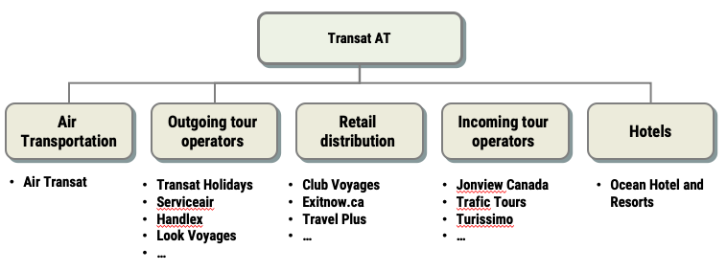
Why do they own an airline? Strongly interdependent divisions, economies of scope, planes are just a tool, they get planes they need for their market, fully vertically integrated
“The Why” (Why internalize? What are advantages of in-house production?)
- Gain full control over its input or output resources
- Improve product quality and scheduling
- Save on raw material costs or distribution costs
- Reduce bargaining power of suppliers, or buyers and rely less on them …
Potential risks of this approach:
- Inflexibility, especially when an outside supplier or distributor may provide a better product / service at a lower cost
- Bureaucratic costs

Collaborative Networks
- Companies join together to become more competitive and to share scarce resources
- Large aerospace firms partner with one another and with smaller companies and suppliers to design next-generation jets
- Large pharmaceutical companies join with small biotechnology firms to share resources and knowledge and spur innovation
- Consulting firms, investment companies and accounting firms may join in alliances to meet customer demands for expanded services

Why Collaboration?
- Sharing risk when entering new markets
- Mounting expensive new programs
- Reducing costs
- Enhancing organizational profile in selected industries or technologies
- Cooperation is a prerequisite for greater innovation, problem solving and performance
- Partnerships are a major avenue for entering global markets, with both large and small firms developing partnerships overseas

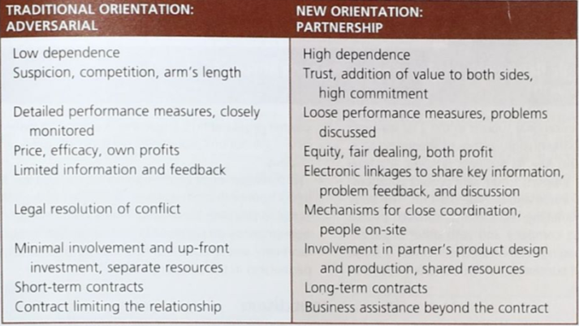

Population Ecology
- Population Ecology focuses on organizational diversity and adaptation within a population of organizations
- A population is a set of organizations engaged in similar activities with similar patterns of resource utilization and outcomes i.e. financial institutions in Montreal
- Innovation and change in a population of organizations take place though the birth of new types of organizations more so than by the reform and change of existing organizations
- New organizations meet the new needs of society more than established organizations that are slow to change
- The population-ecology model is developed from theories of natural selection in biology, and the terms evolution and selection are used to refer to the underlying behavioural processes. Theories of biological evolution try to explain why certain life forms appear and survive whereas others perish. Some theories suggest the forms that survive are typically best fitted to the immediate environment.

Organizational Form & Niche
- Organization form is an organization’s specific technology, structure, products, goals and personnel, which can be selected or rejected by the environment
- Each new organization tries to find a niche (a domain of unique environmental resources and needs) sufficient enough to support it
- Niche is usually small in the early stages of an organization but may increase in size over time if the organization is successful
- If the organization does not find an appropriate niche, it will decline and may perish
- Process of Ecological Change (think evolution & natural selection)
- The process of change in the population is defined by three principles that occurs in the stages: variation, selection and retention
- Variation: large number of variations appear in the population of organizations
- Some may be conceived to meet the perceived needs of the external environment
- The new organizational forms are initiated by entrepreneurs, established by venture capitalists or set up by the government seeking to provide new services
- Selection: is the organizational form suited for the environment? Can it survive?
- Some organizations find a niche or acquire resources and are able to survive
- Only few variations are selected by the environment and survive over the long term
- Retention: few organizations grow large and become institutionalized
- Products and services become highly valued
- Means that it becomes a general norm in society
Important Question: Why do new organizational forms appear?
- Answer: because they meet the new needs of society, more than established organizations that are slow to change.
- New org forms fill a new niche, and over time they take away business from established orgs.
- Role of Environment – the changing environment determines which organizations survive or fail
- The Reason – it is assumed that individual organizations suffer from inertia and find it difficult to adapt to environmental changes
i.e. Zappos, Lyft, pwc

What causes inertia (i.e. why don’t organizations change)?:
- Heavy investment in capital costs (plants, equipment, etc.)
- Limited information
- Established view points of managers/decision makers
- Orgs previous performance history
- Challenges in changing org culture

Strategies for Survival
- Generalists: wide range or products or services, serves a broad market
- wide breadth protects them somewhat from environmental changes
- able to reallocate resources internally to adapt to changing environments

- Specialists: narrower range of products or services, serves a narrower niche
- often smaller companies, more flexible in adapting to environmental changes
- can sometimes be faster at adapting to changes

Institutionalism
- Institutional Perspective describes how organizations survive and succeed through congruence between an organization and the expectations from its environment
- Institutional Environment is composed of norms and values from stakeholders (customers, investors, associations, boards, other organizations, government, the community)
- Thus, the IE view believes that organizations adopt structures and processes to please outsiders, and these activities come to take on rules like status in organizations
- The IE reflects what the greater society views as correct ways of organizing and behaving
- The notion of legitimacy answers an important question for institutional theorists: why is there so much homogeneity in the forms and practices of established organizations?
- When an organizational field is just getting started, diversity is the norm
- New organizations fill emerging niches
- However, once an industry becomes established, there is an invisible push towards similarity. Isomorphism is the term used to describe this move towards similarity

Institutional Theory in Brief
Societal institutions are powerful forces for ensuring control and order:
- In responding to institutional pressures, organizations develop isomorphic (similar) strategies, structures, and systems.
- Normative, coercive, and mimetic forces make all organizations look the same
- Goal: to obtain social legitimacy
- Outcome: predictability, conformance to norms and expectations
- Example: banks, universities, pharmacies
Institutionalism:
- The organizational environment contains cultural prescriptions (norms, beliefs, and stakeholder expectations) for organizational structure and actions
- Organizations need to signal conformity with those prescriptions to internal and external audiences
Legitimacy:
- The general perception that an organization’s actions are desirable, proper, and appropriate within the environment’s system of norms, values, & beliefs
- Pop. Ecology: congruence with the environment
- Institutionalism: congruence with the expectations of the environment

What about companies that only pretend?
- Companies are starting to promote green marketing because it is a growing trend i.e. Fiji frames themselves as going green, untouched by man, the risks are ppl can call them out on it, but people still buy it probably because many other companies are doing the same thing
- We can relate this issue to espoused values and underlying assumptions because espoused values are different from artifacts so there exists a contrast
- i.e. Long Island Iced tea changing name to long blockchain corp in order to attract bitcoin users in tech companies
- i.e. skypeople juice changes name to future fintech in order for stocks to go up
- What is going on & what are the similarities to greenwashing?
Answer: they are aiming to gain legitimacy amongst consumers by following trends
- What is the difference here from population ecology?
Answer: population ecology filters these trends more and make adjustments whereas institutionalism blatantly follows trends due to conformity. They use cultural artifacts and espoused values without changing underlying assumptions whereas in population ecology, they make changes to the underlying assumptions in order to match the cultural artifacts & espoused values

The Institutional View & Organization Design
- The institutional view also sees organizations as having two essential dimensions—technical and institutional
- The technical dimension is the day-to-day work, technology and operating requirements. It is governed by norms of rationality and efficiency.
- The institutional structure is that part of the organization most visible to the outside public. It is governed by expectations from the external environment.

Institutional Similarity
- It is also called Institutional Isomorphism is the emergence of a common structure and approach among organizations in the same field.
- Homogeneity increases over time
- Efficiency is NOT (necessarily) the primary reason for change, it’s more about conformity
- Isomorphism is the process that causes one unit in a population to resemble other units that face the same set of environmental conditions. There are three mechanisms used for institutional adaptation…

Three Core Mechanisms:
- Mimetic Forces
- Results from responses to uncertainty
- The pressure to copy or model other organizations occur
- Benchmarking means identifying who is best at something in an industry and then duplicating the technique for creating excellence, perhaps even improving it in the process
- “We want to adopt this [blank]”
- Copying what successful and/or legitimate others are doing
- Uncertainty reduction by adopting such practices because you see that the companies are doing well

- Coercive Forces
- Stems from political influence
- They are the external pressures exerted on an organization to adopt structures, techniques or behaviours similar to other organizations
- “We have to adopt this [blank]” i.e. way we dress, structure, automaker makes a certain level of fuel efficiency etc.
- Legal or political pressures/prescriptions (Organizational change is a direct response to government mandate) i.e. Canadian Charter of Rights and Freedoms
- Any large power, not just government, can coerce orgs to behave. i.e. activists, public pressure, media
- Consequences of not following coercive isomorphism threats can come from government, public, media, activists etc.

- Normative Forces
- Results from common training and professionalism
- Pressures to change in order to achieve standards of professionalism and to adopt techniques that are considered by the professional community to be up to date and effective
- Changes may be in any area, such as information technology, accounting requirements, marketing techniques or collaborative relationships with other organizations
- “We should adopt this [blank]” you adopt a behavior just because, not really sure why
- Professional standards and techniques
- Perceived duty / obligation
- Examples:
- Professional attire (i.e. baggy suits in the early 2000s compared to 2019 slim fit suits)
- Multi-Dimensional Practices (MDPs) - Accounting firms doing law
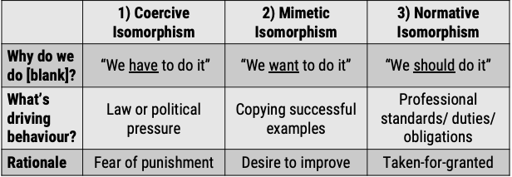
- Podcast from first week, change from shift of emphasis on shareholders to stakeholders
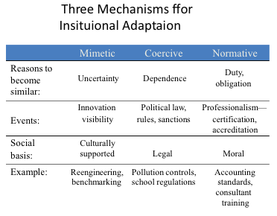
Name the Isomorphism!
- Pure and natural huggies, BAE goes big on ”green” weapons, GM changes blue name brand to green color, spends
- All examples of mimetic isomorphism bc they are copying successful examples
- Obama wore beige suits and conservatives said he had a lack of seriousness due to not wearing black/blue suits
- Example of normative isomorphism because there is a professional standard/obligation
- CEO pay gains vs. stock performance doesn’t increase that much
- Example of perhaps mimetic and normative isomorphism, since other CEOs are getting paid more, so should their valuable CEO
- NBA guy made a tweet about what’s going on in Hong Kong, manager says it’s my freedom of speech, China says no more NBA in china, NBA guy rethinks apology
- Example of coercive isomorphism because there is a fear of punishment
- André Spicer business bullshit, we use these terms to fit in
- Example of normative isomorphism because we don’t think about this lingo, it’s just apparent
- Don Cherry was fired because he refused to apologize for saying immigrants don’t wear poppies on remembrance day
- Example of coercive and normative isomorphism, law or political pressure and professional standards (why is he talking about politics on his show Coach’s Corner about hockey)

Greenwood & Deephouse article: Managing Legitimacy
Where does legitimacy come from?
It comes from the external environment, how stakeholders perceive you
From norms and values in the institutional environment (i.e. from organization’s stakeholders)
Why is it important to get public legitimacy?
- It helps survival and improves economic performance
What are some strategies and practices through which firms pursue organizational legitimacy?
- Conform to the stereotype of how organizations should look and behave i.e. at a pharmacy, pharmacists wear coat, there’s a dropoff/pickoff point
- Signal the appropriateness and credibility of their appearance and actions i.e. Fiji has their green marketing campaign, change brand name
- Change the company name for gaining legitimacy
- Associate with an organization that already enjoys strong social approval i.e. resource dependence such as construction companies associate with government, celebrity sponsorships, companies work with charities

Boyle (2004) article: Can you make fast food healthy?
“The industry is adding new menu items that are genuinely healthier—knowing they’re likely to be poor sellers.”
“Everyone is getting on the bandwagon.”
“No matter how much [consumers] tell pollsters they care about healthy food, they don’t really give a hoot once they’ve crossed the threshold of a fast-food joint”
Why does the industry put healthy items to its menu?
- Getting pressures from social activists, media, local governments, teachers, parents, and consumers.
- Also, a risk mitigation tactic, in order to avoid future backlash from fast food dilemma
- “Some items are marginally healthier, but what fast food restaurants really want is to create the illusion of being healthier even though they aren’t”

Chapter 10: Innovation & Change
Organizational Change
What is change?
- Transition from one state to another
- The act of making or becoming different
Why is it important for organizations?
- Increasing changes in the environment (e.g. regulatory changes, globalization, increased competition, technological advances)
- Adaptation is critical for survival – what strategies, structures, cultures etc. are suitable for this?

Change for Change’s Sake
Unhealthy structures and patterns can build up over time and create problems for your organization
Define | Problem | Solution
1)Silo Formation | Collaboration across units has all disappeared. | Use informal networks to compensate for the limits of the formal structure. Be prepared to repeat the process again and again.
2)The Impact of Routine | There is a persistent failure to spot new developments and opportunities in the market; innovativeness has declined. | Expose people to new aspects of their tasks and opportunities for collaboration. Be prepared to accept a constant state of mild disruption.
3)Entrenched Interests (in the article): org change can threaten your political power (i.e. CEO) so you are more resistant to change | Some groups doing critical work have trouble getting the resources they need; resources are concentrated in a few powerful groups. | Change the dimension along which resources are allocated. Be prepared to disenfranchise and even lose certain people.

Knowing when to change (Puranam and Gulati): can be super practical for managers to see how adaptable/stuck their company is
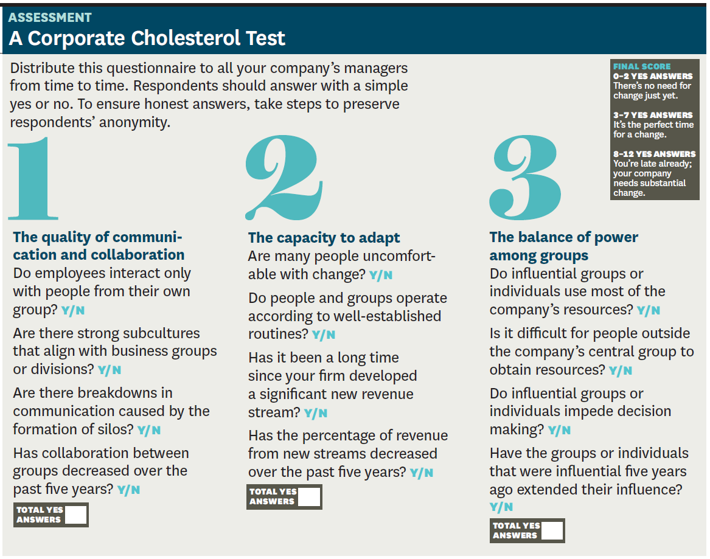

Four Type of Change to Achieve Competitive Advantage
- Technology Change: any company that isn’t continually developing, acquiring, or adapting new technology will likely be out of business in a few years; managers can create the conditions to encourage technology changes
- Product & Service Changes: it involves the product or service outputs of an organization
- Strategy & Structure Changes: it pertains to the administrative domain in an organization, which involves the supervision and management of the organization. It includes changes in the organization structure, strategic management, policies, rewards system, labor relations, coordination devices
- Culture Change: refers to changes in the values, attitudes, expectations, beliefs, abilities and behaviour of employees

Are these changes separate? If you want your change to be more fundamental, then all of these have to change

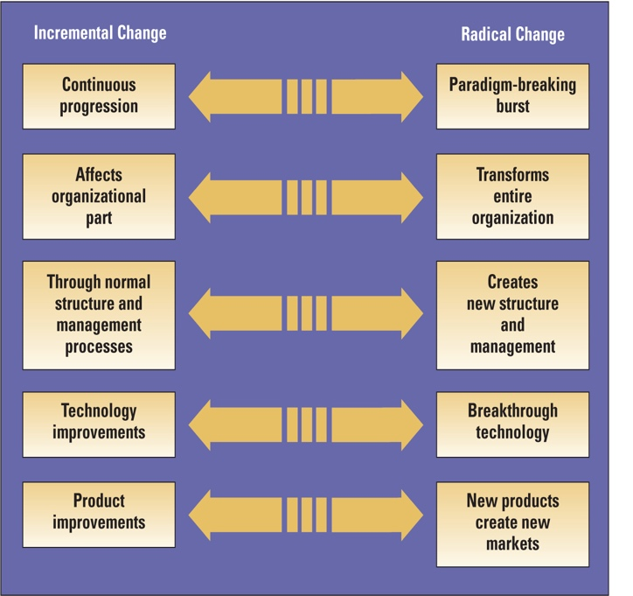
Incremental or Radical?
- Incremental Change: series of continual progressions that maintain the organization’s general equilibrium and often affect only one organizational part
- Radical Change: breaks the frame of reference for the organization, often transforming the entire organization

- Samsung launching the Galaxy S10: incremental because it has continuous product improvement
- Zappos moving to a horizontal structure: radical because their structure and culture completely transformed the entire organization
- Creating a full-time integrator role: incremental because they are changing functions
- Microsoft changing to 3 division from 7: radical because they cut down divisions
- Growth of JetBlue: both incremental and radical because their growth was organic, but it had such a sudden transformation that they had to revamp their structure as well
- Goldman Sachs becoming more profit-focused: incremental
*** Incremental changes turn radical over time

Elements for Successful Change
- Organizational Change: the adoption of a new idea or behavior by an organization
- Organizational Innovation: the adoption of an idea or behaviour that is new to the organization’s industry, market or general environment
- Ideas: No company can remain competitive without new ideas; change is the outward expression of those ideas. Creativity is the generation of novel ideas that may meet perceived needs or respond to opportunities.
- Need: Ideas are generally not seriously considered unless there is a perceived need for change. A perceived need for change occurs when managers see a gap between actual performance and desired performance in the organization.
- Adoption: it occurs when decision makers choose to go ahead with proposed idea. Key managers and employees need to be in agreement to support the change.
- Implementation: it occurs when organization members actually use a new idea, technique or behaviour. Materials and equipment may have to be acquired and workers may have to be trained to use the new idea. Implementation is a very important step because without it, previous steps are to no avail.
- Resources: human energy and activity are required to bring about change. Change does not happen on its own; it requires time and resources, for both creating and implementing a new idea.

Managing Change: Lewin’s three-step model
A classic and enduring model of change
- Big insight: organizations are in inertial equilibrium i.e. “a state of balance between opposing forces”
- “Inertial” equilibrium: organizations must be pushed out of one equilibrium (status quo) and moved into another.
    - Organizational actions are “over determined” – Several factors (structures, processes, culture, strategies) all push in the same direction.
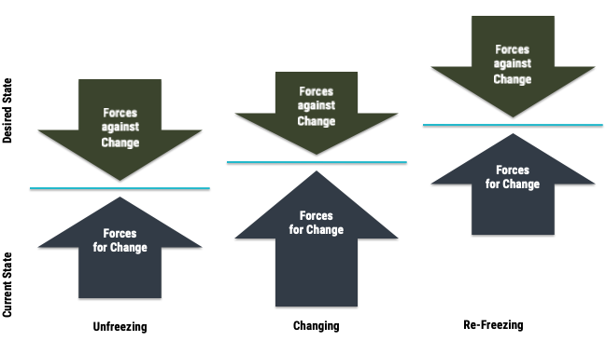
    - Changing one will not lead to overall change. Otherwise they just “roll back” to where they were (e.g., employees return to comfortable habits & ways).

Example of Managing Change: Zappos
CEO incentivizes people to leave the company by saying “you’ll get a 6-month severance package if you leave because we are changing the company to [...] and you may not like it if you stay”

Technology Change
- Organic organizations encourage a bottom-up innovation process. Ideas bubble up from middle and lower level employees because they have the freedom to propose ideas and to experiment
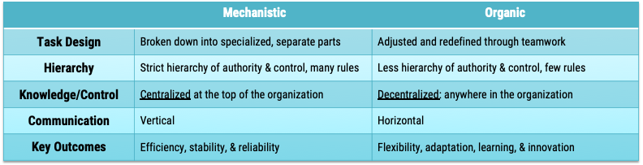
- Mechanistic organization stifles innovation with its emphasis on rules and regulations but it is often the best structure for efficiently producing routine products
Let’s link change to structure… what type of structure would be good for:
  - Incremental technological change? Mechanistic because it focuses on efficiency
  - Radical technological change? Organic because it focuses on innovation and learning

Why is it problematic to pursue only one structure?
- Organizations need both exploration (developing new ideas) and exploitation (implementing those ideas to produce routine products)
- An organic structure generates innovative ideas but is not the best structure for implementing those ideas.
An ambidextrous approach incorporates both mechanistic & organic design elements in an organization. What type of strategy is this? Analyzer strategy
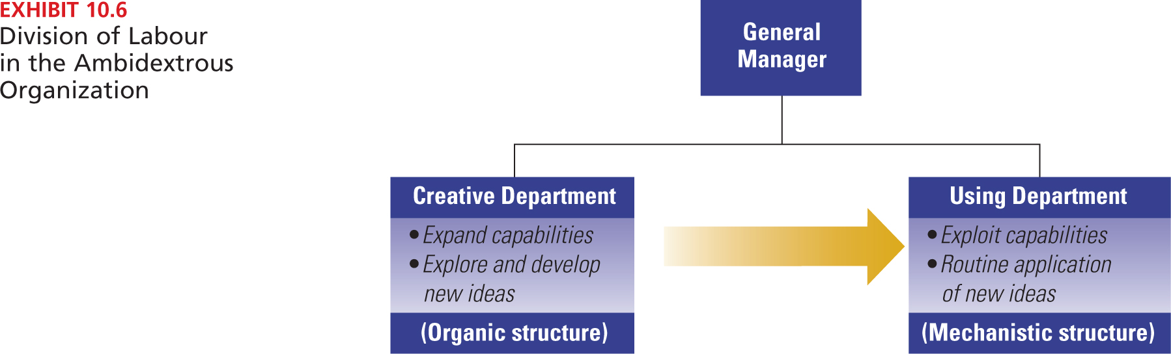

Techniques for Encouraging Technology Change
Some of the techniques used by companies to maintain an ambidextrous approach are switching structures, separate creative departments, venture teams and corporate entrepreneurship
- Basic idea: create a separate department where new ideas can be developed without interference from company bureaucracy or politics
- Often given a separate location and facilities, so they are not constrained by existing organizational procedures
- These are ways that many large, established organizations try to be entrepreneurial and continually encourage change and innovation

- Switching Structures: switching structures occurs when for example a mechanistic organization creates an organic structure for the initiation of new ideas
- Creating Departments: in large organizations, the initiation of innovation is assigned to separate creative departments. Another type of creative department is the idea incubator, an increasingly popular way to facilitate the development of new ideas within the organization. An idea incubator provides a safe harbor where ideas from employees throughout the organization can be developed without interference from company bureaucracy or politics.
- Venture Teams: they are a technique used to give free reins to creativity within organizations. Venture teams are often given a separate location and facilities, so they are not constrained by organizational procedures. A venture team is like a small company within a large company. One type of venture team is skunk works, a separate, small, informal, highly autonomous, and often secretive group that focuses on breakthrough ideas for the business. A variation of the venture team concept is the new-venture fund, which provides financial resources for employees to develop new ideas, products or businesses.
- Corporate Entrepreneurship: attempts to develop an internal entrepreneurial spirit, philosophy and structure that will produce a higher-than-average number of innovations. An important outcome of corporate entrepreneurship is to facilitate idea champions (aka advocate, entrepreneur, change agent). They provide the time and energy to make things happen and come in two types:
-Technical Champion (Product Champion) is the person who generates or adopts
and develops an idea for a technological innovation
-Management Champion acts as a supporter and sponsor to shield and promote an idea, such as a new project or change of structure within the organization

New Products and Services
Reasons for Product Success
- Successful innovating companies had a much better understanding of customer needs and paid much more attention to marketing
- Successful innovating companies made more effective use of outside technology and outside advice, even though they did more work in-house
- Top management support in the successful innovating companies was from people who were more senior and had greater

Horizontal Coordination Model
- Specialization: the personnel in all three of these departments (R&D, marketing and production) are highly competent at their own tasks
- Boundary Spanning: each department involved with new products has excellent linkage with relevant sectors in the external environment
- Horizontal Coordination: technical, marketing and production people share ideas and information

Strategy Structure and Change
The Dual-Core Approach
- Dual-core approach compares administrative and technical changes.
- Administrative changes pertain to the design and structure of the organization itself, including restructuring, downsizing, teams, control systems etc
- Research into administrative changes suggests that (1) admin. changes occur less frequently than technical changes and (2) admin changes occur in response to different environmental sectors and follow different internal process than do technology-based changes

Strategy and Structure Change
All organizations need to make changes in their strategies, structures, management processes, and administrative
procedures from time to time. In the past, when the environment was relatively stable, most organizations
focused on small, incremental changes to solve immediate problems or take advantage of new opportunities.
However, over the past decade, companies throughout the world have faced the need to make radical changes in
strategy, structure, and management processes to adapt to new competitive demands.
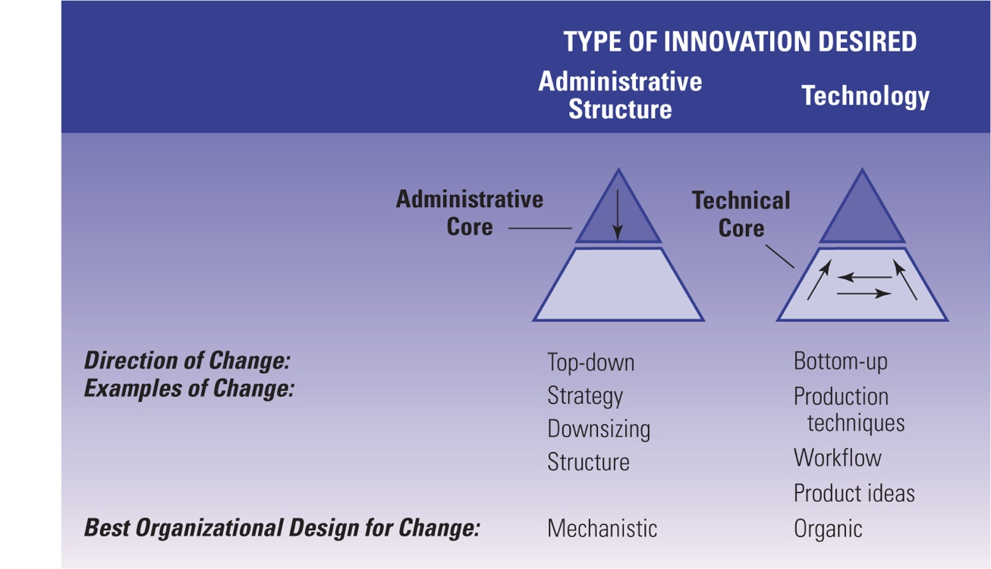

- Organizations have two cores: technical and administrative core
- Each core has its own employees, tasks and environmental domain. Innovation can originate in either core.
- The administrative core is above technical core in the hierarchy and its responsibility include structure, control, coordination of the organization itself and concerns environmental sectors of the government, financial resources, economic conditions, human resources and competitors.
- The technical core is concerned with the transformation of raw materials into organizational products and services and involves the environmental sectors of customers and technology
- Overall, the point is that many organizations—especially not-for-profit and government organizations—must adopt frequent administrative changes and need to be structured differently from organizations that rely on frequent technical and product changes for competitive advantage.

Cultural Change
Why do people often resist change (e.g. why is there “inertia”)?
- Uncertainty avoidance: Change replaces the known with uncertainty, and potentially with fear and anxiety.
- Parochial self–Interest: Change threatens personal investments in & rewards from the status quo.
- Differing assessments of the situation: People affected by the change view the situation – problem, solution, etc. – differently from change initiators.
- Misunderstanding and lack of trust: Especially when trust is lacking, people may not understand the implications of change, and they may fear the worst.
- Excessive focus on costs: management focuses more on cost than employee morale
- Failure to perceive benefits: need more education to help employees and managers to see change in a positive way & if reward system discourages risk taking, they might have to change the system
- Lack of coordination and cooperation: results in organizational fragmentation & conflict
- Fear of loss: managers and employees fear the loss of power, status or jobs

How can you overcome resistance?
How can you overcome resistance?
We saw early on that culture becomes entrenched. What was one way to “dissemble” it?
- Education & Communication: To help people see the logic
  - Almost always key, in general
  - Crucial to help avoid resistance from misunderstandings
- Participation: Involve (and listen to) people. Give them a sense of ownership and control
  - Helps avoid resistance from differing assessments
  - To gain commitment rather than compliance
- Facilitation & Support: Provide personal support to overcome fear (counseling, training, etc.)
  - Helps address resistance from low tolerance for change
However, can be expensive, time consuming, and can still fail

Less desirable ways to overcome resistance:
- Negotiation: Offer incentives to counter self-interest and reduce resistance
  - How does Zappos do this?
  - Can address self-interest, but can be a “slippery slope”
- Manipulation: Hide / distort information to give people a false sense of control and responsibility
  - Tempting at times. But, if manipulation is discovered, trust is lost.
- Coercion: Force compliance with direct or implied threats
  - Useful when your position is strong, fast action is needed (e.g., crisis), you know what needs to be done, and just need compliance (initially)
  - Obviously likely to lead to resentment or revolt.

Chapter 12: Network Centrality
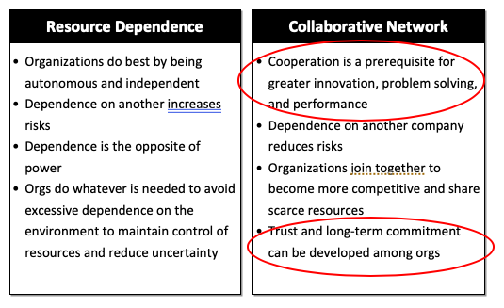
Resource Dependence VS. Collaborative Network

Social Capital
How do we define it?
- Capital: Resource that enables people and organizations to create value, get things done, and achieve goals
- Social: Resides in networks of relationships, not in individuals
Social Capital is the value of interactions and relationships that develop between people – their networks
- What organizations make money from connecting other actors? Recruiting agencies connect people to employers and vice versa.

What do we mean by “networks”?
- A social network: a system of interconnected social actors (people, teams, organizations)
- Networks consist of “nodes” representing actors and “ties” representing relationships (or lack thereof!) among nodes
- What networks are you part of? JMSB, family, friends, neighbourhoods, can also be through profession and religion

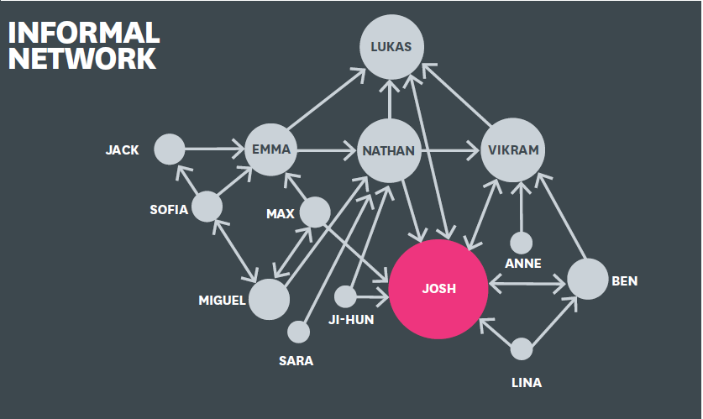
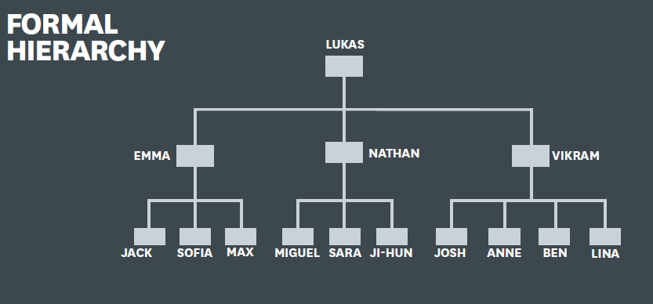
Formal Hierarchy VS. Informal Network

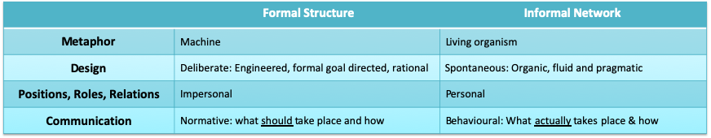
We can see that Josh has more power through informal networks because he has many relationships with others whereas Lukas (& his other VPs) have more power through formal structure.

Types of Ties
Strong Tie | Weak Tie
Similar interests, attitudes, demographic characteristics | Not similar
Know each other well | Doesn’t know each other well
Interact frequently | Rarely interact
Closely related (i.e. spouse, friend, sibling, parent) | Not closely related, usually people you are indirectly related to (i.e. distant cousin, great-uncle, acquaintance)
** Note that weak ties are strong sources of information
i.e. my teacher sucks at teaching the concepts but my friend’s teacher is great so I can learn
from their notes
Selected Benefits of Social Networks for Individuals
- Employees with high centralities get higher performance ratings.
- Managers with large personal networks get higher-paying positions than managers with small networks.
- Managers with large, well-diversified networks get promoted faster and at younger ages compared with their peers who have underdeveloped networks.
- Job candidates with social ties to the hiring organization negotiate higher salaries than candidates without such ties.
- Professionals who find jobs through personal contacts find better, more satisfying jobs that they stay with longer.

Who can be a successful change agent?
Change agents were more successful in the following situations:
- When they were central in the organization’s informal network regardless of their position in the formal hierarchy.
  - Informal connections give people access to information, knowledge, opportunities, and personal support, and thus, the ability to mobilize others!
  - Formal authority is less important relative to network centrality*!
*Network Centrality – centrally located in the organization and having
access to information and people who are critical to the company’s success

- When the shape of their network matched the type of change, they were pursuing:
  - People with bridging networks were more effective at implementing dramatic reforms, while those with cohesive networks were better at instituting minor change
  - Cohesive networks: Most people in your network trust your intentions and those who are harder to convince will be pressured by others to cooperate.
  - Bridging networks: Unconnected resisters are less likely to form a coalition and you have control over what, when, and how you communicate with them

- When they had close relationships with fence-sitters who are ambivalent about the change
  - Being close to endorsers certainly won’t hurt, but it won’t make them more engaged either.
  - Being close to resisters won’t change their mind but they might change yours
  - Being close to fence-sitters presents an opportunity – the relationships may cause them to rethink the issue

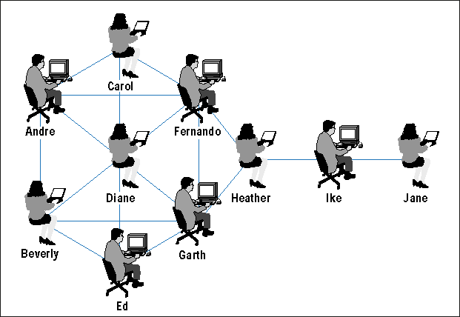
Networks and Power: Who is most influential?

Who is more likely to …?
- Resist change everyone in the circle
- Propose radical change Jane or Ike
- Produce radical change Heather because she connects the circle to Ike and Jane
- Implement incremental change Diane because she knows the people in the circle and incremental change doesn’t affect the existing structure that only Jane/Ike have the authoritative power to change.

Chapter 12: Conflict, Power and Politics
Power & Politics (TEXTBOOK NOTES)
- Power is the ability of one person or department in an organization to influence other people to bring about desired outcomes.
- It is an intangible force in organizations
- Cannot be seen but effects can be felt
- Power in organizations is often the result of structural characteristics and formal hierarchy
- Authority is a force for achieving desired outcomes, but only as prescribed by the formal hierarchy and reporting relationships.
- Authority is vested in organizational positions: it isn’t caused by personal characteristics
- Authority is accepted by subordinates: legitimate right to exercise authority
- Authority flows down the vertical line

Power and Politics (TEACHER’S NOTES)
- Authority is influence that is vested in a position held in formal hierarchy and flows down the hierarchy vertically
- Power is a measure of your ability to exert influence, get things done, and exercise control.
  - The ability of A to get B to do something, that B would not do otherwise.
  - How else do you have power if not through authority? Knowledge: expert power, networking: building relationships leads to information and buy-in, referent power, coercive power: ability to punish someone, incentive powers
- Politics is defined as the use of this power, regardless of where it comes from.

Organizational Politics
It involves activities to acquire, develop and use power and other resources to obtain the preferred outcome when there is uncertainty or disagreement about choices.
- When is political activity used?
Domains of Political Activity:
- Structural change: reorganizations cause bargaining and negotiation
- Management succession: use of hiring and promotion to strengthen network alliances and coalitions by putting their own people in prominent places
- Resource allocation: political activity helps to obtain agreement about allocation

Why Study it?
- Because power strongly affects, and is affected by, the formal and informal structure of an organization
i.e. in Zappos, power comes from culture and is more distributive
perhaps referent or incentive power
- Because power is necessary to be an effective manager, and to be able to get things done
So we should learn how to acquire, and use, power to achieve organizational goals

Rational VS. Political Model
The degree of goal incompatibility, differentiation, interdependence and conflict over limited resources determines whether a rational or political model of behaviour is used within organization to accomplish goals
- Rational Model of Organization: when goals are in alignment, there is little differentiation, departments are characterized by pooled interdependence and resources seem abundant (ideal situation)
- Political Model: when differences are great, organization groups have separate interests, goals and values
Joel: expert power, legitimate power, coercive power, informational, referent power
Pope: referent power, legitimate power, coercive power

When conflict is low, rational model describes organization as… |  | When conflict is high, political model describes organization as…
Consistent across participants | Goals |  | Inconsistent, separate views, pluralistic within the organization
Centralized | Power & Control |  | Decentralized, shifting coalitions and interest groups
Orderly, logical, rational | Decision Process |  | Disorderly, result of bargaining and interplay among interests
Norm of efficiency orientation | Rules & Norms |  | Free play of market forces; conflict is legitimate and expected, power comes collective group effort to reach organizational goals and resources
Extensive, systematic, accurate i.e. formal hierarchy network | Information |  | Ambiguous; information used and withheld strategically  i.e. informal network

Individual VS Organizational Power
Bases of power (French & Raven, 1959):
- Legitimate power: your formal authority in the hierarchy
- Reward power: ability to bestow rewards to other people (i.e. promotion, pay raise)
- Coercive power: authority to punish or recommend punishments
- Expert power: skill of knowledge, what you know
- Referent power: derived from personal characteristics, who you are *very strong, people feel personally connected to you because of your referent power
- Informational power: ability to control what information is collected, how it is interpreted and how it is started
Where does power come from?
Resource Dependence Theory
- A function of resources, dependencies, and alternatives
  - How valuable are the resources?
  - How dependent are firms on those resources?
  - Are there other options?
  - Reward (set prices) and coercive power (bad relationship w/ supplier can lead to them cutting you off)
Network Theory
- Position
- Network Centrality
- Informational power, referent power (Tesla giving off patents so other companies can use it as a standard to create electrical cars)

Back to the second class of this term and the metaphors (machine, organism, community)
Sources of power in the “rational system” (machine):
- Position in Organizational Charts
- Control of decisions, information and resources
Sources of power in “open systems” (organism)?
- Control over key resource issues, and dependencies, in the environment, ability to innovate and adapt, access to information etc.
Sources of power in “natural systems” (community):
- Established reputations, political savvy (as in navigating conflicts)
- Establish(ed) relationships
- Informal positions – remember “weak ties”?

Intergroup Conflict in Organization
- Conflict is natural and inevitable outcomes of close interaction. It can be a positive force because it challenges the status quo, encourages new ideas and approaches and leads to change
- Conflict is when groups clash directly, similar to competition but more severe
- Intergroup Conflict is the behaviour that occurs among organizational groups when participants identify with one group and perceive that other groups may block their group’s goal or expectations
- Competition is rivalry among groups in pursuit of a common prize, whereas conflict presumes direct interference with goal achievement

Intergroup Conflicts in Organizations:
- Group identification: employees have to see themselves as part of a group
- Observable group differences: different floors/buildings, ability to observe as a group
- Frustration: if one group reaches its goal, the other will be blocked

Larry Summers at Harvard
> Why did he get fired?
- Worked for the federal reserve (formal, hierarchical) whereas a university is collaborative need more referent power and expert power because it is a very decentralized/horizontal structure compared to federal reserve where hierarchy matters
- Pushed through a radical change
> What should he have done differently?
- He should’ve built more networks and connections
- Simply wait and build more trust and respect among individuals at the university. You can’t build trust and referent power right away like Larry Summers did.
>Being the smartest in the room isn’t enough: need to understand and navigate political dynamics
- “He failed to appreciate the cultural differences between the hierarchical structure of the federal government and the more collaborative atmosphere of academia”
- “He said his relationship with some faculty had become too dysfunctional for him to continue…”
>Hard to push (radical) change when people don’t see the need ... He should’ve pushed through incremental change
>Need to have support of powerful constituents

Sources of Intergroup Conflict
- Goal Incompatibility: differences in goals among departments are often the greatest cause of intergroup conflict in organizations. The achievement of one department’s goals often interferes with another department’s goals. Between marketing and manufacturing there is the greatest potential for conflict:
Goal Conflict | Marketing: Operative goal is customer satisfaction | Manufacturing: Operative goal is production efficiency
Conflict Area | Typical Comment
Breadth of production line | “Our customers demand variety” | “The product line is too broad, all we get are short, uneconomical runs”
New product introduction | “New products are our lifeblood” | “Unnecessary design changes are prohibitively expensive”
Product scheduling | “We need faster response. Lead times are too long” | “We need realistic customer commitments that don’t change like the wind direction”
Physical distribution | “Why don’t we ever have the right merchandise in inventory” | “We can’t afford to keep huge inventories”
Quality | “Why can’t we have reasonable quality at low cost?” | “Why must we always offer options that are too expensive and offer little customer utility?”

- Differentiation:
- differences in cognitive, and emotional, orientations (values, attitudes, standards, etc.) among managers, in different functional departments
- Think R&D (“wouldn’t that be cool if we did this?”) versus Operational Functions (“how do we make this operationally work?”) exploration versus exploitation
- Pitfalls of exploration and exploitation and the ambidextrous organization
- Task Interdependence: Dependence of one unit on another for materials, resources or information. As interdependence increases, the potential for conflict increases. Pooled Interdependence = little interaction/conflict. Sequential & Reciprocal Interdependence = frequent communication/conflicts
- Limited Resources: In their desire to achieve goals, groups want to increase their resources, which are limited, thus lead to conflict. Competition between groups for limited resources (capital investments, human resources etc.) This is huge!!
- Discourse and Language: Professionals talk differently, as a result of their training and practice. i.e. An engineer will talk in a certain way, while a Marketing expert will talk in their own manner… and sometimes they will talk at cross purposes.

NOT IMP* Vertical Sources of Power
- Formal position: legitimate power
- Resources: top managers control resources and can determine their distribution
- Control of decision premises and information: top managers place constraints on decision made at lower levels by specifying a decision frame of reference and guidelines. Top managers have more access to information
- Network centrally: being centrally located in the organization and having access to information and people are critical to the company’s success. Top executives are more successful at the center of a communication network
- People: group of loyal executives increases power

NOT IMP* Horizontal Sources of Power
- Strategic contingencies: events and activities both inside and outside an organization that are essential for attaining organizational goals. Departments involved with strategic contingencies tend to have greater power. Departmental activities are important when they provide strategic value by solving problems or crises for the organization
- Power sources: powerful departments may possess one or more power sources
    - Dependency: interdepartmental dependency
    - Financial resources: control over financial resources
    - Centrality: role in the primary activity of an organization
    - Non-substitutability: department’s functions cannot be performed by other readily available resources
    - Coping with uncertainty: reduce uncertainty to increase power

Tactics of using Power, Politics and Collaboration to overcome conflict:
Tactics for increasing the power base | Political tactics for using power | Tactics for enhancing collaboration
Enter areas of high uncertainty | Build coalitions and expand networks | Create integration devices i.e. full-time integrator, task force
Create dependencies | Assign loyal people to key positions | Use confrontation and negotiation
Provide scarce resources | Control decision premises | Schedule intergroup consultation
Satisfy strategic contingencies | Enhance legitimacy and expertise | Practice member rotation
Make a direct appeal | Create subordinate goals | Create shared goals (your mission statement, purpose of values)

However:
- Conflict is natural and inevitable in organizations
- Individuals, groups, and departments use power and political activity to address their differences and to manage conflict.
- Conflict can be productive if channelled correctly

Relating back to contingency theory:
Which elements give/remove power?
- Performance:
- is the outcome of structure and context
- perhaps profitability, turnover rates, growth, number of patents you give out
- How does an organization’s definition of performance relate to power? Performance is related to how power is distributed, performance is a legitimation of power***, low turnover rate = justifies HR department doing well
- Specialization: referent power and expert power
- Professionalism: expert power
- Formalization: higher formalization = expert power
- Culture and values: referent power (compare Japan to US)

