Chapter 3: Analyzing the marketing environment

A marketing environment analysis framework:
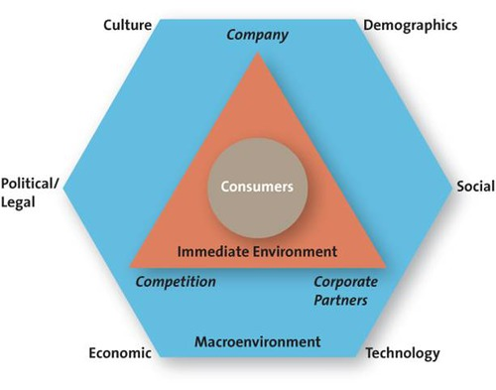

CDSTEP:
- Cultural
- Demographic
- Social/ natural
- Technological
- Economic
- Political/ legal
4C’s
- Suppliers (corporate partners)
  - Company, Competitors
    - Marketing Intermediaries (corporate partners)
      - Customers/ consumers

- Company
- Corporate partners
- Competition
- Consumers

Company capabilities:
- Core competency = satisfy customer needs
- People, knowledgeable, facilities, patents, technology
- Target markets, products etc.
Competition:
- Identify and analyze direct and indirect competitors
- Know strengths and weaknesses
- Competitive intelligence (CI) used to collect and synthesize info

Corporate partners: (from manufacturer to retailer)
- Firms are part of alliances – few works in isolation
- Align with suppliers, corporate partners etc.

Culture: is broadly defined as the share’s meanings, beliefs, morals, values and customs of a group of people
- Country cultures vs regional subcultures
  - Powerful influences in consumer buying decisions – what they buy, where they, how much they spend
Demographics: Characteristics of human populations and segments used to identify consumer markets
- Age/ generational cohort – ex: millenniums, baby boomers etc..
- Gender
- Ethnicity
- Income
- Education
General cohort: is a group of people of the same generation that have similar purchase behaviours because they have shared experiences and are in the same stage of life
- Tweens
- Generation Y (millennials)
- Generation X
- Baby boomers
- Seniors
Income:
- Purchasing power: is tied to income (tracked by statistics Canada)
- Many Middle-class families feel the decline in purchasing power in recent years
Education: is related to income, which determines spending power
Gender:
- Male/ female roles have been shifting – marketing has changed to reflect these shifts
Ethnicity:
- Ethnic composition of Canada is changing
- 1/5 Canadians not born in Canada
- By 2030, population growth will be mainly attributed to immigration
Technological advances:
- Technology has impacted every aspect of marketing:
  - New products
  - New forms of communication
  - New retail channels
Economic Situation:
- The economic environment consists of factors that affect consumer purchasing power and spending patterns
  - Recession
  - Foreign currency fluctuations
  - Combined with inflation and interest rates affect a firm’s ability to market goods and services
Political/ Legal environment:
- Competition Act
- Consumer packaging and labelling act
- Food and drugs act
- Access to information act
- Patent act
- North American free trade agreement (NAFTA)
Social and natural trends:
- Green consumers
  - Customer who appreciate the efforts of companies to supply them with environmentally friendly merchandise
- Privacy concerns
  - Loss of privacy
  - Identity theft
  - Do not call
  - Do not email
- Time-poor society
  - In the majority of families, most parents work
  - Consumer have many more choices regarding leisure time
  - Many consumers multitask
- Health and wellness
  - Health concerns
    - Obesity amoung children leading to high blood pressure and cholesterol, sign of heart disease and type 2 diabetes
  - Consumers interest in improving their health
- Marketing to children

