Chapter 8: Developing new products:

Product:
- Promotion
- Product
- Place
- Price

Why do firms create new products?
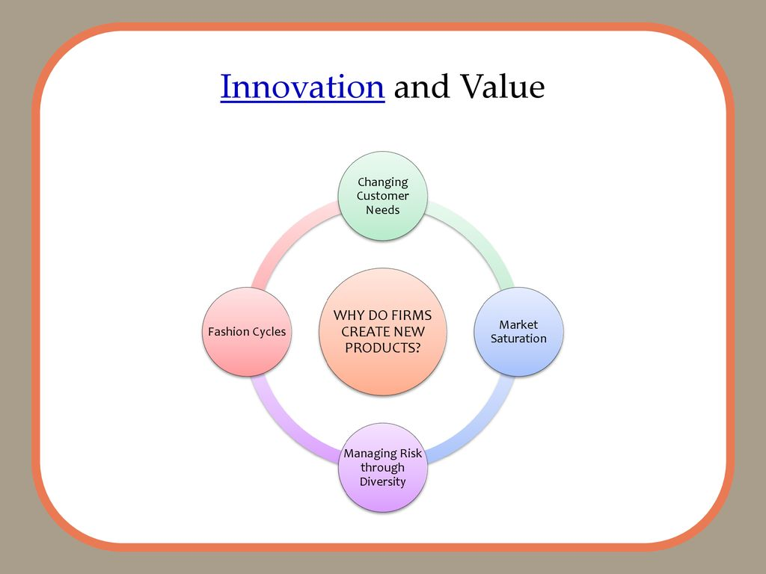

Changing consumer needs:
- Adding new products allows firms to create value by satisfying changing needs of current and new customers
  - Sometimes firms take a well-known product, such as a vacuum and make it much more interesting (ex: Dyson)
Market Saturation:
- The longer a product exists in the marketplace, the more likely the market will become saturated
  - Saturated markets also offer opportunities
- Without new products or services, the value of the firm declines
Managing risk through diversity:
- Innovation allows firms to create a broader portfolio of products
  - This leads to diversification of risk
  - A portfolio of products is better than having just a single product
    - “Don’t put all your eggs in one basket”
Fashion Cycles:
- Fashion industry:
  - Relies on trends
  - Experiences short product like cycles
- Most sales come from new products
Innovation and value;
- Pioneers:
  - New to the world products that create new markets
  - Breakthrough
  - Disruptive
- First movers
  - Pioneers that are first to create a market or products category
New- product development reasons for new product failure
- Overestimation of market size
- Poor design
- Incorrect positioning
- Wrong timing
- Priced too high
- Ineffective promotion
- Management influence
- High development costs
- Competition
Adoption of innovation (8 -11)

Using the diffusion of innovation theory:
- Factors affecting product diffusion:
  - Compatibility
  - Observability
  - Complexity and trialability
  - Relative advantage

How firms develop knew products:
- Idea generation
- Concept testing
- Product development
- Market testing
- Product launch
- Evaluation of results

- Idea generation:
- Internal sources: refer to the company’s own formal research and development (R and D) management and staff, and entrepreneurial programs
- External sources: refer to sources outside the company such as customers, competitors, distributors, suppliers, and outside design firms
- New ideas
  - Customer input
  - Internal (R&D)
  - Competitors product
  - Brainstorming
  - Licensing
- Concept testing
- Concept testing refers to testing new product concepts with groups of target consumers
  - Concept is a brief written description of the product
  - Customer reactions determine whether or not it goes forward
  - Triggers the marketing research process
- Product development
- Product development involves the creation of one or more physical versions
  - Prototype
  - Alpha testing
  - Beta testing
- Market testing
- Premarket tests
  - Customers exposed
  - Customers surveyed
  - Firm makes decisions
- Test marketing
  - Mini product launch
  - More expensive the premarket tests
  - Market demand is estimated
- Product Launch
- Commercialization is the introduction of the new product
  - Planned market rollout
  - New product
    - Promotion
    - Timing
    - Place
    - Price
- Evaluation of results
- Satisfaction of technical requirements
- Customer acceptance
- Satisfaction of firm’s financial requirements

Strategies for extending
- Increase frequency of use
- Increase # of users
- Find new users
- Develop new uses
- Modify product
- Reposition product
- Tweak marketing strategy

