Marketing chapter 4: Consumer Behaviour

The consumer decision Process:
Need recognition -> Information search -> alternative evolution -> purchase decision -> post purchase
Prepurchase decision -> purchase decision -> post purchase decision

Step 1: Need recognition:
- Functional needs: Pertain to the performance of a product or service
- Psychological need: pertain to the personal ratification consumers associate with a product or service
Step 2: Information search:
- Internal search for information – the buyer examines his or her own memory and knowledge about the product or service
- External search for information – The buyer seeks information outside his or her personal knowledge base to help make the buying decision
Factors affecting consumers search processes:
- The length and intensity of the search are based on several factors, including:
  - Perceived benefits vs perceived costs
  - Locus of control
  - The degree of perceived risk
- Perceived benefits of search vs perceived costs of search
  - Is it worth the time and effort to search for information about a product or service?
- Internal locus of control:
  - Some control over outcomes = engage in more search activities
  - Ex: Bad grade – I must not have studied enough. I can do better next time
- External Locus of control:
  - Fate, external factors control all outcomes = why bother?
  - Ex: bad grade- The test was flawed. There is no way to do well
Actual and perceived risk
- Performance risk – performance risk involves the perceived danger inherent in a poorly performing product or service
- Financial risk – associated with a monetary outlay and includes the initial cost of the purchase as well as the costs of using the item or service
- Physiological risk – those risks with the way people will feel if the product or service does not convey the right image
- Social risk- social risk involves the fears of consumers that others may not regard their purchases positively
Step 3: Alternative Evaluation
- Evaluation criteria
  - A set of important attribution
- Determinant attributes
  - Product or service features that are important to the buyer and on which competing brands or stores are perceived to differ
- Compensatory decision rules
  - Trade-offs between characteristics
  - Only 1 attribute is most important
- No compensatory decision rules
  - No trades off between characteristics
  - Consider many attributes when making a decision
- Mental Shortcuts:
  - Price – can send a message about quality to consumers
  - Brand
  - Product presentation – placing product next to a product with high quality consumers will think that the original product is also high quality
Step 4: Purchase decision:
- Customers are ready to buy
- Inventory or availability – being able to predict the demand for products
- Ritual demand of consumption; when shopping season starts during Christmas; another way of saying firms should predict when they need certain inventory
Step 5: post purchase
- Post purchase outcome
  - Customer satisfaction (+)
  - Post purchase dissonance (-) This is a form of dissatisfaction
  - Customer loyalty (+) – your expectations have been exceeded
- Undesirable consumer behaviour:
  - Negative word of mouth (can be damaging)
  - The internet is an effective way to spread negativity
  - Marketers must respond quickly!
Factors Influencing consumer buying decisions:
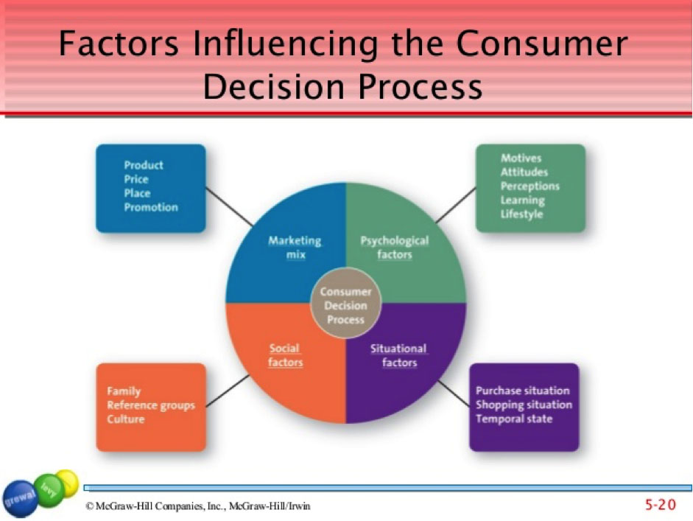
- Psychological factors:
  - Motives
    - Motive – is a need that is sufficiently pressing to direct the person to seek satisfaction
    - Maslow’s Hierarchy of needs
  - Attitude
    - Attitudes: describe a persons enduring evaluation and tendencies toward an object or idea
      - An attitude consists of 3 components:
        - Cognitive (beliefs)
        - Affective (feelings)
        - Behavioural (actions)
  - Perceptions
    - Perception: is the process by which people select, organize and interpret information to form a meaningful picture of the world
      - Components of perception
        - Selective exposure
        - Selective attention – having a straight view of the product
        - Selective comprehension
        - Selective retention
  - Learning
    - Learning: Is he change in an individual thought process or behaviour
      - Arises from experience and takes place throughout he consumer decision process
      - Affects both attitudes and perceptions
  - Lifestyle
    - Lifestyle: is persons pattern of living as expressed in his or her psychographics
    - Measures a consumers AIOs (activities, Interests, opinions)
- Social factors
  - Family
    - Decision makers
    - Influences
  - Reference groups
    - Reference group: is one or more persons whom an individual use as a basis for comparison regarding beliefs, feelings and behaviours
      - Groups
        - Family
        - Friends
        - Co-workers
        - Famous people
      - Affect buying decisions by:
        - Offering information
        - Provide rewards
        - Enhancing self- image
  - Culture:
    - Shared meanings, beliefs, morals and customers
    - Greatly influences consumer behaviour
      - Marketers must understand differences amount countries
- Situational Factors:
  - Purchase situation
  - Shopping situation
  - Temporal State – your current mood
Types of buying decisions:
- Consumers engage in two types of buying process/ decisions depending on their level of involvement
  - Extended problem solving
  - Limited problem solving
    - Impulse buying
    - Habitual decision making

